E
International Union for the Protection of New Varieties of Plants

Technical Working Party on Automation and Computer Programs  Thirty-Fifth Session  Buenos Aires, Argentina, November 14 to 17, 2017 | TWC/35/14  Original: English  Date: October 30, 2017
Reasons and situations when the approaches described in the United Kingdom practical exercise (TWC/30/32) would/would not be appropriate for transforming observations into notes on measured, quantitative characteristics
Document prepared by an expert from the United Kingdom
Disclaimer: this document does not represent UPOV policies or guidance

INTRODUCTION
When the content of Annex V to document TWP/1/15 “Data Processing for the assessment of distinctness and for producing variety descriptions” was presented to TWPs in 2016, experts from the United Kingdom realized that some revision of the content was necessary. The following is the revised content. The experts from the United Kingdom propose that the following replaces the content of Annex V to document TWP/1/15.

Cases when use of delineating varieties chosen by crop expert judgement would or would not be appropriate for transforming observations into notes
Crop expert chosen delineating varieties* would not be used if
- the delineating variety did not express the same state as in previous years, e.g. if the delineating varieties “drifted”, or
- new varieties regularly arose that showed more extreme expression.
- available datasets too small for COYD analysis.
Crop expert chosen delineating varieties would be used if
- the delineating varieties do not drift, such as with herbage crops where there are annual changes according to field and climate conditions, but then all the varieties tend to be affected in the same way by these. It is also used for cereals and winter oilseed rape crops.
* Delineating varieties differ from example varieties in that in the former, a delineating variety defines each upper (or lower) intervening limit of the states within the range of expression. By contrast, with example varieties an example variety represents the typical or mid-interval expression of each state within the range of expression.

Cases when use of equal-spaced states would/would not be appropriate for transforming observations into notes
Equal-spaced states would not be used if
- reference varieties with more ‘extreme’ states are not included in the growing trial
- where the range of values is not continuous, e.g. in pod width characteristic in peas (and to a certain extent also the length characteristic). In peas there are two types of pod; the “normal” and the “balloon”. Below are pictures and a histogram of the over-years mean pod width. This shows that there is a mixture of two distributions for the pod width, corresponding to the two types: a normal distribution for the “normal” type but a scattering of “balloon” types at the top end. If you use the “Equal-spaced method” in this case the individual notes get stretched. There are really two discrete scales here which reflect the two different pod-types.
- available datasets too small for COYD analysis.
Equal-spaced states would be used if
- reference varieties represent the full states of expressions.
- where the range of values is continuous
Balloon pods  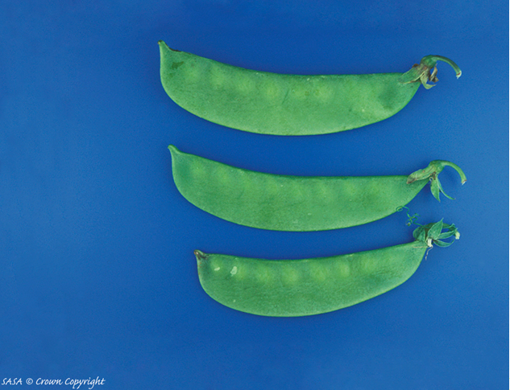 | Normal pods  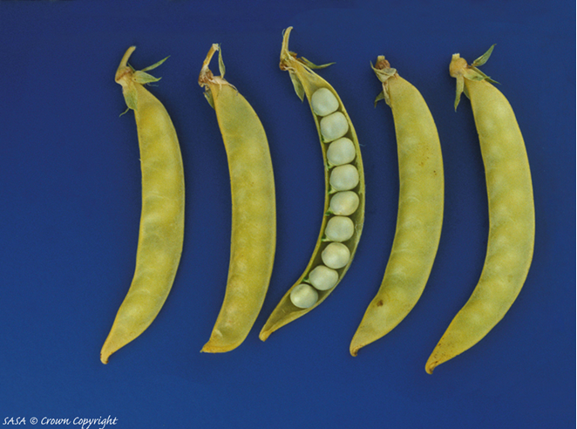

Histogram of pea pod width characteristic
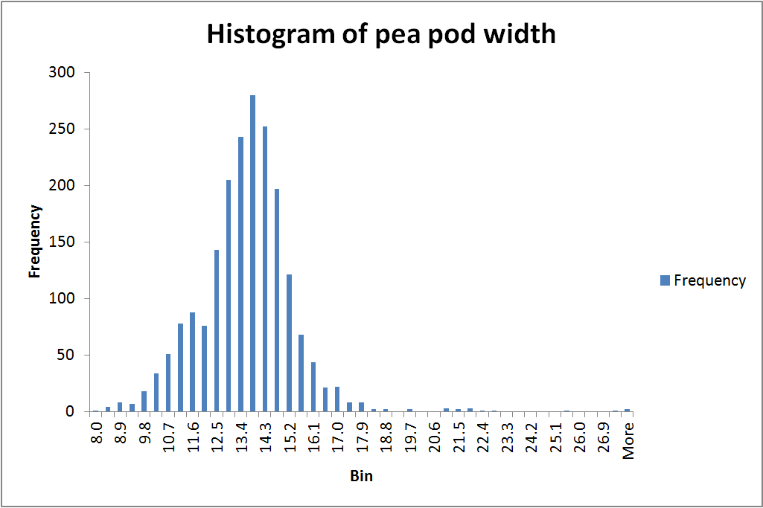

Sally Watson, Consultant Statistician, Statistical Services Branch, Agri-Food & Biosciences Institute, United Kingdom

[End of document]

