E
International Union for the Protection of New Varieties of Plants

Technical Working Party on Automation and Computer Programs  Thirty-Fifth Session  Buenos Aires, Argentina, November 14 to 17, 2017 | TWC/35/12  Original: English  Date: October 23, 2017
Short Explanation on the Japanese Methods for Assessment Table for Producing Variety Descriptions
Document prepared by an expert from Japan
Disclaimer: this document does not represent UPOV policies or guidance

1. The measured data for QN characteristics in DUS growing trial are transformed to numerical notes based on the assessment table. The assessment table are developed by the measurement data of respective example variety which are allocated in the specific notes, are precisely defined each range of notes. In case of major crops as we have accumulated measured data from long standing DUS growing trials which have been carried out under the same places, similar circumstances and same condition for the crops growing.

2. Under these circumstances, the fundamental assessment table(FAT) are developed by these accumulated measured data of the example variety. The FAT is corrected by the growing degree calculated by the comparison with current years measured data of example variety.

[Annex follows]

Introduction to USING FUNDAMENTAL ASSESSMENT TABLE SYSTEM for Quantitative Characteristics in Japan

- Assessment Table
Assessment Table had been working to transform measured data into numerical note in DUS test. Each note was allocated “Range” by their measured data of example varieties.

Table 1: Example of Assessment Table for characteristic ‘Length of leaf blade’

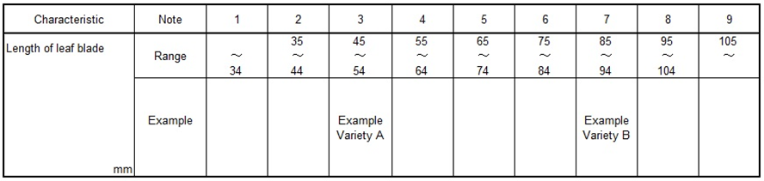

As growing of these example varieties have been affected by the yearly climatic situation or other environmental elements, their actual measured data for QN characteristics have tendency of fluctuation in some extent. Usually registered varieties have been used as similar varieties for DUS growing trials, in the case of registered variety as note 3, registered variety doesn’t always keep their original states when the variety registered by applying above Assessment Table because of fluctuating for the distance of measured data between example variety A and B.
To keep the evaluation unchangeably, The Assessment Table had been improved based on the accumulated measured data of example varieties.

- Fundamental Assessment Table (FAT) System

2.1 FUNDAMENTAL ASSESSMENT TABLE (FAT)
FAT is developed by more than 10 years’ average as “Trial Mean” of data of example varieties which are allocated “Median” of the Range of Note.
Following table is set by 10 years’ average of example varieties.
Table 2: Example FAT for characteristic ‘Length of leaf blade’

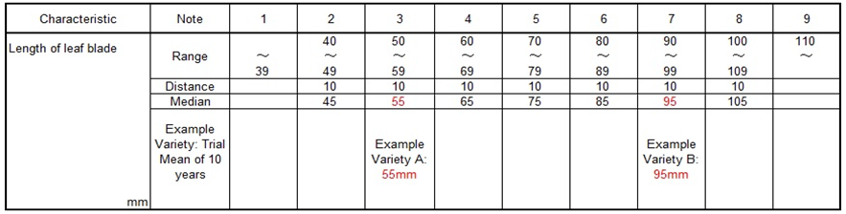

FAT is the assessment table which involved 10 years’ error as principle table, usually FAT is converted by current year’s data of example varieties before the evaluation of the note for QN characteristics.
Current trial data should always be assessed by transforming FUNDAMENTAL ASSESSMENT TABLE (FAT) to CURRENT ASSESSMENT TABLE (CAT).

  - Transforming CURRENT ASSESSMENT TABLE (CAT)
To transform from FAT to CAT, it is used “Growth Score” as followings.

2.2.1 Growth Score
Example
10 years’ average as “Trial Mean” of leaf length is 55mm with example variety A.
“Current years’ Mean” of leaf length is 52mm with example variety A.
Current Mean of 52mm / Trial Mean of 55mm = 0.95 =“Growth Score”

2.2.2 Multiplying “Growth Score”
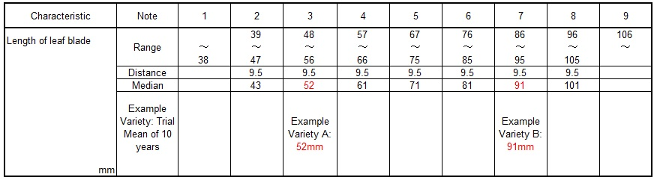
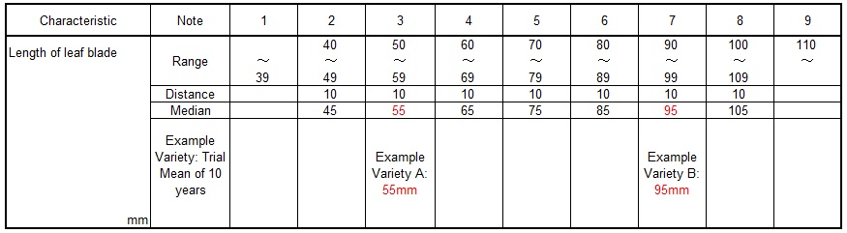
CAT is develo ped by multiplying “Growth Score” to FAT for adjustment to the current growth level.
CAT is produced with reflected growth level of the trial (0.95)
FAT is multiplied Growth Score 0.95
  - Relevance of FAT and CAT
Following graph explains relation between FAT and CAT. FAT is always retained 1.00 Growth Score. Current trial Growth Score to be scored year by year.

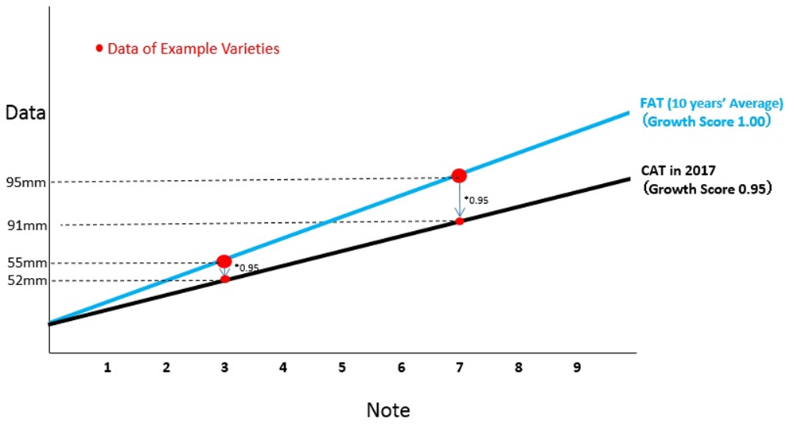

[End of Annex and of document]

