E
TWC/34/30
ORIGINAL: English
DATE: June 2, 2016
INTERNATIONAL UNION FOR THE PROTECTION OF NEW VARIETIES OF PLANTS
Geneva
Technical working party on automation and computer programs
Thirty-Fourth Session
Shanghai, China, June 7 to 10, 2016
A ring-test comparing three different software packages for COYD
Document prepared by an expert from China
Disclaimer: this document does not represent UPOV policies or guidance
The Annex to this document contains a copy of a presentation on “A ring-test comparing three different software packages for COYD” that will be made at the thirty-forth session of the Technical Working Party on Automation and Computer Programs (TWC).

Abbreviations:
CAAS Chinese Academy of Agricultural Sciences
GB The United Kingdom
CN China
DE Germany

Kun Yang, Senior Agronomist, Deputy director of Beijing Station of DUS Testing for New Varieties of Plants, Ministry of Agriculture, China (under Institute of Vegetables and Flowers, Chinese Academy of Agricultural Sciences)

[Annex follows]

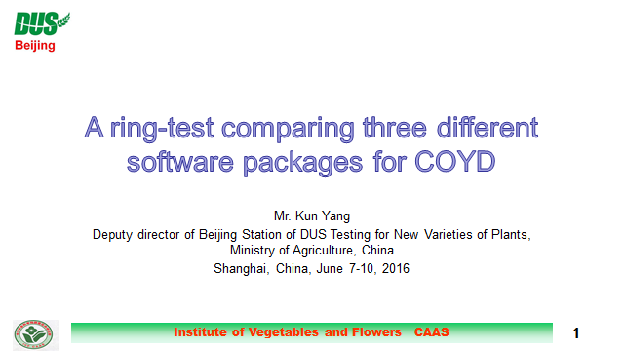

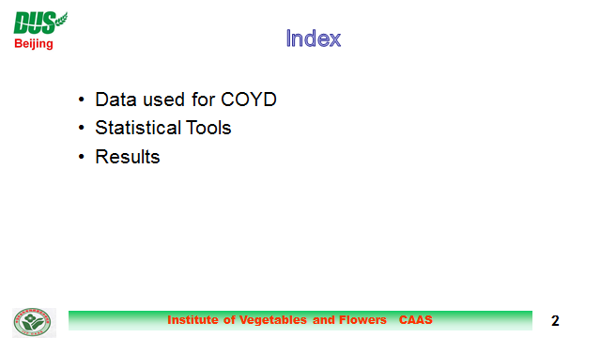

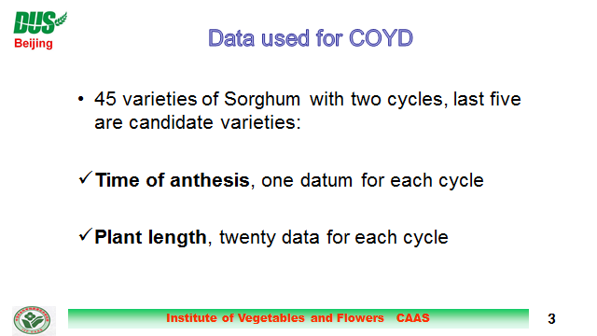

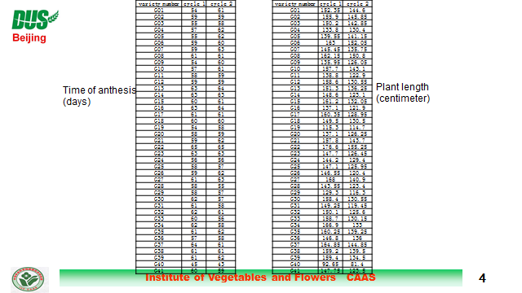

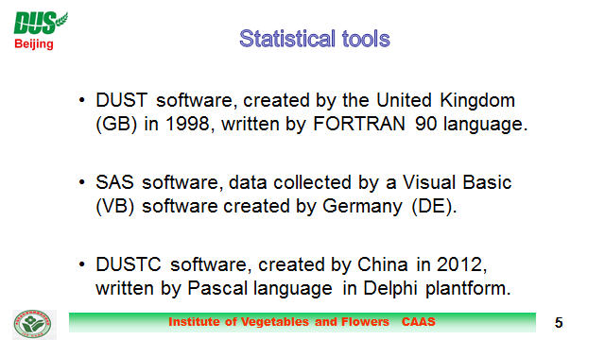

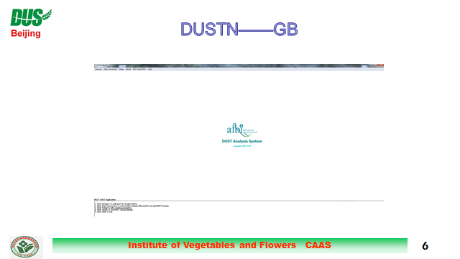

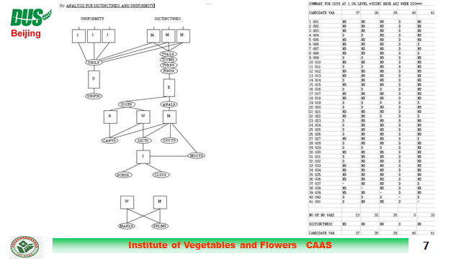

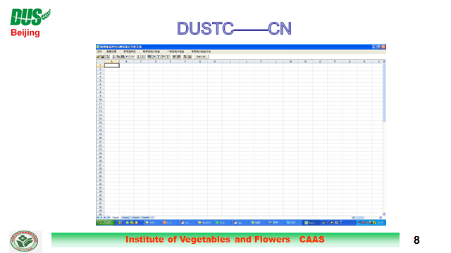

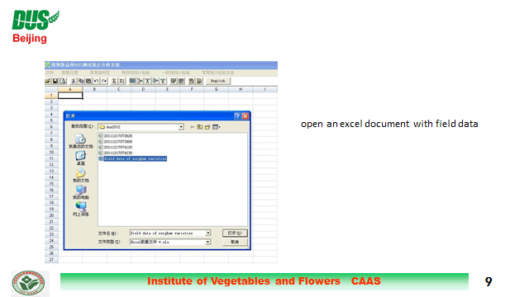

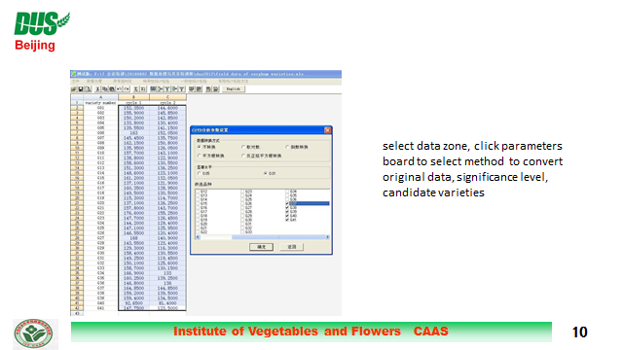

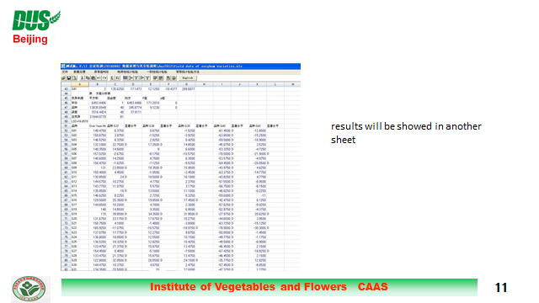

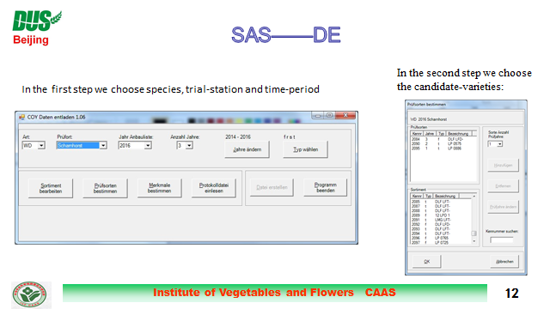

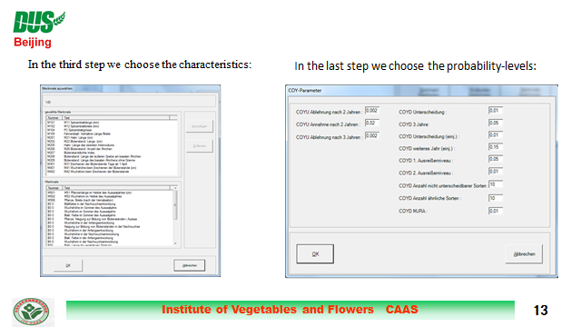

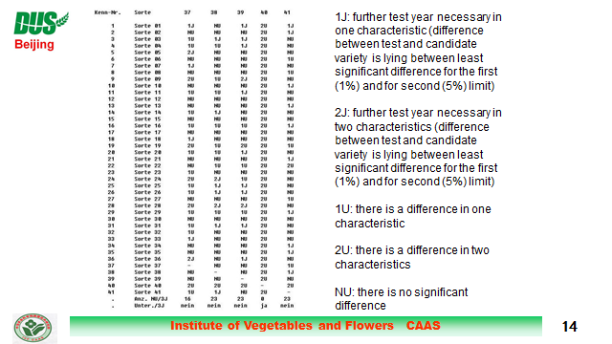

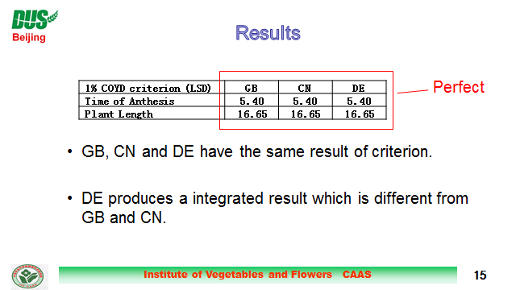

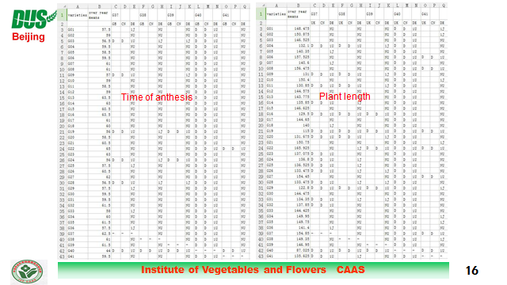

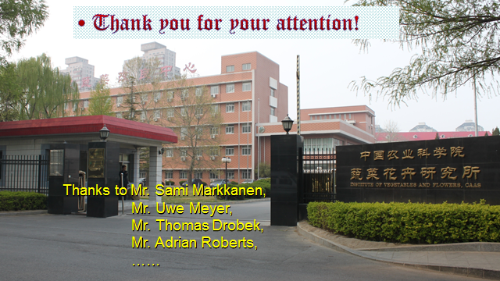

[End of Annex and of document]

