E
TWC/34/21
ORIGINAL: English
DATE: May 18, 2016
INTERNATIONAL UNION FOR THE PROTECTION OF NEW VARIETIES OF PLANTS
Geneva
Technical working party on automation and computer programs
Thirty-Fourth Session
Shanghai, China, June 7 to 10, 2016
Minimum Number of growing cycles
Document prepared by an expert from the Netherlands
Disclaimer: this document does not represent UPOV policies or guidance
The Annex to this document contains a copy of a presentation on “Minimum Number of growing cycles” that will be made at the thirty-fourth session of the Technical Working Party on Automation and Computer Programs (TWC).

Kees van Ettekoven, Head, Variety Registration Department, Naktuinbouw

[Annex follows]

MINIMUM NUMBER OF GROWING CYCLES

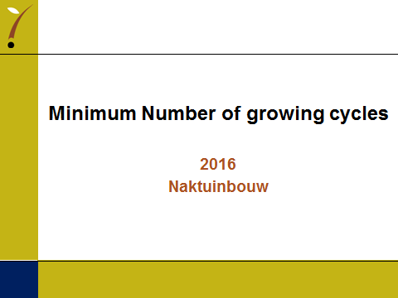

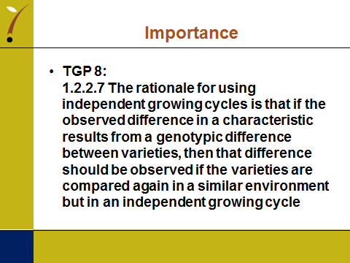

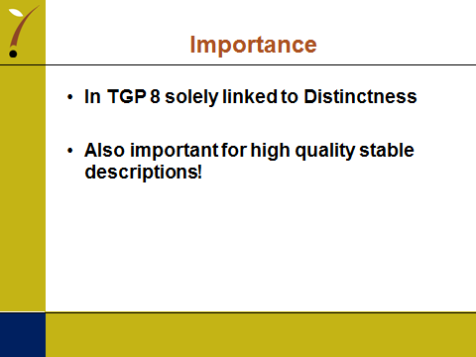

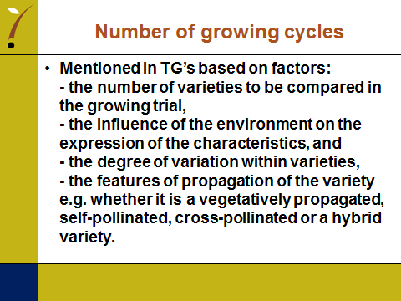

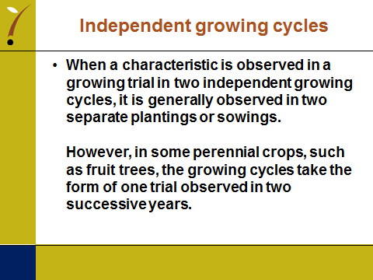

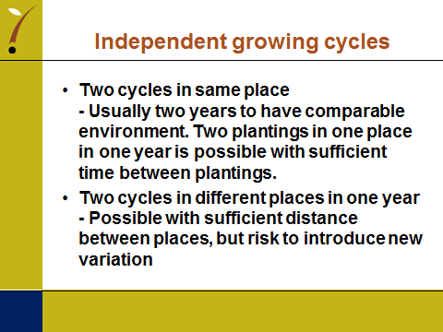

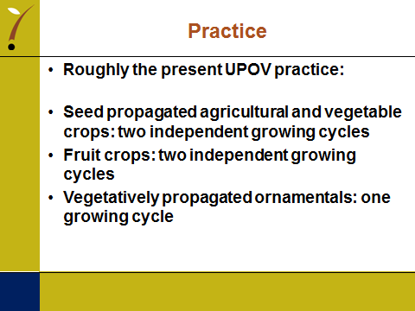

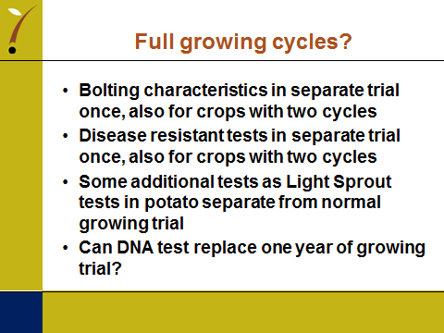

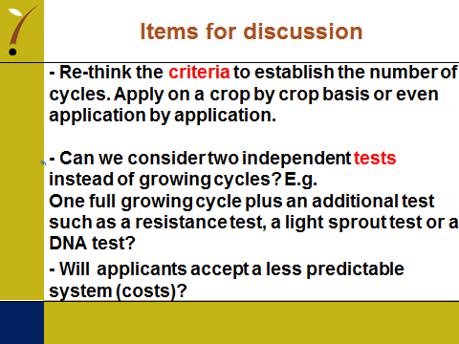

[End of Annex and of document]

