E
TWC/34/20
ORIGINAL: English
DATE: May 19, 2016
INTERNATIONAL UNION FOR THE PROTECTION OF NEW VARIETIES OF PLANTS
Geneva
Technical working party on automation and computer programs
Thirty-Fourth Session
Shanghai, China, June 7 to 10, 2016
Search Plant: A search portal to facilitate tracking and tracing of ornamental varieties
Document prepared by experts from the Netherlands
Disclaimer: this document does not represent UPOV policies or guidance
The Annex to this document contains a copy of a presentation on “Search Plant: A search portal to facilitate tracking and tracing of ornamental varieties” that will be made at the thirty-fourth session of the Technical Working Party on Automation and Computer Programs (TWC).

Abbreviations:
CPVO Community Plant Variety Office of the European Union
ICNCP International Code for Nomenclature of Cultivated Plants
KAVB Royal General Association for Bulb Culture
RHS Royal Horticulture Society

Marco Hoffman, Crop Expert Ornamentals, Naktuinbouw
Kees van Ettekoven, Head, Variety Registration Department, Naktuinbouw

[Annex follows]

SEARCH PLANT: A SEARCH PORTAL TO FACILITATE TRACKING AND TRACING OF ORNAMENTAL VARIETIES

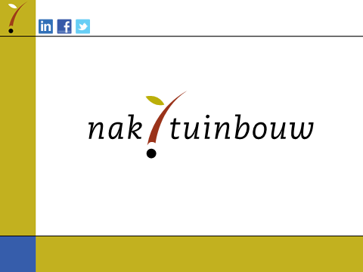

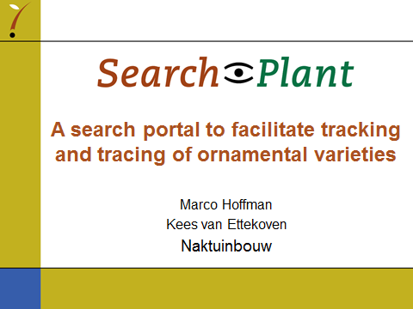

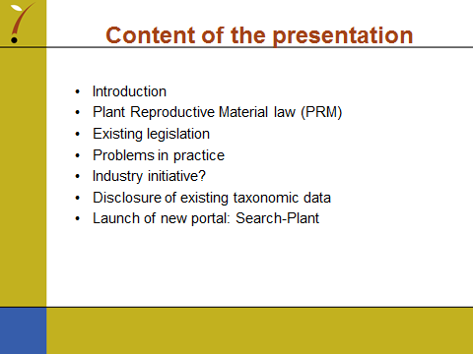

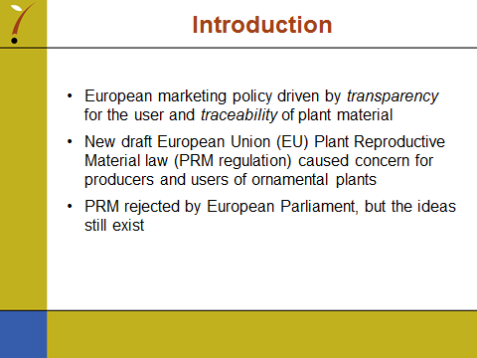

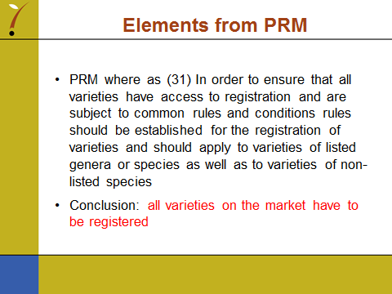

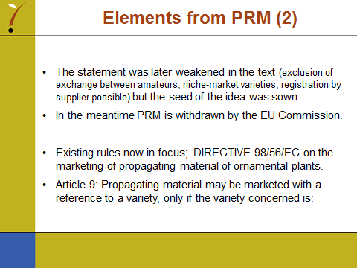

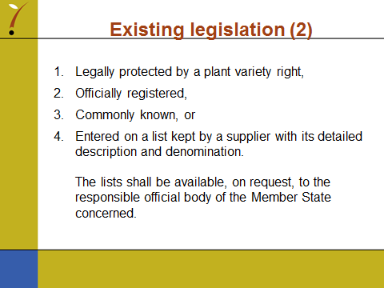

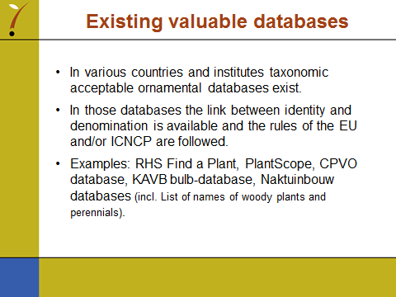

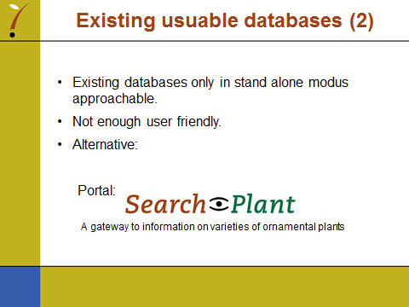

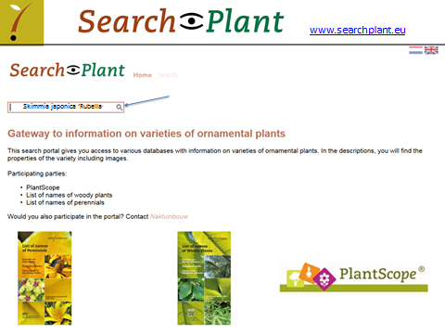

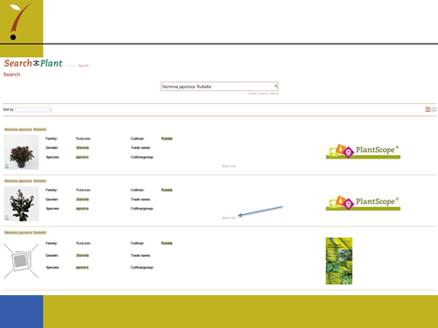

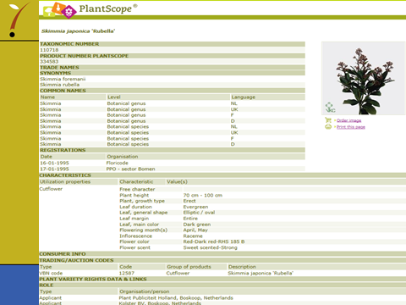

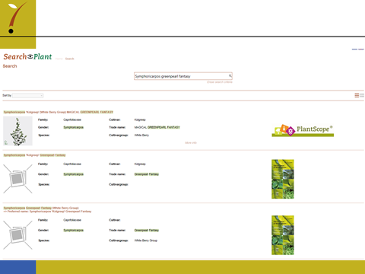

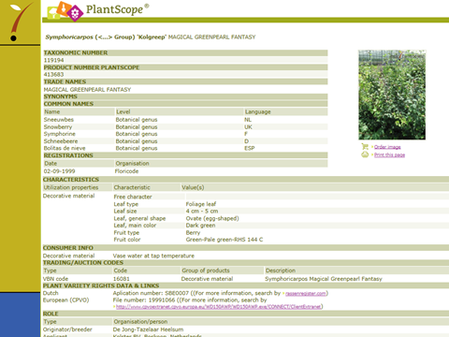

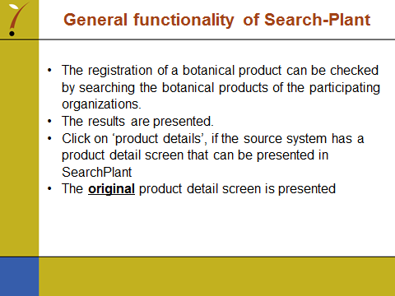

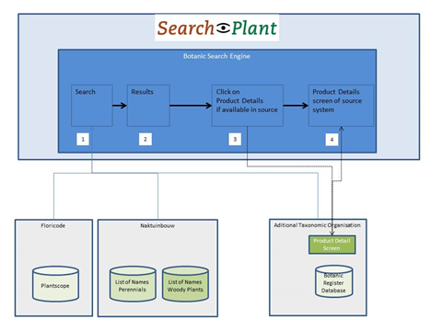

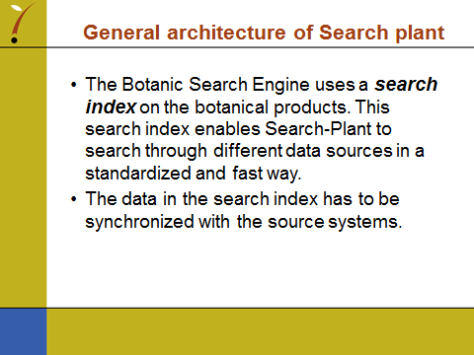

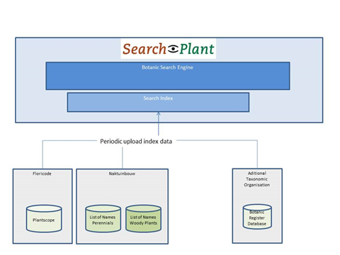

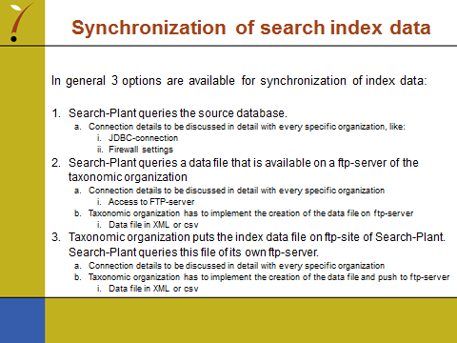

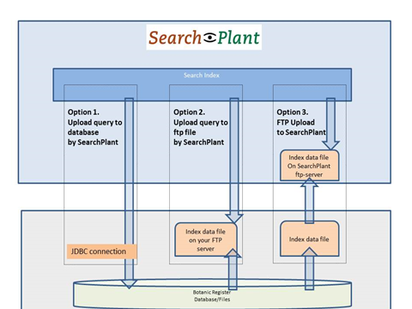

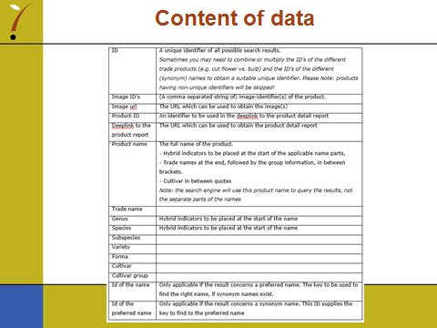

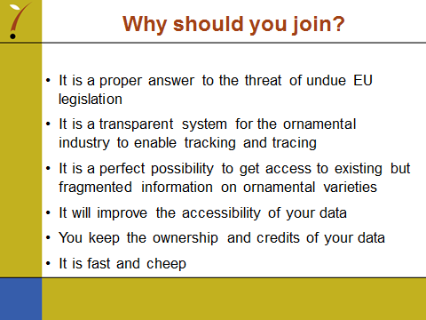

[End of Annex and of document]

