E
TWC/34/17
ORIGINAL: English
DATE: May 6, 2016
INTERNATIONAL UNION FOR THE PROTECTION OF NEW VARIETIES OF PLANTS
Geneva
Technical working party on automation and computer programs
Thirty-Fourth Session
Shanghai, China, June 7 to 10, 2016
Genotype by Enviroment Interaction (GEI) - DUS test and data transformation into notes
Document prepared by experts from Italy and Finland
Disclaimer: this document does not represent UPOV policies or guidance
The Annex to this document contains a copy of a presentation on “Genotype by Environment Interaction (GEI) - DUS test and data transformation into notes” that will be made at the thirty-fourth session of the Technical Working Party on Automation and Computer Programs (TWC).

[Annex follows]

GENOTYPE BY ENVIROMENT INTERACTION (GEI) - DUS TEST AND DATA TRANSFORMATION INTO NOTES

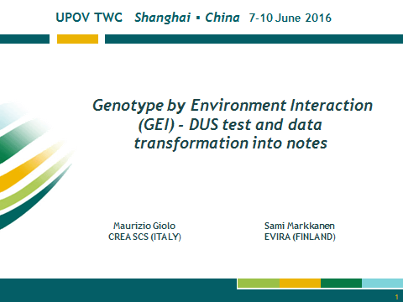

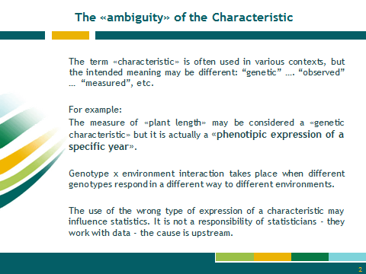

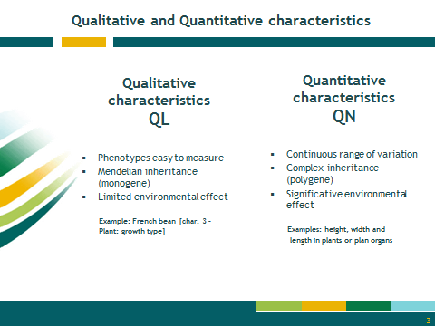

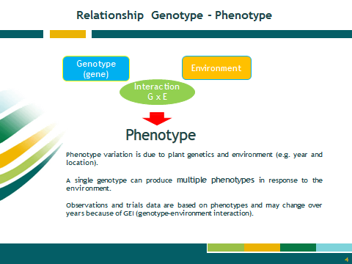

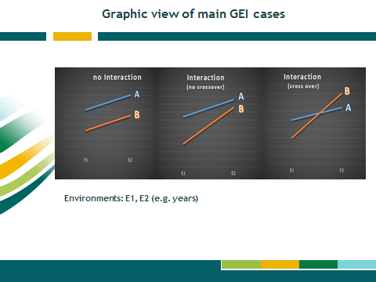

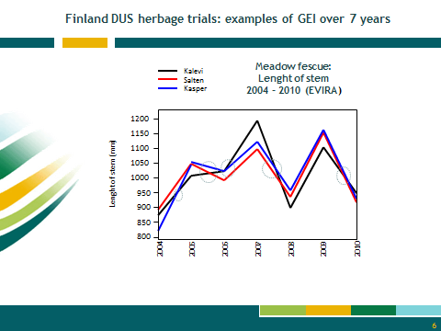

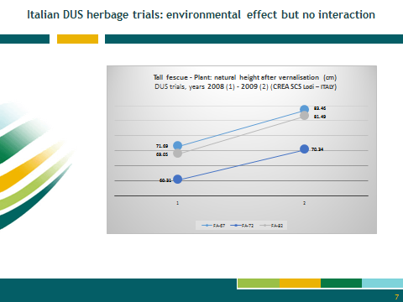

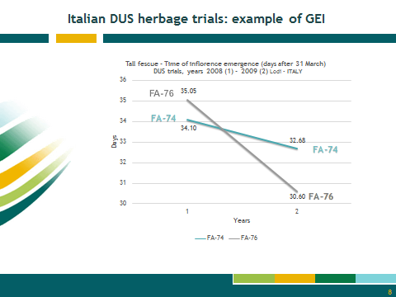

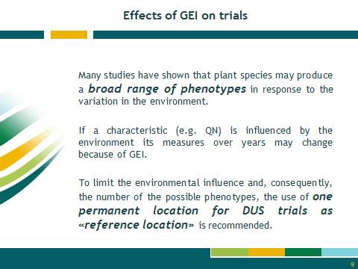

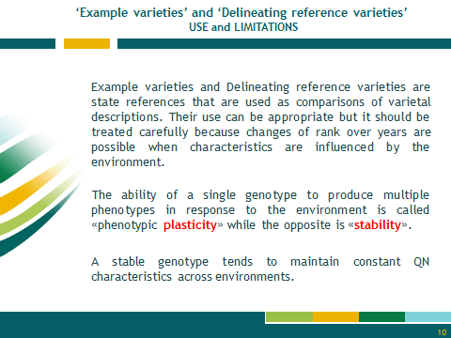

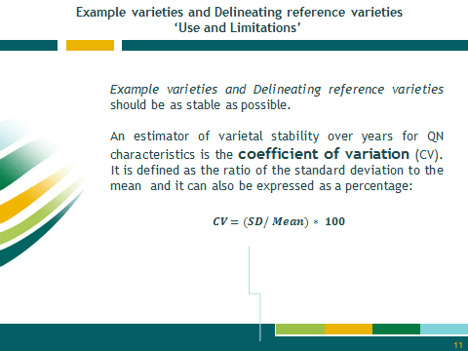

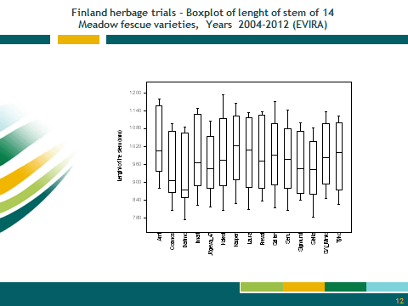

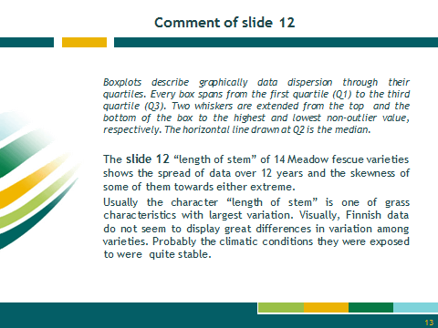

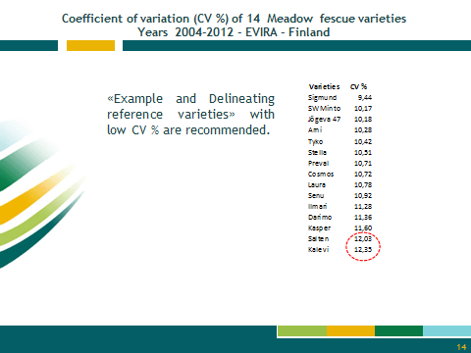

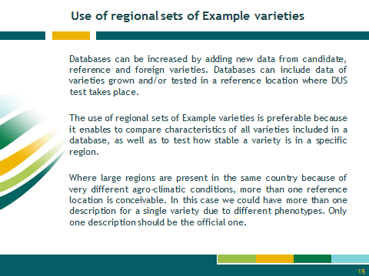

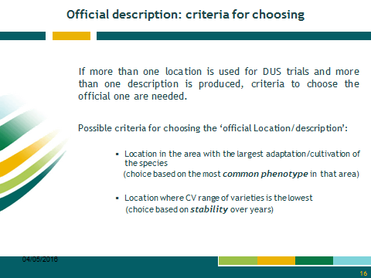

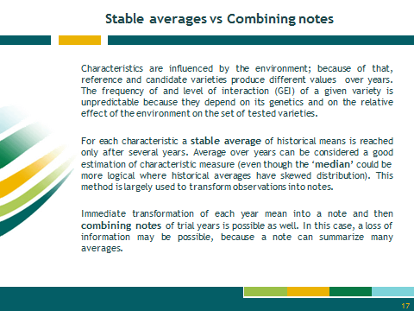

[End of Annex and of document]

