E
TWC/34/12 Add.
ORIGINAL: English
DATE: June 7, 2016
INTERNATIONAL UNION FOR THE PROTECTION OF NEW VARIETIES OF PLANTS
Geneva
Technical working party ON AUTOMATION AND COMPUTER PROGRAMS
Thirty-Fourth Session
Shanghai, China, June 7 to 10, 2016
ADDENDUM TO
Revision of document TGP/8: Part II: Selected Techniques Used in DUS Examination, New Section: Data Processing for the Assessment of Distinctness
and for Producing Variety Descriptions
Document prepared by the Office of the Union
Disclaimer: this document does not represent UPOV policies or guidance

The information provided by an expert of the United Kingdom in reply to the invitation of the Office of the Union, on April 29, 2016, to provide information on the reasons and situations in which example varieties, crop expert judgement and equal-spaced states would/would not be appropriate for transforming observations into notes, is reproduced in the Annexes to this document, as follows:

- Annex I: “Short explanation on measured, quantitative characteristics for United Kingdom veg & herbage”
- Annex II: “Reasons and situations that determine use of approaches”.

[Annexes follow]

TWC/34/12 Add.

ANNEX I

SHORT EXPLANATION ON MEASURED, QUANTITATIVE CHARACTERISTICS
FOR UNITED KINGDOM VEG & HERBAGE

Presentation by Ms. Sally Watson, United Kingdom

Short explanation on the United Kingdom methods for Data Processing for the Assessment of Distinctness and for Producing Variety Descriptions
In the United Kingdom, to develop variety descriptions in vegetable and herbage crops, which are mostly cross-pollinated except for pea which is self-pollinated, the trials are conducted according to the UPOV Test Guidelines. Over-year variety means are calculated from the yearly trial means. Trial means from the past 10 years’ trials are used for herbage crops. Trial means from all years where the reference collection varieties have been tested are used in vegetable crops. The over-year means are calculated using a fitted constants analysis to adjust the over-year means for the different years varieties were present in. Finally, the over-year means are converted to notes. For vegetable crops excluding potato this is done so that the states are equally spaced. For herbage crops this is done by use of delineating varieties.
For greater detail and worked examples, see TWC/30/32.

[Annex II follows]

TWC/34/12 Add.

ANNEX II

REASONS AND SITUATIONS THAT DETERMINE USE OF APPROACHES

Presentation by Ms. Sally Watson, United Kingdom

Reasons and situations when certain approaches would/would not be appropriate for transforming observations into notes

Cases when use of example varieties / crop expert judgement would/would not be appropriate for transforming observations into notes
Example varieties / crop expert judgement would not be used if
- the example variety did not express the same state as in previous years, ie if the delineating varieties “drifted”, or
- new varieties regularly arose that showed more extreme expression.
Example varieties / crop expert judgement would be used if
Such as with herbage crops, which are fairly stable species so the delineating varieties do not drift. There are annual changes according to field and climate conditions, but then all the varieties tend to be affected in the same way by these. It is also used for cereals and winter oilseed rape crops.

Cases when use of equal-spaced states would/would not be appropriate for transforming observations into notes
Equal-spaced states would not be used if
- reference varieties with more ‘extreme’ states cannot be sourced
- where the range of values is not continuous, eg in pod width characteristic in peas (and to a certain extent also the length characteristic). In peas there are two types of pod the “normal” and the “balloon”. Below are pictures and a histogram of the over-years mean pod width. This shows that there is a normal distribution for the “normal” type but a scattering of “balloon” types at the top end. If you use the “Equal-spaced method” in this case the individual notes get stretched. There are really two discrete scales here which reflect the two different pod-types.

Balloon pods  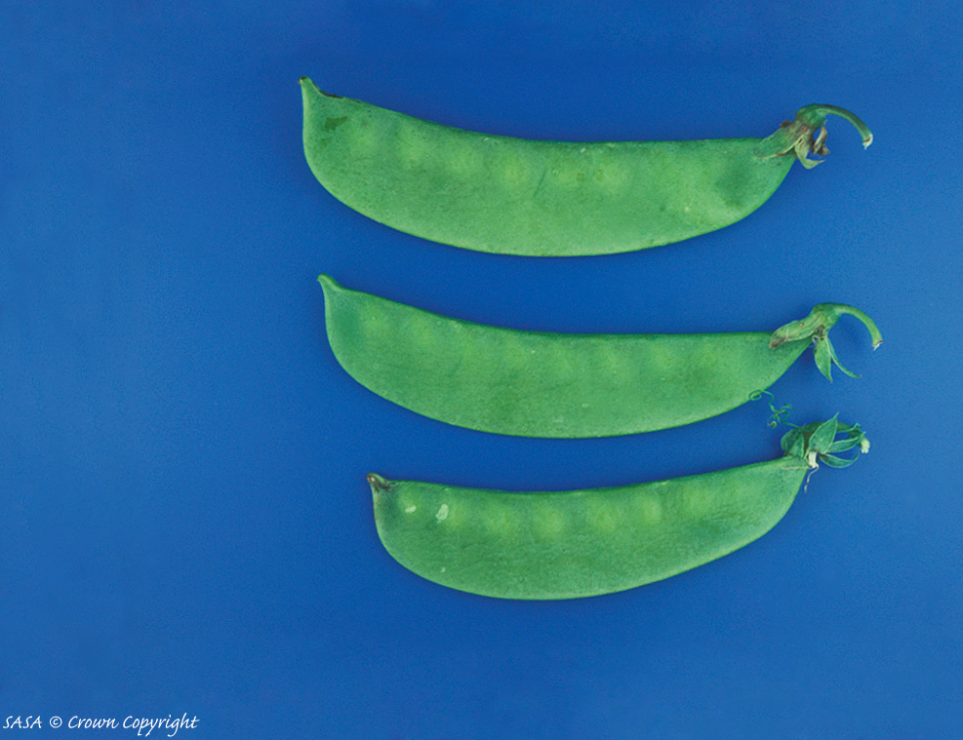 | Normal pods  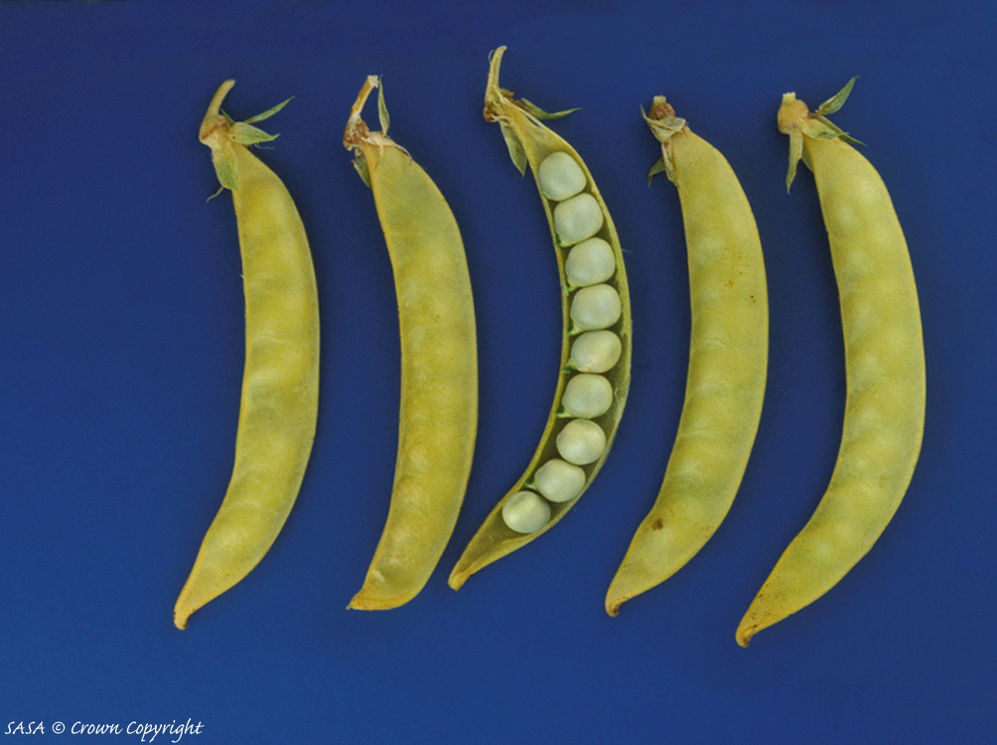

Histogram of pea pod width characteristic

[End of Annex II and of document]

