E
TWC/33/28 Rev.
ORIGINAL: English
DATE: July 13, 2015
INTERNATIONAL UNION FOR THE PROTECTION OF NEW VARIETIES OF PLANTS
Geneva
Technical working party on automation and computer programs
Thirty-Third Session
Natal, Brazil, June 30 to July 3, 2015
The new plant variety protection image analysis system in China
Document prepared by an expert from China
Disclaimer: this document does not represent UPOV policies or guidance
The Technical Working Party on Automation and Computer Programs (TWC), at its thirty-second session, held in Helsinki, Finland, from June 3 to 6, 2014, received a presentation from China on “PVP Database in China“, as set out in Annex II to document TWC/32/6. The TWC noted that the new software included modules for the management of applications, variety description database, data analysis and image analysis. The TWC agreed to request China to make a presentation on the particular features of the software, including image analysis, at its thirty-third session (see document TWC/32/28 “Report”, paragraph 82).

The Annex to this document contains a copy of a presentation on “the new plant variety protection image analysis system in China” that was made at the thirty-third session of the TWC.

[Annex follows]

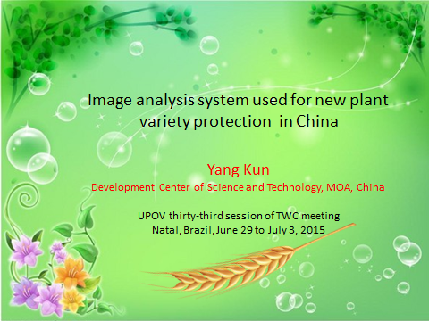

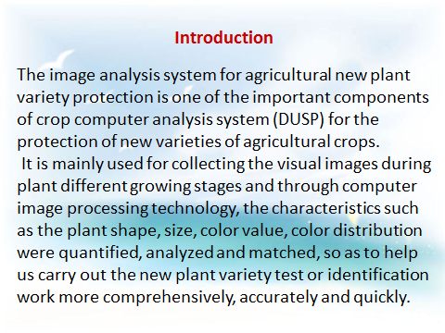

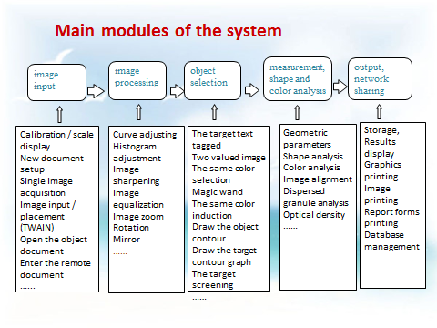

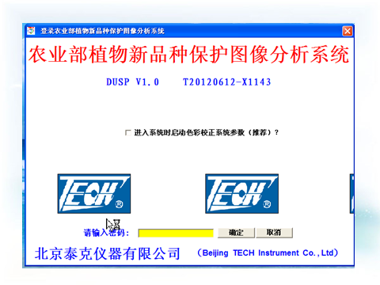

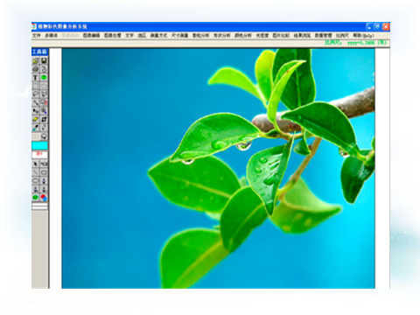

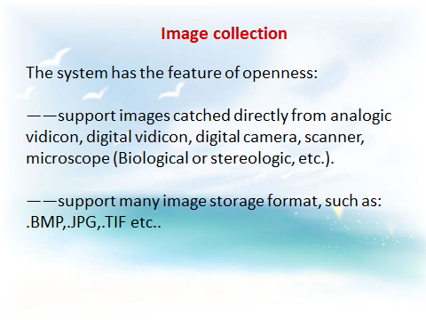

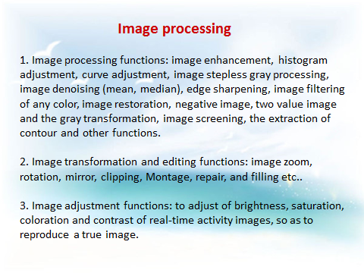

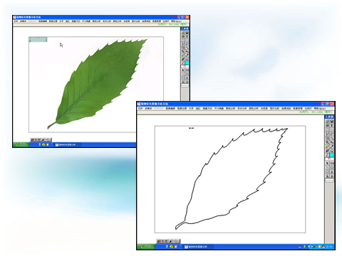

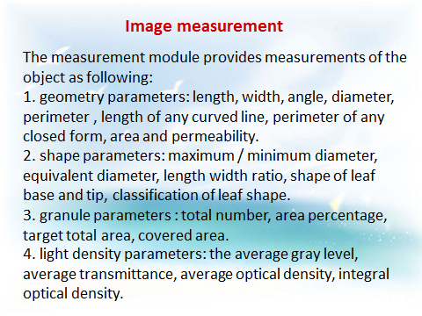

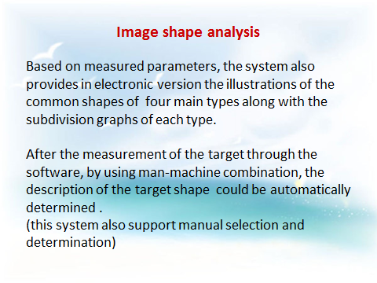

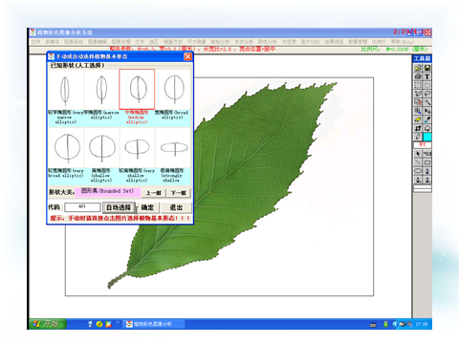

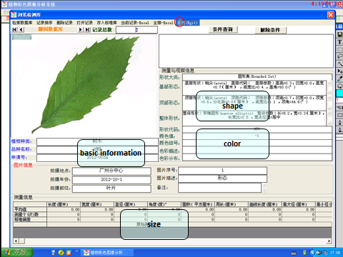

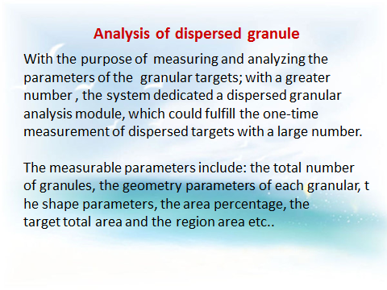

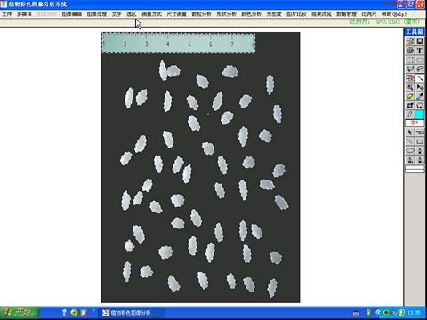

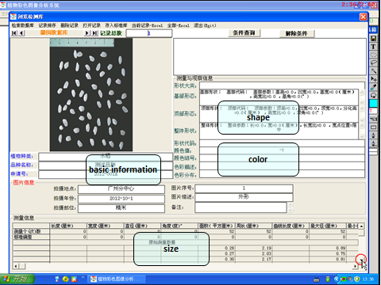

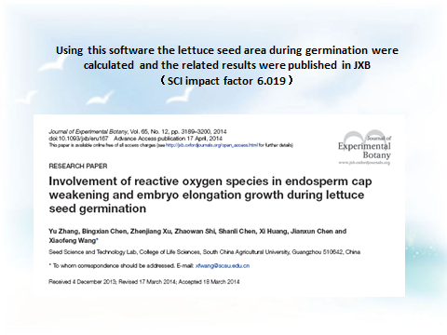

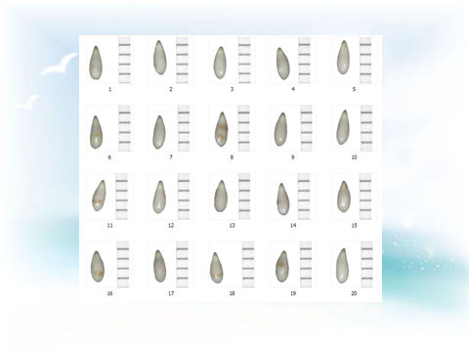

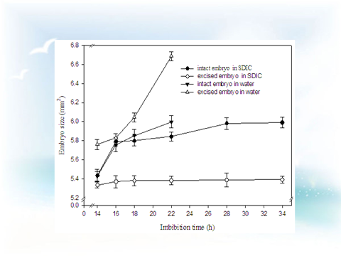

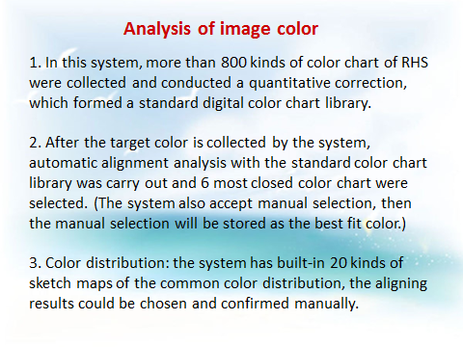

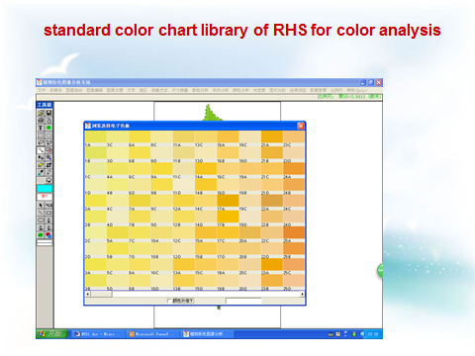

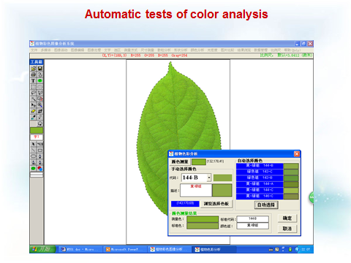

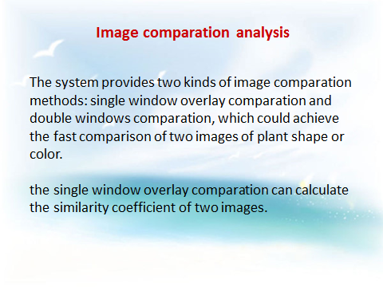

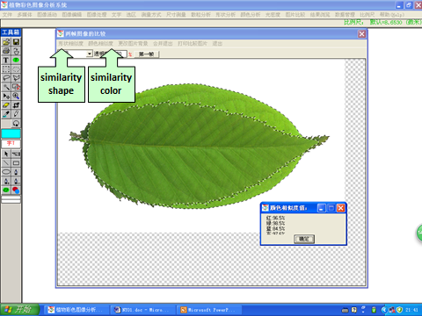

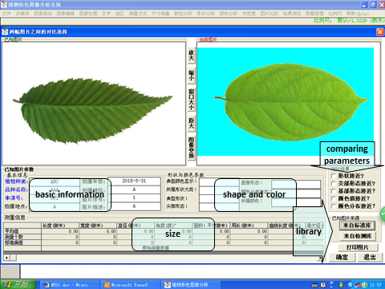

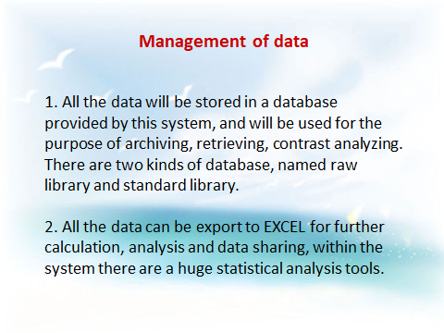

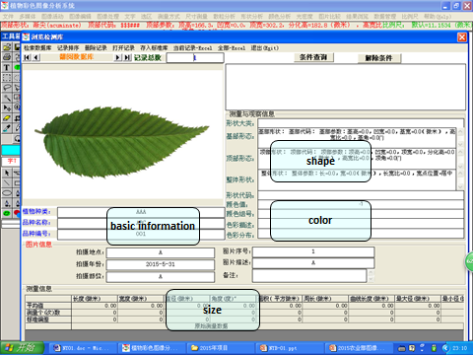

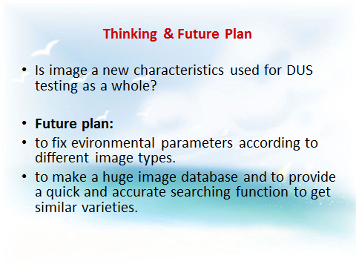

[End of Annex and of document]

