E
TWC/33/26 Add. 2
ORIGINAL: English
DATE: July 13, 2015
INTERNATIONAL UNION FOR THE PROTECTION OF NEW VARIETIES OF PLANTS
Geneva
Technical working party on automation and computer programs
Thirty-Third Session
Natal, Brazil, June 30 to July 3, 2015
ADDENDUM to
Statistical methods for visually observed characteristics
Document prepared by the Office of the Union
Disclaimer: this document does not represent UPOV policies or guidance
The Annex to this document contains a copy of a presentation by Finland, on the way in which Finland intends to use the new statistical method for visually observed characteristics in DUS examination, that was made at the Technical Working Party on Automation and Computer Programs (TWC), at its thirty-third session.

[Annex follows]

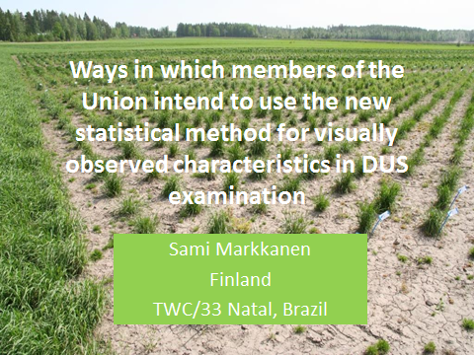

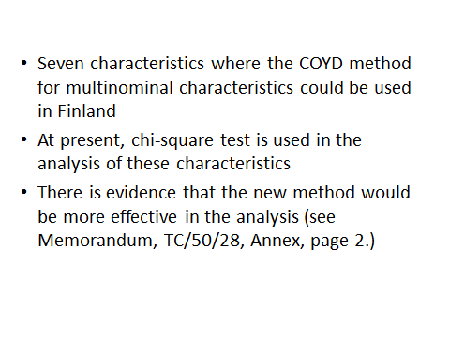

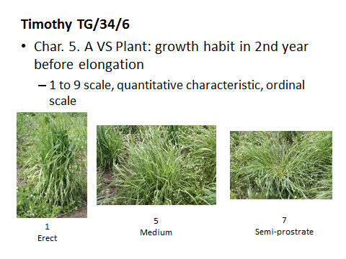

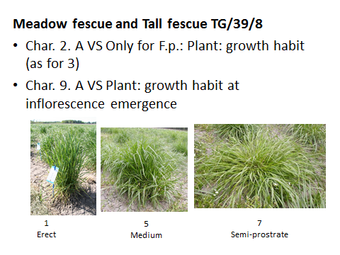

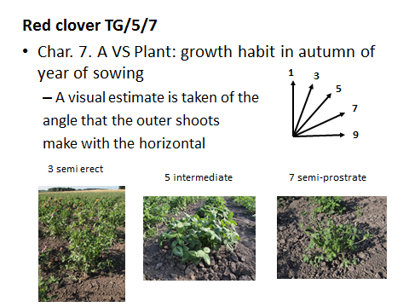

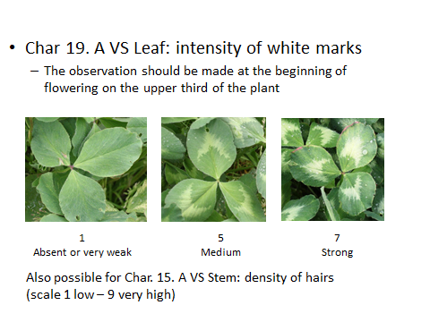

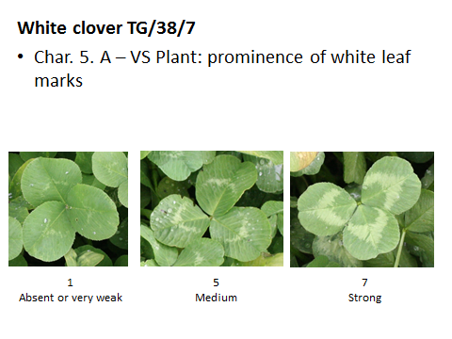

[End of Annex and of document]

