E
TWC/33/25
ORIGINAL: English
DATE: June 12, 2015
INTERNATIONAL UNION FOR THE PROTECTION OF NEW VARIETIES OF PLANTS
Geneva
Technical working party on automation and computer programs
Thirty-Third Session
Natal, Brazil, June 30 to July 3, 2015
Assessing uniformity by off-types on the basis of more than one growing cycle:
Risks, benefits and costs of different approaches
Document prepared by experts from the United Kingdom and Germany
Disclaimer: this document does not represent UPOV policies or guidance
The Annex to this document contains a copy of a presentation on “assessing uniformity by off-types on the basis of more than one growing cycle: risks, benefits and costs of different approaches” that will be made at the Technical Working Party on Automation and Computer Programs (TWC), at its thirty-third session.

[Annex follows]

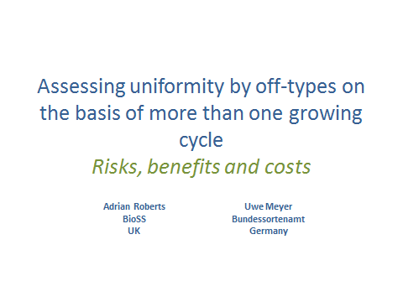

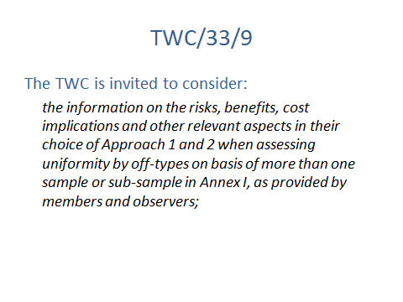

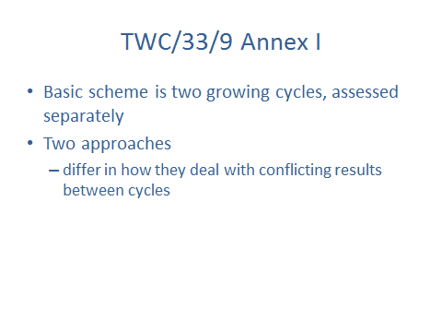

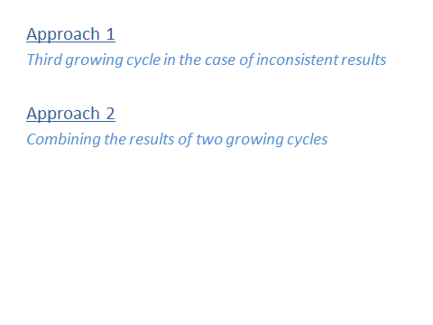

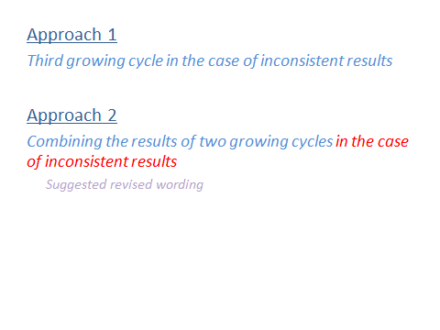

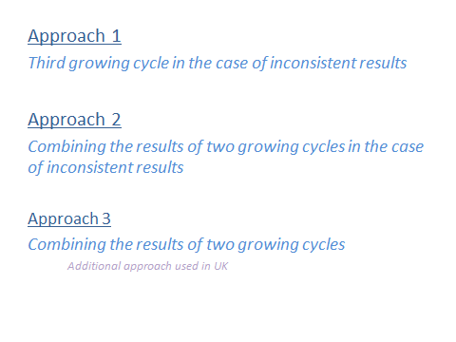

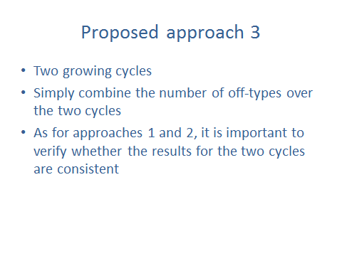

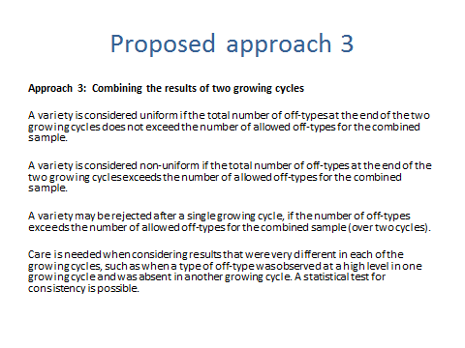

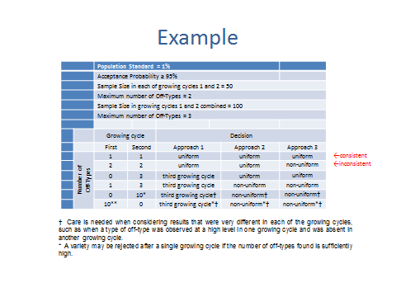

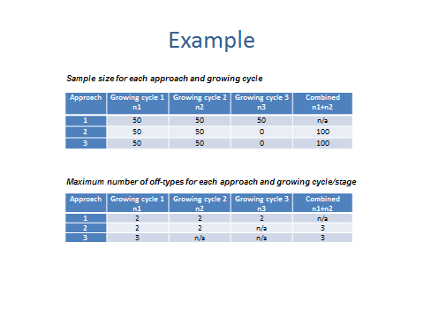

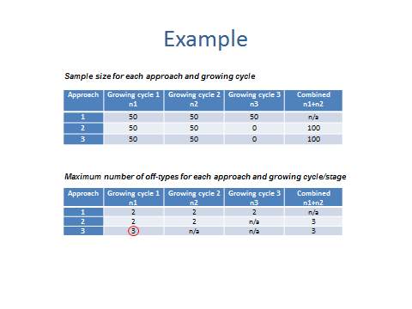

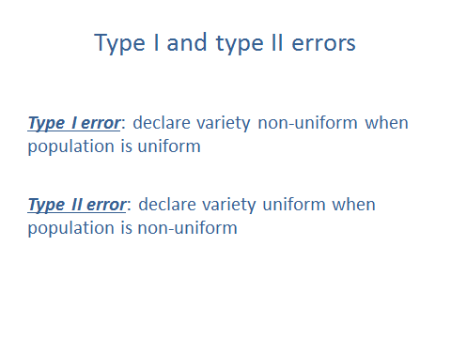

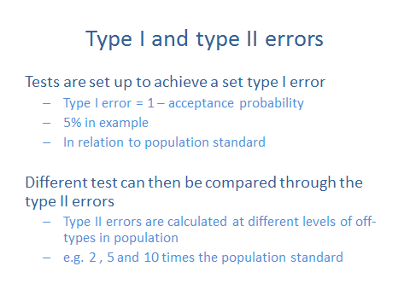

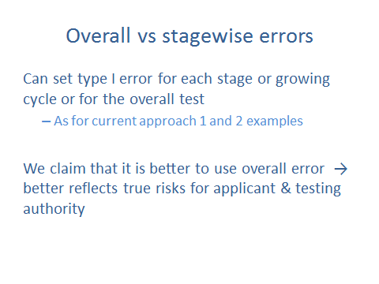

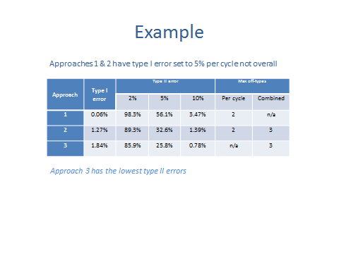

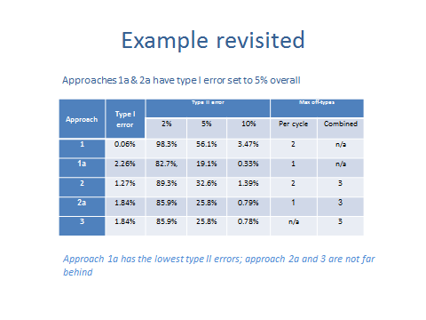

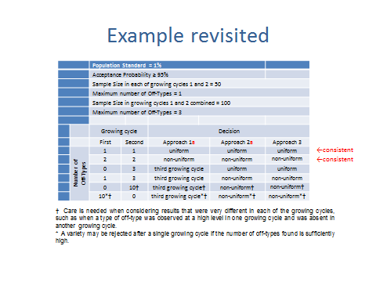

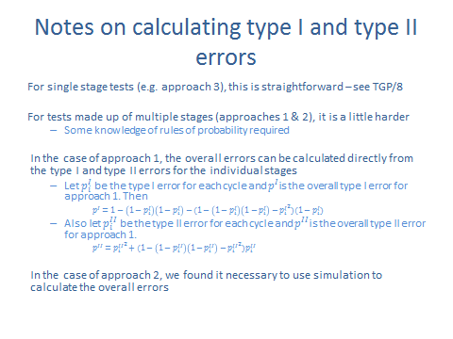

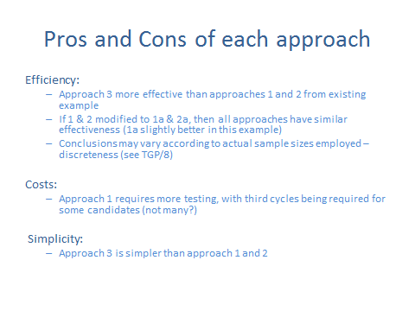

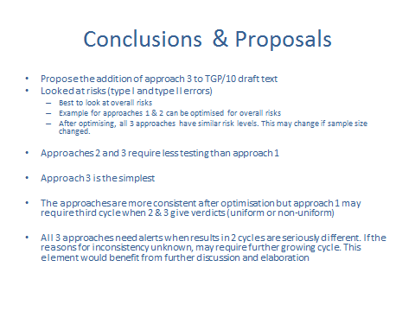

[End of Annex and of document]

