E
TWC/33/20 Add. Rev.
ORIGINAL: English
DATE: July 13, 2015
INTERNATIONAL UNION FOR THE PROTECTION OF NEW VARIETIES OF PLANTS
Geneva
Technical working party on automation and computer programs
Thirty-Third Session
Natal, Brazil, June 30 to July 3, 2015
addendum to
CALCULATED THRESHOLDS FOR EXCLUDING VARIETIES OF COMMON KNOWLEDGE FROM THE SECOND GROWING CYCLE WHEN COYD IS USED,
First Year Thresholds
Document prepared by experts from the United Kingdom
Disclaimer: this document does not represent UPOV policies or guidance
The Annex to this document contains a copy of a presentation on “Calculated Thresholds for Excluding Varieties of Common Knowledge from the Second Growing Cycle when COYD is used, First Year Thresholds” that was made at the thirty-third session of the Technical Working Party on Automation and Computer Programs (TWC).

[Annex follows]

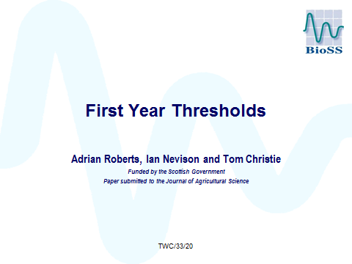

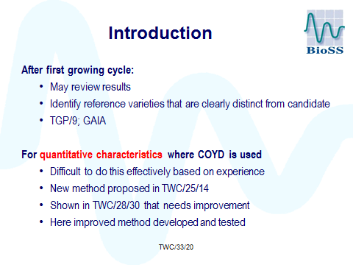

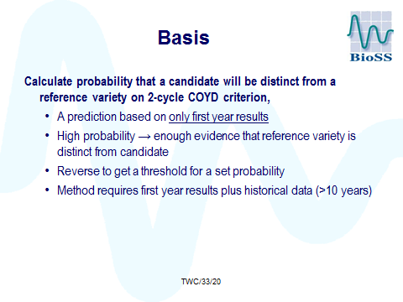

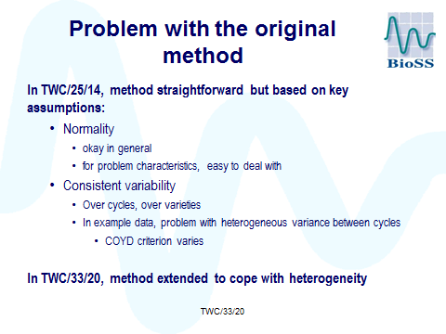

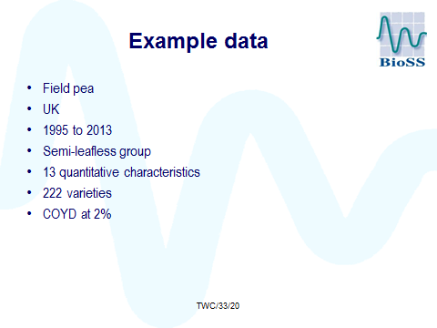

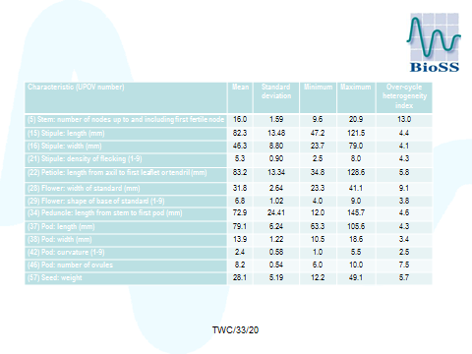

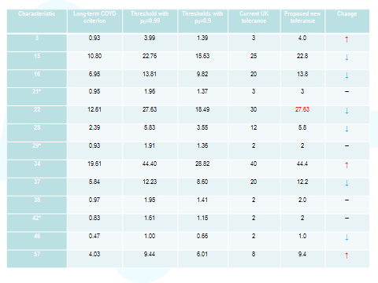

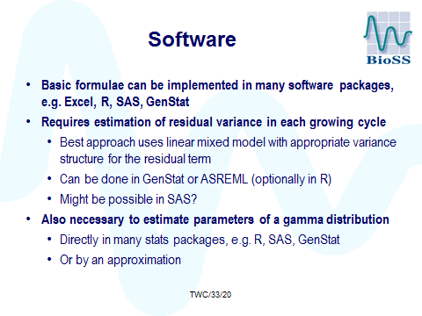

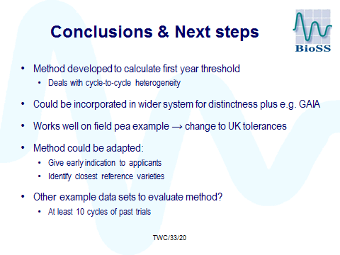

[End of Annex and of document]

