E
TWC/33/16 Add.
ORIGINAL: English
DATE: June 11, 2015
INTERNATIONAL UNION FOR THE PROTECTION OF NEW VARIETIES OF PLANTS
Geneva
Technical working party on automation and computer programs
Thirty-Third Session
Natal, Brazil, June 30 to July 3, 2015
CRITERION (COYU), Method of calculation of COYU ADDENDUM TO Revision of document TGP/8: Part II: Selected Techniques Used in DUS Examination, Section 9: THE COMBINED-OVER-YEARS UNIFORMITY
Document prepared by experts from the United Kingdom
Disclaimer: this document does not represent UPOV policies or guidance
The Annex to this document contains a copy of a presentation on Method of calculation of COYU that will be made at the Technical Working Party on Automation and Computer Programs (TWC), at its thirty-third session.

[Annex follows]

METHOD OF CALCULATION OF COYU

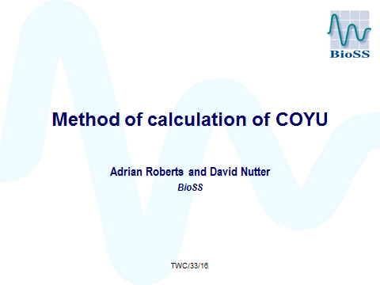

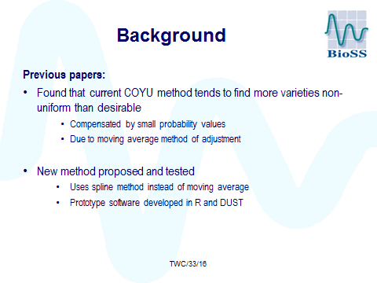

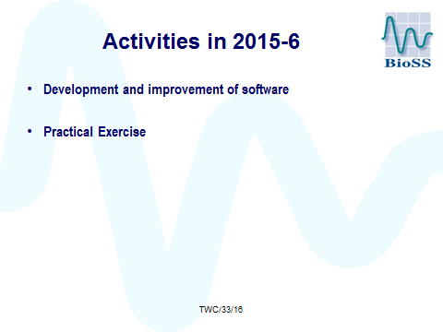

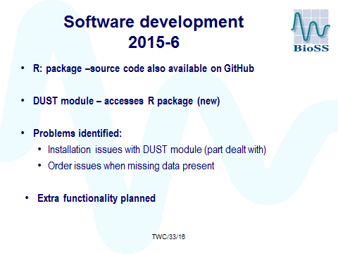

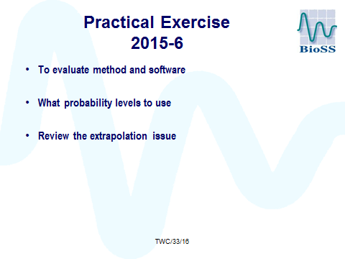

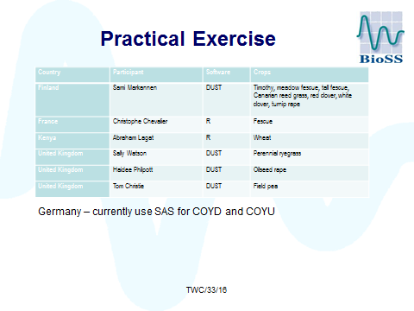

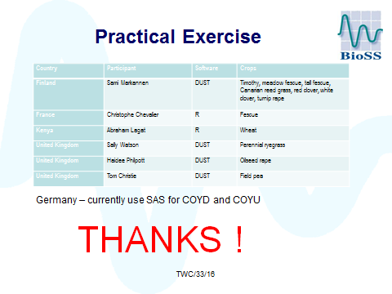

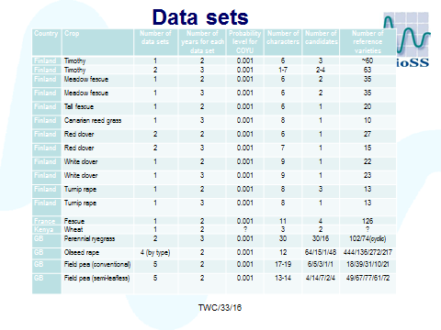

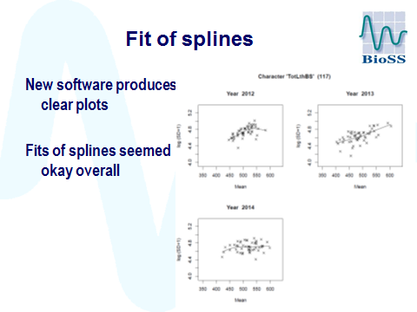

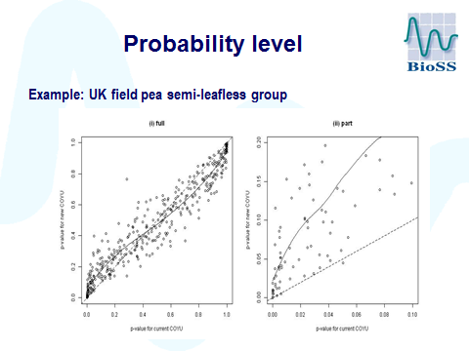

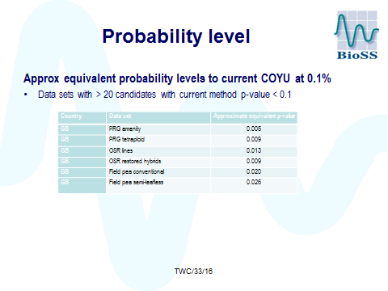

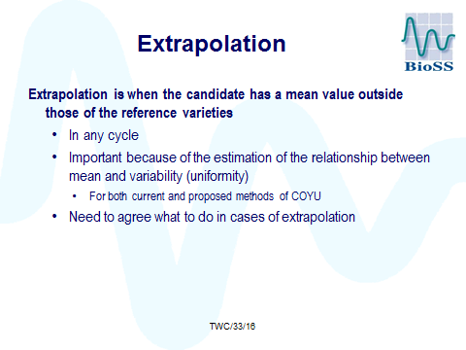

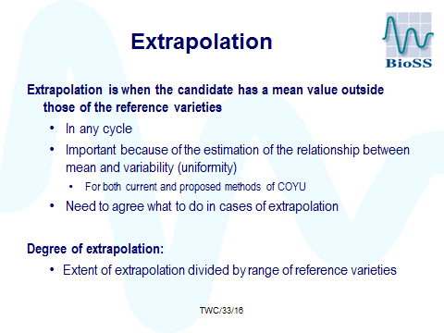

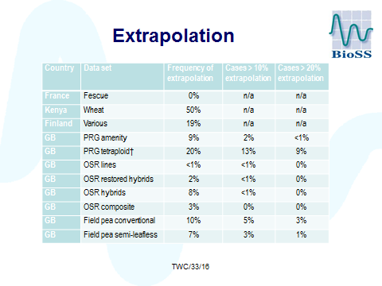
.
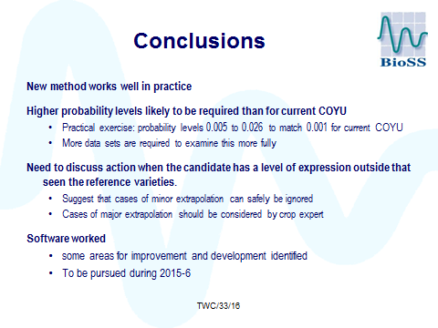

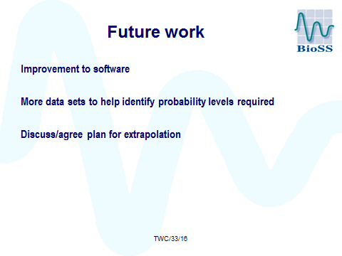

[End of Annex and of document]

