E
TWC/31/29
ORIGINAL: English
DATE: May 13, 2013
INTERNATIONAL UNION FOR THE PROTECTION OF NEW VARIETIES OF PLANTS
Geneva
Technical working party on automation and computer programs
Thirty-First Session
Seoul, Republic of Korea, June 4 to 7, 2013
AIM: management of color analysis
Document prepared by experts from France
The Technical Committee (TC), at its forty-ninth session, held in Geneva, from March 18 to 20, 2013, agreed with the recommendation of the Technical Working Party on Automation and Computer Programs (TWC) concerning the inclusion of the AIM software from France in document UPOV/INF/16, as set out in paragraph 19 of document TC/49/12 “Exchangeable software” (see document TC/49/41 “Report on the conclusions”, paragraph 107).

The CAJ, at its sixty-seventh session, held in Geneva, on March 21, 2013, noted that it would be invited, at its sixty-eighth session, to be held in Geneva in October 2013, to consider a proposed revision of document UPOV/INF/16 “Exchangeable Software” (see document CAJ/67/14 “Report on the conclusions”, paragraph 56).

The Annex to this document contains a copy of a presentation on AIM software that will be made to the TWC, at its thirty-first session, in order to provide further information concerning the use of the AIM software, for color analysis in France.

The TWC is invited to note the information contained in Annex to this document.

[Annex follows]

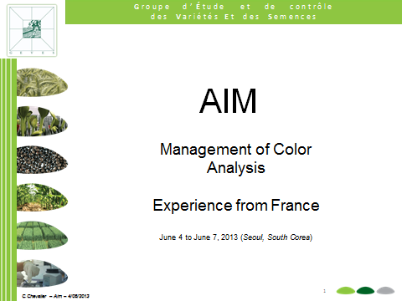

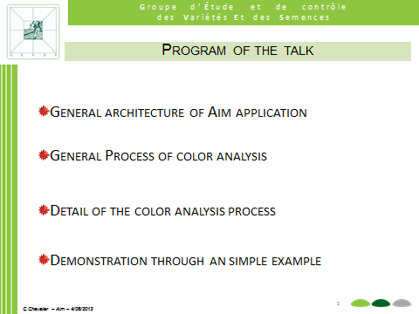

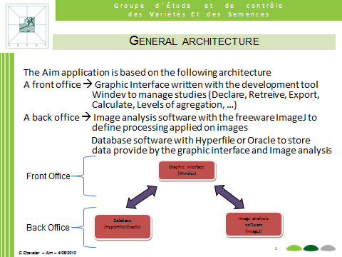

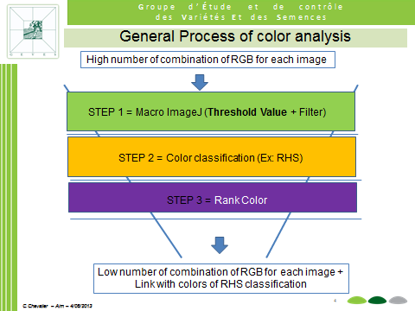

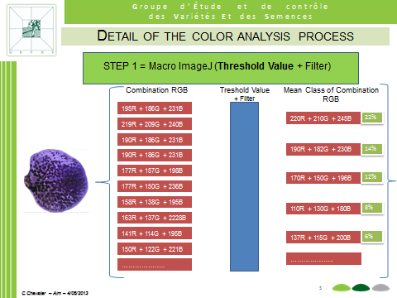

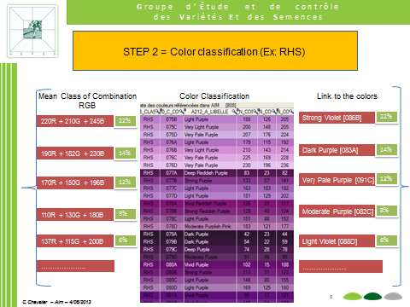

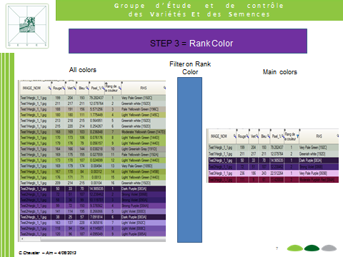

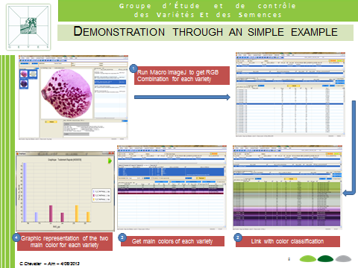

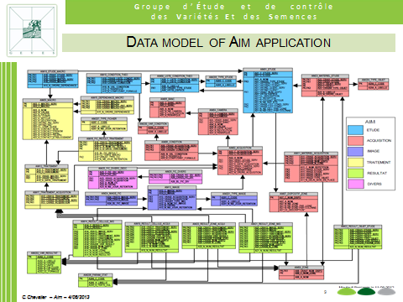

[End of Annex and of document]

