|  |  |
| --- | --- |
|  | E |
| International Union for the Protection of New Varieties of Plants |  |

|  |  |
| --- | --- |
|  | TGP/15/2 Draft 1  Original: English  Date: May 3, 2018 |

|  |
| --- |
| **DRAFT**  **(REVISION)** |

Associated Document to the

General Introduction to the Examination of Distinctness, Uniformity and Stability   
and the Development of Harmonized Descriptions of New Varieties of Plants (document TG/1/3)

DOCUMENT TGP/15  
  
GUIDANCE ON THE USE OF BIOCHEMICAL AND MOLECULAR MARKERS   
IN THE EXAMINATION OF DISTINCTNESS, UNIFORMITY AND STABILITY (DUS)

Document prepared by the Office of the Union

to be considered by   
  
the Technical Working Party for Agricultural Crops   
at its forty-seventh session to be held in Naivasha, Kenya, from May 21 to 25, 2018,  
  
the Working Group on Biochemical and Molecular Techniques, and DNA-Profiling in Particular  
at its seventeenth session to be held in Montevideo, Uruguay, from September 10 to 13, 2018,  
  
the Technical Working Party for Vegetables  
at its fifty-second session to be held in Beijing, China, from September 17 to 21, 2018  
  
and  
  
the Technical Committee  
at its fifty-fourth session to be held in Geneva, from October 29 to 30, 2018

Disclaimer: this document does not represent UPOV policies or guidance

Note for Draft version

**~~Strikethrough~~ (highlighted in grey)** indicates deletion from the text of document TGP/15/1.

**Underlining (highlighted in grey)** indicates insertion to from the text of document TGP/15/1.

**Footnotes** will be retained in published document.

**Endnotes** are for background information when considering this draft and will not appear in the final, published document.

TABLE OF CONTENTS

1. INTRODUCTION 3

2. APPLICATION MODELS 3

2.1 Characteristic-Specific Molecular Markers (see Annex I) 3

2.2 Combining Phenotypic and Molecular Distances in the Management of Variety Collections (see Annex II) 4

2.3 Genetic Selection of Similar Varieties for the First Growing Cycle (see Annex III) 4

ANNEX I MODEL: CHARACTERISTIC-SPECIFIC MOLECULAR MARKERS

EXAMPLE: GENE SPECIFIC MARKER FOR HERBICIDE TOLERANCE

ANNEX II MODEL: COMBINING PHENOTYPIC AND MOLECULAR DISTANCES IN THE MANAGEMENT OF VARIETY COLLECTIONS

EXAMPLE: PARENT LINES IN MAIZE

ANNEX III MODEL: GENETIC SELECTION OF SIMILAR VARIETIES FOR THE FIRST GROWING CYCLE

EXAMPLE: FRENCH BEAN

# 1. INTRODUCTION

1.1 Document UPOV/INF/18 “Possible Use of Molecular Markers in the Examination of Distinctness, Uniformity and Stability (DUS)” considers possible application models for the use of biochemical and molecular markers in the examination of DUS that were proposed to the *Ad hoc* Subgroup of Technical and Legal Experts of Biochemical and Molecular Techniques (BMT Review Group) by the Technical Committee, on the basis of the work of the Working Group on Biochemical and Molecular Techniques, and DNA‑Profiling in Particular (BMT) and *Ad Hoc* Crop Subgroups on Molecular Techniques (Crop Subgroups) (see <http://www.upov.int/about/en/organigram.html>). The assessment of the BMT Review Group and the views of the Technical Committee, the Administrative and Legal Committee (CAJ) on those models are presented in document UPOV/INF/18.

1.2 The purpose of this document is to provide guidance on the use of biochemical and molecular markers in the examination of Distinctness, Uniformity and Stability (DUS) on the basis of the models ~~in document UPOV/INF/18~~that have received a positive assessment and for which accepted examples have been provided.

1.3 The only binding obligations on members of the Union are those contained in the text of the UPOV Convention itself, and this document must not be interpreted in a way that is inconsistent with the relevant Act for the member of the Union concerned.

1.4 The following abbreviations are used in this document:

CAJ: Administrative and Legal Committee

TC: Technical Committee

TC-EDC: Enlarged Editorial Committee

TWA: Technical Working Party for Agricultural Crops

TWC: Technical Working Party on Automation and Computer Programs

TWF: Technical Working Party for Fruit Crops

TWO: Technical Working Party for Ornamental Plants and Forest Trees

TWV: Technical Working Party for Vegetables

TWP(s): Technical Working Party(ies)

BMT: Working Group on Biochemical and Molecular Techniques, and DNA-Profiling in Particular

BMT Review Group: *Ad Hoc* Subgroup of Technical and Legal Experts on Biochemical and Molecular Techniques

Crop Subgroup: *Ad Hoc* Crop Subgroup on Molecular Techniques

# 2. APPLICATION MODELS

## 2.1 Characteristic-Specific Molecular Markers (see Annex I)

2.1.1 Molecular markers can be used as a method of examining DUS characteristics that satisfy the criteria for characteristics set out in the General Introduction, Chapter 4, section 4.2, on the following basis:

(a) the test for the marker is conducted on the same number of individual plants, with the same criteria for distinctness, uniformity and stability as for the examination of the characteristic by a bioassay;

(b) there is verification of the reliability of the link between the marker and the characteristic;

(c) different markers for the same characteristic are different methods for examining the same characteristic;

(d) markers linked to different genes conferring expression of the same characteristic are different methods for examining the same characteristic; and

(e) markers linked to different regulatory elements for the same gene conferring expression of the same characteristic are different methods for examining the same characteristic: 2.1.2 Annex I to this document “Gene Specific Marker for Herbicide Tolerance” provides an example of the use of characteristic-specific molecular markers.

## 2.2 Combining Phenotypic and Molecular Distances in the Management of Variety Collections (see Annex II)

2.2.1 A key feature of the process of eliminating varieties of common knowledge prior to the DUS growing trial is that the threshold is set with a suitable margin of safety. This threshold is termed the “Distinctness plus” threshold, which means that the distances between a candidate variety and “Distinct plus” varieties are robust enough to take a decision without direct comparison in the growing trial.

2.2.2 A combination of phenotypic differences and molecular distances can be used to identify within the variety collection, those varieties which need to be compared with candidate varieties in order to improve the selection of “Distinct plus” varieties, on the following basis:

(a) there is reliable information that the molecular distances are sufficiently related to phenotypic differences, such that

(b) the method selects varieties in the variety collection which are similar to the candidate varieties; and

1. the method does not create an increased risk of not selecting a variety in the variety collection which needs to be compared to the candidate varieties in the field.

2.2.3 Annex II to this document “Combining Phenotypic and Molecular Distances in the Management of Variety Collections” provides an example of the use of combining phenotypic differences and molecular distances in the management of variety collections.

## 2.3 Genetic Selection of Similar Varieties for the First Growing Cycle (see Annex III)

2.3.1 Key features for the process of selecting similar varieties for the growing trial are the quality of the information on the candidate and the completeness and quality of the variety descriptions of the varieties in the variety collection.

2.3.2 A genotypic approach of the selection process of the most similar varieties from common knowledge not only maximises the chance to discover if the candidate variety already exists (identical genetic fingerprint combined with lack of phenotypical distinctness), but also improves the process of selecting (genetically) similar varieties as it has a more objective basis than the TQ supplied by the applicant.

2.3.3 Based on the provisional conclusion on DUS after the first growing cycle and the variety description made in the first growing cycle, an additional search to select possible phenotypical similar varieties for a second growing cycle can be done.

2.3.4 Annex III to this document “Genetic Selection of Similar Varieties for the First Growing Cycle” provides an example of the genetic selection of similar varieties for the first growing cycle.

[Annexes follow]

ANNEX I

MODEL: CHARACTERISTIC-SPECIFIC MOLECULAR MARKERS

EXAMPLE: GENE SPECIFIC MARKER FOR HERBICIDE TOLERANCE

*prepared by experts from France*

Example

1. A variety is genetically modified by the insertion of a gene for tolerance to herbicide “Formula X.” Varieties containing this gene are not harmed when sprayed with Formula X; however, varieties without this gene are always killed if sprayed with this particular herbicide. Tolerance of Formula X, examined in field trials by spraying of plots, is an accepted DUS characteristic, and it can be used to establish distinctness between varieties.

2. It is proposed that, rather than spraying varieties in the field (this is difficult to organize in the standard DUS trial), the characteristic “tolerance of Formula X” is examined by conducting a test for the presence of a molecular marker *linked* to the gene. This marker is located on a part of the gene “construct.” The gene “construct” comprises all the elements which are inserted into the plant during the genetic modification and, in addition to the gene itself, contains additional elements for regulating the gene when in the plant. The marker may be located within the gene, partly on the gene or outside the gene itself.

Assumptions to be made in the example

3. The following assumptions are made:

(a) The DUS Examination

It is assumed that the test for the marker would be conducted to the same extent as for the field test, i.e. the same number of individual plants, over the same number of years and with the same criteria for distinctness, uniformity and stability.

(b) Reliability of the Linkage

It is assumed that the link between the marker and the gene would be checked to ensure that the marker is a reliable predictor of tolerance to Formula X. This check would be necessary to ensure, for example, that the marker does not become separated from the gene and that the presence of the gene is still resulting in tolerance to Formula X.

(c) Development of Different Molecular Markers for the Same Gene

It would be possible to develop different gene constructs containing Formula X tolerance and to identify separate molecular markers for these individual gene constructs, all of which would be linked to exactly the same gene for Formula X tolerance. If all the different markers for the same gene were accepted as different methods for examining the *same existing phenotypic characteristic*, the consideration of the approach would be the same. For the use of “Molecular […] [markers] as a predictor of traditionalcharacteristics,” it is necessary to work on the basis that the markers correspond to a traditional, i.e. existing, approved characteristic. Therefore, it is assumed that different markers for the same gene would be treated as different methods for examining the same characteristic, i.e. tolerance to Formula X.

(d) Different Genes Producing Tolerance to the Same Herbicide

It might be possible to develop different genes which confer tolerance to Formula X. In the simplest case, this could be considered in the same way as different markers for the same gene, i.e. the different genes, with their respective markers, would be considered as different methods for examining the same characteristic, i.e. tolerance to Formula X. However, the different genes are likely to have a different chemical mechanism to produce the tolerance to Formula X. Thus, the chemicals produced from the different genes will be different and, these different chemicals might be a basis for establishing distinctness in some circumstances. Nevertheless, under this model, it would first be necessary to approve the chemical components as UPOV characteristics, before accepting molecular markers linked to these potential characteristics. This in turn would be a separate example. Therefore, it is assumed that different genes would be treated as different methods for examining the same characteristic, i.e. tolerance to Formula X.

(e) Different Gene Constructs Producing the Same Herbicide Tolerance but With Different Control of the Expression

It is also possible that different gene constructs could be developed which contain the same gene for tolerance to Formula X, but which had different regulatory control. For example, the regulatory elements may result in the Formula X tolerance only being switched on at certain stages of development. For simplicity, in considering this example, it is assumed that the different markers linked to different regulatory elements for the same gene would all be treated as different methods for examining the same characteristic of tolerance to Formula X. However, it is also assumed that further consideration would be given to this matter at a later stage.

[Annex II follows]

ANNEX II

MODEL: COMBINING PHENOTYPIC AND MOLECULAR DISTANCES IN  
THE MANAGEMENT OF VARIETY COLLECTIONS

EXAMPLE: PARENT LINES IN MAIZE

*prepared by experts from France*

1. Description

1.1 A key feature of the process of eliminating varieties of common knowledge prior to the DUS growing trial is that the threshold for deciding which varieties can be safely excluded (i.e. are distinct on the basis of descriptions), can be set with a suitable margin of safety, because those varieties which are eliminated, will not be included in the growing trial. This threshold, with a safety margin, is termed the “Distinctness plus” threshold which means that the distances between a candidate variety and “distinct plus” varieties are robust enough to take a decision without direct comparison in the growing trial.

1.2 The objective of this example is to develop an efficient tool, based on a combination of phenotypic and molecular distances, to identify within the variety collection, those varieties which need to be compared with candidate varieties (see Figure 1) in order to improve the selection of “distinct plus” varieties and so to limit the workload without decreasing the quality of the test. The challenge is to develop a secure system that:

(a) only selects varieties which are similar to the candidate varieties; and

(b) limits the risk of not selecting a variety in the variety collection which needs to be compared

in the field, especially when there is a large or expensive variety collection.

*Figure 1*

|  |
| --- |
|  |

1.3 The new system has been elaborated on the following background:

(a) Studies done on molecular distances in maize for DUS testing and essential derivation, which showed the link with the parentage between varieties (see documents BMT/3/6 “The Estimation of Molecular Genetic Distances in Maize or DUS and ED Protocols: Optimization of the Information and new Approaches of Kinship” and document BMT/3/6 Add.)

(b) An experiment done by GEVES on a set of maize parental lines, which showed that there is a link between the evaluation of distinctness by experts (global assessment) and a molecular distance computed on Simple Sequence Repeat (SSR) molecular data (see Figure 2).

(c) Studies done by GEVES from 2013 to 2016 on the use of molecular markers for maize DUS testing, which confirmed a link between the evaluation of distinctness by experts and a molecular distance (see Figure 3).

1.4 Components of the system

1.4.1 GAIA distance

The GAIA distance component is computed with the GAIA software developed by GEVES. The GAIA distance is a combination of differences observed on phenotypic characteristics, where each difference contributes to the distance according to the reliability of the characteristics, especially regarding its variability and its susceptibility to environment. The larger the size of the difference and the greater the reliability of the characteristic, the more the difference contributes to the GAIA distance. Only differences that are equal or larger than the minimum distance required for each individual characteristic are included.

1.4.2 Molecular distance

The molecular distance component is computed on the differences observed on a set of markers. Different types of molecular markers and distances can be used. In the case of the study done in France on maize, 60 SSR markers and Roger’s distance have been used. It is important that sufficient markers, with a good distribution on the chromosomes, are used. The type of markers, the effect of the number of markers and the distribution of the markers need to be considered according to the species concerned.

1.4.3 Before combining these two components, an evaluation of the link between molecular distance and a global assessment of distinctness by a panel of experts needs to be done on a set of pairs of varieties. In the case of maize, that evaluation was made on the following basis:

Material: 504 pairs of varieties tested in parallel with molecular markers

Field design: pairs of varieties grown side by side   
(1 plot = 2 rows of 15 plants)

Visual assessment by maize crop experts:

Scale of similarity:

1. the two varieties are similar or very close

3. the two varieties are distinct but close

5. the comparison was useful, but the varieties are clearly distinct

7. the comparison should have been avoided because the varieties are very different

9. the comparison should have been avoided because the varieties are totally different

(“even” notes are not used in the scale)

In the case of maize, this evaluation showed that no parental lines with a molecular distance greater than 0.15 were considered as similar or very close by a DUS expert evaluation (see Figure 2).

*Figure 2*



~~1.4.4 On the basis of that result, the combination of morphological and molecular distances offers the possibility to establish a decision scheme as follows (see Figure 3):~~

*~~Figure 3~~*

*[to delete this figure]*



1.4.5 GEVES applied the aforementioned decision making scheme to 4,486,001 pairs of maize varieties, which included 1,940 pairs of varieties tested in the field, in parallel with 300 SNP molecular markers. No pairs of varieties with a molecular distance larger than 0.2 were visually assessed by maize crop experts as those which required another year of growing trial (see Figure 3).

*Figure 3*

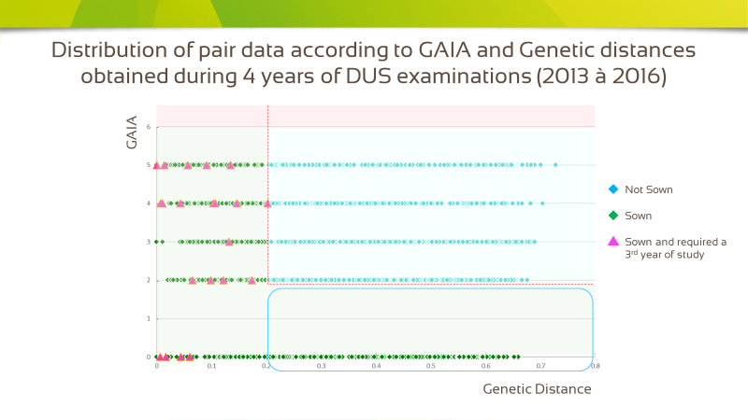

1.4.6 On the basis of that result, the combination of morphological and molecular distances offers the possibility to establish a enhanced decision scheme as follows (see Figure 4):

*Figure 4*



1.4.5 All pairs of varieties with a GAIA distance equal to, or larger than, 6 and all varieties with ~~a GAIA distance between 2 and 6, plus~~ a molecular distance equal to, or larger than, 0.2 are declared “Distinct plus”.

1.4.6 This scheme shows that less parental lines need to be observed in the field compared to the situation where only a GAIA distance of 6 is used on its own.

1.4.7 The robustness of this system has been studied with different GAIA and molecular distances.

2. Advantages and constraints

2.1. Advantages

(a) Improvement of the management of variety collections with less varieties needing to be compared in the field;

(b) Use of morphological and molecular distances with thresholds defined by DUS experts. GAIA was also calibrated against DUS experts’ evaluations when developed by GEVES;

(c) Use of molecular data that are not susceptible to the environment; the set of markers and the laboratory protocol are well defined;

(d) Use of only phenotypic characteristics with a good robustness and possibility to use descriptions coming from different origins under close cooperation (The maize database that has been developed in cooperation between Germany, France, Spain and the Community Plant Variety Office of the European Union (CPVO) is a good example to illustrate the value of this approach with a variety collection shared between different offices);

(e) Electrophoresis characteristics can also be replaced; and

(f) There is no influence of lack of uniformity in molecular profiles provided enough markers are used and the number of variants is low. In the case of maize parental lines, the level of molecular uniformity is high but could be a problem in some other crops.

2.2. Constraints

(a) Not efficient, or less efficient, for species with synthetic varieties or populations;

(b) Necessity to have enough good DNA markers and enough phenotypic characteristics with low susceptibility to environment; and

(c) Preliminary work with calibration in comparison with DUS expert evaluation of distinctness.

[Annex III follows]

ANNEX III

MODEL: GENETIC SELECTION OF SIMILAR VARIETIES FOR THE FIRST GROWING CYCLE

EXAMPLE: FRENCH BEAN

*prepared by an expert from the Netherlands*

1. Description

1.1 Key features for the process of selecting similar varieties for the growing trial are the quality of the information on the candidate and the completeness and quality of the variety descriptions of the varieties in the variety collection.

1.2 The objective of this example is to develop a genotypic approach of the selection process of the most similar varieties from common knowledge in order to improve the process of selecting (genetically) similar varieties.

1.3 The new system has been elaborated on a study done by Naktuinbouw on genetic selection of similar varieties for the first growing cycle (see Figure 1 and 2).

1.4 Procedure

1.4.1 The first selection of similar varieties can be performed more efficiently by using genotypic information of the candidate. Only a rather low number of genetically close varieties will be put in the field trial. If one of these genetically close varieties appears in a database check distinct on QL and/or grouping characteristics, it is discarded. Such a database check on QL and/or grouping characteristics takes not more than 20 minutes. A threshold for genetic distance is not known yet.

1.4.2 At the end of the first growing cycle a database check is done by comparing the description made in the first growing cycle with all morphological descriptions of known varieties. This second selection takes much less time than the traditional first selection, as one can discard influences caused by deviations from the TQ. This check is important to safeguard that the decision on distinctness is taken on morphology.

1.4.3 In the case that the candidate variety is clearly distinct in the first growing cycle, fulfills the uniformity and stability requirements and the database check at the end of the first growing cycle gives no extra similar varieties, the DUS test may be concluded after the first growing cycle.

1.4.4 In all other cases a second growing cycle is performed. The candidate is put in the trial with the closest similar variety from the first year and with all similar varieties from the database check. Distinctness observed in the second growing cycle is supported by the genetic distance. However, a large genetic distance combined with a lack of distinctness on morphological characteristics must not lead to a positive decision on DUS.

*Figure 1*

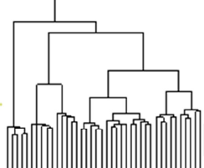

seed

TQ

**Start**

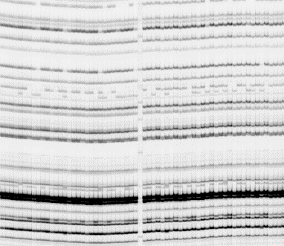

DNA profiling

DNA similarities

first selection



check morphological database

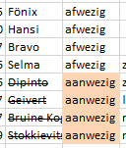

discard on QL and/or grouping characteristics only

(short) list of varieties to be put in field trial (1st cycle)

**1st growing cycle**

Side-by-side comparisons and complete description



‘paper check’ morphological database

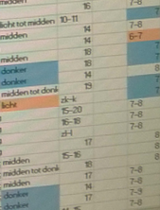

discard on all characteristics

**Clearly D and no extra similar varieties: positive conclusion after 1st cycle**

Not clearly Distinct and/or extra similar varieties needed: normal 2nd growing cycle

Extra similar varieties needed?

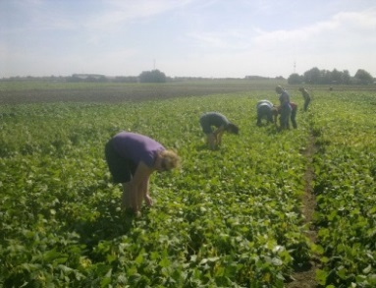

*Figure 2*

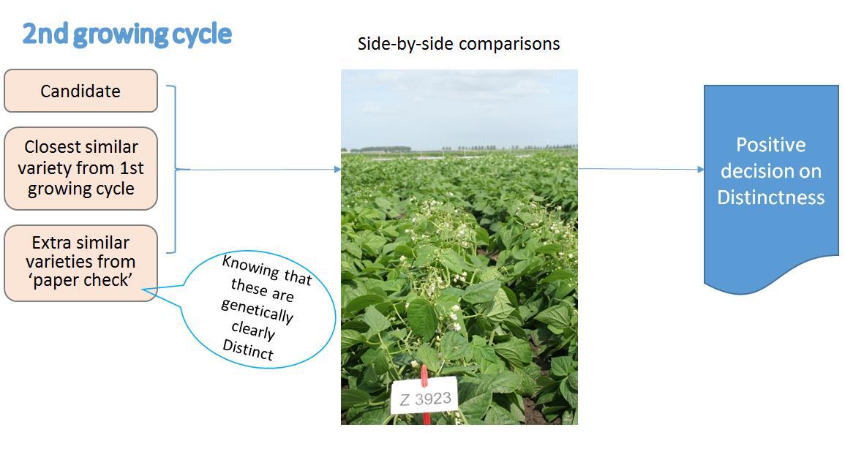

2. Advantages

2.1. This approach has the following advantages:

(a) as the collection of genetic information of the varieties of common knowledge is more objective than variety descriptions (no interaction with the environment) it is a more reliable knowledge base, easier to share between authorities and therefore potentially more complete thus minimizing the chance to overlook similar or even identical varieties.

(b) as often the TQ provided by the applicant leads to wrong conclusions, a genotypic approach is more reliable to find the best similar varieties.

(c) as after the first growing cycle a morphological check is performed against the varieties of the variety collection, the final conclusion is still based on morphology.

(d) there is a chance that after the first growing cycle on the basis of morphology a very similar variety is discovered that was not included in the genetic selection and two additional growing cycles are needed. There is also a chance that after the first growing cycle the DUS conclusion is clear and no further similar varieties are discovered on morphology, so the DUS test can be concluded after the first growing cycle.

[End of Annex III and of document]