E
International Union for the Protection of New Varieties of Plants

Technical Working Party for Agricultural Crops  Forty-Sixth Session  Hanover, Germany, June 19 to 23, 2017  Technical Working Party for Vegetables  Fifty-First Session  Roelofarendsveen, Netherlands, July 3 to 7, 2017  Technical Working Party for Ornamental Plants and Forest Trees  Fiftieth Session  Victoria, Canada, September 11 to 15, 2017  Technical Working Party for Fruit Crops  Forty-Eighth Session  Kelowna, Canada, September 18 to 22, 2017  Technical Working Party on Automation and Computer Programs  Thirty-Fifth Session  Buenos Aires, Argentina, November 14 to 17, 2017 | TWP/1/8  Original: English  Date: June 14, 2017
Guidance for drafters of Test Guidelines
Document prepared by the Office of the Union
Disclaimer: this document does not represent UPOV policies or guidance

EXECUTIVE Summary

The purpose of this document is to provide guidance for drafters of Test Guidelines and to report developments on the web-based Test Guidelines template (web-based TG template).

The TWPs are invited to:

(a) note the items resolved in Version 1.0 of the web-based TG template, as set out in paragraph 18 of this document;

(b) note that a general revision of the software code is underway to eliminate remaining reported malfunctioning issues and to stabilize the system;

(c) note the issues to be considered for inclusion in Version 2 of the web-based TG Template, as set out in paragraph 21 of this document;

(d) note the issues on the web-based TG template agreed by the TC, at its fifty-third session, as set out in paragraphs 25 to 27 of this document;

(e) consider whether explanations covering all characteristics should be displayed before Chapter 8.1 “Explanations covering several characteristics” without a note in the Table of Chars, as set out in paragraphs 28 and 29 of this document;

(f) note the issues currently being addressed on the web-based TG template for inclusion during the second semester of 2017, as set out in paragraph 30 of this document;

(g) note that training on the use of the web-based TG template will be offered to the TWPs, at their sessions in 2017, during the preparatory workshops of the sessions and during discussions on agenda item “guidance for drafters’ of Test Guidelines”; and

(h) note that feedback and questions can be provided directly via the web-bases TG template, as set out in paragraph 33 of this document.

The following abbreviations are used in this document:

TC: Technical Committee
TC-EDC: Enlarged Editorial Committee
TG: Test Guidelines
TWA: Technical Working Party for Agricultural Crops
TWC: Technical Working Party on Automation and Computer Programs
TWF: Technical Working Party for Fruit Crops
TWO: Technical Working Party for Ornamental Plants and Forest Trees
TWPs: Technical Working Parties
TWV: Technical Working Party for Vegetables

The structure of this document is as follows:

EXECUTIVE Summary 1
Developments in 2016 2
Developments in 2017 3
Issues considered by the Technical Committee 4
Order of UPOV codes and botanical names 4
Order of methods of observation 4
Subsequent explanations covering several characteristics 5
Explanations covering all characteristics 5
Issues currently being addressed 6
Training 6
Guidance for users of the web-based TG template 6
ANNEX I Features of the Web-based TG Template
ANNEX II Features currently under development for the web-based TG template (screenshots/ explanations)

Developments in 2016

At their sessions in 2016, the TWC, TWO, TWV, TWA and TWF considered documents TWC/34/9, TWO/49/9, TWV/50/9, TWA/45/9 and TWF/47/9 “Revision of document TGP/7: Drafter’s Kit for Test Guidelines”, respectively, and received a demonstration by the Office of the Union of Version 1 of the web-based TG Template. (see documents TWC/34/32 “Report”, paragraphs 23 to 29; TWO/49/25 “Report”, paragraphs 17 to 23; TWV/50/25 “Report”, paragraphs 23 to 28; TWA/45/25 “Report”, paragraphs 23 to 27; and TWF/47/25 “Report”, paragraphs 22 to 28).

The TWPs noted that the development of Version 2 of the web-based TG Template would not start before 2018, subject to availability of resources, after Version 1 had been fully stabilized and tested.

The TWPs noted that document TGP/7 would be revised to reflect the introduction of the web-based TG Template after Version 1 had been fully stabilized and tested.

The TWC noted that the system specifications of the web-based TG Template allowed the future development of a web-service application to allow data extraction from the web-based TG Template to other databases, which could offer possibilities to support the development of individual authorities’ own test guidelines. The TWC noted that such functionality could be developed in the future if data mapping of their own databases was done by the authorities.

At their sessions in 2016, the TWO, TWV, TWA and TWF also considered documents TWC/34/17, TWO/49/17, TWV/50/17, TWA/45/17 and TWF/47/17 “Guidance for drafters of Test Guidelines”, respectively, and received a demonstration by the Office of the Union on the tutorials for the following different user roles of the web-based Test Guidelines template. (see documents TWO/49/25 “Report”, paragraphs 17 to 23; TWV/50/25 “Report”, paragraphs 100 and 101; TWA/45/25 “Report”, paragraphs 93 to 95; and TWF/47/25 “Report”, paragraphs 64 to 66).

The TWO agreed that the tutorials should continue to be developed to include additional comments received from users of the web-based TG template. The TWO agreed that the tutorials should be made available on the TG drafter’s web page and a link provided in the web-based TG template webpage.

The TWO welcomed Version 1 of the web-based TG template and proposed that the following issues should be addressed:

- to allow immediate visualization of updates made by the Leading Expert in the export file;
- to improve availability online of the tutorials (e.g. link on TG drafter’s web page and web-based TG template);
- to open the Test Guidelines for drafting by Leading Experts as soon as possible after a TWP session;
- to add a shortcut to the print dialog box;
- to enable editing of a comment by an Interested Expert without replacing the text previously drafted;
- to generate a confirmation message when a comment by an Interested Expert had been successfully introduced;
- to improve formatting in TQ 5 to clarify that the applicant has an option to either fill in the RHS Colour Chart number or select to the appropriate color group from the list of color groups in a color characteristics;
- to adjust the standard wording for plant material supplied in the form of corms: “The material is to be supplied in the form of corms able to produce plants to show all the characteristics in the first year of examination.”
The TWO and TWA noted that further comments by users of the web-based TG Template could be sent to the Office of the Union.

The TWA noted that the tutorials were available online on the TG Drafters’ webpage of the UPOV website and that a copy was reproduced in the Annex to document TWA/45/17.

The TWV agreed that the link to the web-based TG Template on the UPOV website should be made more accessible, therefore should appear under “Quick links - Test Guidelines” and under “Meeting documents”.

The TWO received a presentation by an expert from the Republic of Korea on the “Creation of illustrations for Test Guidelines”, a copy of which is reproduced in document TWO/49/23. The TWO noted the use of Microsoft Power Point for creating illustrations of botanical structures used as explanations for characteristics in Test Guidelines, and received a demonstration on creating illustrations for plant growth habit, leaf shapes and flower structures. The TWO welcomed the demonstration and agreed that the method could be used for drafting illustrations to UPOV Test Guidelines (see document TWO/49/25 “Report”, paragraph 70).

Developments in 2017

The TC, at its fifty-third session, held in Geneva from April 3 to 5, 2017, considered document TC/53/29 “Web-based Test Guidelines template” (see document TC/53/31 “Report”, paragraphs 232 to 239).

The TC noted the comments by the TWPs, at their sessions in 2016, as presented in document TC/53/29, paragraphs 7 to 17.

The TC noted that the following items had been resolved in Version 1.0 of the web-based TG template:

- immediate visualization of updates made by the Leading Expert in the export file;
- online availability of tutorials (web-based TG template webpage);
- editing of comments by Interested Experts without replacing previously drafted text;
- confirmation message after successful introduction of comments by Interested Experts;
- addition of a free text box for wording on “form of plant material to be supplied” (e.g. “The material is to be supplied in the form of corms able to produce plants to show all the characteristics in the first year of examination.”)

The TC noted that a general revision of the software code was underway to eliminate remaining reported malfunctioning issues and to stabilize the system. The TC noted that the Office of the Union had introduced a translator’s interface for the generation of versions of Test Guidelines in the official UPOV languages but that further development of the interface would be needed before it could be used efficiently by the translators.

The TC recalled that the development of Version 2 of the web-based TG Template would not start before 2018, subject to availability of resources, after Version 1 had been fully stabilized and tested.

The TC noted that the following issues would be considered for inclusion in Version 2 of the web-based TG Template, as set out in document TC/53/29, paragraphs 21 and 22:

- Addition of hyperlinks in the exported documents to the symbols indicating that a characteristic has explanations covering individual and/or several characteristics in the Table of Characteristics in order to facilitate electronic navigation in the document;
- Possibility to display large tables in landscape format, such as for indication of growth types;
- Provide the comments by the Office of the Union on draft Test Guidelines in the web-based TG Template.

Subject to the completion of discussions on proposed amendments to document TGP/7 “Development of Test Guidelines”, further changes would need to be introduced in the web-based TG Template (see document TWP/1/1 Rev. “TGP Documents”).

The TC agreed that training on the use of the web-based TG template should be offered to the TWPs during the preparatory workshops of the session and/or during the discussions on the agenda item “guidance for drafters’ of Test Guidelines”. The TC agreed that training should also include FAQs and tutorials for users of the web-based TG template.

Issues considered by the Technical Committee

The following issues on the web-based TG template were agreed by the TC, at its fifty-third session (see document TC/53/31 “Report”, paragraphs 129 to 139 and 141):

Order of UPOV codes and botanical names

The TC agreed that UPOV codes and botanical names in draft Test Guidelines should, in general, be displayed in alphabetical order. However, the TC agreed that the web-based TG Template should allow the Leading Expert to change the order, if appropriate.

Order of methods of observation

The TC agreed that the methods of observation of a characteristic should continue to be presented in alphabetical order, thereby avoiding any indication of order of preference.

Subsequent explanations covering several characteristics

The TC agreed that characteristics with the same explanation could be displayed in Chapter 8.2 “Explanations for individual characteristics” with subsequent explanations being cross-referenced to the first characteristic displaying the appropriate information, as follows (see document TC/53/31 “Report”, paragraphs 107 to 110):

e.g.: Ad. 10 “[explanation text/illustration]”

Ad. 11 “See Ad. 10”

[…]

Ad. 50 “See Ad. 10”

Explanations covering all characteristics

The TC considered whether explanations covering all characteristics should be displayed before Chapter 8.1 “Explanations covering several characteristics” without a note in the Table of Characteristics. The TC agreed to invite the TWPs, at their sessions in 2017, to consider this proposal and report to the TC, at its session in 2018 (see document TC/53/31 “Report”, paragraphs 107 to 110).

Current situation:

Indication of explanation (a) on the table of characteristics:
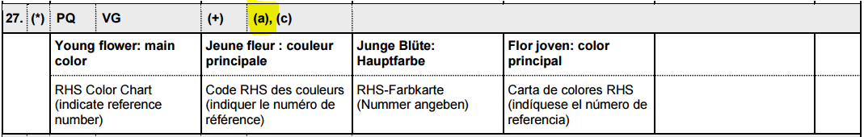

Information in the following example is displayed under Chapter 8.1 “Explanations covering several characteristics”.
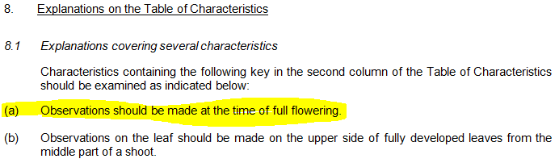

Example: new proposal

The same information is displayed before Chapter 8.1 in the following example:

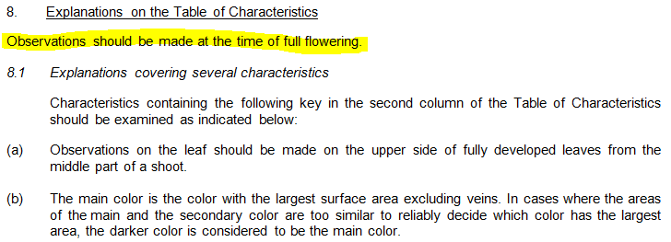

The TWPs may wish to consider the following aspects in relation to the proposal:

- the display of explanations covering all characteristics before Chapter 8.1 would reduce the number of notes displayed at the characteristic header in the table of characteristics;
- not having an indication that such an explanation exists could result in the information being overlooked;
- an important text would not have a Section reference (8.?)

Issues currently being addressed

Solutions for the following issues are currently being developed for inclusion on the web-based TG template during the second semester of 2017 (screenshots provided as Annex II to this document):

- to specify information for more than one method of propagation in Chapter 3.4 “Test Design”;
- addition of new SW paragraph at Chapter 4.2 “Uniformity” to specify type of propagation considered in the Test Guidelines;
- example variety master list: addition of a pop up window with related characteristics before confirming the deletion of a variety from the master list of example varieties;
- improved functionality to move characteristics up and down in the table of characteristics (drag and drop);
- addition of characteristics not contained in the table of characteristics at the end of the Technical Questionnaire (TQ);
- separation of color characteristics in TQ to be indicated as RHS Colour Chart reference or color group;
- addition of a possibility to edit the scope of the Test Guidelines on the cover page (e.g. for excluding species and UPOV Codes).

Training

The TC, at its fifty-third session, agreed that training on the use of the web-based TG template should be offered to the TWPs during the preparatory workshops of the session and/or during the discussions on the agenda item “guidance for drafters’ of Test Guidelines”. The TC agreed that training should also include FAQs and tutorials for users of the web-based TG template (see document TC/51/31 “Report”, paragraph 239).

Training will be provided to all TWPs, at their sessions in 2017, under agenda item “guidance for drafters’ of Test Guidelines”. Bilateral training will also be organized upon request from experts by electronic means.

Users are invited to provide feedback or questions directly via the web-based TG Template by clicking on the link “Feedback”:

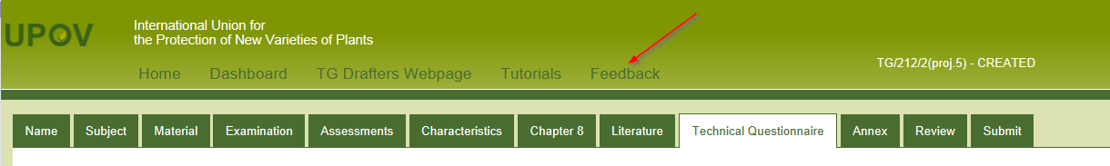

Guidance for users of the web-based TG template

Tutorials for the following user roles are available on the web-based TG Template under the link “Tutorials”:

- Leading Expert drafting tutorial
- Interested Expert comments tutorial
- Leading Expert checking tutorial

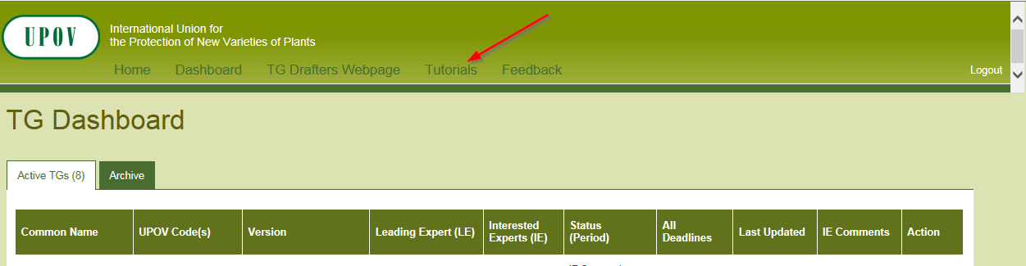

Alternatively, the tutorials are also available for download under the following link: http://upov.int/export/sites/upov/tgp/en/tg_template_tutorial_complete.pdf

The web-based TG template tutorials contain a list of most frequently asked questions for the different user roles.

The TWPs are invited to:

(a) note the items resolved in Version 1.0 of the web-based TG template, as set out in paragraph 18 of this document;

(b) note that a general revision of the software code is underway to eliminate remaining reported malfunctioning issues and to stabilize the system;

(c) note the issues to be considered for inclusion in Version 2 of the web-based TG Template, as set out in paragraph 21 of this document;

(d) note the issues on the web-based TG template agreed by the TC, at its fifty-third session, as set out in paragraphs 25 to 27 of this document;

(e) consider whether explanations covering all characteristics should be displayed before Chapter 8.1 “Explanations covering several characteristics” without a note in the Table of Chars, as set out in paragraphs 28 and 29 of this document;

(f) note the issues currently being addressed on the web-based TG template for inclusion during the second semester of 2017, as set out in paragraph 30 of this document;

(g) note that training on the use of the web-based TG template will be offered to the TWPs, at their sessions in 2017, during the preparatory workshops of the sessions and during discussions on agenda item “guidance for drafters’ of Test Guidelines”; and

(h) note that feedback and questions can be provided directly via the web-bases TG template, as set out in paragraph 33 of this document.

[Annexes follow]

Features of the web-based TG Template

(Extract from document TC/50/10 “Report on developments in UPOV including relevant matters discussed in the last sessions of the Administrative and Legal Committee, the Consultative Committee and the Council”)

The web-based TG Template will be developed in two separate phases in the form of Versions 1 and 2.

Version 1

Version 1 of the web-based TG Template will be fully functional for the development of UPOV Test Guidelines by Leading Experts and will enable Interested Experts to provide comments. Version 1 of the web-based TG Template will be completed in 2016 and a demonstration will be made at the TWPs sessions in 2016.

Features

The main features of Version 1 are as follows:

- Draft Test Guidelines will be prepared by Leading Experts online via the web-based TG Template
- Fixed template containing all universal standard wording which is appropriate for all Test Guidelines (see document TGP/7 “Development of Test Guidelines”, Section 3.1 “The TG Template”)
- Options to add Additional Standard Wording (ASW) (see document TGP/7, Section 3.2 “Additional Standard Wording (ASW) for the TG Template”)
- Links to Guidance Notes (GN) (see document TGP/7, Section 3.3 “Guidance Notes (GN) for the TG Template”)
- A database of characteristics (in English, French, German and Spanish) from Test Guidelines adopted after the adoption of document TGP/7/1 “Development of Test Guidelines” the Collection of Approved Characteristics (adopted in 2004) (see document TGP/7, Annex 4 “Collection of Approved Characteristics”).
The database will contain all information from the Table of Characteristics, including states of expression, notes, example varieties, etc. The database can be searched for relevant characteristics and a relevant characteristic uploaded into draft Test Guidelines with subsequent modification as required.

- Comments boxes for Interested Experts to complete online with a facility to view all comments
- Options to produce output in HTML or Word format.
- English only version
- Translators’ facility for the Table of Characteristics (Chapter 7)

Characteristics uploaded, unchanged, from the database comprising the collection of approved characteristics will be indicated as not requiring translation. For other characteristics, translators will be able to search the database comprising the collection of approved characteristics and input the required translations. The translation of the other chapters of the Test Guidelines will be provided separately for Version 1.

Version 2

Version 2 of the web-based TG Template will provide the two following additional features:

Concurrent translation

In version 2 of the web-based TG Template, the French, German and Spanish language versions of the Test Guidelines will be automatically developed concurrently with the English draft for the standard wording, Additional Standard Wording (ASW) and characteristics uploaded, unchanged, from the database comprising the collection of approved characteristics. Text that has not been automatically translated will be indicated for translation in the language concerned.

Individual authorities’ test guidelines

Version 1 of the web-based TG Template has been designed for the development of Test Guidelines for UPOV. However, it has also been designed such that Version 2 will enable members of the Union to use:

(a) adopted UPOV Test Guidelines as a basis for the development of individual authorities’ test guidelines;

(b) the web-based TG Template and database of characteristics to develop individual authorities’ test guidelines for which there are no UPOV Test Guidelines; and

(c) use individual authorities’ test guidelines, developed using the web-based TG Template, as the basis for draft UPOV Test Guidelines.

Version 2 will have a feature for individual authorities to modify the template wording, within the same structure, to act as a template for their own test guidelines and a feature to allow individual authorities to convert UPOV Test Guidelines into individual authorities’ test guidelines, with necessary modifications.

[Annex II follows]

FEATURES CURRENTLY under development for the web-based TG Template (screenshots/explanations)

The following additional issues are currently being developed for inclusion on the web-based TG template during the second semester of 2017:

1. Chapter 3.4 “Test Design”

the possibility to specify information for more than one method of propagation will be added:

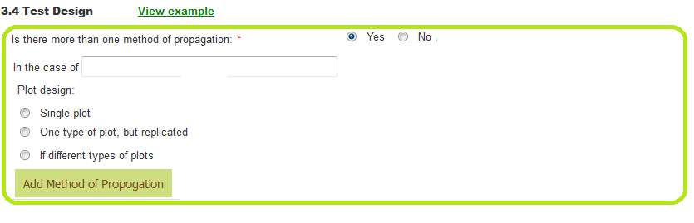

2. Chapter 4.2 “Uniformity”

New standard wording (SW) will be added at the beginning of Chapter 4.2 “Uniformity” to specify type of propagation considered in the Test Guidelines:

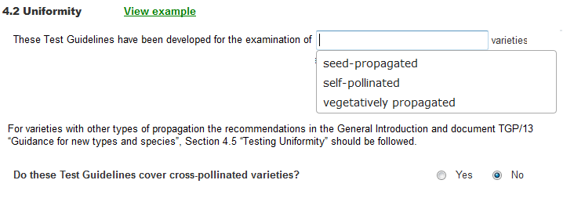

3. Example varieties master list

In case an example variety is deleted from the master list of example varieties, a pop up window indicating which characteristics the variety was used will be displayed before confirming the deletion.
4. List of characteristics

An improved functionality to move characteristics in the table of characteristics by drag and drop will be implemented, instead of having to use the up and down arrows.

5. Characteristics in the Technical Questionnaire (TQ)

It will be possible to add characteristics not contained in the table of characteristics at the end of the Technical Questionnaire (TQ):
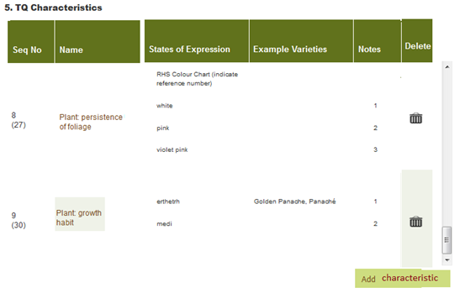
6 RHS Colour Chart references in the Technical Questionnaire (TQ)

Drafters of Test Guidelines will be able to select whether they would wish to request the RHS Colour Chart number besides the color groups for candidate varieties. The new functionality will retain the same screen on the user’s interface but will generate a document with the two separate possibilities for the information to be provided.

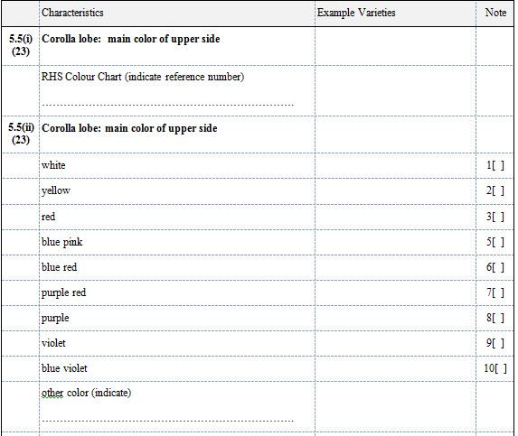

7. Information on scope of the Test Guidelines on the cover page

A new function is being created to edit the scope of the Test Guidelines on the cover page (e.g. for excluding species and UPOV Codes):

Example:
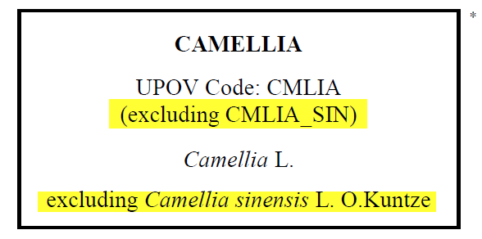
Screenshot:

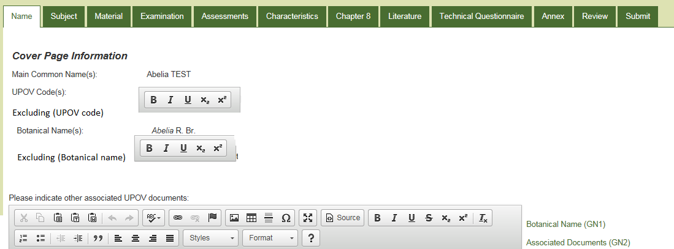

[End of Annex II and of document]

