E
International Union for the Protection of New Varieties of Plants

Technical Working Party for Agricultural Crops  Forty-Sixth Session  Hanover, Germany, June 19 to 23, 2017  Technical Working Party for Vegetables  Fifty-First Session  Roelofarendsveen, Netherlands, July 3 to 7, 2017  Technical Working Party for Ornamental Plants and Forest Trees  Fiftieth Session  Victoria, Canada, September 11 to 15, 2017  Technical Working Party for Fruit Crops  Forty-Eighth Session  Kelowna, Canada, September 18 to 22, 2017  Technical Working Party on Automation and Computer Programs  Thirty-Fifth Session  Buenos Aires, Argentina, November 14 to 17, 2017 | TWP/1/12  Original: English  Date: June 9, 2017
Characteristics which only apply to certain varieties
Document prepared by the Office of the Union
Disclaimer: this document does not represent UPOV policies or guidance

EXECUTIVE SUMMARY

The purpose of this document is to report on the consideration of amending current guidance in document TGP/7 “Development of Test Guidelines” for excluding a characteristic from observation on the basis of a state of expression of a preceding pseudo-qualitative or quantitative characteristic.

The TWPs are invited to consider the possibility and, if appropriate, identify the circumstances under which characteristics could be excluded from observation on the basis of a preceding pseudo-qualitative or quantitative characteristic.

The structure of this document is as follows:

EXECUTIVE SUMMARY 1
BACKGROUND 2
Proposal 2
ANNEX I EXTRACT FROM DOCUMENT TG/13/11(PROJ.5)

The following abbreviations are used in this document:

TC: Technical Committee
TC-EDC: Enlarged Editorial Committee
TWPs: Technical Working Parties

BACKGROUND

The following guidance is provided in document TGP/7 on characteristics which only apply to certain varieties:

“GN 18 (TG Template: Chapter 7: column 3) – Presentation of Characteristics: Heading of a characteristic
[…]

“3. Characteristics which only apply to certain varieties

“In some cases, the state of expression of a preceding qualitative characteristic determines that a subsequent characteristic is not applicable e.g. it would not be possible to describe the shape of leaf lobes for a variety which did not have leaf lobes. In cases where this is not obvious, or where the characteristics are separated in the Table of Characteristics, the heading of the subsequent characteristic is preceded by an underlined reference to the types of varieties to which it applies, on the basis of the preceding characteristic, e.g.:

“‘Only varieties with flower type: single: Flower: shape’”
[…]

The TC, at its fifty-third session, held in Geneva from April 3 to 5, 2017, considered whether to amend document TGP/7, Guidance Note 18(3) “Characteristics which only apply to certain varieties”, to clarify that, in addition to the state of expression of a preceding qualitative characteristic, in some cases the state of expression of a preceding pseudo-qualitative or quantitative characteristic would also determine that a subsequent characteristic was not applicable (see document TC/53/31 “Report”, paragraphs 134 and 135).

The TC agreed to invite the TWPs, at their sessions in 2017, to consider the possibility and, if appropriate, identify the circumstances under which characteristics could be excluded from observation on the basis of a preceding pseudo-qualitative or quantitative characteristic and agreed to discuss the matter further at the TC, at its session in 2018.

Proposal

On the basis of the invitation by the TC, it is proposed that the TWPs, at their sessions in 2017, consider the possibility and, if appropriate, identify the circumstances under which characteristics could be excluded from observation on the basis of a preceding pseudo-qualitative or quantitative characteristic.

In order to facilitate consideration of this proposal an extract of selected characteristics is provided as an Annex to this document.

The TWPs are invited to consider the possibility and, if appropriate, identify the circumstances under which characteristics could be excluded from observation on the basis of a preceding pseudo-qualitative or quantitative characteristic.

[Annex follows]

Extract from document TG/13/11(proj.5)

3. |  | (*) |  | QN |  | VG |  | (+) |  | (a)
 |  |  |  | Plant: degree of overlapping of upper part of leaves |  |  |  | Plante : degré du chevauchement de la partie supérieure des feuilles |  |  |  | Pflanze: Stärke des Überlappens des oberen Teils der Blätter |  | Planta: grado de solapamiento de la parte superior de las hojas
 |  |  |  | absent or weak |  |  |  | nul ou faible |  |  |  | fehlend oder gering |  | ausente o débil |  | Blonde à couper améliorée, Lollo rossa, Actarus, Aquarel, Curtis |  | 1
 |  |  |  | medium |  |  |  | moyen |  |  |  | mittel |  | medio |  | Clarion, Fiorella, Augusta |  | 2
 |  |  |  | strong |  |  |  | fort |  |  |  | stark |  | fuerte |  | Roxette, Vanguard 75 |  | 3
 | 4. |  |  |  | QN |  | MS/VG |  | (+) |  | (a)
 |  |  |  |  | Only varieties with Plant: degree of overlapping of upper part of leaves absent or weak: Plant: number of leaves |  |  |  | Seulement les variétés avec Plante : degré de chevauchement de la partie supérieure des feuilles: nul ou faible : Plante : nombre de feuilles |  |  |  | Nur Sorten mit Pflanze: Stärke des Überlappens des oberen Teils der Blätter: fehlend oder gering: Pflanze: Anzahl Blätter |  | Solo variedades con Planta: grado de solapamiento de la parte superior de las hojas: ausente o débil: Planta: número de hojas
 |  |  |  |  | few |  |  |  | petit |  |  |  | wenige |  | bajo |  | Lollo rossa |  | 3
 |  |  |  |  | medium |  |  |  | moyen |  |  |  | mittel |  | medio |  | Muraï |  | 5
 |  |  |  |  | many |  |  |  | grand |  |  |  | viele |  | alto |  | Sartre, Felucca, Xandra |  | 7
 | 6. |  | (*) |  | QN |  | VG |  | (+) |  | (b)
 |  |  |  |  | Leaf: number of divisions |  |  |  | Feuille : nombre de divisions |  |  |  | Blatt: Anzahl Abschnitte |  | Hoja: número de divisiones
 |  |  |  |  | absent or very few |  |  |  | nul ou très petit |  |  |  | fehlend oder sehr wenige |  | ausentes o muy bajo |  | Lollo rossa, Fiorella |  | 1
 |  |  |  |  | few |  |  |  | petit |  |  |  | wenige |  | bajo |  | Curletta, Rodagio |  | 3
 |  |  |  |  | medium |  |  |  | moyen |  |  |  | mittel |  | medio |  | Jadigon, Ezabel |  | 5
 |  |  |  |  | many |  |  |  | grand |  |  |  | viele |  | alto |  | Expedition, Multired 54 |  | 7
 |  |  |  |  | very many |  |  |  | très grand |  |  |  | sehr viele |  | muy alto |  | Excite, Ezfrill, Telex |  | 9

7. |  | PQ | VG | (+) | (b)
 |  | Only varieties with Leaf: number of divisions: absent or very few: Leaf: shape |  | Seulement les variétés avec Feuille : nombre de divisions : nul ou très petit : Feuille : forme |  | Nur Sorten mit Blatt: Anzahl Abschnitte: fehlend oder sehr wenige: Blatt: Form | Solo variedades con Hoja: número de divisiones: ausentes o muy bajo: Hoja: forma
 |  | triangular |  | triangulaire |  | dreieckig | triangular |  | 1
 |  | lanceolate |  | lancéolée |  | lanzettlich | lanceolada | Qingyuanyewoju | 2
 |  | medium oblate |  | arrondie aplatie moyenne |  | mittel breitrund | achatada media | Stylist | 3
 |  | narrow oblate |  | arrondie aplatie étroite |  | schmal breitrund | achatada estrecha | Fiorella, Commodore | 4
 |  | circular |  | circulaire |  | kreisförmig | circular | Verpia | 5
 |  | broad elliptic |  | elliptique large |  | breit elliptisch | elíptica ancha | Amadeus | 6
 |  | medium elliptic |  | elliptique moyenne |  | mittel elliptisch | elíptica media | Xanadu | 7
 |  | narrow elliptic |  | elliptique étroite |  | schmal elliptisch | elíptica estrecha | Verte maraîchère | 8
 |  | linear |  | linéaire |  | linear | lineal | Hongwoju | 9
 |  | broad obtrullate |  | losangique transverse large |  | breit verkehrt rautenförmig | rómbica ancha |  | 10
 |  | obovate |  | obovale |  | verkehrt eiförmig | oboval | Raisa | 11
 |  | oblanceolate |  | oblancéolée |  | verkehrt lanzettlich | oblanceolada | Xiangshengcai | 12
8. |  | PQ | VG | (+) | (b)
 |  | Only varieties with Leaf: number of divisions: absent or very few: Leaf: shape of apex |  | Seulement les variétés avec Feuille : nombre de divisions : nul ou très petit : Feuille : forme de l’extrémité |  | Nur Sorten mit Blatt: Anzahl Abschnitte: fehlend oder sehr wenige: Blatt: Form der Spitze | Solo variedades con Hoja: número de divisiones: ausentes o muy bajo: Hoja: forma del ápice
 |  | acute |  | aiguë |  | spitz | agudo | Celtuce | 1
 |  | obtuse |  | obtuse |  | stumpf | obtuso | Actarus | 2
 |  | rounded |  | arrondie |  | abgerundet | redondeado | Blonde maraîchère, Maserati | 3
 |  | obcordate |  | obcordiforme |  | verkehrt herzförmig | obcordiforme | PS 6545691 | 4
9. |  | QN | VG | (+) | (b)
 |  | Only varieties with Leaf: number of divisions: absent or very few: Leaf: longitudinal section |  | Seulement les variétés avec Feuille : nombre de divisions : nul ou très petit : Feuille : section longitudinale |  | Nur Sorten mit Blatt: Anzahl Abschnitte: fehlend oder sehr wenige: Blatt: Längsschnitt | Solo variedades con Hoja: número de divisiones: ausentes o muy bajo: Hoja: sección longitudinal
 |  | concave |  | concave |  | konkav | cóncava | Sunstar | 1
 |  | flat |  | plate |  | flach | plana | Clarion, Lollo rossa | 3
 |  | convex |  | convexe |  | konvex | convexa | Tiago | 5
10. |  | QN | VG | (+) | (b)
 |  | Only Oakleaf type varieties: Leaf: width of lobes |  | Seulement les variétés de type Feuille de chêne : Feuille : largeur des lobes |  | Nur Sorten des Typs Eichblatt: Blatt: Breite der Lappen | Solo variedades de tipo Oakleaf: Hoja: anchura de los lóbulos
 |  | narrow |  | étroits |  | schmal | estrecha | Kibrille, Rougini | 3
 |  | medium |  | moyens |  | mittel | media | Bandolin, Ribaï | 5
 |  | broad |  | larges |  | breit | ancha | Horix, Starix, Vizir | 7
21. |  | PQ | VG | (+) | (b)
 |  | Leaf: type of incisions of margin |  | Feuille : type de découpures du bord |  | Blatt: Typ der Randeinschnitte | Hoja: tipo de incisiones del borde
 |  | crenate |  | crénelé |  | gekerbt | crenada | Gloire du Dauphiné | 1
 |  | regularly dentate |  | régulièrement denté |  | regelmäßig gezähnt | dentada regularmente | Soliflore | 2
 |  | irregularly dentate |  | irrégulièrement denté |  | unregelmäßig gezähnt | dentada irregularmente | Rodagio | 3
 |  | bidentate |  | bidenté |  | doppelt gezähnt | bidentada | Great Lakes 118 | 4
 |  | tridentate |  | tridenté |  | dreifach gezähnt | tridentada | Expedition | 5
23. |  | QN | VG | (+) | (b)
 |  | Only varieties with Leaf: type of incisions of margin: irregularly dentate, bi- or tridentate: Leaf: depth of secondary incisions of margin |  | Seulement les variétés avec Feuille : type de découpures du bord : irrégulièrement denté, bidenté ou tridenté : Feuille : profondeur des découpures secondaires du bord |  | Nur Sorten mit Blatt: Typ der Randeinschnitte: unregelmäßig gezähnt, doppelt oder dreifach gezähnt: Blatt: Tiefe der sekundären Randeinschnitte | Solo variedades con Hoja: tipo de incisiones del borde: dentadas irregularmente, bidentadas o tridentadas: Hoja: profundidad de las incisiones secundarias del borde
 |  | shallow |  | peu profondes |  | flach | poco profundas | Great Lakes 659 | 3
 |  | medium |  | moyennes |  | mittel | medias | Expedition | 5
 |  | deep |  | profondes |  | tief | profundas |  | 7
26. |  | QN | MS/VG |  | (a)
 |  | Only varieties with Plant: degree of overlapping of upper part of leaves: medium or strong: Head: size |  | Seulement les variétés avec Plante : degré du chevauchement de la partie supérieure des feuilles : moyen ou fort : Pomme : taille |  | Nur Sorten mit Pflanze: Stärke des Überlappens des oberen Teils der Blätter: mittel oder stark: Kopf: Größe | Solo variedades con Planta: grado de solapamiento de la parte superior de las hojas: medio o fuerte: Cogollo: tamaño
 |  | very small |  | très petite |  | sehr klein | muy pequeño | Tom Thumb | 1
 |  | small |  | petite |  | klein | pequeño | Xanadu | 3
 |  | medium |  | moyenne |  | mittel | medio | Fiorella, Soraya | 5
 |  | large |  | grande |  | groß | grande | Great Lakes 659 | 7
 |  | very large |  | très grande |  | sehr groß | muy grande | El Toro, Blonde maraîchère | 9
27. | (*) | QN | MS/VG | (+) | (a)
 |  | Only varieties with Plant: degree of overlapping of upper part of leaves: medium or strong: Head: shape in longitudinal section |  | Seulement les variétés avec Plante : degré du chevauchement de la partie supérieure des feuilles : moyen ou fort : Pomme : forme en section longitudinale |  | Nur Sorten mit Pflanze: Stärke des Überlappens des oberen Teils der Blätter: mittel oder stark: Kopf: Form im Längsschnitt | Solo variedades con Planta: grado de solapamiento de la parte superior de las hojas: medio o fuerte: Cogollo: forma en sección longitudinal
 |  | narrow elliptic |  | elliptique étroite |  | schmal elliptisch | elíptica estrecha | Verte maraîchère | 1
 |  | broad elliptic |  | elliptique large |  | breit elliptisch | elíptica ancha | Amadeus, Sucrine | 2
 |  | circular |  | circulaire |  | kreisförmig | circular | Verpia | 3
 |  | narrow oblate |  | aplatie arrondie étroite |  | schmal breitrund | achatada estrecha | Ametist | 4

28. |  | QN | VG |  | (a)
 |  | Only varieties with Plant: degree of overlapping of upper part of leaves: medium or strong: Head: density |  | Seulement les variétés avec Plante : degré du chevauchement de la partie supérieure des feuilles : moyen ou fort : Pomme : densité |  | Nur Sorten mit Pflanze: Stärke des Überlappens des oberen Teils der Blätter: mittel oder stark: Kopf: Dichte | Solo variedades con Planta: grado de solapamiento de la parte superior de las hojas: medio o fuerte: Cogollo: densidad
 |  | loose |  | lâche |  | locker | laxa | Nanda | 3
 |  | medium |  | moyenne |  | mittel | media | Delice, Daguan | 5
 |  | dense |  | dense |  | dicht | densa | Islandia, Atella | 7
 |  | very dense |  | très dense |  | sehr dicht | muy densa | Rubette | 9
29. |  | QN | MS/VG | (+) | (a)
 |  | Only stem type varieties: Stem: length |  | Seulement les variétés de type tige : Tige : longueur |  | Nur Sorten des Typs Stengelsalat: Stengel: Länge | Solo variedades de tallo: Tallo: longitud
 |  | short |  | courte |  | kurz | corto | Wuweijianye | 3
 |  | medium |  | moyenne |  | mittel | medio | Zipixiang | 5
 |  | long |  | longue |  | lang | largo | Guasihong | 7
30. |  | QN | MS/VG | (+) | (a)
 |  | Only stem type varieties: Stem: width |  | Seulement les variétés de type tige : Tige : largeur |  | Nur Sorten des Typs Stengelsalat: Stengel: Breite | Solo variedades de tallo: Tallo: anchura
 |  | narrow |  | étroite |  | schmal | estrecho | Ailaowoju | 1
 |  | medium |  | moyenne |  | mittel | medio | Guasihong, Zipixiang | 2
 |  | broad |  | large |  | mittel | ancho | Guasihong | 3
31. |  | PQ | VG | (+) | (a)
 |  | Only stem type varieties: Stem: shape in longitudinal section |  | Seulement les variétés de type tige : Tige : forme en section longitudinale |  | Nur Sorten des Typs Stengelsalat: Stengel: Form im Längsschnitt | Solo variedades de tallo: Tallo: forma en sección longitudinal
 |  | cylindrical |  | cylindrique |  | zylindrisch | cilíndrico | Chiwoju | 1
 |  | conical |  | conique |  | kegelförmig | cónico | Guasihong | 2
 |  | fusiform |  | fusiforme |  | spindelförmig | fusiforme | Zipixiang | 3
32. |  | PQ | VG |  | (a)
 |  | Only stem type varieties: Stem: color |  | Seulement les variétés de type tige : Tige : couleur |  | Nur Sorten des Typs Stengelsalat: Stengel: Farbe | Solo variedades de tallo: Tallo: color
 |  | whitish green |  | vert blanchâtre |  | weißlichgrün | verde blanquecino | Wuweijianye | 1
 |  | light green |  | vert clair |  | hellgrün | verde claro | Chiwoju | 2
 |  | medium green |  | vert moyen |  | mittelgrün | verde medio | Yangwoju | 3
 |  | greenish purple |  | pourpre verdâtre |  | grünlichpurpurn | púrpura verdoso | Guasihong | 4
 |  | purplish red |  | rouge pourpre |  | purpurrot | rojo purpúreo | Hongwosun | 5

33. |  | PQ | VG |  | (a)
 |  | Only stem type varieties: Stem: color of flesh |  | Seulement les variétés de type tige : Tige : couleur de la chair |  | Nur Sorten des Typs Stengelsalat: Stengel: Farbe des Fleisches | Solo variedades de tallo: Tallo: color de la médula
 |  | yellowish white |  | blanc jaunâtre |  | gelblichweiß | blanco amarillento | Wuweijianye | 1
 |  | whitish green |  | vert blanchâtre |  | weißlichgrün | verde blanquecino | Chiwoju | 2
 |  | light green |  | vert clair |  | hellgrün | verde claro | Yangwoju | 3
 |  | medium green |  | vert moyen |  | mittelgrün | verde medio | Guasihong | 4
 |  | dark green |  | vert foncé |  | dunkelgrün | verde oscuro | Chiwosun | 5
34. |  | QN | MG/VG
 |  | Only varieties with Plant: degree of overlapping of upper part of leaves: medium or strong: Time of harvest maturity |  | Seulement les variétés avec Plante : degré du chevauchement de la partie supérieure des feuilles : moyen ou fort : Époque de maturité de récolte |  | Nur Sorten mit Pflanze: Stärke des Überlappens des oberen Teils der Blätter: mittel oder stark: Zeitpunkt der Erntereife | Solo variedades con Planta: grado de solapamiento de la parte superior de las hojas: medio o fuerte: Época de madurez para cosecha
 |  | very early |  | très précoce |  | sehr früh | muy temprana | Gotte jaune d'or | 1
 |  | early |  | précoce |  | früh | temprana | Sucrine, Pantlika | 3
 |  | medium |  | moyenne |  | mittel | media | Clarion | 5
 |  | late |  | tardive |  | spät | tardía | Blonde maraîchère, Calmar | 7
 |  | very late |  | très tardive |  | sehr spät | muy tardía | El Toro, Pinokkio | 9

“8.3 Lettuce types

“See also 5.3 for a table to determine the type using several characteristics.”

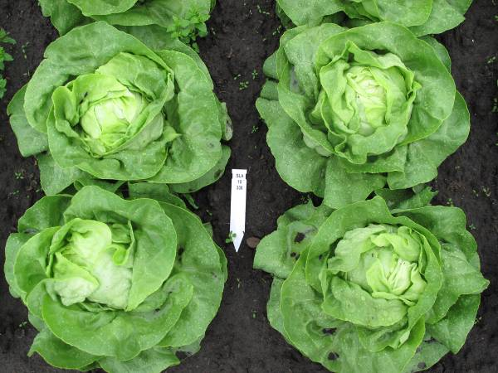 | 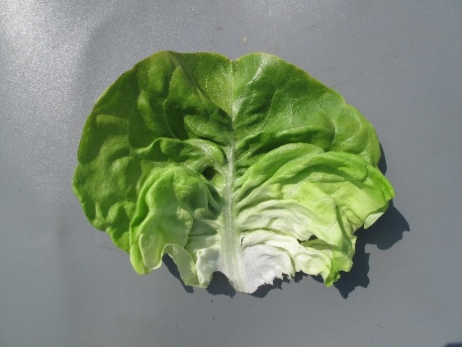 | Heading; thin to rather thick, tender leaves with a clear midrib; leaf shape circular to transverse broad elliptic; in general no incised margin; head shape ranging from broad elliptic to transvers elliptic.
Butterhead type
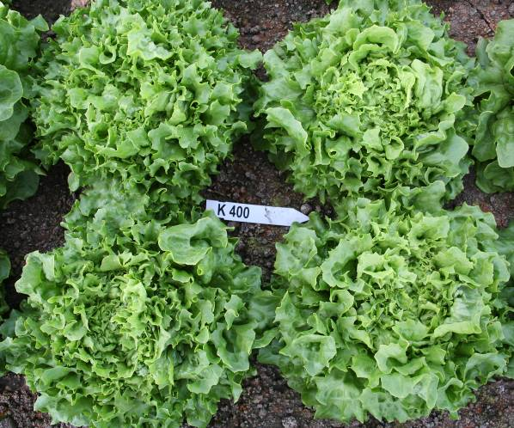 | 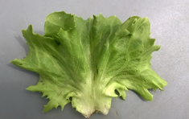 | Cross between Butterhead and Iceberg type for glasshouse growing.  Open heading; leaf structure like Butterhead, incisions of the margin as Iceberg.
Novita type
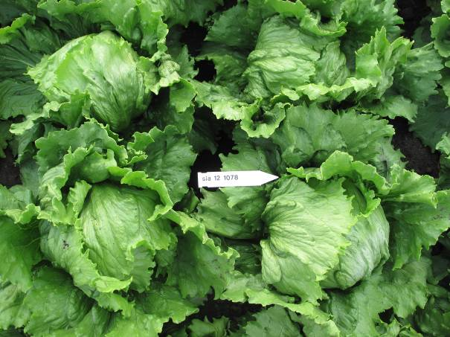 | 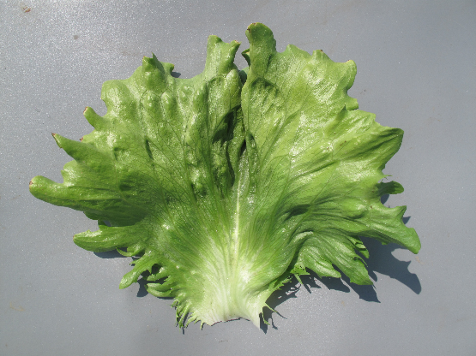 | Heading with strong or very strong overlapping of upper part of leaves; thick and crispy leaves, predominantly green and greyish green, leaf margin hardly to rather strongly incised, no clear midrib but with flabellate venation.
Iceberg type
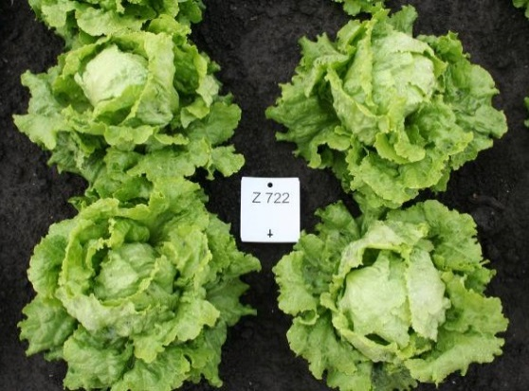 | 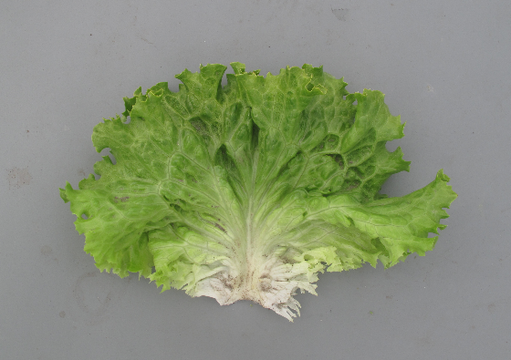 | Open to strong heading; generally medium thick, rather strongly blistered leaves, predominately yellowish or medium green; leaf margin with weak to strong undulation.
Batavia type
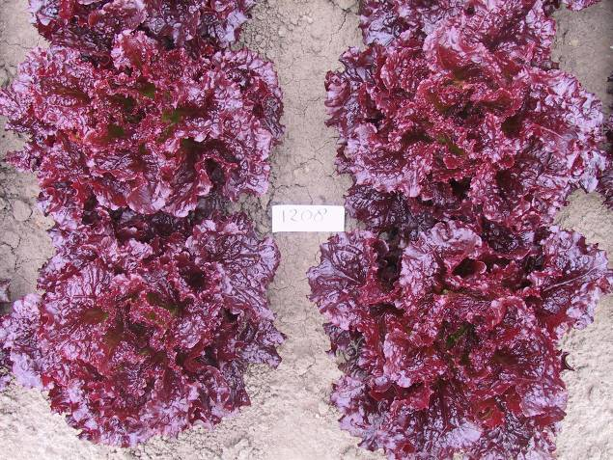 | 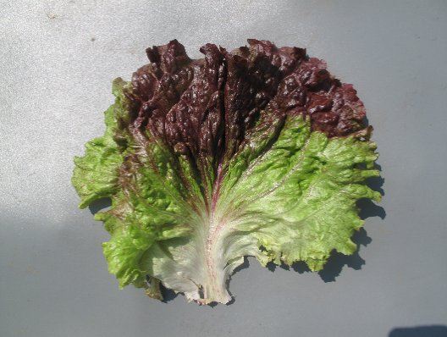 | Non-heading, loose, generally quite large plant; thin leaves. Compared to Lollo type in general less undulating margin and showing more leaf blade. Compared to Batavia type, leaves are thinner. Mainly used for babyleaf production.
Frisée d'Amérique type
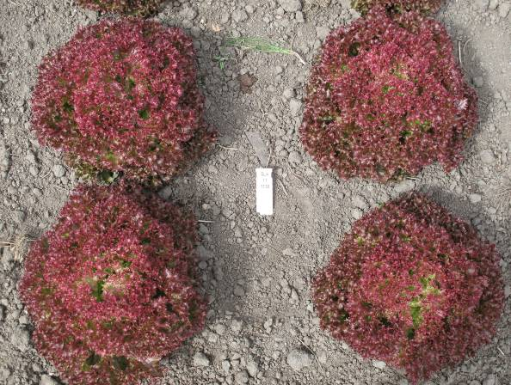 | 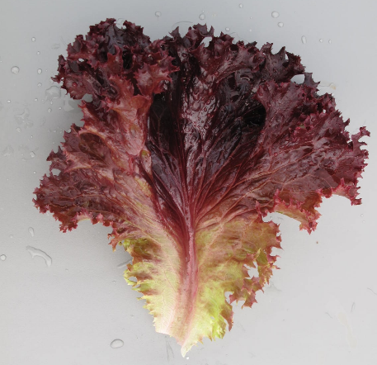 | Non-heading; thin leaves with strongly undulated leaf margin. The plant as a whole shows mainly the undulating leaf margins. In general strongly blistered leaves, blisters are rather small.
Lollo type
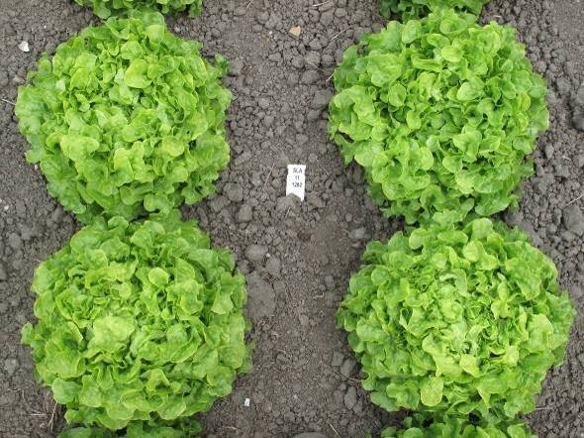 | 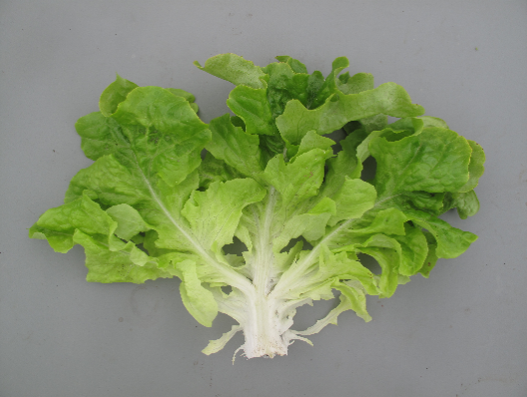 | Thin, divided leaves; divisions have an oakleaf or lobed shape with in general a rounded tip. Radichetta or Catalogna with acute tip of the division. Heart can be loose to dense.
Oakleaf type
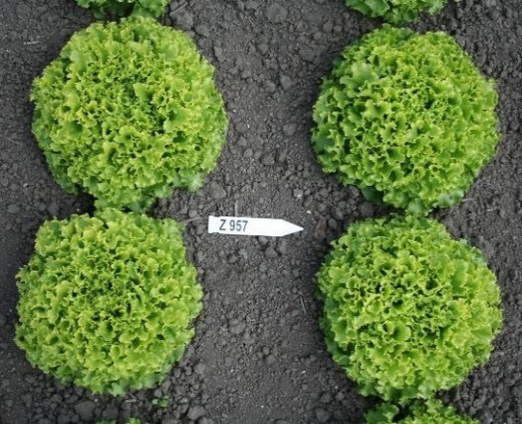 | 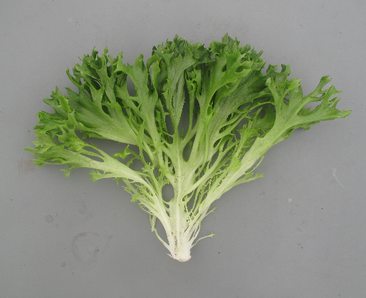 | Non-heading; thin, medium to very strong divided leaves. Tip of divisons can be undulated and incised. Plant may look as a Lollo type, but leaves are always divided.
Multi-divided type

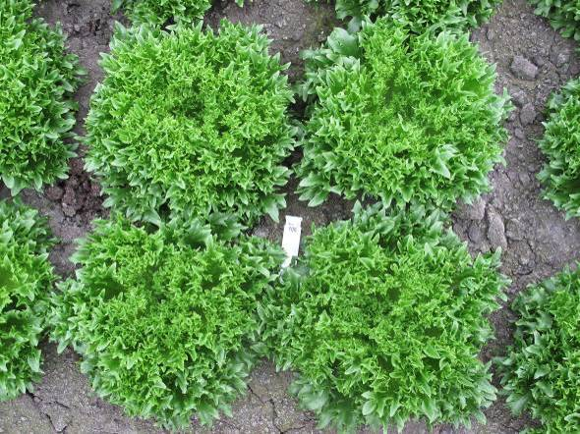 | 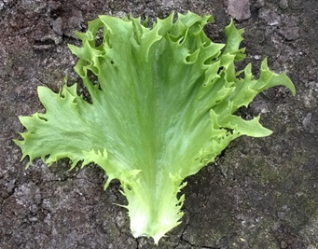 | Non-heading; thick, crispy leaves, sometimes weakly divided. Clearly incised leaf margin.
Frillice type
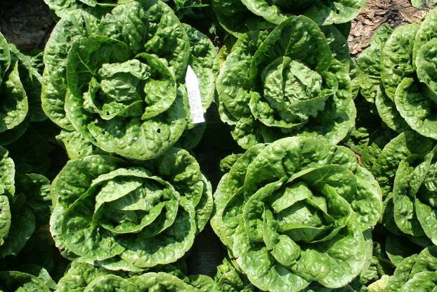 | 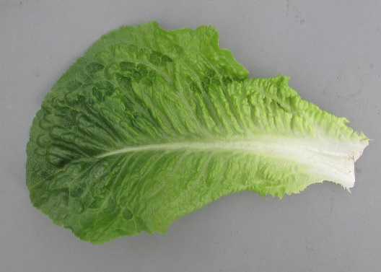 | Elongated and rather tough leaves with a clear midrib, head shape in longitudinal section elliptic, length of head >1.5 x diameter; heading can be very late.
Cos type
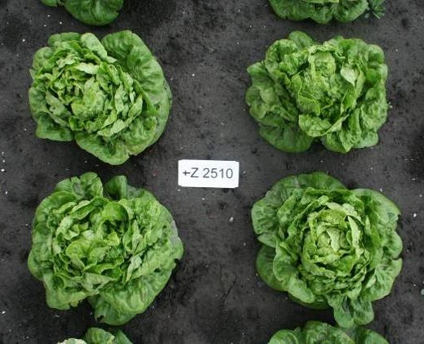 | 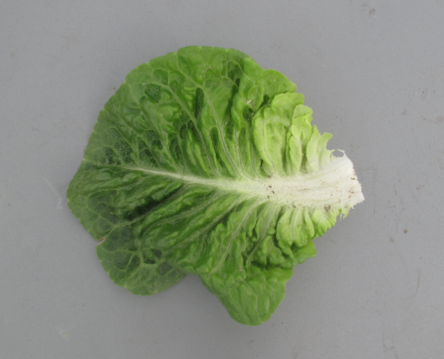 | Tough leaves with clear midrib, head shape short elliptic to slightly obovate. Some types only have a tightly filled heart, others are more similar to a short Cos type. Suitable for semi-arid conditions.
Gem type
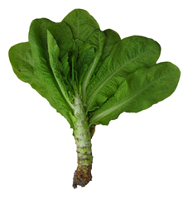 | 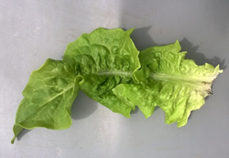 | Forms a fleshy stem before bolting, at least under (semi-)short day condtions; leaves are mainly tough and have a clear midrib. Leaves and/or stem are consumed.
Stem type

[End of Annex and of document]

