E
TWA/45/20
ORIGINAL: English
DATE: June 30, 2016
INTERNATIONAL UNION FOR THE PROTECTION OF NEW VARIETIES OF PLANTS
Geneva
Technical working party for Agricultural crops
Forty-Fifth Session
Mexico City, Mexico, July 11 to 15, 2016
Test Guidelines for UROCHLOA
Document prepared by the Office of the Union
Disclaimer: this document does not represent UPOV policies or guidance
The Technical Working Party for Agricultural Crops (TWA), at its forty-third session held in Mar del Plata, Argentina, from November 17 to 21, 2014, agreed to submit the draft Test Guidelines for Urochloa for adoption by the Technical Committee (TC), at its fifty-first session held in Geneva from March 23 to 25, 2015, on the basis of document TG/UROCH(proj.8) (see document TWA/43/27 “Report”, Annex IV).

At its fifty-first session, the TC considered the draft Test Guidelines for Urochloa (document TG/UROCH(proj.9) and adopted the Test Guidelines subject to the changes proposed by the Enlarged Editorial Committee (TC-EDC) in March 2015, which were still to be included in the document submitted to the TC. The proposed changes are presented in Annex I to this document.

The changes proposed by the TC-EDC contained some information to be provided by the Leading Expert from Brazil. The relevant items are highlighted in grey in Annex I.

With regard to the adoption of draft Test Guidelines by the Technical Committee, the following is set out in document TGP/7/4 “Developments of Test Guidelines”, Section 2 “Procedure for the Introduction and Revision of UPOV Test Guidelines”:

“2.2.8.3 Where the Technical Committee adopts the Test Guidelines subject to further information being provided by the Leading Expert with the agreement of all interested experts and the Chairman of the TWP concerned (see 2.2.7.3(b)), the necessary information, agreed with all interested experts, should be provided to the Office within three months of the Technical Committee meeting, or before the subsequent session of the TWP concerned, whichever is the sooner. In those cases where the necessary information is not provided within this time, the Test Guidelines concerned will not be adopted and will be re-presented at the TWP concerned (Step 4).”

The information requested by the TC-EDC has been provided but not within the period indicated above. The TWA is invited to consider the information provided by the Leading Expert in Annex II to this document.

In the absence of objections by the TWA, the Test Guidelines for Urochloa will be proposed for adoption by the TC at its fifty-third session to be held in Geneva from April 3 to 5, 2017, on the basis of the changes to document TG/UROCH(proj.9) presented in Annexes I and II to this document.

[Annex I follows]

Changes proposed by the Enlarged Editorial Committee (TC-EDC) in March 2015, which are still to be included in the document submitted to the TC (grey highlighting)

General | Leading Expert to confirm that all IP rights on photos, illustrations and text have been respected  Leading Expert: confirmed that all IP rights have been respected
4.1.1 | to delete ASW on hybrids
4.2.4 | to be deleted
Char. 2 | to check whether to add time of observation (see Chapter 8.1)  Leading Expert: to add (c)
Chars. 4, 5 | to delete (b) and add explanation in Chapter 8.2 or new note in 8.1  Leading Expert: to delete (b), add (+) and add Char. 5 to existing Ad. 4
Char. 6 | to read “Flag leaf: curvature”  state 1 to read “absent or weak”
Char. 7 | to read “Flag leaf: width”
Char. 18 | to read “Flower: stigma color” (see Ad.)
Char. 19 | If Characteristic 19 is observed before opening of flowers it should be indicated with (c) and moved before 18. Characteristic 18 is observed at anthesis.  Leading Expert: agreed that Char. 19 be indicated as (c) and moved before Char. 18
8.1 + Ad. 20 | Adjustment of time necessary. What is the difference between (a), (c) and Ad. 21?  Leading Expert: to remove (a) and to replace (a) by (c) in all relevant characteristics in the table of characteristics
8.1 (b) | to check whether to read "Observations on fully developed leaves should be made on the penultimate leaf of the main culm."  Leading Expert: agreed
8.1 (c) | to read “Observations should be made at the time of beginning of flowering.”  Leading Expert: agreed
Ad. 2 | to be clarified, could illustration be provided?  Leading Expert: will be provided
Ad. 4 | to read “… should be made on the middle third of the plant; …”  could illustration be provided?  Improved explanation should cover also char. 5.  Leading Expert: will be provided
Ad. 14-16 | photo to be improved, if possible  Leading Expert: will be provided
Ad. 20 | to be deleted  Leading Expert: to keep Ad. 20 and to read “The anthocyanin coloration on the glume should be assessed at the beginning of flowering, when 50% of the plants have at least one inflorescence fully emerged and before the opening of flowers.”
9. | to delete last literature reference
TQ 4.2.1 | to correct alignment of box (b)
TQ 4.2.3 | request for information on “Ploidy” to be moved to TQ7
TQ 4 | to delete wording on hybrid varieties (below 4.2.3)

[Annex II follows]

Outstanding information provided by the Leading Expert for Ad. 2 “Plant height”

Ad. 2 | to be clarified, could illustration be provided?  Leading Expert: will be provided

English | français | deutsch | español | Example Varieties  Exemples  Beispielssorten  Variedades ejemplo | Note/  Nota
2. (*) QN MS (+)
Plant: height | Plante : hauteur | Pflanze: Höhe | Planta: altura
short | basse | niedrig | corta | BRS Tupi | 3
medium | moyenne | mittel | media | BRS Piatã, MIXE LN 45, Mulato II | 5
tall | haute | hoch | alta | CIAT BR02/1718, Xaraés | 7

Current explanation:

Ad. 2: Plant: height

The height of the plant should be measured in the center of the plant, from the third fully developed leaf to the ground level, excluding inflorescences.

Proposed new explanation:

Ad. 2: Plant: height

The height of the plant should be measured in the center of the plant, from the first fully developed leaf to the ground level, excluding inflorescences.

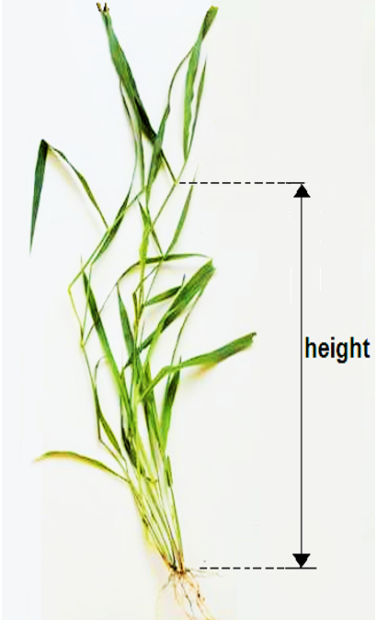

Outstanding information provided by the Leading Expert for Ad. 4 “Culm: length of internode”

Ad. 4 | to read “… should be made on the middle third of the plant; …”  could illustration be provided?  Improved explanation should cover also char. 5.  Leading Expert: will be provided

English | français | deutsch | español | Example Varieties  Exemples  Beispielssorten  Variedades ejemplo | Note/  Nota
4. (*) QN MS (+) (a) (b)
Culm: length of internode | Tige : longueur des entre-nœuds | Halm: Länge des Internodiums | Macollo: longitud del entrenudo
short | court | kurz | corto | BRS Tupi | 3
medium | moyen | mittel | medio | MIXE LN 45 | 5
long | long | lang | largo | Xaraés | 7
5. QN MS (a) (b)
Culm: diameter | Tige : diamètre | Halm: Durchmesser | Macollo: diámetro
small | petit | klein | pequeño |  | 1
medium | moyen | mittel | medio | MIXE LN 45, Mulato II | 2
large | grand | groß | grande |  | 3

Current explanation:

Ad. 4: Culm: length of internode

The assessment of the length of internode should be made medium third of plant; it does not refer to floral culm.

Proposed new explanation:

Ad. 4: Culm: length of internode
Ad. 5: Culm: diameter

The assessment of the length of internode should be made in the medium third of plant; it does not refer to floral culm.

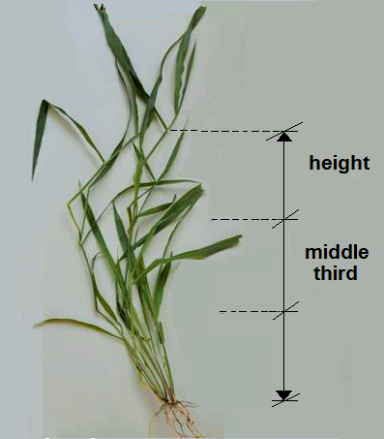

Outstanding information provided by the Leading Expert for Ad. 14 to 16

Ad. 14-16 | photo to be improved, if possible  Leading Expert: will be provided

English | français | deutsch | español | Example Varieties  Exemples  Beispielssorten  Variedades ejemplo | Note/  Nota
14. (*) QN MS (+) (a) (c)
Inflorescence: length of peduncle | Inflorescence : longueur du pédoncule | Blütenstand: Länge des Blütenstandsstiels | Inflorescencia: longitud del pedúnculo
short | court | kurz | corto |  | 3
medium | moyen | mittel | medio | Mulato II | 5
long | long | lang | largo | BRS Piatã, MIXE LN 45 | 7
15. QN MS (+) (a) (c)
Inflorescence: length of rachis | Inflorescence : longueur du rachis | Blütenstand: Länge der Spindeln | Inflorescencia: longitud del raquis
short | court | kurz | corto | Mulato II | 3
medium | moyen | mittel | medio | Llanero | 5
long | long | lang | largo | Marandú | 7
16. QN MS (+) (a) (c)
Inflorescence: length of basal racemes | Inflorescence : longueur des racèmes de la base | Blütenstand: Länge der basalen Blütentrauben | Inflorescencia: longitud de los racimos basales
short | courts | kurz | cortos | BRS Tupi, Humidícola comum | 3
medium | moyens | mittel | medios | MIXE LN 45, Mulato II | 5
long | longs | lang | largos | Marandú | 7

Current explanation:

Ad. 14: Inflorescence: length of peduncle
Ad. 15: Inflorescence: length of rachis
Ad. 16: Inflorescence: length of basal racemes

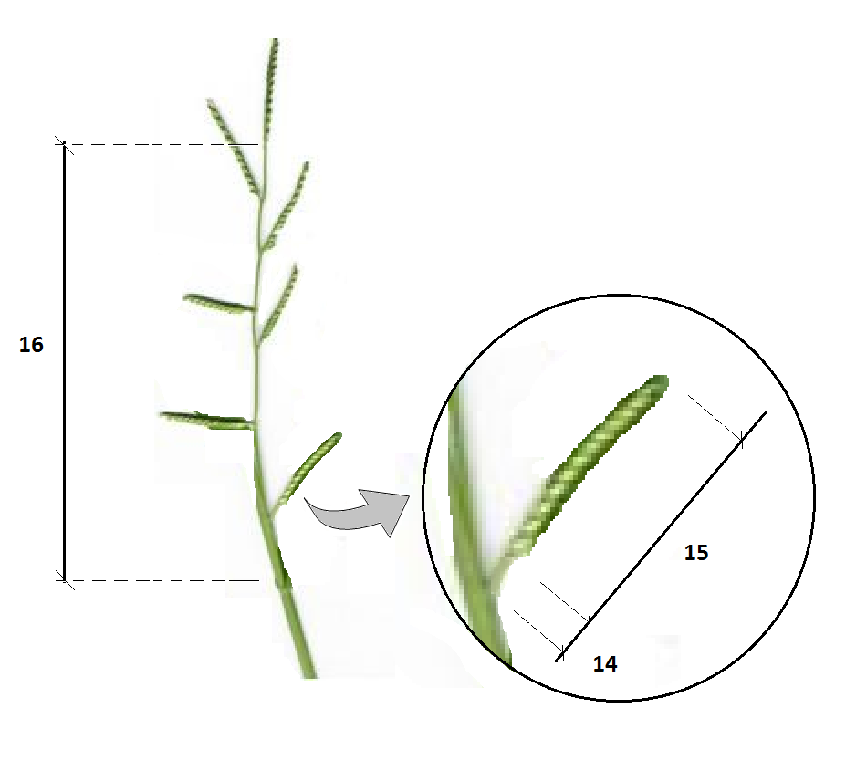
Proposed new explanation:

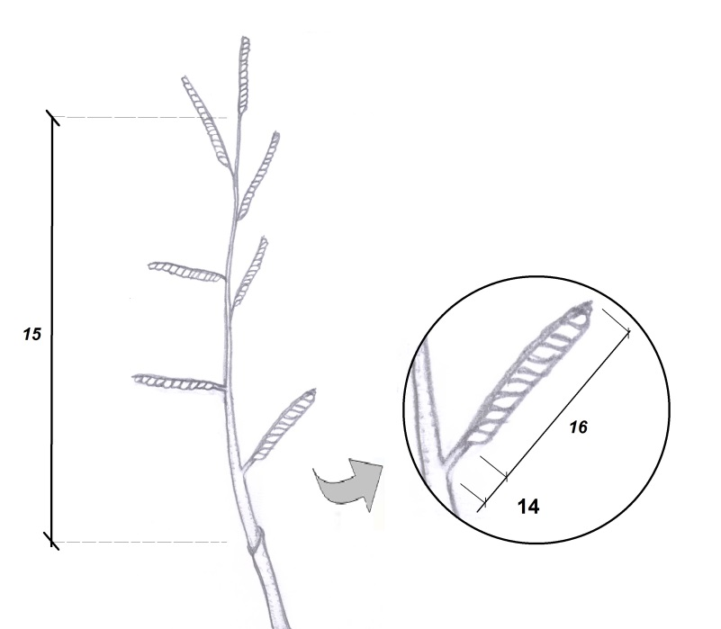

[End of Annex II and of document]

