E
TWA/45/12 Add.
ORIGINAL: English
DATE: June 24, 2016
INTERNATIONAL UNION FOR THE PROTECTION OF NEW VARIETIES OF PLANTS
Geneva
Technical working party for Agricultural crops
Forty-Fifth Session
Mexico City, Mexico, July 11 to 15, 2016
addendum to
Revision of document TGP/8: Part II: Selected Techniques Used in DUS Examination, New Section: Data Processing for the Assessment of Distinctness and for Producing Variety Descriptions
Document prepared by experts from Italy and Finland
Disclaimer: this document does not represent UPOV policies or guidance
The Annex to this document contains a copy of a presentation on “Genotype by Environment Interaction (GEI) - DUS test and data transformation into notes” to be made at the forty-fifth session of the Technical Working Party or Agricultural Crops (TWA).

[Annex follows]

GENOTYPE BY ENVIROMENT INTERACTION (GEI) - DUS TEST AND DATA TRANSFORMATION INTO NOTES

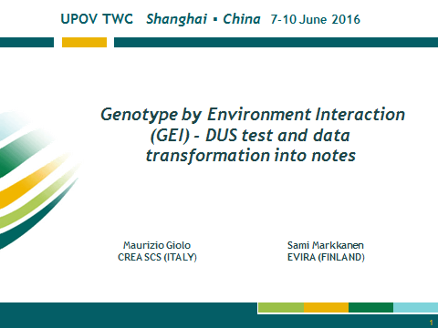

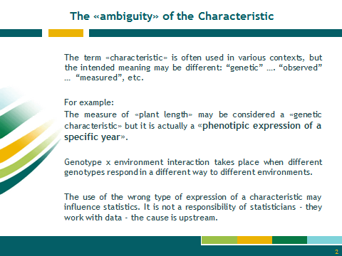

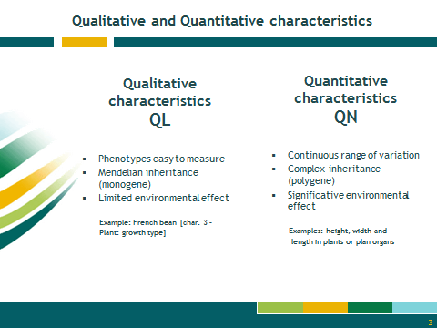

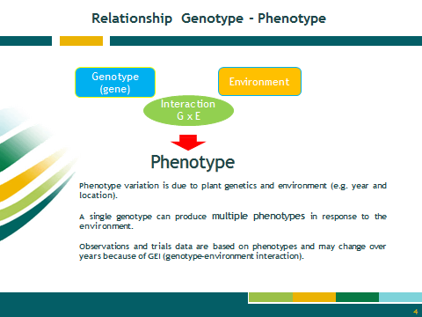

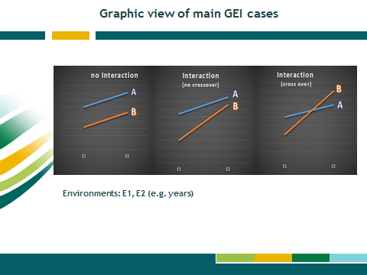

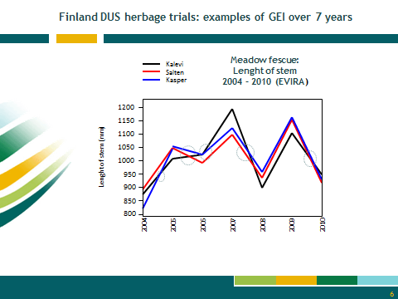

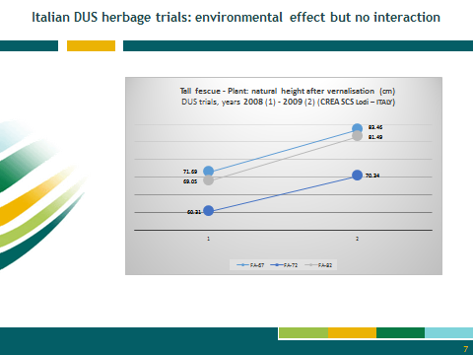

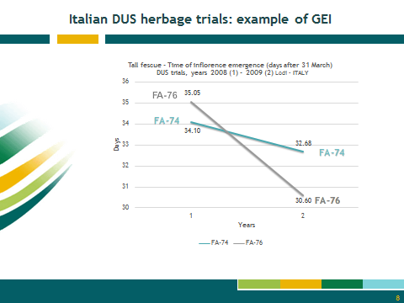

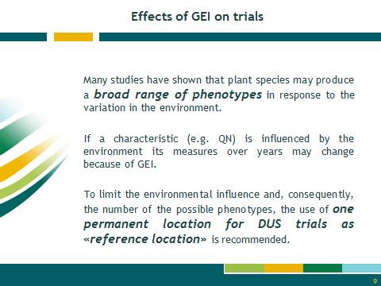

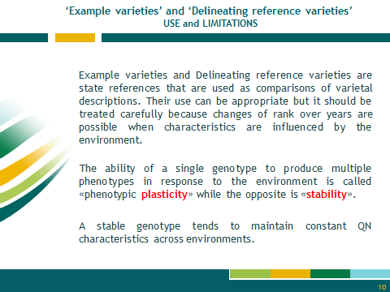

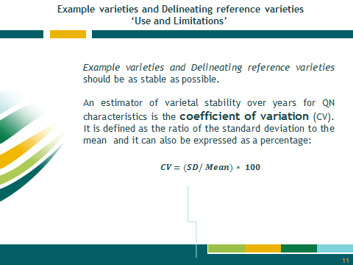

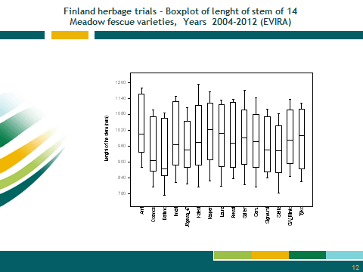

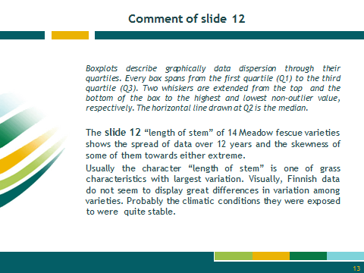

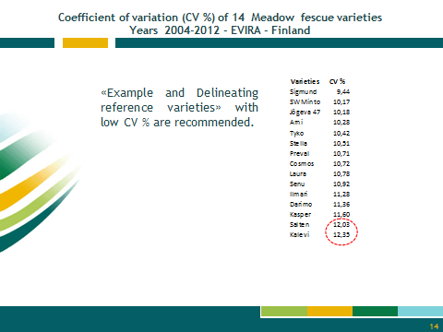

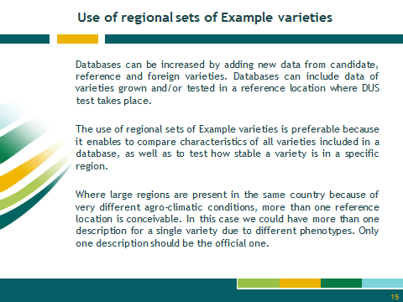

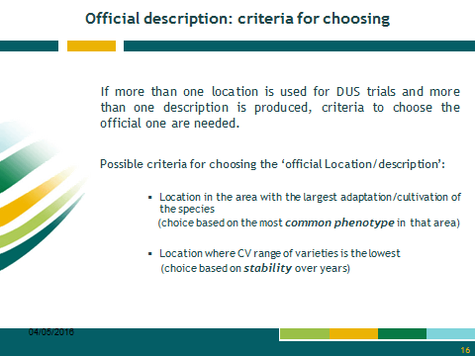

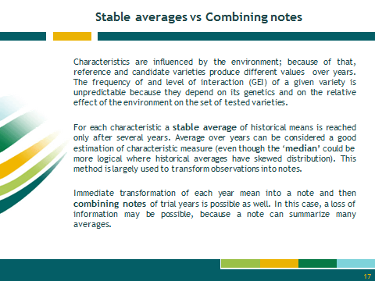

[End of Annex and of document]

