E
TWA/43/18
ORIGINAL: English
DATE: August 14, 2014
INTERNATIONAL UNION FOR THE PROTECTION OF NEW VARIETIES OF PLANTS
Geneva
Technical working party for AGRICULTURAL CROPS
Forty-Third Session
Mar del Plata, Argentina, November 17 to 21, 2014
Revision of document TGP/8: Part II: Selected Techniques Used in DUS Examination, New Section: Data Processing for the Assessment of Distinctness and for Producing Variety Descriptions
Document prepared by the Office of the Union
Disclaimer: this document does not represent UPOV policies or guidance
The purpose of this document is to present developments concerning a possible new section for document TGP/8 “Data Processing for the Assessment of Distinctness and for Producing Variety Descriptions”.

The following abbreviations are used in this document:

CAJ: Administrative and Legal Committee
TC: Technical Committee
TC-EDC: Enlarged Editorial Committee
TWA: Technical Working Party for Agricultural Crops
TWC: Technical Working Party on Automation and Computer Programs
TWF: Technical Working Party for Fruit Crops
TWO: Technical Working Party for Ornamental Plants and Forest Trees
TWV: Technical Working Party for Vegetables
TWPs: Technical Working Parties

The structure of this document is as follows:
background 2
DevelopmentS in 2013 2
Technical Committee 2
Consideration by the Technical Working Parties in 2013 2
DevelopmentS in 2014 3
Technical Committee 3
Practical exercise with a common data set 4
ANNEX I SUMMARY OF DIFFERENT APPROACHES OF TRANSFORMATION OF MEASUREMENTS INTO NOTES FOR VARIETY DESCRIPTION
ANNEX II APPLE VARIETY REFERENCE PROJECT (PREPARED BY AN EXPERT FROM NEW ZEALAND)
ANNEX III DIFFERENT FORMS THAT VARIETY DESCRIPTIONS COULD TAKE AND THE RELEVANCE OF SCALE LEVELS (PREPARED BY AN EXPERT FROM GERMANY)
ANNEX IV GUIDANCE FOR DEVELOPMENT OF VARIETIES DESCRIPTIONS IN ITALY

background

The Technical Committee (TC), at its forty-eighth session, held in Geneva from March 26 to 28, 2012, considered Annex III: “TGP/8 PART I: DUS Trial Design and data analysis, New Section 6 – Data processing for the assessment of distinctness and for producing variety Descriptions” in conjunction with Annex VIII: “TGP/8 PART II: Techniques used in DUS Examination, New Section 13 - Methods for data processing for the assessment of distinctness and for producing variety descriptions” of document TC/48/19 Rev. It agreed that the information provided in Annex VIII of document TC/48/19 Rev. and at the UPOV DUS Seminar, held in Geneva in March 2010, together with the method provided by Japan and the method used in France for producing variety descriptions for herbage crops, as presented at the TWC at its twenty-sixth session (see document TWC/26/15, TWC/26/15 Add. and TWC/26/24), provided a very important first step in developing common guidance on data processing for the assessment of distinctness and for producing variety descriptions, but concluded that the information as presented in Annex VIII of document TC/48/19 Rev. would not be appropriate for inclusion in document TGP/8. It agreed that the Office of the Union should summarize the different approaches set out in Annex VIII of document TC/48/19 Rev. with regard to aspects in common and aspects where there was divergence. As a next step, on the basis of that summary, consideration could be given to developing general guidance. The TC agreed that the section should include examples to cover the range of variation of characteristics. It further agreed that the detailed information on the methods should be made available via the UPOV website, with references in document TGP/8 (see document TC/48/22 “Report on the Conclusions” paragraph 52).

At their sessions in 2012, the TWPs received a presentation prepared by the Office of the Union on “Summary of different approaches of transformation of measurements into notes for Variety Description”, as reproduced in the Annex I of this document.

The TWC, at its thirtieth session, agreed that the experts from Finland, Italy and the United Kingdom would support the Office of the Union to summarize the different approaches for further developing common guidance on data processing for the assessment of distinctness and for producing variety descriptions (see document TWC/30/41 “Report”, paragraph 42). It also agreed that experts from the United Kingdom in cooperation with experts from France and Germany should conduct a practical exercise. The exercise would be to process a common data set to produce variety descriptions in order to determine the aspects in common and where there was divergence among the methods (see document TWC/30/41 “Report”, paragraph 43)

DevelopmentS in 2013

Technical Committee

The Technical Committee (TC), at its forty-ninth session held in Geneva from March 18 to 20, 2013, considered document TC/49/29 “Revision of document TGP/8: Part II: Techniques Used in DUS Examination, New Section: Data Processing for the Assessment of Distinctness and for Producing Variety Descriptions”.

The TC requested the Office of the Union to request experts from the United Kingdom, France and Germany, or other members of the Union, to provide a common data set of self-pollinated and/or vegetatively propagated varieties for performing a practical exercise (see document TC/49/41 “Report on the Conclusions”, paragraph 66).

Consideration by the Technical Working Parties in 2013

The TWO, TWF, TWV, TWC and TWA considered documents TWO/46/18, TWF/44/18, TWV/47/18, TWC/31/18 and TWA/42/18, respectively (see document TWO/46/29 “Report”, paragraphs 40 to 42, document TWF/44/31 “Report”, paragraphs 43 to 46, document TWV/47/34 “Report”, paragraphs 43 to 46, document TWC/31/32 “Report”, paragraphs 40 to 45, and document TWA/42/31 “Report”, paragraphs 44 to 49).

The TWO agreed with the practical exercise and requested the development of guidance on data processing for the assessment of distinctness and for producing variety descriptions of vegetatively propagated crops (see document TWO/46/29 “Report”, paragraph 42).

The TWF and the TWV agreed that the COY method is working well for cross pollinated crops and highlighted the importance of developing guidance for producing variety descriptions for self-pollinated and/or vegetatively propagated varieties. The TWF invited the expert from New Zealand to make a presentation at the forty-fifth session of the TWF in 2014, on the project for “apple reference varieties” that began in New Zealand in 2011, and how this work would contribute to developing improved example varieties and variety descriptions (see document TWF/44/31 “Report”, paragraph 45 and document TWV/47/34 “Report”, paragraph 45).

The TWF and the TWV agreed with the value of a practical exercise and requested the development of guidance on data processing for the assessment of distinctness and for producing variety descriptions of vegetatively propagated crops (see document TWF/44/31 “Report”, paragraph 46 and document TWV/47/34 “Report”, paragraph 46).

The TWC received a presentation by an expert from the United Kingdom on a preliminary use of the Flax data set to illustrate two different methods from the United Kingdom, as contained in document TWC/31/18 Add.. The TWC welcomed the data set of Flax varieties offered by the experts from France for the practical exercise. The TWC noted that the document had been prepared to illustrate the way in which the different methods could be applied and noted that in the United Kingdom one of the methods is currently applied to herbage crops, and so might not be suitable for Flax, and would need to be evaluated (see document TWC/31/32 “Report”, paragraphs 41 and 42).

The TWC noted that there was no guidance on the production of variety descriptions for cross-pollinated, self-pollinated or vegetatively propagated crops (see document TWC/31/32 “Report”, paragraph 43).

The TWC agreed that the Office of the Union should seek to ensure that the crops and data in the practical exercise would enable all methods for self-pollinated and/or vegetatively propagated varieties mentioned to be included (see document TWC/31/32 “Report”, paragraph 45).

The TWA highlighted the importance of producing guidance for variety descriptions in general and agreed that the COY method was not used for producing variety descriptions but for assessing distinctness and uniformity (see document TWA/42/31 “Report”, paragraph 46).

The TWA agreed with the TWC that there was no guidance on data processing for the assessment of distinctness and for producing variety descriptions. The TWA supported the continuation of the practical exercise and the further steps agreed by the TWC (see document TWA/42/31 “Report”, paragraph 47).

The TWA agreed that, in parallel to the practical exercise, the expert from Germany should develop a text to explain the different forms that variety descriptions could take and the relevance of scale levels in that regard (see document TWA/42/31 “Report”, paragraph 48).

The TWA noted the interest of Italy to participate in the practical exercise with use of a common data set (see document TWA/42/31 “Report”, paragraph 49).

DevelopmentS in 2014

Technical Committee

The TC at its fiftieth session, held in Geneva from April 7 to 9, 2014 considered document TC/50/25 “Revision of document TGP/8: Part II: New Section: Data Processing for the Assessment of Distinctness and for Producing Variety Descriptions”.

The TC, noted the invitation by the TWF to an expert from New Zealand to make a presentation at its forty-fifth session, on the project for “apple reference varieties” that began in New Zealand in 2011, and how that work would contribute to developing improved example varieties and variety descriptions (see document TC/50/36 “Report on the Conclusions”, paragraph 55). The expert from New Zealand made a presentation on “Apple variety reference project” at the forty-fifth session of the TWF in 2014, as reproduced in Annex II to this document.

The TC, agreed to invite an expert from Germany to develop a text to explain the different forms that variety descriptions could take and the relevance of scale levels in that regard (see document TC/50/36 “Report on the Conclusions”, paragraph 56).

In response to the request of the TC, the expert from Germany provided a text on the different forms that variety descriptions could take and the relevance of scale levels which is presented in Annex III to this document.

An expert from Italy has provided a presentation on “Guidance for development of Variety Descriptions in Italy”, as reproduced in the Annex IV of this document.

Practical exercise with a common data set

In response to the request for a common data set (see paragraph 8 of this document), the Office of the Union received data sets of Chrysanthemum, Pea and Flax from Japan, the Netherlands and France respectively. In the first instance, it was concluded that the practical exercise should be conducted with a data set for flax, provided by experts from France, on the basis that the data was sufficiently comprehensive and structured in a way that should allow the exercise to be completed by all interested UPOV members.

On December 20, 2013, a request was issued to France, Germany, Italy, Japan, Netherlands, Republic of Korea and United Kingdom, inviting them to apply their methods to the flax data provided for a single characteristic (Stem: length from cotyledon scar to top boll) for the years 2002-2012.

The TC, at its fiftieth session, agreed that the experts from France, Germany, Italy, Japan, Netherlands, Republic of Korea and United Kingdom should provide the results on the practical exercise to the Office of the Union and noted the plans for a summary of aspects in common and divergences between the methods to be presented to the TWPs in 2014 and to the TC at its fifty-first session (see document TC/50/36 “Report on the Conclusions”, paragraph 57).

The TC, on the basis of the results of the practical exercise, will be invited to consider whether to develop guidance on data processing for the assessment of distinctness and for producing variety descriptions that would be relevant for different types of propagation (see document TC/50/36 “Report on the Conclusions”, paragraph 58).

Results were received from France, Germany, Italy and United Kingdom. All available results were presented to the TWC at its thirty-second session, held in Helsinki, Finland from June 3 to 6, 2014 (see document TWC/32/18 Add.).

The TWA is invited to note:

(a) that an expert from New Zealand made a presentation at the forty-fifth session of the TWF, on the project for “apple reference varieties”, as reproduced in Annex II to this document;

(b) the explanation of the different forms that variety descriptions could take and the relevance of scale levels in that regard, as presented in Annex III to this document;

(c) the guidance for variety description in Italy, as presented in Annex IV to this document; and

(d) that the results of the practical exercise with a common data set were presented to the TWC at its thirty-second session.

[Annexes follow]

[Annex II follows]

[Annex III follows]

DIFFERENT FORMS THAT VARIETY DESCRIPTIONS COULD TAKE
AND THE RELEVANCE OF SCALE LEVELS
Document prepared by an expert from Germany

Variety descriptions can be based on different data depending on the purpose of the description. Different variety descriptions may be used for the assessment of distinctness or in the official document which forms the basis for granting protection. When variety descriptions are used for the assessment of distinctness it is important to take into account on which data the descriptions for different varieties are based. Special attention has to be given to the potential influence of years and locations.

The different forms of variety descriptions and their relevance for the assessment of distinctness can be classified according to the different process levels to look at a characteristic. The process levels are defined in document TGP/8: Part I: DUS trial design and data analysis. Section 2 (New): Data to be recorded (see TC/50/5, Annex II) as follows:

Table 5: Definition of different process levels to consider characteristics

Process level | Description of the process level
1 | characteristics as expressed in trial
2 | data for evaluation of characteristics
3 | variety description

The process levels relevant for the assessment of distinctness are level 2 and 3. Any comparison between varieties in the same trial (same year(s), same location) is carried out on the actual data recorded in the trial. This approach relates to process level 2. If varieties are not grown in the same trial, they have to be compared on the basis of variety descriptions which relates to process level 3. In general, the identification of similar varieties to be included in the growing trial ("Management of variety collection") relates to process level 3, whereas data evaluation within the growing trial relates to process level 2.

Process level | Measurements  (QN) | Visual assessment  (QN/QL/PQ) | Remark
2 | Values | Notes | Basis for comparison within the same trial
3 | Transformation into notes  Notes | Same Notes as in Process level 1  Notes | Notes resulting from one year and location
 | "Mean variety description"  If varieties are assessed in several trials/years/locations mean descriptions can be established. |  | Basis for management of variety collection

In general, quantitative characteristics are influenced by the environment. An efficient way to reduce the environmental influence is the transformation of actual measurements into notes. The notes represent a standardized description of varieties in relation to example varieties (see TGP/7). In addition, the comparability of variety descriptions for varieties not tested in the same trial can be improved by calculating a mean description over several growing cycles. In particular, the mean description over several growing cycles at the same location can provide a representative description related to the location. The calculation of a mean description over different locations should only be considered if the effects of the locations are very well known and variety x location interactions can be excluded for all characteristics. The calculation of mean descriptions over locations should be restricted to the cases where these conditions are fulfilled.

If variety descriptions from different growing trials are used for the assessment of distinctness - that means for the management of variety collections - it is important to take into account the origin of the different variety descriptions of the candidate variety and the varieties of common knowledge. The comparability of variety descriptions is influenced by many factors, for example:

- Description based on a single year or a mean over several years?
- Description based on the same location or different locations?
- Are the effects of the different location known?
- Varieties described in relation to the same variety collection or a variety collection which might cover a different range of variation?

The potential bias of variety descriptions due to environmental effects between candidate varieties and varieties in the variety collection have to be taken into account in the process of distinctness testing, and in particular, for the identification of varieties of common knowledge to be included in the growing trial.

[Annex IV follows]

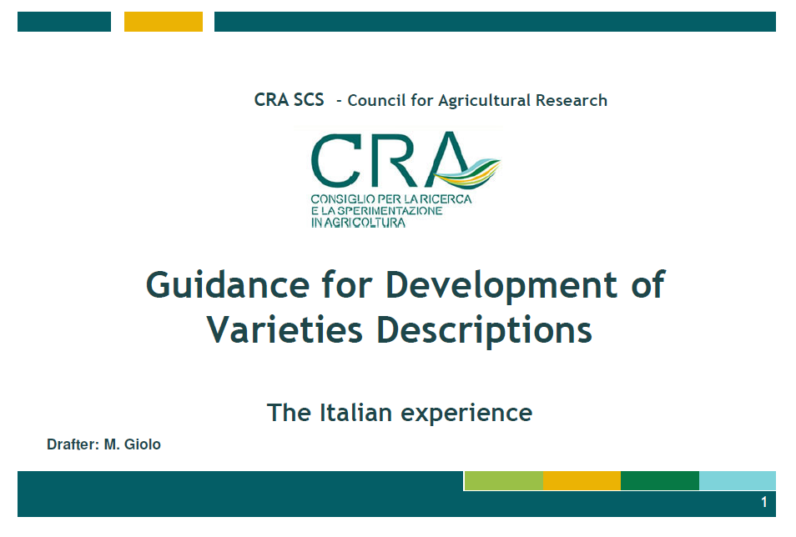
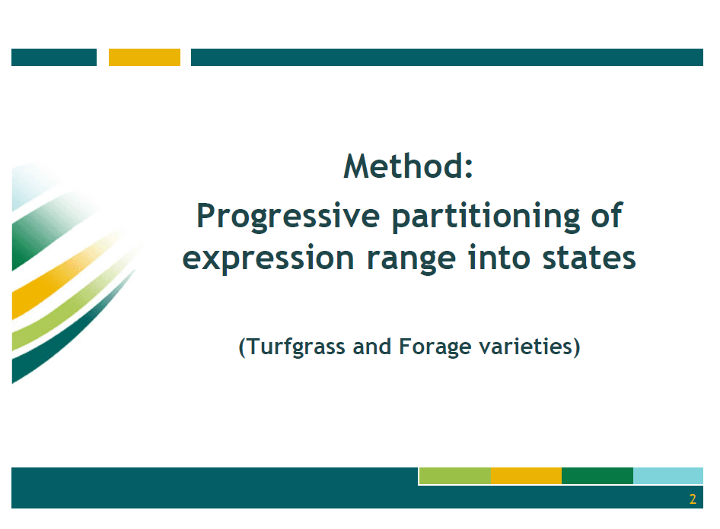

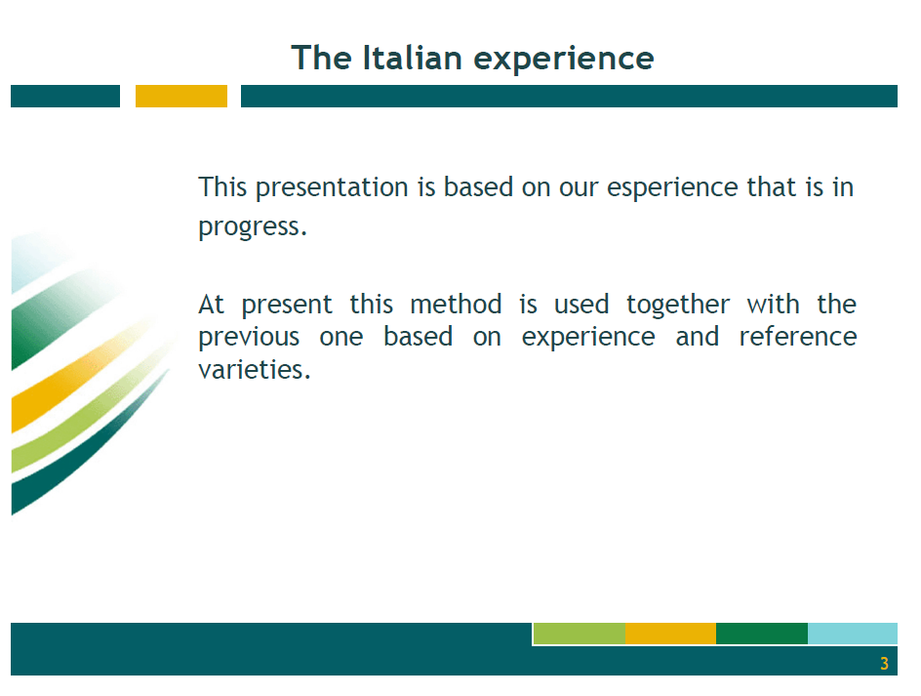
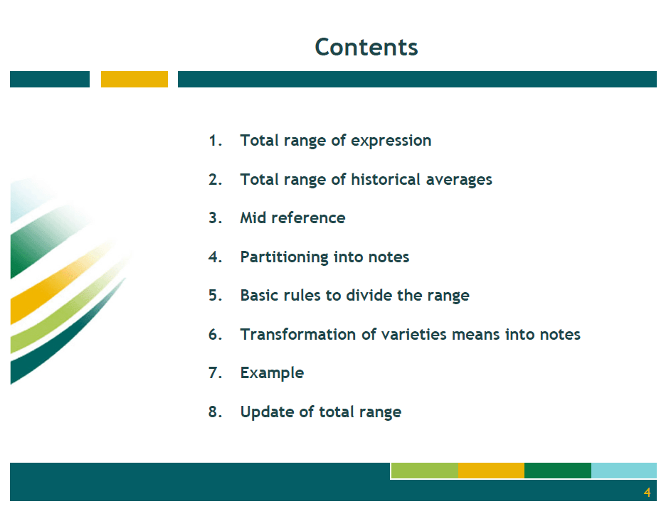

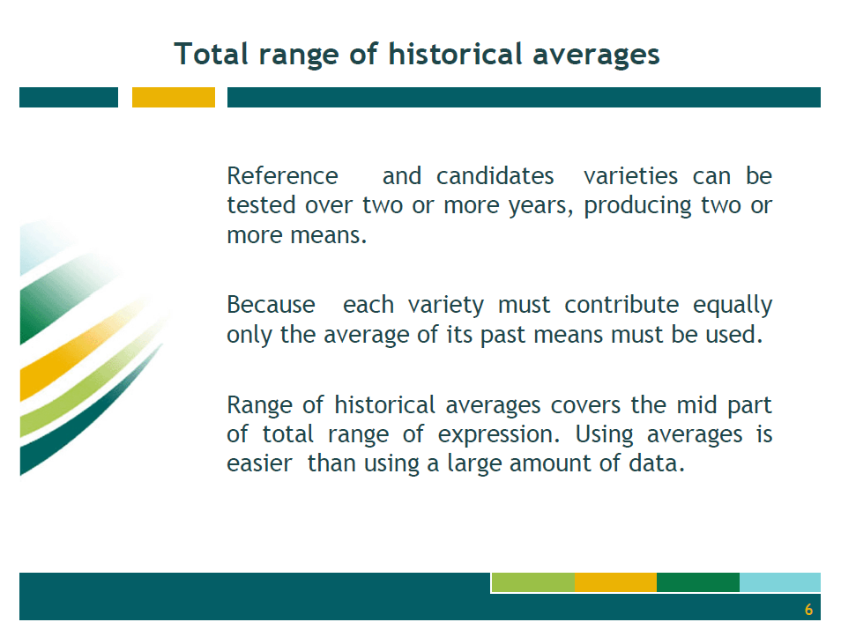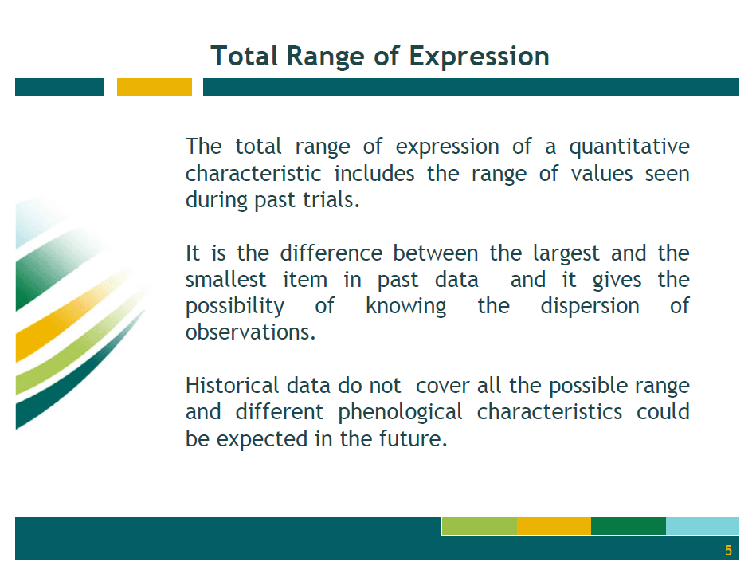

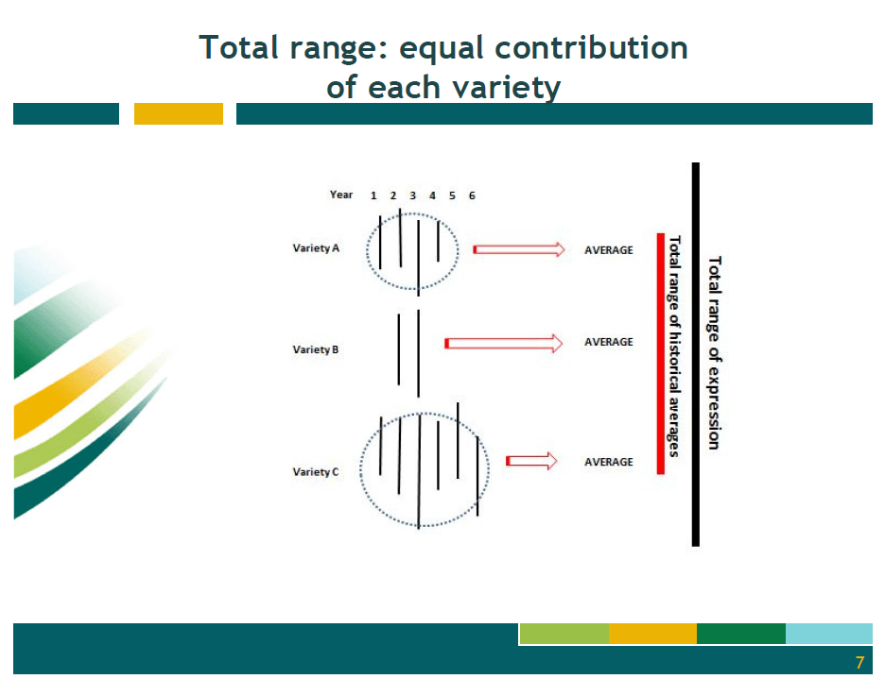

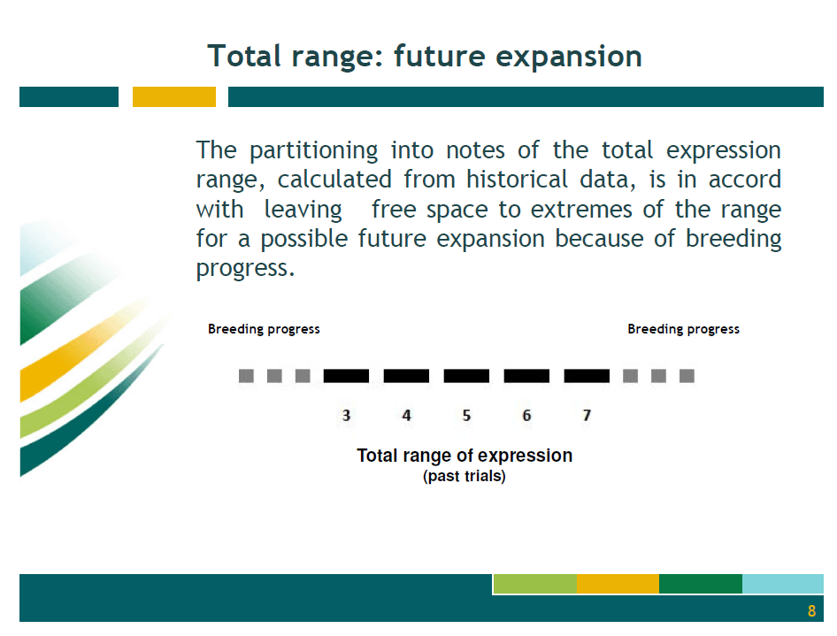

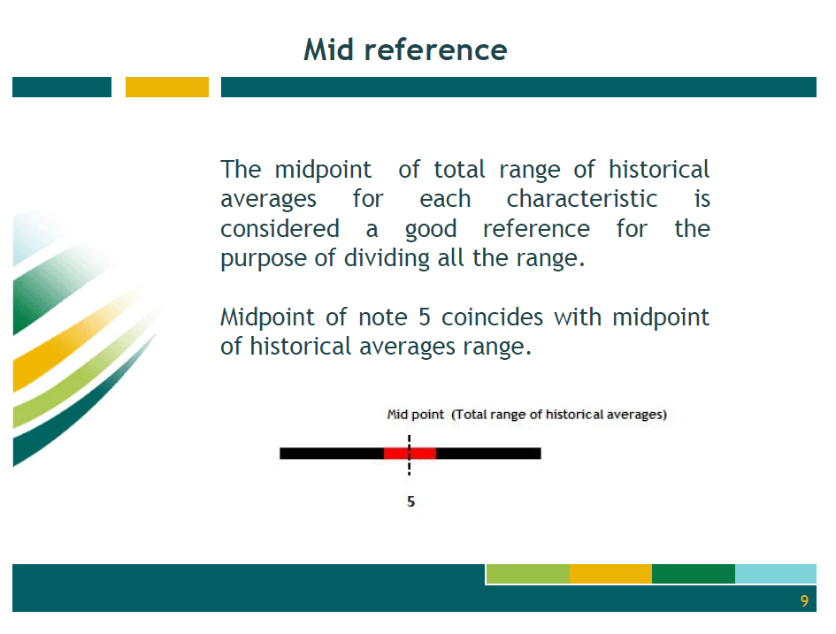

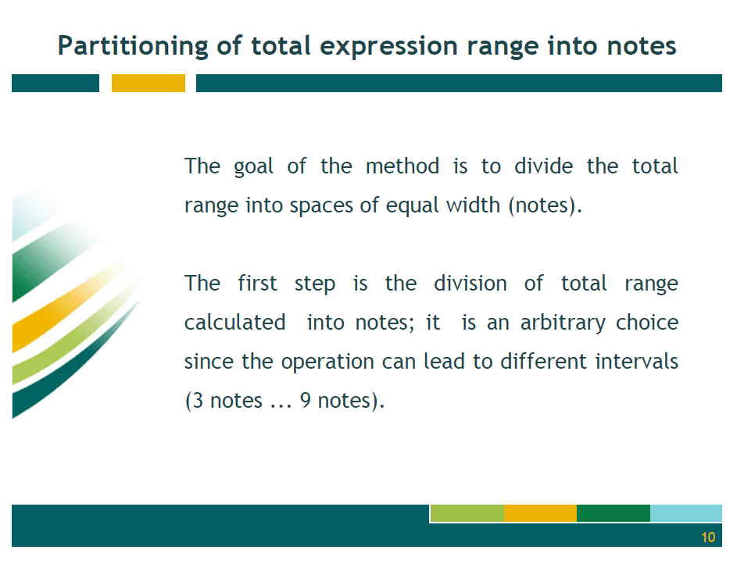

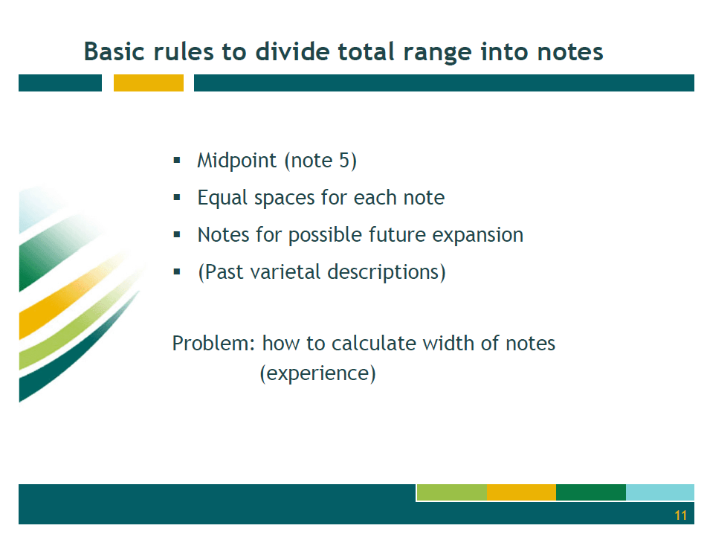

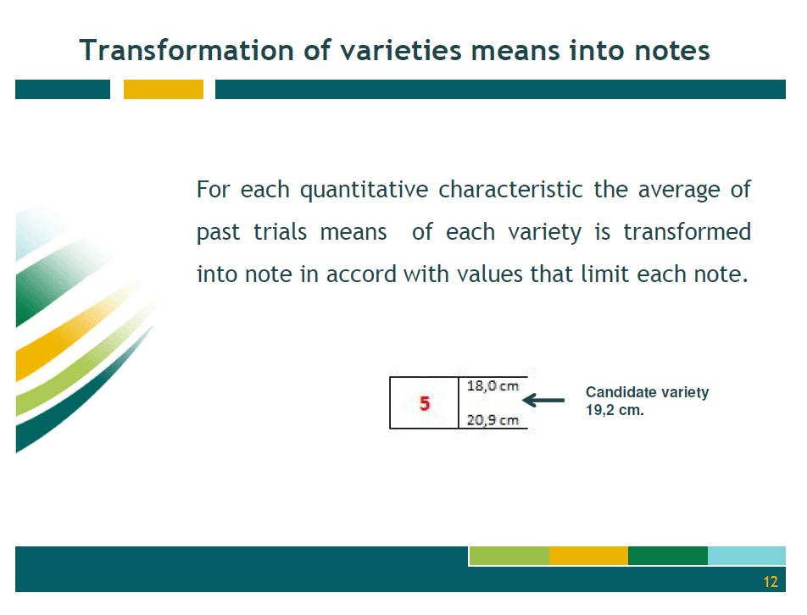

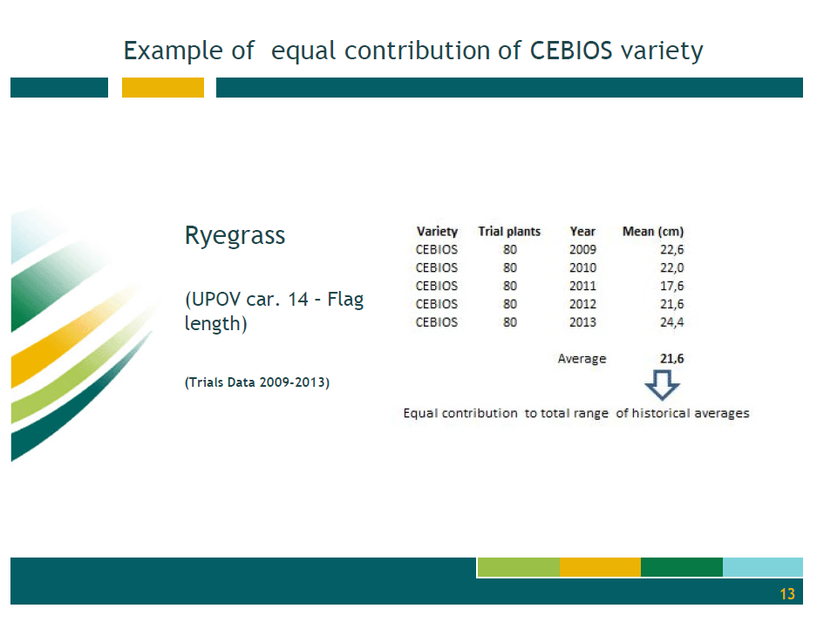

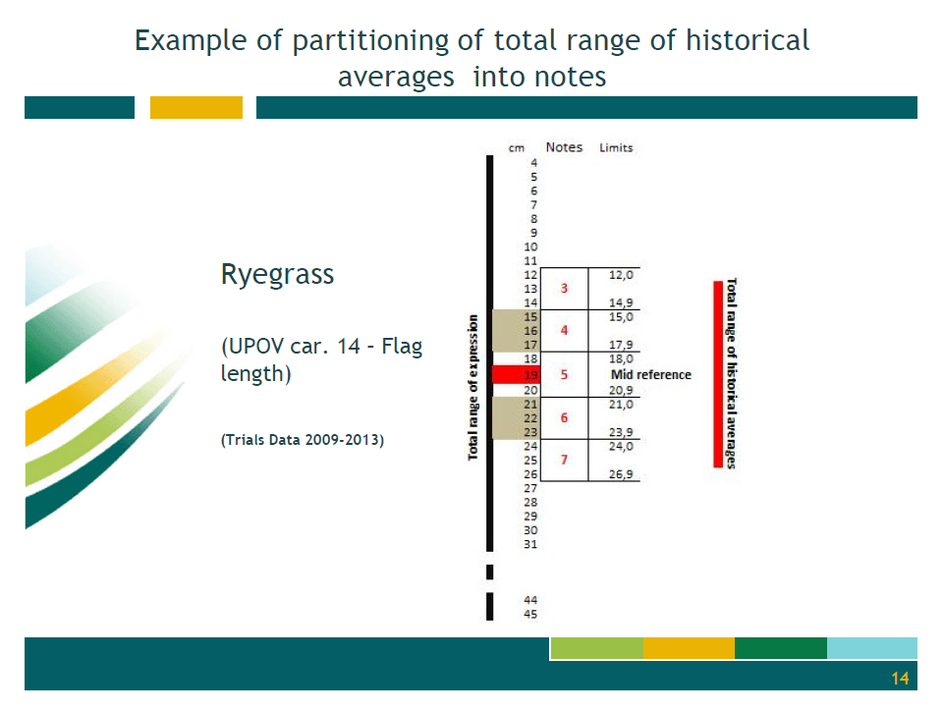

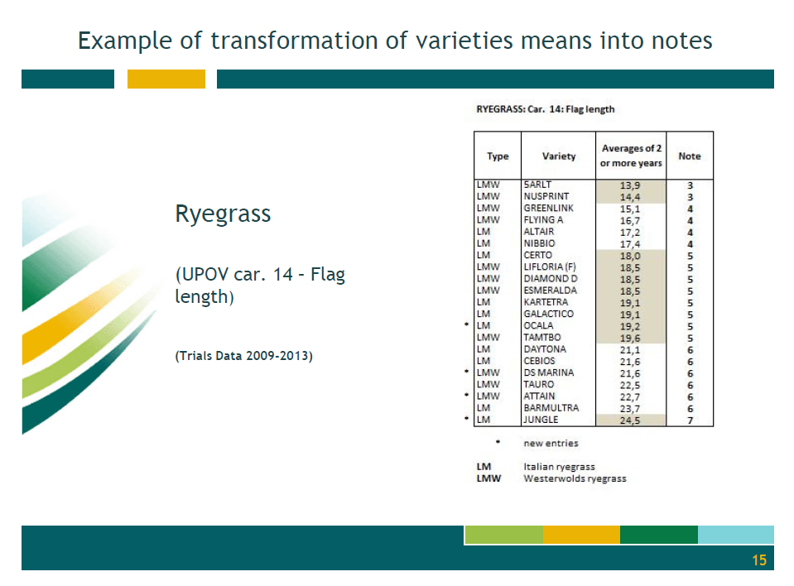

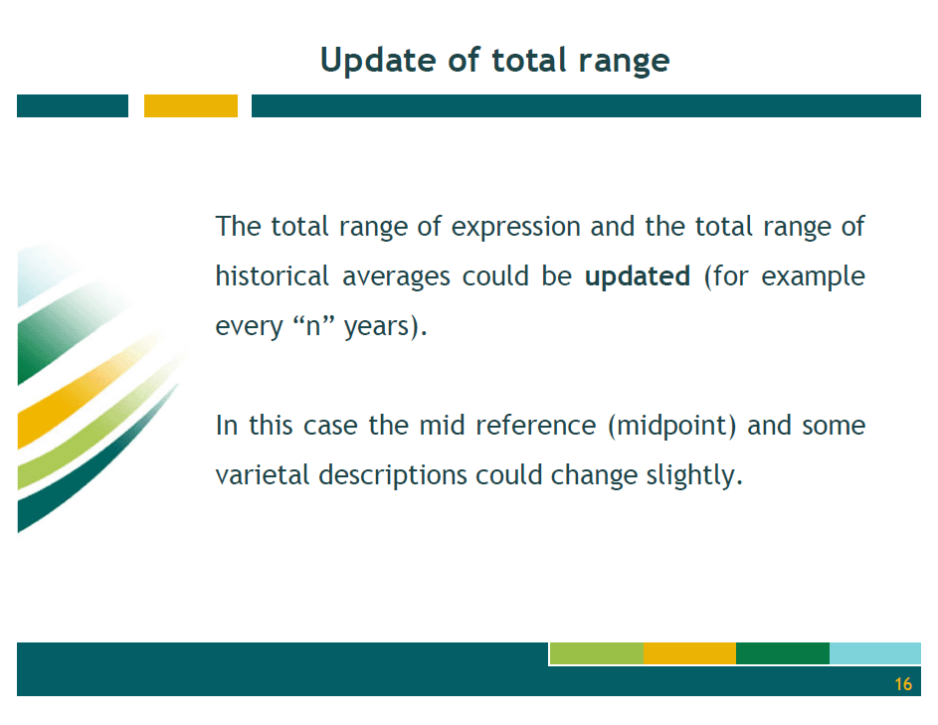

[End of Annex IV and of document]

