E
TWA/43/12 Add.
ORIGINAL: English
DATE: November 4, 2014
INTERNATIONAL UNION FOR THE PROTECTION OF NEW VARIETIES OF PLANTS
Geneva
Technical working party for Agricultural crops
Forty-Third Session
Mar del Plata, Argentina, November 17 to 21, 2014
Addendum to Revision of Document TGP/7:
Plant Material Submitted for Examination
Document prepared by the Office of the Union
The Annex to this document contains a copy of a presentation by an expert from France providing experiences with regard to plant material submitted for examination and how they had addressed the problems that could arise.

[Annex follows]
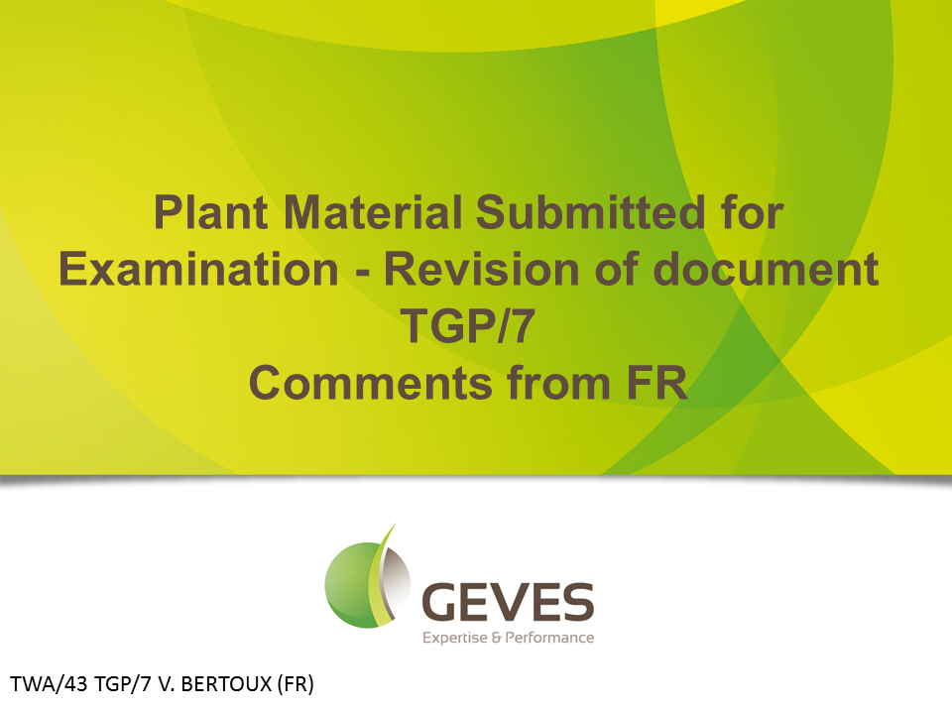
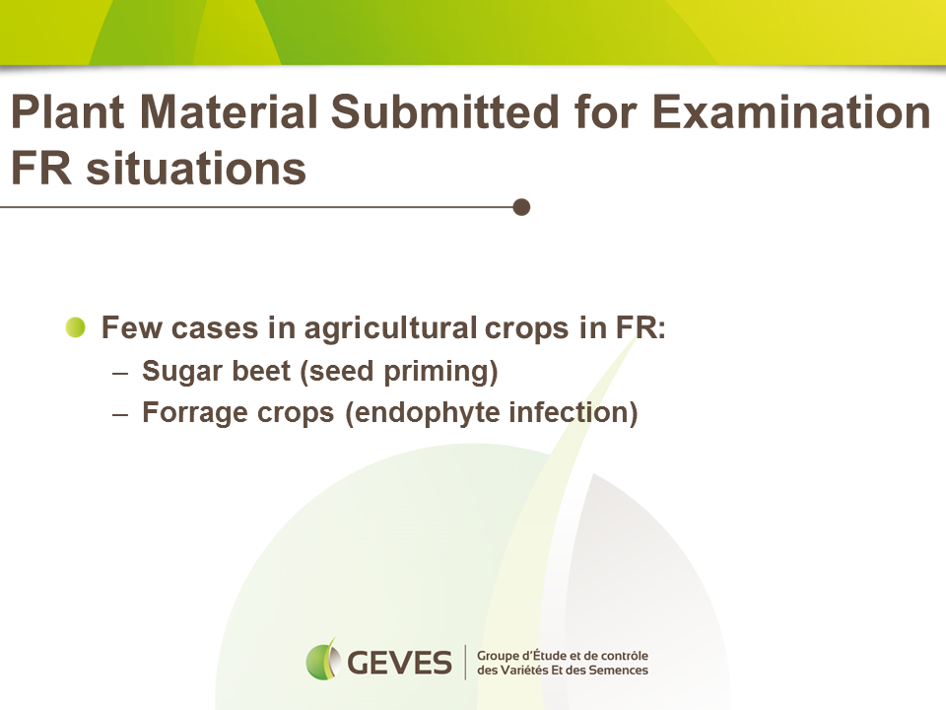
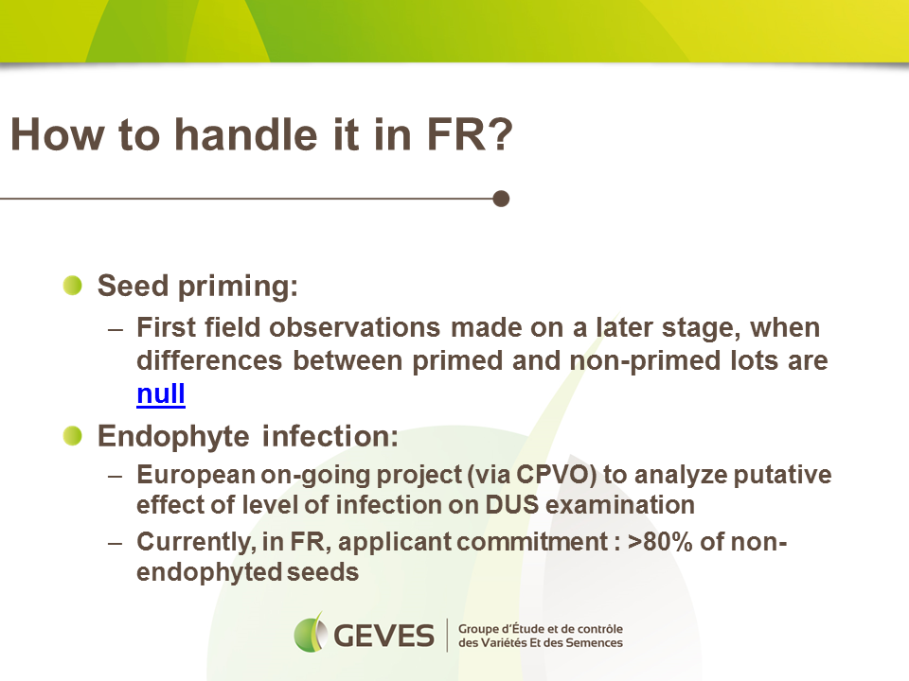

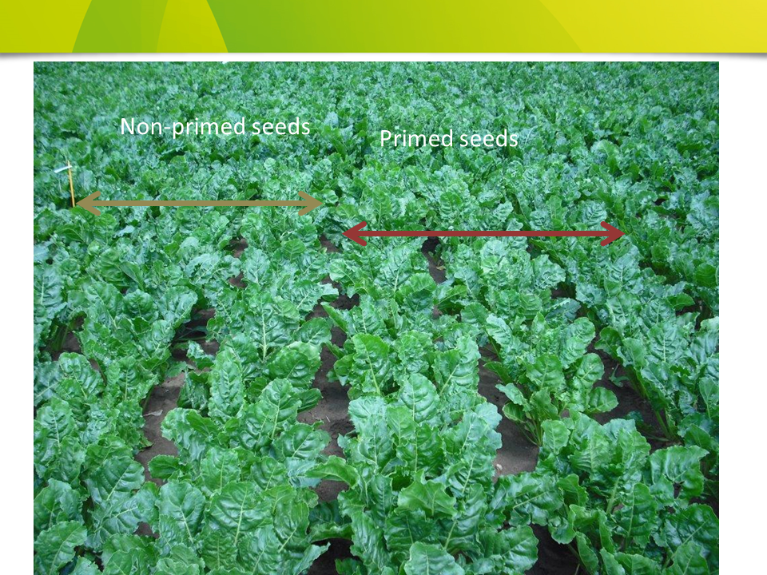

[End of Annex and of document]

