E
TWA/42/21
ORIGINAL: English
DATE: May 10, 2013
INTERNATIONAL UNION FOR THE PROTECTION OF NEW VARIETIES OF PLANTS
Geneva
Technical working party for Agricultural crops
Forty-Second Session
Kyiv, Ukraine, June 17 to 21, 2013
revision of document tgp/14: section 2: botanical terms, subsection 3: color, definition of dot
Document prepared by the Office of the Union
The purpose of this document is to propose a definition for the term “dot” for a future revision of document TGP/14 Section 2: “Botanical Terms, Subsection 3: Color”.

The following abbreviations are used in this document:

TC: Technical Committee
TC-EDC: Enlarged Editorial Committee
TWA: Technical Working Party for Agricultural Crops
TWC: Technical Working Party on Automation and Computer Programs
TWF: Technical Working Party for Fruit Crops
TWO: Technical Working Party for Ornamental Plants and Forest Trees
TWPs: Technical Working Parties
TWV: Technical Working Party for Vegetables

BACKGROUND

The TC, at its forty-ninth session held in Geneva from March 18 to 20, 2013, and the CAJ, at its sixty-seventh session, held in Geneva, on March 21, 2013, agreed to invite the Council to adopt document TGP/14/2 “Glossary of Terms Used in UPOV Documents”, at its forty-seventh session, to be held on October 24, 2013 (see document TC/49/41 “Report on the Conclusions”, paragraphs 29 and 30, and document CAJ/67/14 “Report on the Conclusions”, paragraph 36).

Document TGP/14/2 “Glossary of Terms Used in UPOV Documents” contains a new “Subsection 3: Color”, and provides definitions of botanical terms with an indication of whether those terms are generally used in Test Guidelines, or whether alternative terms might be more appropriate for use in Test Guidelines (see documents TC/49/36, Part I, 1(c), page 4).

Document TGP/14/2 provides a definition of the terms “spot”, “blotch” and “speckle”, but does not mention “dot”. The TC, at its forty-ninth session, agreed that a definition for “dot” be provided in a future revision of document TGP/14 Section 2: “Botanical Terms, Subsection 3: Color” and requested the Office of the Union to prepare a draft for consideration by the TWPs at their sessions in 2013 (see document TC/49/41 “Report on the Conclusions”, paragraph 35).

EXAMPLES of use OF DOT AND SPOT

A search of the UPOV Test Guidelines presents 67 results on the use of the term “dot” in Test Guidelines. The following characteristics are examples on the use of “dot” where the term “spot” is also used:

TG/28/9 Corr.
Zonal Pelargonium, Ivy-leaved Pelargonium/Géranium lierre, Pelargonium zonale/
Zonal-Pelargonie, Efeupelargonie, Efeublättrige Pelargonie/Geranio, 2009-04-01 + 2009-10-27

55.  (+) |  | Lower petal: type of marking | Pétale inférieur : type d’ornementations | Unteres Blütenblatt: Art der Zeichnung | Pétalo inferior: tipo de manchas
PQ | (b) | stripes only | stries seulement | nur gestreift | sólo rayas |  | 1
 | (c) | stripes and dots | stries et points | gestreift und Punkte | rayas y puntos |  | 2
 |  | stripes and spot/spots | stries et tache/taches | gestreift und Fleck/Flecken | rayas y una o más manchas |  | 3
 |  | single spot only | une seule tache | nur einzelner Fleck | sólo una única mancha |  | 4

Ad. 55: Lower petal: type of marking

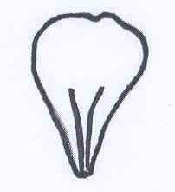 | 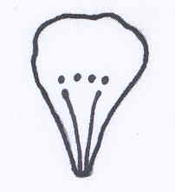 | 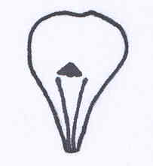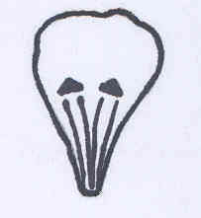 | 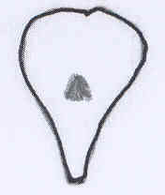
1 | 2 | 3 | 4
stripes only | stripes and dots | stripes and spot/spots | single spot only

TG/70/4 Rev.
Apricot/Abricotier/Aprikose, Marille/Albaricoquero, Chabacano, Damasco, 2007-03-28

48. |  | Fruit: pattern of over color | Fruit: distribution du lavis | Frucht: Verteilung der Deckfarbe | Fruto: distribución del color superpuesto
PQ | (d) | isolated flecks (spots) | panachure isolée (tâches) | isolierte Panaschierung (Flecken) | manchas aisladas (lunares) | Rouge du Roussillon | 1
 |  | solid flush | en plages continues | ganzflächig | tono uniforme | Bergeron | 2
 |  | covered all over with very small dots | totalement recouvert avec de très petits points | überall sehr fein gepunktet | cubierto con puntos muy pequeños | Moniquí | 3

Different translations for the terms “dot” and “spot” were found in all UPOV languages and among the different characteristics.

PROPOSAL FOR DEFINITION of DOT

On the basis of the existing use of the term “dot” in Test Guidelines, it is proposed to add the following definition of “dot”, for inclusion in a future revision of document TGP/14, Section 4.2.1.2.

“4.2.1.2 Spotted/ Blotched / Speckled

Spot: sharp, clear outlined round or nearly round shaped colored area.
Dot: very small sharp, clear outlined round or nearly round shaped colored area (smaller than spot).
Blotch: sharp, clear outlined irregular shaped colored area.
Speckle: diffuse outlined irregular shaped colored area.”

The TWA is invited to consider the definition of dot as presented in paragraph 8, for inclusion in a future revision of document TGP/14, Section 4.2.1.2.

[End of document]

