 |  | E  TWA/41/22  ORIGINAL: English  DATE: April 27, 2012
INTERNATIONAL UNION FOR THE PROTECTION OF NEW VARIETIES OF PLANTS
Geneva
Technical working party for agricultural crops
Forty-First Session
Angers, France, May 21 to 25, 2012
revision of document tgp/8:
PArt II: techniques used in dus examination
New Section 4- 2x1% Method – Minimum Number of Degrees of Freedom for the 2x1% Method
Document prepared by an expert from United Kingdom

background

1 The Technical Committee (TC), at its forty-eighth session, held in Geneva from March 26 to 28, 2012, considered the revision of document TGP/8 “Trial Design and Techniques Used in the Examination of Distinctness, Uniformity and Stability” on the basis of document TC/48/19 Rev. The TC noted that new drafts of relevant sections would need to be prepared by April 26, 2012, in order that the sections could be included in the draft to be considered by the Technical Working Parties (TWPs) at their sessions in 2012 (see document TC/48/22 “Report on Conclusions” paragraph 49).

2 The TC, at its forty-eighth session, noted that at least 10 degrees of freedom were required for the residual mean square used to estimate the standard error in the t-test in each year. It agreed that further clarification was needed with regard to the significance of the wording “preferably at least 20 degrees of freedom” (see document TC/48/22 “Report on Conclusions” paragraph 63).

3 The Annex to this document contains the proposed revised text (highlighted) for Section 4 - 2x1% Method - Minimum Number of Degree of Freedom for the 2x1% Method prepared by Mrs. Sally Watson (United Kingdom).

[Annex follows]

2x1% METHOD – MINIMUM NUMBER OF DEGREES OF FREEDOM FOR THE 2x1% METHOD

4. 2X1% METHOD

4.1 Requirements for application of method

4.1.1 The 2x1% Criterion is an appropriate method for assessing the distinctness of varieties where:

- the characteristic is quantitative;

- there are some differences between plants (or plots) of a variety;

- observations are made on a plant (or plot) basis over two or more years;

- there are at least 10, and preferably at least 20, degrees of freedom for the residual mean square used to estimate the standard error in the t-test in each year;

- To have replicated plots

4.2 The 2x1% Criterion (Method)

4.2.1 For two varieties to be distinct using the 2x1% criterion, the varieties need to be significantly different in the same direction at the 1% level in at least two out of three years in one or more measured characteristics. The tests in each year are based on Student’s two-tailed t--test of the differences between variety means with standard errors estimated using the residual mean square from the analysis of the variety x replicate plot means.

4.2.2 With respect to the 2x1% criterion, compared to COYD, it is important to note that:

- Information is lost because the criterion is based on the accumulated decisions arising from the results of t-tests made in each of the test years. Thus, a difference which is not quite significant at the 1% level contributes no more to the separation of a variety pair than a zero difference or a difference in the opposite direction. For example, three differences in the same direction, one of which is significant at the 1% level and the others at the 5% level would not be regarded as distinct.
- Some characteristics are more consistent over years than others in their expression of differences between varieties. However, beyond requiring differences to be in the same direction in order to count towards distinctness, the 2x1% criterion takes no account of consistency in the size of the differences from year to year.
- It is recommended that there should be at least 10, and preferably at least 20, degrees of freedom for the residual mean square used to estimate the standard error in the t-test in each year. This is to ensure that the residual mean square is based on sufficient data to be a reliable estimate of the varieties-by-replicates variation used in the standard error in the t-test. The fewer the data, the fewer the degrees of freedom for the residual mean square, and the less reliable the estimate of the standard error in the t-test. This is compensated for by use of a larger critical t-value in the t-test. The result is a less powerful test, which means that there is a reduced chance of declaring varieties as being distinct. From the graph below, it can be seen that the power of the test is good with 20 or more degrees of freedom for the residual mean square, that it is still reasonably powerful if the degrees of freedom drop to 10, though more is preferable.
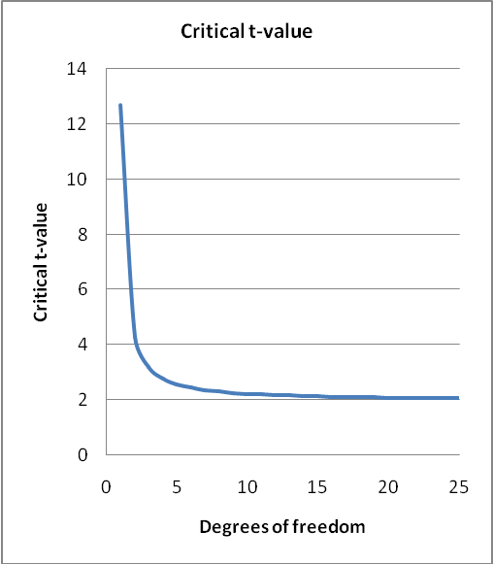

Assuming replicates are arranged in blocks, 20 degrees of freedom corresponds to 11 varieties in three replicates, or 5 varieties in six replicates, whereas, ten degrees of freedom corresponds to 6 varieties in three replicates, or 3 varieties in six replicates.

[End of Annex and of document]

