 |  | E  TWA/41/19  ORIGINAL: English  DATE: April 20, 2012
INTERNATIONAL UNION FOR THE PROTECTION OF NEW VARIETIES OF PLANTS
Geneva
Technical working party for agricultural crops
Forty-First Session
Angers, France, May 21 to 25, 2012
Comments concerning the draft test guidelines for WHEAT
(Document TG/3/12(proj.1))
Document prepared by experts from France
The structure of the document is as follows:

I DRAFT WITH COMMENTS RECEIVED BY THE SUBGROUP
II GENERAL COMMENTS RECEIVED BY THE SUBGROUP

E
TG/3/12(proj.1)
ORIGINAL: English
DATE: 03.04.12
INTERNATIONAL UNION FOR THE PROTECTION OF NEW VARIETIES OF PLANTS
GENEVA
DRAFT
 | WHEAT  UPOV Code: TRITI_AES  Triticum aestivum L. emend. Fiori et Paol. | *

GUIDELINES

FOR THE CONDUCT OF TESTS

FOR DISTINCTNESS, UNIFORMITY AND STABILITY

prepared by experts from France

to be considered by the
Technical Working Party for Agricultural Crops
at its 41st session, to be held in France from May 21 to 25, 2012

Alternative Names:*

Botanical name | English | French | German | Spanish
Triticum aestivum L. emend. Fiori et Paol. | Wheat

The purpose of these guidelines (“Test Guidelines”) is to elaborate the principles contained in the General Introduction (document TG/1/3), and its associated TGP documents, into detailed practical guidance for the harmonized examination of distinctness, uniformity and stability (DUS) and, in particular, to identify appropriate characteristics for the examination of DUS and production of harmonized variety descriptions.

ASSOCIATED DOCUMENTS
These Test Guidelines should be read in conjunction with the General Introduction and its associated TGP documents.
TABLE OF CONTENTS PAGE

1. Subject of these Test Guidelines 4
2. Material Required 4
3. Method of Examination 4
3.1 Number of Growing Cycles 4
3.2 Testing Place 4
3.3 Conditions for Conducting the Examination 4
3.4 Test Design 4
3.5 Additional Tests 5
4. Assessment of Distinctness, Uniformity and Stability 5
4.1 Distinctness 5
4.2 Uniformity 6
4.3 Stability 7
5. Grouping of Varieties and Organization of the Growing Trial 7
6. Introduction to the Table of Characteristics 8
6.1 Categories of Characteristics 8
6.2 States of Expression and Corresponding Notes 8
6.3 Types of Expression 8
6.4 Example Varieties 8
6.5 Legend 9
7. Table of Characteristics/Tableau des caractères/Merkmalstabelle/Tabla de caracteres 10
8. Explanations on the Table of Characteristics 16
8.1 Explanations covering several characteristics 16
8.2 Explanations for individual characteristics 16
The descriptions of the growth stages of the Zadoks decimal code for cereals 25
9. Literature 26
10. Technical Questionnaire 27

Subject of these Test Guidelines
These Test Guidelines apply to all varieties of Triticum aestivum L. emend. Fiori et Paol.

Material Required
2.1 The competent authorities decide on the quantity and quality of the plant material required for testing the variety and when and where it is to be delivered. Applicants submitting material from a State other than that in which the testing takes place must ensure that all customs formalities and phytosanitary requirements are complied with.

2.2 The material is to be supplied in the form of seed.

2.3 The minimum quantity of plant material, to be supplied by the applicant, should be:

Seeds: 5 kg
Ears (if requested): 100

The seed should meet the minimum requirements for germination, species and analytical purity, health and moisture content, specified by the competent authority. In cases where the seed is to be stored, the germination capacity should be as high as possible and should, be stated by the applicant.
If ears are requested, they should contain a sufficient number of viable seeds to establish a satisfactory row of plants for observation.

2.4 The plant material supplied should be visibly healthy, not lacking in vigor, nor affected by any important pest or disease.

2.5 The plant material should not have undergone any treatment which would affect the expression of the characteristics of the variety, unless the competent authorities allow or request such treatment. If it has been treated, full details of the treatment must be given.

Method of Examination

3.1 Number of Growing Cycles
The minimum duration of tests should normally be two independent growing cycles.

3.2 Testing Place
Tests are normally conducted at one place. In the case of tests conducted at more than one place, guidance is provided in TGP/9 “Examining Distinctness”.

3.3 Conditions for Conducting the Examination
3.3.1 The tests should be carried out under conditions ensuring satisfactory growth for the expression of the relevant characteristics of the variety and for the conduct of the examination.

3.3.2 Stage of development for the assessment
The optimum stage of development for the assessment of each characteristic is indicated by a number in the second column of the Table of Characteristics. The stages of development denoted by each number are described in the descriptions of the growth stages of the Zadoks decimal code for cereals at the end of the Chapter 8.

3.4 Test Design
3.4.1 Each test should be designed to result in a total of at least 2000 plants. The assessment for the characteristics “Seasonal type” should be carried out on at least 300 plants.

3.4.2 The design of the tests should be such that plants or parts of plants may be removed for measurement or counting without prejudice to the observations which must be made up to the end of the growing cycle.

3.4.3 Single ear rows: if tests on ear rows are conducted, at least 100 ear rows should be observed.

3.4.4 In case of hybrids, the parent lines have to be included in the test and should be tested and assessed as any other self-pollinating variety. The observations on the hybrid variety itself should be made on at least 200 plants.

3.5 Additional Tests
Additional tests, for examining relevant characteristics, may be established.

Assessment of Distinctness, Uniformity and Stability

4.1 Distinctness
4.1.1 General Recommendations

It is of particular importance for users of these Test Guidelines to consult the General Introduction prior to making decisions regarding distinctness. However, the following points are provided for elaboration or emphasis in these Test Guidelines.

To assess distinctness of hybrids, the parent lines and the formula may be used according to the following recommendations:

- description of parent lines according to the Test Guidelines;

- check of the originality of the parent lines in comparison with the variety collection, based on the characteristics in Chapter 7, in order to identify similar parent lines;

- check of the originality of the hybrid formula in relation to the hybrids in the variety collection, taking into account the most similar lines; and

- assessment of the distinctness at the hybrid level for varieties with a similar formula.

Further guidance is provided in documents TGP/9 “Examining Distinctness” and TGP/8 “Trial Design and Techniques Used in the Examination of Distinctness, Uniformity and Stability”.

4.1.2 Consistent Differences

The differences observed between varieties may be so clear that more than one growing cycle is not necessary. In addition, in some circumstances, the influence of the environment is not such that more than a single growing cycle is required to provide assurance that the differences observed between varieties are sufficiently consistent. One means of ensuring that a difference in a characteristic, observed in a growing trial, is sufficiently consistent is to examine the characteristic in at least two independent growing cycles.

4.1.3 Clear Differences

Determining whether a difference between two varieties is clear depends on many factors, and should consider, in particular, the type of expression of the characteristic being examined, i.e. whether it is expressed in a qualitative, quantitative, or pseudo-qualitative manner. Therefore, it is important that users of these Test Guidelines are familiar with the recommendations contained in the General Introduction prior to making decisions regarding distinctness.

4.1.4 Number of Plants / Parts of Plants to be Examined

Unless otherwise indicated, for the purposes of distinctness, all observations on single plants should be made on 20 plants or parts taken from each of 20 plants and any other observations made on all plants in the test, disregarding any off-type plants.
In the case of observations of parts taken from single plants, the number of parts to be taken from each of the plants should be 1.

4.1.5 Method of Observation

The recommended method of observing the characteristic for the purposes of distinctness is indicated by the following key in the second column of the Table of Characteristics (see document TGP/9 “Examining Distinctness”, Section 4 “Observation of characteristics”):

MG: single measurement of a group of plants or parts of plants
MS: measurement of a number of individual plants or parts of plants
VG: visual assessment by a single observation of a group of plants or parts of plants
VS: visual assessment by observation of individual plants or parts of plants

Type of observation: visual (V) or measurement (M)

“Visual” observation (V) is an observation made on the basis of the expert’s judgment. For the purposes of this document, “visual” observation refers to the sensory observations of the experts and, therefore, also includes smell, taste and touch. Visual observation includes observations where the expert uses reference points (e.g. diagrams, example varieties, side-by-side comparison) or non-linear charts (e.g. color charts). Measurement (M) is an objective observation against a calibrated, linear scale e.g. using a ruler, weighing scales, colorimeter, dates, counts, etc.

Type of record: for a group of plants (G) or for single, individual plants (S)

For the purposes of distinctness, observations may be recorded as a single record for a group of plants or parts of plants (G), or may be recorded as records for a number of single, individual plants or parts of plants (S). In most cases, “G” provides a single record per variety and it is not possible or necessary to apply statistical methods in a plant-by-plant analysis for the assessment of distinctness.”

In cases where more than one method of observing the characteristic is indicated in the Table of Characteristics (e.g. VG/MG), guidance on selecting an appropriate method is provided in document TGP/9, Section 4.2.

4.2 Uniformity
4.2.1 It is of particular importance for users of these Test Guidelines to consult the General Introduction prior to making decisions regarding uniformity. However, the following points are provided for elaboration or emphasis in these Test Guidelines:

4.2.2 Indication of sample size in the Table of Characteristics

The recommended sample size for the assessment of uniformity is indicated by the following key in the table of characteristics:

{A} sample size of 100 plants/parts of plants/ear-rows
{B} sample size of 2000 plants or parts of plants

4.2.3 Uniformity assessment on all plants in the test

For the assessment of uniformity in a sample of 2000 plants, a population standard of 0.3% and an acceptance probability of at least 95% should be applied. In the case of a sample size of 2000 plants, 10 off-types are allowed.

4.2.4 Uniformity assessment on a sub-sample

For the assessment of uniformity in a sample of 100 ear-rows, plants or parts of plants, a population standard of 1% and an acceptance probability of at least 95% should be applied. In the case of a sample size of 100 ear-rows, plants or parts of plants, 3 off-types are allowed.

An ear-row is considered to be an off-type ear-row if there is more than one off-type plant within that ear-row.

For “A” characteristics, with the exception of characteristic 1 and 2, the assessment of uniformity can be done in 2 steps. In a first step, 20 plants are observed. If no off-types are observed, the variety is declared to be uniform. If more than 3 off-types are observed, the variety is declared not to be uniform. If 1 to 3 off-types are observed, an additional sample of 80 plants or parts of plants must be observed.

4.2.6 Uniformity assessment where the parent formula is used

Where the assessment of a hybrid variety involves the parent lines, the uniformity of the hybrid variety should, in addition to an examination of the hybrid variety itself, also be assessed by examination of the uniformity of its parent lines.
For the assessment of uniformity of hybrids, a population standard of 10% and an acceptance probability of at least 95% should be applied. In the case of a sample size of 200 plants, 27 off-types are allowed.

4.3 Stability
4.3.1 In practice, it is not usual to perform tests of stability that produce results as certain as those of the testing of distinctness and uniformity. However, experience has demonstrated that, for many types of variety, when a variety has been shown to be uniform, it can also be considered to be stable.

4.3.2 Where appropriate, or in cases of doubt, stability may be further examined by testing a new seed stock to ensure that it exhibits the same characteristics as those shown by the initial material supplied.

4.3.3 Stability assessment: hybrid varieties

Where appropriate, or in cases of doubt, the stability of a hybrid variety may, in addition to an examination of the hybrid variety itself, also be assessed by examination of the uniformity and stability of its parent lines.

Grouping of Varieties and Organization of the Growing Trial
5.1 The selection of varieties of common knowledge to be grown in the trial with the candidate varieties and the way in which these varieties are divided into groups to facilitate the assessment of distinctness are aided by the use of grouping characteristics.

5.2 Grouping characteristics are those in which the documented states of expression, even where produced at different locations, can be used, either individually or in combination with other such characteristics: (a) to select varieties of common knowledge that can be excluded from the growing trial used for examination of distinctness; and (b) to organize the growing trial so that similar varieties are grouped together.

5.3 The following have been agreed as useful grouping characteristics:

- Straw : pith in cross section (half way between base of ear and stem node below) (characteristic 11)
- Awns or scurs : presence (characteristic 15)
- Ear : color (characteristic 17)
- Seasonal type (characteristic 25)

5.4 An alternative method to grouping characteristics is GAIA method. It has been developed to optimize trials, by avoiding the growing of some of the varieties in the variety collection. The principle is to compute a phenotypic distance between each pair of varieties, this distance being a sum of distances on each individual observed characteristic. The background of the method relies on the possibility given to the crop expert to express his confidence on the differences observed, by giving weights to the difference for each observed characteristic.
GAIA method is mainly used after a first growing cycle to identify those varieties in the variety collection which can be excluded from the subsequent growing cycle(s) because they are “Distinct Plus” (see TGP/8/1 Part II section 1.3.2.1) from all the candidate varieties. GAIA can also identify similar varieties, on which the DUS examiner will need to focus attention in the subsequent growing cycle.

5.5 Guidance for the use of grouping characteristics, in the process of examining distinctness, is provided through the General Introduction and document TGP/9 “Examining Distinctness”.

Introduction to the Table of Characteristics

6.1 Categories of Characteristics
6.1.1 Standard Test Guidelines Characteristics

Standard Test Guidelines characteristics are those which are approved by UPOV for examination of DUS and from which members of the Union can select those suitable for their particular circumstances.

6.1.2 Asterisked Characteristics

Asterisked characteristics (denoted by *) are those included in the Test Guidelines which are important for the international harmonization of variety descriptions and should always be examined for DUS and included in the variety description by all members of the Union, except when the state of expression of a preceding characteristic or regional environmental conditions render this inappropriate.

6.2 States of Expression and Corresponding Notes
6.2.1 States of expression are given for each characteristic to define the characteristic and to harmonize descriptions. Each state of expression is allocated a corresponding numerical note for ease of recording of data and for the production and exchange of the description.

6.2.2 In the case of qualitative and pseudo-qualitative characteristics (see Chapter 6.3), all relevant states of expression are presented in the characteristic. However, in the case of quantitative characteristics with 5 or more states, an abbreviated scale may be used to minimize the size of the Table of Characteristics. For example, in the case of a quantitative characteristic with 9 states, the presentation of states of expression in the Test Guidelines may be abbreviated as follows:

State | Note
small | 3
medium | 5
large | 7

However, it should be noted that all of the following 9 states of expression exist to describe varieties and should be used as appropriate:

State | Note
very small | 1
very small to small | 2
small | 3
small to medium | 4
medium | 5
medium to large | 6
large | 7
large to very large | 8
very large | 9

6.2.3 Further explanation of the presentation of states of expression and notes is provided in document TGP/7 “Development of Test Guidelines”.

6.3 Types of Expression
An explanation of the types of expression of characteristics (qualitative, quantitative and pseudo-qualitative) is provided in the General Introduction.

6.4 Example Varieties
Where appropriate, example varieties are provided to clarify the states of expression of each characteristic.

6.5 Legend
(*) Asterisked characteristic – see Chapter 6.1.2

QL Qualitative characteristic – see Chapter 6.3
QN Quantitative characteristic – see Chapter 6.3
PQ Pseudo-qualitative characteristic – see Chapter 6.3

MG, MS, VG, VS – see Chapter 4.1.5

A, B _ see Chapter 4.2

- See Explanations on the Table of Characteristics in Chapter 8.1

(+) See Explanations on the Table of Characteristics in Chapter 8.2.

Table of Characteristics/Tableau des caractères/Merkmalstabelle/Tabla de caracteres
 |  | English | français | deutsch | español | Example Varieties  Exemples  Beispielssorten  Variedades ejemplo | Note/  Nota
1  (+) | 00  VG | Seed: coloration with phenol | Semence : coloration au phenol | Samen: Phenolfärbung | Semilla: color con phenol
QN | A | None or very light | Nulle ou très faible | Fehlend oder sehr hell |  |  | 1
 |  | light | Faible | Hell | claro | Soissons | 3
 |  | medium | moyenne | mittel | medio | Aerobic | 5
 |  | dark | Forte | Dunkel | Oscuro | Excelcior | 7
 |  | very dark | Très foncée | Sehr dunkel | Muy oscuro | Sideral | 9
2.  (+) | 09-11  VG | Coleoptile: anthocyanin coloration | Coléoptile: pigmentation anthocyanique | Keimscheide: Anthocyanfärbung | Coleóptilo: pigmentación antociánica
QN | A | absent or very weak | absente ou très faible | fehlend oder sehr gering | ausente o muy débil | Altigo | 1
 |  | weak | Faible | Gering | débil | Accor | 3
 |  | medium | Moyenne | Mittel | media | Premio | 5
 |  | strong | Forte | Stark | Fuerte | Arezzo | 7
 |  | very strong | Très forte | Sehr stark | Muy fuerte | Caphorn | 9
3.  (*) | 25-29 VG | Plant: growth habit | Plante: port au tallage | Pflanze: Wuchsform | Planta: porte
(+) | B | erect | dressé | aufrecht | erecto | Bandera | 1
QN |  | semi erect | demi-dressé | halbaufrecht | semierecto | Esperia | 3
 |  | intermediate | demi-dressé à demi-étalé | mittel | medio | Crousty | 5
 |  | semi prostrate | demi-étalé | halbliegend | semipostrado | Euclide | 7
 |  | prostrate | étalé | liegend | postrado | Instinct | 9
4.  (+) | 47-51 VG | Plant: frequency of plants with recurved flag leaves | Plante : fréquence de plantes avec la dernière feuille retombante | Pflanze: Häufigkeit von Pflanzen mit gebogenen obersten Blättern | Planta: frequencia de plantas con ¿
QN | B | absent or very low | nulle ou très faible | fehlend oder sehr gering | ausente o muy débil | Sorrial | 1
 |  | low | faible | gering | débil | Arezzo | 3
 |  | medium | moyenne | mittel | media | Courtot | 5
 |  | high | forte | stark | fuerte | Saturnus | 7
 |  | very high | très forte | sehr stark | muy fuerte | MV kolo | 9
5.  (*)  (+) | 50-52 MG | Time of ear emergence | Époque d’épiaison | Zeitpunkt des Ährenschiebens | Época de ¿
QN | B | very early | très précoce | sehr früh | muy temprana | Accor | 1
 |  | early | précoce | früh | temprana | Caphorn | 3
 |  | medium | moyenne | mittel | media | Richepain | 5
 |  | late | tardive | spät | tardía | Boncap | 7
 |  | very late | très tardive | sehr spät | muy tardía |  | 9
6.  (*) | 60-65 VG | Flag leaf: glaucosity of sheath | Dernière feuille : glaucescence de la gaine | Oberstes Blatt: Bereifung der Blattscheide | Ultima hoja: ¿ de la vaina
QN | B | absent or very weak | absente ou très faible | fehlend oder sehr gering | ausente o muy débil | Benedict | 1
 |  | weak | faible | gering | débil | Aerobic | 3
 |  | medium | moyenne | mittel | medio | Pakito | 5
 |  | strong | forte | stark | fuerte | Solehio | 7
 |  | very strong | très forte | sehr stark | muy fuerte | Illico | 9
7. | 60-65 VG | Flag leaf: glaucosity of blade (lower side) | Dernière feuille : glaucescence du limbe (face inférieure) | Oberste Blatt: Bereifung der Blattspreite | Ultima hoja: ¿ del limbo
QN | B | absent or very weak | absente ou très faible | fehlend oder sehr gering | ausente o muy débil | Courtot | 1
 |  | weak | faible | gering | débil | Bologna | 3
 |  | medium | moyenne | mittel | medio | Amador | 5
 |  | strong | forte | stark | fuerte | Cezanne | 7
 |  | very strong | très forte | sehr stark | muy fuerte | Goncourt | 9
8.  (*) | 60-69 VG | Ear: glaucosity | Epi : glaucescence | Aehre: Bereifung | ¿: ¿
QN | B | absent or very weak | absente ou très faible | fehlend oder sehr gering | ausente o muy débil | Soissons | 1
 |  | weak | faible | gering | débil | Bologna | 3
 |  | medium | moyenne | mittel | medio | Solehio | 5
 |  | strong | forte | stark | fuerte | Premio | 7
 |  | very strong | très forte | sehr stark | muy fuerte | Exelcior | 9
9. | 60-69 VG | Culm: glaucosity of neck | Tige : glaucescence du col de l’épi | Halme: Bereifung des obersten Internodiums | ¿: ¿
QN | B | absent or very weak | absente ou très faible | fehlend oder sehr gering | ausente o muy débil | Benedict | 1
 |  | weak | faible | gering | débil | Saturnus | 3
 |  | medium | moyenne | mittel | medio | Aubusson | 5
 |  | strong | forte | stark | fuerte | Arezzo | 7
 |  | very strong | très forte | sehr stark | muy fuerte | Exelcior | 9
10. | 75-92 | Plant: length | Plante: longueur | Pflanze: Lange | Planta: altura (?)
(*) | MG | very short | très courte | sehr niedrig | muy corta | Cordiale | 1
(+) | B | short | courte | niedrig | corta | Renan | 3
QN |  | medium | moyenne | mittel | media | Intérêt | 5
 |  | long / tall | longue / haute | lang / hoch | larga | Bagatelle 007 | 7
 |  | very long / very tall | très longue / très haute | sehr lang / sehr hoch | muy larga |  | 9
11.  (+) | 80-92  VG | Straw: pith in cross section | Paille : moëlle en section transversale | Halm: Füllung im Querschnitt | Tallo: grosor
PQ | A | absent or very thin | Absente ou très mince | fehlend oder sehr dünn | Ausente o muy delgado | Pakito | 1
 |  | medium | moyenne | mittel | medio | Saturnus | 2
 |  | very thick or filled | Très épaisse ou pleine | Sehr dick oder ? | Muy grueso o ¿ | Aerobic | 3
12  (+) | 92  VG | Ear: shape in profile | Epi: forme en vue de profil | Aehre : form in Seiten-ansicht
PQ | B | tapering | Pyramidal | Pyramiden-förmig |  | Sankara | 1
 |  | fusiform | Fusiforme | Spindle-förmig |  | Arezzo | 2
 |  | parallel sided | À bords parallèles | Parallel |  | Viscount | 3
 |  | semi-clavate | En demi-massue | Halb keulenförmig |  | Aura | 4
 |  | clavate | En massue | keulenförmig |  | Apache | 5
13  (*)  (+) | 80-92 | Ear: density | Epi: compacité | Aehr: Dichte
QN | VG,B or | very lax | Très lâche | Sehr locker |  | Magno | 1
 | MS, A | lax | Lâche | Locker |  | Sponsor | 3
 |  | medium | Demi-lâche à demi-compact | Mittel |  | Aubusson | 5
 |  | dense | Compact | Dicht |  | Premio | 7
 |  | very dense | Très compact | Sehr dicht |  | Rehti | 9
14  (+) | 80-92 | Ear: length | Epi: longueur | Aehre : länge
QN | VG
very short | Très court | Sehr kurz |  |  | 1
 | B | short | Court | Kurz |  | Ambello | 3
 |  | medium | Moyen | Mittel |  | Soissons | 5
 |  | long | Long | Lang |  | Aubusson | 7
 |  | very long | Très long | Sehr lang |  | Folklor | 9
15.  (*)  (+) | 80-92 | Awns or scurs: presence | Barbes ou arêtes: présence | Grannen oder Spelzen-spitzen: Vorhandensein
QL | VG | both absent | Toutes les deux absentes | Beide fehlend |  | Genoveva | 1
 | B | scurs present | Arêtes présentes | Spelzenspitzen vorhanden |  | Aubusson | 2
 |  | awns present | Barbes présentes | Grannen vorhanden |  | Arezzo | 3
16.  (*)  (+) | 80-92 | Awns or scurs at tip of ear: length | Barbes ou arêtes à l’extrémité de l’épi: longueur | Grannen oder Spelzen-spitzen an der Aehrenspitze : länge
QN | VG | very short | Très courtes | Sehr kurz |  | Ephoros | 1
 | B | short | Courtes | Kurz |  | Graindor | 3
 |  | medium | Moyennes | Mittel |  | Pakito | 5
 |  | long | Longues | Lang |  | As de cœur | 7
 |  | very long | Très longues | Sehr lang |  | Arezzo | 9
17.  (*)  (+) | 80-92 | Ear: color | Epi: couleur | Aehre: Farbe
QL | VG | white | Blanc | Weiss |  | Arezzo | 1
 | B | colored | Coloré | gefärbt |  | Segor | 2
18.  (+) | 80-92 | Apical rachis segment: extend of hairiness of convex surface | Article terminal du rachis: étendue de la pilosité de la face externe | Oberstes Spindelglied : äussere Behaarung
QN | VG | absent or very weak | Nulle ou très faible | Fehlend oder sehr gering |  | Graindor | 1
 | A | weak | Faible | Gering |  | Crousty | 3
 |  | medium | Moyenne | Mittel |  | Sirtaki | 5
 |  | strong | Forte | Stark |  | Cadenza | 7
 |  | very strong | Très forte | Sehr stark |  | KWS Scirocco | 9
19.  (+) | 80-92 | Lower glume: shoulder width | Glume inférieure: largeur de la troncature | Hüllspelze : Schulter-breite
QN | VG | absent or very narrow | Nulle ou très étroite | Fehlend oder sehr schmal |  | Courtot | 1
 | A | narrow | Étroite | Schmal |  | Altigo | 3
 | (a) | medium | Moyenne | Mittel |  | Apache | 5
 |  | broad | Large | Breit |  | Orvantis | 7
 |  | very broad | Très large | Sehr breit |  | Aglika | 9
20.  (+) | 80-92 | Lower glume: shoulder shape | Glume inférieure: forme de la troncature | Hüllspelze : chulterform
QN | VG | sloping | Inclinée | Abfallend |  | Ambello | 1
 | A | slightly sloping | Légèrement inclinée | Leicht abfallend |  | Soissons | 3
 | (a) | straight | Droite | Gerade |  | Apache | 5
 |  | elevated | Echancrée | Gehoben |  | Aubusson | 7
 |  | strongly elevated with 2nd point present | Fortement échancrée avec présence d’un 2ème bec | Stark gehoben mit vorhandener zweiter spitze |  | Fiorenzo | 9
21.  (+) | 80-92 | Lower glume: beak length | Glume inférieure: longueur du bec | Hüllspelze : Zahnlänge
QN | VG | very short | Très court | Sehr kurz |  | Graindor | 1
 | A | short | Court | Kurz |  | Sollario | 3
 | (a) | medium | Moyen | Mittel |  | Quality | 5
 |  | long | Long | Lang |  | Soissons | 7
 |  | very long | Très long | Sehr lang |  | Bandera | 9
22.  (*)  (+) | 80-92 | Lower glume: beak shape | Glume inférieure: forme du bec | Hüllspelze : zahnform
QN | VG | straight | Droit | Gerade |  | Premio | 1
 | A | slightly curved | Légèrement coudé | Leicht gebogen |  | Altigo | 3
 | (a) | moderately curved | Demi-coudé | Mittel gebogen |  | Sponsor | 5
 |  | strongly curved | Fortement coudé | Stark gebogen |  | Quebon | 7
 |  | geniculate | Genouillé | geknickt |  | Velocity | 9
23  (*)  (+) | 80-92 | Lower glume: extent of hairiness of internal surface | Glume inférieure: étendue de la pilosité de la face interne | Hüllspelze : verbreitung der inneren behaarung
QN | VG | weak | Faible | Gering |  | Altigo | 1
 | A | medium | Moyenne | Mittel |  | Alixan | 3
 | (a) | strong | Forte | stark |  | Quality | 5
24  (+) | 92 | Grain: color | Graine: couleur | Korn: farbe
QL | VG | white | Blanc | Weiss |  | Recital | 1
 | A | red | Roux | rot |  | Apache | 2
25  (+)  (*) | - | Seasonal type | Type de développement | Wechselverhalten
PQ | VG | winter type | Type hiver | Winterform |  | Aubusson | 1
 |  | alternative type | Type alternatif | Wechselform |  | Cezanne | 2

spring typeType printempssommerformJosselin3Explanations on the Table of Characteristics

8.1 Explanations covering several characteristics
Characteristics containing the following key in the second column of the Table of Characteristics should be examined as indicated below:

(a) Characteristics on lower glume must be observed at midthird of ear spikelet

8.2 Explanations for individual characteristics

Ad 1 : Grain : coloration with phenol
Method for Determination of Phenol Reaction

Number of grains per test 100 grains. The grains should not have been treated chemically
Concentration of solution 1 per cent Phenol-solution (freshly made up)
Preparation of grains Soak grains in phenol solution during 4 hours with a constant move. Rinse out 4 or 5 times with clean water. Drain in half-light during at least 10 hours (reaction occurs in contact with air).
Amount of solution Whole grain surface must be in contact with phenol solution.
Place Laboratory
Light Half-light, out of direct sunshine
Temperature 15 to 25°C
Time of recording At least10 hours after rinsing
Note At least two of the example varieties should be included as a control

 | 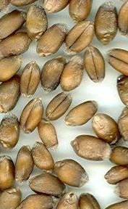 | 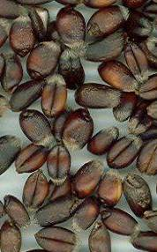 | 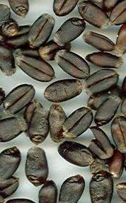 | 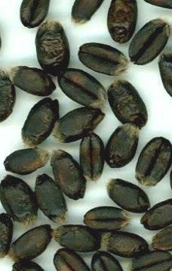
1 | 3 | 5 | 7 | 9
None or very light | Light | Medium | Dark | Very dark

Ad 2 : Coleoptile : anthocyanin coloration
Method for the Determination of Anthocyanin Coloration

Number of grains per test: 100 grains
Preparation of grains: Set up non-dormant grains on moistened filter paper covered with a Petri dish lid during germination
Place: Climate room with controlled temperature
Light: Since the beginning of the test, 12h day / 12h night. Light intensity: 12000-15000 lux.
Temperature: 19°C
Time of recording: Coleoptiles fully developed (about 10 days) at stage 09-11
Note: At least two of the example varieties should be included as a control when testing for distinctness

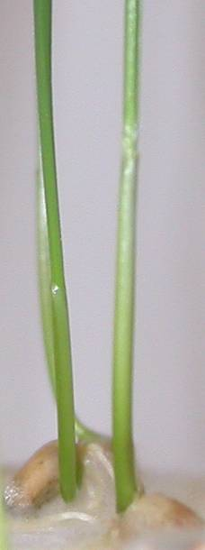 | 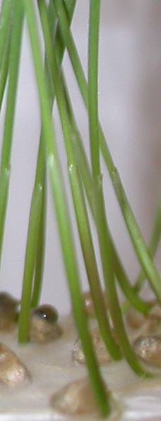 | 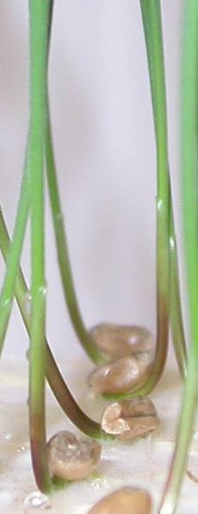 | 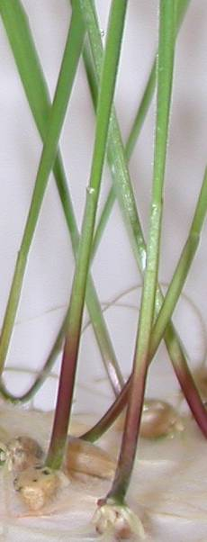 | 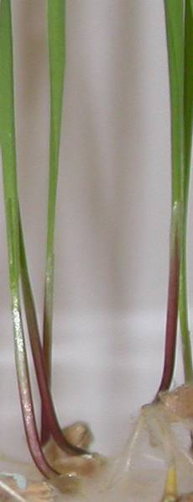
1 | 3 | 5 | 7 | 9
Absent or very weak | Weak | Medium | Strong | Very strong

Ad 3 : Plant : growth habit

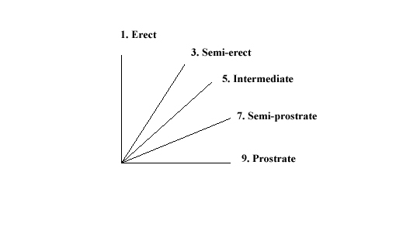
The growth habit should be assessed visually from the attitude of the leaves and tillers. The angle formed by the outer leaves and the tillers with an imaginary vertical axis should be used.

Le port doit être déterminé visuellement d'après le port des feuilles et des talles. On utilisera l'angle formé par les feuilles externes et les talles avec un axe vertical imaginaire.

Die Wuchsform sollte auf Grund der Haltung der Blätter und Triebe visuell erfasst werden. Der vonden äusseren Blättern und Trieben mit einer vertikalen Achse gebildete Winkel sollte verwendet warden.

 | 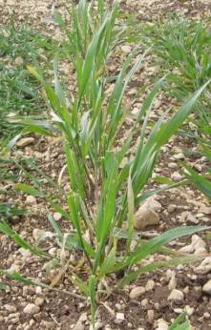 | 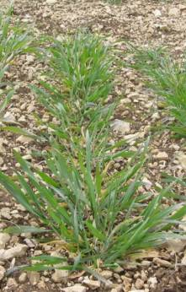 | 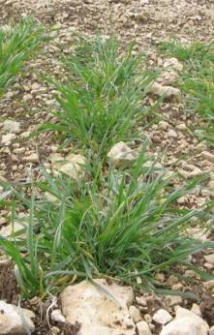 | 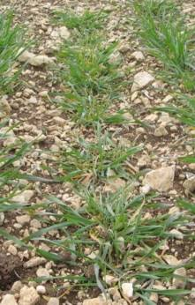
1 | 3 | 5 | 7 | 9
Erect | Semi-erect | Intermediate | Semi-prostrate | Prostrate

Ad 4 : Plant : frequency of plants with recurved flag leaves

1. all flag leaves are rectilinear

3 about 1/4 of the plants with recurved flag leaves

5 about 1/2 of the plants with recurved flag leaves

7 about 3/4 of the plants with recurved flag leaves

9 all flag leaves are recurved

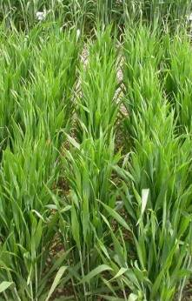 | 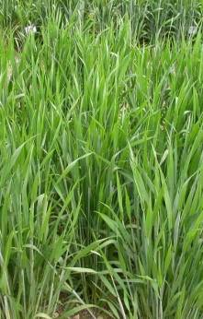 | 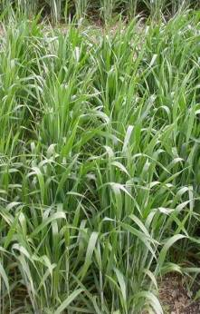 | 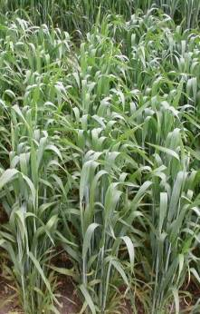 | 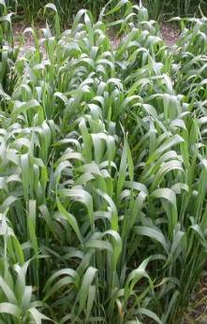
1 | 3 | 5 | 7 | 9
Absent or very low | Low | Medium | High | Very high

Ad 5 : Time of ear emergence
Time of ear emergence should be scored when the first spikelet is visible on 50% of ears.

Ad 10 : Plant : length
The length of plant includes stem, ear, awns and scurs.

Ad 11 : Straw : pith in cross section

Pith in cross section should be observed halfway between base of ear and stem node below.

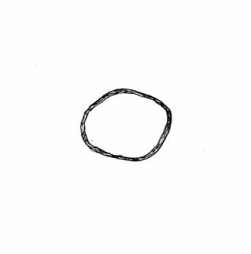 | 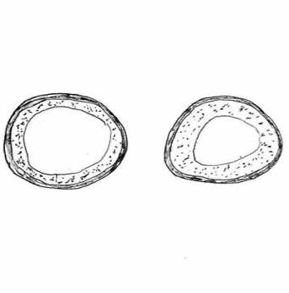 | 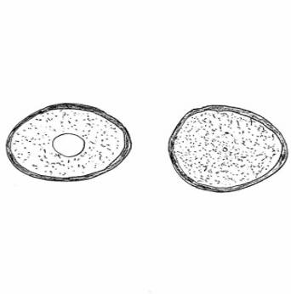
1 | 2 | 3
Absent or very thin | Medium | Very thick or filled

Ad 12 : Ear : shape in profile

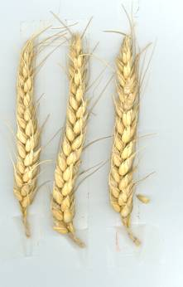 | 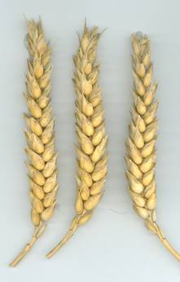 | 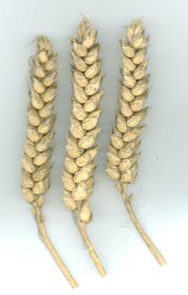 | 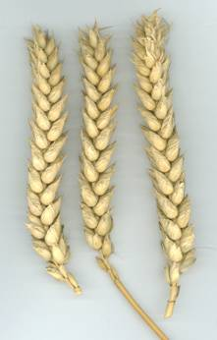 | 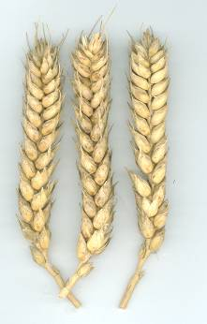
1 | 2 | 3 | 4 | 5
Tapering | Fusiform | Parallel sided | Semi-clavate | Clavate

Ad 13 : Ear : density

The density can be assessed either visually or as measurement of the ratio of the number of spikelets/ear length.

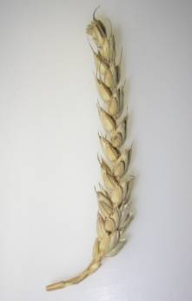 | 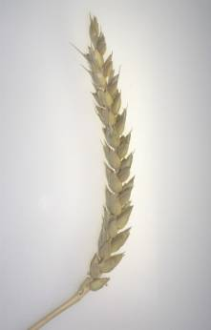 | 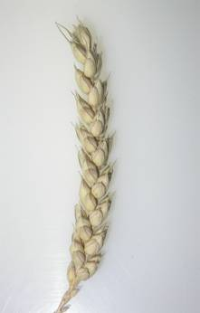 | 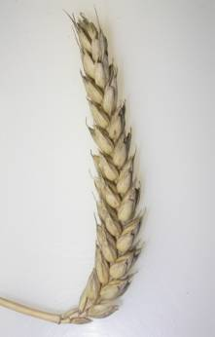 | 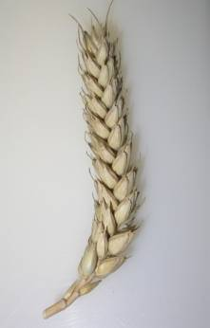
1 | 3 | 5 | 7 | 9
Very lax | Lax | Medium | Dense | Very dense

Ad 14 : Ear : length

Length of ear should be observed excluding awns and scurs.

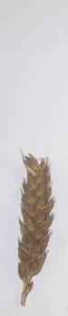 | 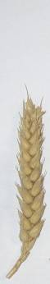 | 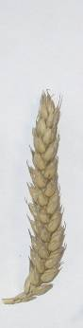 | 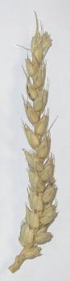 | 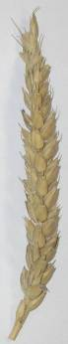
1 | 3 | 5 | 7 | 9
Very short | Short | Medium | Long | Very long

Ad 15 : Awns or scurs : presence

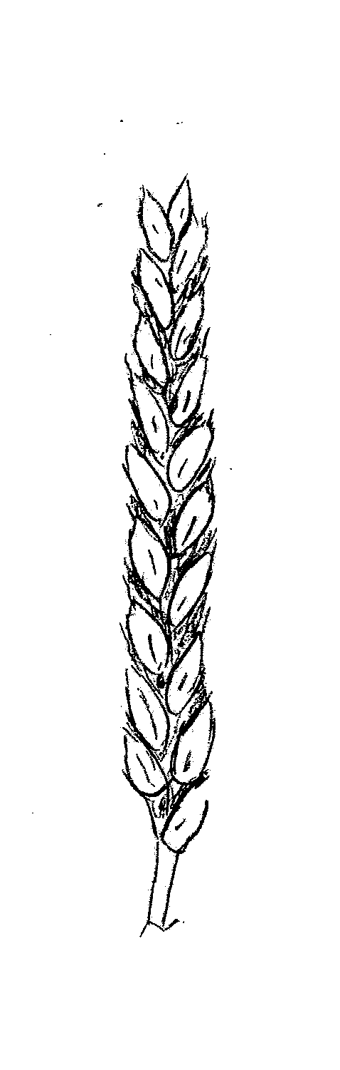 | 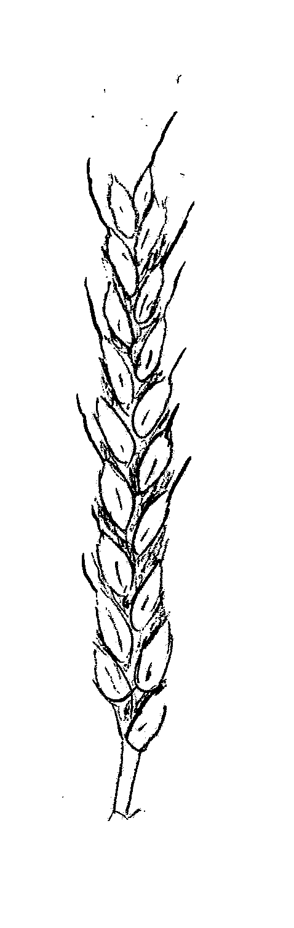 | 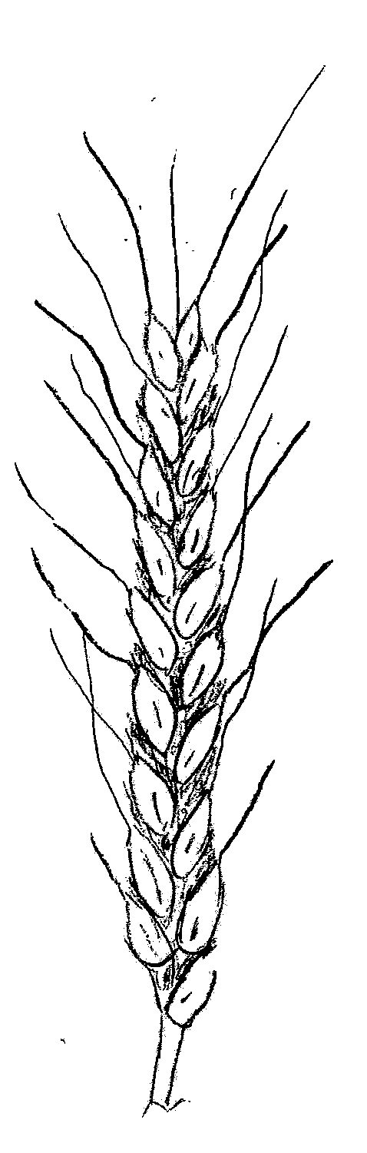
1 | 2 | 3
Both absent | Scurs present | Awns present

Ad 16 : Awns or scurs at tip of ear : length

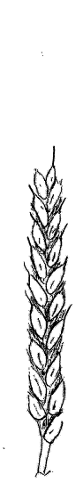 | 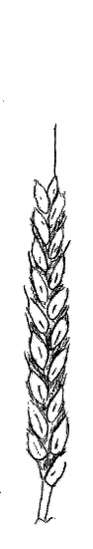 | 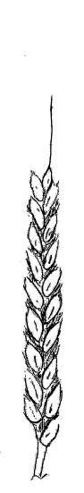 | 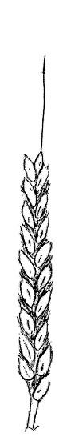 | 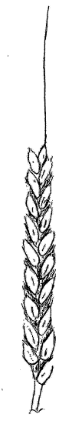
1 | 3 | 5 | 7 | 9
Very short | Short | Medium | Long | Very long

Ad 17 : Ear : colour

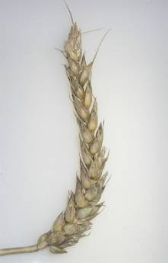 | 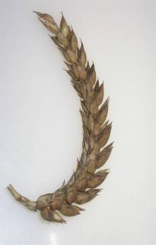
1 | 2
White | Coloured

Ad 18 : Apical rachis segment : hairiness of convex surface

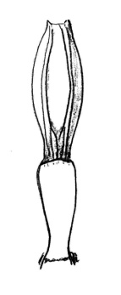 | 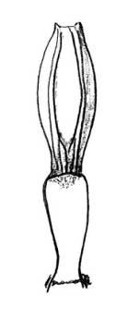 | 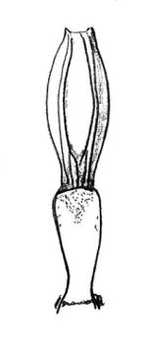 | 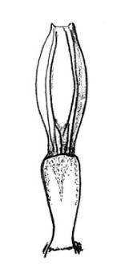 | 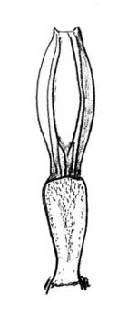
1 | 3 | 5 | 7 | 9
Absent or very weak | Weak | Medium | Strong | Very strong

Ad 19 : Lower glume : shoulder width

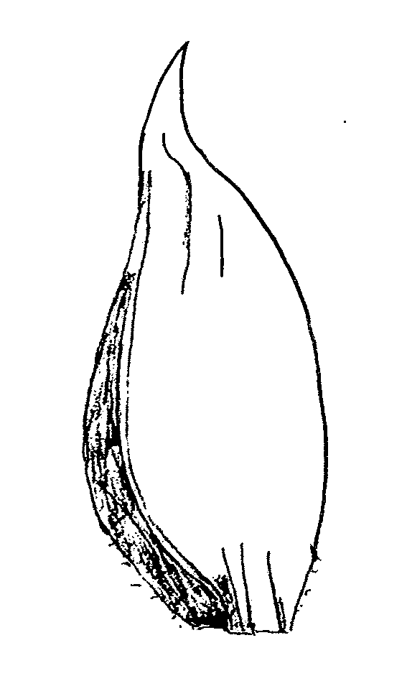 | 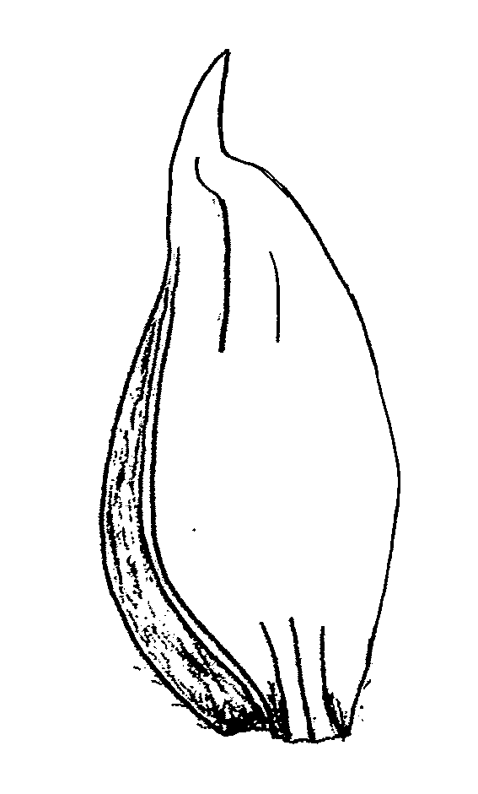 | 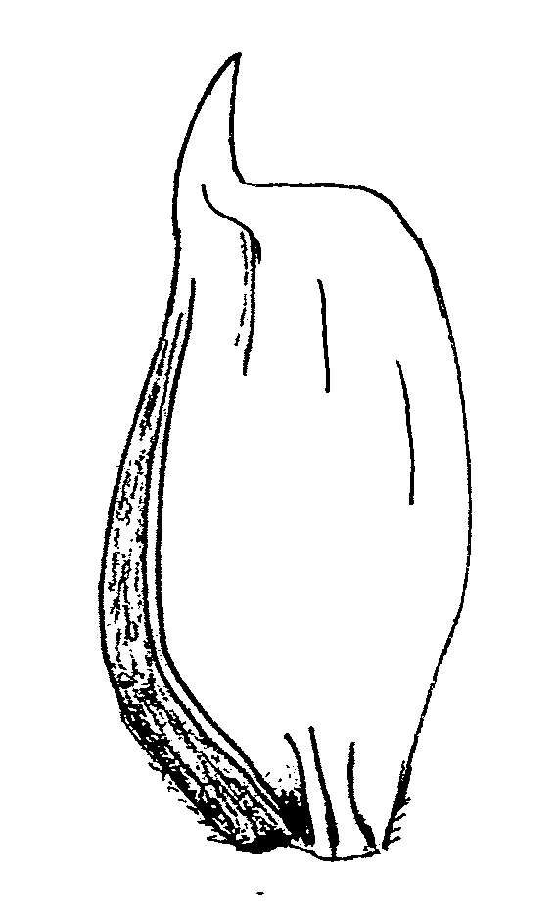 | 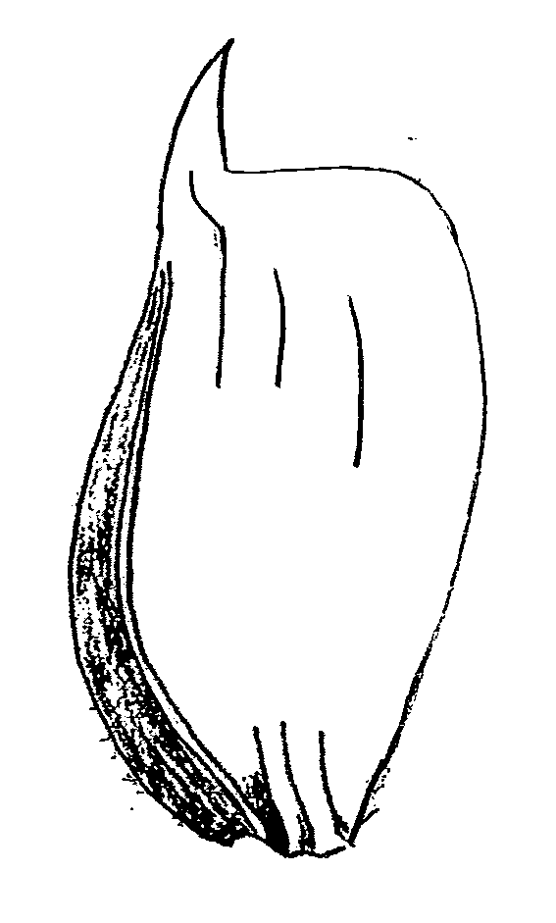 | 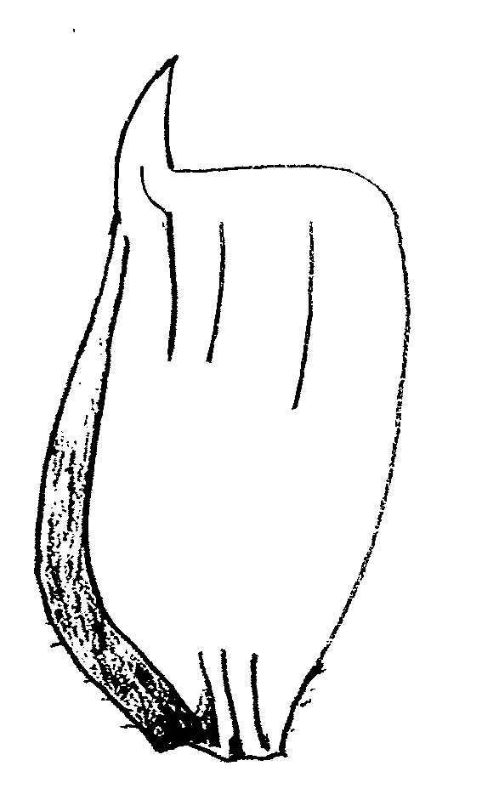
1 | 3 | 5 | 7 | 9
Absent or very narrow | Narrow | Medium | Broad | Very broad

Ad 20 : Lower glume : shoulder shape

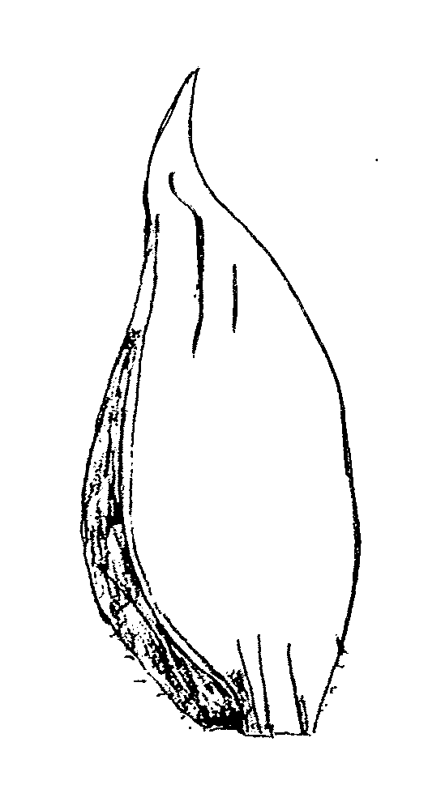 | 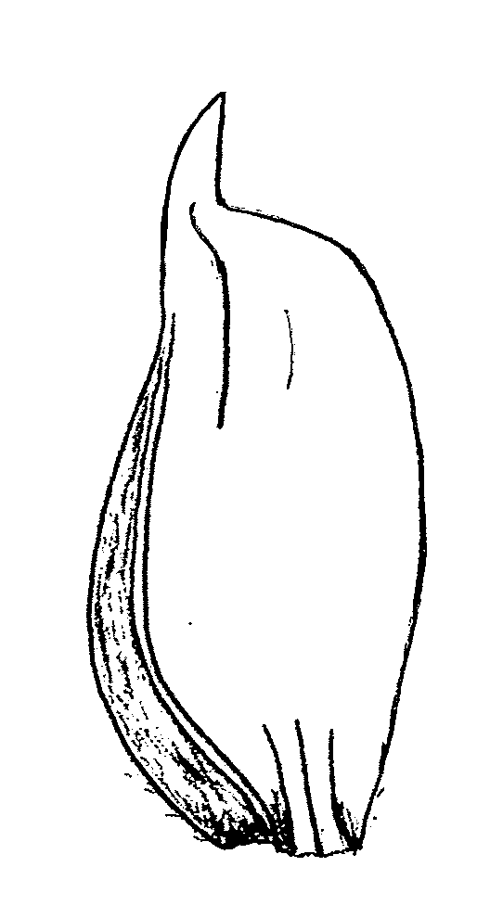 | 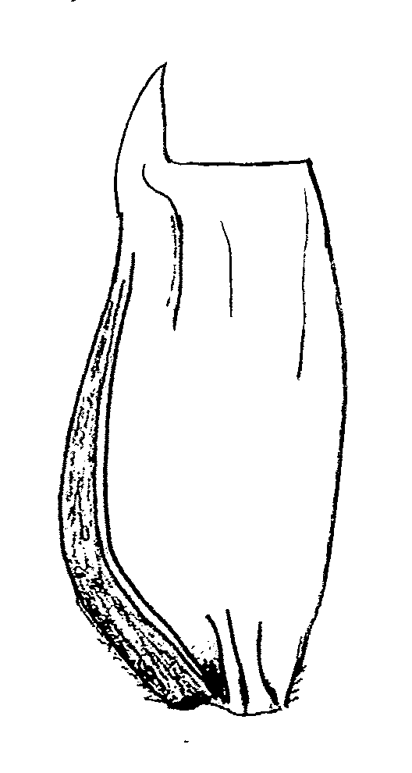 | 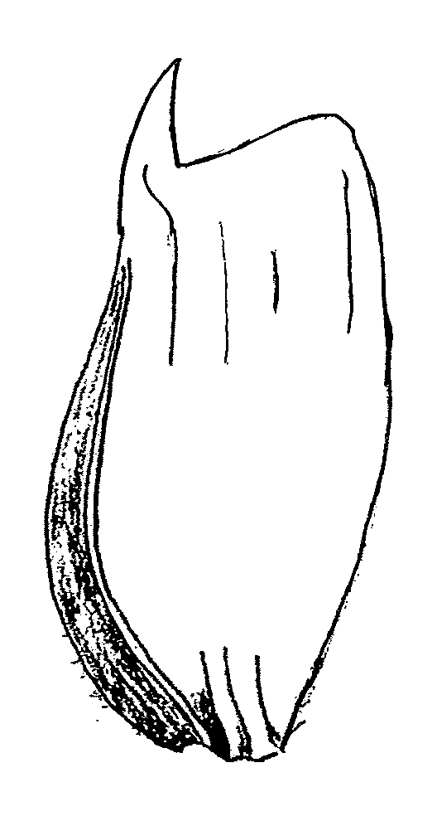 | 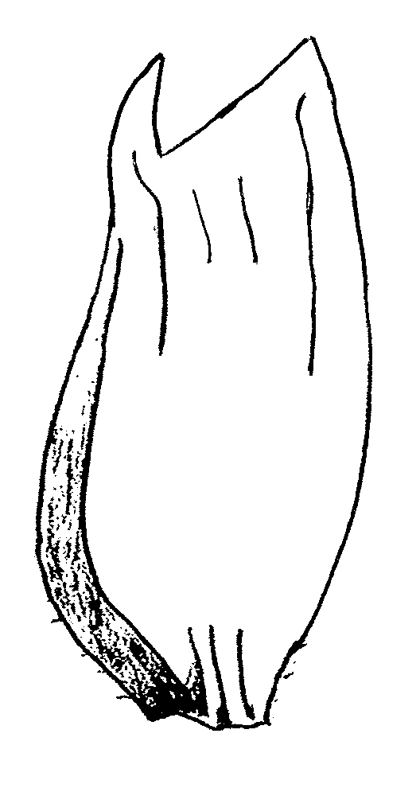
1 | 3 | 5 | 7 | 9
Sloping | Slightly sloping | Straight | Elevated | Strongly elevated with 2nd point present

Ad 21 : Lower glume : beak length

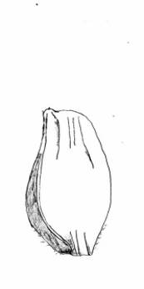 | 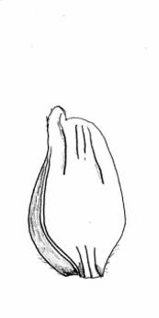 | 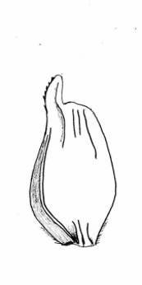 | 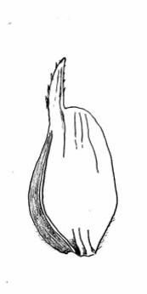 | 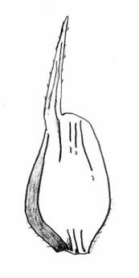
1 | 3 | 5 | 7 | 9
Very short | Short | Medium | Long | Very long

Ad 22 : Lower glume : beak shape

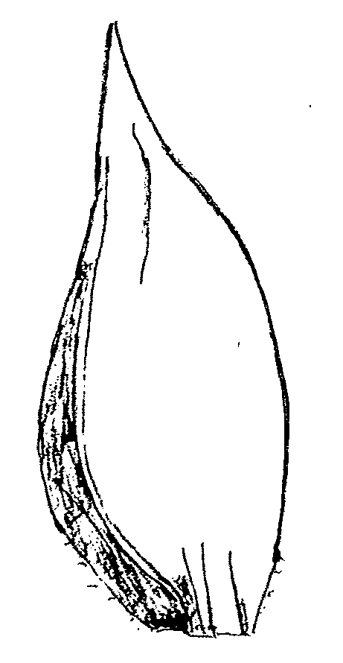 | 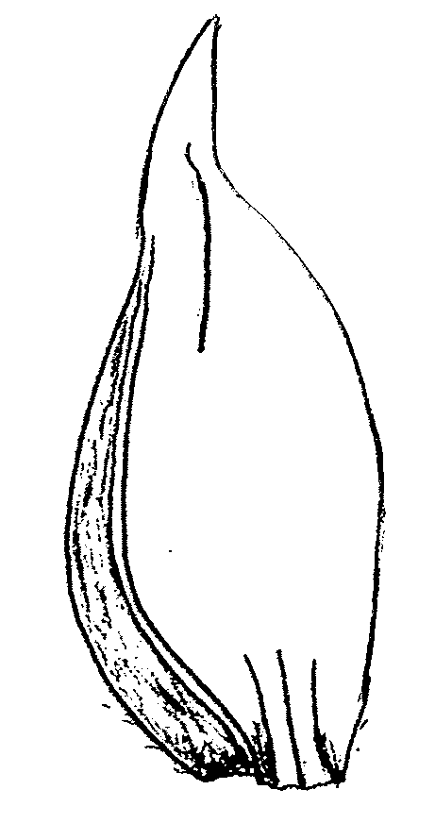 | 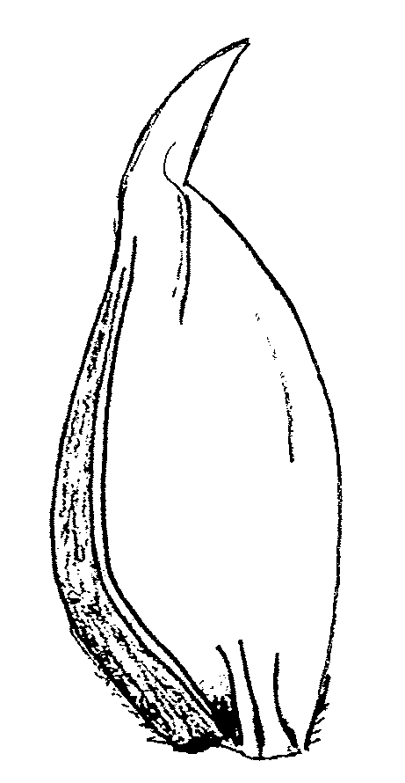 | 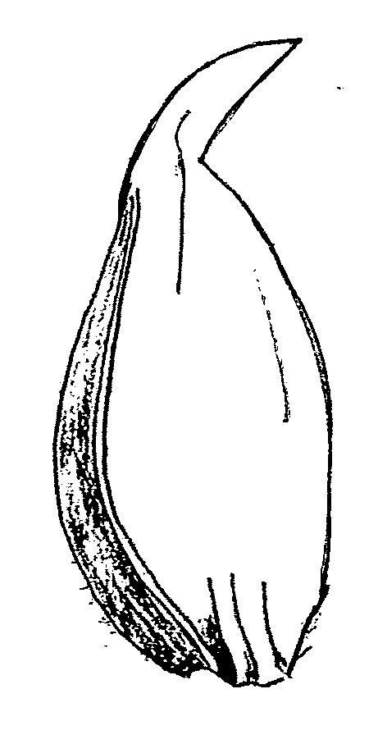 | 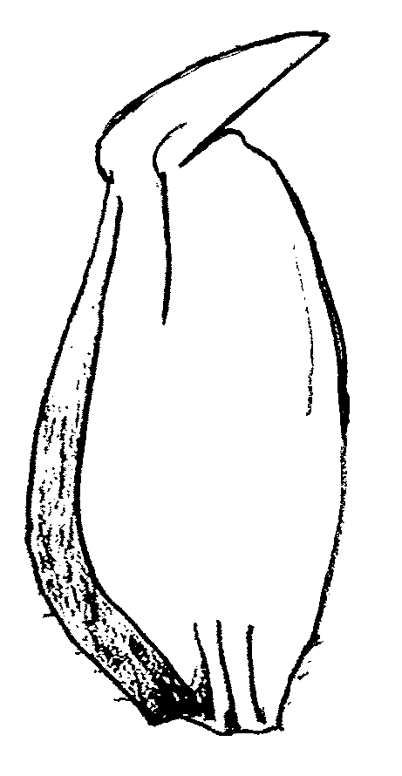
1 | 3 | 5 | 7 | 9
Straight | Slightly curved | Moderately curved | Strongly curved | Geniculate

Ad 23 : Lower glume : extent of internal hair

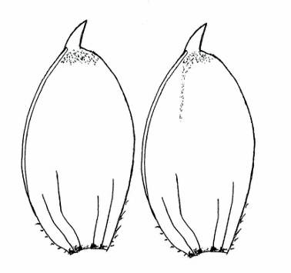 | 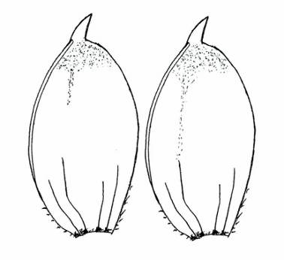 | 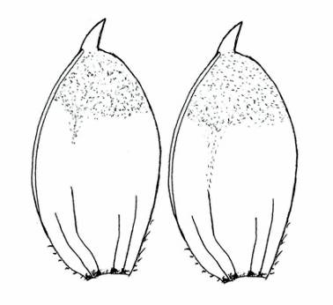
1 | 3 | 5
Weak | Medium | Strong

Ad 24 : Grain colour

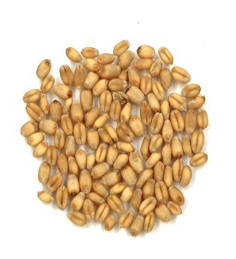 | 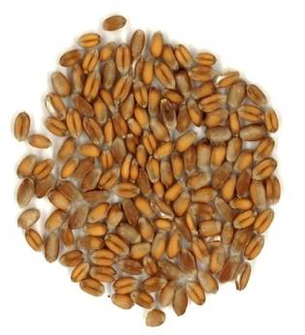
1 | 2
White | Red

Ad 25 : Seasonal type

The seasonal type should be assessed on one or several plots sown in springtime. Example varieties should always be included in the plots. When the example varieties behave according to its description, the varieties under study can be described. At the time when the latest springtype variety is fully mature (stage 91/92 of the Zadoks decimal code), the growth stage reached by the respective variety should be assessed. The states of expression are defined as follows:

Winter type: Winter type: the plants have reached stage 45 of the Zadoks decimal code (boots swollen) at maximum

Alternative type: Alternative type: the plants have exceeded stage 45 of the Zadoks decimal code---as a rule they have exceeded stage 75---and have reached stage 90 at maximum

Spring type: Spring type: the plants have exceeded stage 90 of the Zadoks decimal code.

The descriptions of the growth stages of the Zadoks decimal code for cereals

Zadoks  Decimal code | Description
00 | Dry seed
01 | Start of imbibition
03 | Imbibition complete
05 | Radicle emerged from seed
07 | Coleoptile emerged from seed
09 | Leaf just at coleoptile tip
10 | First leaf through coleoptile
11 | First leaf unfolded
12 | 2 leaves unfolded
13 | 3 leaves unfolded
14 | 4 leaves unfolded
15 | 5 leaves unfolded
16 | 6 leaves unfolded
17 | 7 leaves unfolded
18 | 8 leaves unfolded
19 | 9 or more leaves unfolded
20 | Main shoot only
21 | Main shoot and 1 tiller
22 | Main shoot and 2 tillers
23 | Main shoot and 3 tillers
24 | Main shoot and 4 tillers
25 | Main shoot and 5 tillers
26 | Main shoot and 6 tillers
27 | Main shoot and 7 tillers
28 | Main shoot and 8 tillers
29 | Main shoot and 9 or more tillers
30 | Pseudo stem erection
31 | 1st node detectable
32 | 2nd node detectable
33 | 3rd node detectable
34 | 4th node detectable
35 | 5th node detectable
36 | 6th node detectable
37 | Flag leaf just visible
39 | Flag leaf ligule/collar just visible
40 | -
41 | Flag leaf sheath extending
45 | Boots just swollen
47 | Flag leaf sheath opening
49 | First awns visible
50 | First spikelet of inflorescence visible
53 | 1/4 of inflorescence emerged
55 | 1/2 of inflorescence emerged
57 | 3/4 of inflorescence emerged
59 | Emergence of inflorescence completed
60 | Beginning on anthesis
65 | Anthesis half-way
69 | Anthesis completed
70 | -
71 | Kernel watery ripe
73 | Early milk
75 | Medium milk
77 | Late milk
80 | -
83 | Early dough
85 | Soft dough
87 | Hard dough
90 | -
91 | Kernel hard (difficult to divide with thumbnail)
92 | Kernel hard (no longer dented with thumbnail)
93 | Kernel loosening in daytime
94 | Overripe, straw dead and collapsing
95 | Seed dormant
96 | Viable seed giving 50% germination
97 | Seed not dormant
98 | Secondary dormancy induced
99 | Secondary dormancy lost

Literature
BEZAR, H.J., HADFIELD, P.D., 1982: "Identification of New Zealand Wheat Cultivars" Crop Research Division, D.S.I.R., Christchurch, NZ.

BRIGGLE, L.W., REITZ, L.P., 1963: "Classification of Triticum Species and of Wheat Varieties Grown in the United States" United States Department of Agriculture, Technical Bulletin No. 1278, US.

BUSTARRET, J.,1944: "Variétés et variations" Annales agronomiques, 14ème année, 336, 365, FR.

DE BACKER, A., 1983: "L'homogénéité des variétés de Blé" Mémoire de fin d'études, 122e promotion Beauvais, FR.

DHORNE, D., 1985: "Les cultivars de blé (Triticum spp) et leur identification" Mémoire pour l'obtention du titre d'Ingénieur D.P.E., Ecole Nationale Supérieure Agronomique de Toulouse, FR.

FEINS, G.K. et al, 1975: "Australian Wheat Varieties" CSIR Wheat Research Unit, North Rye, New South Wales, AU.

FRIEDBERG, L. 1958

HERVEY-MURRAY, C.G., 1980: "The Identification of Cereal Varieties", Cambridge University Press, GB.

JONARD, P., 1951: "Les blés tendres (Triticum vulgare vill) cultivés en France" Paris, Institut National de la Recherche Agronomique, FR.

MILATZ, R., 1970: "Kriterien der Getreidearten einschliesslich Mais und ihre Bewertung zur Sortenidentifizierung" Bonn, Verband Deutscher Pflanzenzüchter, DE.

PERCIVAL, J., 1921: "The Wheat Plant" monograph, London, Duckworth and Co., GB.

J.C. Zadoks, T.T. Chang and C.F. Konzak, EUCARPIA Bulletin No 7, 1974, pages 42 - 52.

Technical Questionnaire
TECHNICAL QUESTIONNAIRE |  |  |  | Page {x} of {y} |  | Reference Number:
 |  |  |  |  |  | Application date:
 |  |  |  |  |  | (not to be filled in by the applicant)
TECHNICAL QUESTIONNAIRE
to be completed in connection with an application for plant breeders’ rights

In the case of hybrid varieties which are the subject of an application for plant breeders’ rights, and where the parent lines are to be submitted as a part of the examination of the hybrid variety, this Technical Questionnaire should be completed for each of the parent lines, in addition to being completed for the hybrid variety.

1. Subject of the Technical Questionnaire
1.1 Botanical name |  |  | Triticum aestivum L. emend. Fiori et Paol.
1.2 Common name |  |  | Wheat
2. Applicant
Name
Address
Telephone No.
Fax No.
E-mail address
Breeder (if different from applicant)
3. Proposed denomination and breeder’s reference
Proposed denomination
(if available)

Breeder’s reference
#4. Information on the breeding scheme and propagation of the variety

4.1 Breeding scheme

Variety resulting from:

4.1.1 Crossing

(a) controlled cross [ ]
(please state parent varieties)

(…………………..……………..) x (……………..…………………..…)
female parent male parent

(b) partially known cross [ ]
(please state known parent variety(ies)

(…………………..……………..) x (……………..…………………..…)
female parent male parent

(c) unknown cross [ ]

4.1.2 Mutation [ ]
(please state parent variety)

4.1.3 Discovery and development [ ]
(please state where and when discovered and how developed)

4.1.4 Other [ ]
(please provide details)

4.2 Method of propagating the variety

4.2.1 Seed-propagated varieties

(a) Self-pollination [ ]
(b) Hybrid [ ]
(c) Other [ ]
(please provide details)

4.2.2 Other [ ]
(please provide details)

In the case of hybrid varieties the production scheme for the hybrid should be provided on a separate sheet. This should provide details of all the parent lines required for propagating the hybrid e.g.

Single Hybrid

(…………………..……………..) x (……………..…………………..)
female parent male parent

Three-Way Hybrid

(…………………..……………..) x (……………..…………………..)
female line male line

(……………..…………………..) x (……………..…………………..)
single hybrid used as female parent male parent

and should identify in particular:

(a) any male sterile lines
(b) maintenance system of male sterile lines.
5. Characteristics of the variety to be indicated (the number in brackets refers to the corresponding characteristic in Test Guidelines; please mark the note which best corresponds).

 | Characteristics |  |  |  |  |  | Example Varieties |  |  | Note
5.1 (25) | Seasonal type :  Winter type  Alternative type  Spring type |  |  |  |  |  | Aubusson  Cezanne  Josselin |  |  | 1 [ ]  2 [ ]  3 [ ]
5.2 (5) | Time of emergence :  Very early |  |  |  |  |  | Accor |  |  | 1 [ ]
 | Early  Medium  Late  Very late |  |  |  |  |  | Caphor  Richepain  Boncap |  |  | 3 [ ]  5 [ ]  7 [ ]  9 [ ]
5.3 (10) | Plant : length  Very short  Short  Medium  Long  Very long |  |  |  |  |  | Cordiale  Renan  Intérêt  Bagatelle 007  Vitus |  |  | 1 [ ]  3 [ ]  5 [ ]  7 [ ]  9 [ ]
5.4 (11) | Straw : pith in cross section  Absent or very thin  Medium  Very thick |  |  |  |  |  | Pakito  Saturnus  Aerobic |  |  | 1 [ ]  2 [ ]  3 [ ]
5.5 (15) | Characteristics  Awns or scurs : presence  Both absent  Scurs present  Awns present |  |  |  |  |  | Example Varieties  Genoveva  Aubusson  Arezzo |  |  | Note  1 [ ]  2 [ ]  3 [ ]
5.6 (17) | Ear : color  White  Colored |  |  |  |  |  | Arezzo  Segor |  |  | 1 [ ]  2 [ ]
6. Similar varieties and differences from these varieties

Please use the following table and box for comments to provide information on how your candidate variety differs from the variety (or varieties) which, to the best of your knowledge, is (or are) most similar. This information may help the examination authority to conduct its examination of distinctness in a more efficient way.

Denomination(s) of variety(ies) similar to your candidate variety |  | Characteristic(s) in which your candidate variety differs from the similar variety(ies) |  |  | Describe the expression of the characteristic(s) for the similar variety |  |  | Describe the expression of the characteristic(s) for your candidate variety
Caphorn |  | Coleoptile:anthocyanin  coloration |  |  | 9 |  |  | 6
Comments:

#7. Additional information which may help in the examination of the variety

7.1 In addition to the information provided in sections 5 and 6, are there any additional characteristics which may help to distinguish the variety?

Yes [ ] No [ ]

(If yes, please provide details)

7.2 Are there any special conditions for growing the variety or conducting the examination?

Yes [ ] No [ ]

(If yes, please provide details)

7.3 Other information

A representative color image of the variety should accompany the Technical Questionnaire.

8. Authorization for release

(a) Does the variety require prior authorization for release under legislation concerning the protection of the environment, human and animal health?

Yes [ ] No [ ]

(b) Has such authorization been obtained?

Yes [ ] No [ ]

If the answer to (b) is yes, please attach a copy of the authorization.

9. Information on plant material to be examined or submitted for examination.

9.1 The expression of a characteristic or several characteristics of a variety may be affected by factors, such as pests and disease, chemical treatment (e.g. growth retardants or pesticides), effects of tissue culture, different rootstocks, scions taken from different growth phases of a tree, etc.

9.2 The plant material should not have undergone any treatment which would affect the expression of the characteristics of the variety, unless the competent authorities allow or request such treatment. If the plant material has undergone such treatment, full details of the treatment must be given. In this respect, please indicate below, to the best of your knowledge, if the plant material to be examined has been subjected to:

(a) Microorganisms (e.g. virus, bacteria, phytoplasma) Yes [ ] No [ ]

(b) Chemical treatment (e.g. growth retardant, pesticide) Yes [ ] No [ ]

(c) Tissue culture Yes [ ] No [ ]

(d) Other factors Yes [ ] No [ ]

Please provide details for where you have indicated “yes”.

……………………………………………………………

II GENERAL COMMENTS RECEIVED BY THE SUBGROUP

(These comments don’t include those from Austria, Italy and ESA which received the very first draft later because not listed among the interested bodies. If any, they will be considered during the subgroup meeting in May))

Proposals for deletion made by France

AUS:
I would like to thank experts from France for the 1st draft of revision of wheat guideline. The addition of photographs in explaining the states is helpful and definitely is a major improvement over the existing one.
However, I have a question regarding the states of expression in Ear: shape in profile (Characteristic 12).
Please see the ear shape of a variety name 'Datatine' from the attached photo.
Can we call this Ear shape: Fusiform (state 2) or do we need a separate state to describe this shape?

FR thinks that the shape is fusiform but with a very dense and short ear

BR:
- BR agree with the deletion of the characteristics “flag leaf: anthocianin coloration of auricles” and “Lemma: beak shape”, because, acording to brazilian experts, these are problematic ones.

PL:
- to harmonize spelling for ‘color’ in the document – see table of characteristic and Ad. 17 and Ad. 24
- all state names should start with lowercase letter.

- example varieties for spring and winter type varieties should be provided,

UK
§ 3.4.5: UK uses one plot of 3 rows with 1000 plants and other countries may use different designs. UK suggests allowing individual testing authorities to decide on the layout they wish to use.
§ 4.2.3 UK has particular difficulties with aneuploids. What are the experiences of other countries, and should the population standard be raised to take this into consideration?
§ 4.2.5 UK proposes to delete this paragraph.
. UK proposes the following for inclusion: Lower Glume: surface roughness, Lower Glume: surface hairiness and electrophoresis.
CL:
Chili proposes this new characteristic
26  (+) | 92 | Grain: ?? | Graine: ?? | Korn: ?? | Grano: forma
PQ | VG |  |  |  | Redondo
 | A |  |  |  | Redondo eíptico  Elíptico

Amendments in Spanish have not been introduced in the draft
DE
I understand that there are different views in relation to the illustrations in chapter 8. But we are of the opinion that many of the added images and some of the modified illustrations do not provide additional information and guidance for the experts in the field. In particular, the states in Ad 1, 2, 3, 4 12 and 13 are not all to the point. For Ad 14, 16 and 24 we wonder if images are necessary at all. The images in Ad 15 should be improved (better developed ear for 2, better image quality focus and color). We welcome the new illustrations for 21 and 23. For 18, 19, 20, 22 we prefer the previous version. In particular the beak in 19, 20, 22 is too blatant.
We would be happy for a review of chapter 8 for the next draft.

FR
This is a reference which explains that the soaking of seeds is not necessary for the observation of the characteristic coloration with phenol (char.1) :
Essai de classification des blés d'après leur réaction à l'acide phénique
L. Friedberg
impr. Marc Texier, 1933
40 pages

Document prepared by France , Beaucouzé April, 2nd, 2012

[End of Document]

* These names were correct at the time of the introduction of these Test Guidelines but may be revised or updated. [Readers are advised to consult the UPOV Code, which can be found on the UPOV Website (www.upov.int), for the latest information.]
# Authorities may allow certain of this information to be provided in a confidential section of the Technical Questionnaire.
# Authorities may allow certain of this information to be provided in a confidential section of the Technical Questionnaire.

