 |  |  |  |  |  |  | E  TG/SETARIA(proj.6)  ORIGINAL: English  DATE: 2012-04-18
INTERNATIONAL UNION FOR THE PROTECTION OF NEW VARIETIES OF PLANTS
Geneva
 |  |  | DRAFT
 |  | FOXTAIL MILLET  UPOV Code: SETAR_ITA  Setaria italica (L.) Beauv. |  |  | *

GUIDELINES

FOR THE CONDUCT OF TESTS

FOR DISTINCTNESS, UNIFORMITY AND STABILITY

prepared by an expert from China

to be considered by the
Technical Working Party for Agricultural Crops
at its forty-first session, to be held in Angers, France, from May 21 to 25, 2012

Alternative Names:*

Botanical name | English | French | German | Spanish
Setaria italica L.,  Setaria italica (L.) Beauv. | Foxtail Millet,  Italian Millet,  Hungary Millet | Millet d’Italie,  Millet des oiseaux, Setaire d’Italie | Italienhirse,  Kolbenhirse | Dana, Mijo de cola de zorro,  Moha de Hungria

The purpose of these guidelines (“Test Guidelines”) is to elaborate the principles contained in the General Introduction (document TG/1/3), and its associated TGP documents, into detailed practical guidance for the harmonized examination of distinctness, uniformity and stability (DUS) and, in particular, to identify appropriate characteristics for the examination of DUS and production of harmonized variety descriptions.

ASSOCIATED DOCUMENTS
These Test Guidelines should be read in conjunction with the General Introduction and its associated TGP documents.
TABLE OF CONTENTS PAGE

1. Subject of these Test Guidelines 3
2. Material Required 3
3. Method of Examination 3
3.1 Number of Growing Cycles 3
3.2 Testing Place 3
3.3 Conditions for Conducting the Examination 3
3.4 Test Design 3
3.5 Additional Tests 4
4. Assessment of Distinctness, Uniformity and Stability 4
4.1 Distinctness 4
4.2 Uniformity 5
4.3 Stability 5
5. Grouping of Varieties and Organization of the Growing Trial 5
6. Introduction to the Table of Characteristics 6
6.1 Categories of Characteristics 6
6.2 States of Expression and Corresponding Notes 6
6.3 Types of Expression 6
6.4 Example Varieties 6
6.5 Legend 7
7. Table of Characteristics/Tableau des caractères/Merkmalstabelle/Tabla de caracteres 8
8. Explanations on the Table of Characteristics 14
8.1 Explanations covering several characteristics 14
8.2 Explanations for individual characteristics 14
8.3 Decimal Code for the Growth Stages of Cereals (Foxtail Millet) 19
9. Literature 21
10. Technical Questionnaire 22

Subject of these Test Guidelines

These Test Guidelines apply to all varieties of of Setaria italica (L.) Beauv..

Material Required

2.1 The competent authorities decide on the quantity and quality of the plant material required for testing the variety and when and where it is to be delivered. Applicants submitting material from a State other than that in which the testing takes place must ensure that all customs formalities and phytosanitary requirements are complied with.

2.2 The material is to be supplied in the form of seed and, if required by the competent authority, panicles with a sufficient number of viable seeds to establish a satisfactory row of plants for observation.

2.3 The minimum quantity of plant material, to be supplied by the applicant, should be:

100 g and 50 panicles (if required by the competent authorities).

The seed should meet the minimum requirements for germination, species and analytical purity, health and moisture content, specified by the competent authority. In cases where the seed is to be stored, the germination capacity should be as high as possible and should, be stated by the applicant.

2.4 The plant material supplied should be visibly healthy, not lacking in vigor, nor affected by any important pest or disease.

2.5 The plant material should not have undergone any treatment which would affect the expression of the characteristics of the variety, unless the competent authorities allow or request such treatment. If it has been treated, full details of the treatment must be given.

Method of Examination

3.1 Number of Growing Cycles

The minimum duration of tests should normally be two independent growing cycles.”

3.2 Testing Place

Tests are normally conducted at one place. In the case of tests conducted at more than one place, guidance is provided in TGP/9 “Examining Distinctness”.

3.3 Conditions for Conducting the Examination

3.3.1 The tests should be carried out under conditions ensuring satisfactory growth for the expression of the relevant characteristics of the variety and for the conduct of the examination.

3.3.2 The optimum stage of development for the assessment of each characteristic is indicated by a number in the second column of the Table of Characteristics. The stages of development denoted by each number are described in Chapter 8.3.

3.4 Test Design

3.4.1 Each test should be designed to result in a total of at least 1,000 plants, which should be divided between at least two replicates.

3.4.2 Single panicle-rows: if tests on panicle-rows are conducted, at least 50 panicle-rows should be observed. Each panicle row should be sown with at least 200 seeds.

3.4.3 The design of the tests should be such that plants or parts of plants may be removed for measurement or counting without prejudice to the observations which must be made up to the end of the growing cycle.

3.5 Additional Tests

Additional tests, for examining relevant characteristics, may be established.

Assessment of Distinctness, Uniformity and Stability

4.1 Distinctness

4.1.1 General Recommendations

It is of particular importance for users of these Test Guidelines to consult the General Introduction prior to making decisions regarding distinctness. However, the following points are provided for elaboration or emphasis in these Test Guidelines.

4.1.2 Consistent Differences

The differences observed between varieties may be so clear that more than one growing cycle is not necessary. In addition, in some circumstances, the influence of the environment is not such that more than a single growing cycle is required to provide assurance that the differences observed between varieties are sufficiently consistent. One means of ensuring that a difference in a characteristic, observed in a growing trial, is sufficiently consistent is to examine the characteristic in at least two independent growing cycles.

4.1.3 Clear Differences

Determining whether a difference between two varieties is clear depends on many factors, and should consider, in particular, the type of expression of the characteristic being examined, i.e. whether it is expressed in a qualitative, quantitative, or pseudo-qualitative manner. Therefore, it is important that users of these Test Guidelines are familiar with the recommendations contained in the General Introduction prior to making decisions regarding distinctness.

4.1.4 Number of Plants / Parts of Plants to be Examined

Unless otherwise indicated, for the purposes of distinctness, all observations on single plants should be made on 20 plants or parts taken from each of 20 plants and any other observations made on all plants in the test, disregarding any off-type plants.

4.1.5 Method of Observation

The recommended method of observing the characteristic for the purposes of distinctness is indicated by the following key in the second column of the Table of Characteristics (see document TGP/9 “Examining Distinctness”, Section 4 “Observation of characteristics”):

MG: single measurement of a group of plants or parts of plants
MS: measurement of a number of individual plants or parts of plants
VG: visual assessment by a single observation of a group of plants or parts of plants
VS: visual assessment by observation of individual plants or parts of plants

Type of observation: visual (V) or measurement (M)

“Visual” observation (V) is an observation made on the basis of the expert’s judgment. For the purposes of this document, “visual” observation refers to the sensory observations of the experts and, therefore, also includes smell, taste and touch. Visual observation includes observations where the expert uses reference points (e.g. diagrams, example varieties, side-by-side comparison) or non-linear charts (e.g. color charts). Measurement (M) is an objective observation against a calibrated, linear scale e.g. using a ruler, weighing scales, colorimeter, dates, counts, etc.

Type of record: for a group of plants (G) or for single, individual plants (S)

For the purposes of distinctness, observations may be recorded as a single record for a group of plants or parts of plants (G), or may be recorded as records for a number of single, individual plants or parts of plants (S). In most cases, “G” provides a single record per variety and it is not possible or necessary to apply statistical methods in a plant-by-plant analysis for the assessment of distinctness.

In cases where more than one method of observing the characteristic is indicated in the Table of Characteristics (e.g. VG/MG), guidance on selecting an appropriate method is provided in document TGP/9, Section 4.2.

4.2 Uniformity

4.2.1 It is of particular importance for users of these Test Guidelines to consult the General Introduction prior to making decisions regarding uniformity. However, the following points are provided for elaboration or emphasis in these Test Guidelines:

4.2.2 Row Plots: for the assessment of uniformity in a sample of 1,000 plants, a population standard of 1% and an acceptance probability of at least 95% should be applied. In the case of a sample size of 1,000 plants 15 off-types are allowed.

4.2.3 Single panicle-rows: for the assessment of uniformity of panicle-rows, a population standard of 1% and an acceptance probability of at least 95% should be applied. In the case of a sample size of 50 panicle rows, 2 off-type panicle rows are allowed. A panicle row is considered to be an off-type panicle row if there is more than one off-type plant within that panicle row.

4.2.4 The recommended sample size for the assessment of uniformity is indicated by the following key in the table of characteristics:

(A) sample size of 1,000 plants
(B) sample size of 50 panicle-rows

4.3 Stability

4.3.1 In practice, it is not usual to perform tests of stability that produce results as certain as those of the testing of distinctness and uniformity. However, experience has demonstrated that, for many types of variety, when a variety has been shown to be uniform, it can also be considered to be stable.

4.3.2 Where appropriate, or in cases of doubt, stability may be further examined by testing a new seed stock to ensure that it exhibits the same characteristics as those shown by the initial material supplied.

Grouping of Varieties and Organization of the Growing Trial

5.1 The selection of varieties of common knowledge to be grown in the trial with the candidate varieties and the way in which these varieties are divided into groups to facilitate the assessment of distinctness are aided by the use of grouping characteristics.

5.2 Grouping characteristics are those in which the documented states of expression, even where produced at different locations, can be used, either individually or in combination with other such characteristics: (a) to select varieties of common knowledge that can be excluded from the growing trial used for examination of distinctness; and (b) to organize the growing trial so that similar varieties are grouped together.

5.3 The following have been agreed as useful grouping characteristics:

(a) Seedling: anthocyanin coloration of basal leaf sheath (characteristic 2)
(b) Time of heading (characteristic 6)
(c) Stem: length (characteristic 15)
(d) Grain: color (characteristic 27)
(e) Endosperm: type (characteristic 29)

5.4 Guidance for the use of grouping characteristics, in the process of examining distinctness, is provided through the General Introduction and document TGP/9 “Examining Distinctness”.

Introduction to the Table of Characteristics

6.1 Categories of Characteristics

6.1.1 Standard Test Guidelines Characteristics

Standard Test Guidelines characteristics are those which are approved by UPOV for examination of DUS and from which members of the Union can select those suitable for their particular circumstances.

6.1.2 Asterisked Characteristics

Asterisked characteristics (denoted by *) are those included in the Test Guidelines which are important for the international harmonization of variety descriptions and should always be examined for DUS and included in the variety description by all members of the Union, except when the state of expression of a preceding characteristic or regional environmental conditions render this inappropriate.

6.2 States of Expression and Corresponding Notes

6.2.1 States of expression are given for each characteristic to define the characteristic and to harmonize descriptions. Each state of expression is allocated a corresponding numerical note for ease of recording of data and for the production and exchange of the description.

6.2.2 In the case of qualitative and pseudo-qualitative characteristics (see Chapter 6.3), all relevant states of expression are presented in the characteristic. However, in the case of quantitative characteristics with 5 or more states, an abbreviated scale may be used to minimize the size of the Table of Characteristics. For example, in the case of a quantitative characteristic with 9 states, the presentation of states of expression in the Test Guidelines may be abbreviated as follows:

State | Note
small | 3
medium | 5
large | 7

However, it should be noted that all of the following 9 states of expression exist to describe varieties and should be used as appropriate:

State | Note
very small | 1
very small to small | 2
small | 3
small to medium | 4
medium | 5
medium to large | 6
large | 7
large to very large | 8
very large | 9

6.2.3 Further explanation of the presentation of states of expression and notes is provided in document TGP/7 “Development of Test Guidelines”.

6.3 Types of Expression

An explanation of the types of expression of characteristics (qualitative, quantitative and pseudo-qualitative) is provided in the General Introduction.

6.4 Example Varieties

Where appropriate, example varieties are provided to clarify the states of expression of each characteristic.

6.5 Legend

(*) Asterisked characteristic – see Chapter 6.1.2

QL Qualitative characteristic – see Chapter 6.3
QN Quantitative characteristic – see Chapter 6.3
PQ Pseudo-qualitative characteristic – see Chapter 6.3

MG, MS, VG, VS – see Chapter 4.1.5

(a) See Explanations on the Table of Characteristics in Chapter 8.1
(+) See Explanations on the Table of Characteristics in Chapter 8.2
11-92 See Explanations on the Table of Characteristics in Chapter 8.3

Table of Characteristics/Tableau des caractères/Merkmalstabelle/Tabla de caracteres

 |  | English | français | deutsch | español | Example Varieties/  Exemples/  Beispielssorten/  Variedades ejemplo | Note/  Nota
1.  (+) | VG  11 | First leaf: shape of tip | Première feuille : forme du sommet | Erstes Blatt: Form der Spitze | Primera hoja: forma del ápice
PQ |  | pointed | pointue | spitz | puntiaguda | Lianggu | 1
 |  | pointed to rounded | pointue à arrondie | spitz bis abgerundet | puntiaguda a redondeada | Ribenchixu | 2
 |  | rounded | arrondie | abgerundet | redondeada | Yugu 8 | 3
2.  (*)  (+) | VG  15 | Seedling: anthocyanin coloration of basal leaf sheath | Plantule : pigmentation anthocyanique de la gaine de la feuille basale | Sämling: Anthocyanfärbung der basalen Blattscheide | Plántula: pigmentación antociánica de la vaina de la hoja basal
QN |  | absent or weak | absente ou faible | fehlend oder sehr gering | ausente o débil | Jingumi | 1
 |  | medium | moyenne | mittel | media | Ribenchixu | 2
 |  | strong | forte | stark | fuerte | Lianggu | 3
3. | VG  35 | Foliage: intensity of green color | Feuillage : intensité de la couleur verte | Laub: Intensität der Grünfärbung | Follaje: intensidad del color verde
QN |  | light | claire | hell | claro | Jinmiaogu | 1
 |  | medium | moyenne | mittel | medio | Yugu 1 | 3
 |  | dark | foncée | dunkel | oscuro | Jingumi | 5
4.  (+) | VG  35 | Plant: growth habit | Plante : port | Pflanze: Wuchsform | Planta: porte
QN |  | erect | dressée | aufgerichtet | erecto | Yugu 1 | 1
 |  | semi-erect | demi-dressée | halbaufrecht | semierecto | Hongruangu | 2
 |  | spreading | étalée | breitwüchsig | extendido | Yin 120 | 3
5.  (+) | VG  35 | Plant: anthocyanin coloration of leaf pedestal | Plante : pigmentation anthocyanique du pédestal de la feuille | Pflanze: Anthocyanfärbung des Blattknotens | Planta: pigmentación antociánica de la base de la hoja
QN |  | absent or weak | absente ou faible | fehlend oder sehr gering | ausente o débil | Jinmiaogu | 1
 |  | medium | moyenne | mittel | media | Lianggu | 2
 |  | strong | forte | stark | fuerte | Hongmiaoqing | 3
6.  (*)  (+) | MG | Time of heading | Époque d’épiaison | Zeitpunkt des Ährenschiebens | Época de espigado
QN |  | very early | très précoce | sehr früh | muy temprana | Loulixiu | 1
 |  | early | précoce | früh | temprana | Lianggu | 3
 |  | medium | moyenne | mittel | media | Jinmiaogu | 5
 |  | late | tardive | spät | tardía | Ribenchixu | 7
 |  | very late | très tardive | sehr spät | muy tardía | W56 | 9
7. | VG  45 | Stem: anthocyanin coloration of brace roots | Tige : pigmentation anthocyanique des racines | Blüte: Anthocyanfärbung der Kronenwurzeln | Tallo: pigmentacion antociánica de las raíces de anclaje
QL |  | absent | absente | fehlend | ausente | Yugu 8 | 1
 |  | present | présente | vorhanden | presente | Ribenchixu | 9
8.  (*)  (+) | VG  47 | Leaf: attitude of blade | Feuille : port du limbe | Blatt: Haltung der Blattspreite | Hoja: porte del limbo
QN |  | erect | dressé | aufgerichtet | erecto | Anai 3 | 1
 |  | semi erect | demi-dressé | halbaufrecht | semierecto | Lianggu | 2
 |  | horizontal | horizontal | waagerecht | horizontal | Ribenchixu | 3
 |  | drooping | retombant | überhängend | colgante | Jinmiaogu | 4
9.  (*)  (+) | VG  65 | Panicle: length of bristles | Panicule : longueur des épines | Rispe: Länge der Stachelborsten | Panícula: longitud de las aristas
QN |  | short | courte | kurz | corta | Yugu 8 | 1
 |  | medium | moyenne | mittel | media | Lianggu | 3
 |  | long | longue | lang | larga | Ribenchixu | 5
10. | VG  65 | Panicle: anthocyanin coloration of bristles | Panicule : pigmentation anthocyanique des épines | Rispe: Anthocyanfärbung der Stachelborsten | Panícula: pigmentación antociánica de las aristas
QL |  | absent | absente | fehlend | ausente | Yugu 8 | 1
 |  | present | présente | vorhanden | presente | Baishagu | 9
11.  (*)  (+) | VG  65 | Anther: color | Anthère : couleur | Staubbeutel: Farbe | Antera: color
PQ |  | white | blanche | weiß | blanco | Yugu 8 | 1
 |  | orange | orange | orange | naranja | Hongmiaoqing | 2
 |  | brown | brune | braun | marrón | Yegu 5 | 3
12. | MG  71 | Flag leaf : length of blade | Dernière feuille : longueur du limbe | Fahnenblatt: Länge der Blattspreite | Última hoja: longitud del limbo
QN |  | short | courte | kurz | corto | Loulixiu | 3
 |  | medium | moyenne | mittel | medio | Lianggu | 5
 |  | long | longue | lang | largo | Yegu 5 | 7
13.  (+) | MG  71 | Flag leaf : width of blade | Dernière feuille : largeur du limbe | Fahnenblatt: Breite der Blattspreite | Última hoja: anchura del limbo
QN |  | very narrow | très étroite | sehr schmal | muy estrecho | Loulixiu | 1
 |  | medium | moyenne | mittel | medio | Hongshilixiang | 3
 |  | very broad | très large | sehr breit | muy ancho | Anai 4 | 5
14. | VG  71 | Flag leaf: anthocyanin coloration of blade | Dernière feuille : pigmentation anthocyanique du limbe | Fahnenblatt: Anthocyanfärbung der Blattspreite | Última hoja: pigmentación antociánica del limbo
QN |  | weak | faible | gering | débil | Jinmiaogu | 1
 |  | medium | moyenne | mittel | media | Lianggu | 3
 |  | strong | forte | stark | fuerte | Bianganhuang | 5
15.  (*)  (+) | MG  71 | Stem: length | Tige : longueur | Halm: Länge | Tallo: longitud
QN |  | very short | très courte | sehr kurz | muy corto | Loulixiu | 1
 |  | short | courte | kurz | corto | Zhangai 10 | 3
 |  | medium | moyenne | mittel | medio | Kenya | 5
 |  | long | longue | lang | largo | Lianggu | 7
 |  | very long | très longue | sehr lang | muy largo | Yintianhan | 9
16.  (+) | MG  71 | Stem: diameter | Tige : diamètre | Halm: Durchmesser | Tallo: diámetro
QN |  | small | petit | klein | pequeño | Loulixiu | 1
 |  | medium | moyen | mittel | medio | Lianggu | 3
 |  | large | grand | groß | grande | Yintianhan | 5
17. | VG  81 | Glume: anthocyanin coloration | Glume : pigmentation anthocyanique | Hüllspelze: Anthocyanfärbung | Gluma: pigmentación antociánica
QL |  | absent | absente | fehlend | ausente | Yanandali | 1
 |  | present | présente | vorhanden | presente | Yugu 8 | 9
18.  (+) | MG  91 | Plant: number of elongated internodes | Plante : nombre d’entre-noeuds allongés | Pflanze: Anzahl der langgezogenen Internodien | Planta: número de entrenudos alargados
QN |  | few | petit | gering | bajo | Hongshilixiang | 3
 |  | medium | moyen | mittel | mediano | Yegu 5 | 5
 |  | many | élevé | groß | alto | W 77 | 7
19.  (*)  (+) | VG  91 | Panicle: attitude in relation to stem | Panicule : port par rapport à la tige | Rispe: Haltung im Vergleich zum Halm | Panícula: porte en relación con el tallo
QN | (a) | erect | dressée | aufgerichtet | erecto | Anai 3 | 1
 |  | semi erect | demi-dressée | halbaufrecht | semierecto | Yugu 8 | 2
 |  | horizontal | horizontale | waagerecht | horizontal | Lianggu | 3
 |  | drooping | légèrement retombante | mäßig überhängend | moderadamente colgante | Ribenchixu | 4
20.  (*)  (+) | MG  91 | Plant: length of peduncle | Plante : longueur du pédoncule | Frucht: Länge des Blütenstiels | Planta: longitud del pedúnculo
QN | (a) | short | courte | kurz | corto | Ai 88 | 3
 |  | medium | moyenne | mittel | medio | Anai 17 | 5
 |  | long | longue | lang | largo | Anai 3 | 7
21.  (*)  (+) | VG  91 | Panicle: shape | Panicule : forme | Rispe: Form | Panícula: forma
PQ | (a) | conical | conique | konisch | cónica | Hongfengu | 1
 |  | spindle | fusiforme | spindelförmig | fusiforme | Kenya | 2
 |  | cylindrical | cylindrique | zylindrisch | cilíndrica | Ai 88 | 3
 |  | club | en massue | klump | claviforme | Taohuami | 4
 |  | duck mouth | bec de canard | Entenschnabel | en forma de boca de pato | W 59 | 5
 |  | cat foot | patte de chat | Katzenpfote | en forma de pie de gato | Maotigu | 6
 |  | branched | ramifiée | verzweigt | ramificada | Foshougu | 7
22.  (*) | MG  92 | Panicle: length | Panicule : longueur | Rispe: Länge | Panícula: longitud
QN | (a) | short | courte | kurz | corta | Loulixiu | 3
 |  | medium | moyenne | mittel | media | Hongshilixiang | 5
 |  | long | longue | lang | larga | Yintianhan | 7
23.  (*)  (+) | MG  92 | Excluding varieties with panicle shape: branched: Panicle: density | À l’exclusion des variétés avec forme en panicule : ramifiée : panicule : densité | Ohne Sorten mit Form der Rispe: verzweigt: Rispe: Dichte | Excluidas las variedades con forma de panícula: ramificada: panícula: densidad
QN | (a) | lax | lâche | locker | laxa | Jinmiaogu | 1
 |  | medium | moyenne | mittel | media | Lianggu | 3
 |  | dense | dense | dicht | densa | Yugu 8 | 5
24.  (+) | MS  92 | Panicle: number of grains on secondary branch | Panicule : nombre de grains sur la ramification secondaire | Rispe: Anzahl der Köner am Sekundärast | Panícula: número de granos en la rama secundaria
QN | (a) | few | faible | gering | bajo | Ribenchixu | 3
 |  | medium | moyen | mittel | medio | Lianggu | 5
 |  | many | élevé | groß | alto | W 77 | 7
25.  (*) | MG  92 | 1000 grain weight | Poids de 1 000 grains | 1000- Korngewicht | Peso de 1.000 granos
QN |  | low | petit | gering | pequeño | W 67 | 3
 |  | medium | moyen | mittel | medio | Hongmiaoqing | 5
 |  | high | grand | hoch | grande | Lianggu | 7
26.  (*)  (+) | VG  92 | Grain: shape | Grain : forme | Korn: Form | Grano: forma
PQ |  | narrow ovate | ovale étroit | schmal eiförmig | oval estrecho |  | 1
 |  | medium ovate | ovale moyen | mittel eiförmig | oval medio |  | 2
 |  | circular | circulaire | kreisförmig | circular |  | 3
27.  (*) | VG  92 | Grain: color | Grain : couleur | Korn: Farbe | Grano: color
PQ |  | whitish | blanchâtre | weißlich | blanquecino | Anai 3 | 1
 |  | grey | gris | grau | gris | Kenya | 2
 |  | yellow | jaune | gelb | amarillo | Jinmiaogu,  Ribenchixu | 3
 |  | brown | brun | braun | marrón | Yugu 8 | 4
 |  | red | rouge | rot | rojo | Hongmiaoqing | 5
 |  | black | noir | schwarz | negro | Heiniangu | 6
28.  (*) | VG  92 | Dehusked grain: color (not polished) | Grain décortiqué : couleur (sans polissage) | Entspelztes Korn: Farbe (nicht poliert) | Grano descascarado: color (sin pulir)
PQ |  | whitish | blanchâtre | weißlich | blanquecino | Taohuami | 1
 |  | grey | gris | grau | gris | Hongmiaoqing | 2
 |  | yellow | jaune | gelb | amarillo | Lianggu, Yugu 8 | 3
29.  (*)  (+) | VG  92 | Endosperm: type | Endosperme : type | Endosperm: Typ | Endospermo: tipo
QL |  | waxy | cireux | wachsig | ceroso |  | 1
 |  | non-waxy | non cireux | nicht-wachsig | no ceroso |  | 2

Explanations on the Table of Characteristics

8.1 Explanations covering several characteristics

Characteristics containing the following key in the second column of the Table of Characteristics should be examined as indicated below:

(a) To be observed on the panicle of the main stem.

8.2 Explanations for individual characteristics

Ad. 1: First leaf: shape of tip

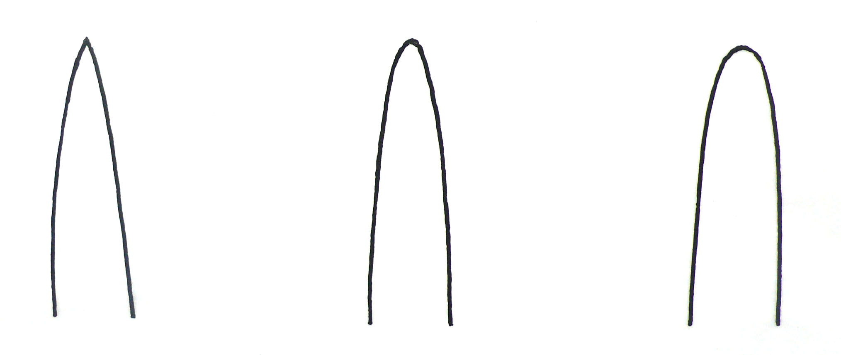
1 | 2 | 3
pointed | pointed to rounded | rounded

Ad. 2: Seedling: anthocyanin coloration of basal leaf sheath

The observation should be made on the bottom of shoot after the 7th leaf fully developed.

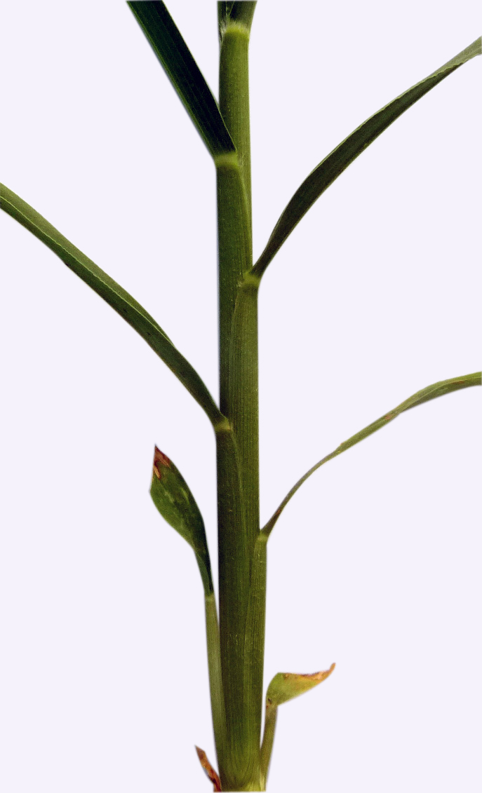 | 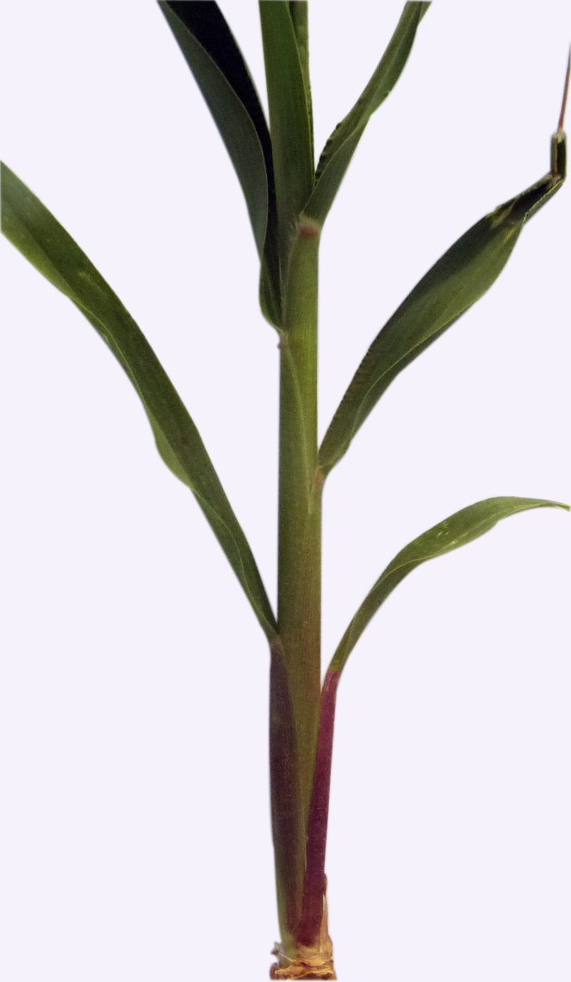 | 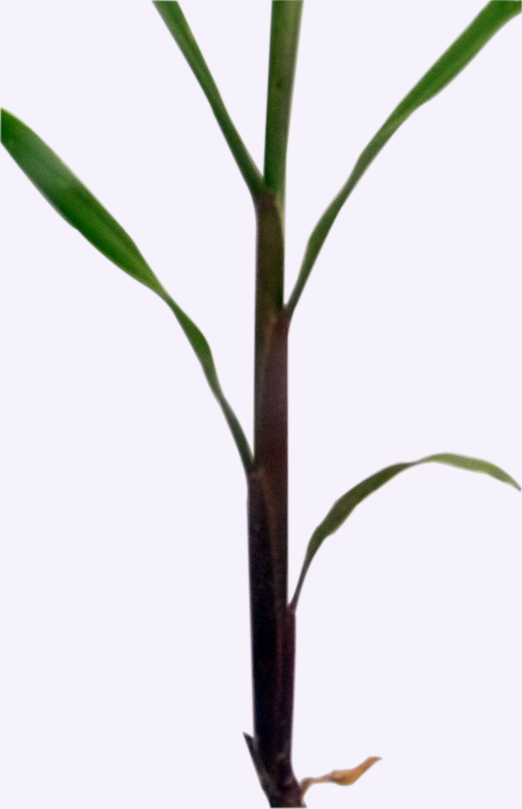
1 | 2 | 3
absent or weak | medium | strong

Ad. 4: Plant: growth habit
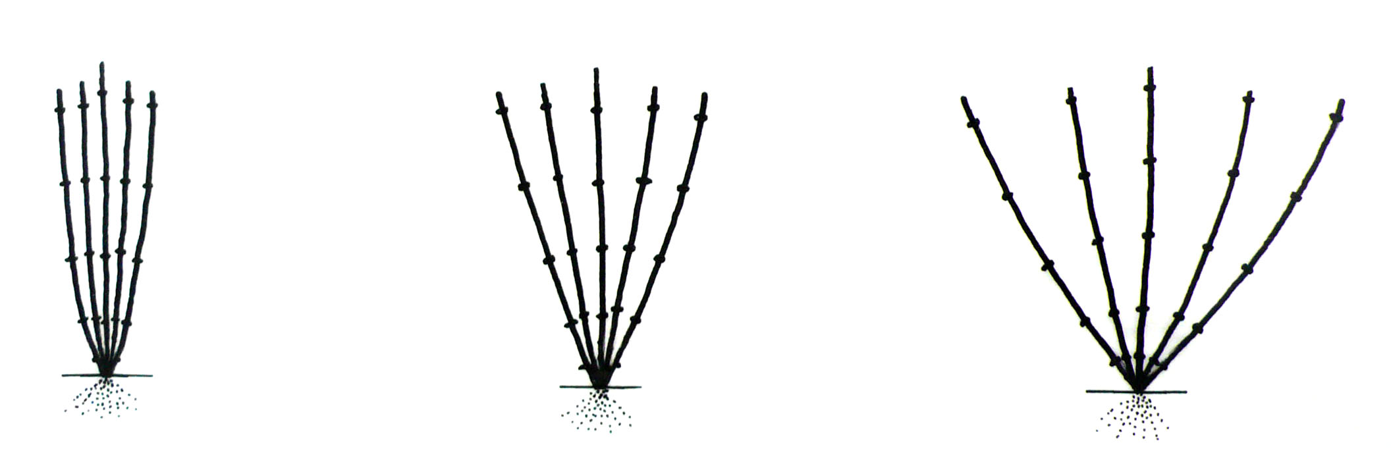
1 | 2 | 3
erect | semi-erect | spreading

Ad. 5: Plant: anthocyanin coloration of leaf pedestal

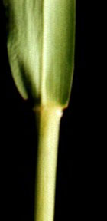 | 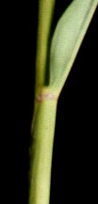 | 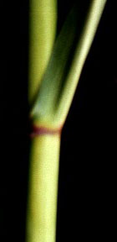
1 | 2 | 3
absent or weak | medium | strong

Ad. 6: Time of heading

Time of heading is the time when 50% of plants have reached stage 45.

Ad. 8: Leaf: attitude of blade

The observation should be made on the middle third leaves of the stem.

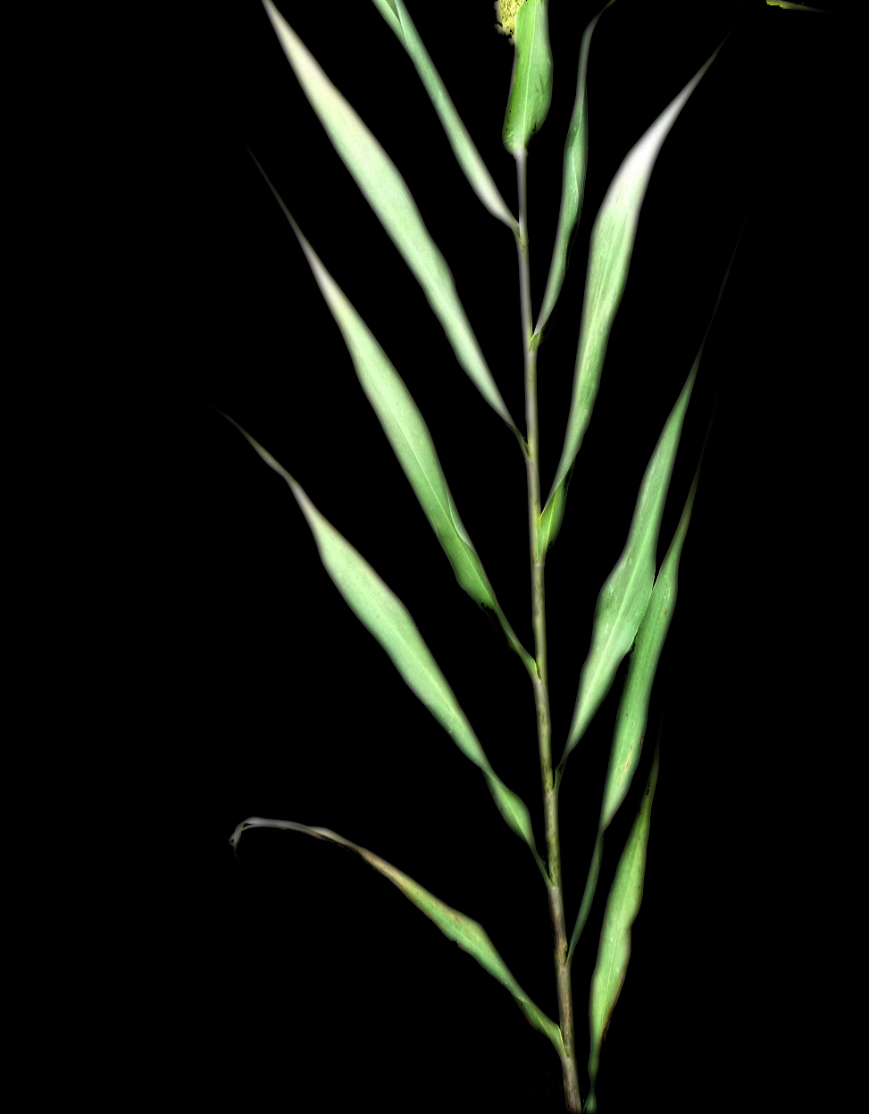 | 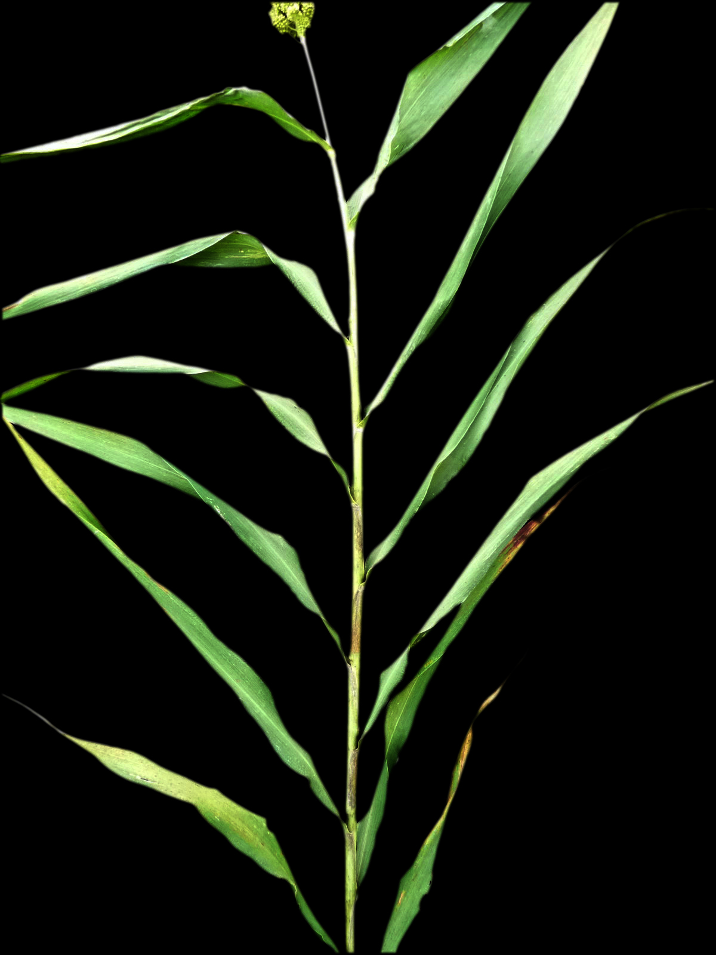 | 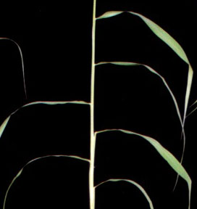 | 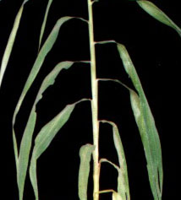
1 | 2 | 3 | 4
erect | semi erect | horizontal | drooping

Ad. 9: Panicle: length of bristles

Bristles in foxtail millet originated from the sterile spikelets.

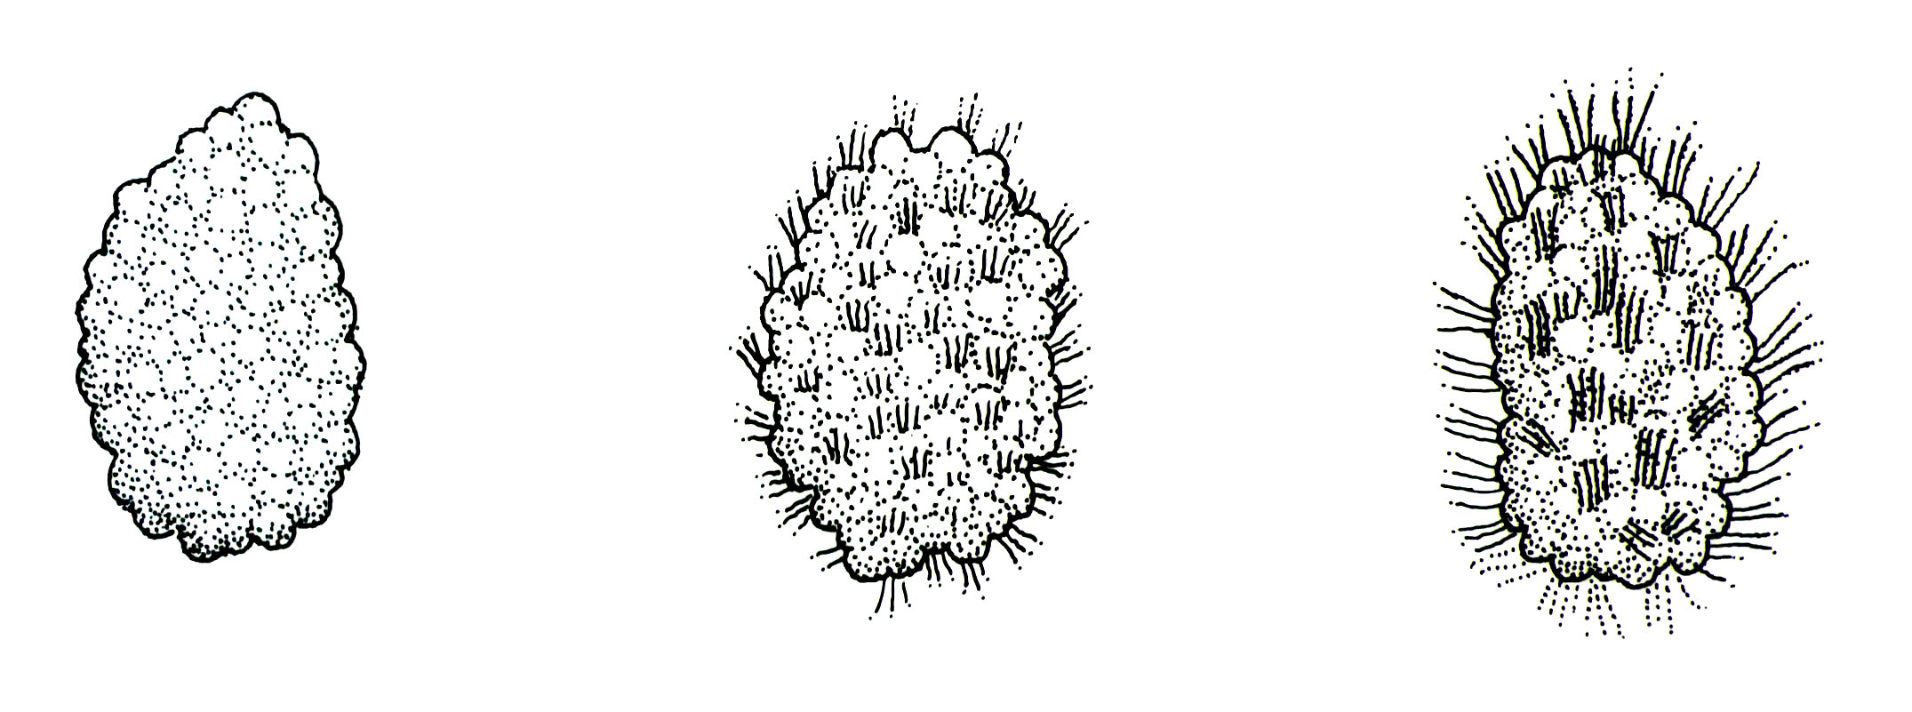
1 | 3 | 5
short | medium | long

Ad. 11: Anther: color

The observation should be made early in the morning before the anthers splits.

Ad. 13: Flag leaf: width of blade

The observation should be made at the broadest part of the blade.

Ad. 15: Stem: length

Plant length to be observed from the natural base of the main stem to the bottom point of the panicle (cm).

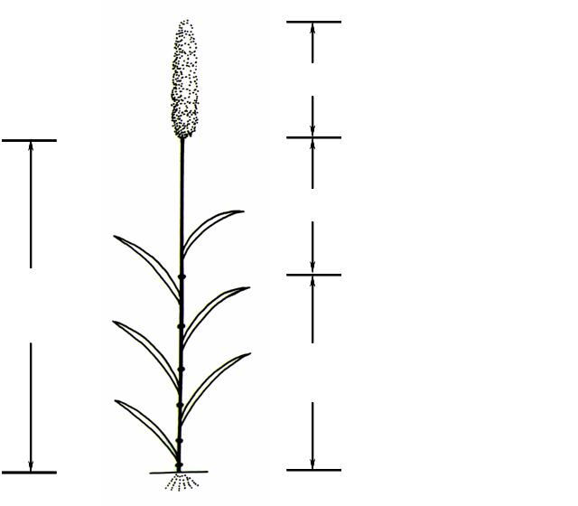
Ad. 15: Stem: length

Ad. 22: length of panicle
Ad. 20: length of peduncle
Ad. 18: number of elongated internodes

Ad. 16: Stem: diameter

To be observed at the third elongated nodes from the base.

Ad. 18: Plant: number of elongated internodes

See explanation at Ad. 15. Count the elongated internodes, excluding the peduncle.

Ad. 19: Panicle: attitude in relation to stem

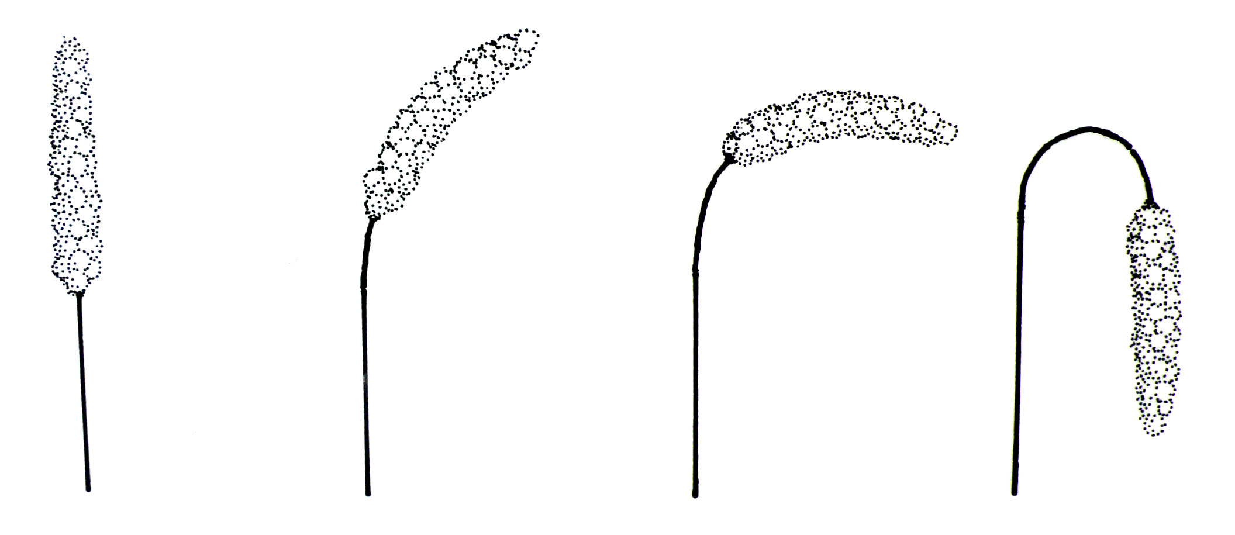
1 | 2 | 3 | 4
erect | semi erect | horizontal | drooping

Ad. 20: Plant: length of peduncle

See explanation at Ad. 15. The length of peduncle should be observed from the base of the panicle to the flag leaf node.

Ad. 21: Panicle: shape

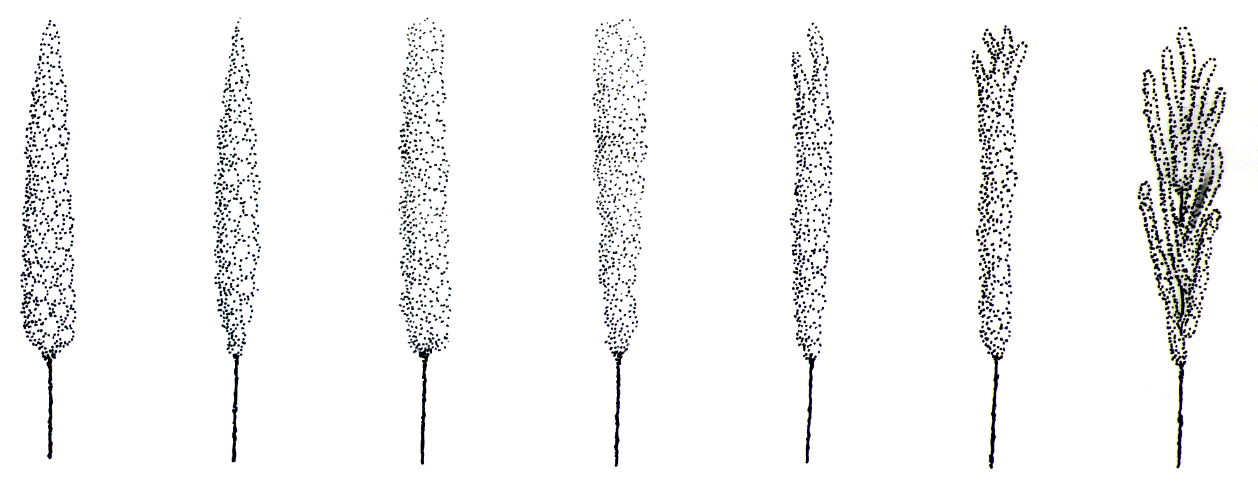
1 | 2 | 3 | 4 | 5 | 6 | 7
conical | spindle | cylindrical | club | duck mouth | cat foot | branched  (primary branches)

Ad. 22: Panicle: length

See explanation at Ad. 15.

Ad. 23: Excluding varieties with panicle shape: branched: panicle: density

The density of the main stem panicle is the number of rachis per centimeter in the middle third of the panicle.

Ad. 24: Panicle: number of grains on secondary branch

The number of grains should be counted on a secondary branch taken from the middle third of a main stem panicle.

Ad. 26: Grain: shape

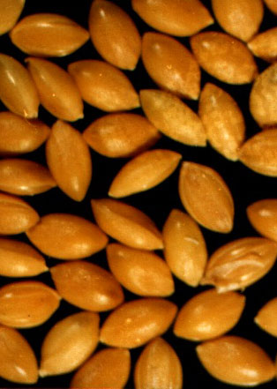 | 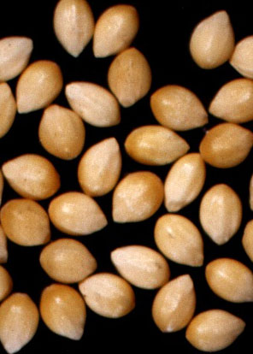 | 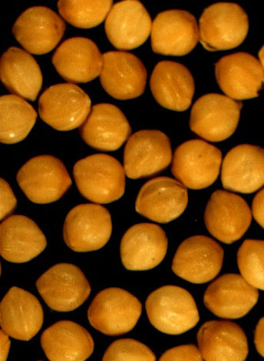
1 | 2 | 3
narrow ovate | medium ovate | circular

Ad. 29: Endosperm: type

The characteristic is observed by reaction to Potassium Iodide solution: waxy type endosperm is stained reddish purple; non-waxy type endosperm is stained blue purple.

8.3 Decimal Code for the Growth Stages of Cereals (Foxtail Millet)

2-digit Code | General Description
1 | 2
Germination
00 | Dry seed
01 | Start of imbibition
02
03 | Imbibition complete
04
05 | Radicle emerged from caryopsis
06
07 | Coleoptile emerged from caryopsis
08
09 | Leaf just at coleoptile tip
Seedling growth
10 | First leaf emerge through coleoptle
11 | First leaf unfolded
12 | 2 leaves unfolded
13 | 3 leaves unfolded
14 | 4 leaves unfolded
15 | 5 leaves unfolded
16 | 6 leaves unfolded
17 | 7 leaves unfolded
18 | 8 leaves unfolded
19 | 9 or more leaves unfolded
Tillering
20 | Main shoot only
21 | Main shoot and 1 tiller
22 | Main shoot and 2 tillers
23 | Main shoot and 3 tillers
24 | Main shoot and 4 tillers
25 | Main shoot and 5 tillers
26 | Main shoot and 6 tillers
27 | Main shoot and 7 tillers
28 | Main shoot and 8 tillers
29 | Main shoot and 8 tillers
Stem elongation
30 | Pseudo stem erection
31 | 1st node detectable
32 | 2ed node detectable
33 | 3rd node detectable
34 | 4th node detectable
35 | 5th node detectable
36 | 6th node detectable
37 | 7th node detectable
38 | 8th node detectable
39 | Flag leaf/collor just visible
Booting and inflorescence emergence
40
41 | Boots swollen
43 | 10% of inflorescence visible/emerged
45 | 50% of inflorescence visible/emerged
47 | All inflorescence visible/emerged
49
Anthesis
60 | Beginning of anthesis
65 | Anthesis half-way
69 | Anthesis complete
Milk development
70
71 | Caryopsis watery ripe
73 | Early milk
75 | Medium milk
77 | Late milk
Dough development
80
81 | Early dough
85 | Soft dough
89 | Hard dough
Ripening
90
91 | Caryopsis hard (difficult to divide by thumbnail)
92 | Caryopsis hard (can on longer be dented by thumbnail)
93 | Caryopsis loosening in daytime
94 | Over-rip, straw dead and collapsing
95 | Seed dormant
96 | Viable seed giving 50% germination
97 | Seed dormancy ended

Literature

Institute of Plant Germplasm, CAAS, 1985: Catergery of Chinese Land Races of Foxtail Millet. Agriculture Press. Beijing, CN.

Ping Lu, 2006: Descriptors and Data standard for foxtail millet (Setaria italica (L.) Beauv.). China Agriculture Press. Beijing, CN.

Xianmin Diao, Wei Li, Zhihai Zhao, Wenying Zhang, Hui Zhi, Yongfang Wang, Runqi Wang, Peng Wang, 2005: Guidelines for the Conduct of Test for Distinctness, Uniformity and Stability of Foxtail Millet (Setaria italica Beauv.). Chinese standard, in Chinese.

Yinmei Li et al., 1997: Breeding of Foxtail Millet. Agriculture Press. Beijing, CN.

Zadoks, J.C., Chang, T.T., Konzak, C.F., 1974: A decimal code for the growth stages of cereals. Weed Research 14: pp. 415-421.

Technical Questionnaire

TECHNICAL QUESTIONNAIRE |  |  |  | Page {x} of {y} |  | Reference Number:
 |  |  |  |  |  | Application date:
 |  |  |  |  |  | (not to be filled in by the applicant)
TECHNICAL QUESTIONNAIRE
to be completed in connection with an application for plant breeders’ rights

1. Subject of the Technical Questionnaire
1.1 Botanical name |  |  | Setaria italica (L.) Beauv.
1.2 Common name |  |  | Foxtail millet
2. Applicant
Name
Address
Telephone No.
Fax No.
E-mail address
Breeder (if different from applicant)
3. Proposed denomination and breeder’s reference
Proposed denomination
(if available)

Breeder’s reference
#4. Information on the breeding scheme and propagation of the variety

4.1 Breeding scheme

Variety resulting from:

4.1.1 Crossing

(a) controlled cross [ ]
(please state parent varieties)

(…………………..……………..…) x (……………..…………………..…)
female parent male parent

(b) partially known cross [ ]
(please state known parent variety(ies))

(…………………..……………..…) x (……………..…………………..…)
female parent male parent

(c) unknown cross [ ]

4.1.2 Mutation [ ]
(please state parent variety)

4.1.3 Discovery and development [ ]
(please state where and when discovered and how developed)

4.1.4 Other [ ]
(please provide details)”

4.2 Method of propagating the variety

Type of material

(a) line
male fertile line [ ]
male sterile line [ ]
(b) hybrid [ ]
(c) other (specify) [ ]

In the case of hybrid varieties the production scheme for the hybrid should be provided on a separate sheet. This should provide details of all the parent lines required for propagating the hybrid.

5. Characteristics of the variety to be indicated (the number in brackets refers to the corresponding characteristic in Test Guidelines; please mark the note which best corresponds).

 | Characteristics |  |  |  |  |  | Example Varieties |  |  | Note
5.1  (2) | Seedling: anthocyanin coloration of basal leaf sheath
 | absent or weak |  |  |  |  |  | Jingumi |  |  | 1 [ ]
 | medium |  |  |  |  |  | Ribenchixu |  |  | 2 [ ]
 | strong |  |  |  |  |  | Lianggu |  |  | 3 [ ]
5.2  (6) | Time of heading
 | very early |  |  |  |  |  | Loulixiu |  |  | 1 [ ]
 | very early to early |  |  |  |  |  |  |  |  | 2 [ ]
 | early |  |  |  |  |  | Lianggu |  |  | 3 [ ]
 | early to medium |  |  |  |  |  |  |  |  | 4 [ ]
 | medium |  |  |  |  |  | Jinmiaogu |  |  | 5 [ ]
 | medium to late |  |  |  |  |  |  |  |  | 6 [ ]
 | late |  |  |  |  |  | Ribenchixu |  |  | 7 [ ]
 | late to very late |  |  |  |  |  |  |  |  | 8 [ ]
 | very late |  |  |  |  |  | W 56 |  |  | 9 [ ]
5.3  (15) | Stem: length
 | very short |  |  |  |  |  | Loulixiu |  |  | 1 [ ]
 | very short to short |  |  |  |  |  |  |  |  | 2 [ ]
 | short |  |  |  |  |  | Zhangai 10 |  |  | 3 [ ]
 | short to medium |  |  |  |  |  |  |  |  | 4 [ ]
 | medium |  |  |  |  |  | Kenya |  |  | 5 [ ]
 | medium to tall |  |  |  |  |  |  |  |  | 6 [ ]
 | long |  |  |  |  |  | Lianggu |  |  | 7 [ ]
 | long to very long |  |  |  |  |  |  |  |  | 8 [ ]
 | very long |  |  |  |  |  | Yintianhan |  |  | 9 [ ]
 | Characteristics |  |  |  |  |  | Example Varieties |  |  | Note
5.4  (27) | Grain: color
 | whitish |  |  |  |  |  | Anai 3 |  |  | 1 [ ]
 | grey |  |  |  |  |  | Kenya |  |  | 2 [ ]
 | yellow |  |  |  |  |  | Jinmiaogu, Ribenchixu |  |  | 3 [ ]
 | brown |  |  |  |  |  | Yugu 8 |  |  | 4 [ ]
 | red |  |  |  |  |  | Hongmiaoqing |  |  | 5 [ ]
 | black |  |  |  |  |  | Heiniangu |  |  | 6 [ ]
5.5  (29) | Endosperm:type
 | waxy |  |  |  |  |  |  |  |  | 1 [ ]
 | non-waxy |  |  |  |  |  |  |  |  | 2 [ ]
6. Similar varieties and differences from these varieties

Please use the following table and box for comments to provide information on how your candidate variety differs from the variety (or varieties) which, to the best of your knowledge, is (or are) most similar. This information may help the examination authority to conduct its examination of distinctness in a more efficient way.

Denomination(s) of variety(ies) similar to your candidate variety |  | Characteristic(s) in which your candidate variety differs from the similar variety(ies) |  |  | Describe the expression of the characteristic(s) for the similar variety(ies) |  |  | Describe the expression of the characteristic(s) for your candidate variety
Example |  | Leaf: attitude of blade |  |  | erect |  |  | semi erect
Comments:

#7. Additional information which may help in the examination of the variety

7.1 In addition to the information provided in sections 5 and 6, are there any additional characteristics which may help to distinguish the variety?

Yes [ ] No [ ]

(If yes, please provide details)

7.2 Are there any special conditions for growing the variety or conducting the examination?

Yes [ ] No [ ]

(If yes, please provide details)

7.3 Other information

8. Authorization for release

(a) Does the variety require prior authorization for release under legislation concerning the protection of the environment, human and animal health?

Yes [ ] No [ ]

(b) Has such authorization been obtained?

Yes [ ] No [ ]

If the answer to (b) is yes, please attach a copy of the authorization.

9. Information on plant material to be examined or submitted for examination.

9.1 The expression of a characteristic or several characteristics of a variety may be affected by factors, such as pests and disease, chemical treatment (e.g. growth retardants or pesticides), effects of tissue culture, different rootstocks, scions taken from different growth phases of a tree, etc.

9.2 The plant material should not have undergone any treatment which would affect the expression of the characteristics of the variety, unless the competent authorities allow or request such treatment. If the plant material has undergone such treatment, full details of the treatment must be given. In this respect, please indicate below, to the best of your knowledge, if the plant material to be examined has been subjected to:

(a) Microorganisms (e.g. virus, bacteria, phytoplasma) Yes [ ] No [ ]

(b) Chemical treatment (e.g. growth retardant, pesticide) Yes [ ] No [ ]

(c) Tissue culture Yes [ ] No [ ]

(d) Other factors Yes [ ] No [ ]

Please provide details for where you have indicated “yes”.

……………………………………………………………

10. I hereby declare that, to the best of my knowledge, the information provided in this form is correct:

Applicant’s name

Signature Date

[End of document]

* These names were correct at the time of the introduction of these Test Guidelines but may be revised or updated. [Readers are advised to consult the UPOV Code, which can be found on the UPOV Website (www.upov.int), for the latest information.]
# Authorities may allow certain of this information to be provided in a confidential section of the Technical Questionnaire.
# Authorities may allow certain of this information to be provided in a confidential section of the Technical Questionnaire.

