 |  |  |  |  |  |  | E  TG/32/7(proj.3)  ORIGINAL: English  DATE: 2012-04-18
INTERNATIONAL UNION FOR THE PROTECTION OF NEW VARIETIES OF PLANTS
Geneva
 |  |  | DRAFT
 |  | COMMON VETCH  UPOV Code: VICIA_SAT  Vicia sativa L. |  |  | *

GUIDELINES

FOR THE CONDUCT OF TESTS

FOR DISTINCTNESS, UNIFORMITY AND STABILITY

prepared by an expert from Spain

to be considered by the
Technical Working Party for Agricultural Crops
at its forty-first session, to be held in Angers, France, from May 21 to 25, 2012

Alternative Names:*

Botanical name | English | French | German | Spanish
Vicia sativa L. | Common vetch | Vesce commune | Saatwicke | Veza común

The purpose of these guidelines (“Test Guidelines”) is to elaborate the principles contained in the General Introduction (document TG/1/3), and its associated TGP documents, into detailed practical guidance for the harmonized examination of distinctness, uniformity and stability (DUS) and, in particular, to identify appropriate characteristics for the examination of DUS and production of harmonized variety descriptions.

ASSOCIATED DOCUMENTS
These Test Guidelines should be read in conjunction with the General Introduction and its associated TGP documents.
TABLE OF CONTENTS PAGE

1. Subject of these Test Guidelines 3
2. Material Required 3
3. Method of Examination 3
3.1 Number of Growing Cycles 3
3.2 Testing Place 3
3.3 Conditions for Conducting the Examination 3
3.4 Test Design 3
3.5 Additional Tests 4
4. Assessment of Distinctness, Uniformity and Stability 4
4.1 Distinctness 4
4.2 Uniformity 5
4.3 Stability 5
5. Grouping of Varieties and Organization of the Growing Trial 5
6. Introduction to the Table of Characteristics 6
6.1 Categories of Characteristics 6
6.2 States of Expression and Corresponding Notes 6
6.3 Types of Expression 6
6.4 Example Varieties 7
6.5 Legend 7
7. Table of Characteristics/Tableau des caractères/Merkmalstabelle/Tabla de caracteres 8
8. Explanations on the Table of Characteristics 14
8.1 Phenological growth stages and BBCH-identification keys of common vetch (is adapted from BBCH of pea) 14
8.2 Explanations for individual characteristics 15
9. Literature 18
10. Technical Questionnaire 19

ANNEX Comments by the subgroup

Subject of these Test Guidelines

These Test Guidelines apply to all varieties of Vicia sativa L..

Material Required

2.1 The competent authorities decide on the quantity and quality of the plant material required for testing the variety and when and where it is to be delivered. Applicants submitting material from a State other than that in which the testing takes place must ensure that all customs formalities and phytosanitary requirements are complied with.

2.2 The material is to be supplied in the form of seed.

2.3 The minimum quantity of plant material, to be supplied by the applicant, should be:

1 kg of seed.

The seed should meet the minimum requirements for germination, species and analytical purity, health and moisture content, specified by the competent authority. In cases where the seed is to be stored, the germination capacity should be as high as possible and should, be stated by the applicant.

2.4 The plant material supplied should be visibly healthy, not lacking in vigor, nor affected by any important pest or disease.

2.5 The plant material should not have undergone any treatment which would affect the expression of the characteristics of the variety, unless the competent authorities allow or request such treatment. If it has been treated, full details of the treatment must be given.

Method of Examination

3.1 Number of Growing Cycles

The minimum duration of tests should normally be two independent growing cycles.

3.2 Testing Place

Tests are normally conducted at one place. In the case of tests conducted at more than one place, guidance is provided in TGP/9 “Examining Distinctness”.

3.3 Conditions for Conducting the Examination

3.3.1 The tests should be carried out under conditions ensuring satisfactory growth for the expression of the relevant characteristics of the variety and for the conduct of the examination. In this sense, the Common Vetch trial should be carried out with some physical support to ensure the correct training of the plant.

3.3.2 The optimum stage of development for the assessment of each characteristic is indicated by a number in the second column of the Table of Characteristics. The stages of development denoted by each number are described in Chapter 8.

3.4 Test Design

3.4.1 Each test should be designed to result in a total of at least 200 plants, which should be divided between 2 or more replicates.

3.4.2 The design of the tests should be such that plants or parts of plants may be removed for measurement or counting without prejudice to the observations which must be made up to the end of the growing cycle.

3.5 Additional Tests

Additional tests, for examining relevant characteristics, may be established.

Assessment of Distinctness, Uniformity and Stability

4.1 Distinctness

4.1.1 General Recommendations

It is of particular importance for users of these Test Guidelines to consult the General Introduction prior to making decisions regarding distinctness. However, the following points are provided for elaboration or emphasis in these Test Guidelines.

4.1.2 Consistent Differences

The differences observed between varieties may be so clear that more than one growing cycle is not necessary. In addition, in some circumstances, the influence of the environment is not such that more than a single growing cycle is required to provide assurance that the differences observed between varieties are sufficiently consistent. One means of ensuring that a difference in a characteristic, observed in a growing trial, is sufficiently consistent is to examine the characteristic in at least two independent growing cycles.

4.1.3 Clear Differences

Determining whether a difference between two varieties is clear depends on many factors, and should consider, in particular, the type of expression of the characteristic being examined, i.e. whether it is expressed in a qualitative, quantitative, or pseudo-qualitative manner. Therefore, it is important that users of these Test Guidelines are familiar with the recommendations contained in the General Introduction prior to making decisions regarding distinctness.

4.1.4 Number of Plants / Parts of Plants to be Examined

Unless otherwise indicated, for the purposes of distinctness, all observations on single plants should be made on 20 plants or parts taken from each of 20 plants and any other observations made on all plants in the test, disregarding any off-type plants.

4.1.5 Method of Observation

The recommended method of observing the characteristic for the purposes of distinctness is indicated by the following key in the second column of the Table of Characteristics (see document TGP/9 “Examining Distinctness”, Section 4 “Observation of characteristics”):

MG: single measurement of a group of plants or parts of plants
MS: measurement of a number of individual plants or parts of plants
VG: visual assessment by a single observation of a group of plants or parts of plants
VS: visual assessment by observation of individual plants or parts of plants

Type of observation: visual (V) or measurement (M)

“Visual” observation (V) is an observation made on the basis of the expert’s judgment. For the purposes of this document, “visual” observation refers to the sensory observations of the experts and, therefore, also includes smell, taste and touch. Visual observation includes observations where the expert uses reference points (e.g. diagrams, example varieties, side-by-side comparison) or non-linear charts (e.g. color charts). Measurement (M) is an objective observation against a calibrated, linear scale e.g. using a ruler, weighing scales, colorimeter, dates, counts, etc.

Type of record: for a group of plants (G) or for single, individual plants (S)

For the purposes of distinctness, observations may be recorded as a single record for a group of plants or parts of plants (G), or may be recorded as records for a number of single, individual plants or parts of plants (S). In most cases, “G” provides a single record per variety and it is not possible or necessary to apply statistical methods in a plant-by-plant analysis for the assessment of distinctness.

In cases where more than one method of observing the characteristic is indicated in the Table of Characteristics (e.g. VG/MG), guidance on selecting an appropriate method is provided in document TGP/9, Section 4.2.

4.2 Uniformity

4.2.1 It is of particular importance for users of these Test Guidelines to consult the General Introduction prior to making decisions regarding uniformity. However, the following points are provided for elaboration or emphasis in these Test Guidelines:

4.2.2 For the assessment of uniformity a population standard of 1% and an acceptance probability of at least 95 % should be applied. In the case of a sample size of 200 plants, 5 off-types are allowed. Characteristics which should be observed on a sample size of 200 plants are indicated by a “B” in the Table of Characteristics.

4.2.3 For the assessment of uniformity in a sample of 100 plants or parts of plants, a population standard of 1% and an acceptance probability of at least 95% should be applied. In the case of a sample size of 100 plants or parts of plants, 3 off-types plants are allowed. Characteristics which should be observed on a sample size of 100 plants are indicated by an “A” in the Table of Characteristics.

4.2.4 For these “A” characteristics, the assessment of uniformity can be done in 2 steps. In a first step, 20 plants or parts of plants are observed. If no off-types are observed, the variety is declared to be uniform. If more than 3 off-types are observed, the variety is declared not to be uniform. If 1 to 3 off-types are observed, an additional sample of 80 plants or parts of plants must be observed.

4.3 Stability

4.3.1 In practice, it is not usual to perform tests of stability that produce results as certain as those of the testing of distinctness and uniformity. However, experience has demonstrated that, for many types of variety, when a variety has been shown to be uniform, it can also be considered to be stable.

4.3.2 Where appropriate, or in cases of doubt, stability may be tested, either by growing a further generation, or by testing a new seed stock to ensure that it exhibits the same characteristics as those shown by the previous material supplied.

Grouping of Varieties and Organization of the Growing Trial

5.1 The selection of varieties of common knowledge to be grown in the trial with the candidate varieties and the way in which these varieties are divided into groups to facilitate the assessment of distinctness are aided by the use of grouping characteristics.

5.2 Grouping characteristics are those in which the documented states of expression, even where produced at different locations, can be used, either individually or in combination with other such characteristics: (a) to select varieties of common knowledge that can be excluded from the growing trial used for examination of distinctness; and (b) to organize the growing trial so that similar varieties are grouped together.

5.3 The following have been agreed as useful grouping characteristics:

(a) Time of beginning of flowering (characteristic 4)
(b) Seed: ground color of testa (characteristic 18)
(c) Seed: brown ornamentation (characteristic 19)
(d) Seed: blue-black ornamentation (characteristic 21)
(e) Seed: color of cotyledons (characteristic 23)

5.4 Guidance for the use of grouping characteristics, in the process of examining distinctness, is provided through the General Introduction and document TGP/9 “Examining Distinctness”.

Introduction to the Table of Characteristics

6.1 Categories of Characteristics

6.1.1 Standard Test Guidelines Characteristics

Standard Test Guidelines characteristics are those which are approved by UPOV for examination of DUS and from which members of the Union can select those suitable for their particular circumstances.

6.1.2 Asterisked Characteristics

Asterisked characteristics (denoted by *) are those included in the Test Guidelines which are important for the international harmonization of variety descriptions and should always be examined for DUS and included in the variety description by all members of the Union, except when the state of expression of a preceding characteristic or regional environmental conditions render this inappropriate.

6.2 States of Expression and Corresponding Notes

6.2.1 States of expression are given for each characteristic to define the characteristic and to harmonize descriptions. Each state of expression is allocated a corresponding numerical note for ease of recording of data and for the production and exchange of the description.

6.2.2 In the case of qualitative and pseudo-qualitative characteristics (see Chapter 6.3), all relevant states of expression are presented in the characteristic. However, in the case of quantitative characteristics with 5 or more states, an abbreviated scale may be used to minimize the size of the Table of Characteristics. For example, in the case of a quantitative characteristic with 9 states, the presentation of states of expression in the Test Guidelines may be abbreviated as follows:

State | Note
small | 3
medium | 5
large | 7

However, it should be noted that all of the following 9 states of expression exist to describe varieties and should be used as appropriate:

State | Note
very small | 1
very small to small | 2
small | 3
small to medium | 4
medium | 5
medium to large | 6
large | 7
large to very large | 8
very large | 9

6.2.3 Further explanation of the presentation of states of expression and notes is provided in document TGP/7 “Development of Test Guidelines”.

6.3 Types of Expression

An explanation of the types of expression of characteristics (qualitative, quantitative and pseudo-qualitative) is provided in the General Introduction.

6.4 Example Varieties

Where appropriate, example varieties are provided to clarify the states of expression of each characteristic.

6.5 Legend

(*) Asterisked characteristic – see Chapter 6.1.2

QL Qualitative characteristic – see Chapter 6.3
QN Quantitative characteristic – see Chapter 6.3
PQ Pseudo-qualitative characteristic – see Chapter 6.3

MG, MS, VG, VS – see Chapter 4.1.5

A: Sample size of 100 plants required for uniformity – see Chapters 4.2.3 and 4.2.4
B: Sample of 200 plants required for uniformity – see Chapter 4.2.2

0-92 See Explanations on the Table of Characteristics in Chapter 8.1
(+) See Explanations on the Table of Characteristics in Chapter 8.2

Table of Characteristics/Tableau des caractères/Merkmalstabelle/Tabla de caracteres

 |  | English | français | deutsch | español | Example Varieties  Exemples  Beispielssorten  Variedades ejemplo | Note/  Nota
1.  (*)  (+) | 12 VG/  MS B | Seedling: ratio length/width of leaflet of second primary leaf | Plantule : rapport longueur/largeur de la foliole de la deuxième feuille primaire | Keimpflanze: Verhältnis Länge/Breite des Blättchens des zweiten Primärblattes | Plántula: relación longitud/anchura del foliolo de la segunda hoja primaria
QN |  | very low | très petit | sehr klein | muy baja |  | 1
 |  | low | petit | klein | baja | Ebena | 3
 |  | medium | moyen | mittel | media | Candy | 5
 |  | high | grand | gross | alta | Prontivesa | 7
 |  | very high | très grand | sehr gross | muy alta | Aneto | 9
2. | 11-13 VG B | Seedling: anthocyanin coloration on the base of the stem | Plantule : intensité de la pigmentation anthocyanique à la base de la tige | Keimpflanze: Intensität der Anthocyanfärbung an der Basis des Stengels | Plántula: intensidad de la coloración antociánica de la base del tallo
QN |  | absent or  very weak | nulle ou  très faible | fehlend oder  sehr gering | ausente o  muy débil | Cobra | 1
 |  | weak | faible | gering | débil |  | 3
 |  | medium | moyenne | mittel | media | Ina, Prontivesa | 5
 |  | strong | forte | stark | fuerte | Nacre | 7
 |  | very strong | très forte | sehr stark | muy fuerte |  | 9
3.  (+) | 51-59 VG B | Plant: intensity of green color of foliage | Plante: intensité de la couleur vert du feuillage | Pflanze: Intensität der Grünfärbung der Blätter | Planta: intensidad del color verde del follaje
QN |  | light | claire | hell | claro | Acisreina | 1
 |  | medium | moyenne | mittel | medio | Kwarta | 3
 |  | dark | foncée | dunkel | oscuro |  | 5
4.  (*)  (+) | 61 MG B | Time of beginning of flowering | Epoque de début floraison | Zeitpunkt des Blühbeginns | Época de comienzo de la floración
QN |  | very early | très précoce | sehr früh | muy temprana | Barbicos, Piedade | 1
 |  | early | précoce | früh | temprana | Labari | 3
 |  | medium | moyenne | mittel | media | Ina, Pepite, Rada | 5
 |  | late | tardive | spät | tardía | Kwarta | 7
 |  | very late | très tardive | sehr spät | muy tardía | Berninova, Jaga | 9
5.  (*)  (+) | 60-69 VG B | Stem: hairiness of upper internodes | Tige: pilosité des entrenoeuds supérieurs | Stengel: Behaarung der obersten Internodien | Tallo: vellosidad de los entrenudos superiores
QN |  | absent or  very weak | nulle ou  très faible | fehlend oder  sehr gering | ausente o  muy débil | Neska | 1
 |  | weak | faible | gering | débil | Prontivesa | 3
 |  | medium | moyenne | mittel | media |  | 5
 |  | strong | forte | stark | fuerte | Candy, Kwarta | 7
 |  | very strong | très forte | sehr stark | muy fuerte | Berninova, Caravelle, Hanka | 9
6. | 60-69 VG B | Stem: anthocyanin coloration on leaf axil | Tige: pigmentation anthocyanique à l'aisselle des feuilles | Stengel: Anthocyanfärbung der Blattachsel | Tallo: coloración antociánica en la axila de las hojas
QN |  | absent or  very weak | nulle ou  très faible | fehlend oder  sehr gering | ausente o  muy débil | Acisreina, Fama, Kwarta, Pepite | 1
 |  | weak | faible | gering | débil | Candy, Caravelle | 3
 |  | medium | moyenne | mittel | media | Castilla, Rada, Trafic | 5
 |  | strong | forte | stark | fuerte | Miranda, Nacre | 7
 |  | very strong | très forte | sehr stark | muy fuerte |  | 9
7.  (*)  (+) | 60-69 VG B | Leaf: shape of tip of leaflet | Feuille: forme de l'extrémité de la foliole | Blatt: Form der Spitze der Blattfieder | Hoja: forma del extremo del foliolo
QN |  | convex | convexe | konvex | convexa | Corail, Trafic | 3
 |  | straight | droite | gerade | recta | Aneto, Candy, Fama, Kwarta, Prontivesa | 5
 |  | concave | concave | konkav | cóncava | Nacre | 7
8.  (+) | 60-69 VG/  MS B | Leaf: width of leaflet | Feuille: largueur de la foliole | Blatt: Breite der Blattfieder | Hoja: anchura del foliolo
QN |  | narrow | étroite | schmal | estrecho | Prontivesa | 3
 |  | medium | moyenne | mittel | medio | Hanka, Libia, Pepite | 5
 |  | wide | large | breit | ancho | Acisreina | 7
9.  (*) | 60-69 VG B | Stipule: anthocyanin coloration of nectaries | Stipule: pigmentation anthocyanique des nectaires | Nebenblätter: Anthocyanfärbung der Nektarien | Estípula: coloración antociánica de los nectarios
QN |  | absent or  very weak | nulle ou  très faible | fehlend oder  sehr gering | ausente o  muy débil | Albaflor, Jade | 1
 |  | weak | faible | gering | débil | Alcaraz, Melissa, Prontivesa | 3
 |  | medium | moyenne | mittel | media | Aneto, Castilla | 5
 |  | strong | forte | stark | fuerte | Labari, Libia, Nacre | 7
 |  | very strong | très forte | sehr stark | muy fuerte |  | 9
10.  (*) | 60-65 VG B | Flower: color of standard | Fleur: couleur de l'étendard | Blüte: Farbe der Fahne | Flor: color del estandarte
PQ |  | white | blanc | weiss | blanco | Albaflor | 1
 |  | pink | rose | rosa | rosa |  | 2
 |  | light violet | violet clair | hellviolett | violeta claro | Miranda, Piedade | 3
 |  | medium violet | violet moyen | mittelviolett | violeta medio | Labari, Nacre | 4
 |  | dark violet | violet foncé | dunkelviolett | violeta oscuro | Castilla, Prontivesa | 5
11.  (*) | 71-79 VG B | Pod: hairiness | Gousse : pilosité | Hülse: Behaarung | Vaina: vellosidad
QN |  | absent or  very weak | nulle ou  très faible | fehlend oder  sehr gering | ausente o  muy débil | Amelia, Spinelle | 1
 |  | weak | faible | gering | débil | Alcaraz, Granit | 3
 |  | medium | moyenne | mittel | media | Barvicos, Miranda, Topaze | 5
 |  | strong | forte | stark | fuerte | Kwarta | 7
 |  | very strong | très forte | sehr stark | muy fuerte | Ina | 9
12. | 71-79 VG/  MS B | Pod: length (excluding beak) | Gousse : longueur | Hülse: Länge | Vaina: longitud (excluyendo el pico)
QN |  | short | courte | kurz | corta | Acisreina, Berninova | 3
 |  | medium | moyenne | mittel | media | Ebena, Fama | 5
 |  | long | longue | lang | larga | Miranda, Prontivesa | 7
13.  (+) | 71-79 VG/  MS B | Pod: width | Gousse : largeur | Hülse: Breite | Vaina: anchura
QN |  | narrow | étroite | schmal | estrecha | Acisreina | 3
 |  | medium | moyenne | mittel | media | Ebena, Kwarta | 5
 |  | wide | large | breit | ancha | Labari, Prontivesa | 7
14. | 71-79 VG B | Pod: length of beak | Gousse : longueur du bec | Hülse: Länge der Spitze | Vaina: longitud del pico
QN |  | short | courte | kurz | corto | Carole | 1
 |  | medium | moyenne | mittel | medio | Granit, Libia, Labari, Prontivesa | 2
 |  | long | longue | lang | largo | Amelia, Candy | 3
15.  (+) | 71-75 MS A | Pod: number of ovules | Gousse : nombre d’ovules | Hülse: Anzahl Samenanlagen | Vaina: número de óvulos
QN |  | few | faible | gering | bajo | Barvicos | 3
 |  | medium | moyen | mittel | medio | Ina, Labari | 5
 |  | many | élevé | gross | alto | Albina, Ebena | 7
16.  (*)  (+) | 89-99 MG | Seed: weight | Graine : poids de semences | Samen: Samengewicht | Semilla: peso
QN |  | very low | très faible | sehr niedrig | muy bajo | Berninova, Carole | 1
 |  | low | faible | niedrig | bajo | Ina | 3
 |  | medium | moyen | mittel | medio | Aneto, Rada | 5
 |  | high | élevé | hoch | alto | Castilla | 7
 |  | very high | très élevé | sehr hoch | muy alto | Labari, Prontivesa | 9
17.  (+) | 89-99 VG A | Seed: shape | Graine : forme | Samen: Form | Semilla: forma
QL |  | circular |  |  | globular | Aneto, Ebena, Fama | 1
 |  | irregular |  |  | irregular | Castilla, Labari, Prontivesa | 2
18.  (*)  (+) | 89-99 VG A | Seed: ground color of testa | Graine : couleur de fond du tégument | Samen: Grundfarbe der Samenschale | Semilla: color de fondo de la testa
PQ |  | greyish green |  |  | verde grisáceo | Acisreina, Ebena, Nacre | 1
 |  | greyish brown |  |  | marrón grisáceo | Candy | 2
 |  | brown | brun | braun | marrón | Kwarta | 3
 |  | colorless |  |  | translúcido | Ina | 4
19.  (*)  (+) | 89-99 VG A | Seed: brown ornamentation | Graine : ornementations brunes | Samen: braune Ornamentierung | Semilla: ornamentación marrón
PQ |  | absent | absentes | fehlend | ausente | Albaflor, Albina, Fama, Ina | 1
 |  | spotted |  |  | con lunares | Cumbre | 2
 |  | blotched |  |  | con manchas | Candy, Pepite | 3
 |  | speckled |  |  | con lunares y manchas | Labari, Prontivesa | 4
20.  (*)  (+) | 89-99 VG A | Seed: extension of brown ornamentation | Graine : étendue des ornementations brunes | Samen: Ausdehnung der braunen Ornamentierung | Semilla: extensión de la ornamentación marrón
QN |  | very small | très petite | sehr gering | muy pequeña |  | 1
 |  | small | petite | gering | pequeña | Achileas | 3
 |  | medium | moyenne | mittel | media | Neska | 5
 |  | large | grande | stark | grande | Acisreina, Prontivesa | 7
 |  | very large | très grande | sehr stark | muy grande |  | 9
21.  (*)  (+) | 89-99 VG A | Seed: blue-black ornamentation | Graine : ornementations bleu-noir | Samen: blauschwarze Ornamentierung | Semilla: ornamentación azul-negra
PQ |  | absent | absentes | fehlend | ausente | Albaflor, Albina, Fama, Ina, Kwarta, Nacre | 1
 |  | dotted |  |  | con puntos |  | 2
 |  | blotched |  |  | con manchas | Ebena, Castilla, Prontivesa | 3
 |  | speckled |  |  | con lunares y manchas | Acisreina, Pepite | 4
22.  (*)  (+) | 89-99 VG A | Seed: extension of blue-black ornamentation | Graine : étendue des ornementations bleu-noir | Samen: Ausdehnung der blauschwarze Ornamentierung | Semilla: extensión de la ornamentación azul-negra
QN |  | very small | très petite | sehr gering | muy pequeña |  | 1
 |  | small | petite | gering | pequeña | Prontivesa | 3
 |  | medium | moyenne | mittel | media | Acisreina | 5
 |  | large | grande | stark | grande |  | 7
 |  | very large | très grande | sehr stark | muy grande | Ebena | 9
23.  (*) | 89-99 VG A | Seed: color of cotyledons | Graine : couleur des cotylédons | Samen: Farbe der Keimblätter | Semilla: color de los cotiledones
QL |  | greyish brown | café au lait | graubraun | marrón grisáceo | Acisreina, Castilla, Labari, Prontivesa | 1
 |  | orange | orangés | orange | naranja | Aneto, Ina, Kwarta, | 2

Explanations on the Table of Characteristics

8.1 Phenological growth stages and BBCH-identification keys of common vetch (is adapted from BBCH of pea)

Principal growth stage 0: Germination
00 - Dry seed
01 - Beginning of seed imbibition
03 - Seed imbibition complete
05 - Radicle emerged from seed
07 - Shoot breaking through seed coat
08 - Shoot growing towards soil surface; hypocotyl arch visible
09 - Emergence: shoot breaks through soil surface

Principal growth stage 1: Leaf development
10 - Pair of scale leaves visible
11 - First true leaf unfolded
12 - 2 leaves unfolded
13 - 3 leaves unfolded
1.. - Stages continuous till . . .
19 - 9 or more leaves unfolded

Principal growth stage 3: Stem elongation (Main shoot)
30 - Beginning of stem elongation
31 - 1 visibly extended internode¹
32 - 2 visibly extended internodes¹
33 - 3 visibly extended internodes¹
3 .. - Stages continuous till . . .
39 - 9 or more visibly extended internodes¹

Principal growth stage 5: Inflorescence emergence
51 - First flower buds visible outside leaves
55 - First separated flower buds visible outside leaves but still closed
59 - First petals visible, flowers still closed

Principal growth stage 6: Flowering
60 - First flowers open (sporadically within the population)
61 - Beginning of flowering: 10% of flowers open
62 - 20% of flowers open
63 - 30% of flowers open
64 - 40% of flowers open
65 - Full flowering: 50% of flowers open
67 - Flowering declining
69 - End of flowering

Principal growth stage 7: Development of fruit
71 - 10% of pods have reached typical length
72 - 20% of pods have reached typical length
73 - 30% of pods have reached typical length
74 - 40% of pods have reached typical length
75 - 50% of pods have reached typical length
76 - 60% of pods have reached typical length
77 - 70% of pods have reached typical length
79 - Pods have reached typical size (green ripe); seeds fully formed

Principal growth stage 8: Ripening of fruit and seed
81 - 10% of pods ripe, seeds final colour, dry and hard
82 - 20% of pods ripe, seeds final colour, dry and hard
83 - 30% of pods ripe, seeds final colour, dry and hard
84 - 40% of pods ripe, seeds final colour, dry and hard
85 - 50% of pods ripe, seeds final colour, dry and hard
86 - 60% of pods ripe, seeds final colour, dry and hard
87 - 70% of pods ripe, seeds final colour, dry and hard
88 - 80% of pods ripe, seeds final colour, dry and hard
89 - Fully ripe: all pods dry and brown. Seeds dry and hard (dry ripe)

Principal growth stage 9: Senescence
97 - Plants dead and dry
99 - Harvested product

8.2 Explanations for individual characteristics

Ad. 1: Seedling: ratio length/width of leaflet of second primary leaf

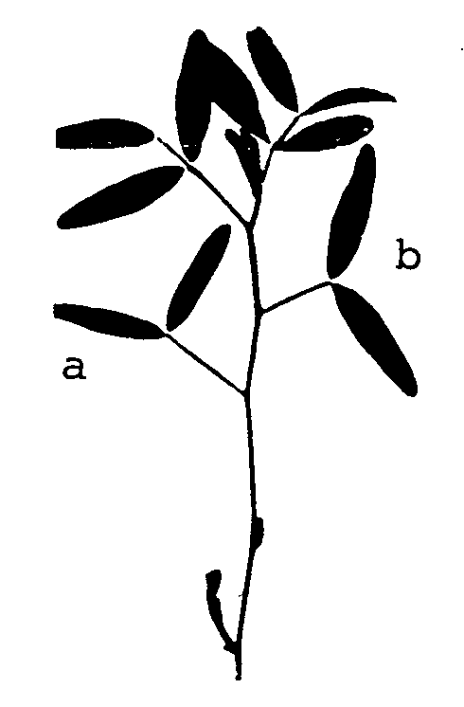

a: first primary leaf
b: second primary leaf

Ad. 3: Plant: intensity of green color of foliage

The observations should be made just before flowering.

Ad. 4: Time of beginning of flowering

Time of beginning of flowering is when 30% of plants have at least one flower open.

Ad. 5: Stem: hairiness of upper internodes

The observations should be made on upper third of plant.

Ad. 7: Leaf: shape of tip of leaflet

The observations should be made on middle third of plant.

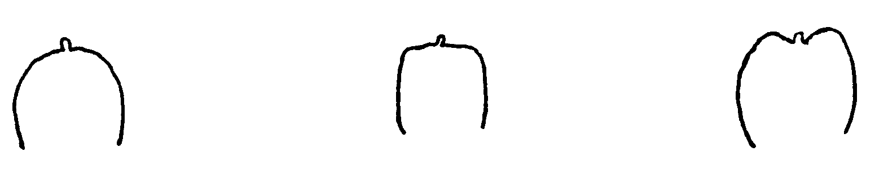
3 | 5 | 7
convex | straight | concave

Ad. 8: Leaf: width of leaflet

The observations should be made on middle third of plant.

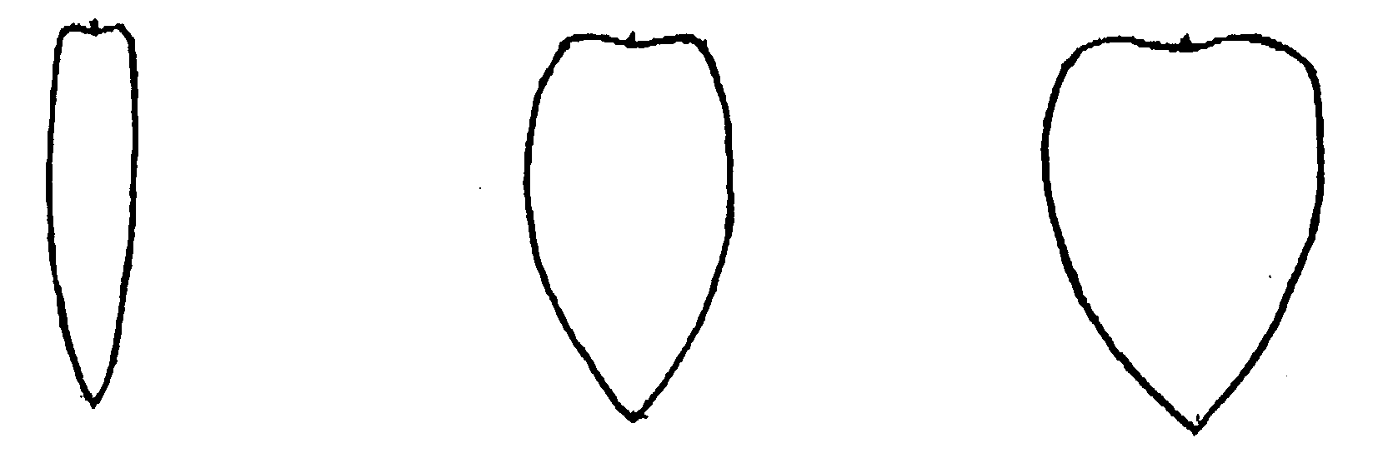
3 | 5 | 7
narrow | medium | wide

Ad. 13: Pod: width

The observations should be made on well-developed green pods; the width is assessed from suture to suture on unopened pods.

Ad. 15: Pod: number of ovules

The number of ovules is best recorded when the pods are flat. The number of ovules should be observed before seed development.

Ad. 16: Seed: weight

Seed weight should be measured on at least two samples of 100 seeds. Immature and infected seeds should be excluded.

Ad. 17: Seed: shape

Seeds which grow nearest the peduncle end or the distal end of the pod (‘end seeds’) should be excluded before shape is assessed.

The observations should be made from an upper view on spread out seeds on a flat surface. Seeds should be placed with the line between hilum and radicle parallel to the surface.

1. Circular 2. Irregular
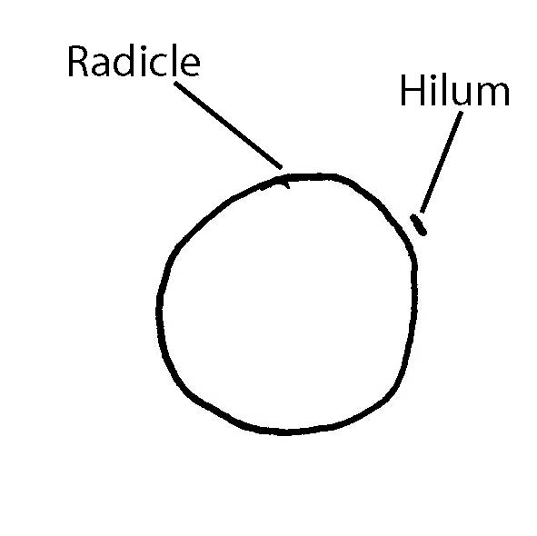

No circular shape.

Ad. 18: Seed: ground color of testa

The ground color of the testa may be overshadowed by a very strong expression of the blue- black ornamentation (characteristic 22).

Ad. 19: Seed: brown ornamentation

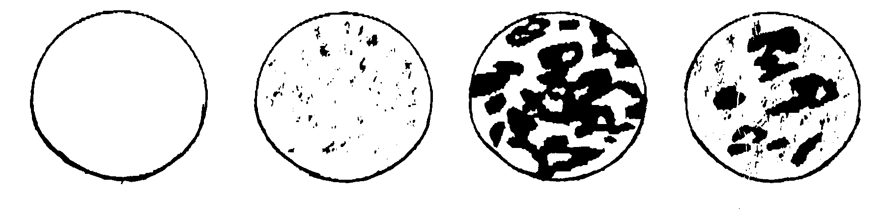
1 | 2 | 3 | 4
absent | spotted | blotched | speckled

Ad. 20: Seed: extension of brown ornamentation
Ad. 22: Seed: extension of blue-black ornamentation

The extension means the surface covered by the ornamentation.

Ad. 21: Seed: blue-black ornamentation

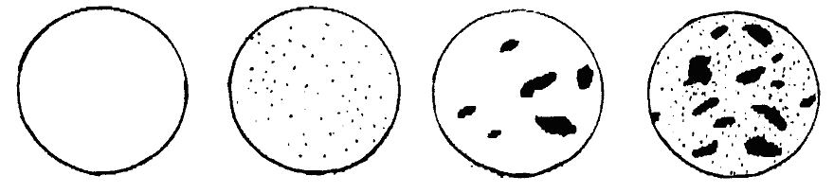
1 | 2 | 3 | 4
absent | dotted | blotched | speckled

Literature

Meier U., 1997: Growth stages of mono- and dicotyledonous plants: BBCH-Monograph. Federal Biological Research Center for Agriculture and Forestry (Ed.). Blackwell Wissenschafts-Verlag, Berlin, Wien.

Technical Questionnaire

TECHNICAL QUESTIONNAIRE |  |  |  | Page {x} of {y} |  | Reference Number:
 |  |  |  |  |  | Application date:
 |  |  |  |  |  | (not to be filled in by the applicant)
TECHNICAL QUESTIONNAIRE
to be completed in connection with an application for plant breeders’ rights

1. Subject of the Technical Questionnaire
1.1 Botanical name |  |  | Vicia sativa L.
1.2 Common name |  |  | Common vetch
2. Applicant
Name
Address
Telephone No.
Fax No.
E-mail address
Breeder (if different from applicant)
3. Proposed denomination and breeder’s reference
Proposed denomination
(if available)

Breeder’s reference
#4. Information on the breeding scheme and propagation of the variety

4.1 Breeding scheme

Variety resulting from:

4.1.1 Crossing

(a) controlled cross [ ]
(please state parent varieties)

(…………………..……………..…) x (……………..…………………..…)
female parent male parent

(b) partially known cross [ ]
(please state known parent variety(ies))

(…………………..……………..…) x (……………..…………………..…)
female parent male parent

(c) unknown cross [ ]

4.1.2 Mutation [ ]
(please state parent variety)

4.1.3 Discovery and development [ ]
(please state where and when discovered and how developed)

4.1.4 Other [ ]
(please provide details)

4.2 Method of propagating the variety

4.2.1 Seed-propagated varieties

(a)
Self-pollination [ ]
(b) Other [ ]
(please provide details)

5. Characteristics of the variety to be indicated (the number in brackets refers to the corresponding characteristic in Test Guidelines; please mark the note which best corresponds).

 | Characteristics |  |  |  |  |  | Example Varieties |  |  | Note
5.1  (4) | Time of beginning of flowering
 | very early |  |  |  |  |  | Barbicos, Piedade |  |  | 1 [ ]
 | very early to early |  |  |  |  |  |  |  |  | 2 [ ]
 | early |  |  |  |  |  | Labari |  |  | 3 [ ]
 | early to medium |  |  |  |  |  |  |  |  | 4 [ ]
 | medium |  |  |  |  |  | Ina, Pepite, Rada |  |  | 5 [ ]
 | medium to late |  |  |  |  |  |  |  |  | 6 [ ]
 | late |  |  |  |  |  | Kwarta |  |  | 7 [ ]
 | late to very late |  |  |  |  |  |  |  |  | 8 [ ]
 | very late |  |  |  |  |  | Berninova, Jaga |  |  | 9 [ ]
5.2  (18) | Seed: ground color of testa
 | greyish green |  |  |  |  |  | Acisreina, Ebena, Nacre |  |  | 1 [ ]
 | greyish brown |  |  |  |  |  | Candy |  |  | 2 [ ]
 | brown |  |  |  |  |  | Kwarta |  |  | 3 [ ]
 | colorless |  |  |  |  |  | Ina |  |  | 4 [ ]
5.3  (19) | Seed: brown ornamentation
 | absent |  |  |  |  |  | Albaflor, Albina, Fama, Ina |  |  | 1 [ ]
 | spotted |  |  |  |  |  | Cumbre |  |  | 2 [ ]
 | blotched |  |  |  |  |  | Candy, Pepite |  |  | 3 [ ]
 | speckled |  |  |  |  |  | Labari, Prontivesa |  |  | 4 [ ]
5.4  (21) | Seed: blue-black ornamentation
 | absent |  |  |  |  |  | Albaflor, Albina, Fama, Ina, Kwarta, Nacre |  |  | 1 [ ]
 | dotted |  |  |  |  |  |  |  |  | 2 [ ]
 | blotched |  |  |  |  |  | Ebena, Castilla, Prontivesa |  |  | 3 [ ]
 | speckled |  |  |  |  |  | Acisreina, Pepite |  |  | 4 [ ]
 | Characteristics |  |  |  |  |  | Example Varieties |  |  | Note
5.5  (23) | Seed: color of cotyledons
 | greyish brown |  |  |  |  |  | Acisreina, Castilla, Labari, Prontivesa |  |  | 1 [ ]
 | orange |  |  |  |  |  | Aneto, Ina, Kwarta, |  |  | 2 [ ]
6. Similar varieties and differences from these varieties

Please use the following table and box for comments to provide information on how your candidate variety differs from the variety (or varieties) which, to the best of your knowledge, is (or are) most similar. This information may help the examination authority to conduct its examination of distinctness in a more efficient way.

Denomination(s) of variety(ies) similar to your candidate variety |  | Characteristic(s) in which your candidate variety differs from the similar variety(ies) |  |  | Describe the expression of the characteristic(s) for the similar variety(ies) |  |  | Describe the expression of the characteristic(s) for your candidate variety
Example |  | [e.g. Seed: brown ornamentation] |  |  | [e.g. absent] |  |  | [e.g. diffuse alone]
Comments:

#7. Additional information which may help in the examination of the variety

7.1 In addition to the information provided in sections 5 and 6, are there any additional characteristics which may help to distinguish the variety?

Yes [ ] No [ ]

(If yes, please provide details)

7.2 Are there any special conditions for growing the variety or conducting the examination?

Yes [ ] No [ ]

(If yes, please provide details)

7.3 Other information

8. Authorization for release

(a) Does the variety require prior authorization for release under legislation concerning the protection of the environment, human and animal health?

Yes [ ] No [ ]

(b) Has such authorization been obtained?

Yes [ ] No [ ]

If the answer to (b) is yes, please attach a copy of the authorization.

9. Information on plant material to be examined or submitted for examination.

9.1 The expression of a characteristic or several characteristics of a variety may be affected by factors, such as pests and disease, chemical treatment (e.g. growth retardants or pesticides), effects of tissue culture, different rootstocks, scions taken from different growth phases of a tree, etc.

9.2 The plant material should not have undergone any treatment which would affect the expression of the characteristics of the variety, unless the competent authorities allow or request such treatment. If the plant material has undergone such treatment, full details of the treatment must be given. In this respect, please indicate below, to the best of your knowledge, if the plant material to be examined has been subjected to:

(a) Microorganisms (e.g. virus, bacteria, phytoplasma) Yes [ ] No [ ]

(b) Chemical treatment (e.g. growth retardant, pesticide) Yes [ ] No [ ]

(c) Tissue culture Yes [ ] No [ ]

(d) Other factors Yes [ ] No [ ]

Please provide details for where you have indicated “yes”.

……………………………………………………………

10. I hereby declare that, to the best of my knowledge, the information provided in this form is correct:

Applicant’s name

Signature Date

[Annex follows]
Comments by the Subgroup

3.3 | To delete Common Vetch. First paragraph to read:  “The tests should be carried out under conditions ensuring satisfactory growth for the expression of the relevant characteristics of the variety and for the conduct of the examination. In this sense, the trial should be carried out with some physical support to ensure the correct training of the plant.” | Germany
4.2.2 | To read:  “The recommended sample size for the assessment of uniformity is indicated by the following key in the table of characteristics:  A sample size of 100 plants/parts of plants  B sample size of 200 plants” | Germany
4.2.3 | To read:  “For the assessment of uniformity a population standard of 1% and an acceptance probability of at least 95 % should be applied. In the case of a sample size of 200 plants, 5 off-types are allowed. In the case of a sample size of 100 plants or parts of plants, 3 off-types plants are allowed” | Germany
4.2.4 | To delete “these”. To read:  “For “A” characteristics, the assessment of...” | Germany
6.5 | To read:  “(*) Asterisked characteristic – see Chapter 6.1.2  QL: Qualitative characteristic – see Chapter 6.3  QN: Quantitative characteristic – see Chapter 6.3  PQ: Pseudo-qualitative characteristic – see Chapter 6.3  MG, MS, VG, VS – see Chapter 4.1.5  A, B – see Chapters 4.2.2  (+) See Explanations on the Table of Characteristics in Chapter 8.1  0-92 See Explanations on the Table of Characteristics in Chapter 8.2” | Germany
Char. 3 | According to Ad 3 I wonder if only stage 59 should be indicated. | Germany
Char. 4 | Stage to be deleted because more precisely indicated in Ad 4. | Germany
Char. 5 | To change “internodes” by the singular “internode”. | Germany
Char. 7 | To change notes 3, 5, 7 by 1, 3, 5.  (Comment from Spain - This change was discussed in the TWA 40 but it wasn´t included in the final report) | Germany
Char. 9 | FR proposes that this characteristic becomes a grouping characteristic | France
Char. 19 | FR proposes to call this state of expression “white”. This proposal leads to put it with the note 1 | France
8.1 | First paragraph to read:  “Phenological growth stages of common vetch adapted from BBCH of pea (Meier U., 1997)” | Germany
8.1 | To replace 8.1 by 8.2 and vice versa.  Comment from Germany: Normally the growth stages come after the characteristics. | Germany
Ad. 3 | Ad 3 not necessary if growth stage is indicated correctly. | Germany
Ad. 4 | To delete “(30% of the plants)”. | Germany
Ad. 7 | To change notes 3, 5, 7 by 1, 3, 5. | Germany
Ad. 17 | I wonder if the drawing is really helpful if there is no example for irregular. I suggest to keep only the text. | Germany
TQ 5.1 | To delete “(30% of the plants)”. | Germany

[End of Annex and of document]

* These names were correct at the time of the introduction of these Test Guidelines but may be revised or updated. [Readers are advised to consult the UPOV Code, which can be found on the UPOV Website (www.upov.int), for the latest information.]
# Authorities may allow certain of this information to be provided in a confidential section of the Technical Questionnaire.
# Authorities may allow certain of this information to be provided in a confidential section of the Technical Questionnaire.

