E
TC-EDC/Jan15/8
ORIGINAL: English
DATE: December 4, 2014
INTERNATIONAL UNION FOR THE PROTECTION OF NEW VARIETIES OF PLANTS
Geneva
enlarged editorial Committee
Geneva, January 7 and 8, 2015
Revision of document TGP/8: Part II: Selected Techniques used in DUS Examination, New Section: Examining DUS in Bulk Samples
Document prepared by the Office of the Union
Disclaimer: this document does not represent UPOV policies or guidance
The purpose of this document is to report on developments concerning guidance on examining DUS in bulk samples for inclusion in a future revision of document TGP/8.

The following abbreviations are used in this document:

TC: Technical Committee
TC-EDC: Enlarged Editorial Committee
TWA: Technical Working Party for Agricultural Crops
TWC: Technical Working Party on Automation and Computer Programs
TWF: Technical Working Party for Fruit Crops
TWO: Technical Working Party for Ornamental Plants and Forest Trees
TWPs: Technical Working Parties
TWV: Technical Working Party for Vegetables

background

The background to this matter is provided in document TC/50/24 “Revision of document TGP/8: Part II: Selected Techniques Used in DUS Examination, New Section: Examining DUS in Bulk Samples”.

Developments in 2014

Technical Committee

The TC, at its fiftieth session, held in Geneva, from April 7 to 9, considered document TC/50/24 “Revision of document TGP/8: Part II: Selected Techniques used in DUS Examination, New Section: Examining DUS in Bulk Samples” and invited experts from France and the Netherlands to provide examples of their experience in the development of characteristics based on bulk samples, for seed- and vegetatively propagated varieties, as a basis to develop guidance on the development of characteristics examined on the basis of bulk samples (see document TC/50/36 “Report on the Conclusions“, paragraph 53).

Technical Working Parties

At their sessions in 2014, the TWO, TWF, TWC, TWV and TWA considered documents TWO/47/17, TWF/45/17, TWC/32/17, TWV/48/17 and TWA/43/17, respectively.

The TWO, TWF and TWV considered the example of a bulk characteristic from the Netherlands and agreed that the scale used should have non-overlapping notes (0-5; 56-10; 1011-15; …)(see
documents TWO/47/28 “Report” paragraph 44, TWF/45/32 “Report” paragraph 35 and TWV/48/43 “Report”, paragraph 40, respectively)

The TWO noted the information that “[…] the results per variety are stable over the years with only 3 plants per variety. This is an indication that the characteristic is uniform between plants within the variety. […]”. The TWO agreed and the TWA agreed that the usual approach was to confirm uniformity prior to the establishment of stability and that care would be needed on the examination of stability allowing for the establishment of uniformity of a variety for a given characteristic (see documents TWO/47/28 “Report” paragraph 45 and TWA/43/27 “Report” paragraph 37).

The TWO agreed that examples of other characteristics examined on the basis of bulk samples could be considered for the development of guidance (see documents TWO/47/28 “Report” paragraph 46).

The TWF and TWV agreed on the development of guidance on the development of characteristics examined on the basis of bulk samples (see documents TWF/45/32 “Report” paragraph 36 and TWV/48/43 “Report”, paragraph 42, respectively)

The TWC received a presentation by an expert from the Netherlands on the use of the content of Glycoraphanin in broccoli based on bulk samples, as set out in the Annex to document TWC/32/17 (see document TWC/32/28 “Report”, paragraph 34).

The TWC agreed that a sufficient number of plants should be used to assess uniformity in bulk samples and the TWC noted that care would be needed to attest stability due to known variation in chemical content in other crops such as oilseed rape (see document TWC/32/28 “Report”, paragraph 35).

The TWA agreed that the example was not supported by sufficient data (see document TWA/43/27 “Report”, paragraph 38).

The TWC noted and the TWA agreed that the routine measurement of this characteristic in the Netherlands would allow sufficient data set to be generated for further consideration and agreed to invite the Netherlands to provide further information (see document TWC/32/28 “Report”, paragraph 36 and TWA/43/27 “Report”, paragraph 38).

The TWC agreed that the assessment of uniformity for characteristics based on bulk samples should consider the analysis of individual plants to validate characteristics and noted the possible cost implication of this approach (see document TWC/32/28 “Report”, paragraph 37).

The TWV agreed that characteristics examined on the basis of bulk samples should be assessed on the basis on the number of plants recommended in the Test Guidelines under chapter 4.1.4. (see document TWV/48/43 “Report” paragraph 41).

The TWA noted that the states of expression had a fixed scale of values and a remark on variation due to environmental influence. The TWA agreed that the determination of states of expression should be based on existing variation between varieties and considering environmental influence (see document TWA/43/27 “Report”, paragraph 39).

The TC-EDC is invited to note the information in this document to be presented to the TC and propose any improvements to the document in that regard.

[Annex follows]
AN EXAMPLE OF A BULK CHARACTERISTIC IN THE NETHERLANDS: CONTENT OF GLYCORAPHANIN

- Consideration if the characteristic is suitable as a characteristic for DUS testing
- Description of the characteristic
- Method of detection

- Consideration if the characteristic is suitable as a characteristic for DUS testing

Selection of Characteristics is mentioned in the technical guidance of the UPOV: TG/1/3 page 9
In this chapter we consider if the characteristic Content of Glycoraphanin in broccoli does fulfil the requirements of a characteristic in the sense of UPOV.

4.2 Selection of Characteristics

4.2.1 The basic requirements that a characteristic should fulfill before it is used for DUS testing or producing a variety description are that its expression:

(a) results from a given genotype or combination of genotypes
(this requirement is specified in Article l(vi) of the 1991 Act of the UPOV Convention but is a basic requirement in all cases);

The content of Glycoraphanin is stable per variety over the years, but different between varieties.

(b) is sufficiently consistent and repeatable in a particular environment;

The content of Glycoraphanin is stable per variety over three years tested. The results between the contents as stated by the TQ is in congruence with the data recorded in a trial at Naktuinbouw.
(c) exhibits sufficient variation between varieties to be able to establish distinctness;
Very clear.
(d) is capable of precise definition and recognition
(this requirement is specified in Article 6 of the 1961/1972 and 1978 Acts of the UPOV Convention, but is a basic requirement.in all çases);

Yes, see method.

(e) allows uniformity requirements to be fulfilled;

At the moment we do not have reasons to doubt the uniformity within this characteristic. As mentioned above the results per variety are stable over the years with only 3 plants per variety. This is an indication that the characteristic is uniform between plants within the variety. Because of the cost aspect we did not yet test the uniformity of 20 plants within several varieties. However technically this is very well possible to carry out.

(f) allows stability requirements to be fulfilled, meaning that it produces consistent and repeatable results after repeated propagation or, where appropriate, at the end of each cycle of propagation.

Yes. The content of Glycoraphanin was tested over several years.

Conclusion:
In principle all requirements mentioned by UPOV are fulfilled. The uniformity requirement is not fully proven.

- Description of the characteristic

Type of characteristic
Quantitative characteristic
Characteristic:
Glucoraphanin content

3. Low
5. Medium
7. High

Growth stage
Harvest maturity

Type of observation of characteristic
MG – single Measurement on a Group of plants
(specification in protocol see method)

States of expression (µmol/g DW)
1. 0-5
2. 5-10
3. 10-15
4. 15-20
5. 20-25
6. 25-30
7. 30-35
8. 35-40
9 > 40

Remark
Although genetics play a major role in the glucoraphanin levels in a variety, values can vary due to growing conditions and geographic locations, so the results of measurements should be related to example varieties. The values given in this example are based on repeated trials at Naktuinbouw in the Netherlands.

Example varieties
Low: Ironman
Medium: Steel
High: BRM533934

Note

- Method of detection

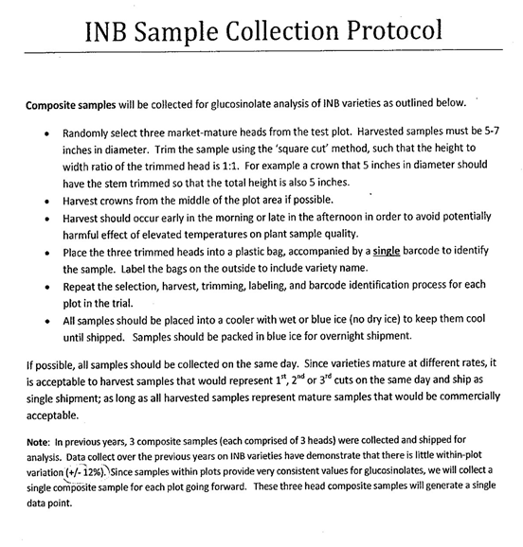
[End of Annex and of document]

