E
TC-EDC/Jan15/25
ORIGINAL: English
DATE: December 16, 2014
INTERNATIONAL UNION FOR THE PROTECTION OF NEW VARIETIES OF PLANTS
Geneva
enlarged editorial Committee
Geneva, January 7 and 8, 2015
Partial Revision of the Test Guidelines for Garden Sorrel (Document TG/268/1)
Document prepared by the Office of the Union
Disclaimer: this document does not represent UPOV policies or guidance
The purpose of this document is to propose a partial revision of Ad. 15 to 18 of the Test Guidelines for Garden Sorrel (document TG/268/1):

Current explanation:

Ad. 15: Stem leaf: length of blade (b)
Ad. 16: Stem leaf: width of blade (a)
Ad. 17: Stem leaf: ratio length/ width of blade
Ad. 18: Stem leaf: length of petiole (c)

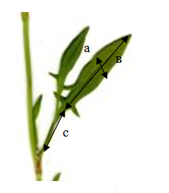
The characteristics should be observed on a fully developed leaf on the middle part of the main stem.

Proposed new illustration:

Ad. 15: Stem leaf: length of blade (b)
Ad. 16: Stem leaf: width of blade (a)
Ad. 17: Stem leaf: ratio length/ width of blade
Ad. 18: Stem leaf: length of petiole (c)

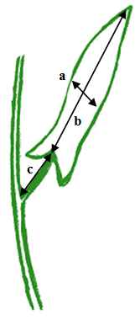
The characteristics should be observed on a fully developed leaf on the middle part of the main stem.

[End of document]

