E
International Union for the Protection of New Varieties of Plants

Technical Committee  Fifty-Fourth Session  Geneva, October 29 and 30, 2018 | TC/54/25  Original: English  Date: July 24, 2018
Cooperation in examination
Document prepared by the Office of the Union
Disclaimer: this document does not represent UPOV policies or guidance

executive summary

The purpose of this document is to present the results of a survey of the current situation of members of the Union with regard to cooperation in examination, as a starting point for discussion on further possibilities to facilitate cooperation.

The TC is invited to consider the results of the survey of the current situation of members of the Union with regard to cooperation in examination, as set out in the Annex to this document.

Background

At its fifty-second session, held in Geneva, from March 14 to 16, 2016, the Technical Committee (TC), as a result of the discussion under agenda item 3 “Discussion on quality parameters for DUS examination”, noted that there may be obstacles to cooperation in examination, including exchange of DUS reports, and agreed to explore the situation further. As a starting point for discussion, the TC agreed that it would be useful for the Office of the Union to conduct a survey of the current situation of members of the Union and to report the results to the TC at its fifty-third session (see document TC/52/29 Rev. “Revised Report”, paragraph 207).

Survey on cooperation

On November 18, 2016, Circular E-16/276 “UPOV Survey: Cooperation in DUS Examination” was issued to designated persons to the Council and TC of members of the Union.

The TC, at its fifty-third session, held in Geneva from April 3 to 5, 2017, considered document TC/53/20 and the oral report by the Office of the Union, which highlighted the following results of the survey (see document TC/53/31 “Report”, paragraphs 146 to 151):

- 93% of respondents were fairly/very confident of options for cooperation (whilst noting that only 38% of UPOV members had replied)
- 50% of respondents reported that the DUS report is used as the basis for the DUS decision without the need for further information
- 30% of respondents considered that further practical measures might facilitate the use of existing DUS reports
- 29% of respondents found that cooperation in DUS examination was “not at all easy”

The Office of the Union reported that the Working Group on a possible International System of Cooperation (WG-ISC) had identified acceptance of DUS reports from any member of the Union as a matter for consideration.

The TC noted that there were important policy aspects relating to cooperation in DUS examination and agreed that the results of the survey should be reported to the WG-ISC with an explanation of the issues, if requested.
The TC agreed that a new survey should be issued in order to increase the number of members of the Union contributing information. The TC agreed that the questions in the previous survey should be used as the basis but the new survey should be shortened by consolidating some of the questions on the basis of the information obtained from the first survey. The TC agreed that the results of the new survey should be presented to the TC at its session in 2018.

On October 24, 2017, the Office of the Union made a presentation on “Existing arrangements for DUS cooperation and the results of the TC survey on cooperation in DUS examination”, during the third meeting of the Working Group on a Possible International System of Cooperation (UPOV/WG-ISC/3), a copy of which is available on the website (see document UPOV/WG-ISC/3/3 “Report”, paragraph 5).

The TC also agreed that the causes of difficulties in establishing cooperation should be investigated via the new questionnaire.

The TC noted the report from Japan on its new administrative procedures to facilitate the exchange of DUS test reports between Japan and other UPOV members, as a result of which, DUS test reports would be provided free of charge for those UPOV members which Japan had a memorandum of cooperation.

On August 10, 2017, Circular E-17/137 “UPOV Survey: Cooperation in DUS Examination” was issued to designated persons to the Council and TC of members of the Union.

Survey results

Complete responses to Circular E-17/137 were received from 55 members of the Union, namely:

African Intellectual Property Organization | Germany | Republic of Korea
Argentina | Hungary | Republic of Moldova
Australia | Israel | Romania
Austria | Italy | Serbia
Belarus | Japan | Slovakia
Bolivia (Plurinational State of) | Jordan | Slovenia
Brazil | Kenya | South Africa
Bulgaria | Latvia | Spain
Canada | Lithuania | Sweden
Chile | Mexico | Switzerland
China | Morocco | Trinidad and Tobago
Colombia | Netherlands | Tunisia
Costa Rica | New Zealand | Turkey
Denmark | Norway | United Kingdom
Ecuador | Panama | United Republic of Tanzania
Estonia | Peru | United States of America
European Union | Poland | Uruguay
Finland | Portugal | Viet Nam
France

The responses to the survey are presented in the Annex to this document.

The TC is invited to consider the results of the survey of the current situation of members of the Union with regard to cooperation in examination, as set out in the Annex to this document.

[Annex follows]

Comment report

Lists all the questions in the survey and displays all the free text responses to these questions, if applicable

Table of contents

Question 1: *UPOV Member on behalf of whom you are completing this survey 2

Question 2: *Name (mandatory) 3

Question 3: *Job title (mandatory) 3

Question 4: *Organization (mandatory) 3

Question 5: *E-mail address (mandatory) 3

Question 6: * Acknowledgement I understand that, for the purposes of this survey, the following ter 3

Question 7: Does your authority accept existing DUS reports from: 4

Question 8: If your authority accepts existing DUS reports from other UPOV members, is the DUS report used as the basis
for the DUS decision without the need for further information 6

Question 9: If your authority accepts existing DUS reports from other UPOV members, do you require that UPOV Test Guidelines are the basis for the DUS examination .7

Question 10: Does your authority provide existing DUS reports to: 8

Question 11: If your authority provides existing DUS reports from other UPOV members, how much do you
charge for the DUS report 9

Question 12: Does your authority cooperate with other UPOV members to avoid parallel/duplicate
DUS examinations for the same variety 11

Question 13: If your authority cooperates with other UPOV members to avoid parallel/duplicate DUS examinations
for the same variety, do you require that UPOV Test Guidelines are the basis for the DUS examination? 13

Question 14: In your experience, how easy is it to arrange cooperation in DUS examination with other UPOV members? 14

Question 15: What is/are the main cause(s) of difficulty in arranging cooperation in DUS examination with other
UPOV members? 15

Question 16: Is the examination in the GENIE database complete and accurate for your authority with regard to
cooperation in DUS examination:
(a) Taxa for which the Authority Offers to carry out DUS Examinations on Behalf of Other Authorities 17

Question 17: Is the examination in the GENIE database complete and accurate for your authority with regard to
cooperation in DUS examination:
(b) Taxa for which Other Authorities carry out the DUS Examination on Behalf of the Authority 18

Question 18: Is the examination in the GENIE database complete and accurate for your authority with regard to
cooperation in DUS examination:
(c) Taxa for which the Authority Offers to provide Existing DUS Reports to other Authorities 19

Question 19: Is the examination in the GENIE database complete and accurate for your authority with regard to
cooperation in DUS examination:
(d) Taxa for which the Authority Utilizes Existing DUS Reports from Other Authorities 20

Question 1:
*UPOV Member on behalf of whom you are completing this survey
(in the alphabetical order of the English names of the Members)

Frequency table
Items | Absolute  frequency | Relative  frequency | Adjusted relative  frequency
African Intellectual Property Organization (OAPI) | 1 | 1.79% | 1.79%
Argentina | 1 | 1.79% | 1.79%
Australia | 1 | 1.79% | 1.79%
Austria | 1 | 1.79% | 1.79%
Belarus | 1 | 1.79% | 1.79%
Bolivia (Plurinational State of) | 1 | 1.79% | 1.79%
Brazil | 1 | 1.79% | 1.79%
Bulgaria | 1 | 1.79% | 1.79%
Canada | 1 | 1.79% | 1.79%
Chile | 1 | 1.79% | 1.79%
China | 2∗ | 3.57% | 3.57%
Colombia | 1 | 1.79% | 1.79%
Costa Rica | 1 | 1.79% | 1.79%
Denmark | 1 | 1.79% | 1.79%
Ecuador | 1 | 1.79% | 1.79%
Estonia | 1 | 1.79% | 1.79%
European Union | 1 | 1.79% | 1.79%
Finland | 1 | 1.79% | 1.79%
France | 1 | 1.79% | 1.79%
Germany | 1 | 1.79% | 1.79%
Hungary | 1 | 1.79% | 1.79%
Israel | 1 | 1.79% | 1.79%
Italy | 1 | 1.79% | 1.79%
Japan | 1 | 1.79% | 1.79%
Jordan | 1 | 1.79% | 1.79%
Kenya | 1 | 1.79% | 1.79%
Latvia | 1 | 1.79% | 1.79%
Lithuania | 1 | 1.79% | 1.79%
Mexico | 1 | 1.79% | 1.79%
Morocco | 1 | 1.79% | 1.79%
Netherlands | 1 | 1.79% | 1.79%
New Zealand | 1 | 1.79% | 1.79%
Norway | 1 | 1.79% | 1.79%
Panama | 1 | 1.79% | 1.79%
Peru | 1 | 1.79% | 1.79%
Poland | 1 | 1.79% | 1.79%
Portugal | 1 | 1.79% | 1.79%
Republic of Korea | 1 | 1.79% | 1.79%
Republic of Moldova | 1 | 1.79% | 1.79%
Romania | 1 | 1.79% | 1.79%
Serbia | 1 | 1.79% | 1.79%
Slovakia | 1 | 1.79% | 1.79%
Slovenia | 1 | 1.79% | 1.79%
South Africa | 1 | 1.79% | 1.79%
Spain | 1 | 1.79% | 1.79%
Sweden | 1 | 1.79% | 1.79%
Switzerland | 1 | 1.79% | 1.79%
Trinidad and Tobago | 1 | 1.79% | 1.79%
Tunisia | 1 | 1.79% | 1.79%
Turkey | 1 | 1.79% | 1.79%
United Kingdom | 1 | 1.79% | 1.79%
United Republic of Tanzania | 1 | 1.79% | 1.79%
United States of America | 1 | 1.79% | 1.79%
Uruguay | 1 | 1.79% | 1.79%
Viet Nam | 1 | 1.79% | 1.79%
Total answered: 56

Question 2:
*Name

Question 3:
*Job title

Question 4:
*Organization

Question 5:
*E-mail address

Question 6:
*Acknowledgement
I understand that, for the purposes of this survey, the following terms are used: • “DUS report” means the information in document TGP/5 “Experience and Cooperation in DUS Testing”, Section 6: UPOV Report on Technical Examination and UPOV Variety Description (see http://www.upov.int/edocs/tgpdocs/en/tgp_5_section_6.pdf) • “Existing DUS report” means a DUS report resulting from a DUS examination that has already been completed by a UPOV member

Question 7:
Does your authority accept existing DUs reports from:
Any other UPOV member
Some other UPOV members
No other UPOV members
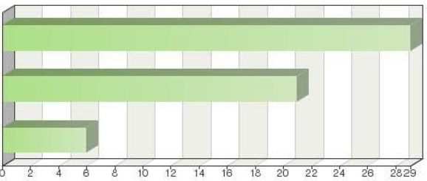

Frequency table
Choices | Absolute  frequency | Adjusted relative  frequency | Adjusted  relative frequency
Any other UPOV member | 29 | 51.79% | 51.79%
Some other UPOV members | 21 | 37.50% | 37.50%
No other UPOV members | 6 | 10.71% | 10.71%
Sum: | 56 | 100% | 100%
Not answered: | 0 | 0% | -
Total answered: 56

Comments

Switzerland accepts DUS reports wherever available
OAPI purchases the reports even if it does not have a formal cooperation agreement with the examination canter in question.
The DUS report must be compatible with the national guidelines
For the time being we do not purchase DUS reports from other UPOV members, but according to our national law this is possible.
only in crops where we have limited technical expertise and or infrastructural limitation
the environmental conditions in which the examination has been done, must be comparable with the Norwegian conditions
Acceptance of reports is near-automatic in the context of CPVO's quality assurance of EU Examination Offices. Outside of this, it is possible but more complex to accept reports from other UPOV members.
Canada accepts DUS test reports from other UPOV members for ornamental and horticulture species, when those members follow UPOV test guidelines and testing procedures/protocols.
Reports provided by EU countries
So far all examinations are carried out mainly because they are used in other registers such as the certification or commercial registers.
Lithuania accept DUS reports from the European Union countries
only if DUS test is on CPVO entrustment level
Preferably from the Northern Hemisphere (agricultural crops)
for listing varieties only members that are included in the EU equivalence regime for maintainers
Currently South Africa accepts existing DUS reports for lucerne, potato, and chrysanthemum
We accepted the DUS Test report from: Japan, France, CVPO, the Netherlands, the Republic of Korea
Only for species where we do not perform our own DUS testing
The CPVO takes over DUS reports from entrusted examination offices of its network. If within the network a DUS report cannot be established, Article 27 of Commission Regulation (EC) No 874/2009 rules the conditions for take-overs from countries outside the EU.
OEVV accepts DUS reports from offices accredited by the Community Plant Variety Office (CPVO).

Question 8:
If your authority accepts existing DUS reports from other UPOV members, is the DUS report used as the basis for the DUS decision without the need for further information
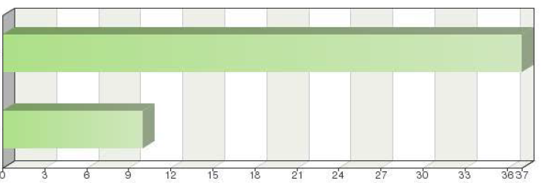
Yes
No

Frequency table
Choices | Absolute  frequency | Relative  frequency | Adjusted  relative frequency
Yes | 37 | 66.07% | 78.72%
No | 10 | 17.86% | 21.28%
Sum: | 47 | 83.93% | 100%
Not answered: | 9 | 16.07%
Total answered: 47

Comments

The report is used as a basis only. It will suffice for informed decision making.
Only on one occasion did we contact the authority concerned, in an examination […]. There was no comparison between the proposed variety and commonly known varieties. However, we were informed that the comparison was not made because the experts felt that the candidate variety did not resemble any collection of reference. With at answer explaining the situation, the decision was taken.
In some cases, we nonetheless request, in addition to the DHS report, a plant material sample for our reference collection. In some rare cases, additional information may be requested (comparison varieties used, raw results of observations and measurements...).
Only in crops that do not require mandatory seed certification and are in closed value chain system
Decisions are based on the DUS report but more information is requested and analyzed in detail.
It is often necessary to ask further questions about reference varieties used in the assessment of distinctness.
Technical and administrative elements are agreed in advance.
DUS report have to be the genuine (original) document, signed and stamped by the official authority which issued report.
The DUS reports from other EU members are used for the DUS decision.
There may be environmental factors that may influence expression such as temperature and amount of sunlight that we may enquire about to see if we need to retest under our conditions. E.g. some test guideline conditions are way outside what we experience here
Sometimes no further information is required but a description of the variety that meets the requirements for publication must be possible. Consequently, in most cases, additional information is needed.
In most cases. If a report is the first from that authority or a first for that species we may request additional information from the authority or have a reduced national growing trial.
We accept DUS reports from examination offices entrusted By CPVO.
It can only form the basis for a decision on a CPVR if the technical examination has been carried out according to the so called entrustment requirements. Those have to be fulfilled in order to become an entrusted examination offices for a given species
A sample of plant material from the variety is also requested.

Question 9:
If your authority accepts existing DUS reports from other UPOV members, do you require that UPOV Test Guidelines are the basis for the DUS examination
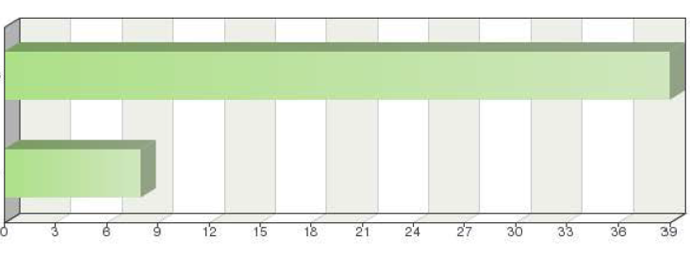
Yes
No

Frequency table
Choices | Absolute  frequency | Relative  frequency | Adjusted  relative frequency
Yes | 39 | 69.64% | 82.98%
No | 8 | 14.29% | 17.02%
Sum: | 47 | 83.93% | 100%
Not answered: | 9 | 16.07%
Total answered: 47

Comments

The requirement for the UPOV guidelines is generally met.
For these Guidelines may not cover all species.
We consider that the UPOV guidelines ensure that harmonization of the analysis to be carried out is maintained, facilitating the understanding of the authority that receives the examination.
But not only: as a member of the European Union, another basis for accepting reports is the CPVO accreditation system.
Considering our national guidelines were based in UPOV guidelines, as well
The Test Guidelines harmonies DUS exercise among the UPOV member states
CPVO test guidelines are also accepted
Sometime we can accept test report with no test guidelines.
The normal requirement is for compliance with CPVO's protocols, which very closely follow UPOV Test Guidelines.
If there aren't UPOV guideline
In case of Community Plant Variety Office (CPVO) we accept DUS Reports made on the basis of CPVO TP Guidelines.
For the species without CPVO protocols.
Reports that go beyond UPOV test guidelines are also of interest to us. Some test guidelines do not capture all forms of expression and may need to be augmented by national test guidelines.
also to non UPOV members
Generally yes but not always. The legislation requires, for example, that the DUS report is 'equivalent' to an examination undertaken in Australia. Although not common, if there is no TG for the crop but it is determined that the testing was conducted using TGP principles then it may be acceptable.
If there is no UPOV TG, a national TG may be acceptable.
when CPVO protocols are available the reports must be in line with those protocols
In case the UPOV Test Guidelines are not existing we accept also DUS reports performed according to the National Test Guidelines
CPVO requires that the CPVO Technical Protocol is the basis for the DUS examination and only if non such CPVO-TP is available, the UPOV-TG as basis is accepted, however the CPVO-TP are based on UPOV TGs
Question 10:
Does your authority provide existing DUS reports to:
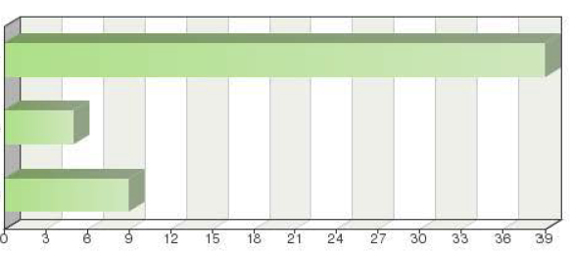

Any other UPOV member
Some other UPOV members
No other UPOV members

Frequency table
Choices | Absolute  frequency | Relative  frequency | Adjusted relative  frequency
Any other UPOV member | 39 | 69.64% | 73.58%
Some other UPOV members | 5 | 8.93% | 9.43%
No other UPOV members | 9 | 10.07% | 16.98%
Sum: | 53 | 94.64% | 100%
Not answered: | 3 | 5.36% | -
Total answered: 53

Comments

We refer to the authority that has carried out the examination.
No restrictions. The authority replies to all requests.
We have little experience in carrying out DUS examinations, but if any authority requests a DUS report from us or if we receive reports from any institution, we can provide them to any UPOV member.
DUS reports of agricultural crops
Our office has no bank account to accept payment from outside. We can provide our DUS test report with no charge between 11 countries under the Memorandum of Cooperation.
Reports are provided to any UPOV member which is prepared to accept them.
The registration system for varieties in Mexico is based on technical reports presented by applicants and therefore, we can only provide to those who have carried out through the authority. So far, only Jatropha curcas l has done this.
It is the responsibility of the other member whether they want to use our results.
As an authority we do not carry out DUS examinations on any crop however, we can request that a local university carry out a DUS examination.
We are willing to but have never had the opportunity as yet.
At no cost
We also provide to non-UPOV member countries
Any UPOV Member or not

Question 11:
If your authority provides existing DUS reports to other UPOV members, how much do you charge for the DUS report:
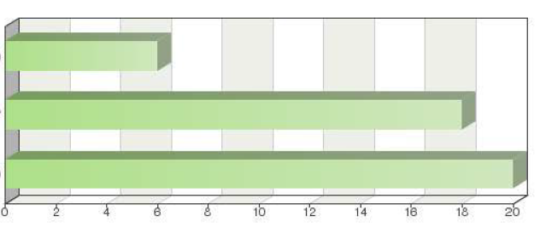
Nothing (free)
350 Swiss Francs
Other (please specify)

Frequency table
Choices | Absolute  frequency | Relative  frequency | Adjusted relative  frequency
Nothing (free) | 6 | 10.71% | 13.64%
350 Swiss Francs | 18 | 32.14% | 40.91%
Other (please specify) | 20 | 25.71% | 45.45%
Sum: | 44 | 78.57% | 100%
Not answered: | 12 | 21.43% | -
Total answered: 44

Other (details)

250 USD
320 Euro
Equivalent of CHF 350, used also by CPVO
240 Euro
$3.60 per page
240 Euro
540 BGN
240 Euro
250$
TT$800.00
Via the payment of 350 Swiss Francs by the applicant, by means of Memorandum of Understanding or simply free of charge
The administrative expenses are included in fees established by the Authority
150 Euro
220 Euro
247,50 Euro
320 Euro

Comments

In accordance with UPOV texts adopted by the members themselves.
Fees established by IEPI.
If we were asked for a DUS report provided by the competent Peruvian authority, there would be no charge since this is not stipulated in our regulations.
The sum in euros is based on 350 Swiss francs.
Equivalent of 320EUR
We provide free of charge DUS reports to UPOV members who provide us with free of charge DUS reports.
under the MOC
The amount is 6,000 Argentinian pesos, which is equivalent to 350 Swiss francs.
There is a memorandum of cooperation between the Mexican and Japanese authorities for the exchange of DUS reports free of charge.
We provide reports to other members. Reports from other members are not provided to third members. There is probably a mistake in the question. The takeover fee may deviate due to exchange rate with Euro.
The base of the calculation of DUS report fee is made on the base of 350 Swiss Francs, during the preparation of the national tariff
The cost of the DUS examination is paid by the law firm that represents the breeder and/or their agent in the country.
We don't provide other counties with existing DUS reports from other UPOV members
The equivalent of 350 Swiss francs paid by the owner of the plant variety or their agent.
This fee is an estimate based on initial discussions and has not yet been set. Final fees may be a scale of fees depending on duration of examination.
The amount is equivalent to 350 Swiss Francs
We don't provide existing DUS reports from other UPOV members. We only provide DUS reports of which we have ownership, then we charge an equivalent of 350 Swiss francs.
According to CPVO fees for agricultural crops
We charge an equivalent of 350 Swiss Frances (equivalent to South African Rands)
The CPVO only provides DUS reports it owns (produced on request from the CPVO by an entrusted EO), not those from other UPOV members. In sells its own DUS reports for an amount of 320 Euros. In case the CPVO gets requests for reports not owned by it we react by stating to the requester to whom he should send the request

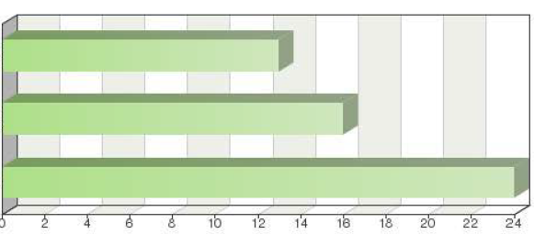
Question 12:
Does your authority cooperate with other UPOV members to avoid parallel/duplicate DUS examinations for the same variety:

Yes, with any other UPOV member
Yes, with some other UPOV members
No

Frequency table
Choices | Absolute  frequency | Relative  frequency | Adjusted relative  frequency
Yes, with any other UPOV member | 13 | 23.21% | 24.53%
Yes, with some other UPOV members | 16 | 28.57% | 30.19%
No | 24 | 42.86% | 45.28%
Sum: | 53 | 94.64% | 100%
Not answered: | 3 | 5.36% | -
Total answered: 53

Comments

Cooperation must be open and diversified. Saves time and leads to efficiency gains.
We do not organize or cooperate with other UPOV members. Rather, our legislation provides for the use of the DUS examination available (conducted by the breeder, an institution or competent authority) or we could even wait for ongoing examinations (created by the breeder, an institution or relevant authority) to be finalized. We do not require applicants to have a fresh DUS examination conducted in our country, unless the applicant so requests.
I have doubts if 'yes' would be the right answer. We don´t have a kind of formal agreement in order to stablish that, for example, for the species X we would carry out the DUS tests for other member; and for species Y, they would carry it for us. In Brazil, the DUS tests results are responsibility of the breeders. For most species (mainly ornamental, fruit and vegetables), they decide if they want carry out the tests by themselves or if they want us to request other authority to carry it out. In these cases, we have just informal agreements (to buy existing reports and to ask some authorities to carry out the DUS tests on our behalf). We only have 1 formal agreement with Japan, but it is to Exchange existing DUS reports
We try to examine with our DUS test results by ourselves, because we have our national TGs which are different from UPOV TGs.
We cooperate with CPVO and EU Member States to avoid duplication.
Canada provides the following options to the applicant (for ornamental and horticulture crops): 1) Conduct the DUS in Canada or 2) Use the DUS from another UPOV member (with provision). However, many applicants may wish to conduct the DUS in Canada even though the report is available from another UPOV member (i.e. observe the phenotype under domestic growing conditions).
In the case that other authority already started with DUS test we will wait until the end of testing, and accept results/DUS report issued by the other authority.
We are willing to but the opportunity has not yet arisen.
Until now this has not occurred.
If we know that a variety is under examination in another member state, then we request for takeover of the DUS-report.
informal arrangements exist in some specific cases
Within the context of CPVO
To some extent, depending on species. For some fruit crops, the length of national testing can be reduced by using a test report as supplementary examination
Cooperation is performed if requested.
In the network of entrusted EOs (sometimes with an exception as described in Article 27, see above) the CPVO takes over exiting DUS reports in order to avoid duplicate testing.
In the area of the CPVO and its accredited examination offices for plant varieties.
Question 13:
If your authority cooperates with other UPOV members to avoid parallel/duplicate DUS examinations for the same variety, do you require that UPOV Test Guidelines are the basis for the DUS examination?
Yes
No
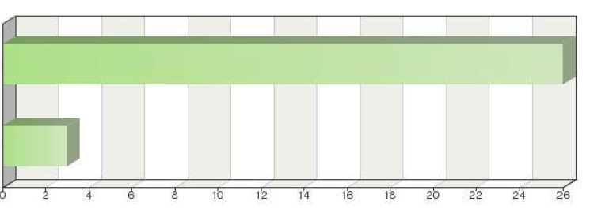

Frequency table

Choices | Absolute  frequency | Relative  frequency | Adjusted  relative frequency
Yes | 26 | 46.43% | 89.6%
No | 3 | 5.36% | 10.34%
Sum: | 29 | 51.79% | 100%
Not answered: | 27 | 48.21%
Total answered: 29

Comments

This requirement is generally met.
An examination based on these principles must yield satisfactory results.
But also the CPVO accreditation system.
If our national guidelines are based on UPOV. PS: note considerations on question 12
or CPVO guidelines
The normal requirement is for compliance with CPVO's protocols, which very closely follow UPOV Test Guidelines.
When no UPOV guideline exists we accept agreed national guideline or protocol.
Generally yes
If CPVO protocols are not available
See above. Basis should be the CPVO-TP, only if not available for the species, the UPOV-TG can be the basis, and in the absences of those, national protocols.
CPVO guidelines are preferably used based, on UPOV. In the absence of CPVO guidelines, those of UPOV are used.

Question 14:
In your experience, how easy is it to arrange cooperation in DUS examination with other UPOV members?

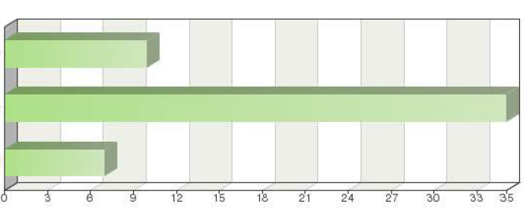
Not at all easy
Fairly easy
Very easy

Frequency table

Choices | Absolute  frequency | Relative  frequency | Adjusted relative  frequency
Not at all easy | 10 | 17.86% |  | 19.23%
Fairly easy | 35 | 62.5% |  | 67.31%
Very easy | 7 | 12.5% |  | 13.46%
Sum: | 52 | 92.86% |  | 100%
Not answered: | 4 | 7.14% |  | -
Total answered: 52

Comments

To very easy
Administratively, it is relatively easy. Technically, it is not easy at all (geographical areas, interaction with the environment, different reference collections between members, etc.).
In most of cases it is pretty easy. It depends on the country.
MOA, China has not accepted any DUS testing report from other UPOV members yet.
Very easy within the EU but the EU approach and PVR regulation makes it difficult to cooperate outside of the EU.
Full range of experiences, from very easy to very difficult/impossible (i.e. do not follow UPOV test guidelines or testing protocols).
The cooperation in DUS examination based on bilateral agreements
I believe there is a lack of knowledge among some members and others can only obtain cooperation through an interpretation that lawyers make of national legislation.
This has little to do with the actual cooperating institutions and more to do with national rules for engaging in any type of agreement or formal cooperation with a foreign institution.
When it is proved that certain quality levels for DUS testing are met, then it is fairly easy to cooperate with other UPOV members.
Phytosanitary restrictions.
Some authorities have requirements which go beyond the basic provision for the exchange of reports in the Convention and from a national view are difficult to understand.
Depending on the variety that is requested.
If it is necessary we can arrange cooperation.
Easy with some members, not so easy with some.
The entrustment requirements ease cooperation. Beyond that, cooperation with countries outside the EU require a higher input.

Question 15:
What is/are the main cause(s) of difficulty in arranging cooperation in DUS examination with other UPOV members?
(more than one can be selected)

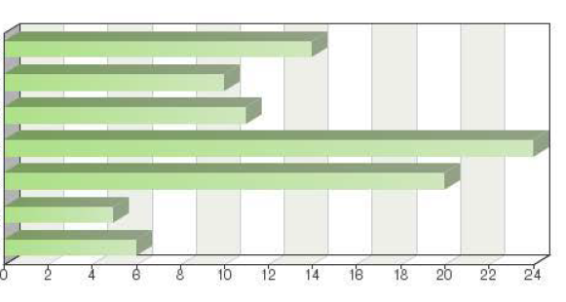
Identifying the correct contact persons
Language difficulties
Knowledge of the possibilities for cooperation
Legal and/or administrative procedures
Technical concerns
Not an accepted policy
Other (please provide details)

Frequency table

Choices | Absolute  frequency | Relative  frequency  by choice | Relative  frequency | Adjusted relative  frequency
Identifying the correct contact persons | 14 | 15.56% | 25% | 31.82%
language difficulties | 10 | 11.11% | 17.86% | 22.73%
Knowledge of the possibilities for cooperation | 11 | 12.22% | 19.64% | 25.00%
Legal and/or administrative procedures | 24 | 26.67% | 42.86% | 54.55%
Technical concerns | 20 | 22.22% | 35.71% | 45.45%
Not an accepted policy | 5 | 5.56% | 8.93% | 11.36%
Other (please provide details) | 6 | 6.67% | 10.71% | 13.64%
Sum: | 90 | 100% | - | -
Not answered: | 12 | - | 21.43% | -
Total answered: 44

Other

Other administrative agreement
not allowing the breeder to pay it directly to the Authority
Comparative trials

Comments

We are not clear on some aspects of the procedures of each office from which we request examination results, e.g., we do not know the period needed to process our application –from when we e-mail the UPOV-form requesting an examination both to issue the fee payment order (if required) and to send the final report of the DUS examination when payment has been made. We do not know the time limit allowed for the person or institution in charge of making the payment to do so from when they receive the payment order. We also do not know when they are notified. On some occasions it is difficult to get a response from a particular office for any consultation despite using the contact details mentioned on the UPOV website. It would be advisable to make a directory of contacts for each office for the sole purpose of cooperation in DUS examinations.
Requirements for Plant health certificates for vegetatively multiplicated plants
We tend to mind difference of expression of characteristics taken by other area. Especially expression of color would be affected by climate or location.
There is very interesting argument against arranging cooperation in DUS examination with some EU UPOV members: for undertaking the examination for distinctness need full collection EU common knowledge varieties and so on.
Some countries are not aware of the alternatives to cooperation, especially those that do not participate in UPOV meetings, while others have problems with interpretations of their legislation. In some countries staff in offices is changed frequently.
Previously were comparative trials conducted, however this is no longer the case. This is conceived as a deficiency.
The Convention provides the basis for the exchange of reports and it can be frustrating when authorities add additional requirements such as separate cooperation agreements.
It is necessary to know whether the UPOV member can cooperate with other members and the experience it has.
Up to now we don't need any technical requirement
'Not an accepted policy' unless conditions under Article 27 are fulfilled

Question 16:
Is the information in the GENIE database complete and accurate for your authority with regard to cooperation in DUS examination:

(a) Taxa for which the Authority Offers to carry out DUS Examinations on Behalf of Other Authorities

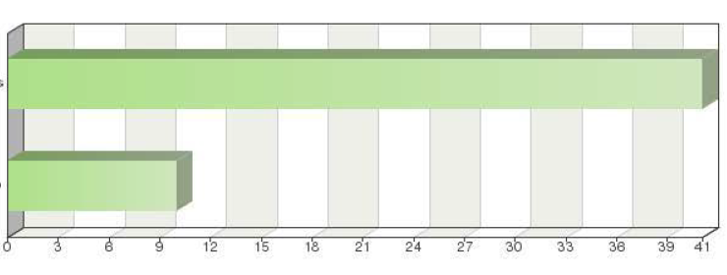
Yes
No

Frequency table
Choices | Absolute  frequency | Relative  frequency | Adjusted relative  frequency
Yes | 41 | 73.21% | 80.39%
No | 10 | 17.86% | 19.61%
Sum: | 51 | 91.07% | 100%
Not answered: | 5 | 8.93% | -
Total answered: 51

Comments

Yes and no – the information is a little unclear. It would also be useful to be able to retrieve the address of the competent authority and possibly see an application deadline (date) for the relevant variety.
Yes, will be updated systematically.
Yes, but Canada has not yet offered, nor has another UPOV member requested that we conduct DUS Examinations on their behalf. Could be a possibility in future if there was sufficient demand.
We had no experience for DUS examination on behalf of other authorities instead we offer some report to other country.
Taxa for the DUS examination is not high.
We were not able to send all the information.
N/A. As all the species Finland has needed to test, have been tested in Europe and information on Examination offices is available from CPVO.
South Africa does not carry out DUS Examinations on behalf of other authorities (GENIE database indicates otherwise)

Question 17:
(b) Taxa for which Other Authorities carry out the DUS Examination on Behalf of the Authority
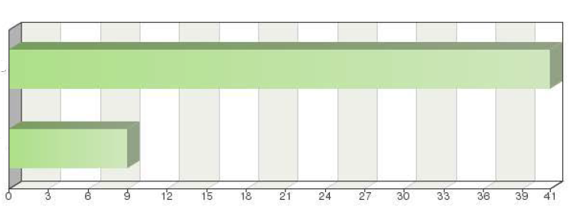
Yes
No

Frequency table
Choices | Absolute  frequency | Relative  frequency | Adjusted relative  frequency
Yes | 41 | 73.21% | 82%
No | 9 | 16.07% | 18%
Sum: | 50 | 89.29% | 100%
Not answered: | 6 | 10.71% | -
Total answered: 50

Comments

Yes and no – the information is a little unclear. It would also be useful to be able to retrieve the address of the competent authority and possibly see an application deadline (date) for the relevant variety.
Yes, will be updated systematically.
Yes, but not really applicable in our situation. Canada will always provide the following options for the applicant/breeder to: a) conduct the DUS domestically, or for ornamental/horticulture crops, b) use a DUS report from another UPOV member. Obviously, in cases where a variety is unadapted to Canadian agro-climatic growing conditions, the applicant would have to use an existing DUS report from another UPOV member.
Sweden collaborates within CPVO
N/A. As all the species Finland has needed to test, have been tested in Europe and information on Examination offices is available from CPVO.
South Africa does not have other authorities carry out DUS Examinations on their behalf (GENIE database indicates otherwise)

Question 18:
(c) Taxa for which the Authority Offers to provide Existing DUS Reports to other Authorities

Yes
No
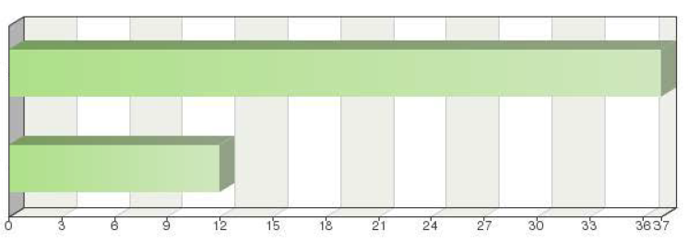

Frequency table

Choices | Absolute  frequency | Relative  frequency | Adjusted relative  frequency
Yes | 37 | 66.07% | 75.51%
No | 12 | 21.43% | 24.49%
Sum: | 49 | 87.5% | 100%
Not answered: | 7 | 12.5% | -
Total answered: 49

Comments

Yes and no – the information is a little unclear. It would also be useful to be able to retrieve the address of the competent authority and possibly see an application deadline (date) for the relevant variety.
Yes, will be updated systematically.
Phalaris arundinacea should be taken out from the list
We can offer DUS reports for the soybean species.
Unlikely to be up to date for species which are no longer tested in the United Kingdom
Apart from entering details in the Genie data base, we can carry out DUS examinations for the following varieties: wheat, barley, rape, oats, dactylis, bromus catharticus, red clover, white clover, alfalfa, lotus, moha, sudangrass, rice, soy, potato, strawberry, sweet potato and chicory.
Sweden collaborates within CPVO
South Africa offers to provide existing DUS reports to other Authorities for all taxa we are examining (GENIE indicates selected taxa)
No update. The office provides existing DUS reports to the following other Authorities: AT, BE, BIH, BG, HR, IR, MOL, CZ, RO, RS, HU, SK, SI, TR, RU, UA.

Question 19:
(d) Taxa for which the Authority Utilizes Existing DUS Reports from other Authorities

Yes
No
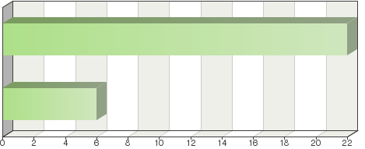

Frequency table
Choices | Absolute  frequency | Relative  frequency | Adjusted relative  frequency
Yes | 37 | 66.07% | 77.08%
No | 11 | 19.64% | 22.92%
Sum: | 48 | 85.71% | 100%
Not answered: | 8 | 14.29% | -
Total answered: 48

Comments

Yes and no – the information is a little unclear. It would also be useful to be able to retrieve the address of the competent authority and possibly see an application deadline (date) for the relevant variety.
Yes, will be updated systematically.
We have also requested corresponding DUS reports for the following species: vine, apple tree, pear tree, strawberry, raspberry, cherry, tangelo, orange tree, kiwi, tomato, carrot, melon, onion, watermelon.
The EU system makes this difficult to answer. In principle, we would accept any CPVO report but rarely need to do so.
Minor amendments required to the information displayed, resulting from a recent expansion of the Canada's DUS policy.
We had no experience for utilizes existing DUS reports from other authorities.
Citrus
Sweden collaborates within CPVO
Chrysanthemum is not listed

[End of annex and of document]

∗ Ministry of Agriculture and State Forestry Administration

