E
TC/52/20
ORIGINAL: English
DATE: January 27, 2016
INTERNATIONAL UNION FOR THE PROTECTION OF NEW VARIETIES OF PLANTS
Geneva
Technical Committee
Fifty-Second Session
Geneva, March 14 to 16, 2016
Revision of document TGP/10: New section: Assessing Uniformity by Off-Types
on the Basis of More than One growing cycle or on the basis of Sub-Samples
Document prepared by the Office of the Union
Disclaimer: this document does not represent UPOV policies or guidance
EXECUTIVE SUMMARY

The purpose of this document is to present a proposal for revision of document TGP/10 “Examining uniformity” to provide guidance on assessing uniformity by off-types on the basis of more than one growing cycle or on the basis of sub-samples.

The TC is invited to:

(a) consider the new proposed “Approach 3: Combining the results of two growing cycles” for the assessment of uniformity by off-types, as presented in Annex I to this document;
(b) note that the TWA agreed to request a video link with the experts from the TWC to discuss the new proposed “Approach 3: Combining the results of two growing cycles” at its forty-fifty session, to be held in 2016;
(c) consider whether to clarify in the text that the guidance in Annex I is not intended to be used for the assessment of uniformity by off-types on the same plants in two growing cycles; and
(d) consider the draft guidance as presented in Annexes I and II for inclusion in a future revision of document TGP/10.

The structure of this document is as follows:
DEVELOPMENTS IN 2015 2
Technical Committee 2
Technical Working Parties 2
Technical Working Party for Vegetables 2
Technical Working Party on Automation and Computer Programs 3
Technical Working Party for Agricultural Crops 3
Technical Working Party for Fruit Crops 4
Technical Working Party on Ornamental Plants 4
Summary of approaches 4
ANNEX I: Assessing uniformity by off-types on basis of more than one growing cycle
ANNEX II: Assessing uniformity by off-types on the basis of sub-samples within a single test/trial
ANNEX III: Assessing uniformity by off-types on the basis of more than one growing cycle: risks benefits and costs (Presentation by the experts from Germany and the United Kingdom) during
the thirty-third session of the TWC, held in Natal, Brazil, from June 30 to July 3, 2015)
(in English only)
The following abbreviations are used in this document:

TC: Technical Committee
TC-EDC: Enlarged Editorial Committee
TWA: Technical Working Party for Agricultural Crops
TWC: Technical Working Party on Automation and Computer Programs
TWF: Technical Working Party for Fruit Crops
TWO: Technical Working Party for Ornamental Plants and Forest Trees
TWPs: Technical Working Parties
TWV: Technical Working Party for Vegetables

BACKGROUND

The background to this matter is provided in document TC/51/24 “Assessing Uniformity by Off-Types on the Basis of More than One Sample or Sub-Samples”.

DEVELOPMENTS IN 2015

Technical Committee

The TC, at its fifty-first session held in Geneva from March 23 to 25, 2015, considered document TC/51/24 “Revision of document TGP/10: New section: Assessing Uniformity by Off-Types on Basis of More than One Sample or Sub-Samples”.

The TC agreed with the proposals made by the TWPs at their sessions in 2014 and the TC-EDC at its meeting in January 2015, on the draft guidance for inclusion in a future revision of document TGP/10, as presented in Annexes I to IV to document TC/51/24.

The TC agreed that the title of the document should be amended to read: “Assessing uniformity by off-types on basis of more than one growing cycle or on the basis of sub-samples”.

The TC agreed that situations A and B as presented in Annexes I and II to document TC/51/24 should be combined, with an explanation that two independent growing cycles could take place in a single location in different years, or in different locations in the same year, according to document TGP/8 Part I, Sections 1.2 and 1.3.

The TC agreed to invite members of the Union to present to the TWPs and the TC information on the risks, benefits, cost implications and other relevant aspects in their choice of Approach 1 and 2 when assessing uniformity by off-types on basis of more than one sample or sub-sample, as set out in Annexes I and II to document TC/51/24

The TC agreed to clarify the possibility to reject a variety on the basis of a lack of uniformity after a single growing cycle. It further agreed to review the fifth example to be more realistic, given that a variety with 10 off-types in the first growing cycle would probably be rejected after the first growing cycle (see document TC/51/39 “Report”, paragraphs 157 to 162).

By means of Circular E-15/108 of May 5, 2015, the TC and TWP members and observers were invited to present information on the risks, benefits, cost implications and other relevant aspects in their choice of Approach 1 and 2 when assessing uniformity by off-types on basis of more than one sample or sub-sample, as set out in Annexes I and II to document TC/51/24, during the TWP sessions.

Technical Working Parties

Technical Working Party for Vegetables

The TWV, at its forty-ninth session, held in Angers, France, from June 15 to 19, 2015, considered document TWV/49/9 “Revision of document TGP/10: New section: Assessing Uniformity by Off-Types on Basis of More than One Growing Cycle or on the Basis of Sub-Samples”.

The TWV agreed with the draft guidance for inclusion in a future revision of document TGP/10, as presented in Annexes I and II to document TWV/49/9 (see document TWV/49/32 Rev. “Revised Report”, paragraphs 62 and 63).

Technical Working Party on Automation and Computer Programs

The TWC, at its thirty-third session, held in Natal, Brazil, from June 30 to July 3, 2015, considered document TWC/33/9 “Revision of document TGP/10: New section: Assessing Uniformity by Off-Types on Basis of More than One Growing Cycle or on the Basis of Sub-Samples”.

The TWC considered the draft guidance in document TWC/33/9, Annex I, and agreed to propose amending the title of Approach 2 to read “Combining the results of two growing cycles in the case of inconsistent results”.

The TWC received a presentation by the experts from Germany and the United Kingdom, as reproduced in Annex III of this document (English only), and agreed to propose the addition of the third approach to the draft guidance as follows:

“Approach 3: Combining the results of two growing cycles

“A variety is considered uniform if the total number of off-types at the end of the two growing cycles does not exceed the number of allowed off-types for the combined sample.

“A variety is considered non-uniform if the total number of off-types at the end of the two growing cycles exceeds the number of allowed off-types for the combined sample.

“A variety may be rejected after a single growing cycle, if the number of off-types exceeds the number of allowed off-types for the combined sample (over two cycles).

“Care is needed when considering results that are very different in each of the growing cycles, such as when a type of off-type is observed at a high level in one growing cycle and is absent in another growing cycle. A statistical test for consistency is possible.”

The TWC noted that the approach presented by the experts from Germany and the United Kingdom was used in the United Kingdom and always combined the results of two growing cycles. The TWC noted the explanation that this approach allowed an early decision on uniformity to be taken when the number of off-types was greater in a sub-sample than the allowed number for the combined sample. The TWC also noted the explanation that this approach reduced the type 2 error (to accept a non-uniform variety), when compared with the other two approaches presented in the draft guidance, by considering the overall risk of the combined samples instead of the risks for each stage of evaluation separately.

The TWC agreed that the presentation made by the experts from Germany and the United Kingdom should be made available to the other TWPs (see document TWC/33/30 “Report”, paragraphs 57 to 61).

Technical Working Party for Agricultural Crops

The TWA, at its forty-forth session, held in Obihiro, Japan, from July 6 to 10, 2015, considered document TWA/44/9 “Revision of document TGP/10: New section: Assessing Uniformity by Off-Types on Basis of More than One Growing Cycle or on the Basis of Sub-Samples”.

The TWA agreed that the draft guidance for inclusion in a future revision of document TGP/10, as presented in document TWA/44/9 Annex I, should continue to be developed considering the information provided by the TWC on the proposed “Approach 3: combining the results of two growing cycles” and the comparison between the overall risk of the combined samples and the risks for each stage of evaluation separately. The TWA agreed to request a video link with the experts from the TWC to discuss the proposed “Approach 3”.

The TWA agreed to propose that the first sentence in Annex I be amended to read: “two independent growing cycles could take place in a single location in different years, or in different locations in the same year, according to document TGP/8 Part I, Sections 1.2 and 1.3.”

The TWA considered the draft guidance provided in document TWA/44/9 Annex I, on the possibility to reject a variety on the basis of a lack of uniformity after a single growing cycle. The TWA agreed that a variety should not be rejected if the uniformity standard is slightly exceeded in the first year. This possibility should only be used if it can be foreseen that the maximum limit will be exceeded also in another growing cycle. In this regard, the TWA agreed to propose that the explanation provided in Annex I on the possibility to reject a variety on the basis of a lack of uniformity after a single growing cycle should be amended to read: “Furthermore, on the basis of a clear lack of uniformity, a variety may be rejected after a single growing cycle” (see document TWA/44/23 “Report”, paragraphs 52 to 55)

Technical Working Party for Fruit Crops

The TWF, at its forty-sixth session, held in Mpumalanga, South Africa, from August 24 to 28, 2015, considered document TWF/46/9 “Revision of document TGP/10: New section: Assessing Uniformity by Off-Types on Basis of More than One Growing Cycle or on the Basis of Sub-Samples”.

The TWF received an oral report by an expert from New Zealand on the assessment of uniformity using more than one growing cycle: New Zealand’s experience for apple varieties originating as mutations.

The TWF also received an oral report by an expert from France on assessing uniformity by off types on basis of more than one growing cycle or on the basis of sub samples: considerations on uniformity, distinction and description.

The TWF agreed that the authority in charge of DUS examination should be able to refuse a candidate because of a lack of uniformity after the first growing cycle, in particular for fruit crops where number of growing cycles was normally two.

The TWF considered the draft guidance for inclusion in a future revision of document TGP/10, as presented in Annexes I and II to document TWF/46/9. The TWF agreed that it should be clarified in the document whether the guidance in Annex I was meant for combining the results of two growing cycles of the same plant material (perennial crops). The TWF agreed that the document should continue to be discussed at its next session.

The TWF agreed to propose the following amendment to clarify the decision rule in Annex I, Approach 2: “…a variety is considered uniform if the total number of off-types at the end of the two growing cycles does not exceed the number of allowed off-types for the combined sample size of growing cycles 1 and 2 combined” (see document TWF/46/29 “Report”, paragraphs 55 to 60).

Technical Working Party on Ornamental Plants

The TWO, at its forty-eighth session, held in Cambridge, United Kingdom, from September 14 to 18, 2015, considered document TWO/48/9 “Revision of document TGP/10: New section: Assessing Uniformity by Off-Types on Basis of More than One Growing Cycle or on the Basis of Sub-Samples”.

The TWO noted that when assessing uniformity by off-types on the same plants in two growing cycles the same off-type plants observed in the first growing cycle would still be off-types in the second growing cycle in addition to any other off-type plants observed only in the second growing cycle and agreed that combining the sample sizes in both growing cycles was not useful for the assessment of uniformity by off-types in ornamental plants.

The TWO agreed that it should be clarified in document TWO/48/9 that the guidance provided was not intended to be used for the assessment of uniformity by off-types on the same plants in two growing cycles.

The TWO also agreed that the numbers of off-types in the examples provided in Annex I, second growing cycle column, lines 2 and 3 (number of off-types = 3), should have an asterisk to indicate that “care is needed when considering results that were very different in each of the growing cycles, such as when a type of off-type was observed at a high level in one growing cycle and was absent in another growing cycle.”

Summary of approaches

Annexes I and II to this document summarize different situations when different samples are combined for the overall assessment of uniformity of a variety in accordance with the conclusions of the TC at its fifty-first session and on the basis of the proposals made by the TWPs at their sessions in 2015, as follows:

Note for revisions of Annex I

Strikethrough (highlighted) indicates proposed deletion of text according to amendments proposed by the TWPs, at their sessions in 2015.

Underlining (highlighted) indicates proposed insertion of text according to amendments proposed by the TWPs, at their sessions in 2015.

Annex I: Assessing uniformity by off-types on basis of more than one growing cycle

Approach 1: Third growing cycle in the case of inconsistent results
Approach 2: Combining the results of two growing cycles in the case of inconsistent results
Approach 3: Combining the results of two growing cycles

Annex II: Assessing sub-samples within a single test/trial

Approach: Sub-sample as a first step of assessment

The summary in Annexes I and II only relates to situations where more than one sample, or sub-sample, concern the examination of the same characteristic. In the case of different samples, or sub-samples (e.g. special test), to examine a different characteristic there is no requirement to combine the results because a variety is required to be uniform for all relevant characteristics.

The TC is invited to:

(a) consider the new proposed “Approach 3: Combining the results of two growing cycles” for the assessment of uniformity by off-types, as presented in Annex I to this document;

(b) note that the TWA agreed to request a video link with the experts from the TWC to discuss the new proposed “Approach 3: Combining the results of two growing cycles” at its forty-fifty session, to be held in 2016;

(c) consider whether to clarify in the text that the guidance in Annex I is not intended to be used for the assessment of uniformity by off-types on the same plants in two growing cycles; and

(d) consider the draft guidance as presented in Annexes I and II for inclusion in a future revision of document TGP/10.

[Annexes follow]

ASSESSING UNIFORMITY BY OFF-TYPES ON BASIS OF MORE THAN ONE GROWING CYCLE

Two independent growing cycles could take place in a single location in different years, or in different locations in the same year, according to (see document TGP/8 Part I, Sections 1.2 and 1.3)

The following guidance is not intended to be used for the assessment of uniformity by off-types on the same plants in two growing cycles.

Approach 1: Third growing cycle in the case of inconsistent results

A variety is considered uniform if it is within the uniformity standard in both of the two growing cycles.

A variety is considered non-uniform if it fails to meet the uniformity standard in both of the two growing cycles.

If at the end of the two growing cycles the variety is within the uniformity standard in one growing cycle but is not within the uniformity standard in the other growing cycle, then uniformity is assessed in a third growing cycle. If in the third growing cycle the variety is within the uniformity standard, the variety is considered uniform. If in the third growing cycle the variety fails to meet the uniformity standard, the variety is considered non-uniform.

Care is needed when considering results that were very different in each of the growing cycles, such as when a type of off-type was observed at a high level in one growing cycle and was absent in another growing cycle.

Furthermore, on the basis of a clear lack of uniformity, a variety may be rejected after a single growing cycle.

Approach 2: Combining the results of two growing cycles in the case of inconsistent results

A variety is considered uniform if it is within the uniformity standard in both of the two growing cycles.

A variety is considered non-uniform if it fails to meet the uniformity standard in both of the two growing cycles.

If at the end of the two growing cycles the variety is within the uniformity standard in one growing cycle but is not within the uniformity standard in the other growing cycle, a variety is considered uniform if the total number of off-types at the end of the two growing cycles does not exceed the number of allowed off-types for the combined sample size of growing cycles 1 and 2 combined.

Care is needed when considering results that were very different in each of the growing cycles, such as when a type of off-type was observed at a high level in one growing cycle and was absent in another growing cycle.

Furthermore, on the basis of a lack of uniformity, a variety may be rejected after a single growing cycle.

Approach 3: Combining the results of two growing cycles

A variety is considered uniform if the total number of off-types at the end of the two growing cycles does not exceed the number of allowed off-types for the combined sample.

A variety is considered non-uniform if the total number of off-types at the end of the two growing cycles exceeds the number of allowed off-types for the combined sample.

A variety may be rejected after a single growing cycle, if the number of off-types exceeds the number of allowed off-types for the combined sample (over two cycles).

Care is needed when considering results that are very different in each of the growing cycles, such as when a type of off-type is observed at a high level in one growing cycle and is absent in another growing cycle. A statistical test for consistency is possible.

Example:
 |  | Population Standard = 1%
 |  | Acceptance Probability ≥ 95%
 |  | Sample Size in each of growing cycles 1 and 2 = 50
 |  | Maximum number of Off-Types = 2
 |  | Sample Size in growing cycles 1 and 2 combined = 100
 |  | Maximum number of Off-Types = 3
 |  | Growing cycle |  |  | Decision
 |  | First | Second |  | Approach 1 |  | Approach 2 | Approach 3
 | Number of  Off-Types | 1 | 1 |  | uniform |  | uniform | uniform
 |  | 2 | 2 |  | uniform |  | uniform | non-uniform
 |  | 0 | 3* |  | third growing cycle* |  | uniform* | uniform*
 |  | 1 | 3* |  | third growing cycle* |  | non-uniform* | non-uniform*
 |  | 1 | 4* |  | third growing cycle* |  | non-uniform* | non-uniform*
 |  | 4 | 1* |  | third growing cycle* |  | non-uniform* | non-uniform

* Care is needed when considering results that were very different in each of the growing cycles, such as when a type of off-type was observed at a high level in one growing cycle and was absent in another growing cycle.

[Annex II follows]

SITUATION: ASSESSING UNIFORMITY BY OFF-TYPES ON THE BASIS OF SUB-SAMPLES
WITHIN A SINGLE TEST/TRIAL

Approach: Use of sub-sample as a first step of assessment

A variety is considered uniform if the number of off-types does not exceed a predefined lower limit in the sub-sample.

A variety is considered non–uniform if the number of off-types exceeds a predefined upper limit in the sub-sample.

If the number of off-types is between the predefined lower and upper limits, the whole sample is assessed. The lower and upper limits have to be chosen considering comparable type I and type II errors in the sub-sample and the whole sample.

Example:

In a sample size of 100 plants, the acceptable number of off-types is 3 (based on a population standard of 1% and an acceptance probability of at least 95%).

In a subsample of 20 plants used in the context of the sample size of 100 plants above:

A variety is considered uniform if no off-types are observed in the sub-sample.

A variety is considered non–uniform if the number of off-types in the sub-sample exceeds 3.

If the number of off-types is 1 to 3, the whole sample of 100 plants is assessed.

If the number of off-types in the sample of 100 plants exceeds 3, the variety is considered non-uniform.

Document TWC/32/9 Annex V provides a full description of the statistical basis for this approach.

[Annex III follows]

(in English only)

Assessing uniformity by off-types on the basis of more than one growing cycle: risks benefits and costs

Presentation by the experts from Germany and the United Kingdom during the thirty-third session of the TWC, held in Natal, Brazil, from June 30 to July 3, 2015 (document TWC/33/25)

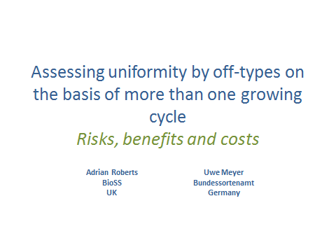

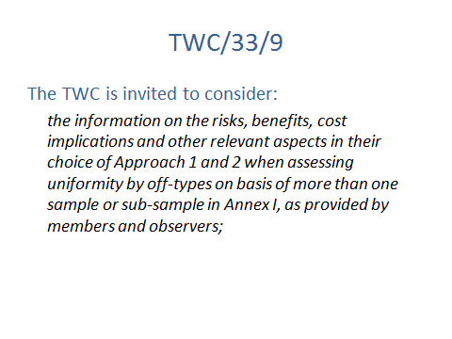

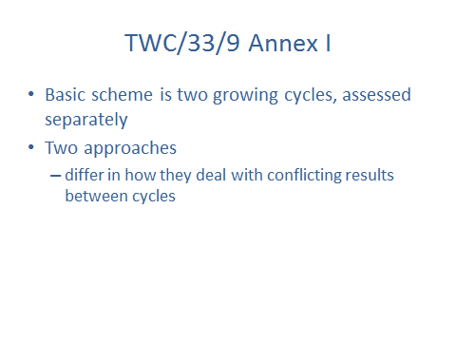

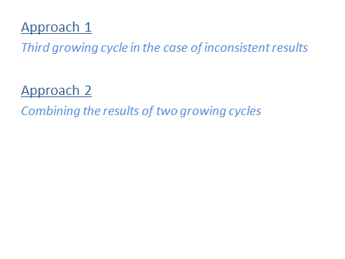

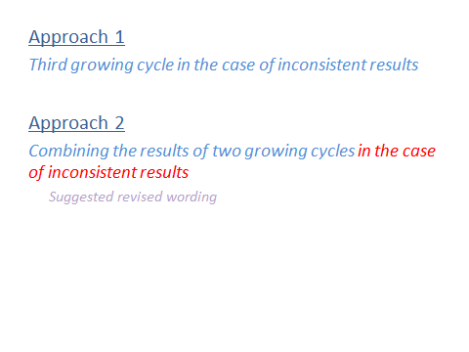

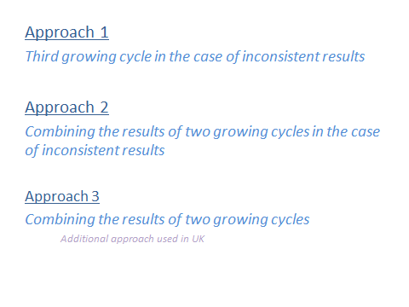

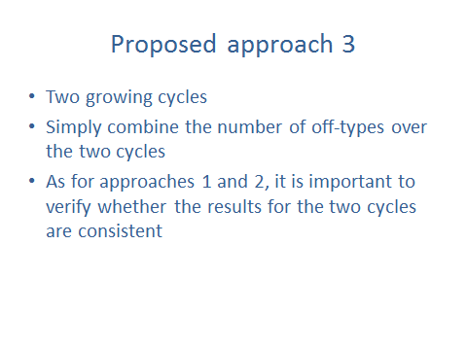

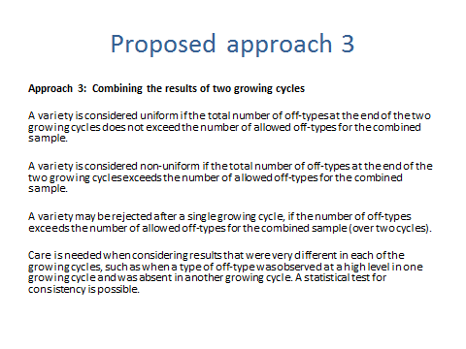

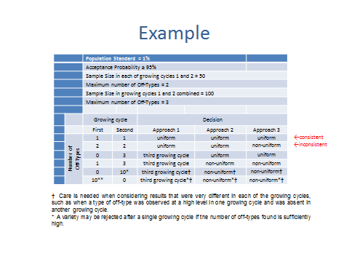

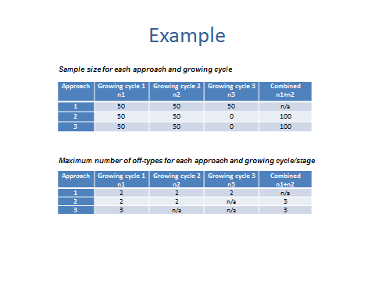

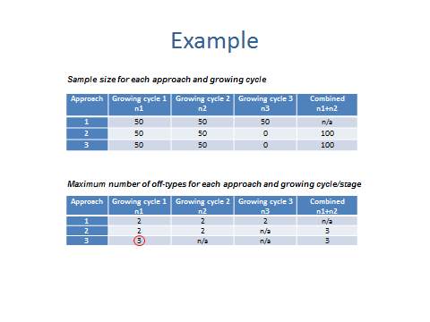

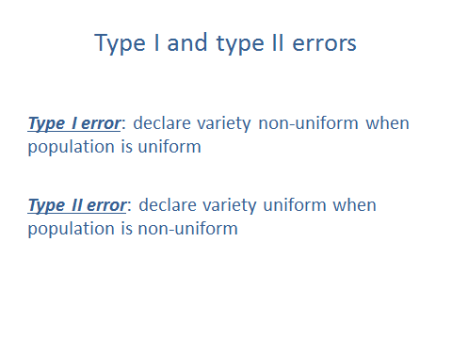

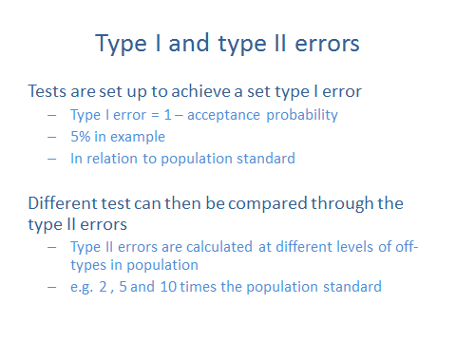

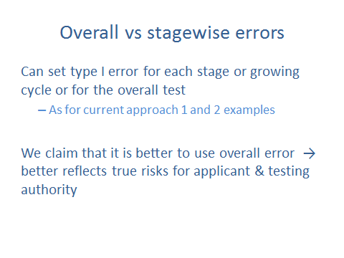

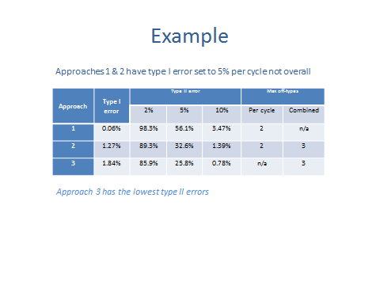

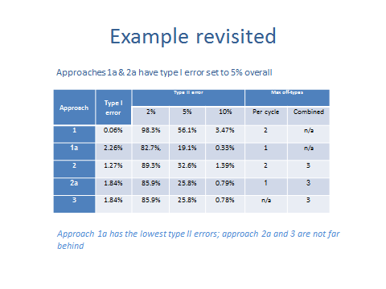

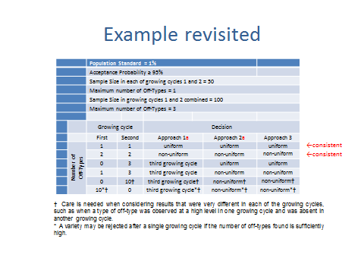

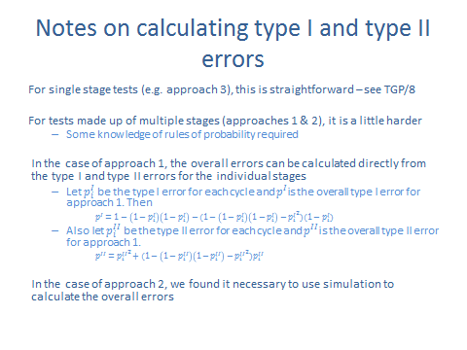

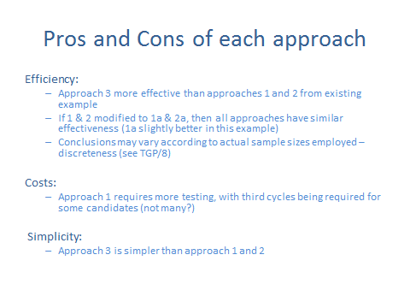

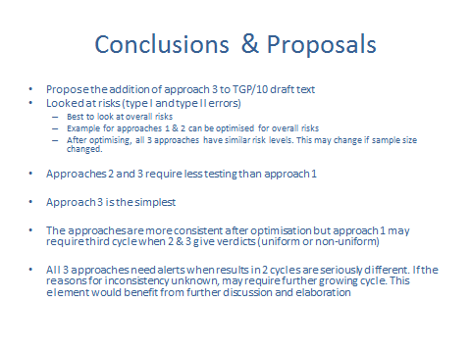

[End of Annex III and of document]

