E
TC/52/17 Add.
ORIGINAL: English
DATE: March 2, 2016
INTERNATIONAL UNION FOR THE PROTECTION OF NEW VARIETIES OF PLANTS
Geneva
Technical Committee
Fifty-Second Session
Geneva, March 14 to 16, 2016
ADDENDUM TO DOCUMENT TC/52/17

Revision of document TGP/8: Part II: Selected Techniques Used in DUS Examination, Section 9: THE COMBINED-OVER-YEARS UNIFORMITY CRITERION (COYU)
Document prepared by the Office of the Union
Disclaimer: this document does not represent UPOV policies or guidance
The Annex to this document contains a copy of a presentation by an expert from the United Kingdom on the Combined-Over-Years Uniformity Criterion (COYU) (in English only) to be made at the fifty-second session of the Technical Committee, to be held in Geneva, from March 14 to 16, 2016.

[Annex follows]

COMBINED OVER-YEARS UNIFORMITY (COYU) CRITERION
(IN ENGLISH ONLY)

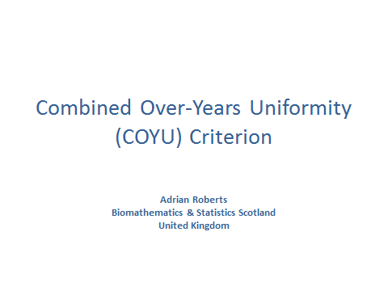

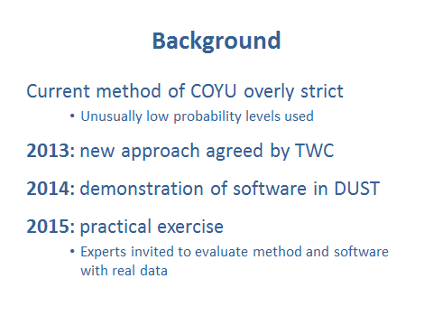

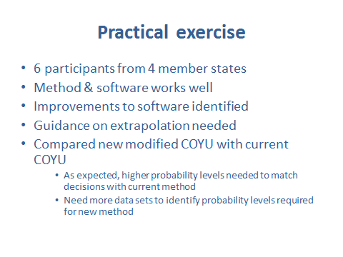

[End of Annex and of document]

