E
TC/52/17
ORIGINAL: English
DATE: January 27, 2016
INTERNATIONAL UNION FOR THE PROTECTION OF NEW VARIETIES OF PLANTS
Geneva
Technical Committee
Fifty-Second Session
Geneva, March 14 to 16, 2016
Revision of document TGP/8: Part II: Selected Techniques Used in DUS Examination, Section 9: THE COMBINED-OVER-YEARS UNIFORMITY CRITERION (COYU)
Document prepared by the Office of the Union
Disclaimer: this document does not represent UPOV policies or guidance

EXECUTIVE SUMMARY

The purpose of this document is to report on developments concerning the method of calculation of the Combined-Over-Years Uniformity Criterion (COYU).

The TC is invited to note that:

(a) experts from Finland, France, Germany, Kenya and the United Kingdom participated in the exercise to test the software module on the new method for calculation of COYU;

(b) the TWC agreed that the new method for calculation of COYU worked well in practice and agreed to request the expert from the United Kingdom to provide guidance on extrapolation when the candidate had a level of expression outside that seen in the reference varieties;

(c) the TWC noted the need for larger data sets to be tested in order to develop probability levels for the new method. Such data sets should include at least 100 candidate varieties, with a possibility that data for those 100 varieties could be derived from several years;

(d) the TWC agreed to invite experts from China and France to join in the next steps of the practical exercise and to provide their data sets for use in the testing; and

(e) the TWC proposed to invite the TWA to provide large data sets from field crops in order to identify suitable probability levels on the new method for calculation of COYU.

The following abbreviations are used in this document:

TC: Technical Committee
TC-EDC: Enlarged Editorial Committee
TWA: Technical Working Party for Agricultural Crops
TWC: Technical Working Party on Automation and Computer Programs
TWF: Technical Working Party for Fruit Crops
TWO: Technical Working Party for Ornamental Plants and Forest Trees
TWPs: Technical Working Parties
TWV: Technical Working Party for Vegetables

The structure of this document is as follows:

EXECUTIVE SUMMARY 1
BACKGROUND 2
DEVELOPMENTS IN 2015 2
Technical Committee 2
Technical Working Parties 2

ANNEX : New Statistical Method for Visually Observed Characteristics with Multinomial Distributed Data (English only)

BACKGROUND

The background to this matter is provided in document TC/51/17 “Revision of document TGP/8: Part II: Selected Techniques Used in DUS Examination, Section 9: The Combined-Over-Years Uniformity Criterion (COYU)”.

DEVELOPMENTS IN 2015

Technical Committee

The TC, at its fifty-first session, held in Geneva, from March 23 to 25, 2015, considered document TC/51/17 “Revision of document TGP/8: Part II: Selected Techniques Used in DUS Examination, Section 9: The Combined-Over-Years Uniformity Criterion (COYU)” and a practical exercise using real data to compare decisions made using the current and the proposed improved method of calculation of COYU (see document TC/51/39 “Report”, paragraphs 134 to 138).

The TC noted that participants of the exercise to test the software on the new method for the calculation of COYU should:

(i) seek to define probability levels to match decisions using the previous COYU method;
(ii) run the test for rejection probabilities of 1, 2 and 5% levels; and
(iii) assess whether the results are consistent in all crops.

The TC noted that the expert from the United Kingdom had distributed the software module for calculation of COYU and the guidance document to participants of the exercise.

The TC noted that the experts from Czech Republic, France, Finland, Germany, Kenya, Poland and United Kingdom would participate in the exercise to test the new software on COYU.

The TC noted that a report on the practical exercise and the development of the DUST module would be presented at the thirty-third session of the TWC.

Technical Working Parties

At their sessions in 2015, the TWV, TWC, TWA, TWF and TWO considered documents TWV/49/16, TWC/33/16 and TWC/33/16 Add., TWA/44/16, TWF/46/16 and TWO/48/16 “Revision of document TGP/8: Part II: Selected Techniques Used in DUS Examination, Section 9: The Combined-Over-Years Uniformity Criterion (COYU)”, respectively.

The TWV, TWA, TWF and TWO noted that the participants of the exercise to test the software on the new method for the calculation of should (see documents TWV/49/32 “Report”, paragraph 45, TWA/44/23 “Report”, paragraph 38, TWF/46/29 Rev. “Revised Report”, paragraph 41 and TWO/48/26 “Report”, paragraph 34, respectively):

(i) seek to define probability levels to match decisions using the previous COYU method;
(ii) run the test for rejection probabilities of 1, 2 and 5% levels; and
(iii) assess whether the results are consistent in all crops

The TWV, TWA, TWF and TWO noted that the expert from the United Kingdom had distributed the new software on COYU and the guidance document to the participants of the exercise (see documents TWV/49/32, paragraph 46, TWA/44/23, paragraph 39, TWF/46/29 Rev., paragraph 42 and TWO/48/26, paragraph 35, respectively).

The TWV, TWA, TWF and TWO noted that the experts from Czech Republic, France, Finland, Germany, Kenya, Poland and United Kingdom would participate in the exercise to test the new software on COYU (see documents TWV/49/32, paragraph 47, TWA/44/23, paragraph 40, TWF/46/29 Rev., paragraph 43 and TWO/48/26, paragraph 36, respectively).

The TWV noted that a report on the practical exercise and the development of DUST module would be presented at the thirty-third session of the TWC by an expert from the United Kingdom (see document TWV/49/32, paragraph 48)

The TWC noted that the experts from Finland, France, Germany, Kenya and the United Kingdom had participated in the exercise to test the new software on COYU (see document TWC/33/30 “Report”, paragraph 23).

The TWC considered the report on the practical exercise as presented by an expert from the United Kingdom in the Annex to document TWC/33/16 (see document TWC/33/30 “Report”, paragraph 24).

The TWC received a presentation on the “Method of calculation of COYU” from an expert from the United Kingdom, a copy of which was provided in an addendum to document TWC/33/16, reproduced as Annex to this document (in English only). The TWC agreed that the new method worked well in practice and requested the expert from the United Kingdom to provide guidance on extrapolation when the candidate had a level of expression outside that seen in the reference varieties (see document TWC/33/30 “Report”, paragraph 25).

The TWC noted the need for larger data sets to be tested in order to develop probability levels for the new method. Such data sets should include at least 100 candidate varieties, with a possibility that data for those 100 varieties could be derived from several years (see document TWC/33/30 “Report”, paragraph 26).

The TWC agreed to invite the experts from China and France to join in the next steps of the practical exercise and to provide their data sets for use in the testing. The TWC also agreed to invite the TWA to provide large data sets from field crops (see document TWC/33/30 “Report”, paragraph 27).

The TWA, TWF and TWO noted that a report on the practical exercise and the development of a DUST module was presented at the thirty-third session of the TWC by an expert from the United Kingdom (see documents TWA/44/23, paragraph 41, TWF/46/29 Rev., paragraph 44 and TWO/48/26, paragraph 37, respectively).

The TC is invited to note that:

(a) experts from Finland, France, Germany, Kenya and the United Kingdom participated in the exercise to test the software module on the new method for calculation of COYU;

(b) the TWC agreed that the new method for calculation of COYU worked well in practice and agreed to request the expert from the United Kingdom to provide guidance on extrapolation when the candidate had a level of expression outside that seen in the reference varieties;

(c) the TWC noted the need for larger data sets to be tested in order to develop probability levels for the new method. Such data sets should include at least 100 candidate varieties, with a possibility that data for those 100 varieties could be derived from several years;

(d) the TWC agreed to invite experts from China and France to join in the next steps of the practical exercise and to provide their data sets for use in the testing; and

(e) the TWC proposed to invite the TWA to provide large data sets from field crops in order to identify suitable probability levels on the new method for calculation of COYU.

[Annex follows]

METHOD OF CALCULATION OF COYU
(ENGLISH ONLY)

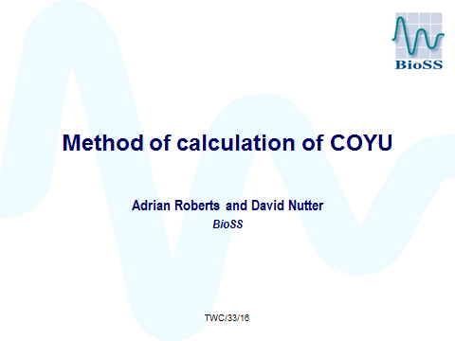

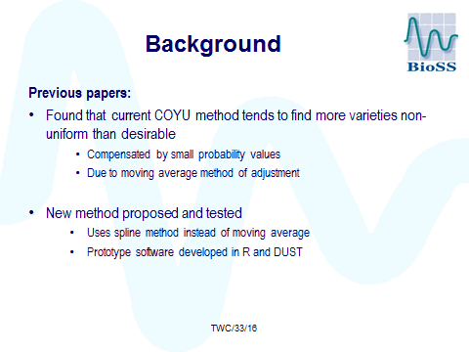

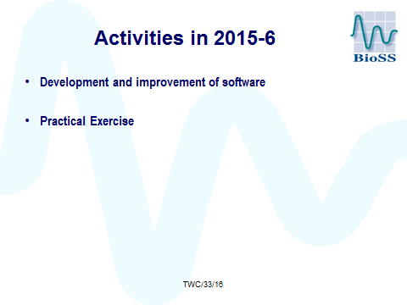

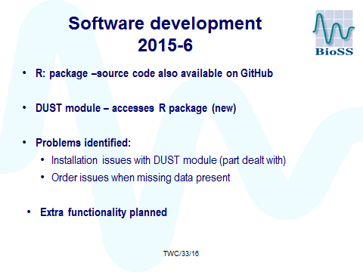

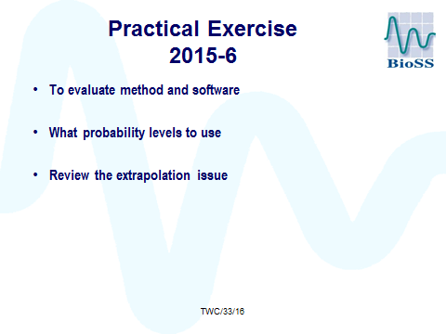

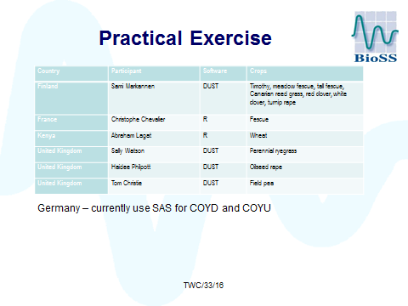

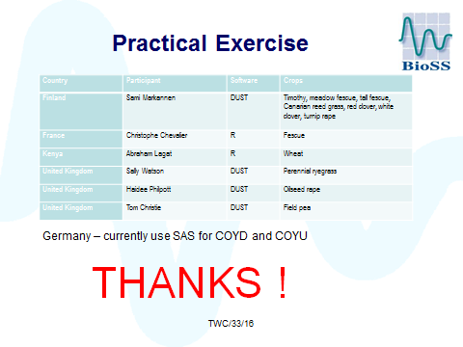

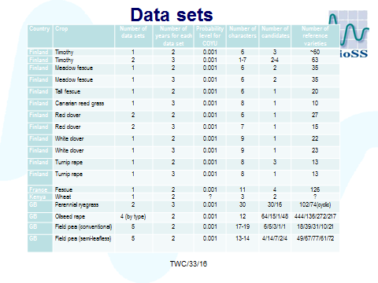

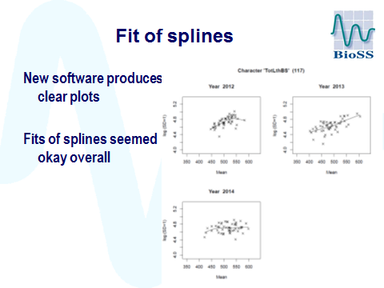

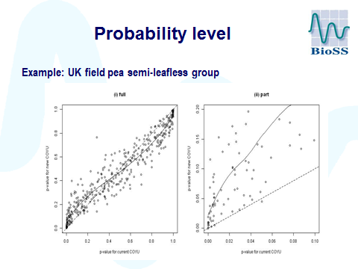

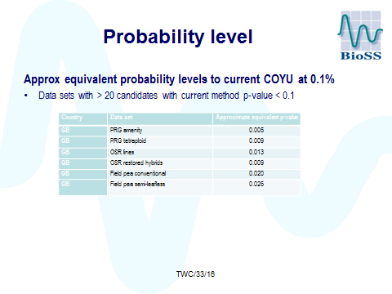

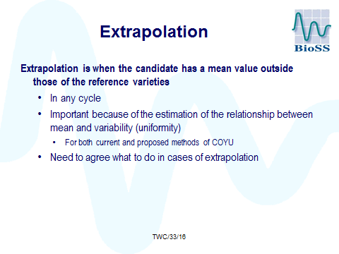

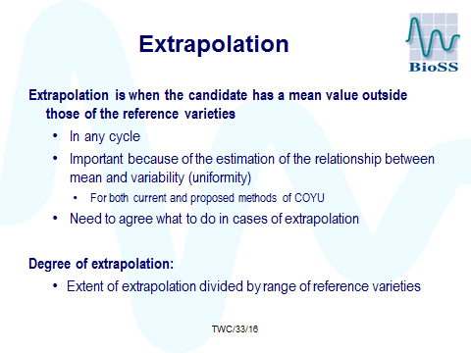

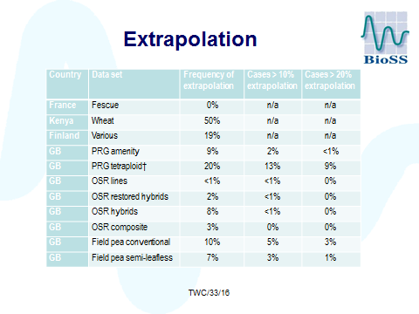
.
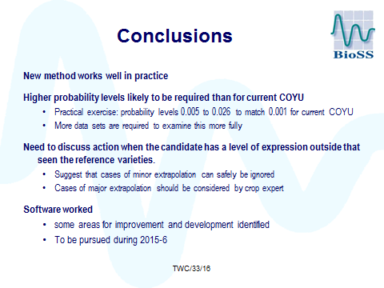

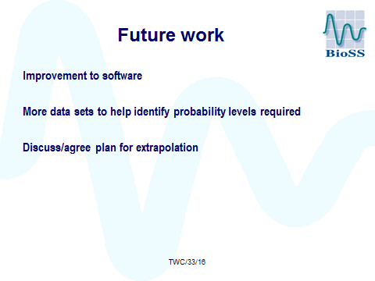

[End of Annex and of document]

