E
TC/51/37
ORIGINAL: English
DATE: February 20, 2015
INTERNATIONAL UNION FOR THE PROTECTION OF NEW VARIETIES OF PLANTS
Geneva
Technical Committee
Fifty-First Session
Geneva, March 23 to 25, 2015
Possible ways of improving the effectiveneSS of the
Technical Committee, Technical Working Parties and Preparatory Workshops
Document prepared by the Office of the Union
Disclaimer: this document does not represent UPOV policies or guidance
The purpose of this document is to provide proposals concerning possible means of improving the effectiveness of the Technical Committee, Technical Working Parties and Preparatory Workshops.

The following abbreviations are used in this document:

TC: Technical Committee
TWA: Technical Working Party for Agricultural Crops
TWC: Technical Working Party on Automation and Computer Programs
TWF: Technical Working Party for Fruit Crops
TWO: Technical Working Party for Ornamental Plants and Forest Trees
TWV: Technical Working Party for Vegetables
BMT: Working Group on Biochemical and Molecular Techniques, and DNA-Profiling in Particular
TWP: Technical Working Party

The structure of this document is as follows:
BACKGROUND 2
developments in 2014 3
Technical Committee 3
Technical Working Parties 3
Survey of participants at the TWP sessions in 2014 4

ANNEX I: RESULTS OF THE SURVEY TO SEEK VIEWS ON THE EFFECTIVENESS OF TECHNICAL WORKING PARTIES, PREPARATORY WORKSHOPS AND TECHNICAL COMMITTEE SUBMITTED AT THEIR SESSIONS IN 2014

ANNEX II: COMMENTS OF THE TWPS ON PROPOSALS FOR IMPROVING THE EFFECTIVENESS OF THE TECHNICAL COMMITTEE, TECHNICAL WORKING PARTIES AND PREPARATORY WORKSHOPS

BACKGROUND

The Technical Committee (TC) at its forty-ninth session, held in Geneva from March 18 to 20, 2013, considered document TC/49/3 “Matters arising from the Technical Working Parties” and received presentations by the Office of the Union on a survey of participants in the TWO, at its forty-fifth session, held in Jeju, Republic of Korea, from August 6 to 10, 2012, and in the TWF, at its forty-third session, held in Beijing, China, from July 30 to August 3, 2012, and an analysis of participation in the TC and the TWPs.

The TC noted the following proposals concerning possible means of improving the effectiveness of the TWPs, as a basis for future consideration:

(a) the possible benefits of regional distribution of the TWP venues within a year, in order to maximize opportunities for participation;
(b) inviting the TWPs to consider modifying the length (shorten or lengthen) of the TWP sessions according to the agenda and number of Test Guidelines to be discussed;
(c) providing a summary of the main changes to, and key features of, relevant TGP documents (e.g. TGP/7, TGP/8 and TGP/14), under agenda item 3(b) “Reports on developments within UPOV”;
(d) preparing a “quick reference” guide document for TWP participants with extracts from, for example, documents TGP/7 and TGP/14, covering frequently arising matters in the Test Guidelines (e.g. ratio/shape, color, notes, types of expression, method of observation);
(e) adding a decision paragraph in the TWP documents, to help to reach a clear conclusion on important points; and
(f) inviting the TWPs to review the results of the survey of the TWO and TWF participants, at their sessions in 2013 (see document TC/49/41” Report on the Conclusions”, paragraph 19).

In addition, the TC agreed that consideration should be given to the organization of subgroups for specific matters, e.g. TGP document subgroups and to the holding of Technical Working Parties in consecutive weeks, such as was arranged for the TWO and TWF (see document TC/49/41” Report on the Conclusions”, paragraph 20).

The TC agreed to the proposal for the Office of the Union to organize a survey:

(a) for participants at the TWP sessions in 2013, as proposed in Annex III of document TC/49/3;
(b) for participants at the preparatory workshops in 2013, as explained in document TC/49/10;
(c) for participants at the forty-ninth session of the TC as proposed in Annex IV of document TC/49/3; and
(d) for those members of the Union that did not attend the TC and TWP sessions (see document TC/49/41” Report on the Conclusions”, paragraph 21).

The TC agreed that consideration of possible means of improving the effectiveness of the TWPs should be deferred until its fiftieth session in order to consider the results of the surveys above (see document TC/49/41” Report on the Conclusions”, paragraph 22).

The TC agreed that it would be important to survey the members of the Union that had not attended the TC and the TWPs in order to understand the reasons why they had chosen not to attend (see document TC/49/41” Report on the Conclusions”, paragraph 23).

In relation to the proposals as set out in paragraph 5 of this document, the following measures were implemented for the TWP at their sessions in 2013:

- an oral summary of the main changes, and key features of, relevant TGP documents (e.g. TGP/7, TGP/8 and TGP/14), under agenda item 3(b) “Reports on developments within UPOV”;
- addition of decision paragraphs in the TWP documents, to help to reach a clear conclusion on important points; and
- invitation to the TWPs to review the results of the survey of the TWO and TWF participants, at their sessions in 2012.

developments in 2014

Technical Committee

As requested by the TC at its forty-ninth session, participants in the TWP sessions in 2013, participants in the preparatory workshops in 2013, participants in the forty-ninth session of the TC, and the members of the Union that did not attend the TC and TWP sessions were invited to participate in surveys (see paragraph 7 of this document).

The TC at its fiftieth session, held in Geneva from April 7 to 9, 2014, considered document TC/50/35 “Improving the effectiveness of the Technical Committee, Technical Working Parties and Preparatory Workshops” and noted the summary of the participation in the surveys and the results of the surveys as presented in the document (see document TC/50/36 “Report on the Conclusions”, paragraphs 132 to 140).

The TC noted that the results of the surveys in 2013 indicated that the following aims should be considered with regard to improving the effectiveness of the TWPs:

- Better use of time at TWP sessions;
- Improve understanding between TWPs (especially in the development of TGP documents);
- Increase participation by a greater number of participants; and
- Capitalize on TWPs and TC as an opportunity for training.

In addition to the information provided in Annex I to document TC/50/35, the TC noted the information provided in document TC/50/35, Annex II, containing information on attendance of members of the Union to the TC and TWPs in the last five years.

The TC agreed the following proposals concerning possible means of improving the effectiveness of the Technical Committee:

- the report from the Office of the Union on developments in UPOV to be made available on the website in advance of the TC session;
- to continue the use of PowerPoint presentations for the oral reports by TWP chairpersons;
- oral reports by TWP chairpersons to focus only on items of particular relevance to their TWP; and
- to provide conclusions at the end of discussion sessions.

The TC agreed that further consideration should be given to other proposals at its fifty-first session.

The TC considered the proposals concerning possible means of improving the effectiveness of the TWPs as set out in document TC/50/35 paragraphs 23 and 24, and agreed:

(a) to revise TWP invitations, as proposed in document TC/50/35, Annex III; and

(b) to make a survey of the participants at the TWP sessions in 2014, on the basis of document TC/50/35, Annex IV, and to include a question on whether participants to the TWPs and Preparatory Workshops had participated in the UPOV distance learning courses.

In the case of proposals that could imply cost or timing changes, the TC agreed that the TWPs should be invited to consider the proposals set out in document TC/50/35, paragraphs 23 and 24, on the basis of further information to be provided by the Office of the Union. The TC would consider those proposals, on the basis of the comments of the TWPs, at its fifty-first session.

Technical Working Parties

As requested by the TC at its fiftieth session, participants in the TWP sessions in 2014 were invited to participate in a survey (see paragraph 17 of this document).

A summary of the participation in the surveys is presented below:

Survey of participants at the TWP sessions in 2014

 | TWA | TWC | TWF | TWO | TWV
Total number of participants | 58 | 29 | 44 | 51 | 38
Total Number of participant countries / organizations | 34 | 16 | 23 | 21 | 20
Number of replies (i.e. participants) | 19 | 18 | 22 | 24 | 20
Response rate | 33% | 62% | 50% | 47% | 53%

The results of the surveys are presented in Annex I to this document.

The TWPs were invited to consider proposals that could imply cost or timing changes. Their comments are presented in Annex II to this document.

At a meeting held in Geneva, on January 9, 2015, in conjunction with the Enlarged Editorial Committee meeting (TC-EDC), the Chairpersons of the TC and the TWPs reviewed the results of the survey, as provided in Annex I to this document.

It was concluded that the results of the surveys in 2014 indicated that the following proposals should be considered with regard to improving the effectiveness of the TWPs:

GENERAL
To be more specific for each TWP, e.g.:
  - Technical visit,
  - Matters to be discussed,
  - Workplan (e.g. time allocated for TGPs vs. TGs)
To Update document: “Guidance Note: UPOV Technical Working Party arrangements” (meeting arrangement and technical visit):
  - Name badges
  - Participant lists on large poster board
  - Notice board for announcement
To review the document: “Guidance Note: UPOV Technical Working Party arrangements” and include the key points in a cover letter (e.g. encourage national workshop in conjunction with the session to take advantage of international experts presence in the country; indicate earliest date for the first TWP to be organized after the TC)
To announce the next TWP venue on the first day of the session so participants have sufficient time to reflect on suggestion for the agenda and the technical visit (invite the host to explain the intended program, e.g. technical visit)
To introduce a session for open discussion in a similar way to the session in the TC
WORKPLAN
To circulate the proposed TWP schedule of the week in advance
To provide links to the documents in the program of the week on the UPOV website
DOCUMENTS
Decision paragraph to be continued in TWP documents
Executive summary to be added to TWP documents
TEST GUIDELINES
To add information on the responsible TWP for Test Guidelines on the UPOV website
To consider a multi-annual working plan for Test Guidelines
PREPARATORY WORKSHOP
To invite/ encourage experienced experts from members of the Union to participate in the preparatory workshop
To organize small groups of participants with different levels of experience for the group exercises (as far as practical)
To renew exercises for the preparatory workshops on a regular basis
To organize E-workshops and workshop in conjunction with preparatory workshop on the use of the Web-based TG template, and guidance on the presentation of Test Guidelines at the sessions
Pre-recorded e-workshops to be made available on the website

The chairpersons’ meeting proposed that the following proposals presented to the TWPs in 2014 should not be considered further:

Survey in 2015
Change in the invitation and its distribution
Presentation of documents (already improved since 2014)
Request for participants to provide their comments in advance for TGP documents
Separate annual meeting to discuss TGP documents
Change on the day of the preparatory workshop (Sunday)

The TC is invited to:

- note the participation in the survey in 2014, as presented in paragraph 20 of this document;

- note the results of the surveys in 2014, presented in Annex I of this document;

- note the comments made by the TWPs at their sessions in 2014 on proposals that could imply cost or timing changes, as presented in Annex II of this document;

- consider the proposals concerning possible means of improving the effectiveness of the TWPS, as set out in paragraph 24 of this document; and

- agree that the proposals as set out in paragraph 25 of this document should not be considered further.

[Annexes follow]

SURVEY TO SEEK VIEWS ON THE EFFECTIVENESS OF TECHNICAL WORKING PARTIES, PREPARATORY WORKSHOPS AND TECHNICAL COMMITTEE
SUBMITTED AT THEIR SESSIONS IN 2014
(comments in the original language received)

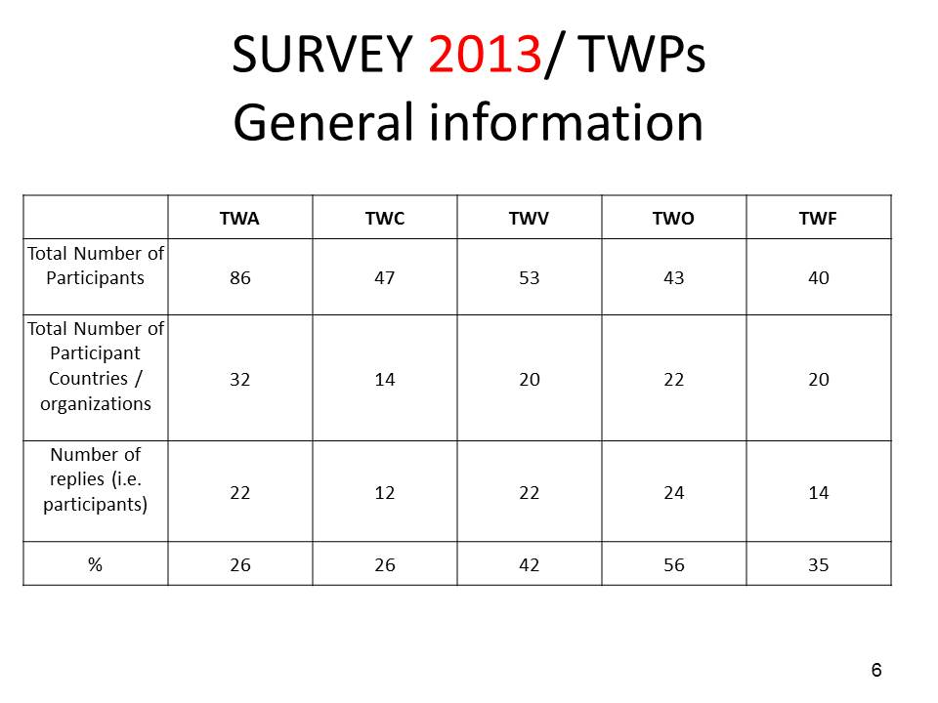

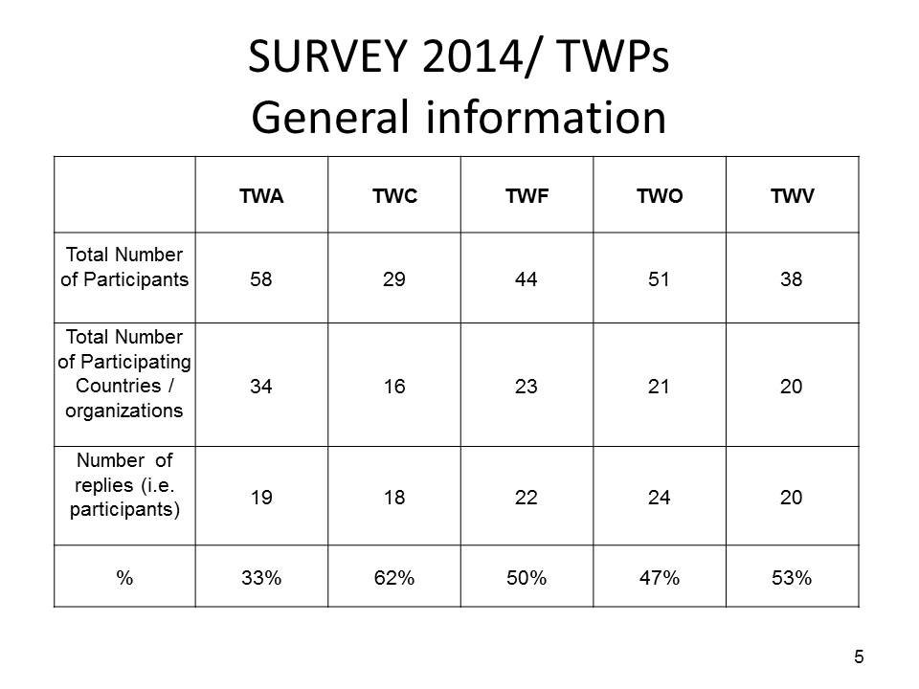
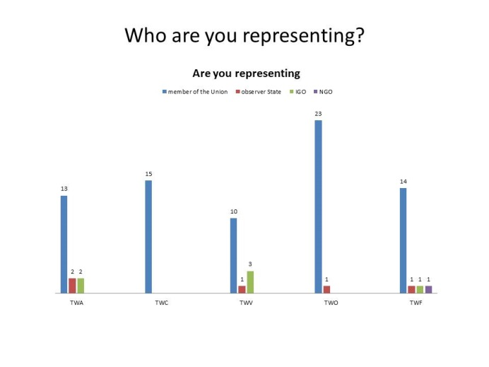

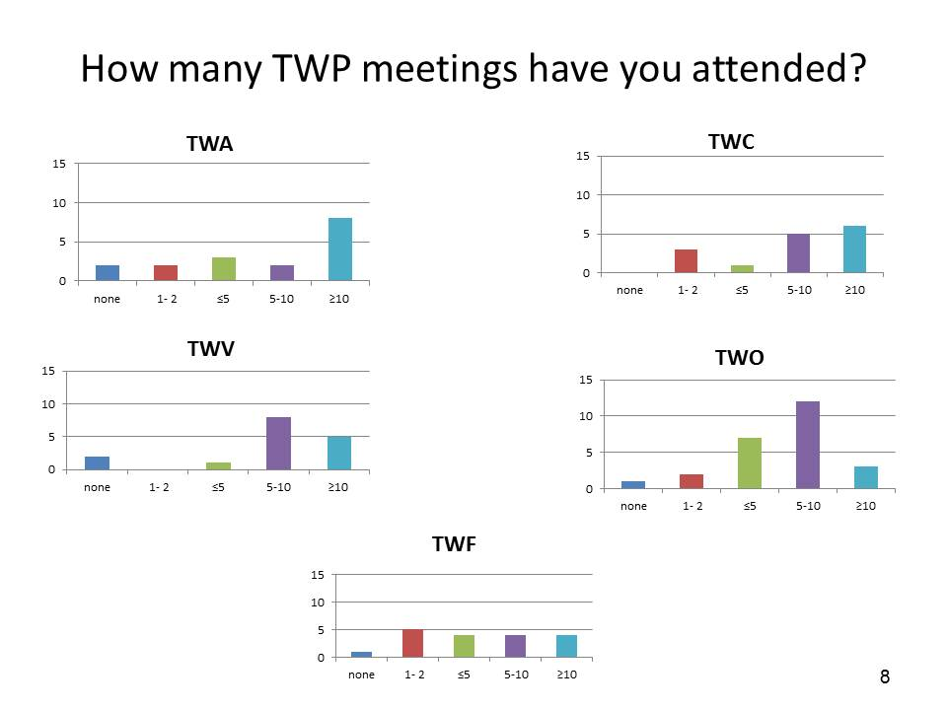

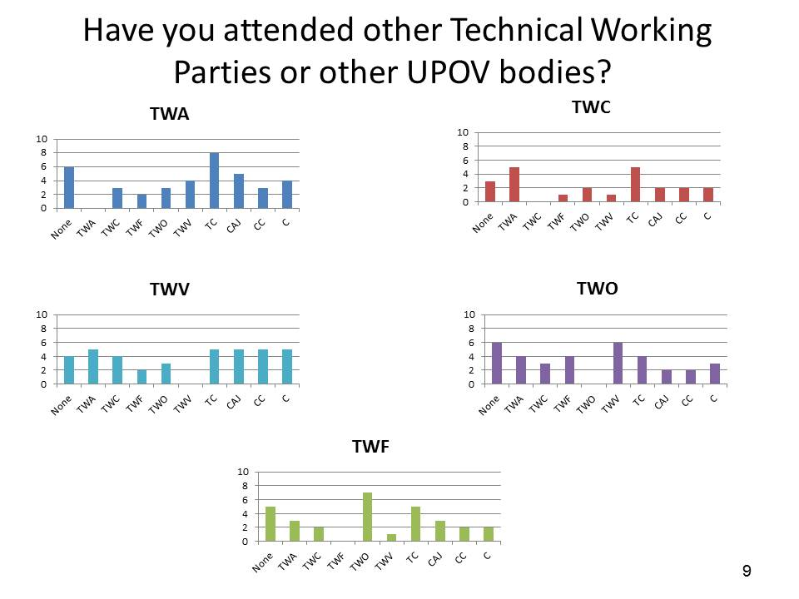

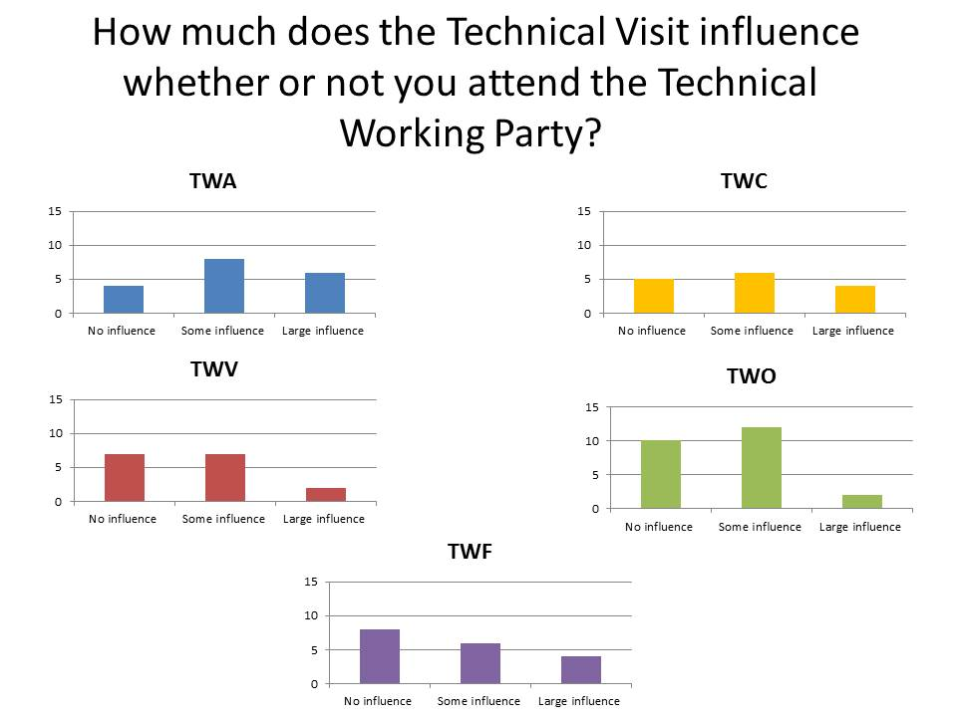

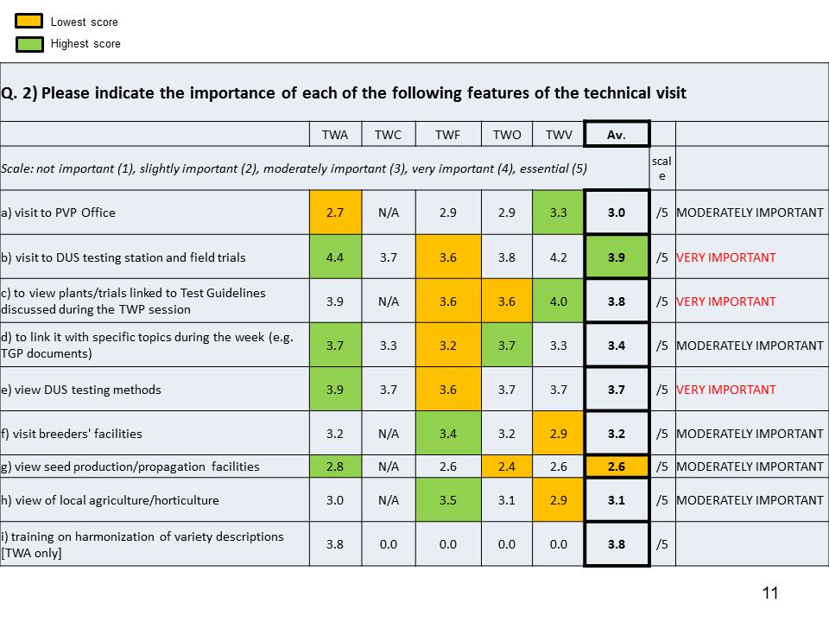

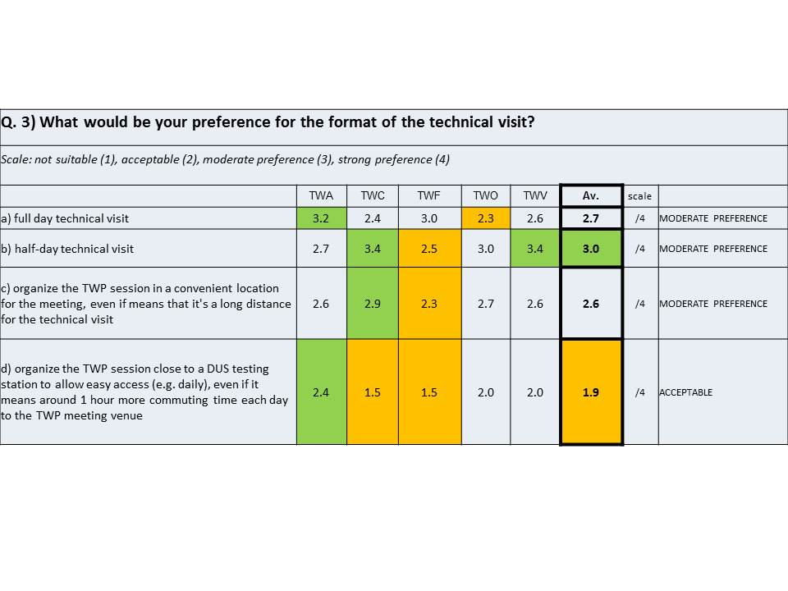

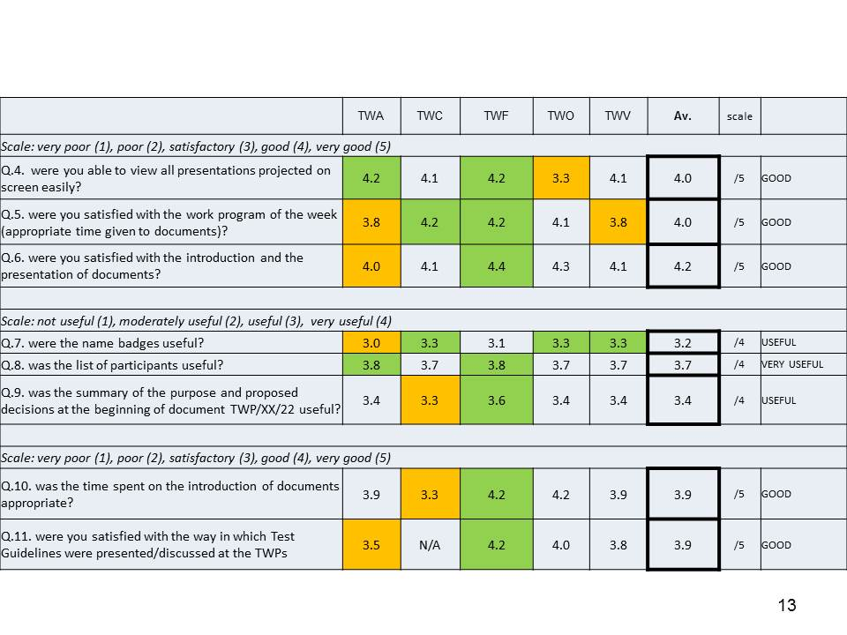

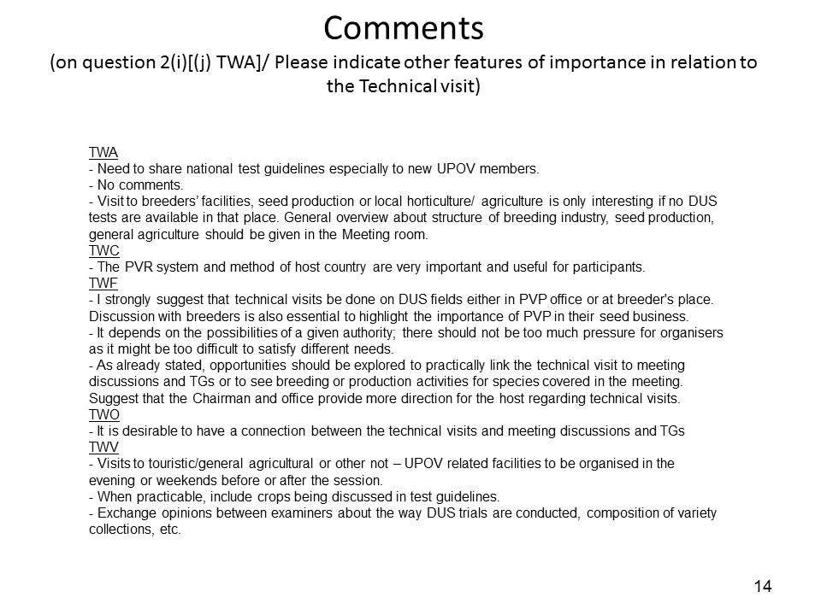

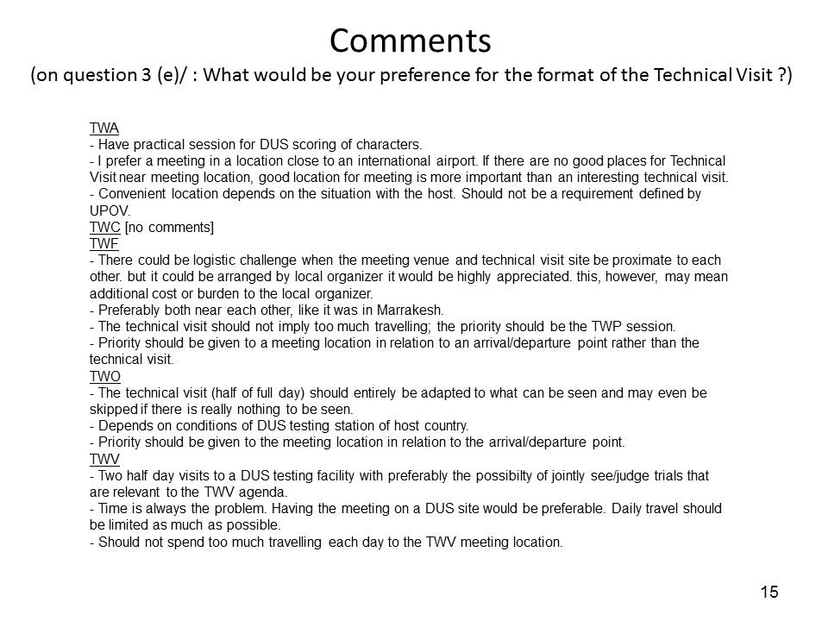

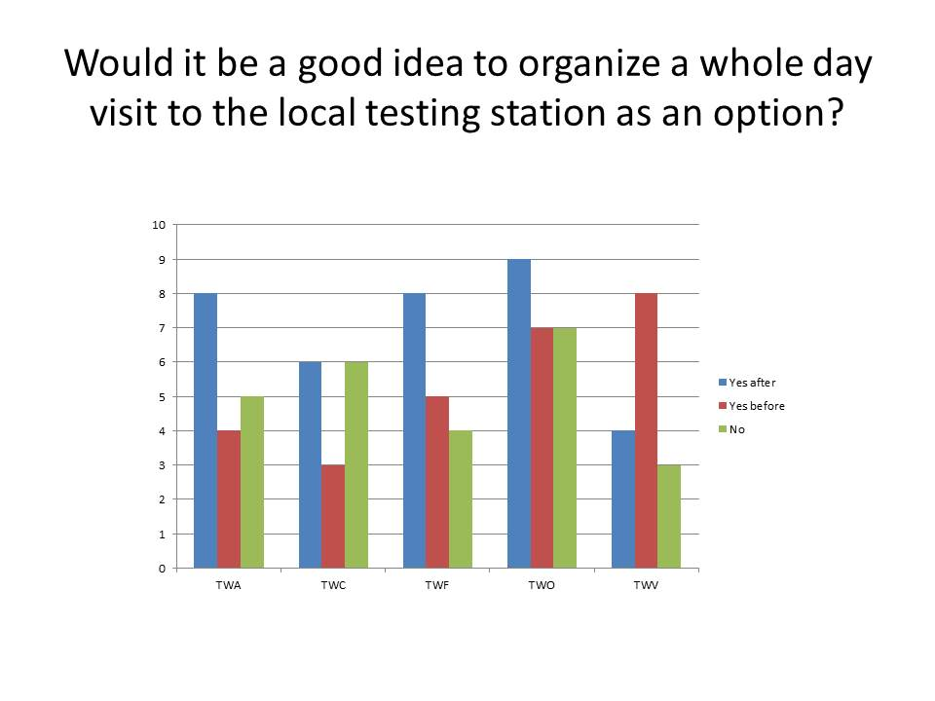

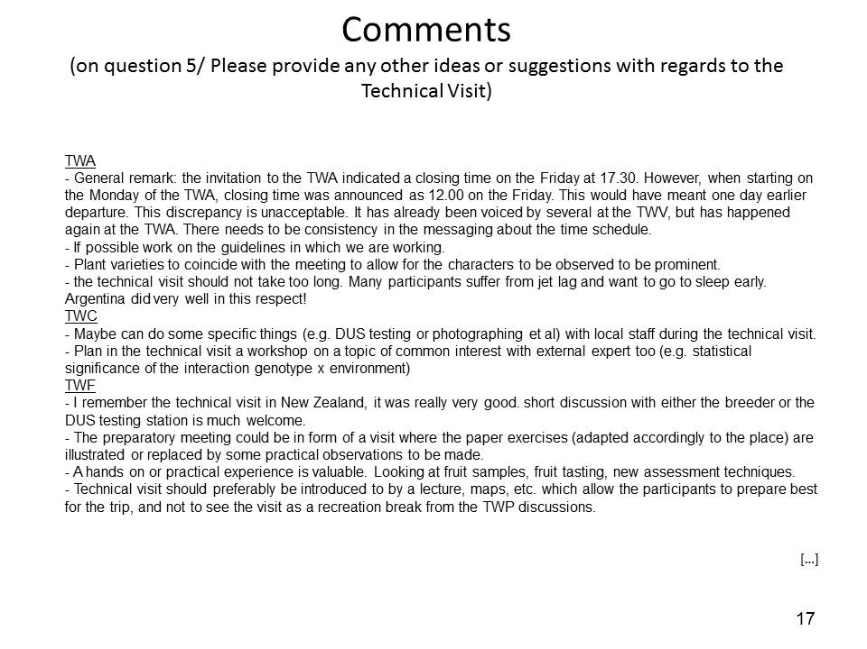

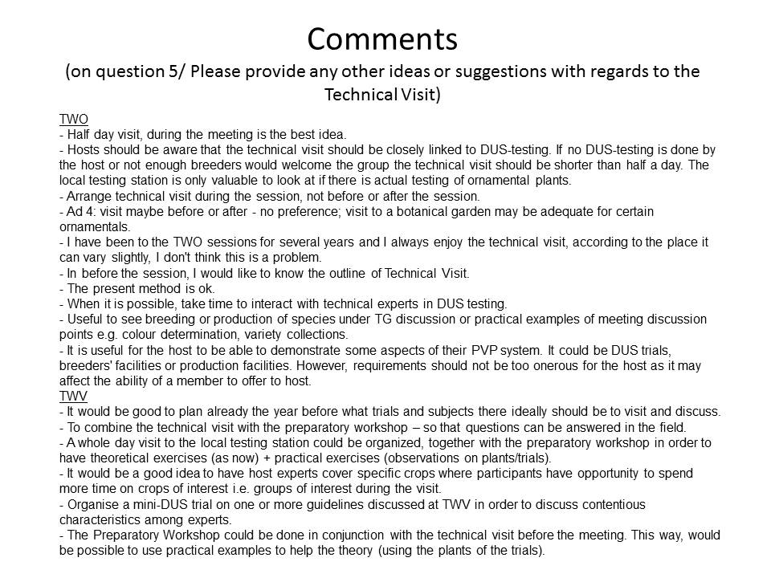

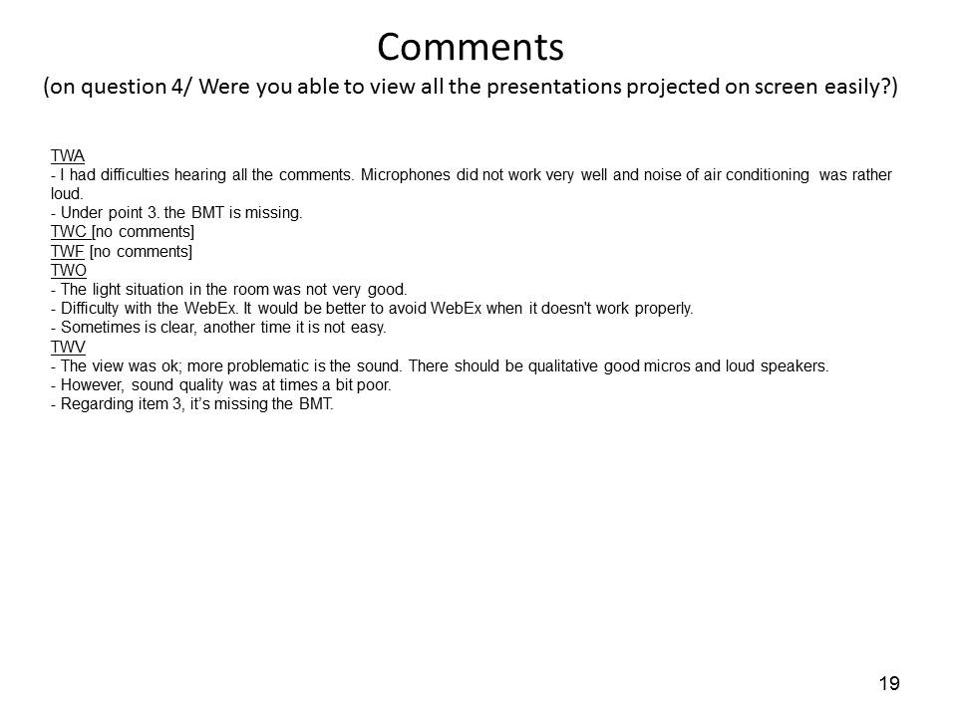

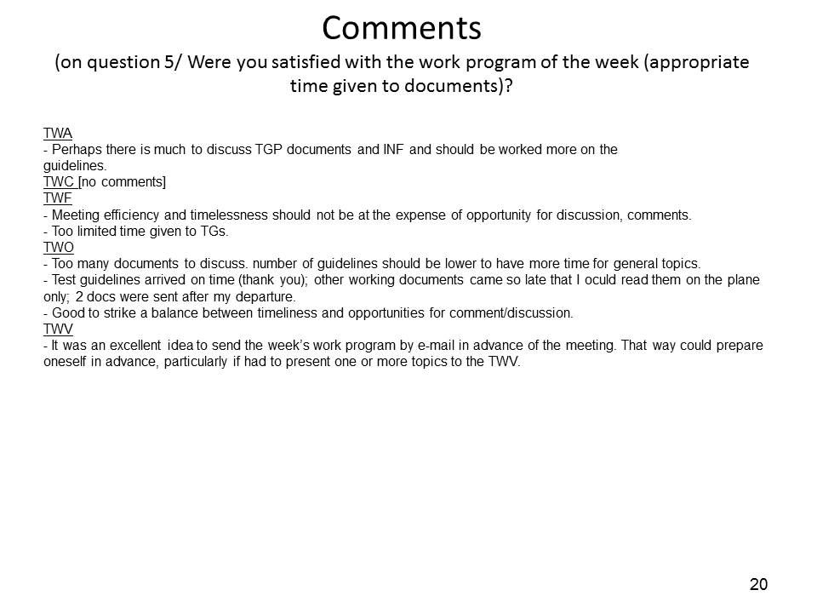

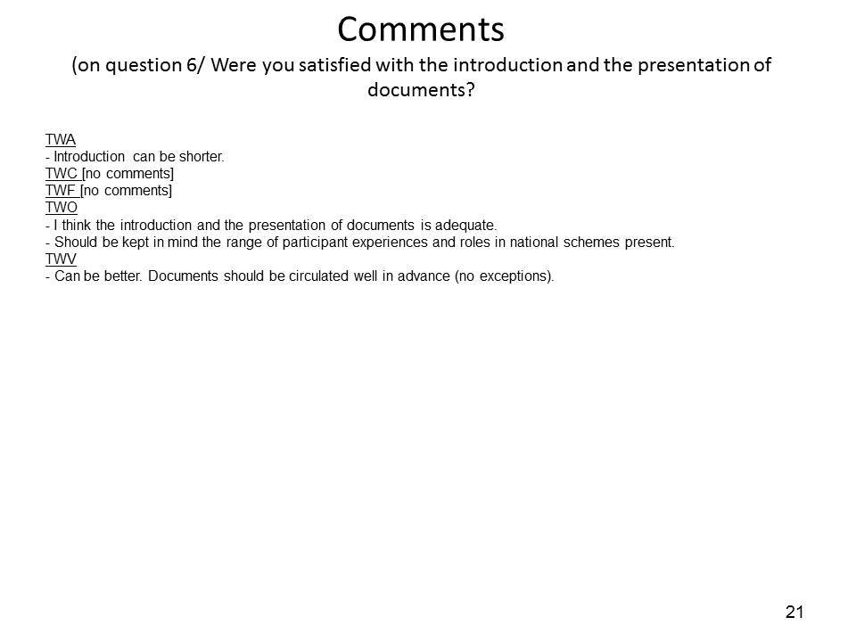

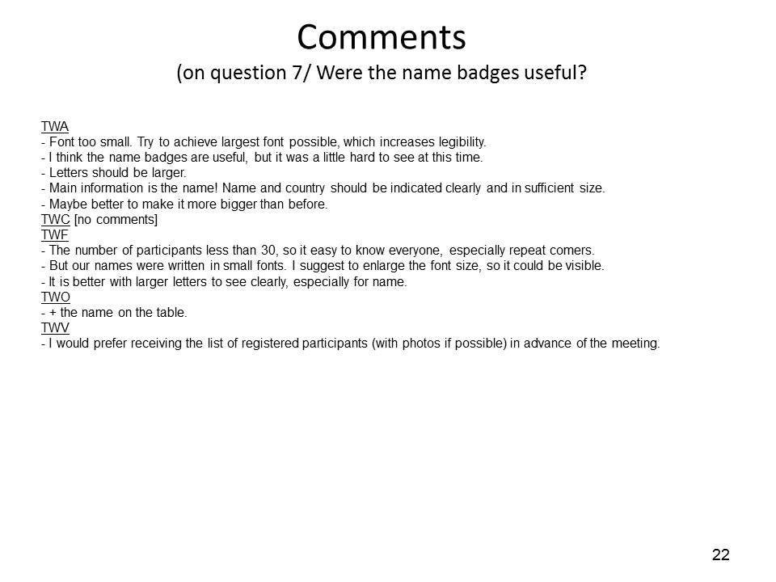

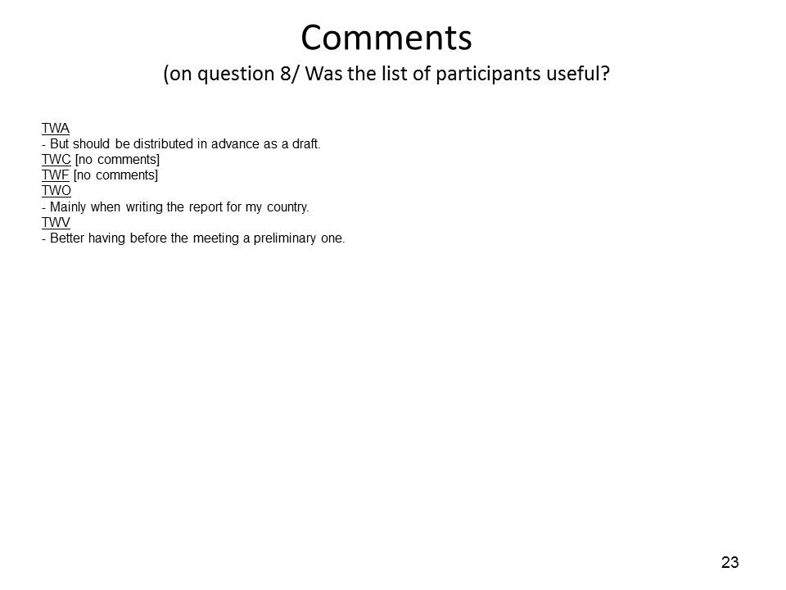

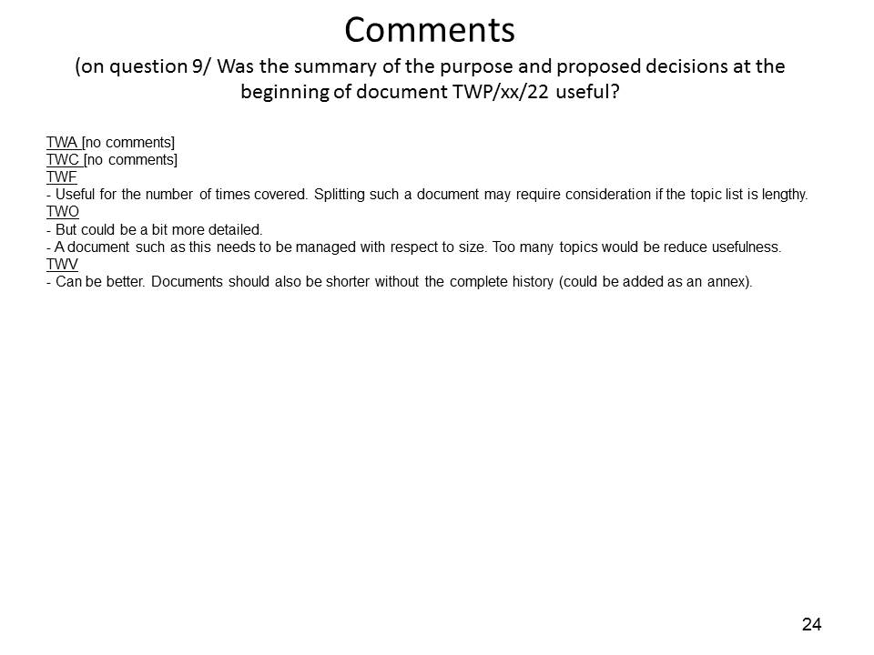

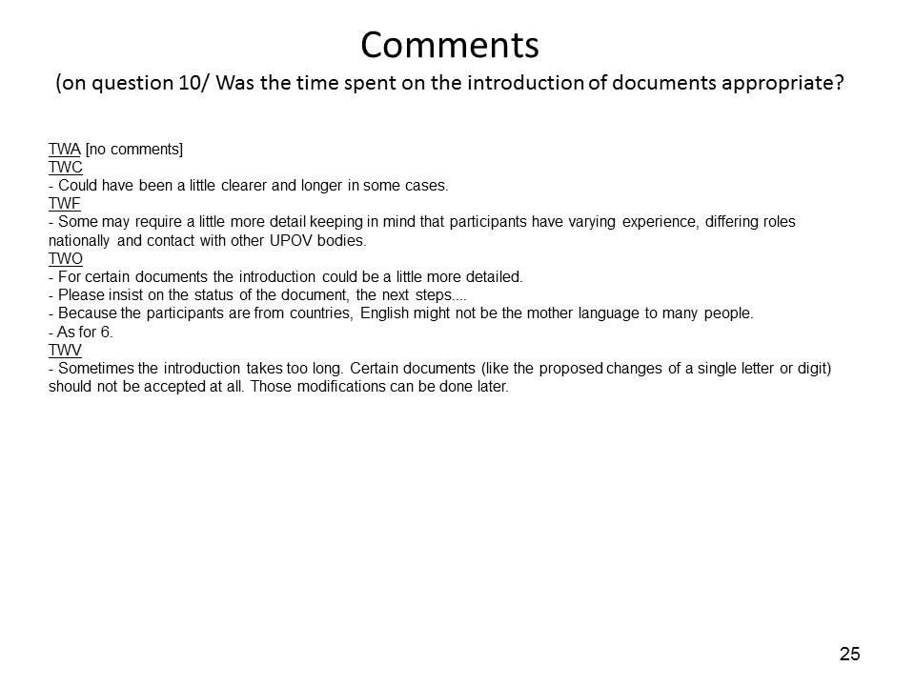

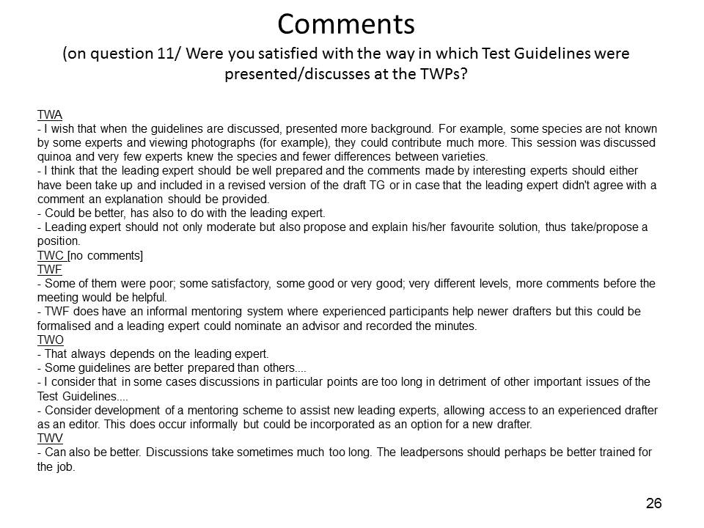

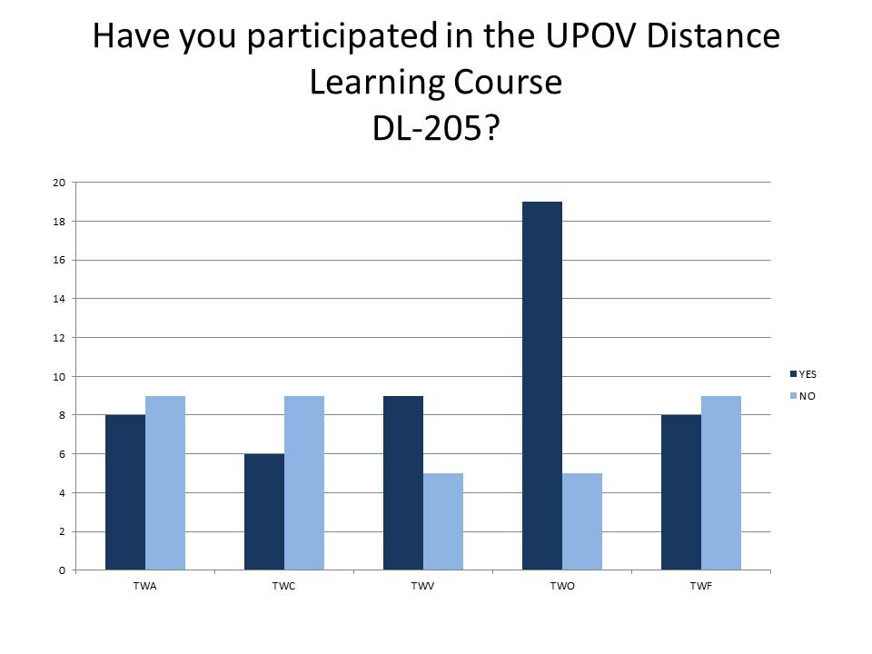

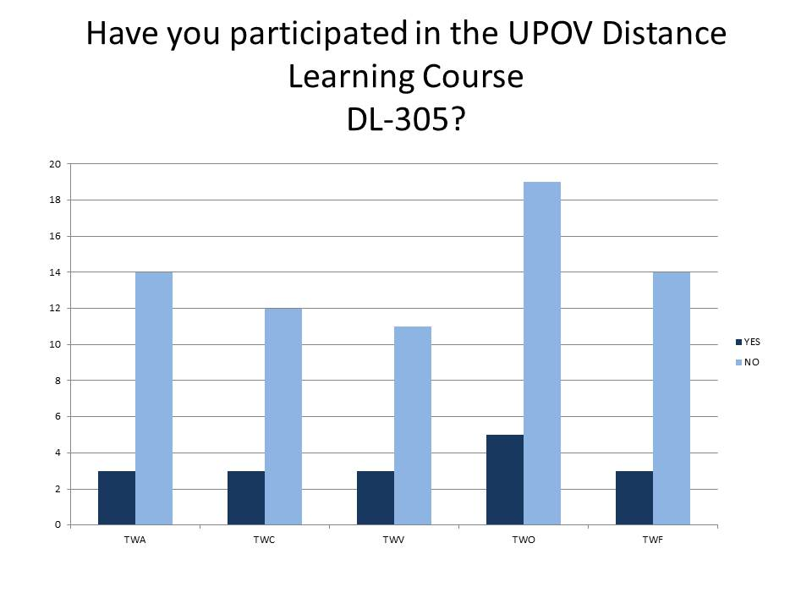

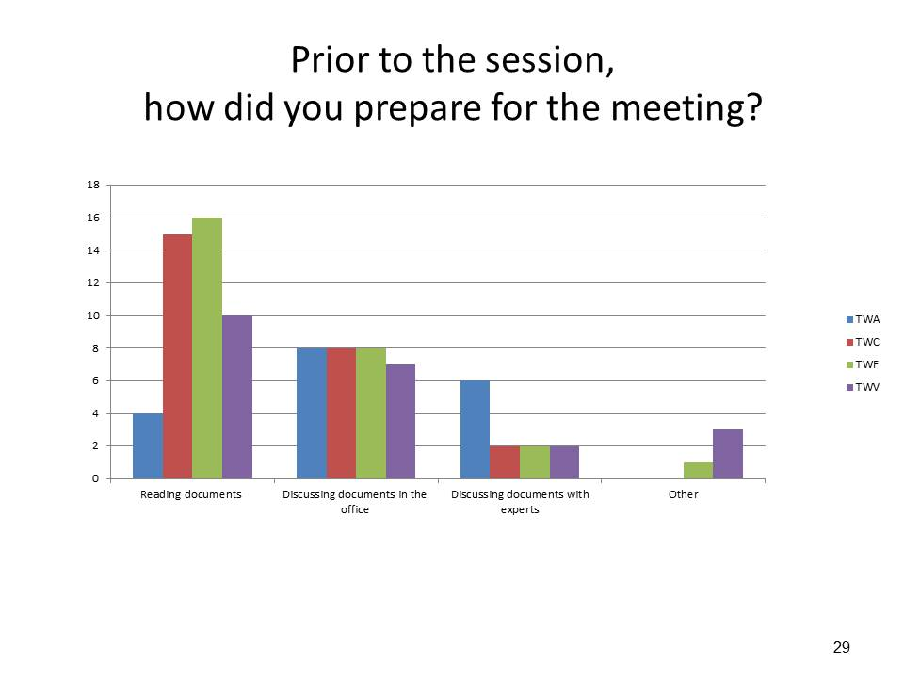

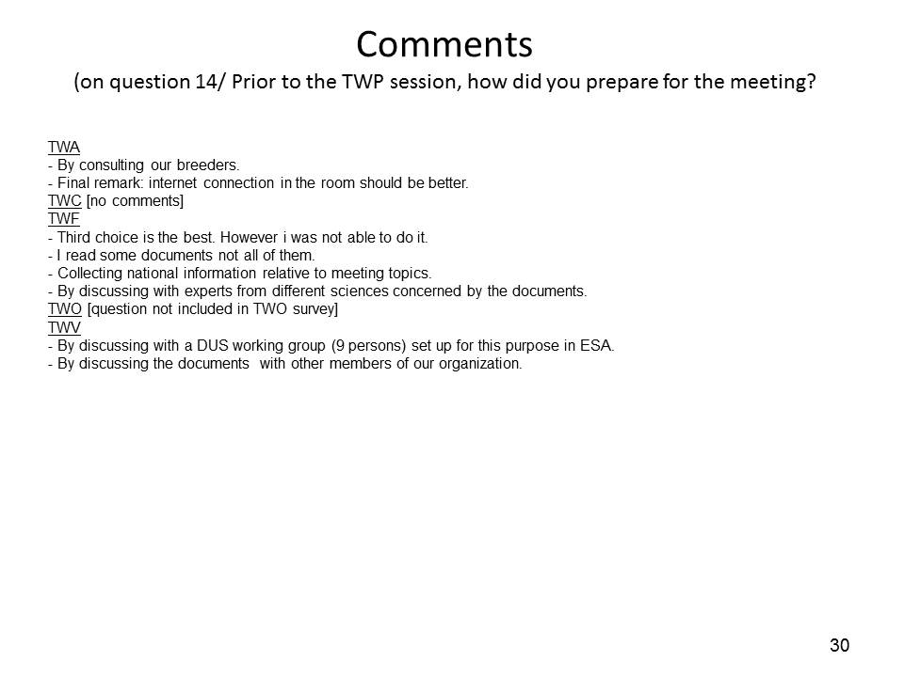

[Annex II follows]

COMMENTS OF THE TWPS ON PROPOSALS FOR IMPROVING THE EFFECTIVENESS OF THE TECHNICAL COMMITTEE,
TECHNICAL WORKING PARTIES AND PREPARATORY WORKSHOPS

Technical Working Parties |  |  |  |  | Proposed conclusion
General
(a) conduct a survey of TWP participants in 2014 in order to identify further areas for improvement and to obtain feedback on the effectiveness of measures already taken
TWA | TWC | TWF | TWO | TWV
• second survey would be more effective in gathering views from more participants.  • separate analysis should be prepared according to the number of sessions a respondent has participated. Respondents may have different views according to experience in UPOV meetings | The survey would be an additional method to express participant’s views on improving effectiveness to discussions during TWC meetings.  The survey would provide opportunity for written comments and would allow participants sufficient time for elaboration. | • To make the survey available during the meeting  • To encourage a higher response rate  • To add a question on “How to encourage participants to be prepared for the meeting” | • to have the survey available during the week of the TWP meeting  • to allow time for discussion on the survey | - agreed  - interesting to have feedback from participants  - to be decided year-by-year | - done
(b) review the TWP invitations in order to ensure that information is disseminated to all appropriate persons
TWA | TWC | TWF | TWO | TWV
 | The invitations should also reach participants to the previous session of the TWC. | • To be sent by email at least 3 months before the meeting  • To post the invitation on the UPOV website  • To mention in the invitation the participants at the previous session  • To improve distribution of the invitation but it must go through the UPOV representatives as it is a matter for the UPOV member and the relevant national authority to disseminate to the appropriate persons  • The list of designated persons for the relevant TWP should be checked on a frequent basis | • to periodically inform the UPOV representatives on the list of designated persons and check for updates  • to make a list of designated persons accessible on the UPOV website | - support the idea even if the distribution seems to be already efficient  - encourage the idea of geographical distribution  - to be more precise on the invitation (e.g. additional costs)  - to ensure to reach good person in authorities  to allow the possibility for designated persons to invite experts | - distribution of invitations is governed by specific procedures  - designation of representative in UPOV bodies is a matter for the Council representative
(c) in order to encourage greater participation by all participants in the TWP sessions, to request participants at the beginning of the session to introduce themselves and to briefly (in 30 seconds) report the most important issue they faced at that time. Matters of broad interest could then be considered for further discussion at an appropriate time
TWA | TWC | TWF | TWO | TWV
• not supported in the format proposed  • pressing issues should be included in a separate part of the country report.  • discussions on relevant issues identified should be included in the agenda for upcoming sessions to allow sufficient time for preparation. | An invitation should be sent to participants for the preparation of a topic to be presented.  This would be an opportunity to share topics that are not sufficiently prepared to be discussed as a meeting document.  Allows a general overview of interests among participants. | • Agreed with the 2 proposals  • Need to allocate time in the agenda  • Should be voluntary not mandatory  • Should be just before coffee break to allow time for further discussion during the break | • to indicate in the agenda issues of particular relevance for discussion during each TWP  • issues of particular relevance for discussion should be informed in advance along with first invitation to TWP  • where possible/appropriate combine discussion on relevant issues with technical visit  • to organize workshops on issues of particular relevance for TWP  • to balance the number of Test Guidelines discussed to allow time for discussion of relevant issues  • where possible the work program timings should allow opportunity for informal inter-sessional discussions of participants (e.g. by allowing a longer period around lunch) | • agreed, but should be very brief  • to take into consideration non-native English speakers/ participants  • to clarify that this should be complementary to the country report  • to allow at least one minute per participant | - no further specific action required
(d) organize presentations by experts of members of the Union on topical and relevant matters
TWA | TWC | TWF | TWO | TWV
• this approach is currently used and should be continued  • item should be introduced in the agenda for next session  • discussions should be structured with sharing of information (presentation or document) in advance of the session | Allows the demonstration of practical work and case studies.  Has been successfully used previously in the TWC. | • The matters need to be identified and seen as relevant for the TWP  • Should be in the agenda  • Was already implemented in 2014 and brought some interesting technical discussions  • Useful to share experiences | • the format is useful for providing concrete examples  • invitations to make presentations should be sent in sufficient time for the presenters to prepare  • useful to engage discussions with participants | • agreed  • allocating a specific time (e.g. 5 to 10 minutes per presentation) | - to be considered when drafting the agenda for the subsequent TWP session
(e) request hosts to provide:
• name badges for all participants (including local participants),
• a large poster board with the participant names and photographs and a space for each participant to indicate their area of particular interest
(specifically including local participants),
• a notice board for host announcements (e.g. visits),
• 2 projector screens in large rooms (at opposite ends of room)
include hyperlinks to locate agenda items in the agenda and program for the week
TWA | TWC | TWF | TWO | TWV
• name badges are important  • other items could be used at the discretion of the host but should not be compulsory  • guidance for hosts should mention that size of table for participants should allow sufficient space to work  • area of expertise could be included in the list of participants  • hosts could create mailing lists and social media for sharing information to facilitate localizing documents | Measures considered useful and should be undertaken.  Facilitates interaction among participants. | • Name badges are already implemented  • To elaborate the list of participants, including areas of expertise  • Announcement board would be welcomed  • Additional changes should not have additional costs for the host  • Guidance should not be too prescriptive on the requirements for the host | • general support for the proposals listed  • guidance for host needs to be updated to provide more details/examples on suitable arrangements.  • to specify that poster board to display information could be simple. The participants and UPOV could provide the information to be placed on the board at the beginning and during the meeting as required. | • disagreed on the idea of 2 projector screens, if needed it would be better to have TV screen, minimizing the impact on budget  • poster board proposal not supported  • to add a box in the list of participants for areas of interest  • keep it simple for the host, just ensure information is well spread  • list of participants to be distributed in advance | - guidance note to be updated to encourage the host to provide requested elements
TWP documents
(f) provide a summary of the purpose and proposed decisions at the beginning of TWP documents
TWA | TWC | TWF | TWO | TWV
• general support for inclusion of executive summary  • comments by other TWP are useful to summarize discussions | The summary would be useful to highlight the proposal to be considered and to facilitate general understanding of document.  External drafters of documents should be requested to provide a summary of the text elaborated.  Provides a tool to improve the organization of information presented in the document.  Could also present a summary of key features of document. | • Agreed with the idea of an executive summary  • Would be a great improvement | • summary is useful and should be used  • should clarify the next steps on discussions of the document | • agreed | - executive summary to be added to documents
(g) post documents sufficiently in advance of the meetings
TWA | TWC | TWF | TWO | TWV
• to establish deadlines for posting documents online  • documents later than certain number of weeks prior to TWP session (e.g. 2 weeks) should be removed from agenda | Documents with technical nature should be posted sufficiently in advance of the meeting to allow consultations and time for consideration.  Important due to the amount of information discussed at each session and the extensive background information in some cases. | • To define sufficient time (e.g. 2 weeks to 1 month)  • Constitute a key for proper preparation of participants | • first TWP should take place allowing sufficient time after the TC session | • agreed  • ensure drafters provide their inputs on time | - to update the host guidance to encourage hosts to avoid proposing TWP dates earlier than 6 weeks after the TC session
(h) continue to include decision paragraphs in TWP documents
TWA | TWC | TWF | TWO | TWV
general support to keep decision paragraphs | Decision paragraphs should continue to be used. | • Considered to be very helpful | • decision paragraphs are useful and should continue to be used | • agreed | - discussion paragraph to be included
(i) minimize the time for presentation of documents, particularly where presented for information only
TWA | TWC | TWF | TWO | TWV
• all documents should be allowed sufficient time for presentation even if for information only.  • documents that inform about work being developed in other TWPs should be presented | The TWPs should be informed on all topics being discussed but the allocation of time for presentation and discussion of each topic should be considered according to the relevance for each TWP. | • Documents need sufficient time to allow discussion  • Need to find a good balance under the governance of the Chairperson | - all documents should continue to be presented to all TWPs  level of detail on presentation of documents should be according to relevance to TWP and in agreement with relevant Chairperson | • agreed but allow time for questions  • allow time for participants to contribute in advance, even when documents are presented for information  • to be indicated in the agenda (for consideration/ for comment…) | - see results from survey 2014. presentation of documents has already improved
Test guidelines
(j) request TWP designated persons to make proposals for new or revised Test Guidelines in advance of the TWP session
TWA | TWC | TWF | TWO | TWV
• TWP designated person could be requested to make proposals which should be presented during the TWP session. | not applicable for the TWC | - Should be complementary to proposals made during the course of the meeting  Could be interesting to share first proposals before the session in order to consult experts in authorities | request for proposals in advance should be implemented | • agreed  • will help to have a list of adopted Test Guidelines containing the date of the last revision | - the date of the last revision Test Guidelines is available on the UPOV website  - to consider adding information on the responsible TWP for Test Guidelines
(k) circulate the proposed schedule of TG to be discussed during the session to TWP participants one week before the TWP session
TWA | TWC | TWF | TWO | TWV
• draft program of the week should be circulated before the TWP session | It would be useful to circulate the work program for the week before the TWP. | • Good proposal in order to avoid conflict and allow experts to join the relevant subgroup  • Should be circulated at least one week before the meeting | • the draft program of work for the week should be circulated in advance, including discussion on TGP documents, date of technical visit and reception  • to include disclaimer/clarification that the program will be reviewed at the beginning of the week and may change | • agreed  • should be even more in advance (e.g. 2 weeks)  • ensure consistency between, agenda, work plan, documents  • to provide link to the documents in the WP | - to circulate the proposed TWP schedule in advance but to clarify the agenda is subject to approval at the beginning of the session  - to provide link to the documents (see UPOV sessions in Geneva)
(l) improve preparation of Test Guidelines and presentation of Test Guidelines at TWPs by the Leading expert by:
• training (e.g. electronic training workshops, including the use of the Web-based TG template, and guidance on the presentation of Test Guidelines at the sessions),
• providing UPOV comments in advance
TWA | TWC | TWF | TWO | TWV
• subgroups with small number of interested experts should be balanced with participation of more experienced participants  • to provide a forum for information for Leading Experts  • to discuss some Test Guidelines during plenary sessions to create capacity among participants  • to have two experts for presenting complex Test Guidelines  • to visit trials on Test Guidelines under discussion and address specific issues in the field, if possible | Guidance for drafters was already available on the UPOV website.  Useful to remind its availability. | • Support needed on the web-based TG template training which would improve the preparation and probably the presentation of Test Guidelines  • Document TGP/7 contains also Guidance Notes which could be useful in the training of the LE and should be included in the training  • As soon as possible (e.g. 2 weeks before the session) in order to collect the proposal and study the proposal  • The discussion at the TWP should be just to agree on the draft and not to have new proposals | • e-workshops should be recorded and made available on the UPOV website  • e-workshops should be repeated during the preparatory workshops  • new web based TG template will reduce number of editorial comments by the Office of the Union | • agreed  • to ensure the diffusion of the 1st draft is circulated to all Interested experts  • agreed  • sufficiently in advance (e.g. 10 days) | - to consider  e-workshops on the use of the  Web-based TG template, and guidance on the presentation of Test Guidelines at the sessions  - pre-recorded  e-workshop to be available on the website  - UPOV provides comments on TGs in advance
TGP documents
(m) request participants to provide their comments on TGP documents in advance of the TWP session, according to a specified date
TWA | TWC | TWF | TWO | TWV
• proposal not supported  • feasible only for documents that could be available online 6 weeks before the meeting.  • should be requested in particular cases only  • useful for participants who could not attend a session or wish to comment in written.  • could reduce importance of attendance to meetings  • it should be avoided that written comments submitted in advance replace discussions during the meeting. | Generally not supported by the TWC.  Would require additional coordination work and sufficient time to get clearance prior to submission of comments. | • This should not avoid discussion during the session  • Should not be mandatory  • Should be complementary with comments during the session | • there was no consensus from the TWO  • could increase time necessary to introduce the comments received along with the introduction of the document  • could be useful for some particular issues  • should not become mandatory for all topics  • could lead to longer documents  • non-systematized information may not be useful  • a blog could be established (perhaps on the UPOV website) for discussion on particular issues | • is not seen as necessary  • could be helpful but should not avoid comments and discussion during the meeting | - Proposal not supported by the TWPs
(n) organize a separate, annual meeting of a working group to discuss TGP documents in the week before the TC sessions in Geneva. The meetings would be open to all TC and TWP designated persons and consideration would be given to the possibility to view the meeting electronically
TWA | TWC | TWF | TWO | TWV
• proposal not supported  • would not increase attendance  • discussion on TGP documents requires inputs from crop experts during TWP sessions | Proposal not supported by the TWC.  Would increase cost and time to attend additional meeting.  The specific focus of each TWP would be important for discussion of TGP documents. | • Would have a big impact on cost  • Could disconnect the experts with technical matters contained in TGP documents and disconnect TGP documents from the reality in the fields  • Could be appropriate in a particular case on relevant matters (e.g. special working group) | • the TWO did not support a separate meeting to discuss TGP documents  • reduces the number of participating experts in discussions  • discussion on TGP documents is important for capacity building in Technical Working Parties  • agenda of TWPs should be balanced to allow time for discussion of relevant TGP documents | • disagreed  • do not see the usefulness of such separate meetings  • better to have discussion in TWV  • electronic means will decrease the participation in discussion  • necessary to keep the experts in touch with technical matters and TGP documents | - Proposal not supported by the TWPs
(o) in conjunction with this approach, to report on significant developments at TWPs, without detailed discussion of individual TGP documents
to reduce the amount of time used to discuss TGP documents
TWA | TWC | TWF | TWO | TWV
• proposal not supported  to allow time for discussion on technical matters relating to implementing the PVP system  • to reduce the amount of time used to discuss TGP documents | Not supported. | Not supported | • approach not supported | • Not applicable | - Proposal not supported by the TWPs
Technical visit
(p) conduct a survey of TWP participants of their requirements for technical visits
TWA | TWC | TWF | TWO | TWV
• survey should seek preferences or interests from experts for technical visit.  • outcomes of survey should not become a requirement for hosts of Technical Working Parties | The survey was supported.  Hosts of TWPs should have flexibility to propose the technical visit and demonstrate areas of interest. | • The technical visit should  o be largely determined by the host, with some guidance provided  o focus on DUS examination trial if possible  o include practical exercises for examination of varieties to share experience and knowledge  o be relevant for the interest of the TWPs and participants | • to provide guidance for hosts on objectives of technical visit  • flexibility is necessary to adjust to local conditions  • careful consideration on logistics for transportation of participants | • agreed  • to have the technical visit in conjunction with the preparatory workshop  • important to let the host propose and organize  • to consider the impact for the host  • to consider having closer relation between the plants discussed during the week (e.g. TGs) and the technical visit | - done: see survey 2014
Preparatory Workshops
(a) if the length of time spent on TGP and information documents is reduced, to hold the preparatory workshops on Monday in order to encourage all TWP participants to attend the Preparatory Workshop
TWA | TWC | TWF | TWO | TWV
• approach not supported  • would reduce time of discussions during TWP session  • to review the purpose of the preparatory workshop for training on UPOV system.  • could be used to introduce particular topics to be further discussed during the session | This proposal was considered ineffective to encourage participants to attend the Preparatory Workshop. | • Approach not supported  • Would have a negative impact of the time left in the week as it would reduce time for discussion on other technical matters | • the TWO considered such an approach would not be effective for improving attendance at the preparatory workshop  • no significant cost reduction associated  • available time during the week could be better used for discussion of matters of particular relevance to the TWP | • Not applicable -see (n) | - Proposal not supported by the TWPs
(b) to use more, shorter presentations and use experts from members of the Union as presenters
TWA | TWC | TWF | TWO | TWV
• general support for using shorter presentations and more practical exercises  • to revise the content of the preparatory workshop  • could include or detail specific topics from online distance training courses DL-205 and DL-305 | This proposal could be implemented but was not considered critical for improving the effectiveness of the Preparatory Workshop. | • Agreed  • Would need participation from the expert during the Preparatory Workshop | • experts could be used to present real examples during preparatory workshop  • could lead to reduction of UPOV content presented  • to request participants to express main interests for clarification during the preparatory workshop  • existing UPOV presentation materials could be used by presenters and tailored to suit their style  • additional benefit that presenters would become more familiar with UPOV presentation and materials  • should ensure that presentations by experts remain consistent with UPOV guidance | • agreed | - to be considered further with regard to the implication for experts (preparation and participation time) and extra organization work for the UPOV Office
(c) to continually renew exercises for existing topics
TWA | TWC | TWF | TWO | TWV
• general support for renewing exercises | Case studies could be presented to stimulate discussions | • Agreed with examples relevant for the TWP | • exercises should use examples from Test Guidelines relevant for each TWP  • to develop exercises on number of notes observable and on selection of characteristics for international harmonization (asterisk) | • agreed | - to renew exercises on a regular basis
(d) to organize small groups of participants with different levels of experience for the group exercises
TWA | TWC | TWF | TWO | TWV
• useful to have to have a more experienced participant in the groups | Group exercises should continue to be organized in small groups of participants with different levels of experience and from different regions. | • Agreed | • better interaction within participants  • groups should have participants with different levels of experience  • to inform on the timetable for circulation of draft TGs and posting on the web (document TGP/7 Section 2.2.5.3) | • agreed | - to organize small groups of participants with different levels of experience for the group exercises as far as practical

[End of Annex II and of document]

