E
TC/50/18
ORIGINAL: English
DATE: January 27, 2014
INTERNATIONAL UNION FOR THE PROTECTION OF NEW VARIETIES OF PLANTS
Geneva
Technical Committee
Fiftieth Session
Geneva, April 7 to 9, 2014
Revision of document TGP/7: Indication of Growth Stage in Test Guidelines
Document prepared by the Office of the Union
Disclaimer: this document does not represent UPOV policies or guidance
The purpose of this document is to propose guidance on indicating the growth stage at which to observe characteristics in the Test Guidelines for a future revision of document TGP/7: “Development of Test Guidelines”.

The following abbreviations are used in this document:

TC: Technical Committee
TC-EDC: Enlarged Editorial Committee
TWA: Technical Working Party for Agricultural Crops
TWC: Technical Working Party on Automation and Computer Programs
TWF: Technical Working Party for Fruit Crops
TWO: Technical Working Party for Ornamental Plants and Forest Trees
TWPs: Technical Working Parties
TWV: Technical Working Party for Vegetables

The structure of this document is as follows:

BACKGROUND 1
Existing GUIDANCE IN DOCUMENT TGP/7 2
TG Template 2
GN 23 3
Chapter 3.3 and GN 9 3
comments by the technical working parties in 2013 4
PROPOSAL 5

BACKGROUND

The Technical Committee (TC), at its forty-ninth session held in Geneva from March 18 to 20, 2013, agreed that clarification should be provided in a future revision of document TGP/7 with regard to the inclusion of growth stage keys in Chapter 8 of the Test Guidelines and requested the Office of the Union to prepare draft guidance for consideration by the TWPs at their sessions in 2013 (see document TC/49/41 “Report on the Conclusions”, paragraph 83).

Existing GUIDANCE IN DOCUMENT TGP/7

TG Template

The TG Template and associated Guidance Note (GN24) provide the following guidance for indicating the growth stage for the observation of characteristics in the Test Guidelines:

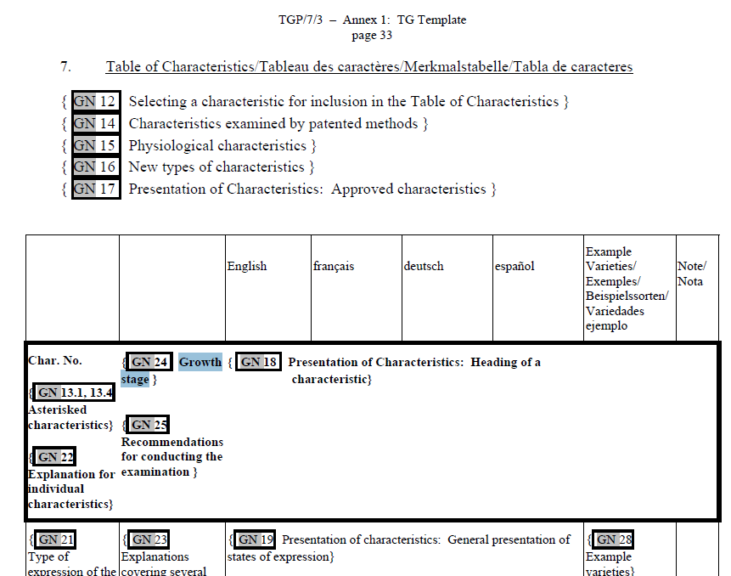

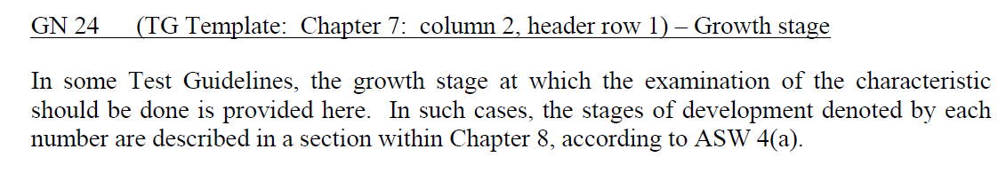

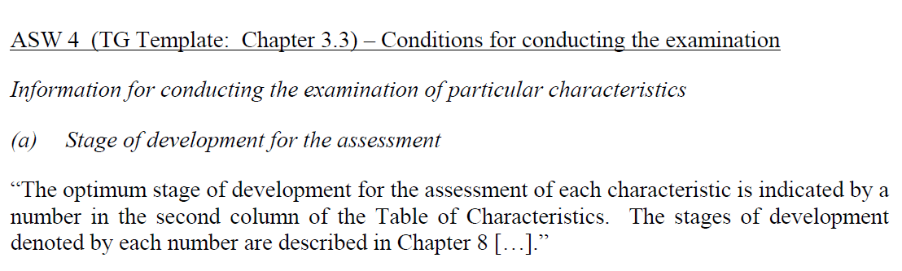

GN 23

Guidance Note GN 23 for drafters of Test Guidelines: “Explanations covering several characteristics”, also states as follows:

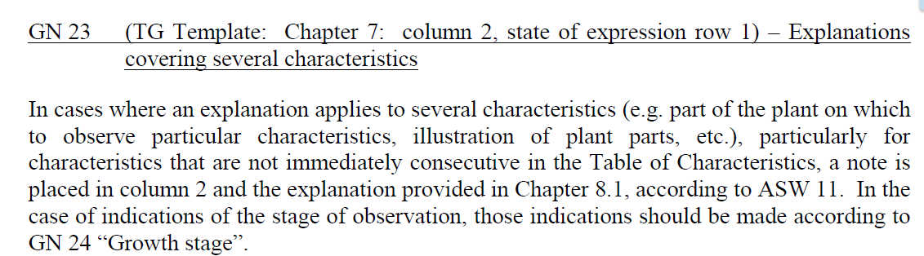

Chapter 3.3 and GN 9

The TG Template and Guidance Note (GN 9) provide further guidance as follows:

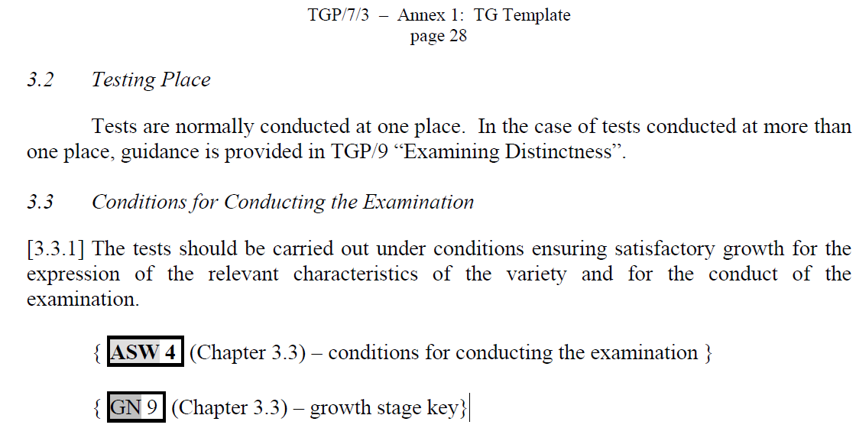

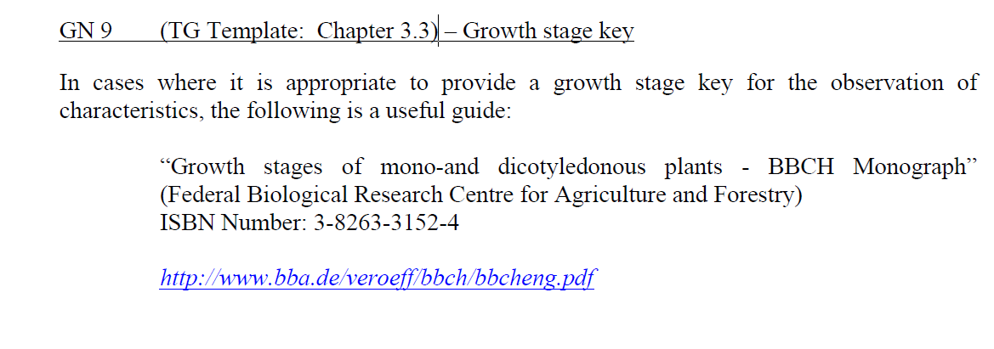

comments by the technical working parties in 2013

The TWO, TWF, TWV, TWC and TWA considered documents TWO/46/11, TWF/44/11, TWV/47/11, TWC/31/11 and TWA/42/11, respectively (see documents TWO/46/29 “Report”, paragraphs 24 to 26, TWF/44/31 “Report”, paragraphs 28 to 29, TWV/47/34 “Report”, paragraphs 28 and 29, TWC/31/32 “Report”, paragraph 25, and TWA/42/31 “Report”, paragraphs 27 and 28).

The TWO noted that ornamental plants are usually observed at the time of full flowering and the indication of growth stages in Test Guidelines should remain optional and used where appropriate.

The TWO and the TWA agreed that the Additional Standard Wording 4 (ASW 4) should be amended in order to reflect the current practice in Test Guidelines to indicate growth stages using letters, numbers and combinations of letters and numbers, to read as follows:

ASW 4 (TG Template: Chapter 3.3) – Conditions for conducting the examination
Information for conducting the examination of particular characteristics
(a) Stage of development for the assessment
“The optimum stage of development for the assessment of each characteristic is indicated by a number reference in the second column of the Table of Characteristics. The stages of development denoted by each number reference are described in Chapter 8 […].”

The TWA noted that GN 24 should be amended to reflect the proposed change in ASW 4, by replacing the word “number” by “reference”.

GN 24 (TG Template: Chapter 7: column 2, header row 1) – Growth stage
In some Test Guidelines, the growth stage at which the examination of the characteristic should be done is provided here. In such cases, the stages of development denoted by each number reference are described in a section within Chapter 8, according to ASW 4(a).

The TWF considered that there was no need to amend the existing guidance in document TGP/7 with regard to the indication of the growth stage at which to observe characteristics in the Test Guidelines. The TWF agreed that the existing guidance provided sufficient information and that the indication of growth stages in Test Guidelines should remain optional and used where appropriate.

The TWF noted that the expert from Germany would provide an updated link for “Growth stages of mono-and dicotyledonous plants – BBCH Monograph” in GN 9

The TWV considered that there was no need to amend the existing guidance in document TGP/7 with regard to the indication of the growth stage at which to observe characteristics in the Test Guidelines. The TWV agreed that the existing guidance provided sufficient information and that the indication of growth stages in Test Guidelines should remain optional and used where appropriate.

The TWV agreed with the TWO that the indication of growth stages in Test Guidelines should be used where appropriate, and should as far as possible use a harmonized, simple numbering, such as in the Test Guidelines for Potato (document TG/23/6) as illustrated below:

“8.3 Optimal Stage of Development for the Assessment of Characteristics
1 = bud stage
2 = flowering stage
3 = ripening stage of tubers
4 = after harvest”

The TWC agreed that there was no need to amend the existing guidance in document TGP/7 with regard to the indication of the growth stage at which to observe characteristics in the Test Guidelines.

PROPOSAL

In accordance with the comments from the TWPs in 2013, it is proposed to amend the guidance in document TGP/7 with regard to the indication of the growth stage at which to observe characteristics in the Test Guidelines as follows:

ASW 4 (TG Template: Chapter 3.3) – Conditions for conducting the examination
Information for conducting the examination of particular characteristics

(a) Stage of development for the assessment
“The optimum stage of development for the assessment of each characteristic is indicated by a number reference in the second column of the Table of Characteristics. The stages of development denoted by each number reference are described in Chapter 8 […].”

GN 9 (TG Template: Chapter 3.3) – Growth stage key
In cases In some cases, where it is appropriate to provide a growth stage key for the observation of
characteristics, the following is a useful guide:

“Growth stages of mono-and dicotyledonous plants - BBCH Monograph”
(Federal Biological Research Centre for Agriculture and Forestry)
ISBN Number: 3-8263-3152-4
http://www.bba.de/veroeff/bbch/bbcheng.pdf
http://www.jki.bund.de/fileadmin/dam_uploads/_veroeff/bbch/BBCH-Skala_englisch.pdf

In some other cases, a simplified growth stages key might be more appropriate, such as the example in the Test Guidelines for Potato (document TG/23/6):

“8.3 Optimal Stage of Development for the Assessment of Characteristics

1 = bud stage
2 = flowering stage
3 = ripening stage of tubers
4 = after harvest”

GN 24 (TG Template: Chapter 7: column 2, header row 1) – Growth stage
In some Test Guidelines, the growth stage at which the examination of the characteristic should be done is provided here. In such cases, the stages of development denoted by each number reference are described in a section within Chapter 8, according to ASW 4(a).

The TC is invited to consider the proposed amendments to document TGP/7, ASW 4, GN 24 and GN 9, as set out in paragraph 17 of this document.

[End of document]

