 |  | E  TG/120/4(proj.5)  ORIGINAL: English  DATE: 2012-01-26
INTERNATIONAL UNION FOR THE PROTECTION OF NEW VARIETIES OF PLANTS
GENEVA
DRAFT

 | DURUM WHEAT  UPOV Code: TRITI_TUR_DUR  Triticum turgidum L. subsp. durum (Desf.) Husn. | ∗

GUIDELINES

FOR THE CONDUCT OF TESTS

FOR DISTINCTNESS, UNIFORMITY AND STABILITY

prepared by an expert from Australia

to be considered by the

Technical Committee at its forty-eighth session,
to be held in Geneva from March 26 to 28, 2012

Alternative Names:*

Botanical name | English | French | German | Spanish
Triticum turgidum L. subsp. durum (Desf.) Husn.,  Triticum durum Desf.,  Triticum turgidum subsp. turgidum conv. durum (Desf.) MacKey,  Triticum turgidum L. | Durum Wheat, Hard Wheat, Macaroni Wheat  Pasta Wheat | Blé dur | Durumweizen, Hartweizen | Trigo Duro

The purpose of these guidelines (“Test Guidelines”) is to elaborate the principles contained in the General Introduction (document TG/1/3), and its associated TGP documents, into detailed practical guidance for the harmonized examination of distinctness, uniformity and stability (DUS) and, in particular, to identify appropriate characteristics for the examination of DUS and production of harmonized variety descriptions.

ASSOCIATED DOCUMENTS

These Test Guidelines should be read in conjunction with the General Introduction and its associated TGP documents.
TABLE OF CONTENTS PAGE

1. Subject of these Test Guidelines 3
2. Material Required 3
3. Method of Examination 3
3.1 Number of Growing Cycles 3
3.2 Testing Place 3
3.3 Conditions for Conducting the Examination 3
3.4 Test Design 4
3.5 Additional Tests 4
4. Assessment of Distinctness, Uniformity and Stability 4
4.1 Distinctness 4
4.2 Uniformity 6
4.3 Stability 6
5. Grouping of Varieties and Organization of the Growing Trial 6
6. Introduction to the Table of Characteristics 7
6.1 Categories of Characteristics 7
6.2 States of Expression and Corresponding Notes 7
6.3 Types of Expression 8
6.4 Example Varieties 8
6.5 Legend 8
7. Table of Characteristics/Tableau des caractères/Merkmalstabelle/Tabla de caracteres 9
8. Explanations on the Table of Characteristics 18
8.1 Explanations covering several characteristics 18
8.2 Explanations for individual characteristics 18
8.3 The descriptions of the growth stages of the Zadoks decimal code for cereals 25
9. Literature 26
10. Technical Questionnaire 27

Subject of these Test Guidelines
These Test Guidelines apply to all varieties of Triticum turgidum L. subsp. durum (Desf.) Husn.

Material Required
2.1 The competent authorities decide on the quantity and quality of the plant material required for testing the variety and when and where it is to be delivered. Applicants submitting material from a State other than that in which the testing takes place must ensure that all customs formalities and phytosanitary requirements are complied with.

2.2 The material is to be supplied in the form of seed.

2.3 The minimum quantity of plant material, to be supplied by the applicant, should be:

Seed: 5 kg and
Ears (if requested): 100.

The seed should meet the minimum requirements for germination, species and analytical purity, health and moisture content, specified by the competent authority. In cases where the seed is to be stored, the germination capacity should be as high as possible and should, be stated by the applicant. Ears should contain a sufficient number of viable seeds to establish a satisfactory row of plants for observation.

2.4 The plant material supplied should be visibly healthy, not lacking in vigor, nor affected by any important pest or disease.

2.5 The plant material should not have undergone any treatment which would affect the expression of the characteristics of the variety, unless the competent authorities allow or request such treatment. If it has been treated, full details of the treatment must be given.

Method of Examination

3.1 Number of Growing Cycles
The minimum duration of tests should normally be two independent growing cycles.

3.2 Testing Place
Tests are normally conducted at one place. In the case of tests conducted at more than one place, guidance is provided in TGP/9 “Examining Distinctness”.

3.3 Conditions for Conducting the Examination
3.3.1 The tests should be carried out under conditions ensuring satisfactory growth for the expression of the relevant characteristics of the variety and for the conduct of the examination.
    - Stage of development for the assessment

The optimum stage of development for the assessment of each characteristic is indicated by a number in the second column of the Table of Characteristics. The stages of development denoted by each number are described in the descriptions of the growth stages of the Zadoks decimal code for cereals in Chapter 8.3.

3.4 Test Design
3.4.1 Each test should be designed to result in a total of at least 2,000 plants, which should be divided between at least 2 replicates. The assessment for the characteristic ‘Seasonal type’ should be carried out on at least 300 plants.

3.4.2 The design of the tests should be such that plants or parts of plants may be removed for measurement or counting without prejudice to the observations which must be made up to the end of the growing cycle.

3.4.3 Single ear rows: if tests on ear rows are conducted, at least 100 ear rows should be observed.

3.4.4 In case of hybrids, the parent lines have to be included in the test and should be tested and assessed as any other self-pollinating variety. The observations on the hybrid variety itself should be made on at least 200 plants

3.5 Additional Tests
Additional tests, for examining relevant characteristics, may be established.

Assessment of Distinctness, Uniformity and Stability

4.1 Distinctness

4.1.1 General Recommendations

It is of particular importance for users of these Test Guidelines to consult the General Introduction prior to making decisions regarding distinctness. However, the following points are provided for elaboration or emphasis in these Test Guidelines.

4.1.2 Consistent Differences

The differences observed between varieties may be so clear that more than one growing cycle is not necessary. In addition, in some circumstances, the influence of the environment is not such that more than a single growing cycle is required to provide assurance that the differences observed between varieties are sufficiently consistent. One means of ensuring that a difference in a characteristic, observed in a growing trial, is sufficiently consistent is to examine the characteristic in at least two independent growing cycles.

4.1.3 Clear Differences

Determining whether a difference between two varieties is clear depends on many factors, and should consider, in particular, the type of expression of the characteristic being examined, i.e. whether it is expressed in a qualitative, quantitative, or pseudo-qualitative manner. Therefore, it is important that users of these Test Guidelines are familiar with the recommendations contained in the General Introduction prior to making decisions regarding distinctness.

4.1.4 Number of Plants / Parts of Plants to be Examined
Unless otherwise indicated, for the purposes of distinctness, all observations on single plants should be made on 20 plants or parts taken from each of 20 plants and any other observations made on all plants in the test, disregarding any off-type plants.

4.1.5 Method of Observation
The recommended method of observing the characteristic for the purposes of distinctness is indicated by the following key in the second column of the Table of Characteristics (see document TGP/9 “Examining Distinctness”, Section 4 “Observation of characteristics”):

MG: single measurement of a group of plants or parts of plants
MS: measurement of a number of individual plants or parts of plants
VG: visual assessment by a single observation of a group of plants or parts of plants
VS: visual assessment by observation of individual plants or parts of plants

Type of observation: visual (V) or measurement (M)

“Visual” observation (V) is an observation made on the basis of the expert’s judgment. For the purposes of this document, “visual” observation refers to the sensory observations of the experts and, therefore, also includes smell, taste and touch. Visual observation includes observations where the expert uses reference points (e.g. diagrams, example varieties, side-by-side comparison) or non-linear charts (e.g. color charts). Measurement (M) is an objective observation against a calibrated, linear scale e.g. using a ruler, weighing scales, colorimeter, dates, counts, etc.

Type of record: for a group of plants (G) or for single, individual plants (S)

For the purposes of distinctness, observations may be recorded as a single record for a group of plants or parts of plants (G), or may be recorded as records for a number of single, individual plants or parts of plants (S). In most cases, “G” provides a single record per variety and it is not possible or necessary to apply statistical methods in a plant-by-plant analysis for the assessment of distinctness.

In cases where more than one method of observing the characteristic is indicated in the Table of Characteristics (e.g. VG/MG), guidance on selecting an appropriate method is provided in document TGP/9, Section 4.2.

4.2 Uniformity

4.2.1 It is of particular importance for users of these Test Guidelines to consult the General Introduction prior to making decisions regarding uniformity. However, the following points are provided for elaboration or emphasis in these Test Guidelines:

    - For the assessment of uniformity, in a sample of 2,000 plants, a population standard of 0.1% and an acceptance probability of at least 95% should be applied. In the case of a sample size of 2,000 plants, 5 off-types are allowed. Characteristics which should be observed on a sample size of 2,000 plants are indicated by a “B” in the Table of Characteristics.

    - For the assessment of uniformity in a sample of 100 plants or parts of plants and ear-rows, a population standard of 1% and an acceptance probability of at least 95% should be applied. In the case of a sample size of 100 plants, parts of plants or ear-rows, 3 off-types plants/ear-rows are allowed. An ear-row is considered to be an off-type if there is more than one off-type plant within that ear row. Characteristics which should be observed on a sample size of 100 plants are indicated by an “A” in the Table of Characteristics.

    - For these “A” characteristics, with the exception of characteristic 1, the assessment of uniformity can be done in 2 steps. In a first step, 20 plants or parts of plants are observed. If no off-types are observed, the variety is declared to be uniform. If more than 3 off-types are observed, the variety is declared not to be uniform. If 1 to 3 off-types are observed, an additional sample of 80 plants or parts of plants must be observed.

4.3 Stability
4.3.1 In practice, it is not usual to perform tests of stability that produce results as certain as those of the testing of distinctness and uniformity. However, experience has demonstrated that, for many types of variety, when a variety has been shown to be uniform, it can also be considered to be stable.

4.3.2 Where appropriate, or in cases of doubt, stability may be further examined by testing a new seed stock to ensure that it exhibits the same characteristics as those shown by the initial material supplied.

Grouping of Varieties and Organization of the Growing Trial
5.1 The selection of varieties of common knowledge to be grown in the trial with the candidate varieties and the way in which these varieties are divided into groups to facilitate the assessment of distinctness are aided by the use of grouping characteristics.

5.2 Grouping characteristics are those in which the documented states of expression, even where produced at different locations, can be used, either individually or in combination with other such characteristics: (a) to select varieties of common knowledge that can be excluded from the growing trial used for examination of distinctness; and (b) to organize the growing trial so that similar varieties are grouped together.

5.3 The following have been agreed as useful grouping characteristics:

(a) Lower glume: hairiness of external surface (characteristic 19)
(b) Straw: pith in cross section (characteristic 20)
(c) Awn: color (characteristic 21)
(d) Ear: coloration (characteristic 23)
(e) Grain: coloration with phenol (characteristic 27)
(f) Plant: seasonal type (characteristic 28)

  - Guidance for the use of grouping characteristics, in the process of examining distinctness, is provided through the General Introduction and document TGP/9 “Examining Distinctness”.

Introduction to the Table of Characteristics

6.1 Categories of Characteristics
6.1.1 Standard Test Guidelines Characteristics

Standard Test Guidelines characteristics are those which are approved by UPOV for examination of DUS and from which members of the Union can select those suitable for their particular circumstances.

6.1.2 Asterisked Characteristics

Asterisked characteristics (denoted by *) are those included in the Test Guidelines which are important for the international harmonization of variety descriptions and should always be examined for DUS and included in the variety description by all members of the Union, except when the state of expression of a preceding characteristic or regional environmental conditions render this inappropriate.

6.2 States of Expression and Corresponding Notes
6.2.1 States of expression are given for each characteristic to define the characteristic and to harmonize descriptions. Each state of expression is allocated a corresponding numerical note for ease of recording of data and for the production and exchange of the description.

6.2.2 In the case of qualitative and pseudo-qualitative characteristics (see Chapter 6.3), all relevant states of expression are presented in the characteristic. However, in the case of quantitative characteristics with 5 or more states, an abbreviated scale may be used to minimize the size of the Table of Characteristics. For example, in the case of a quantitative characteristic with 9 states, the presentation of states of expression in the Test Guidelines may be abbreviated as follows:

State | Note
small | 3
medium | 5
large | 7

However, it should be noted that all of the following 9 states of expression exist to describe varieties and should be used as appropriate:

State | Note
very small | 1
very small to small | 2
small | 3
small to medium | 4
medium | 5
medium to large | 6
large | 7
large to very large | 8
very large | 9

6.2.3 Further explanation of the presentation of states of expression and notes is provided in document TGP/7 “Development of Test Guidelines”.

6.3 Types of Expression
An explanation of the types of expression of characteristics (qualitative, quantitative and pseudo-qualitative) is provided in the General Introduction.

6.4 Example Varieties
Where appropriate, example varieties are provided to clarify the states of expression of each characteristic.

6.5 Legend
(*) Asterisked characteristic – see Chapter 6.1.2

QL Qualitative characteristic – see Chapter 6.3
QN Quantitative characteristic – see Chapter 6.3
PQ Pseudo-qualitative characteristic – see Chapter 6.3

MG, MS, VG, VS – see Chapter 4.1.5

A: Sample size of 100 plants required for uniformity – see Chapter 4.2.3
B: Sample of 2,000 plants required for uniformity – see Chapter 4.2.2
C: Additional test – see Chapter 3.5

(a) See Explanations on the Table of Characteristics in Chapter 8.1
(+) See Explanations on the Table of Characteristics in Chapter 8.2

0-92 See Explanations on the Table of Characteristics in Chapter 8.3

Table of Characteristics/Tableau des caractères/Merkmalstabelle/Tabla de caracteres
 |  | English | français | deutsch | español | Example Varieties/  Exemples/  Beispielssorten/  Variedades ejemplo | Note/  Nota
1  (+) | 09-11  VG  C  A | Coleoptile: anthocyanin coloration | Coléoptile : pigmentation anthocyanique | Koleoptile: Anthocyanfärbung | Coleóptilo: pigmentación antociánica
QN |  | absent or very weak | nulle ou très faible | fehlend oder sehr gering | ausente o muy débil | Fara, Kronos, Valgiorgio | 1
 |  | weak | faible | gering | débil | Campomoro | 3
 |  | medium | moyenne | mittel | media | Capdur, Chandur, Yallaroi | 5
 |  | strong | forte | stark | fuerte | Kamilaroi, Primadur, Wollaroi | 7
 |  | very strong | très forte | sehr stark | muy fuerte | EGA Bellaroi, Miradur, Tamaroi | 9
2  (*) (+) | 25-29  VG  B | Plant: growth habit | Plante : port | Pflanze: Wuchsform | Planta: porte
QN |  | erect | dressé | aufrecht | erecto | EGA Bellaroi | 1
 |  | semi-erect | demi-dressé | halbaufrecht | semierecto | Kronos | 3
 |  | intermediate | demi-dressé à demi-étalé | intermediär | intermedio | Don Sebastian, Tamaroi, Valnova, Yallaroi | 5
 |  | semi-prostrate | demi-étalé | halbliegend | semipostrado | Buck Aguará,  Buck Ambar,  Buck Granate,  Buck Topacio | 7
 |  | prostrate | étalé | liegend | postrado |  | 9
3 | 50-51  VG  B | Frequency of plants with recurved flag leaves | Fréquence des plantes avec la dernière feuille retombante | Häufigkeit von Pflanzen mit gebogenen Fahnenblättern | Frecuencia de plantas con hojas bandera recurvadas
QN |  | absent or very low | nulle ou très faible | fehlend oder sehr gering | ausente o muy baja | Bolo, Roqueño | 1
 |  | low | faible | gering | baja | Don Jose | 3
 |  | medium | moyenne | mittel | media |  | 5
 |  | high | élevée | hoch | alta |  | 7
 |  | very high | très élevée | sehr hoch | muy alta | Capdur | 9
4  (*)  (+) | 50-51  MG  B | Time of ear emergence | Époque d’épiaison | Zeitpunkt des Ährenschiebens | Época de espigado
QN |  | early | précoce | früh | temprana | Don Jose | 3
 |  | medium | moyenne | mittel | media | Arrivato,  Don Sebastian, Tamaroi, Yallaroi | 5
 |  | late | tardive | spät | tardía | Kronos | 7
5 | 55-59  VG  A | Flag leaf: anthocyanin coloration of auricles | Dernière feuille : pigmentation anthocyanique des oreillettes | Fahnenblatt: Anthocyanfärbung der Blatthäutchen | Hoja bandera: pigmentación antociánica de las aurículas
QN |  | absent or very weak | nulle ou très faible | fehlend oder sehr gering | ausente o muy débil | Kamilaroi, Tamaroi | 1
 |  | weak | faible | gering | débil | Carpio, Yallaroi | 2
 |  | medium | moyenne | mittel | media | Don Jose | 3
 |  | strong | forte | stark | fuerte | Carioca, Wollaroi | 4
 |  | very strong | très forte | sehr stark | muy fuerte |  | 5
6  (*) | 55-65  VG  B | Flag leaf: glaucosity of sheath | Dernière feuille : glaucescence de la gaine | Fahnenblatt: Bereifung der Blattscheide | Hoja bandera: glauescencia de la vaina
QN |  | absent or very weak | nulle ou très faible | fehlend oder sehr gering | ausente o muy débil | Capeiti 8 | 1
 |  | weak | faible | gering | débil | Hyperno | 3
 |  | medium | moyenne | mittel | media | Kalka | 5
 |  | strong | forte | stark | fuerte | Arrivato, Don José, Don Sebastian, Grandur, Yallaroi | 7
 |  | very strong | très forte | sehr stark | muy fuerte | Tamaroi, Valnova | 9
7  (*) | 55-65  VG  B | Flag leaf: glaucosity of lower side of leaf blade | Dernière feuille : glaucescence de la face inférieure du limbe | Fahnenblatt: Bereifung der Unterseite der Blattspreite | Hoja bandera: glauescencia del envés del limbo
QN |  | absent or very weak | nulle ou très faible | fehlend oder sehr gering | ausente o muy débil | EGA Bellaroi | 1
 |  | weak | faible | gering | débil | Bolo, Grandur, Hyperno | 3
 |  | medium | moyenne | mittel | media |  | 5
 |  | strong | forte | stark | fuerte | Kalka | 7
8  (+) | 55-69  VG  B | Culm: density of hairiness of uppermost node | Tige : intensité de la pilosité du dernier nœud | Halm: Dichte der Behaarung des obersten Knotens | Tallo: densidad de la vellosidad del nudo superior
QN |  | absent or very weak | nulle ou très faible | fehlend oder sehr gering | ausente o muy débil | Don Sebastian | 1
 |  | weak | faible | gering | débil | Carpio, Esquilache, Grandur, Tamaroi | 3
 |  | medium | moyenne | mittel | media | Mexa, Yallaroi | 5
 |  | strong | forte | stark | fuerte | Arrivato | 7
9  (*) | 60-69  VG  B | Culm: glaucosity of neck | Tige : glaucescence du col de l’épi | Halm: Bereifung des obersten Internodiums | Tallo: glauescencia del cuello de la espiga
QN |  | absent or very weak | nulle ou très faible | fehlend oder sehr gering | ausente o muy débil | Capeiti 8 | 1
 |  | weak | faible | gering | débil |  | 3
 |  | medium | moyenne | mittel | media | Don Jose | 5
 |  | strong | forte | stark | fuerte | Don Sebastian, Roqueño, Tamaroi | 7
 |  | very strong | très forte | sehr stark | muy fuerte | Kronos | 9
10 (*) | 60-69  VG  B | Ear: glaucosity | Épi : glaucescence | Ähre: Bereifung | Espiga: glauescencia
QN |  | absent or very weak | nulle ou très faible | fehlend oder sehr gering | ausente o muy débil | Capeiti 8 | 1
 |  | weak | faible | gering | débil | Kronos | 3
 |  | medium | moyenne | mittel | media | Don Jose, Oscar, Yallaroi | 5
 |  | strong | forte | stark | fuerte | Don Sebastian, EGA Bellaroi, Grandur, Roqueño, Tamaroi | 7
11 (*)  (+) | 75-92  MG  B | Plant: length | Plante : longueur | Pflanze: Länge | Planta: longitud
QN |  | very short | très courte | sehr kurz | muy corta | Gargiflash, Oscar | 1
 |  | short | courte | kurz | corta | Kamilaroi, Mexa | 3
 |  | medium | moyenne | mittel | media | Don Jose, Grandur, Yallaroi | 5
 |  | long | longue | lang | larga | Capelli, Tamaroi | 7
12  (+) | 75-92  VG  B | Ear: distribution of awns | Épi : répartition des barbes | Ähre: Verteilung der Grannen | Espiga: distribución de las barbas
PQ |  | awnless | sans barbes | grannenlos | sin aristas |  | 1
 |  | tip awned | extrémité barbue | nur an der Spitze | en el ápice | Saintly | 2
 |  | half awned | demi-barbu | obere Hälfte | en la mitad |  | 3
 |  | fully awned | sur toute la longueur | ganze Länge | en toda la espiga | Arrivato, Tamaroi | 4
13 (*)  (+) | 75-92  VG  B | Ear: length of awns at tip relative to length of ear | Épi : longueur des barbes à l’extrémité par rapport à la longueur de l’épi | Ähre: Grannenlänge an der Spitze im Verhältnis zur Länge der Ähre | Espiga: longitud de las barbas en el extremo en relación con la longitud de la espiga
QN |  | shorter | plus courtes | kürzer | más cortas | Saintly | 1
 |  | equal | égales | gleich lang | iguales | Tamaroi | 2
 |  | longer | plus longues | länger | más largas | Arrivato, Oscar | 3
14  (+) | 80-92  VG  A | Lower glume: shape | Glume inférieure : forme | Hüllspelze: Form | Gluma inferior: forma
PQ | (a) | ovoid | ovoïde | eiförmig | ovoide | Carpio, Grandur, Kronos, Randur, Tamaroi | 1
 |  | medium oblong | moyennement oblongue | mittel rechteckig | oblonga media | Don Jose, Oscar, Yallaroi | 2
 |  | narrow oblong | oblongue étroite | schmal rechteckig | oblonga estrecha | Don Sebastian | 3
15  (+) | 80-92  VG  A | Lower glume: shape of shoulder | Glume inférieure : forme de la troncature | Hüllspelze: Form der Schulter | Gluma inferior: forma del hombro
PQ | (a) | sloping | inclinée | abfallend | puntiagudo | Don Jaime, Yallaroi | 1
 |  | rounded | arrondie | abgerundet | redondeado | Wollaroi | 2
 |  | straight | droite | gerade | recto | Don Jose, Hyperno, Roqueño | 3
 |  | elevated | échancrée | gehoben | elevado | Amilcar, Tamaroi | 4
 |  | elevated with a 2nd beak | échancrée avec présence d’un 2e bec | gehoben mit zweitem Zahn | elevado con presencia de un segundo pico | Capdur, Don Sebastian, Oscar, Saintly | 5
16  (+) | 80-92  VG  A | Lower glume: width of shoulder | Glume inférieure : largeur de la troncature | Hüllspelze: Breite der Schulter | Gluma inferior: anchura del hombro
QN | (a) | very narrow | très étroite | sehr schmal | muy estrecho | Don Sebastian | 1
 |  | narrow | étroite | schmal | estrecho | Oscar, Tamaroi | 3
 |  | medium | moyenne | mittel | medio | Kronos | 5
 |  | broad | large | breit | ancho |  | 7
17 | 80-92  VG  A | Lower glume: length of beak | Glume inférieure : longueur du bec | Hüllspelze: Länge des Zahns | Gluma inferior: longitud del pico
QN | (a) | very short | très court | sehr kurz | muy corto | Saintly | 1
 |  | short | court | kurz | corto | Tamaroi, Vitron | 3
 |  | medium | moyen | mittel | medio | Don Jose, Kailaroi | 5
 |  | long | long | lang | largo | Mellaria, Mexa | 7
18  (+) | 80-92  VG  A | Lower glume: curvature of beak | Glume inférieure : courbure du bec | Hüllspelze: Biegung des Zahns | Gluma inferior: curvatura del pico
QN | (a) | absent | nulle | fehlend | ausente | Durox, Mexa, Saintly | 1
 |  | weak | faible | gering | débil | Don Jose, Hyperno, Tamaroi | 3
 |  | moderate | moyenne | mäßig | moderada | Capdur, Don Jaime, Kamilaroi | 5
 |  | strong | forte | stark | fuerte |  | 7
19  (*)  (+) | 80-92  VG  A | Lower glume: hairiness of external surface | Glume inférieure : pilosité de la face externe | Hüllspelze: Behaarung der äußeren Oberfläche | Gluma inferior: vellosidad de la superficie externa
QL | (a) | absent | absente | fehlend | ausente | Don Sebastian, Grandur, Hyperno, Roqueño | 1
 |  | present | présente | vorhanden | presente | Don Jose, Paramo, Wollaroi | 9
20 (*)  (+) | 90-92  VG  A | Straw: pith in cross section | Paille : moelle en section transversale | Halm: Füllung im Querschnitt | Tallo: médula en la sección transversal
QN |  | thin | peu épaisse | dünn | delgada | Hyperno, Valnova | 1
 |  | medium | moyenne | mittel | media | Tamaroi | 3
 |  | thick | épaisse | dick | gruesa | line4210.23.6, Paramo | 5
21 (*) | 90-92  VG  B | Awn: color | Barbes : couleur | Granne: Farbe | Barba: color
PQ |  | white | blanc | weiß | blanco | Don Sebastian, Kronos | 1
 |  | light brown | brun clair | hellbraun | marrón claro | Kamailaroi, Yallaroi | 2
 |  | medium purple | pourpre moyen | mittelpurpurn | púrpura medio | line4210.23.6, Tejon | 3
 |  | dark purple | pourpre foncé | dunkelpurpurn | púrpura oscuro | Capdur, Don Jose, Tamaroi, Valnova | 4
22 (*) | 90-92  MS  A | Ear: length (excluding awns) | Épi : longueur (à l’exclusion des barbes) | Ähre: Länge (ohne Grannen) | Espiga: longitud (excluidas las barbas)
QN |  | short | court | kurz | corta | Don Jaime | 3
 |  | medium | moyen | mittel | media | Arrivato, Don Jose, Kronos, Tamaroi | 5
 |  | long | long | lang | larga | Valnova | 7
23 (*) | 90-92  VG  B | Ear: coloration | Épi : coloration | Ähre: Färbung | Espiga: coloración
PQ |  | white | blanc | weiß | blanco | Don Jose, Valdur, Yallaroi | 1
 |  | slightly colored | faiblement coloré | schwach gefärbt | ligeramente coloreada | Randur | 2
 |  | strongly colored | fortement coloré | stark gefärbt | muy coloreada | Kronos, Tamaroi | 3
24 (*)  (+) | 92  VG/MS  A | Ear: density | Épi : compacité | Ähre: Dichte | Espiga: densidad
QN |  | lax | lâche | locker | laxa | Kamilaroi | 3
 |  | medium | demi-lâche à demi-compact | mittel | media | Kalka, Roqueño, Vitron | 5
 |  | dense | compact | dicht | densa | Arrivato, Don Jose | 7
25 (*)  (+) | 92  VG  A | Grain: length of brush hair | Grain : longueur des poils de la brosse | Korn: Länge der Behaarung | Grano: longitud de los pelos del pincel
QN |  | short | courts | kurz | cortos | Kalka | 1
 |  | medium | moyens | mittel | medianos | Chandur, Roqueño | 3
 |  | long | longs | lang | largos | Arrivato,  Buck Topacio, Valdur | 5
26  (+) | 92  MS/  VG  A | Grain: shape | Grain : forme | Korn: Form | Grano: forma
QN |  | slightly elongated | légèrement allongé | leicht langgezogen | ligeramente alargada | Arrivato | 1
 |  | moderately elongated | modérément allongé | mäßig langgezogen | moderatamente alargada | Bolo, Tamaroi, Vitron | 2
 |  | strongly elongated | fortement allongé | stark langgezogen | fuertemente alargada | EGA Bellaroi | 3
27  (*)  (+) | 92  VG  C | Grain: coloration with phenol | Grain : coloration au phénol | Korn: Phenolfärbung | Grano: coloración al fenol
QN |  | absent or very light | nulle ou très faible | fehlend oder sehr hell | ausente o muy ligera | Don Jose, Hyperno | 1
 |  | light | faible | hell | ligera |  | 3
 |  | medium | moyenne | mittel | media | Burgos, Randur | 5
 |  | dark | forte | dunkel | oscura |  | 7
28  (*)  (+) | VG  C | Plant: seasonal type | Plante : type de développement | Pflanze: Wechselverhalten | Planta: tipo de desarrollo
PQ |  | winter type | type hiver | Winterform | tipo de invierno |  | 1
 |  | alternative type | type alternatif | Wechselform | tipo alternativo | Valmora | 2
 |  | spring type | type printemps | Sommerform | tipo de primavera | Kalka, Saintly | 3

Explanations on the Table of Characteristics

8.1 Explanations covering several characteristics
Characteristics containing the following key in the second column of the Table of Characteristics should be examined as indicated below:

- All observations on the spikelet should be made in the mid-third of the ear.

8.2 Explanations for individual characteristics
Ad. 1: Coleoptile: anthocyanin coloration

Method for the Determination of Anthocyanin Coloration

Number of grains per test 100 grains for distinctness and uniformity

Preparation of grains Set up non-dormant grains on moistened filter paper
with a Petri dish lid during germination

Place Laboratory or glasshouse

Light After the coleoptiles have reached a length of about
1 cm in darkness, they are placed in artificial
light (daylight equivalent), 12,000 to 15,000 lux
continuously for 3 - 4 days

Temperature 15 to 20oC.

Time of recording Coleoptiles fully developed (about 1 week) at
stage 09-11

Scale of recording See characteristic 1 in the Table of
Characteristics

Ad. 2: Plant: growth habit

The growth habit should be assessed visually from the attitude of the leaves and tillers at tillering stage (growth stages 25-29). The angle formed by the outer leaves and the tillers with an imaginary middle axis should be used.
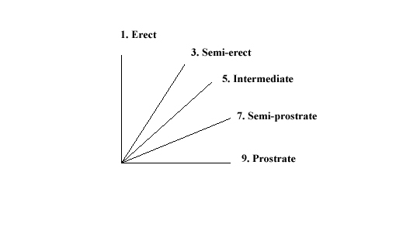
Ad. 4: Time of ear emergence

The time of ear emergence is reached when the first spikelet is visible on ears of 50% of the plants.

Ad. 8: Culm: density of hairiness of uppermost node

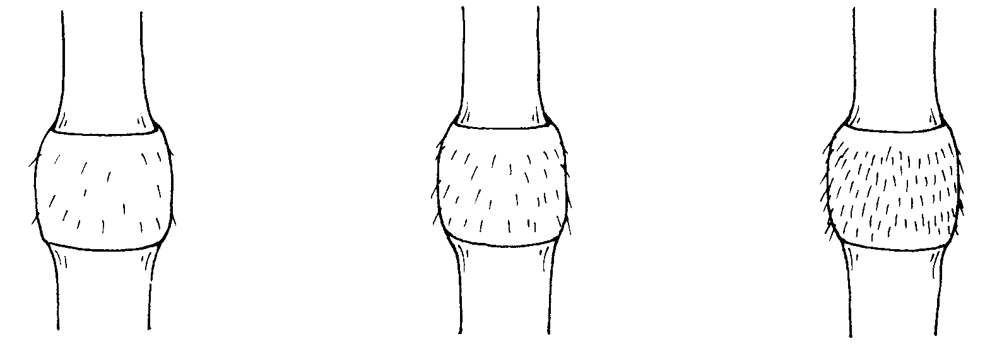
3 | 5 | 7
weak | medium | strong

Ad. 11: Plant: length

Plant length should be measured including stem, ear and awn. The length is taken from the base of the plant to the tip of the highest awn.

Ad. 12: Ear: distribution of awns

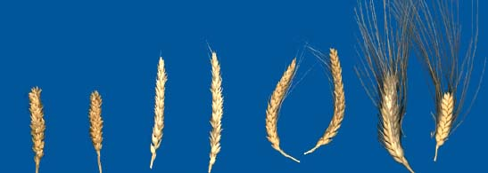
1 | 2 | 3 | 4
awnless | tip awned | half awned | fully awned

Ad. 13: Ear: length of awns at tip relative to length of ear
1 | 2 | 3
shorter | equal | longer

Ad. 14: Lower glume: shape

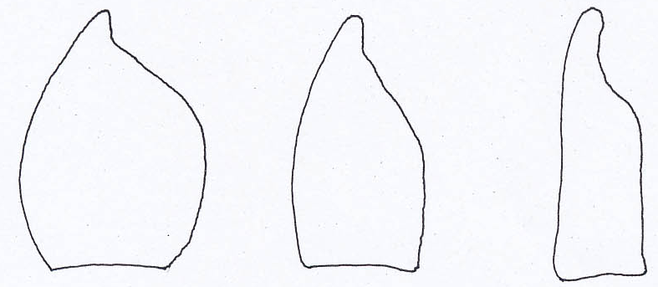

1 | 2 | 3
ovoid | medium oblong | narrow oblong

Ad. 15: Lower glume: shape of shoulder

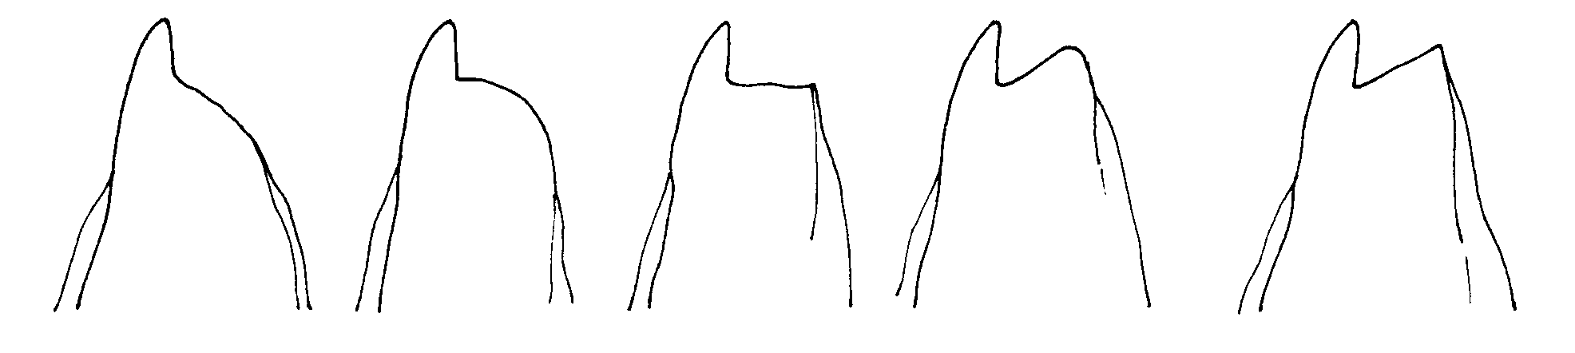
1 | 2 | 3 | 4 | 5
sloping | rounded | straight | elevated | elevated with a 2nd beak

Ad. 16: Lower glume: width of shoulder

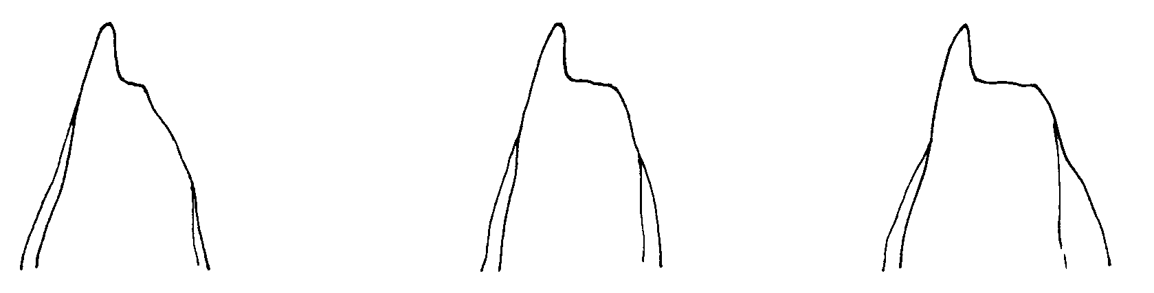

3 | 5 | 7
narrow | medium | broad
Ad. 18: Lower glume: curvature of beak

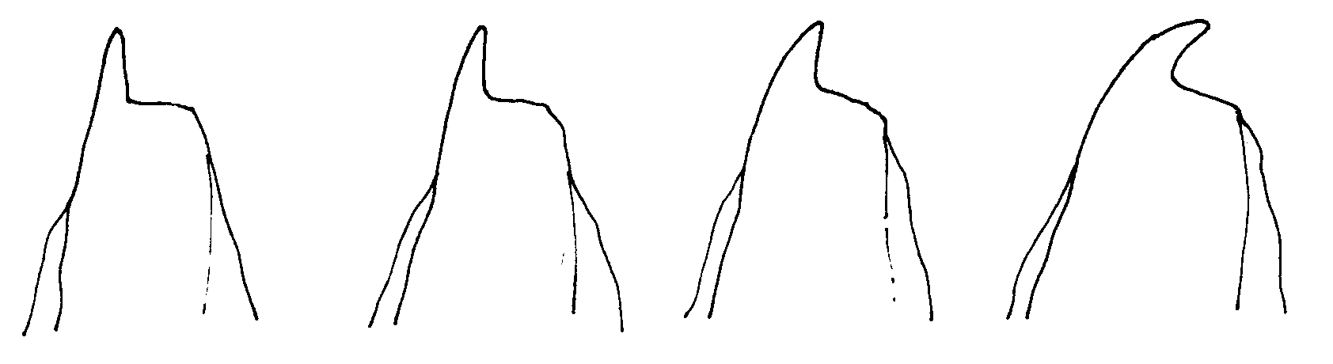
1 | 3 | 5 | 7
absent | weak | moderate | strong

Ad. 19: Lower glume: hairiness of external surface

Observations should be made with a hand lens (x10 magnification).

Ad. 20: Straw: pith in cross section

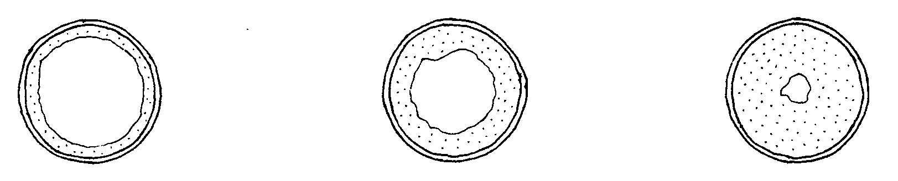
1 | 3 | 5
thin | medium | thick

The pith in cross section should be observed half way between base of ear and stem node below.

Ad. 24: Ear: density

Ear density can be determined by counting the number of spikelets and then dividing the number by the ear length. The higher ratio will indicate a higher density.

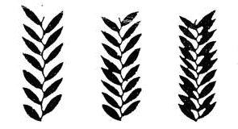
3 | 5 | 7
lax | medium | dense
Ad. 25: Grain: length of brush hair

Observations should be made with a hand lens (x10 magnification). Brush hair length is viewed from the top of the grain on the dorsal side and can be described in the following ways:

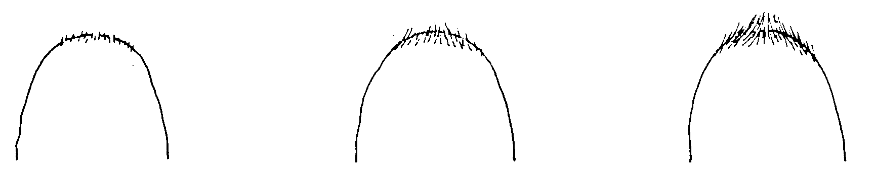
1 | 3 | 5
short | medium | long

Ad. 26: Grain: shape

To be observed in dorsal view.
1 | 2 | 3
slightly elongated | moderately elongated | strongly elongated

Ad. 27: Grain: coloration with phenol

Method for Determination of Phenol Reaction

Number of grains per test 100 grains for distinctness and uniformity. The grains should not have been treated chemically.

Equipment Petri dishes (approx. 9 cm diameter).

Preparation of grains Soak in tap water for 16 to 20 hours, drain and remove surface water, place the grains with crease downwards, cover dish with lid.

Concentration of solution 1 per cent Phenol-solution (freshly made up).

Amount of solution The grains should be about 3/4 covered.

Place Laboratory

Light Daylight - out of direct sunshine.

Temperature 18 to 20oC.

Time of recording 4 hours (after adding solution).

Scale of recording See characteristic 27 in the Table of Characteristics.

Ad. 28: Plant: seasonal type

The seasonal type should be assessed on one or several plots sown in springtime. At the time when the latest spring type variety is fully mature (growth stage 91/92 of the Zadoks decimal code), the growth stage reached by the respective variety should be assessed. The states of expression are defined as follows:

Winter type: The plants have not exceeded stage 45 of the Zadoks decimal code (boots swollen).

Alternative type: The plants have exceeded stage 45 of the Zadoks decimal code --- as a rule they have exceeded stage 75 --- and have not exceeded stage 90.

Spring type: The plants have exceeded stage 90 of the Zadoks decimal code.

8.3 The descriptions of the growth stages of the Zadoks decimal code for cereals (Zadoks et al., 1974)

Zadoks  Decimal code | Description
00 | Dry seed
01 | Start of imbibition
03 | Imbibition complete
05 | Radicle emerged from seed
07 | Coleoptile emerged from seed
09 | Leaf just at coleoptile tip
10 | First leaf through coleoptile
11 | First leaf unfolded
12 | 2 leaves unfolded
13 | 3 leaves unfolded
14 | 4 leaves unfolded
15 | 5 leaves unfolded
16 | 6 leaves unfolded
17 | 7 leaves unfolded
18 | 8 leaves unfolded
19 | 9 or more leaves unfolded
20 | Main shoot only
21 | Main shoot and 1 tiller
22 | Main shoot and 2 tillers
23 | Main shoot and 3 tillers
24 | Main shoot and 4 tillers
25 | Main shoot and 5 tillers
26 | Main shoot and 6 tillers
27 | Main shoot and 7 tillers
28 | Main shoot and 8 tillers
29 | Main shoot and 9 or more tillers
30 | Pseudo stem erection
31 | 1st node detectable
32 | 2nd node detectable
33 | 3rd node detectable
34 | 4th node detectable
35 | 5th node detectable
36 | 6th node detectable
37 | Flag leaf just visible
39 | Flag leaf ligule/collar just visible
40 | -
41 | Flag leaf sheath extending
45 | Boots just swollen
47 | Flag leaf sheath opening
49 | First awns visible
50 | First spikelet of inflorescence visible
53 | 1/4 of inflorescence emerged
55 | 1/2 of inflorescence emerged
57 | 3/4 of inflorescence emerged
59 | Emergence of inflorescence completed
60 | Beginning on anthesis
65 | Anthesis half-way
69 | Anthesis completed
70 | -
71 | Kernel watery ripe
73 | Early milk
75 | Medium milk
77 | Late milk
80 | -
83 | Early dough
85 | Soft dough
87 | Hard dough
90 | -
91 | Kernel hard (difficult to divide with thumbnail)
92 | Kernel hard (no longer dented with thumbnail)
93 | Kernel loosening in daytime
94 | Overripe, straw dead and collapsing
95 | Seed dormant
96 | Viable seed giving 50% germination
97 | Seed not dormant
98 | Secondary dormancy induced
99 | Secondary dormancy lost

Literature
Annicchiarico, P., Pecetti, L., 1994: Morpho-physiological traits as descriptors for discrimination of durum wheat germplasm. Genetic Resources and Crop Evoluation. Kluwer Academic Publishers. NL, 41: 47-54.

Fitzsimmons, R.W., Martin, R.H., Roberts, G.l., Wrigley, C.W., 1986: Australian Cereal Identification. Commonwealth Scientific and Industrial Research Organization. East Melbourne, AU.

Zadoks, J.C., Chang, T.T., Konzak, C.F., 1974: A Decimal Code for the Growth Stages of Cereals. Weed Research. NL, 14: 415-421.

Sparks, G.A., Bezar, H.J., Lamberrts, R., 1987: Identification of New Zealand Wheat Cultivars. Crop Research Division, DISR. Christchurch, NZ.

Technical Questionnaire
TECHNICAL QUESTIONNAIRE |  |  |  | Page {x} of {y} |  |  | Reference Number:
 |  |  |  |  |  |  | Application date:
 |  |  |  |  |  |  | (not to be filled in by the applicant)
TECHNICAL QUESTIONNAIRE
to be completed in connection with an application for plant breeders’ rights

1. Subject of the Technical Questionnaire
1.1 Botanical name |  |  | Triticum turgidum L. subsp. durum (Desf.) Husn.
1.2 Common name |  |  | Durum Wheat
2. Applicant
Name
Address
Telephone No.
Fax No.
E-mail address
Breeder (if different from applicant)
3. Proposed denomination and breeder’s reference
Proposed denomination
(if available)

Breeder’s reference
#4. Information on the breeding scheme and propagation of the variety

4.1 Breeding scheme

Variety resulting from:

4.1.1 Crossing

(a) controlled cross [ ]
(please state parent varieties)

(…………………..……………..…) x (……………..…………………..…)
female parent male parent

(b) partially known cross [ ]
(please state known parent variety(ies))

(…………………..……………..…) x (……………..…………………..…)
female parent male parent

(c) unknown cross [ ]

4.1.2 Mutation [ ]
(please state parent variety)

4.1.3 Discovery and development [ ]
(please state where and when discovered and how developed)

4.1.4 Other [ ]
(please provide details)

4.2 Method of propagating the variety

4.2.1 Seed-propagated varieties

(a) Self-pollination [ ]
(b) Hybrid [ ]
(c) Other [ ]
(please provide details)

4.2.2 Other [ ]
(please provide details)

In the case of hybrid varieties the production scheme for the hybrid should be provided on a separate sheet. This should provide details of all the parent lines required for propagating the hybrid e.g.

Single Hybrid

(…………………..……………..…) x (……………..…………………..…)
female parent male parent

Three-Way Hybrid

(…………………..……………..…) x (……………..…………………..…)
female parent male parent

(…………………..……………..…) x (……………..…………………..…)
female parent male parent

and should identify in particular:

(a) any male sterile lines
(b) maintenance system of male sterile lines.

5. Characteristics of the variety to be indicated (the number in brackets refers to the corresponding characteristic in Test Guidelines; please mark the note which best corresponds).

 | Characteristics |  |  |  |  |  |  | Example Varieties |  |  |  | Note
5.1  (19) | Lower glume: hairiness of external surface
 | absent |  |  |  |  |  |  | Don Sebastian, Grandur, Hyperno, Roqueño |  |  |  | 1[ ]
 | present |  |  |  |  |  |  | Don Jose, Paramo, Wollaroi |  |  |  | 9[ ]
5.2  (20) | Straw: pith in cross section
 | thin |  |  |  |  |  |  | Hyperno, Valnova |  |  |  | 1[ ]
 | thin to medium |  |  |  |  |  |  |  |  |  |  | 2[ ]
 | medium |  |  |  |  |  |  | Tamaroi |  |  |  | 3[ ]
 | medium to thick |  |  |  |  |  |  |  |  |  |  | 4[ ]
 | thick |  |  |  |  |  |  | line4210.23.6, Paramo |  |  |  | 5[ ]
5.3  (21) | Awn: color
 | white |  |  |  |  |  |  | Don Sebastian, Kronos |  |  |  | 1[ ]
 | light brown |  |  |  |  |  |  | Kamailaroi, Yallaroi |  |  |  | 2[ ]
 | medium purple |  |  |  |  |  |  | line4210.23.6, Tejon |  |  |  | 3[ ]
 | dark purple |  |  |  |  |  |  | Capdur, Don Jose, Tamaroi, Valnova |  |  |  | 4[ ]
5.4  (23) | Ear: coloration
 | white |  |  |  |  |  |  | Don Jose, Valdur, Yallaroi |  |  |  | 1[ ]
 | slightly colored |  |  |  |  |  |  | Randur |  |  |  | 2[ ]
 | strongly colored |  |  |  |  |  |  | Kronos, Tamaroi |  |  |  | 3[ ]
 | Characteristics |  |  |  |  |  |  | Example Varieties |  |  |  | Note
5.5  (27) | Grain: coloration with phenol
 | absent or very light |  |  |  |  |  |  | Don Jose, Hyperno |  |  |  | 1[ ]
 | very light to light |  |  |  |  |  |  |  |  |  |  | 2[ ]
 | light |  |  |  |  |  |  |  |  |  |  | 3[ ]
 | light to medium |  |  |  |  |  |  |  |  |  |  | 4[ ]
 | medium |  |  |  |  |  |  | Burgos, Randur |  |  |  | 5[ ]
 | medium to dark |  |  |  |  |  |  |  |  |  |  | 6[ ]
 | darl |  |  |  |  |  |  |  |  |  |  | 7[ ]
 | dark to very dark |  |  |  |  |  |  |  |  |  |  | 8[ ]
 | very dark |  |  |  |  |  |  |  |  |  |  | 9[ ]
5.7  (28) | Plant: seasonal type
 | winter type |  |  |  |  |  |  |  |  |  |  | 1[ ]
 | alternative type |  |  |  |  |  |  | Valmora |  |  |  | 2[ ]
 | spring type |  |  |  |  |  |  | Kalka, Saintly |  |  |  | 3[ ]
6. Similar varieties and differences from these varieties

Please use the following table and box for comments to provide information on how your candidate variety differs from the variety (or varieties) which, to the best of your knowledge, is (or are) most similar. This information may help the examination authority to conduct its examination of distinctness in a more efficient way.

Denomination(s) of variety(ies) similar to your candidate variety |  | Characteristic(s) in which your candidate variety differs from the similar variety(ies) |  |  | Describe the expression of the characteristic(s) for the similar variety(ies) |  |  |  |  | Describe the expression of the characteristic(s) for your candidate variety
Example |  | Ear: color at maturity |  |  |  | white |  |  | strongly colored
Comments:

#7. Additional information which may help in the examination of the variety

7.1 In addition to the information provided in sections 5 and 6, are there any additional characteristics which may help to distinguish the variety?

Yes [ ] No [ ]

(If yes, please provide details)

7.2 Are there any special conditions for growing the variety or conducting the examination?

Yes [ ] No [ ]

(If yes, please provide details)

8. Authorization for release

(a) Does the variety require prior authorization for release under legislation concerning the protection of the environment, human and animal health?

Yes [ ] No [ ]

(b) Has such authorization been obtained?

Yes [ ] No [ ]

If the answer to (b) is yes, please attach a copy of the authorization.

9. Information on plant material to be examined or submitted for examination.

9.1 The expression of a characteristic or several characteristics of a variety may be affected by factors, such as pests and disease, chemical treatment (e.g. growth retardants or pesticides), effects of tissue culture, different rootstocks, scions taken from different growth phases of a tree, etc.

9.2 The plant material should not have undergone any treatment which would affect the expression of the characteristics of the variety, unless the competent authorities allow or request such treatment. If the plant material has undergone such treatment, full details of the treatment must be given. In this respect, please indicate below, to the best of your knowledge, if the plant material to be examined has been subjected to:

(a) Microorganisms (e.g. virus, bacteria, phytoplasma) Yes [ ] No [ ]

(b) Chemical treatment (e.g. growth retardant, pesticide) Yes [ ] No [ ]

(c) Tissue culture Yes [ ] No [ ]

(d) Other factors Yes [ ] No [ ]

Please provide details for where you have indicated “yes”.

……………………………………………………………

10. I hereby declare that, to the best of my knowledge, the information provided in this form is correct:

Applicant’s name

Signature Date

[End of document]

 These names were correct at the time of the introduction of these Test Guidelines but may be revised or updated. [Readers are advised to consult the UPOV Code, which can be found on the UPOV Website (www.upov.int), for the latest information.]
# Authorities may allow certain of this information to be provided in a confidential section of the Technical Questionnaire.
# Authorities may allow certain of this information to be provided in a confidential section of the Technical Questionnaire.

