 |  | E  TC/48/3  ORIGINAL: English  DATE: January 30, 2012
INTERNATIONAL UNION FOR THE PROTECTION OF NEW VARIETIES OF PLANTS
Geneva
Technical Committee
Forty-Eighth Session
Geneva, March 26 to 28, 2012
Matters arising from the Technical Working Parties
Document prepared by the Office of the Union
1 This document summarizes certain matters arising from the 2011 sessions of the Technical Working Parties (TWPs) which are not expressly covered by specific agenda items. The matters arising are presented in two sections. The first section, “Matters for information and for a possible decision to be taken by the Technical Committee (TC)”, identifies matters raised by the TWPs, which may require a decision to be taken by the TC. The Office of the Union (Office) has highlighted aspects where the TC may wish to take a decision by introducing a proposed decision paragraph shown in italics. The second section, “Matters for information”, is provided for the information of the TC but does not require decisions at this stage.

2 The following abbreviations are used in this document:

BMT: Working Group on Biochemical and Molecular Techniques, and DNA-Profiling in Particular
CAJ: Administrative and Legal Committee
TC: Technical Committee
TC-EDC: Enlarged Editorial Committee
TWA: Technical Working Party for Agricultural Crops
TWC: Technical Working Party on Automation and Computer Programs
TWF: Technical Working Party for Fruit Crops
TWO: Technical Working Party for Ornamental Plants and Forest Trees
TWPs: Technical Working Parties
TWV: Technical Working Party for Vegetables

3 The following table of contents specifies the items covered in this document:
I. MATTERS FOR INFORMATION AND FOR A POSSIBLE DECISION TO BE TAKEN BY THE TECHNICAL COMMITTEE 3
Guidance for drafters of Test Guidelines 3
II. MATTERS FOR INFORMATION 3
Short reports from Members and Observers at the Technical Working Party sessions 3
Experiences with new types and species 3
Data loggers 3

ANNEX : REVISED PRACTICAL GUIDE FOR DRAFTERS (LEADING EXPERTS) OF UPOV TEST GUIDELINES

I. MATTERS FOR INFORMATION AND FOR A POSSIBLE DECISION TO BE TAKEN BY THE TECHNICAL COMMITTEE

Guidance for drafters of Test Guidelines

4 At the sessions of the TWA, TWF, TWO and TWV in 2011, the Office of the Union made a presentation of the latest version of the “Practical guide for drafters (Leading Experts) of UPOV Test Guidelines”, a copy of which is provided as the Annex to this document.

5 The TWO and the TWF considered document TC/47/3, Annex II “Practical Guide for Drafters (Leading Experts) of UPOV Test Guidelines”, Section “Test Guidelines for Discussion at the Technical Working Party” and agreed that draft Test Guidelines should not show revisions to previous versions and should not include comments, other than in an annex or separate document. It agreed that the Leading Expert should present a clear draft on the basis of the comments received by interested experts on the interim draft (see document TWO/44/29 “Report”, paragraph 84 and document TWF/42/26 Rev. “Revised Report”, paragraph 78).

6 The TC is invited to consider a proposal of a revised “Practical Guidance for Drafters (Leading Experts) of UPOV Test Guidelines”, Section “Test Guidelines for Discussion at the Technical Working Party”, as set out in the Annex to this document.

II. MATTERS FOR INFORMATION

Short reports from Members and Observers at the Technical Working Party sessions

7 At its forty-fifth session held in Monterey, California, United States of America, from July 25 to 29, 2011, the TWV received a presentation from the Office of the Union on the latest developments within UPOV, a copy of which is attached as Annex IV to document TWV/45/26 “Report”. The TWV agreed that, for future sessions, it would be beneficial for the report to be provided in advance of the session, thereby allowing the Office of the Union to focus on certain key elements during the presentation (see document TWV/45/26 “Report”, paragraph 7).

Experiences with new types and species

8 At its forty-fifth session, the TWV received a presentation on “Watercress DUS Test in the United Kingdom” by Tom Christie, as provided in document TWV/45/23 (see document TWV/45/26 “Report”, paragraph 67).

9 At its forty-second session held in Hiroshima, Japan, from November 14 to 18, 2011, the TWF received a presentation on “Testing Varieties of Pyrus Hybrids” by Mr. Chris Barnaby (New Zealand) as provided in document TWF/42/25 (see document TWF/42/26 Rev. “Revised Report”, paragraph 61).

Data loggers

10 The TWC, at its twenty-ninth session held in Geneva, Switzerland, from June 7 to 10, 2011, noted the information provided in document TWC/29/2 “Data loggers” and agreed that a new circular concerning hand-held data capture devices should be sent by the Office of the Union, inviting further entries in advance of the thirtieth session of the TWC (see document TWC/29/31 “Report”, paragraph 57).

[Annex follows]
REVISED PRACTICAL GUIDE FOR DRAFTERS (LEADING EXPERTS)
OF UPOV TEST GUIDELINES

TEST GUIDELINES FOR DISCUSSION AT THE TECHNICAL WORKING PARTY
(a) Test Guidelines to be re-discussed by the TWP
• Please use the Word version of the draft Test Guidelines prepared by the Office for the TWP session as the starting point for the subsequent year’s draft (it will be correctly formatted) and incorporate all agreed changes as recorded in the TWP report; then repeat the process in (b) and (c) below
• The necessary information is provided in the UPOV website at http://www.upov.int/restricted_temporary/tg/index.html

Unless otherwise agreed at the TWP session, or thereafter by the TWP Chairperson, the timetable for the consideration of draft Test Guidelines by the Technical Working Parties is as follows:

- Draft for circulation to the subgroup of interested experts
Timing: | The deadline for circulation by the Leading Expert to the Interested Experts (Subgroup) is provided in an Annex to the TWP report
Circulation of Subgroup draft by Leading Expert |  | 14 weeks before TWP session
Format: | Draft Test Guidelines should be prepared using the Electronic TG Template (http://www.upov.int/restricted_temporary/tg/index.html)
Sources of information: | Drafter’s webpage (http://www.upov.int/restricted_temporary/tg/index.html):  – adopted TGs in Word format & Word versions of TWP drafts  – TGP/7 Annex 4 “Collection of Approved Characteristics”  – Subgroup of Interested Experts
Circulation and comments: | The Leading Expert (not the Office) circulates the draft to the Interested Experts.  The list of Interested Experts is provided in an Annex to the TWP report and on the Drafter’s webpage. A deadline for comments to be made by the subgroup of Interested Experts is provided in the same Annex to the TWP report.
Comments to be received from Subgroup: |  |  | 10 weeks before TWP session

- Draft for the TWP session
Timing: | The deadline for the draft to be submitted to the Office of the Union (Office) is provided in the Annex to the TWP report
Sending of draft to the Office by the Leading Expert |  |  | 6 weeks
Format: |  | Draft Test Guidelines should be prepared with the Electronic TG Template (http://www.upov.int/restricted_temporary/tg/index.html)  A “clean” version of the draft should be provided: the draft should not contain any comments within the document. If necessary, any comments should be included in an annex or in a separate document  All characteristics in the Table of Characteristics should be numbered in sequence without letters (i.e. 1, 2, 3, not 1, 2, 2(a), 3) (previous numbering can be shown in brackets, e.g. “5. (old 4.)”  Revisions (track change) mode should not be used:  Additions can be indicated (manually) by highlighting & underlining  Deletions can be indicated (manually) by highlighting & strikethrough  Different colored text should not be used to indicate comments / changes  Illustrations should be inserted as shown on the following page
Posting of draft on the website by the Office |  |  | 4 weeks
“Final” drafts: | Drafts at the “final” stage should have no missing information from any chapter of the Test Guidelines and should include, for example, explanations of characteristics contained in the Table of Characteristics and an appropriate set of example varieties.

In cases where either of the deadlines for circulation of the Subgroup draft or for the sending of the draft to the Office by the Leading Expert is not met, the Test Guidelines would be withdrawn from the TWP agenda and the Office would inform the TWP accordingly at the earliest opportunity (i.e. not later than 4 weeks before the TWP session). In those cases where draft Test Guidelines are withdrawn from the TWP agenda because of failure by the Leading Expert to meet the relevant dates, it would be possible for specific matters concerning those Test Guidelines to be discussed at the TWP session. However, to consider specific matters it would be necessary for a document to be provided to the Office at least 6 weeks before the TWP session.

TEST GUIDELINES TO BE SUBMITTED TO THE TECHNICAL COMMITTEE (TC)
• The Office will prepare the draft Test Guidelines for the TC.
• Please provide all missing information requested in the TWP report by the date specified in the Annex to the TWP report, but please do not provide that information in the form of revised Test Guidelines containing that information.

INSERTING IMAGES INTO THE TEST GUIDELINES

In order to avoid distortions of the illustrations and to minimize the size of the files, please:

(a) – Use: JPG, JPEG or PNG format to reduce the size of the images.
Please do not use: TIF, TIFF, BMP, TGA, PCX or JP2.

(b) – Insert the illustration for each individual state into an individual cell of a table (e.g. by using the command edit; copy and then “paste” or “paste special”). Please see Annex for further guidance.

Example

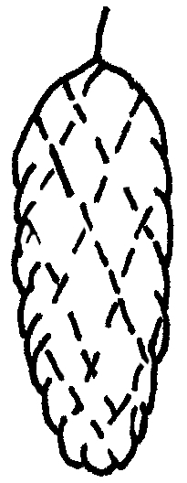 | 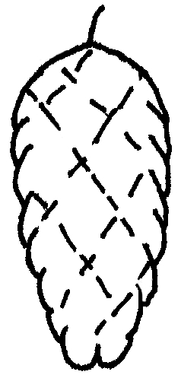 | 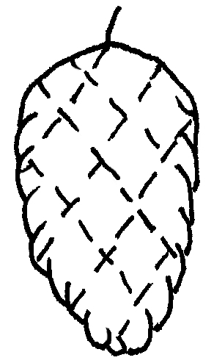 | 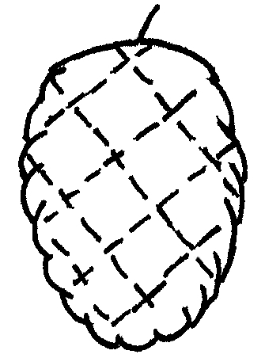 | 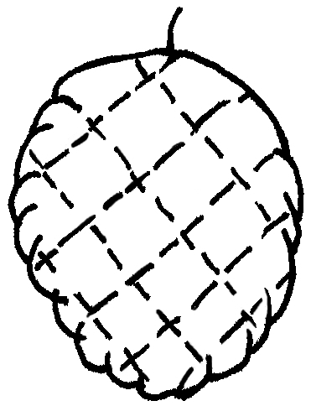
1 | 2 | 3 | 4 | 5
cylindrical | narrow ovate | medium ovate | broad ovate | circular

(c) – When an illustration contains several elements (e.g. drawings, arrows, figures, text, etc.) please, fix them in place, by “grouping” or by incorporating them into an image (e.g. by using the command edit; copy and inserting it using “paste special” and PNG format).

Ad. 21: Corolla: reflexing of lateral lobes
Ad. 22: Corolla: length in relation to width

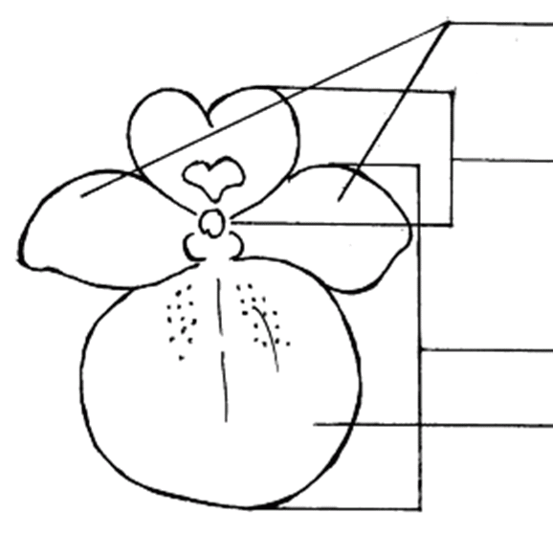 | lateral lobes of corolla  upper lip of corolla  lower lip of corolla  lower lobe of corolla

IN WORD 2003 (AND ALIKE), CHECK THAT THE FOLLOWING SETTINGS ARE ACTIVATED:

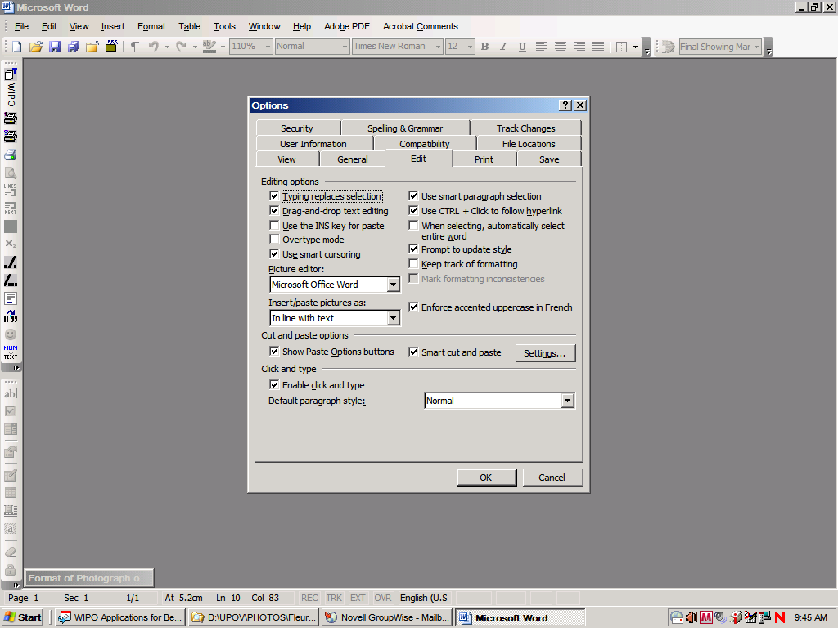
Menu > Tools > Options > Edit

and

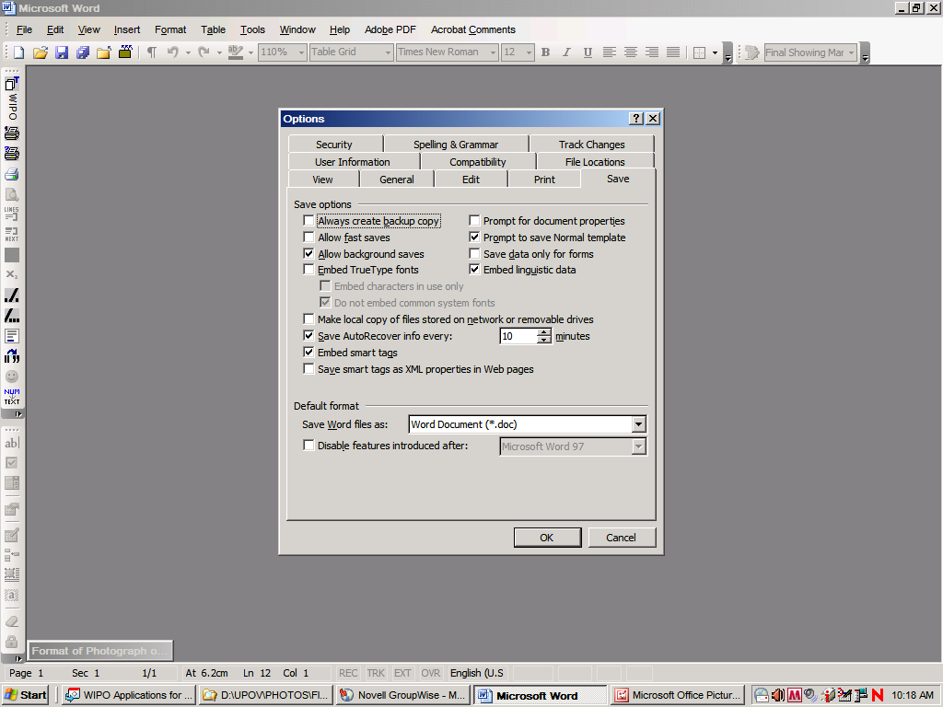

Once the cursor is inside the table, insert the picture (Menu > insert > picture > from file >…).

If the picture is already in a Word document, cut and paste it in the table.

In previous versions of Word (Word 6.0 1995, or Word 97), use “Paste special” and uncheck the option “floating over text” on the right hand in order to paste the picture inside the table.

[End of Annex and of document]

