 |  | E  TC/48/17  ORIGINAL: English  DATE: February 23, 2012
INTERNATIONAL UNION FOR THE PROTECTION OF NEW VARIETIES OF PLANTS
Geneva
Technical Committee
Forty-Eighth Session
Geneva, March 26 to 28, 2012
Partial Revisions of Test Guidelines
Document prepared by the Office of the Union
1 The purpose of this document is to present the proposals for partial revisions to the following Test Guidelines, to be considered by the Technical Committee, at its meeting to be held in Geneva from March 26 to 28, 2012:

• Test Guidelines for French Bean (document TG/12/9)
• Test Guidelines for Strawberry (document TG/22/10)
• Test Guidelines for Kalanchoe (document TG/78/4)
• Test Guidelines for New Guinea Impatiens (document TG/196/2)
2 The structure of this document is as follows:

Partial revision of the Test Guidelines for French Bean (document TG/12/9) 1
Partial revision of the Test Guidelines for Strawberry (document TG/22/10) 2
Partial revision of the Test Guidelines for Kalanchoe (document TG/78/4) 2
Partial revision of the Test Guidelines for New Guinea Impatiens (document TG/196/2) 2
ANNEX I Partial Revision of the Test Guidelines for French Bean (Document TG/12/9)
ANNEX II Partial Revision of the Test Guidelines for Strawberry (Document TG/22/10)
ANNEX III Partial Revision of the Test Guidelines for Kalanchoe (Document TG/78/4)
ANNEX IV Partial Revision of the Test Guidelines for New Guinea Impatiens (Document TG/196/2)

Partial revision of the Test Guidelines for French Bean (document TG/12/9)

3 The Technical Working Party for Vegetables (TWV), at its forty-fifth session, held in Monterey, United States of America, from July 25 to 29, 2011, agreed to propose to revise the Test Guidelines for French Bean (document TG/12/9) as follows:

• Proposed Amendment of Characteristic 49 “Resistance to Bean anthracnose (Colletotrichum lindemuthianum)” (Quadrilingual)

• Proposal of Deletion of Characteristic 50 “Type of resistance to Bean Common Mosaic Virus (BCMV)” and addition of a new characteristic 50 “Resistance to Bean Common Mosaic Necrosis Virus (BCMNV)”

• Proposed Amendment of Characteristic 51 “Resistance to Halo Blight (Pseudomonas syringae pv. phaseo licola)”

4 The proposals are set out in Annex I to this document.

Partial revision of the Test Guidelines for Strawberry (document TG/22/10)

5 The Technical Working Party for Fruit Crops (TWF), at its forty-second session, held in Hiroshima, Japan, from November 14 to 18, 2011, agreed to propose to revise the Test Guidelines for Strawberry (document TG/22/10) as follows:

• Proposal to replace the drawing in Chapter 8.1 (d) in the Test Guidelines for Strawberry.

6 The proposals are set out in Annex II to this document.

Partial revision of the Test Guidelines for Kalanchoe (document TG/78/4)

7 The Technical Working Party for Ornamental Plants and Forest Trees (TWO) at its forty-fourth session in Fukuyama City, Japan, from November 7 to 11, 2011, agreed to propose to revise the Test Guidelines for Kalanchoe (document TG/78/4) as follows:

• Proposal to add a new state of expression for characteristic 32 ”Corolla lobe: distribution of secondary color”

• Proposal to add a new state of expression for characteristic 38 “Only varieties with double flowers: Outer corolla lobe: distribution of secondary color”

• Proposal to add the drawing for a new state of expression in the explanations on the Table of Characteristics:
Ad.32: Corolla lobe: distribution of secondary color
Ad.38: Only varieties with double flowers: Outer corolla lobe: distribution of secondary color

8 The proposals are set out in Annex III to this document.

Partial revision of the Test Guidelines for New Guinea Impatiens (document TG/196/2)

9 The Technical Working Party for Ornamental Plants and Forest Trees (TWO), at its forty-fourth session in Fukuyama City, Japan, from November 7 to 11, 2011, agreed to propose to revise the Test Guidelines for New Guinea Impatiens (document TG/196/2) as follows.

• Proposal to add new states of expression for characteristic 22 “Varieties with bi- or multicolored flowers only: Flower: distribution of secondary color”

• Proposal to add the drawings for new states of expression in the explanations on the Table of Characteristics:
Ad. 22: Varieties with bi- or multicolored flowers only: Flower: distribution of secondary color

10 The proposals are set out in Annex IV to this document.

[Annexes follow]
PARTIAL REVISION OF THE TEST GUIDELINES FOR FRENCH BEAN (DOCUMENT TG/12/9)

Proposed Amendment of Characteristic 49 in the Table of Characteristics

Current wording

49.  (+) |  | Resistance to Bean anthracnose (Colletotrichum lindemuthianum) | Résistance à l’anthracnose du Haricot (Colletotrichum lindemuthianum) | Resistenz gegen Brennflecken-krankheit (Colletotrichum lindemuthianum) | Resistencia a la antracnosis de la judía (Colletotrichum lindemuthianum)
49.1 | VG | Race Lambda | Pathotype Lambda | Pathotyp Lambda | Patotipo Lambda
QL |  | absent | absente | fehlend | ausente | Daisy (D), Tuf (D) | 1
 |  | present | présente | vorhanden | presente | Belfin (D), Label (D), Reskia (D) | 9
49.2 | VG | Race Kappa | Pathotype Kappa | Pathotyp Kappa | Patotipo Kappa
QL |  | absent | absente | fehlend | ausente | Belfin (D), Label (D) | 1
 |  | present | présente | vorhanden | presente | Reskia (D) | 9

Proposed new wording

49.  (+) |  | Resistance to Bean anthracnose (Colletotrichum lindemuthianum) | Résistance à l’anthracnose du Haricot (Colletotrichum lindemuthianum) | Resistenz gegen Brennflecken-krankheit (Colletotrichum lindemuthianum) | Resistencia a la antracnosis de la judía (Colletotrichum lindemuthianum)
49.1  (*) | VS/  VG | Race 6 | Pathotype 6 | Pathotyp 6 | Patotipo 6
QL |  | absent | absente | fehlend | ausente | Goldrush, Masaï, Michelet | 1
 |  | present | présente | vorhanden | presente | Booster, Pastoral | 9
49.2 | VS/  VG | Race Kappa | Pathotype Kappa | Pathotyp Kappa | Patotipo Kappa
QL |  | absent | absente | fehlend | ausente | Goldrush, Masaï, Michelet | 1
 |  | present | présente | vorhanden | presente | Booster, Pastoral | 9

Proposal of Deletion of Characteristic 50 “Type of resistance to Bean Common Mosaic Virus (BCMV)” and addition of a new characteristic 50 “Resistance to Bean Common Mosaic Necrosis Virus (BCMNV)”

Current wording

50.  (*)  (+) | VG | Type of resistance to Bean Common Mosaic Virus (BCMV) | Type de résistance au virus de la mosaïque commune du Haricot (BCMV) | Art der Resistenz gegen Gewöhnliches Bohnenmosaikvirus (BCMV) | Tipo de resistencia al virus del mosaico común de la judía (BCMV)
QL |  | mosaic development present, blackroot development absent | développement de la mosaïque présent, développement du blackroot absent | Mosaikentwicklung vorhanden, Entwicklung von Schwarzbeinigkeit fehlend | desarrollo del mosaico presente, desarrollo del pie negro ausente | Michelite (D), Rapier (D), Spinel (C) | 1
 |  | mosaic development absent, blackroot development present | développement de la mosaïque absent, développement du blackroot présent | Mosaikentwicklung fehlend, Entwicklung von Schwarzbeinigkeit vorhanden | desarrollo del mosaico ausente, desarrollo del pie negro presente | Arena (D), Masai (D), Odessa (D), Topcrop (D) | 2
 |  | mosaic development absent, blackroot development absent | développement de la mosaïque absent, développement du blackroot absent | Mosaikentwicklung fehlend, Entwicklung von Schwarzbeinigkeit fehlend | desarrollo del mosaico ausente, desarrollo del pie negro ausente | Felspar (C), Great Northern 31 (D) | 3

Proposal

Characteristic 50 to be deleted.

50.  (*)  (+) | VG | Type of resistance to Bean Common Mosaic Virus (BCMV) | Type de résistance au virus de la mosaïque commune du Haricot (BCMV) | Art der Resistenz gegen Gewöhnliches Bohnenmosaikvirus (BCMV) | Tipo de resistencia al virus del mosaico común de la judía (BCMV)
QL |  | mosaic development present, blackroot development absent | développement de la mosaïque présent, développement du blackroot absent | Mosaikentwicklung vorhanden, Entwicklung von Schwarzbeinigkeit fehlend | desarrollo del mosaico presente, desarrollo del pie negro ausente | Michelite (D), Rapier (D), Spinel (C) | 1
 |  | mosaic development absent, blackroot development present | développement de la mosaïque absent, développement du blackroot présent | Mosaikentwicklung fehlend, Entwicklung von Schwarzbeinigkeit vorhanden | desarrollo del mosaico ausente, desarrollo del pie negro presente | Arena (D), Masai (D), Odessa (D), Topcrop (D) | 2
 |  | mosaic development absent, blackroot development absent | développement de la mosaïque absent, développement du blackroot absent | Mosaikentwicklung fehlend, Entwicklung von Schwarzbeinigkeit fehlend | desarrollo del mosaico ausente, desarrollo del pie negro ausente | Felspar (C), Great Northern 31 (D) | 3

Proposed wording for new characteristic 50

50.  (*)  (+) | VS/  VG | Resistance to Bean Common Mosaic Necrosis Virus (BCMNV) | Résistance au virus de la mosaïque nécrotique commune du Haricot (BCMNV) | Resistenz gegen Gewöhnliches nekrotisches Bohnenmosaikvirus (BCMNV) | Resistencia al virus del mosaico necrotico común de la judía (BCMNV)
QL |  | absent | absente | fehlend | ausente | Dufrix, Flandria | 1
 |  | present with necrosis | présente avec nécroses | vorhanden mit Nekrose | presente con necrosis | Booster, Odessa | 2
 |  | present without symptoms | présente sans symptômes | vorhanden ohne Symptome | presente sin síntomas | Bizet | 3
Proposed Amendment of Characteristic 51 in the Table of Characteristics

Current wording

51.  (+) |  | Resistance to Halo Blight (Pseudomonas syringae pv. phaseo licola) | Résistance à la graisse à halo (Pseudomonas syringae pv. phaseolicola) | Resistenz gegen Fettfleckenkrankheit (Pseudomonas syringae pv. phaseolicola) | Resistencia a la grasa (Pseudomonas syringae pv. phaseolicola)
51.1 | VG | US Race 1 | US Pathotype 1 | US Pathotyp 1 | US Patotipo 1
QL |  | absent | absente | fehlend | ausente | Amboy (D), Michelite (D) | 1
 |  | present | présente | vorhanden | presente | RM UI-3 (D),  RM UI-34 (D), Forum (D), Masai (D) | 9
51.2 | VG | US Race 2 | US Pathotype 2 | US Pathotyp 2 | US Patotipo 2
QL |  | absent | absente | fehlend | ausente | RM UI-3 (D),  RM UI-34 (D) | 1
 |  | present | présente | vorhanden | presente | Forum (D), Masai (D) | 9

Proposed new wording

51.  (+) | VS/  VG | Resistance to Halo Blight (Pseudomonas syringae pv. phaseo licola) | Résistance à la graisse à halo (Pseudomonas syringae pv. phaseolicola) | Resistenz gegen Fettfleckenkrankheit (Pseudomonas syringae pv. phaseolicola) | Resistencia a la grasa (Pseudomonas syringae pv. phaseolicola)
 |  | Race 6 | Pathotype 6 | Pathotyp 6 | Patotipo 6
QL |  | absent | absente | fehlend | ausente | Michelet (D) | 1
 |  | present | présente | vorhanden | presente | Masai (D), Vaillant (D) | 9

[Annex II follows]
PARTIAL REVISION OF THE TEST GUIDELINES FOR STRAWBERRY (DOCUMENT TG/22/10)

Proposal to replace the drawing in Chapter 8.1 (d) in the Test Guidelines for Strawberry.

Current illustration and explanation:

- Unless otherwise indicated, observations on the fruit should not be made on terminal fruits.

terminal flower / fruit

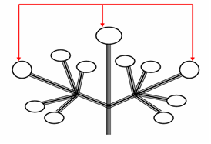

Proposed illustration:

terminal flower / fruit

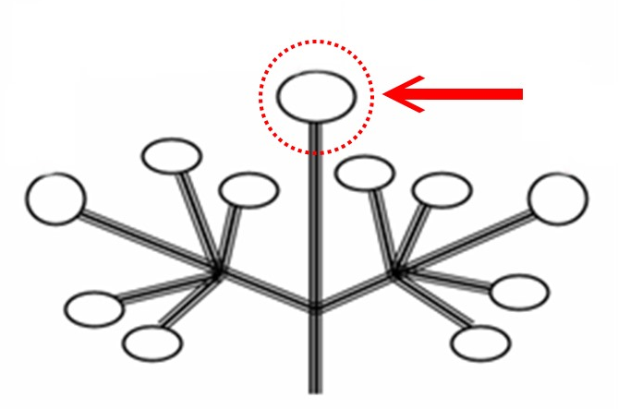

[Annex III follows]
PARTIAL REVISION OF THE TEST GUIDELINES FOR KALANCHOE (DOCUMENT TG/78/4)

Proposal to add a new state of expression for characteristic 32 “Corolla lobe:
distribution of secondary color”

Characteristic 32 “Corolla lobe: distribution of secondary color” of the Test Guidelines for Kalanchoe (document TG/78/4 dated 2008-04-09)

Current wording:
32.  (*)  (+) |  | Corolla lobe: distribution of secondary color | Lobe de la corolle : distribution de la couleur secondaire | Kronzipfel: Verteilung der Sekundärfarbe | Lóbulo de la corola: distribución del color secundario
PQ | (d) | at margin only | en bordure seulement | nur am Rand | únicamente en el margen | Alcedo | 1
 |  | at margin and at base | en bordure et à la base | am Rand und an der Basis | en el margen y en la base | Mipinkstar | 2
 |  | at base only | à la base seulement | nur an der Basis | únicamente en la base | Impromero | 3
 |  | at base and in median stripe | à la base et une raie médiane | an der Basis und als Mittelstreifen | en la base y en la estría central | Milos | 4
 |  | median stripe only | raie médiane seulement | nur als Mittelstreifen | únicamente estría central |  | 5
 |  | mainly on one half | principalement sur une moitié | hauptsächlich auf einer Hälfte | principalmente en una mitad | Rewiros | 6
 |  | dotted | pointillée | gepunktet | salpicado | Greco | 7
 |  | brindled | panachée | gescheckt | pinto |  | 8

Proposal

To add a new state of expression: “at apex” (9)

Proposal to add a new state of expression for characteristic 38 “Only varieties with double flowers: Outer corolla lobe: distribution of secondary color”

Characteristic 38 “Only varieties with double flowers: Outer corolla lobe: distribution of secondary color”

Current wording:
38.  (+) |  | Only varieties with double flowers: Outer corolla lobe: distribution of secondary color | Variétés à fleurs doubles seulement : lobe extérieur de la corolle : distribution de la couleur secondaire | Nur Sorten mit gefüllten Blüten: Äußerer Kronzipfel: Verteilung der Sekundärfarbe | Únicamente variedades con flores dobles:  Lóbulo exterior de la corola: distribución del color secundario
PQ | (c) | at margin only | en bordure seulement | nur am Rand | únicamente en el margen |  | 1
 |  | at margin and at base | en bordure et à la base | am Rand und an der Basis | en el margen y en la base |  | 2
 |  | at base only | à la base seulement | nur an der Basis | únicamente en la base |  | 3
 |  | at base and in median stripe | à la base et une raie médiane | an der Basis und als Mittelstreifen | en la base y en la estría central |  | 4
 |  | median stripe only | raie médiane seulement | nur als Mittelstreifen | únicamente estría central |  | 5
 |  | mainly on one half | principalement sur une moitié | hauptsächlich auf einer Hälfte | principalmente en una mitad |  | 6
 |  | dotted | pointillé | gepunktet | salpicado |  | 7
 |  | brindled | panachée | gescheckt | pinto |  | 8

Proposal

To add a new state of expression: “at apex” (9)

Proposal to add the drawing for a new state of expression in the explanations on the
Table of Characteristics

Ad.32: Corolla lobe: distribution of secondary color
Ad.38: Only varieties with double flowers: Outer corolla lobe: distribution of secondary color

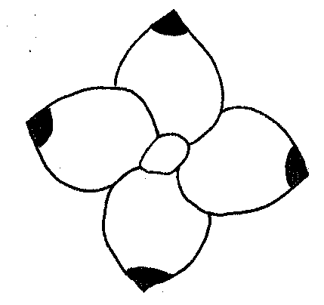
9
at apex

[Annex IV follows]
PARTIAL REVISION OF THE TEST GUIDELINES FOR NEW GUINEA IMPATIENS (DOCUMENT TG/196/2)

Proposal to add new states of expression for characteristic 22 ”Varieties with bi- or multicolored flowers only: Flower: distribution of secondary color”

Characteristic 22 “Varieties with bi- or multicolored flowers only: Flower: distribution of secondary color” of the Test Guidelines for New Guinea Impatiens (document TG/196/2 dated 2006-04-05).

Current wording:
22.  (*)  (+) | Varieties with bi- or multicolored flowers only: Flower: distribution of secondary color | Seulement les variétés à fleurs bicolores ou multicolores: fleur: distribution de la couleur secondaire | Nur Sorten mit zwei- oder mehrfarbigen Blüten: Blüte: Verteilung der Sekundärfarbe | Sólo para variedades con flores bicolores o multicolores: Flor: distribución del color secundario
PQ | mainly on upper petal | surtout sur le pétale supérieur | hauptsächlich auf dem oberen Blütenblatt | principalmente en el pétalo superior | Vulcain | 1
 | on all petals around base | sur tous les pétales autour de la base | auf allen Blütenblättern um die Basis herum | en todos los pétalos alrededor de la base | Balcelisow | 2
 | on all petals along mid-rib | sur tous les pétales le long de la nervure centrale | auf allen Blütenblättern entlang der Mittelrippe | a lo largo del nervio central de todos los pétalos | Kiluis | 3
 | on all petals v-shaped at distal end | sur tous les pétales en V vers le sommet | auf allen Blütenblättern V-förmig am distalen Ende | en forma de “v” en el extremo distal de todos los pétalos | Danharpurcrown | 4
 | on all petals irregularly distributed | sur tous les pétales irrégulièrement répartie | auf allen Blütenblättern unregelmäßig verteilt | distribuido irregularmente en todos los pétalos | Fisnics Magpink | 5

Proposal:

To add the following new states of expression:

“mainly on lateral petals” (6)
“on all petals as some longitudinal stripes and on upper petal as spot” (7)

Proposal to add the drawings for new states of expression in the explanations on the Table of Characteristics: Ad.22: “Varieties with bi- or multicolored flowers only:
Flower: distribution of secondary color”

Ad. 22: Varieties with bi- or multicolored flowers only: Flower: distribution of secondary color

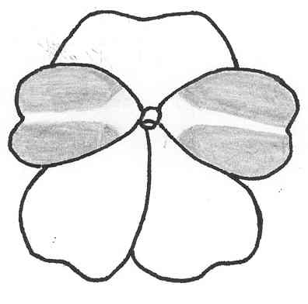 | 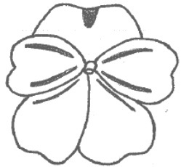
6 | 7
mainly on lateral petals | on all petals as some longitudinal stripes and  on upper petal as spot

[End of Annex IV and of document]

