E
CAJ-AG/13/8/3
ORIGINAL: English
DATE: September 17, 2013
INTERNATIONAL UNION FOR THE PROTECTION OF NEW VARIETIES OF PLANTS
Geneva
Administrative and Legal Committee Advisory Group
Eighth Session
Geneva, October 25, 2013
Explanatory Notes on Acts in Respect of Harvested Material
Document prepared by the Office of the Union
Disclaimer: this document does not represent UPOV policies or guidance
The Council, at its forty-seventh ordinary session, to be held in Geneva on October 24, 2013, will be invited to adopt document UPOV/EXN/HRV/1 “Explanatory Notes on Acts in Respect of Harvested Material under the 1991 Act of the UPOV Convention” on the basis of document UPOV/EXN/HRV Draft 10.

The CAJ, at its sixty-seventh session, held in Geneva, on March 21, 2013, agreed to invite the Administrative and Legal Committee Advisory Group (CAJ-AG) to immediately start work on a future possible revision of the “Explanatory Notes on Acts in Respect of Harvested Material under the 1991 Act of the UPOV Convention” in order to include illustrative examples of situations where breeders might be considered to be able to exercise their rights in relation to harvested material. The CAJ further agreed to invite the CAJ-AG to consider the development of guidance on “reasonable opportunity” in relation to a possible revision of the “Explanatory Notes on Acts in Respect of Harvested Material under the 1991 Act of the UPOV Convention” (see document CAJ/67/14 “Report on the Conclusions”, paragraphs 13 and 14).

On the above basis, the purpose of this document is to present proposals concerning illustrative examples of situations where breeders might be considered to be able to exercise their rights in relation to harvested material and to consider the development of guidance on “reasonable opportunity”.

CONTENTS
ILLUSTRATIVE EXAMPLES 3
Background 3
Scope of the Breeder’s Right 3
Exhaustion 4
Discussions that took place prior to the 1991 Diplomatic Conference 4
Analysis of illustrative examples 6
Example 1 7
Example 2 8
Example 3 9
Example 4 10
Example 5 11
Example 6 12
Example 7 13
Example 8 14
Example 9 15
Example 10 16
Example 11 16
Reasonable opportunity 17
Background 17
Development of guidance 17

ILLUSTRATIVE EXAMPLES

Background

At its sixth session, held in Geneva on October 18, 2011, the CAJ-AG considered document UPOV/EXN/HRV Draft 6 “Explanatory Notes on Acts in Respect of Harvested Material under the 1991 Act of the UPOV Convention”. With regard to Section (e) “Illustrative examples”, the CAJ-AG noted that the illustrative examples could cause some confusion with regard to matters concerning unauthorized use of propagating material and matters concerning exhaustion. It agreed that the illustrative examples should be replaced by a general explanation of “unauthorized use of propagating material”, on the basis of the cases provided in the illustrative Examples 1 to 8. The CAJ-AG noted that Example 9 did not make reference to unauthorized use of propagating material (see CAJ­AG/11/6/7 “Report”, paragraph 10).

The CAJ-AG, at its seventh session, held in Geneva on October 29 and 30, 2012, agreed that on the basis of the amendments agreed at the session, the Office of the Union should prepare a revised version of document UPOV/EXN/HRV Draft 8, to be considered by the CAJ at its sixty-seventh session, to be held in Geneva on March 21, 2013, and for subsequent adoption by the Council. The CAJ-AG further agreed to propose to the CAJ that the CAJ-AG be invited to immediately start work on illustrative examples for a future possible revision (see CAJ-AG/12/7/7 “Report”, paragraph 78). As explained in the introduction to this document, the CAJ, at its sixty-seventh session, held in Geneva, March 21, 2013, agreed to invite the Administrative and Legal Committee Advisory Group (CAJ-AG) to immediately start work on a future possible revision of the “Explanatory Notes on Acts in Respect of Harvested Material under the 1991 Act of the UPOV Convention” in order to include illustrative examples of situations where breeders might be considered to be able to exercise their rights in relation to harvested material.

Scope of the Breeder’s Right

Article 14, paragraphs (1) and (2), of the 1991 Act of the UPOV Convention are reproduced here for ease of reference:

Article 14 of the 1991 Act of the UPOV Convention

(1) [Acts in respect of the propagating material] (a) Subject to Articles 15 and 16, the following acts in respect of the propagating material of the protected variety shall require the authorization of the breeder:

(i) production or reproduction (multiplication),
(ii) conditioning for the purpose of propagation,
(iii) offering for sale,
(iv) selling or other marketing,
(v) exporting,
(vi) importing,
(vii) stocking for any of the purposes mentioned in (i) to (vi), above.

(b) The breeder may make his authorization subject to conditions and limitations.

(2) [Acts in respect of the harvested material] Subject to Articles 15 and 16, the acts referred to in items (i) to (vii) of paragraph (1)(a) in respect of harvested material, including entire plants and parts of plants, obtained through the unauthorized use of propagating material of the protected variety shall require the authorization of the breeder, unless the breeder has had reasonable opportunity to exercise his right in relation to the said propagating material.

[…]

Exhaustion

Article 16 of the UPOV Convention is reproduced here for ease of reference:

Article 16 of the 1991 Act: Exhaustion of the breeder’s right

(1) [Exhaustion of right] The breeder’s right shall not extend to acts concerning any material of the protected variety, or of a variety covered by the provisions of Article 14(5), which has been sold or otherwise marketed by the breeder or with his consent in the territory of the Contracting Party concerned, or any material derived from the said material, unless such acts

(i) involve further propagation of the variety in question or

(ii) involve an export of material of the variety, which enables the propagation of the variety, into a country which does not protect varieties of the plant genus or species to which the variety belongs, except where the exported material is for final consumption purposes.

(2) [Meaning of “material”] For the purposes of paragraph (1), “material” means, in relation to a variety,

(i) propagating material of any kind,

(ii) harvested material, including entire plants and parts of plants, and

(iii) any product made directly from the harvested material.

(3) [“Territory” in certain cases] For the purposes of paragraph (1), all the Contracting Parties which are member States of one and the same intergovernmental organization may act jointly, where the regulations of that organization so require, to assimilate acts done on the territories of the States members of that organization to acts done on their own territories and, should they do so, shall notify the Secretary-General accordingly.

Discussions that took place prior to the 1991 Diplomatic Conference

In order to assist the CAJ­AG in its consideration of the possibility of developing illustrative examples, the following extracts from the preparatory work for the Diplomatic Conference for the Revision of the International Convention for the Protection of New Varieties of Plants, held in Geneva from March 4 to 19, 1991 (1991 Diplomatic Conference) may be of assistance.

Extract from document CAJ/XXII/8
(Report of the twenty-second session of the Administrative and Legal Committee,
held in Geneva from April 18 to 21, 1988)
Extract relates to the item “Revision of the Convention”, “Article 5” and refers to document CAJ/XXII/6, a copy of which is posted on the UPOV website (see http://www.upov.int/meetings/en/details.jsp?meeting_id=29783)

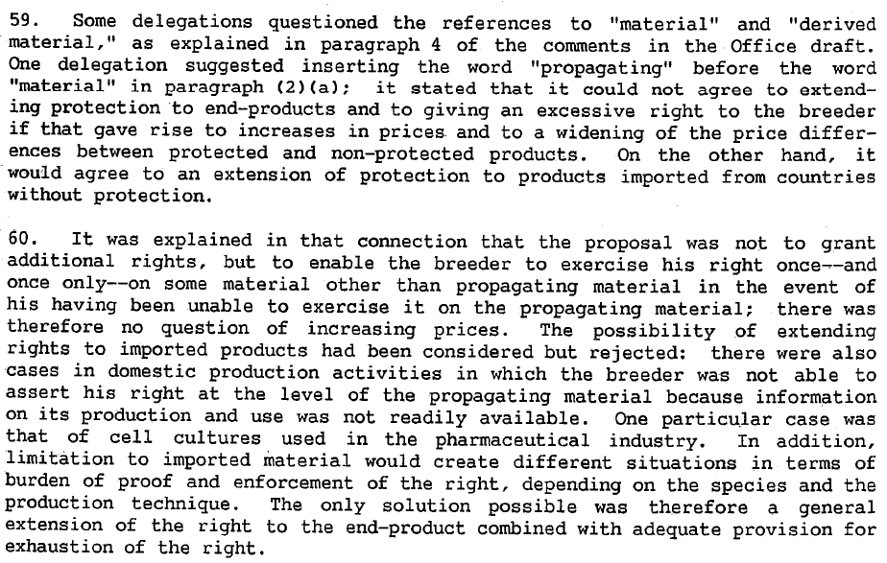

Extract from document CAJ/XXIII/7
(Report of the twenty-third session of the Administrative and Legal Committee,
held in Geneva from October 11 to 14, 1988)
Extract relates to the item “Revision of the Convention”, “Article 5” and refers to document CAJ/XXIII/2, a copy of which is posted on the UPOV website (see http://www.upov.int/meetings/en/details.jsp?meeting_id=29783)

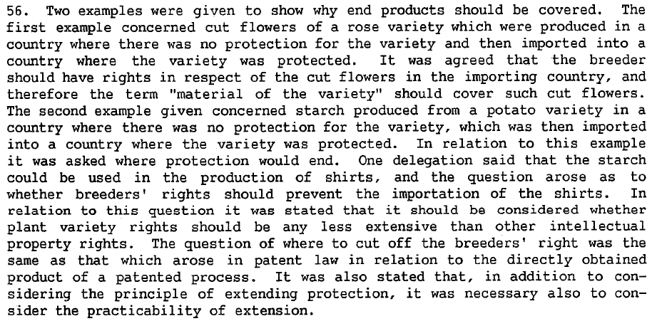

Extract from document CAJ/XXIV/6
(Report of the twenty-fourth session of the Administrative and Legal Committee,
held in Geneva from April 10 to 13, 1989)
Extract relates to the item “Revision of the Convention”, “Article 5” and refers to document CAJ/XXIV/2, a copy of which is posted on the UPOV website (see http://www.upov.int/meetings/en/details.jsp?meeting_id=29783)

76. Paragraph (2) (i) [exhaustion of right].- A discussion ensued on the
phrase "material which has been put on the market in the member State of the
Union concerned," that is to say the question whether a breeder who had placed
material on the market in one country should still have the possibility of
exercising his right of prohibition in another country to oppose imports of
the material into the latter country. That question was answered affirmatively
in view of the nature, that is to say domestic, of the titles of protection
issued and of the independence of protection afforded in the various member
States. The proposed text was held to be satisfactory on that point.

Analysis of illustrative examples

In order to seek to clarify the issues concerning unauthorized use of propagating material and matters concerning exhaustion, the examples in document UPOV/EXN/HRV Draft 6, with two additional examples, are considered further in the following section. Examples 1 to 9 in this document have been graphically illustrated in order to improve clarity with regard to the situation in the territories and further explanations have been provided with regard to unauthorized use of propagating material and matters concerning exhaustion, in order to facilitate discussion on the suitability of the examples.

The alternative explanations are based on matters raised in previous discussions in the CAJ­AG, comments received and the discussions that took place prior to the 1991 Diplomatic Conference, based in particular on the extracts above. The purpose of preparing the alternative explanations is to seek to find an agreed explanation, but also to seek to ensure that reasons for rejecting an explanation are clearly understood on the basis of Articles 14 and 16 of the 1991 Act of the UPOV Convention.

Example 1

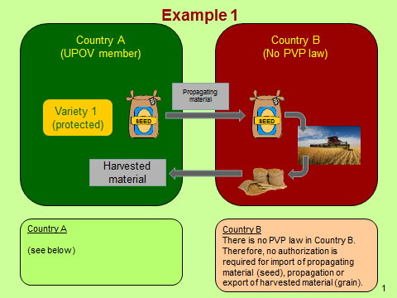
Country A

Possible explanations:

Alternative (a)

The breeder of Variety 1 can exercise the right on the imported harvested material if there was unauthorized export (use) of propagating material and the breeder did not have a reasonable opportunity in Country A to exercise the right in relation to the export of propagating material.

The breeder’s right is not exhausted in Country A, because there is “further propagation of the variety in question”.

(Note: this alternative assumes that “further propagation” does not mean propagation that requires the authorization of the breeder, because authorization is not required in Country B.)

Alternative (b)

The breeder of Variety 1 can exercise the right on the imported harvested material if there was unauthorized export (use) of propagating material and the breeder did not have a reasonable opportunity in Country A to exercise the right in relation to the export of propagating material.

The breeder’s right is not exhausted in Country A, because there is “export of material of the variety, which enables the propagation of the variety, into a country which does not protect varieties of the plant genus or species to which the variety belongs, except where the exported material is for final consumption purposes”.

Example 2

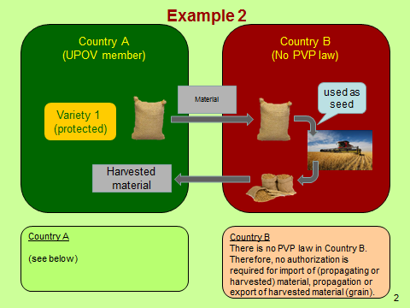
Country A

Possible explanations:

Alternative (a)

The breeder of Variety 1 can exercise the right on the imported harvested material if there was unauthorized export (use) of material that was used as propagating material and the breeder did not have a reasonable opportunity in Country A to exercise the right in relation to the export.

The breeder’s right is not exhausted in Country A, because there is “further propagation of the variety in question”.

(Note: this alternative assumes that “further propagation” does not mean propagation that requires the authorization of the breeder, because authorization is not required in Country B.)

Alternative (b)

The breeder of Variety 1 can exercise the right on the imported harvested material if there was unauthorized export (use) of material that was used as propagating material and the breeder did not have a reasonable opportunity in Country A to exercise the right in relation to the export.

The breeder’s right is not exhausted in Country A, because there is “export of material of the variety, which enables the propagation of the variety, into a country which does not protect varieties of the plant genus or species to which the variety belongs, except where the exported material is for final consumption purposes”.

Example 3

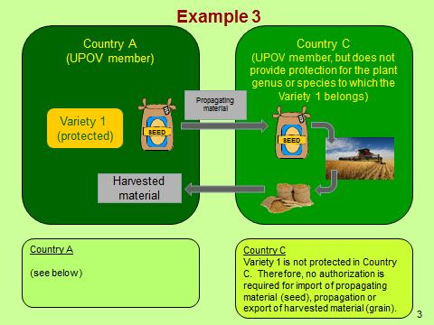
Country A

Possible explanations:

Alternative (a)

The breeder of Variety 1 can exercise the right on the imported harvested material if there was unauthorized export (use) of propagating material and the breeder did not have a reasonable opportunity in Country A to exercise the right in relation to the export of propagating material.

The breeder’s right is not exhausted in Country A, because there is “further propagation of the variety in question”.

(Note: this alternative assumes that “further propagation” does not mean propagation that requires the authorization of the breeder, because authorization is not required in Country C.)

Alternative (b)

The breeder of Variety 1 can exercise the right on the imported harvested material if there was unauthorized export (use) of propagating material and the breeder did not have a reasonable opportunity in Country A to exercise the right in relation to the export of propagating material.

The breeder’s right is not exhausted in Country A, because there is “export of material of the variety, which enables the propagation of the variety, into a country which does not protect varieties of the plant genus or species to which the variety belongs, except where the exported material is for final consumption purposes”.

Example 4

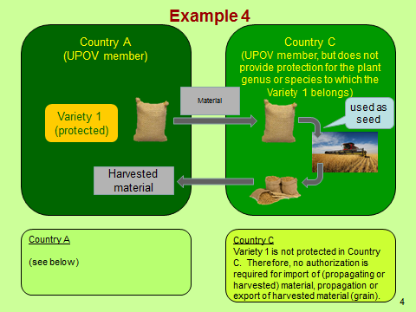
Country A

Possible explanations:

Alternative (a)

The breeder of Variety 1 can exercise the right on the imported harvested material if there was unauthorized export (use) of material that was used as propagating material and the breeder did not have a reasonable opportunity in Country A to exercise the right in relation to the export.

The breeder’s right is not exhausted in Country A, because there is “further propagation of the variety in question”.

(Note: this alternative assumes that “further propagation” does not mean propagation that requires the authorization of the breeder, because authorization is not required in Country C.)

Alternative (b)

The breeder of Variety 1 can exercise the right on the imported harvested material if there was unauthorized export (use) of material that was used as propagating material and the breeder did not have a reasonable opportunity in Country A to exercise the right in relation to the export.

The breeder’s right is not exhausted in Country A, because there is “export of material of the variety, which enables the propagation of the variety, into a country which does not protect varieties of the plant genus or species to which the variety belongs, except where the exported material is for final consumption purposes”.

Example 5

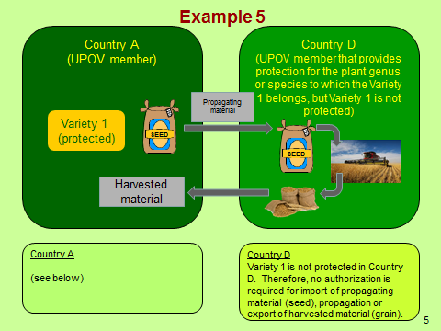
Country A

Possible explanations:

Alternative (a)

The breeder of Variety 1 can exercise the right on the imported harvested material if there was unauthorized export (use) of propagating material and the breeder did not have a reasonable opportunity in Country A to exercise the right in relation to the export of propagating material.

The breeder’s right is not exhausted in Country A, because there is “further propagation of the variety in question”.

(Note: this alternative assumes that “further propagation” does not mean propagation that requires the authorization of the breeder, because authorization is not required in Country D.)

Alternative (b)

The breeder of Variety 1 cannot exercise the right on the imported harvested material because the right is exhausted.

(Note: this alternative assumes that there is exhaustion of the right because there is no “export of material of the variety, which enables the propagation of the variety, into a country which does not protect varieties of the plant genus or species to which the variety belongs, except where the exported material is for final consumption purposes” and assumes that that “further propagation” means propagation that requires the authorization of the breeder, because authorization is not required in Country D.

In previous discussions in the CAJ­AG, it was noted that such an explanation implied that there would be less protection for breeders in Country A if harvested material originated from a non-UPOV member with no PVP law compared to a UPOV member, for the same situation, and concluded that such a situation would not have been the intention of the Convention.)

Example 6

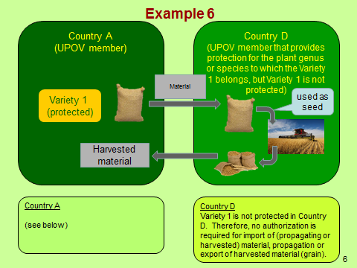
Country A

Possible explanations:

Alternative (a)

The breeder of Variety 1 can exercise the right on the imported harvested material if there was unauthorized export (use) of material that was used as propagating material and the breeder did not have a reasonable opportunity in Country A to exercise the right in relation to the export.

The breeder’s right is not exhausted in Country A, because there is “further propagation of the variety in question”.

(Note: this alternative assumes that “further propagation” does not mean propagation that requires the authorization of the breeder, because authorization is not required in Country D.)

Alternative (b)

The breeder of Variety 1 cannot exercise the right on the imported harvested material because the right is exhausted.

(Note: this alternative assumes that there is exhaustion because there is no “export of material of the variety, which enables the propagation of the variety, into a country which does not protect varieties of the plant genus or species to which the variety belongs, except where the exported material is for final consumption purposes” and assumes that that “further propagation” means propagation that requires the authorization of the breeder, because authorization is not required in Country D.

In previous discussions in the CAJ­AG, it was noted that such an explanation implied that there would be less protection for breeders in Country A if harvested material originated from a non-UPOV member with no PVP law compared to a UPOV member, for the same situation, and concluded that such a situation would not have been the intention of the Convention.)

Example 7

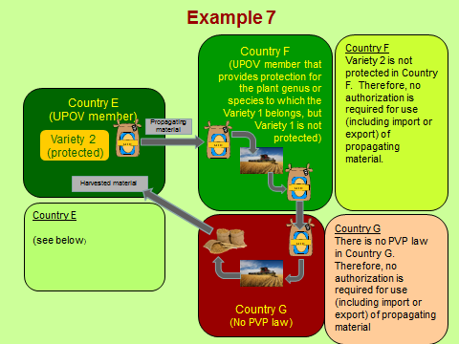
Country E

Possible explanations:

Alternative (a)

The breeder of Variety 2 can exercise the right on the imported harvested material if there was unauthorized export (use) of propagating material and the breeder did not have a reasonable opportunity in Country E to exercise the right in relation to the export of propagating material.

The breeder’s right is not exhausted in Country E, because there is “further propagation of the variety in question”.

(Note: this alternative assumes that “further propagation” does not mean propagation that requires the authorization of the breeder, because authorization is not required in Country F.)

Alternative (b)

The breeder of Variety 2 can exercise the right on the imported harvested material if there was unauthorized export (use) of propagating material and the breeder did not have a reasonable opportunity in Country A to exercise the right in relation to the export of propagating material.

The breeder’s right is not exhausted in Country E, because there is “export of material of the variety, which enables the propagation of the variety, into a country which does not protect varieties of the plant genus or species to which the variety belongs, except where the exported material is for final consumption purposes”.

Example 8

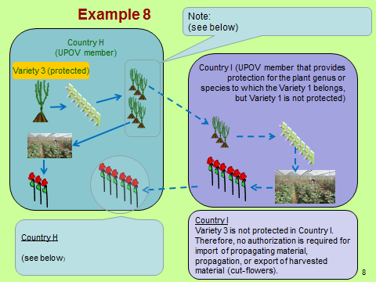
(Note: The breeder of variety 3 authorizes a propagator in Country H to produce 50,000 plants for sale for cut-flower production. The propagator produces 50,000 plants, which are sold to a grower in Country H. The grower in Country H plants 25,000 plants, but sells 25,000 plants to a grower in Country I (for cut-flower production), where variety 3 is not protected. However, the grower in Country I uses the 25,000 plants to propagate further plants of variety 3.)

Country H

Possible explanations:

Alternative (a)

The breeder of Variety 3 can exercise the right on the imported harvested material if there was unauthorized export (use) of propagating material and the breeder did not have a reasonable opportunity in Country H to exercise the right in relation to the export of propagating material.

The breeder’s right is not exhausted in Country H, because there is “further propagation of the variety in question”.

(Note: this alternative assumes that “further propagation” does not mean propagation that requires the authorization of the breeder, because authorization is not required in Country I.)

Alternative (b)

The breeder of Variety 3 cannot exercise the right on the imported harvested material because the right is exhausted.

(Note: this alternative assumes that there is exhaustion because there is no “export of material of the variety, which enables the propagation of the variety, into a country which does not protect varieties of the plant genus or species to which the variety belongs, except where the exported material is for final consumption purposes” and assumes that that “further propagation” means propagation that requires the authorization of the breeder, because authorization is not required in Country I.)

Example 9

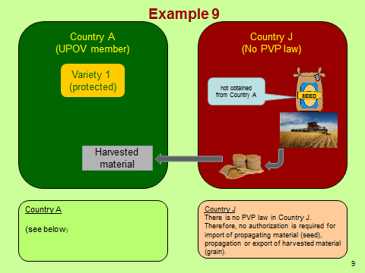
Country A

Possible explanations:

Alternative (a)

The breeder of Variety 1 can exercise the right on the imported harvested material if the breeder did not have a reasonable opportunity in Country A to exercise the right in relation to propagating material.

The breeder’s right is not exhausted in Country A, because it is the first opportunity to exercise the right.

(Note: this alternative is based on the extracts from the preparatory work for the 1991 Diplomatic Conference (see paragraph 7 of this document), which indicated a wish to

- extend protection to “products imported from countries without protection” and to “enable the breeder to exercise his right once – and only once – on some material other than propagating material” (see document CAJ/XXII/8)
- provide rights in respect of cut flowers “produced in a country where there was no protection for the variety and then imported into a country where the variety was protected” (see document CAJ/XXIII/7))

Alternative (b)

The breeder of Variety 3 cannot exercise the right on the imported harvested material because there was no unauthorized use of propagating material.

Example 10

Variety 4 is protected in Country K. In Country K, there is an exception under Article 15(2) of the 1991 Act, but that exception is not applicable for the species to which variety 4 belongs. A farmer uses some of the harvested material of variety 4 for propagating purposes on his own holding without the authorization of the breeder.

Explanation

The breeder of Variety 4 can exercise the right on the harvested material if the breeder did not have a reasonable opportunity to exercise the right in relation to the propagating material.

The breeder’s right is not exhausted because there is “further propagation of the variety in question”.

Example 11

Variety 5 is protected in Country L. In Country L, an exception under Article 15(2) of the 1991 Act is applicable for variety 5, with a limit on the amount of the harvested material which the farmer is allowed to use for propagating purposes. The farmer uses more than the permitted amount for propagating purposes on his own holding without the authorization of the breeder.

Explanation

The breeder of Variety 5 can exercise the right on the harvested material if the breeder did not have a reasonable opportunity to exercise the right in relation to the propagating material.

The breeder’s right is not exhausted because there is “further propagation of the variety in question”.

The CAJ­AG is invited to consider Examples 1 to 11 and the possible explanations in relation to the ability of the breeder to exercise the right in relation to harvested material.

Reasonable opportunity

Background

The Council, at its forty-seventh ordinary session, to be held in Geneva on October 24, 2013, will be invited to adopt document UPOV/EXN/HRV/1 “Explanatory Notes on Acts in Respect of Harvested Material under the 1991 Act of the UPOV Convention” on the basis of document UPOV/EXN/HRV Draft 10.

The CAJ, at its sixty-seventh session, held in Geneva, March 21, 2013, agreed to invite the CAJ-AG to consider the development of guidance on “reasonable opportunity” in relation to a possible revision of the “Explanatory Notes on Acts in Respect of Harvested Material under the 1991 Act of the UPOV Convention” (see document CAJ/67/14 “Report on the Conclusions”, paragraph 14).

The only text that has been considered by the CAJ­AG in relation to an elaboration of the term “reasonable opportunity” was the following (see document UPOV/EXN/HRV Draft 8, paragraph 13):

“It is a matter for each member of the Union to determine what constitutes ‘reasonable opportunity’ to exercise his right.”

However, the CAJ-AG, at its seventh session, held in Geneva on October 29 and 30, 2012, agreed that the above text should be deleted (see document CAJ-AG/12/7/7 “Report”, paragraph 76).

Development of guidance

In the absence of previous proposals and discussion on the matter of “reasonable opportunity”, it is proposed that members of the Union and observer organizations representing breeders be invited to submit proposals for guidance on the matter.

The CAJ­AG is invited to propose to the CAJ to invite members of the Union and observer organizations representing breeders to submit proposals for guidance on the matter.

[End of document]

