E
CAJ/73/2
ORIGINAL: English
DATE: October 10, 2016
INTERNATIONAL UNION FOR THE PROTECTION OF NEW VARIETIES OF PLANTS
Geneva
ADministrative and legal committee
Seventy-Third Session
Geneva, October 25, 2016
Development of information materials concerning the UPOV Convention
Document prepared by the Office of the Union
Disclaimer: this document does not represent UPOV policies or guidance
EXECUTIVE SUMMARY

The purpose of this document is to provide background information to assist the Administrative and Legal Committee (CAJ) in its consideration of relevant matters at its seventy-third session and present a tentative program for the development of information materials.

The CAJ is invited to:

- consider the draft “Explanatory Notes on Essentially Derived Varieties under the 1991 Act of the UPOV Convention” (Revision) (see document UPOV/EXN/EDV/2 Draft 7), as set out in paragraphs 6 to 13 of this document;

- note that, if approved by the CAJ, a draft of the “Explanatory Notes on Essentially Derived Varieties under the 1991 Act of the UPOV Convention (Revision)” (document UPOV/EXN/EDV/2 ) would be presented for adoption by the Council at its thirty-fourth extraordinary session in April 2017;

- note that a meeting of the Office of the Union with the International Community of Breeders of Asexually Reproduced Ornamental and Fruit Varieties (CIOPORA), the International Seed Federation (ISF) and the World Intellectual Property Organization (WIPO) has been tentatively scheduled to take place during the first quarter of 2017 in order to explore the possible role of UPOV in alternative dispute settlement mechanisms for matters concerning essentially derived varieties, including the provision of experts on EDV matters, as set out in paragraphs 14 and 15 of this document;

- note the developments concerning document UPOV/EXN/PPM/1 Draft 6, “Explanatory Notes on Propagating Material under the UPOV Convention” at the ninety-first session of the Consultative Committee and the thirty-third extraordinary session of the Council; as set out in paragraphs 20 and 21 of this document;

- note the developments concerning the “Seminar on Propagating and Harvested Material in the context of the UPOV Convention,” to be held in Geneva on October 24, 2016, and

- consider a possible way forward for the development of guidance on the notion of propagating material, taking into consideration:

- document UPOV/EXN/PPM/1 Draft 6;

- comments by the Consultative Committee, at its ninety-first session, and by the Council at its thirty-third extraordinary session, as set out in paragraphs 20 and 21 of this document; and
- the “Seminar on Propagating and Harvested Material in the context of the UPOV Convention”;

- consider a possible revision of the Explanatory Notes on Conditions and Limitations Concerning the Breeder's Authorization in Respect of Propagating Material under the UPOV Convention (document UPOV/EXN/CAL/1);

- consider a possible revision of the Explanatory Notes on Provisional Protection under the UPOV Convention” (document UPOV/EXN/PRP/2);

- continue to defer the preparation of a draft revision of document UPOV/INF/5 “UPOV Model Plant Breeders’ Rights Gazette (Revision)” (document UPOV/INF/5/1 Draft 1), pending developments in relation to the development of a prototype electronic form (see document CAJ/73/4 “Electronic application form”);

- note that a report on the work concerning the possible development of a UPOV similarity search tool for variety denomination purposes and proposals concerning a possible revision of document UPOV/INF/12 “Explanatory Notes on Variety Denominations under the UPOV Convention” are provided in document CAJ/73/3 “Variety denominations”;

- note the report of the discussions, at the fifty-second session of the TC, on variety descriptions and the role of plant material, as set out in paragraph 37 of this document; and

- consider the program for the development of information materials in conjunction with the discussions on the scheduling of the CAJ sessions, under the item “Program for the seventy-fourth session”, as set out in paragraph 39 of this document.

Table of Contents

INTRODUCTION 3
OVERVIEW OF THE DEVELOPMENT OF INFORMATION MATERIALS 3
INFORMATION MATERIALS 3
Explanatory Notes on Essentially Derived Varieties under the 1991 Act of the UPOV Convention (Revision) (document UPOV/EXN/EDV/2 Draft 7) 3
Explanatory Notes on Propagating Material under the UPOV Convention (document UPOV/EXN/PPM/1 Draft 6) 6
Possible revision of the Explanatory Notes on Conditions and Limitations Concerning the Breeder's Authorization in Respect of Propagating Material under the UPOV Convention (document UPOV/EXN/CAL/1) 9
Possible revision of the Explanatory Notes on Provisional Protection under the UPOV Convention (document UPOV/EXN/PRP/2) 9
UPOV Model Plant Breeders’ Rights Gazette (Revision) 9
Explanatory Notes on Variety Denominations under the UPOV Convention (Revision) 10
Variety descriptions and role of plant material 10
TENTATIVE PROGRAM FOR THE DEVELOPMENT OF INFORMATION MATERIALS 10

INTRODUCTION

The CAJ, at its fifty-second session, agreed an approach for the preparation of information materials concerning the UPOV Convention. It also agreed to the establishment of an advisory group to the CAJ (CAJ-AG) to assist in the preparation of documents concerning such materials. The agreed approach is summarized as follows: the Office of the Union will develop certain draft materials which it considers covers aspects of a straightforward nature and will circulate these to the CAJ for comments within a specified time. In other cases, where it is considered that there are difficult issues, where discussions at a CAJ session would be important for the development of suitable information materials, and also in cases where the drafts on seemingly straightforward materials provoke unexpected concerns when circulated for comments, it was agreed that the assistance of the CAJ-AG would be sought prior to the CAJ being invited to discuss those matters at its sessions.

The CAJ, at its seventieth session agreed that all matters under consideration by the CAJ-AG at its ninth session should, following the ninth session of the CAJ-AG, be considered by the CAJ and that the CAJ-AG should only be convened, on an ad hoc basis, as considered appropriate by the CAJ.

OVERVIEW OF THE DEVELOPMENT OF INFORMATION MATERIALS

An overview of the development of the information materials is provided in Annex I to this document.

INFORMATION MATERIALS

Explanatory Notes on Essentially Derived Varieties under the 1991 Act of the UPOV Convention (Revision) (document UPOV/EXN/EDV/2 Draft 7)

The CAJ, at its seventy-second session, agreed the following amendments to document “Explanatory Notes on Essentially Derived Varieties under the 1991 Act of the UPOV Convention” (Revision) (document UPOV/EXN/EDV/2 Draft 6).

Paragraph 4 | To read as follows: “The requirement of predominant derivation from an initial variety means that a variety can only be essentially derived from one initial variety. The intention is that a variety should only be essentially derived from another variety when it retains virtually the whole genotype of the other variety. A derived variety could not, in practice, retain the expression of the essential characteristics of the variety from which it is derived unless it is almost entirely derived from that initial variety.”
Paragraph 4 | Spanish version to read as follows:  “El requisito de derivación principal de una variedad inicial implica que una variedad solo puede ser esencialmente derivada de una sola variedad inicial. La intención es que una variedad solo sea esencialmente derivada de otra variedad cuando conserve prácticamente todo el genotipo de la otra variedad. En la práctica, una variedad derivada no puede conservar la expresión de los caracteres esenciales de la variedad de la que deriva excepto si deriva casi exclusivamente de esa variedad inicial.”
Paragraph 5 | To read as follows: “The phrase “while retaining the expression of the essential characteristics” requires that the expression of the essential characteristics conforms to and be derived from the initial variety.”
Paragraph 11 | To read as follows: “The derived variety must retain almost the totality of the genotype of the initial variety and be distinguishable different from that variety by a very limited number of characteristics (typically by one).”
Paragraphs 20 and 21 | 20. Another example of an indirect way in which it might be possible to obtain an essentially derived variety from an initial variety could be the use of a hybrid variety to obtain a variety which is essentially derived from one of the parent lines of the hybrid.  21. The use of molecular data from an initial variety, for the purpose of selection of genotypes from a population that is mostly related to the initial variety, to produce a variety with a similar phenotypic expression of the essential characteristics may provide an indication of predominant derivation, if the variety fulfills the definition in Article 14(5)(b).  A joint proposal on paragraphs 20 and 21 to be provided by ESA and ISF for consideration by the CAJ at its seventy-third session. ESA and ISF would be invited to present to the CAJ the background issues to paragraphs 20 and 21 and the proposed text.
Paragraph 31 | Spanish version to read as follows:  “Tanto la derivación predominante principal (por ejemplo, datos sobre la conformidad genética con la variedad inicial) como la conformidad respecto de los caracteres esenciales (por ejemplo, datos sobre la conformidad en la expresión de los caracteres esenciales de la variedad inicial) son posibles puntos de partida para ofrecer indicios de que una variedad podría ser esencialmente derivada de la variedad inicial.”
Paragraph 32 | To read as follows: “In some situations, relevant information provided by the breeder of the initial variety on predominant derivation and/or on conformity on the essential characteristics might be used as the basis for the reversal of the burden of proof. In such situations, the other breeder might need to prove that the other variety is not essentially derived from the initial variety. For instance, the other breeder would need to provide information on the breeding history of the second other variety to prove that the variety was not essentially derived from the initial variety.”
Paragraph 32 | Spanish version to read as follows:  “En algunas situaciones, podría utilizarse como base de la inversión de la carga de la prueba información pertinente proporcionada por el obtentor de la variedad inicial relativa a la derivación predominante principal o la conformidad respecto de los caracteres esenciales. En tales situaciones, el otro obtentor podría estar obligado a demostrar que su variedad no es esencialmente derivada de la variedad inicial. Por ejemplo, el otro obtentor debería aportar información sobre el método de obtención de la segunda variedad para demostrar que la variedad no se derivó de la variedad inicial.”

The CAJ agreed that a new draft of the “Explanatory Notes on Essentially Derived Varieties under the 1991 Act of the UPOV Convention (Revision)” (document UPOV/EXN/EDV/2 Draft 7), incorporating the changes and reflecting the approach agreed by the CAJ at its seventy-second session, be posted as soon as possible for consideration by the CAJ at its seventy-third session.

On May 30, 2016, document UPOV/EXN/EDV/2 Draft 7 “Explanatory Notes on Essentially Derived Varieties under the 1991 Act of the UPOV Convention” was posted on the UPOV website for consideration by the CAJ, at its seventy-third session (see UPOV Circular E-16/086).

The CAJ, at its seventy-second session, agreed that “[a] joint proposal on paragraphs 20 and 21 […] be provided by ESA and ISF for consideration by the CAJ at its seventy-third session. ESA and ISF would be invited to present to the CAJ the background issues to paragraphs 20 and 21 and the proposed text.” (see document CAJ/72/9 “Report on the Conclusions”, paragraph 11).
On July 21, 2016, the Office of the Union circulated to the CAJ the joint ISF/ESA proposal for paragraphs 20 and 21 of document UPOV/EXN/EDV/2 Draft 7 received from ISF and ESA on July 20, 2016 with a request for the CAJ to provide comments on the ISF/ESA proposal no later than August 20, 2016 (see UPOV Circular E-16/190). On August 17, 2016, a comment was received from the Delegation of the Russian Federation.

The ISF/ESA proposal and the comment received from the Delegation of the Russian Federation are reproduced below and their communications appear as Annexes II and III respectively.

ISF/ESA joint proposal

“20. Another example of an indirect way in which it might be possible to obtain an essentially derived variety from an initial variety could be the use of a hybrid variety to obtain a variety which is essentially derived from one of the parent lines of the hybrid.

“21. The use of molecular data from an initial variety, for the purpose of selection of genotypes from a population that is mostly related to the initial variety, to produce a variety with a similar phenotypic expression of the essential characteristics may provide an indication of predominant derivation, if the variety fulfills the definition in Article 14(5)(b).

“20. Another example of a way in which it might be possible to obtain EDV from an initial variety could be the physical use of a hybrid variety to obtain a variety which is essentially derived from one of the parent lines of the hybrid. In such a case the parent line is the initial variety. The hybrid is obtained by using the initial variety and the EDV is obtained by using the hybrid. It might be that the breeder of the EDV did not use the initial variety himself, but by using the hybrid he is using a variety that is derived from the initial variety. This means the initial variety has been used in the derivation process.”

Comment from the Russian Federation on the ISF/ESA joint proposal

“A new edition of Item 20 of document UPOV/EXN/EDV/2 Draft 7 under the joint ISF/ESA suggestion sets up that hybrids can be considered as essentially derived varieties (EDVs) from one of parents’ lines what is inappropriate.

“Hybrids belong to the varieties whose production requires the repeated use of protected varieties / lines. This concerns Article 14(5)(a)(iii) of the UPOV Convention but not Article 14(5)(a)(i).

“A hybrid and each of its parent lines are independent objects of protection and can be used on a general basis (without ties) as initial varieties when developing EDVs.”

The CAJ is invited to consider a new draft of the “Explanatory Notes on Essentially Derived Varieties under the 1991 Act of the UPOV Convention” (Revision), as presented in document UPOV/EXN/EDV/2 Draft 7, in conjunction the ISF/ESA proposal and the comment received from the Delegation of the Russian Federation, reproduced in paragraph 11 above.

Subject to approval by the CAJ, a draft of the “Explanatory Notes on Essentially Derived Varieties under the 1991 Act of the UPOV Convention (Revision)” (document UPOV/EXN/EDV/2) would be presented for adoption by the Council at its thirty-fourth extraordinary session, in April 2017.

The CAJ, at its seventy-second session, endorsed the proposal for the Office of the Union to organize a meeting to exchange information with the International Community of Breeders of Asexually Reproduced Ornamental and Fruit Varieties (CIOPORA), the International Seed Federation (ISF) and the World Intellectual Property Organization (WIPO), in order to explore the possible role of UPOV in alternative dispute settlement mechanisms for matters concerning essentially derived varieties, including the provision of experts on EDV matters.

The Office of the Union contacted CIOPORA, ISF and WIPO in relation to the above proposal and a meeting has been tentatively scheduled to take place during the first quarter of 2017 in order to explore the possible role of UPOV in alternative dispute settlement mechanisms for matters concerning essentially derived varieties, including the provision of experts on EDV matters. A report on this meeting will be made to the CAJ at its seventy-fourth session.

The CAJ is invited to:

(a) consider the draft “Explanatory Notes on Essentially Derived Varieties under the 1991 Act of the UPOV Convention” (Revision) (see document UPOV/EXN/EDV/2 Draft 7), as set out in paragraphs 6 to 13 of this document;

(b) note that, if approved by the CAJ, a draft of the “Explanatory Notes on Essentially Derived Varieties under the 1991 Act of the UPOV Convention (Revision)” (document UPOV/EXN/EDV/2 ) would be presented for adoption by the Council at its thirty-fourth extraordinary session in April 2017; and

(c) note that a meeting of the Office of the Union with the International Community of Breeders of Asexually Reproduced Ornamental and Fruit Varieties (CIOPORA), the International Seed Federation (ISF) and the World Intellectual Property Organization (WIPO) has been tentatively scheduled to take place during the first quarter of 2017 in order to explore the possible role of UPOV in alternative dispute settlement mechanisms for matters concerning essentially derived varieties, including the provision of experts on EDV matters, as set out in paragraphs 14 and 15 of this document.

Explanatory Notes on Propagating Material under the UPOV Convention (document UPOV/EXN/PPM/1 Draft 6)

The CAJ, at its seventy-second session, agreed the following amendments to document “Explanatory Notes on Propagating Material under the UPOV Convention” (document UPOV/EXN/PPM/1 Draft 5):

Section (a) | To delete Section (a) and incorporate in the Annex to the document the provisions of the UPOV Convention where reference is made to the notion of propagating material.
Paragraph 1 | To read as follows:  “The UPOV Convention does not provide a definition of ‘propagating material’. Propagating material encompasses reproductive and vegetative propagating material. The following are non-exhaustive examples of factors that have been considered by members of the Union in relation to whether material is propagating material:  “(i) plant or part of plants used for the variety reproduction;  “(ii) whether the material has been used to propagate the variety;  “(iii) whether the material is capable of producing entire plants of the variety and is factually used for propagating purposes;  “(iv) whether there has been a custom/practice of using the material for propagating purposes or, as a result of new developments, there is a new custom/practice of using the material for that purpose;  “(v) the intention on the part of those concerned (producer, seller, supplier, buyer, recipient, user);  “(vi) if, based on the nature and condition of the material and/or the form of its use, it can be determined that the material is “propagating material”; or  “(vii) the variety material where conditions and mode of its production meet the purpose of reproduction of new plants of the variety but not of final consumption.”

The CAJ agreed, at its seventy-second session, that a draft of document “Explanatory Notes on Propagating Material under the UPOV Convention” (document UPOV/EXN/PPM/1 Draft 6) incorporating the changes agreed by the CAJ at its seventy-second session, be presented for adoption by the Council at its extraordinary session in March 2016.
Developments concerning document UPOV/EXN/PPM/1 Draft 6 since the seventy-second session of the Administrative and Legal Committee

The Consultative Committee, at its ninety-first session, held in Geneva, on March 17, 2016, considered document UPOV/EXN/PPM/1 Draft 6 “Explanatory Notes on Propagating Material under the UPOV Convention”. The following suggestions were made to modify the text:

“FACTORS THAT MIGHT BE HAVE BEEN CONSIDERED IN RELATION TO PROPAGATING MATERIAL

“The UPOV Convention does not provide a definition of ‘propagating material’. Propagating material encompasses reproductive and vegetative propagating material. The following are non-exhaustive examples of factors that have been considered by members of the Union in relation to whether material is propagating material:

[…]

(ii) whether the material has been or may be used to propagate the variety;

(iii) whether the material is capable of producing entire plants of the variety and is factually used for propagating purposes;
[…]”

The Consultative Committee, at its ninety-first session, agreed that it would not be possible to recommend to the Council the adoption of document UPOV/EXN/PPM/1 “Explanatory Notes on Propagating Material under the UPOV Convention”, on the basis of document UPOV/EXN/PPM/1 Draft 6, and recommended to the Council to ask the CAJ to consider document UPOV/EXN/PPM/1 Draft 6 at its seventy-third session, to be held in October 2016. The Consultative Committee agreed that the comments made on document UPOV/EXN/PPM/1 Draft 6, at its ninety-first session and at the “Seminar on Propagating and Harvested Material in the context of the UPOV Convention”, to be held in Geneva on October 24, 2016, should be considered by the CAJ in conjunction with document UPOV/EXN/PPM/1 Draft 6.

The Council, at its thirty-third extraordinary session,agreed that it would not be possible to adopt document UPOV/EXN/PPM/1 “Explanatory Notes on Propagating Material under the UPOV Convention”, on the basis of document UPOV/EXN/PPM/1 Draft 6, and requested the CAJ to consider document UPOV/EXN/PPM/1 Draft 6 at its seventy-third session, to be held in October 2016. The Council agreed that the comments made on document UPOV/EXN/PPM/1 Draft 6, by the Consultative Committee at its ninety-first session and at the “Seminar on Propagating and Harvested Material in the context of the UPOV Convention”, to be held in Geneva on October 24, 2016, should be considered by the CAJ in conjunction with document UPOV/EXN/PPM/1 Draft 6.

Seminar on Propagating and Harvested Material in the context of the UPOV Convention

The CAJ, at its seventy-second session, agreed to propose to the Council to organize a one-day seminar on propagating and harvested material to be held in conjunction with the UPOV sessions in October 2016. The seminar should include speakers to report on cases in which the notions of harvested material and/or propagating material have been considered, and speakers from relevant academic institutions and judicial authorities to provide perspectives on the subject. CAJ members and observers would be invited to propose speakers. The Office of the Union, Chair of the CAJ and President of the Council would prepare a draft program for consideration by the Consultative Committee and approval by the Council in March 2016.

The Council, at its thirty-third extraordinary session, approved the draft program for the “Seminar on Propagating and Harvested Material in the context of the UPOV Convention,” to be held in Geneva on October 24, 2016, as set out in document C(Extr.)/33/3, paragraphs 30 to 32, and its Annex. The Council also agreed that the Seminar should be open to the public and that a publication of the proceedings of the Seminar would be made available on the UPOV website.

The Draft Program of the Seminar (document UPOV/SEM/GE/16/1 Prov.2) is attached as Annex IV
to this document. Further information concerning the Seminar will be provided at http://www.upov.int/meetings/en/details.jsp?meeting_id=39124.

The CAJ may wish to consider a possible way forward for the development of guidance on the notion of propagating material, taking into consideration: (i) document UPOV/EXN/PPM/1 Draft 6; (ii) the comments by the Consultative Committee, at its ninety-first session, and by the Council at its thirty-third extraordinary session, as set out in paragraphs 20 and 21 above; and (iii) the “Seminar on Propagating and Harvested Material in the context of the UPOV Convention”.

The CAJ is invited to:

(a) note the developments concerning document UPOV/EXN/PPM/1 Draft 6, “Explanatory Notes on Propagating Material under the UPOV Convention” at the ninety-first session of the Consultative Committee and the thirty-third extraordinary session of the Council; as set out in paragraphs 20 and 21 of this document;

(b) note the developments concerning the “Seminar on Propagating and Harvested Material in the context of the UPOV Convention,” to be held in Geneva on October 24, 2016; and

(c) consider a possible way forward for the development of guidance on the notion of propagating material, taking into consideration:

(i) document UPOV/EXN/PPM/1 Draft 6;

(ii) comments by the Consultative Committee, at its ninety-first session, and by the Council at its thirty-third extraordinary session, as set out in paragraphs 20 and 21 of this document; and

(iii) the “Seminar on Propagating and Harvested Material in the context of the UPOV Convention”.

Possible revision of the Explanatory Notes on Conditions and Limitations Concerning the Breeder's Authorization in Respect of Propagating Material under the UPOV Convention (document UPOV/EXN/CAL/1)

The CAJ, at its seventy-second session, considered the program for the development of information materials and, at the request of the Delegation of the Russian Federation, agreed to consider at its seventy-third session a possible revision of the Explanatory Notes on Conditions and Limitations Concerning the Breeder's Authorization in Respect of Propagating Material under the UPOV Convention (document UPOV/EXN/CAL/1). Document UPOV/EXN/CAL/1 can be consulted at http://www.upov.int/explanatory_notes/en/.

The CAJ is invited to consider a possible revision of the Explanatory Notes on Conditions and Limitations Concerning the Breeder's Authorization in Respect of Propagating Material under the UPOV Convention (document UPOV/EXN/CAL/1).

Possible revision of the Explanatory Notes on Provisional Protection under the UPOV Convention (document UPOV/EXN/PRP/2)

The Council, at its forty-ninth ordinary session, adopted a revision of document UPOV/EXN/PRP/1 “Explanatory Notes on Provisional Protection under the UPOV Convention” (document UPOV/EXN/PRP/2), on the basis of document UPOV/EXN/PRP/2 Draft 4.

The Council noted the request by the Delegation of the Russian Federation to discuss a possible future revision of the “Explanatory Notes on Provisional Protection under the UPOV Convention” at the seventy-third session of the CAJ.

The Chair of the CAJ noted the request by the Delegation of the Russian Federation to discuss a possible future revision of the “Explanatory Notes on Provisional Protection under the UPOV Convention” at the seventy-third session of the CAJ.
The CAJ is invited to consider a possible revision of the Explanatory Notes on Provisional Protection under the UPOV Convention” (document UPOV/EXN/PRP/2).

UPOV Model Plant Breeders’ Rights Gazette (Revision)

The CAJ, at its seventy-second session, noted that the CAJ, at its seventy-first session, had agreed to defer the preparation of a draft revision of document UPOV/INF/5 “UPOV Model Plant Breeders’ Rights Gazette (Revision)” (document UPOV/INF/5/1 Draft 1), pending developments in relation to the development of a prototype electronic form. Developments concerning the electronic application form (EAF) are presented in document CAJ/73/4.

The CAJ is invited to continue to defer the preparation of a draft revision of document UPOV/INF/5 “UPOV Model Plant Breeders’ Rights Gazette (Revision)” (document UPOV/INF/5/1 Draft 1), pending developments in relation to the development of a prototype electronic form (see document CAJ/73/4 “Electronic application form”).

Explanatory Notes on Variety Denominations under the UPOV Convention (Revision)

The CAJ is invited to note that a report on the work concerning the possible development of a UPOV similarity search tool for variety denomination purposes and proposals concerning a possible revision of document UPOV/INF/12 “Explanatory Notes on Variety Denominations under the UPOV Convention” are provided in document CAJ/73/3 “Variety denominations”.

Variety descriptions and role of plant material

The CAJ, at its seventy-second session, recalled that the CAJ, at its seventy-first session, had noted that the Technical Committee (TC) had agreed to include discussion on variety descriptions and the role of plant material, including minimum number of growing cycles for DUS examination, during its fifty-second session of the TC, to be held in Geneva in 2016. The CAJ noted that any matter concerning variety descriptions and the role of plant material for consideration by the CAJ would be reported by the TC to the CAJ (see document CAJ/71/10 “Report on the Conclusions”, paragraph 24).

Discussions, at the fifty-second session of the TC, on variety descriptions and the role of plant material are reported in document TC/52/29 Rev. “Revised Report” (see paragraphs 134, 138 to 142). Matters on variety descriptions and the role of plant material have been under consideration by the Technical Working Parties (TWP) at their sessions in 2016. Discussions on those matters will be reported to the TC at its fifty-third session in April 2017, and any matters for consideration by the CAJ will be reported by the TC to the CAJ.

The CAJ is invited to note the report of the discussions, at the fifty-second session of the TC, on variety descriptions and the role of plant material, as set out in paragraph 37 of this document.

TENTATIVE PROGRAM FOR THE DEVELOPMENT OF INFORMATION MATERIALS

The CAJ is invited to consider the program for the development of information materials, as proposed in Annex I to this document, on the basis of the conclusions at its seventy-third session on the matters raised above, and in conjunction with the discussions under the item “Program for the seventy-fourth session”.

The CAJ is invited to consider the program for the development of information materials in conjunction with the discussions on the scheduling of the CAJ sessions, under the item “Program for the seventy-fourth session”, as set out in paragraph 39 of this document.

[Annexes follow]

CAJ/73/2

ANNEX I

OVERVIEW OF THE DEVELOPMENT OF INFORMATION MATERIALS

EXPLANATORY NOTES

Reference | Explanatory Notes on: | Status
UPOV/EXN/BRD | Definition of Breeder under the 1991 Act of the UPOV Convention | UPOV/EXN/BRD/1 adopted in October 2013
UPOV/EXN/CAL | Conditions and Limitations Concerning the Breeder’s Authorization in Respect of Propagating Material under the UPOV Convention | UPOV/EXN/CAL/1 adopted in October 2010
UPOV/EXN/CAN | Cancellation of the Breeder’s Right under the UPOV Convention | UPOV/EXN/CAN/2 adopted in October 2015
UPOV/EXN/EDV | Essentially Derived Varieties under the 1991 Act of the UPOV Convention | UPOV/EXN/EDV/1 adopted in October 2009  UPOV/EXN/EDV/2 Draft 7 to be considered by the CAJ in October 2016
UPOV/EXN/ENF | Enforcement of Breeders’ Rights under the UPOV Convention | UPOV/EXN/ENF/1 adopted in October 2009
UPOV/EXN/EXC | Exceptions to the Breeder’s Right under the 1991 Act of the UPOV Convention | UPOV/EXN/EXC/1 adopted in October 2009
UPOV/EXN/GEN | Genera and Species to be Protected under the 1991 Act of the UPOV Convention | UPOV/EXN/GEN/1 adopted in October 2009
UPOV/EXN/HRV | Acts in Respect of Harvested Material under the 1991 Act of the UPOV Convention | UPOV/EXN/HRV/1 adopted in October 2013
UPOV/EXN/NAT | National Treatment under the 1991 Act of the UPOV Convention | UPOV/EXN/NAT/1 adopted in October 2009
UPOV/EXN/NOV | Novelty under the UPOV Convention | UPOV/EXN/NOV/1 adopted in October 2009
UPOV/EXN/NUL | Nullity of the Breeder’s Right under the UPOV Convention | UPOV/EXN/NUL/2 adopted in October 2015
UPOV/EXN/PPM | Propagating Material under the 1991 Act of the UPOV Convention | UPOV/EXN/PPM/1 Draft 6 to be considered by the CAJ in October 2016
UPOV/EXN/PRI | Right of Priority under the UPOV Convention | UPOV/EXN/PRI/1 adopted in October 2009
UPOV/EXN/PRP | Provisional Protection under the UPOV Convention | UPOV/EXN/PRP/2 adopted in October 2015
UPOV/EXN/VAR | Definition of Variety under the 1991 Act of the UPOV Convention | UPOV/EXN/VAR/1 adopted in October 2010
INFORMATION DOCUMENTS

Latest reference | INF documents | Status
UPOV/INF-EXN | List of UPOV/INF-EXN Documents and Latest Issue Dates | UPOV/INF-EXN/8 adopted in October 2015  UPOV/INF-EXN/9 Draft 2 to be considered by the Council in October 2016
UPOV/INF/4 | Financial Regulations and Rules of UPOV | UPOV/INF/4/4 adopted in March 2015
UPOV/INF/5 | UPOV model plant breeders' rights gazette | UPOV/INF/5 adopted in October 1979
UPOV/INF/6 | Guidance for the preparation of laws based on the 1991 Act of the UPOV Convention | UPOV/INF/6/4 adopted in October 2015
UPOV/INF/7 | Rules of Procedure of the Council | UPOV/INF/7 adopted in October 1982
UPOV/INF/8 | Agreement between the World Intellectual Property Organization and the International Union for the Protection of New Varieties of Plants | UPOV/INF/8 signed in November 1982
UPOV/INF/9 | Agreement between the International Union for the Protection of New Varieties of Plants and the Swiss Federal Council to Determine the Legal Status in Switzerland of that Union (Headquarters Agreement) | UPOV/INF/9 signed in November 1983
UPOV/INF/10 | Internal Audit | UPOV/INF/10/1 adopted in October 2010
UPOV/INF/12 | Explanatory Notes on Variety Denominations under the UPOV Convention | UPOV/INF/12/5 adopted in October 2015  UPOV/INF/12/6 Draft 2 to be considered by the WG-DEN in October 2016
UPOV/INF/13 | Guidance on how to become a member of UPOV | UPOV/INF/13/1 adopted in October 2009
UPOV/INF/14 | Guidance for members of UPOV on how to ratify, or accede to, the 1991 Act of the UPOV Convention | UPOV/INF/14/1 adopted in October 2009
UPOV/INF/15 | Guidance for Members of UPOV on Ongoing Obligations and Related Notifications | UPOV/INF/15/3 adopted in March 2015
UPOV/INF/16 | Exchangeable Software | UPOV/INF/16/5 adopted in October 2015  UPOV/INF/16/6 Draft 1 to be considered by the CAJ and the Council in October 2016
UPOV/INF/17 | Guidelines for DNA-Profiling: Molecular Marker Selection and Database Construction (“BMT Guidelines”) | UPOV/INF/17/1 adopted in October 2010
UPOV/INF/18 | Possible use of Molecular Markers in the Examination of Distinctness, Uniformity and Stability (DUS) | UPOV/INF/18/1 adopted in October 2011
UPOV/INF/19 | Rules governing the granting of observer status to States, intergovernmental organizations and international non-governmental organizations in UPOV bodies | UPOV/INF/19/1 adopted in November 2012
UPOV/INF/20 | Rules governing access to UPOV documents | UPOV/INF/20/1 adopted in November 2012
UPOV/INF/21 | Alternative Dispute Settlement Mechanisms | UPOV/INF/21/1 adopted in November 2012
UPOV/INF/22 | Software and Equipment Used by Members of the Union | UPOV/INF/22/2 adopted in October 2015  UPOV/INF/22/3 Draft 1 to be considered by the CAJ and the Council in October 2016

[Annex II follows]

CAJ/73/2

ANNEX II

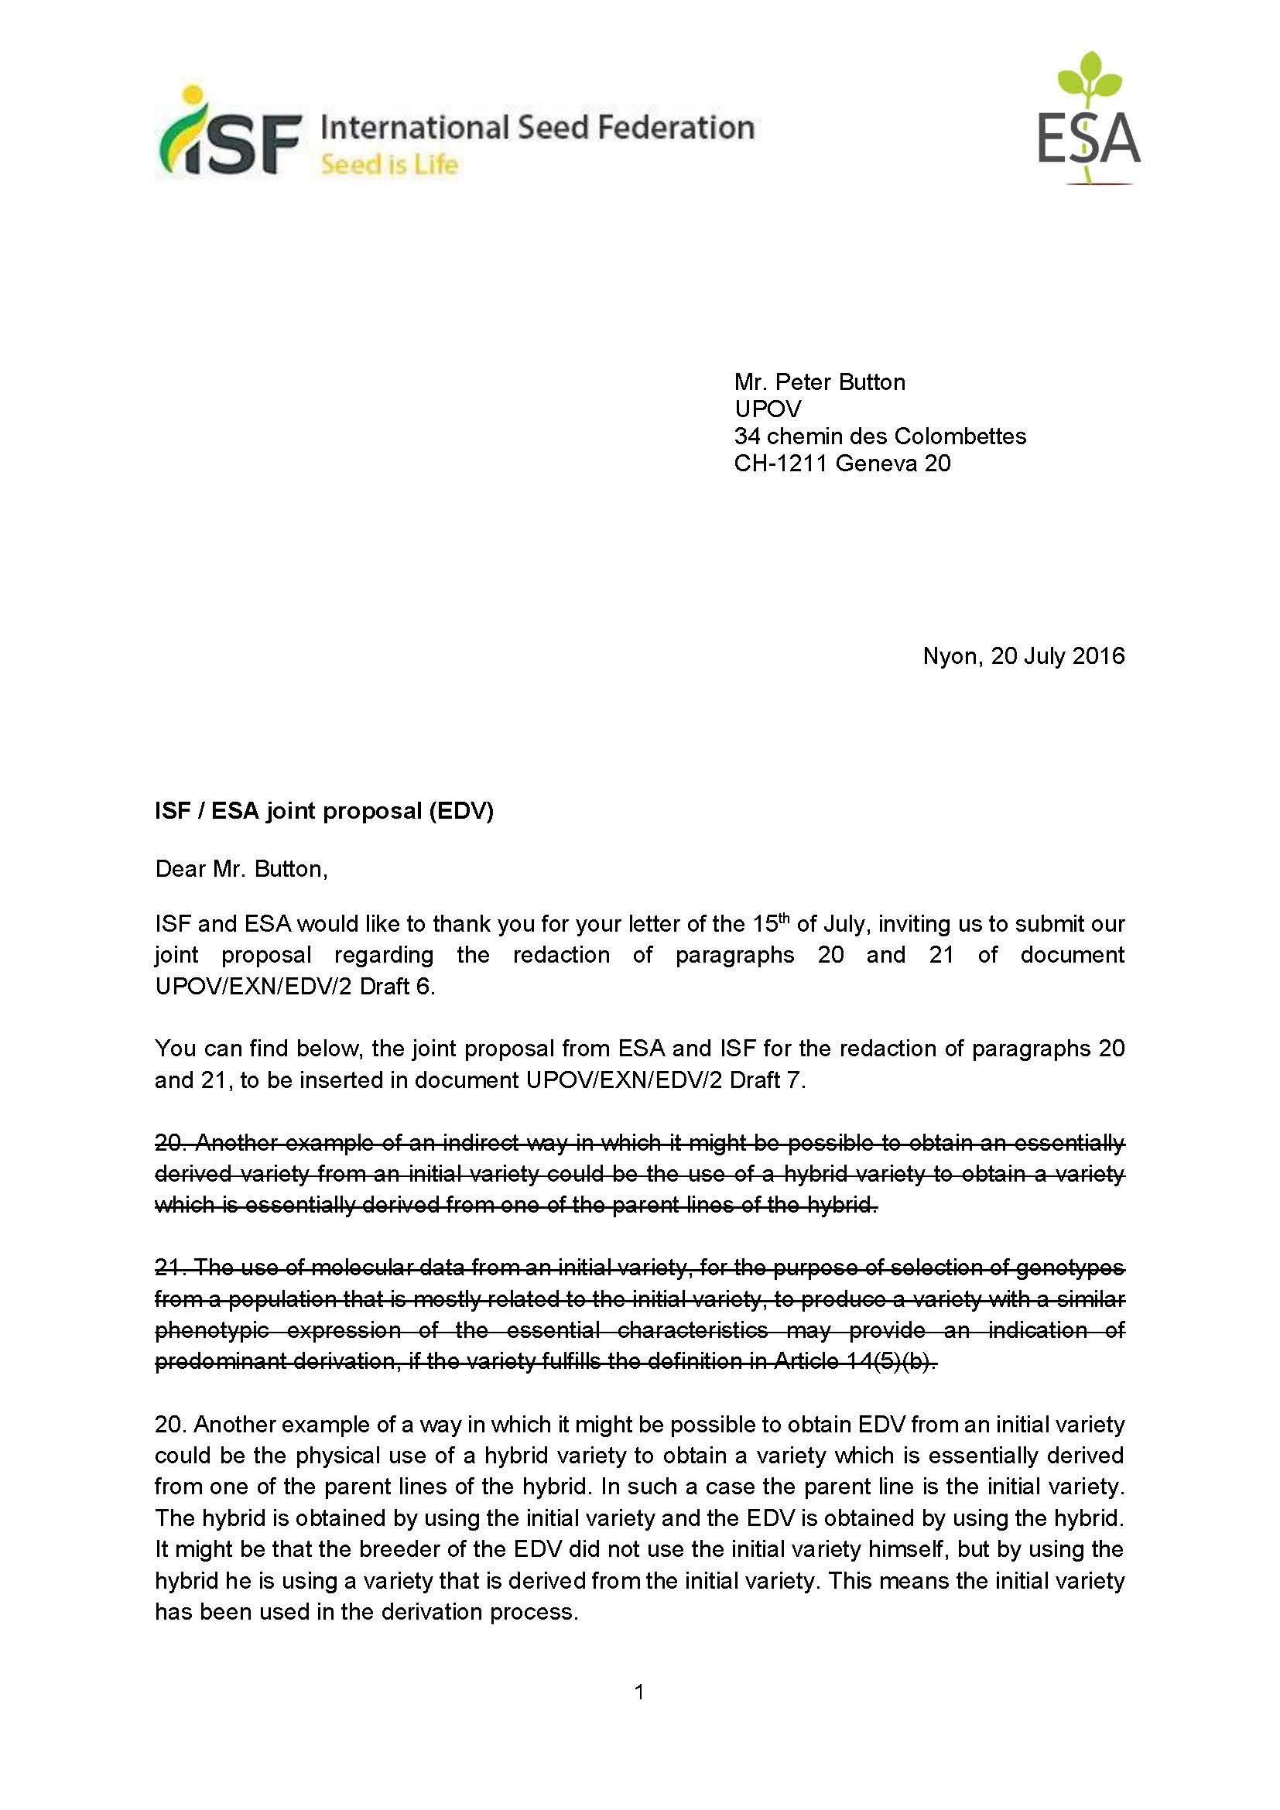
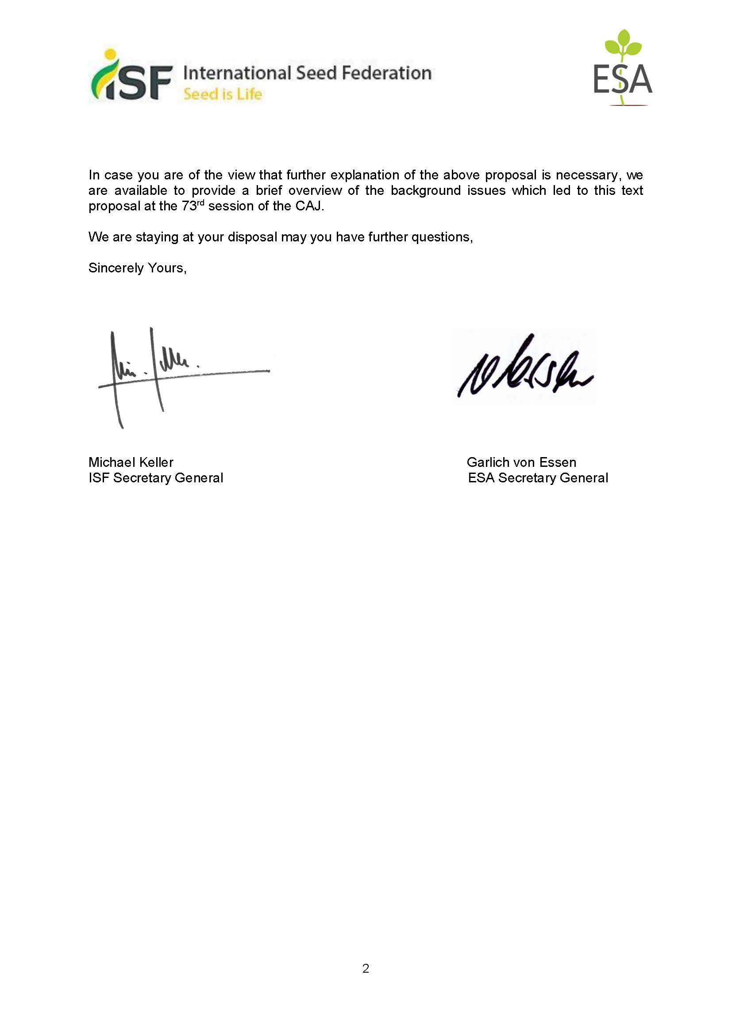

[Annex III follows]

CAJ/73/2

ANNEX III

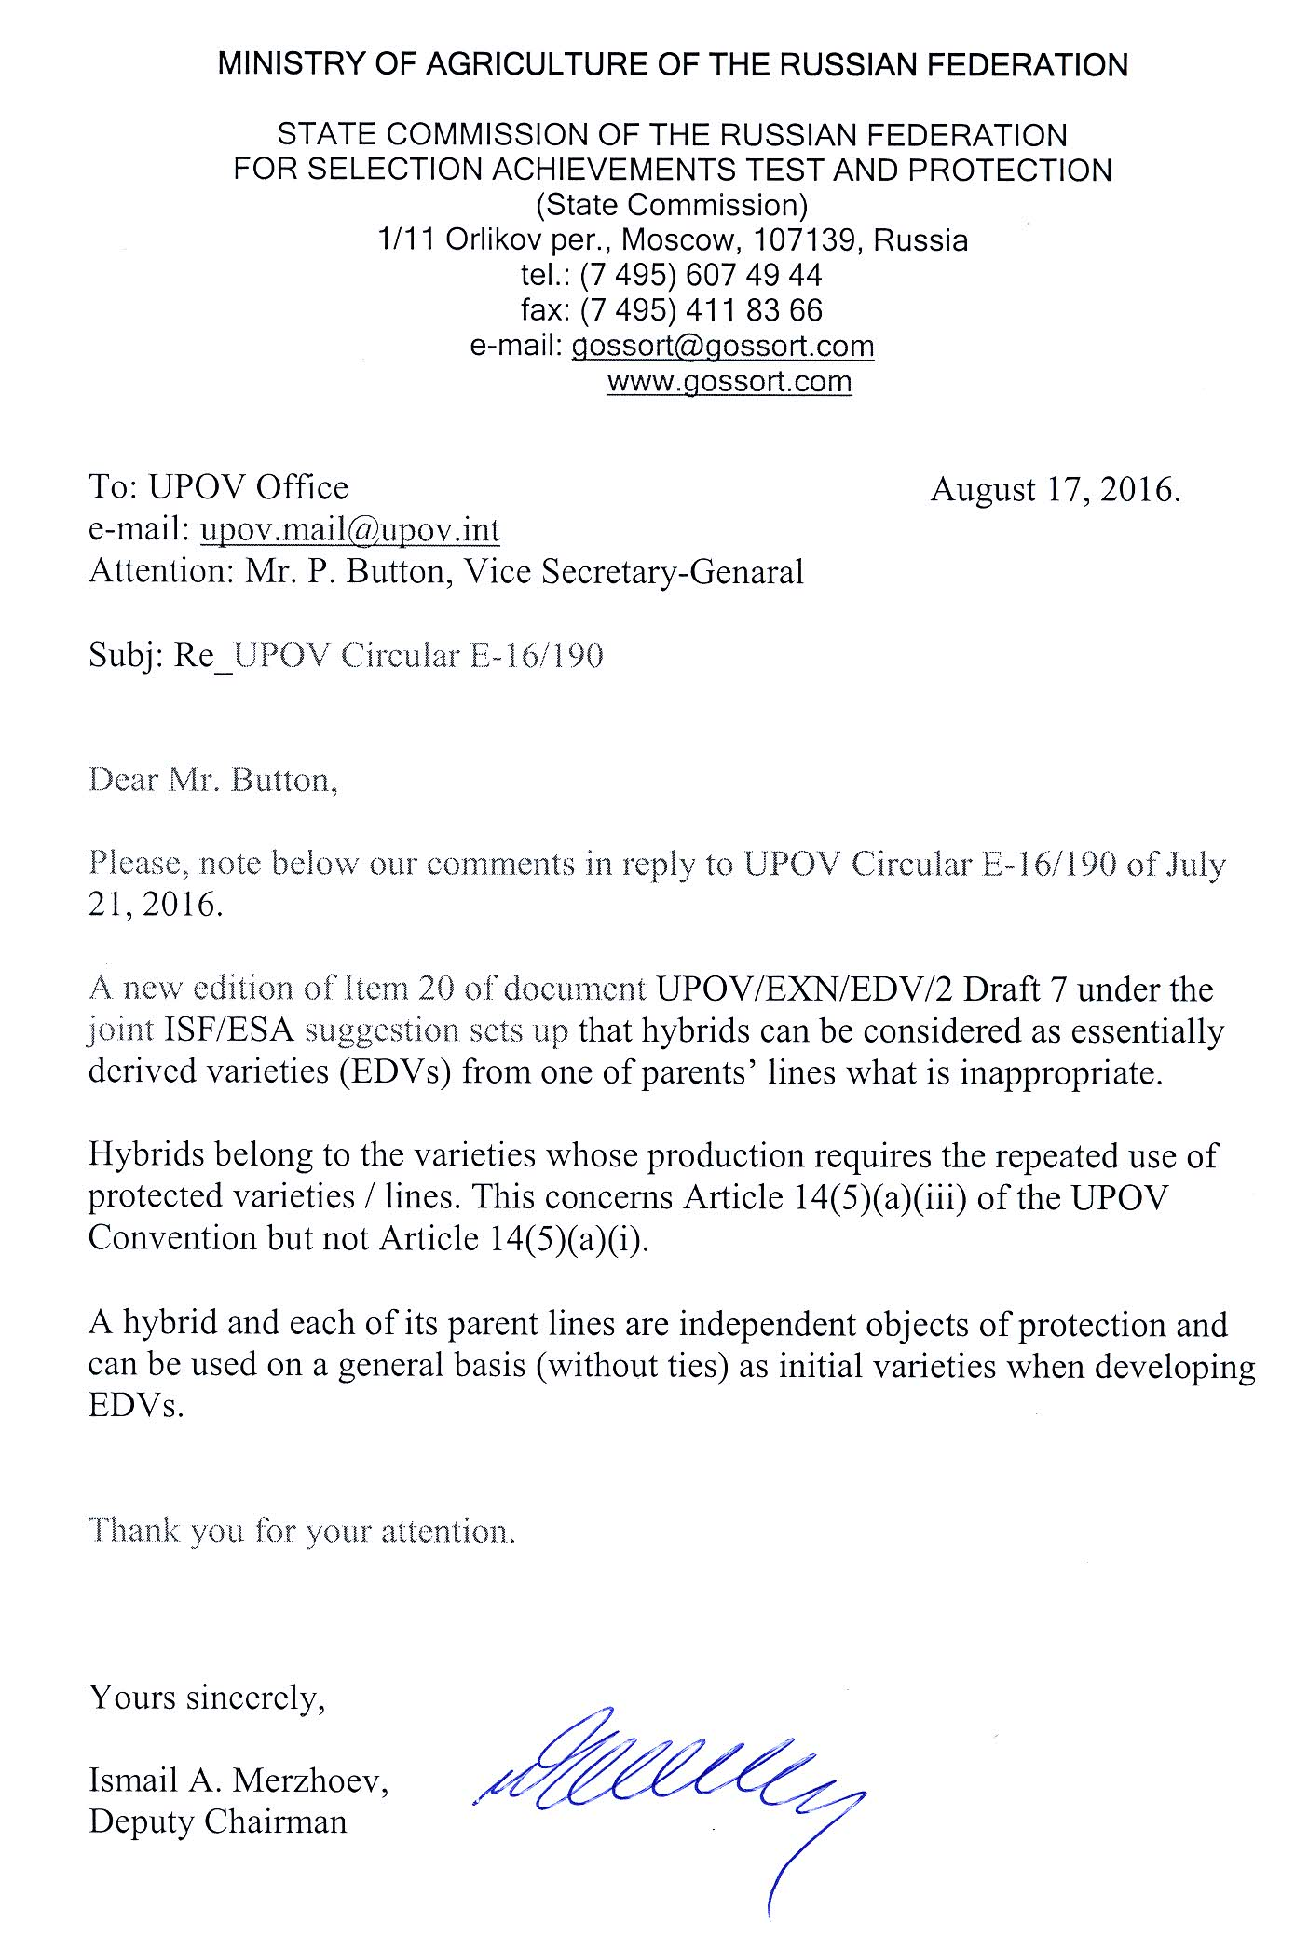
[Annex IV follows]

CAJ/73/2

ANNEX IV
E
UPOV/SEM/GE/16/1 Prov. 2
ORIGINAL: English
DATE: October 10, 2016
INTERNATIONAL UNION FOR THE PROTECTION OF NEW VARIETIES OF PLANTS
Geneva
Seminar on propagating and harvested material
in the context of the UPOV Convention
Geneva, October 24, 2016
DRAFT PROGRAM
prepared by the Office of the Union
Disclaimer: this document does not represent UPOV policies or guidance
8.30 |  | Registration
9.30 |  | Welcome address by Mr. Francis Gurry, Secretary-General, UPOV
9.35 |  | Opening by Mr. Raimundo Lavignolle, Vice-President of the Council of UPOV
9.40 |  | Development of UPOV guidance on propagating and harvested material
 |  | Mr. Peter Button, Vice Secretary-General, UPOV
Session I: Perspectives on the notions of propagating material and harvested material

Moderator: Mr. Button
9.50 |  | Perspective of the International Community of Breeders of Asexually Reproduced Ornamental and Fruit-Tree Varieties (CIOPORA)  Mr. Andrea Mansuino, President, CIOPORA
10.10 |  | Perspective of the Committee of Professional Agricultural Organisations (COPA) –General Committee for Agricultural Cooperation in the European Union (COGECA)  Mr. Thor Gunnar Kofoed, Denmark
10.30 |  | Perspective of the European Coordination Via Campesina  Mr. Guy Kastler
10.50 |  | Perspective of the International Seed Federation (ISF)  Mr. Micheal Keller, Secretary-General, ISF
11.10 |  | Coffee

Session II: Analysis of court decisions on propagating material and harvested material

Moderator: Ms. Yolanda Huerta, Legal Counsel, UPOV
11.30 |  | Mr. Axel Metzger  University of Humboldt, Germany
11.50 |  | Mr. Fernando Ardila  Instituto Nacional de Tecnología Agropecuaria (INTA), Argentina
12.10 |  | Mr. Herbert Zech  University of Basel, Switzerland
12.30 |  | Lunch
Session III: Experiences concerning propagating material and harvested material

Moderator: Mr. Martin Ekvad, Chair of the Administrative and Legal Committee of UPOV

14.30 |  | Mr. Antonio Villarroel  Asociación Nacional de Obtentores Vegetales (ANOVE), Spain  European Seed Association (ESA)
14.50 |  | Mr. Nik Hulse  Chief of Plant Breeders' Rights, Plant Breeder's Rights Office, IP Australia
15.10 |  | Mr. Geert Staring  Breeders Trust, Belgium
15.30 |  | Ms. Carmen Gianni  Instituto Nacional de Semillas (INASE), Argentina
15.50 |  | Mr. Casper van Kempen  Anti-Infringement Bureau for Intellectual Property Rights on Plant Material (AIB), Belgium
16.10 |  | Mr. Gert Würtenberger  Würtenberger Kunze, Germany
16.30 |  | Coffee
16.45 |  | Panel Discussion  Moderator: Mr. Lavignolle
 |  | Panel members: (to be confirmed)
17.25 |  | Closing remarks by Mr. Ekvad
17.30 |  | End of Seminar

[End of Annex IV and of document]

Held in Geneva on October 24, 2005.
See document CAJ/52/4” Approach for the development of information materials concerning the UPOV Convention”, paragraphs 8 to 10.
See document CAJ/52/4, paragraphs 11 to 14 and document CAJ/52/5 “Report”, paragraph 67.
Held in Geneva on October 13, 2014
Held in Geneva on October 14 and 17, 2014.
See document CAJ/70/10 “Report on the Conclusions”, paragraphs 38 to 41.
Held in Geneva on October 26 and 27, 2015.
See document CAJ/72/9 “Report on the Conclusions”, paragraph 11.
See document CAJ/72/9 “Report on the Conclusions”, paragraph 12.
See document CAJ/72/9 “Report on the Conclusions”, paragraph 10.
See document CAJ/72/9 “Report on the Conclusions”, paragraph 14.
See document CAJ/72/9 “Report on the Conclusions”, paragraph 15.
See document C(Extr.)/33/3 “Report by the President on the work of the ninety-first session of the Consultative Committee; adoption of recommendations, if any, prepared by that Committee”, paragraph 5.
See document C(Extr.)/33/3 “Report by the President on the work of the ninety-first session of the Consultative Committee; adoption of recommendations, if any, prepared by that Committee”, paragraph 6.
Held in Geneva, on March 17, 2016.
See document C(Extr.)/33/6 “Report on the Decisions”, paragraph 6.
See document CAJ/72/9 “Report on the Conclusions”, paragraph 27.
See document C(Extr.)/33/3 “Report by the President on the work of the ninety-first session of the Consultative Committee; adoption of recommendations, if any, prepared by that Committee”, paragraphs 30 to 32, and its Annex and document C(Extr.)/33/6 “Report on the Decisions”, paragraph 8(d)
See document C(Extr.)/33/6 “Report on the Decisions”, Annex II.
See document CAJ/72/9 “Report on the Conclusions”, paragraph 16.
Held in Geneva, October 29, 2015.
See document C/49/18 “Report on the Decisions”, paragraph 27.
See document C/49/18 “Report on the Decisions”, paragraph 26.
See document C/49/18 “Report on the Decisions”, paragraph 48.
See documents CAJ/71/4 “Electronic Application Systems” and CAJ/71/10 “Report on the Conclusions”, paragraph 30.
See document CAJ/71/10 “Report on the Conclusions”, paragraph 24.
See document CAJ/72/9 “Report on the Conclusions”, paragraph 18.

