E
CAJ/72/2 Add.
ORIGINAL: English
DATE: October 27, 2015
INTERNATIONAL UNION FOR THE PROTECTION OF NEW VARIETIES OF PLANTS
Geneva
ADministrative and legal committee
Seventy-Second Session
Geneva, October 26 and 27, 2015
Addendum to document CAJ/72/2
Development of information materials concerning the UPOV Convention
Document prepared by the Office of the Union
Disclaimer: this document does not represent UPOV policies or guidance
The Annex to this document contains a presentation made by the European Union on its system concerning essentially derived varieties, at the seventy-second session of the Administrative and Legal Committee (CAJ).

[Annex follows]

CAJ/72/2 Add.

ANNEX

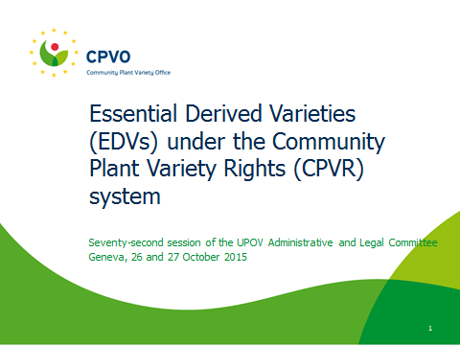

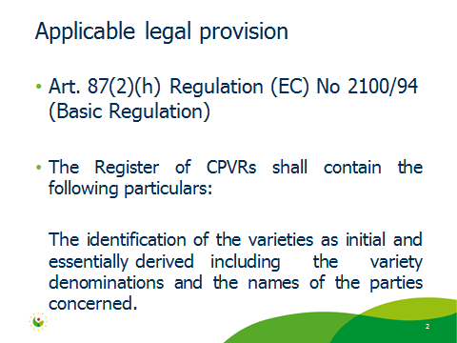

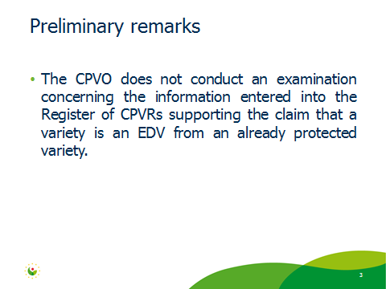

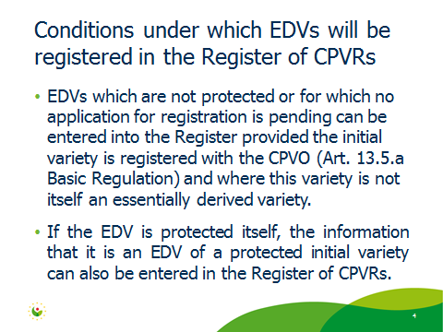

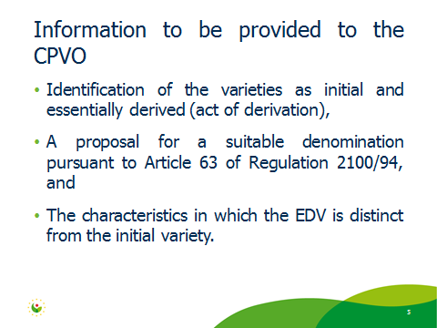

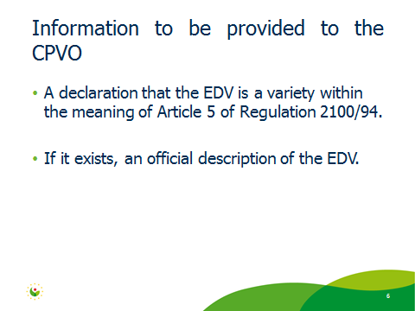

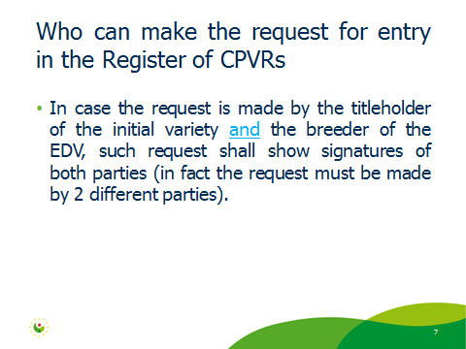

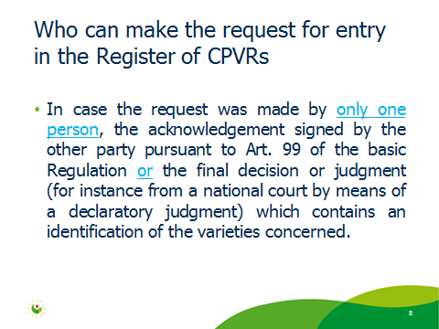

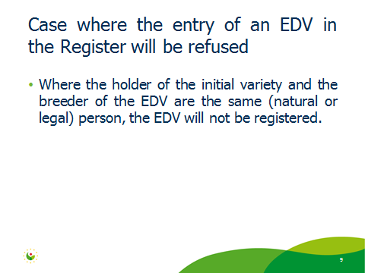

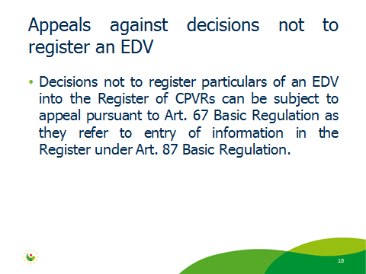

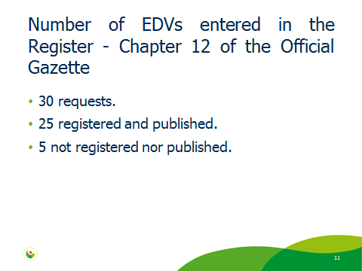

[End of Annex and of document]

