|  |  |  |
| --- | --- | --- |
|  |  | E  CAJ/71/7  **ORIGINAL:** English  DATE: February 16, 2015 |
| INTERNATIONAL UNION FOR THE PROTECTION OF NEW VARIETIES OF PLANTS | | |
| Geneva | | |

ADministrative and legal committee

Seventy-First Session  
Geneva, March 26, 2015

TGP documents

Document prepared by the Office of the Union  
  
Disclaimer: this document does not represent UPOV policies or guidance

# Executive summary

The purpose of this document is to report on developments concerning TGP documents to assist the Administrative and Legal Committee (CAJ) in its consideration of individual TGP documents for adoption by the Council, at its forty-ninth ordinary session, to be held in Geneva on October 29, 2015, and to present a tentative program for the development of TGP documents.

The CAJ is invited to:

1. consider the following proposed revisions of document TGP/9 “Examining distinctness”:
   1. revisions previously agreed by the TC, as set out in Annex I to this document;
   2. Section 1.6 “Schematic overview of TGP documents concerning distinctness”, as set out in Annexes II and III of this document;
   3. Section 2.5 “Photographs”, as set out in paragraph 9 of this document;
   4. Section 4.3.2 “Single record for a group of plants or parts of plants (G)” and Section 4.3.4 “Schematic Summary”, as set out in paragraphs 10 and 11 of this document;
2. consider the following proposed revisions of document TGP/14 “Glossary of terms used in UPOV documents”:
   1. Section 2.4 “Apex/tip shape characteristics”, as set out in paragraph 13 of this document;
   2. Subsection 3 “Color” Annex (Correction French translation) as set out in paragraph 14 of this document;
3. consider whether to revise the web links provided in the following sections of document TGP/5: “Experience and Cooperation in DUS Testing”:
   1. Section 3: “Technical Questionnaire to be Completed in Connection with an Application for Plant Breeders’ Rights”, as set out in paragraph 20;
   2. Section 8: “Cooperation in Examination”, as set out in paragraph 22; and
   3. Section 9: “List of Species in Which Practical Knowledge has Been Acquired or for Which National Test Guidelines Have Been Established”, as set out in paragraph 24 of this document;
4. note that the Council will be invited to adopt document TGP/0/8, in order to reflect the revisions of TGP documents; and
5. consider the program for the development of TGP documents, as set out in the Annex V to this document.

The structure of this document is as follows:

Executive summary 1

PURPOSE 3

Matters for adoption by the council in 2015 3

TGP/9: Examining Distinctness 3

(i) Revision of document TGP/9: Section 1.6: Schematic Overview of TGP Documents Concerning Distinctness 3

(ii) Revision of document TGP/9: Section 2.5: Photographs 3

(iii) Revision of document TGP/9: Sections 4.3.2 and 4.3.4 Method of Observation (Single Measurement – MG) 3

TGP/14: Glossary of Terms Used in UPOV Documents 4

(i) Revision of document TGP/14: Section 2.4 “Apex/tip shape characteristics” 4

(ii) Revision of document TGP/14: Subsection 3: “Color”, Annex 5

TGP/0: List of TGP Documents and Latest Issue Dates 5

possible Future Revision of TGP Documents 6

TGP/5: Experience and Cooperation in DUS Testing 6

(i) Revision of document TGP/5: Section 3: Technical Questionnaire to be Completed in Connection with an Application for Plant Breeders’ Rights 6

(ii) Revision of document TGP/5: Section 8: Cooperation in Examination 6

(iii) Revision of document TGP/5: Section 9: List of Species in Which Practical Knowledge has Been Acquired or for Which National Test Guidelines Have Been Established 6

PROGRAM FOR THE DEVELOPMENT OF TGP DOCUMENTS 7

ANNEX I: Revision of Document TGP/9: Matters previously agreed by the TC

ANNEX II: Schematic overview of TGP documents concerning distinctness

ANNEX III: Schematic overview of TGP documents

ANNEX IV: Schematic summary of single record for a group of plants or parts of plants

ANNEX V: Program for the development of TGP documents

Appendix: Program for Revision of Document TGP/8

The following abbreviations are used in this document:

CAJ: Administrative and Legal Committee

TC: Technical Committee

TC-EDC: Enlarged Editorial Committee

TWA: Technical Working Party for Agricultural Crops

TWC: Technical Working Party on Automation and Computer Programs

TWF: Technical Working Party for Fruit Crops

TWO: Technical Working Party for Ornamental Plants and Forest Trees

TWV: Technical Working Party for Vegetables

TWPs: Technical Working Parties

# PURPOSE

The purpose of this document is to report on developments concerning TGP documents to assist the Administrative and Legal Committee (CAJ) in its consideration of individual TGP documents, and to present a tentative program for the development of TGP documents.

# Matters for adoption by the council in 2015

The TC, at its fiftieth session, and the CAJ, at its sixty-ninth session, approved the program for the development of TGP documents. The following revisions of TGP documents were agreed to be proposed for adoption by the Council at its forty‑ninth ordinary session, to be held in Geneva on October 29, 2015[1]:

## TGP/9: Examining Distinctness

Annex I to this document contains a new section already agreed by the TC for document TGP/9 “Examining Distinctness”.

### Revision of document TGP/9: Section 1.6: Schematic Overview of TGP Documents Concerning Distinctness

Annexes II and III to this document contain a proposal for revision of the flow diagram in TGP/9, Section 1.6 “Schematic overview of TGP documents concerning distinctness”, to be considered by the TC at its fifty-first session.

### Revision of document TGP/9: Section 2.5: Photographs

It is proposed to amend document TGP/9: Section 2.5 “Photographs” to include a new paragraph, as follows:

“2.5.3 The suitability of photographs for the identification of similar varieties is strongly influenced by the quality of the photographs taken by the authority for the varieties in the reference collection and the photograph of the candidate variety provided by the applicant with the Technical Questionnaire. Comprehensive guidance for taking suitable photographs is provided in document TGP/7, GN 35. The guidance was developed in particular for the applicants to provide suitable photographs of the candidate variety. The same instructions are important and useful for the authorities to take photographs of the varieties in the variety collection under standardized conditions.”

### Revision of document TGP/9: Sections 4.3.2 and 4.3.4 Method of Observation (Single Measurement – MG)

The following example of a “single record for a group of plants (MG) taken on plant parts” is proposed for inclusion in a future revision of document TGP/9, Section 4.3.2 “Single record for a group of plants or parts of plants (G)” and Section 4.3.4 “Schematic Summary”:

“Example (MG)

“Measurement (MG): ‘Leaf blade: width” in Hosta (vegetatively propagated): a representative measurement in the plot.’”

An illustration is proposed for inclusion in Section 4.3.4, as presented in Annex IV to this document.

*The CAJ, in conjunction with the comments of the TC at its fifty-first session, is invited to consider:*

1. *the revision to document TGP/9 previously agreed by the TC, as set out in Annex I to this document;*
2. *the proposal for revisions of the flow diagram in TGP/9, Section 1.6 “Schematic overview of TGP documents concerning distinctness” for adoption in 2015, as set out in Annexes II and III of this document;*
3. *the proposed guidance on photographs for inclusion in document TGP/9, Section 2.5 “Photographs”, as set out in paragraph 9 of this document; and*
4. *the proposed example of a single record for a group of plants (MG) taken on plant parts for inclusion in document TGP/9, Section 4.3.2 “Single record for a group of plants or parts of plants (G)” and Section 4.3.4 “Schematic Summary”, as set out in paragraphs 10 and 11;*

*as a basis for the adoption of document TGP/9/2 “Examining distinctness” by the Council, at its forty‑ninth ordinary session.*

## TGP/14: Glossary of Terms Used in UPOV Documents

### Revision of document TGP/14: Section 2.4 “Apex/tip shape characteristics”

It is proposed to revise document TGP/14, Section 2.4 “Apex/tip shape characteristics” to read as follows:

*“2.4 Apex/Tip Shape Characteristics*

“2.4.1 The APEX (apical or distal part) of an organ or plant part is the end furthest from the point of attachment. In some cases, the distal extremity of the apex may be differentiated into a “TIP”.

“2.4.2 ~~In some cases, the distal extremity of the apex may be differentiated into a “TIP”.~~ In considering the approach to describe the apex, the size of the organ and the number of apex shapes should be taken into account. Apex characteristics can be described in simple terms and if a differentiated tip is present it could be further described as a separate characteristic. Generally, it is not necessary to separate the apex shape characteristic.

“2.4.3 In cases where it is appropriate to separate into differentiated tip and apex characteristics, the shape of the apex is taken as the general shape, excluding any differentiated tip (if present) and the separation of tip and apex should be indicated in the explanation of the characteristic. For example:

|  |  |  |  |
| --- | --- | --- | --- |
| “Differentiated tip |  |  |  |
| “Apex |
| “Differentiated tip: | acuminate | acuminate | acuminate |
| Apex: | acute | rounded | truncate |

“~~2.4.3~~ 2.4.4 As explained in Section 2.1, it is only necessary to develop a characteristic for the shape of apex when the variation in shape between varieties in the variety collection has not been accounted for by the ratio length/width or the position of the broadest part concerning the full plant part. […]”

### Revision of document TGP/14: Subsection 3: “Color”, Annex

The French translation of the color group “dark purple red” should be corrected to read “*rouge‑pourpre foncé*”.

The CAJ is invited to:

1. consider the proposal to revise document TGP/14, Section 2.4 “Apex/tip shape characteristics”, as set out in paragraph 13, in conjunction with the comments of the TC at its fifty‑first session; and
2. note the correction to the French translation of the color group “dark purple red” to read “rouge‑pourpre foncé” in to document TGP/14 Subsection 3: “Color”, as set out in paragraph 14 of this document.

## TGP/0: List of TGP Documents and Latest Issue Dates

Document TGP/0/7[2] will need to be updated (to become document TGP/0/8) to reflect revisions of TGP documents adopted by the Council at its forty-ninth ordinary session.

*The CAJ is invited to note that the Council will be invited to adopt document TGP/0/8, in order to reflect the revisions of TGP documents.*

# possible Future Revision of TGP Documents

New proposals for possible future revision of TGP documents have been developed for consideration by the TC and the CAJ as follows:

## TGP/5: Experience and Cooperation in DUS Testing

### Revision of document TGP/5: Section 3: Technical Questionnaire to be Completed in Connection with an Application for Plant Breeders’ Rights

Document TGP/5: Section 3 currently states that:

“A model Technical Questionnaire is provided in document TGP/7 “Development of Test Guidelines”: Annex 1: TG Template: Chapter 10. The UPOV Test Guidelines (http://www.upov.int/en/publications/tg-rom/index.html ) contain, in Chapter 10, a specific Technical Questionnaire for varieties covered by those Test Guidelines.

Following the launching of the redesigned UPOV website on November 1, 2011, the web link provided in document TGP/5: Section 3 needs to be amended to read as follows:

“A model Technical Questionnaire is provided in document TGP/7 “Development of Test Guidelines”: Annex 1: TG Template: Chapter 10. The UPOV Test Guidelines (<http://www.upov.int/edocs/tgpdocs/en/tgp_7.pdf>) contain, in Chapter 10, a specific Technical Questionnaire for varieties covered by those Test Guidelines.”

### Revision of document TGP/5: Section 8: Cooperation in Examination

Document TGP/5: Section 8 currently states that:

“A synopsis of cooperation in examination between authorities is provided in the form of a Council document:

“C/[session]/5 (e.g. C/38/5), (http://www.upov.int/en/documents/index_c.htm).”

Following the launching of the redesigned UPOV website on November 1, 2011, the web link provided in document TGP/5: Section 8 needs to be amended to read as follows:

“A synopsis of cooperation in examination between authorities is provided in the form of a Council document:

“C/[session]/5 (e.g. C/49/5), (<http://www.upov.int/meetings/en/topic.jsp?group_id=251>).”

### Revision of document TGP/5: Section 9: List of Species in Which Practical Knowledge has Been Acquired or for Which National Test Guidelines Have Been Established

Document TGP/5: Section 9 currently states that:

“A list of genera and species in which practical knowledge has been acquired or for which national test guidelines have been established is provided in the Technical Committee document:

“TC/[session]/4 (e.g. TC/41/4), (http://www.upov.int/restrict/en/tc/index_tc.htm).

Following the launching of the redesigned UPOV website on November 1, 2011, the web link provided in document TGP/5: Section 9 needs to be amended to read as follows:

“A list of genera and species in which practical knowledge has been acquired or for which national test guidelines have been established is provided in the Technical Committee document:

“TC/[session]/4 (e.g. TC/51/4), (<http://www.upov.int/meetings/en/topic.jsp?group_id=254>).”

*The CAJ is invited to consider whether to revise the following web links provided in document TGP/5, in conjunction with the comments of the TC at its fifty‑first session:*

1. *Section 3: “Technical Questionnaire to be Completed in Connection with an Application for Plant Breeders’ Rights”, as set out in paragraph 20;*
2. *Section 8: “Cooperation in Examination”, as set out in paragraph 22; and*
3. *Section 9: “List of Species in Which Practical Knowledge has Been Acquired or for Which National Test Guidelines Have Been Established”, as set out in paragraph 24.*

# PROGRAM FOR THE DEVELOPMENT OF TGP DOCUMENTS

Annex V to this document proposes a program for the development of TGP documents on the basis of the conclusions by the TC, at its fiftieth session, the CAJ, at its sixty-ninth session, the Technical Working Parties at their sessions in 2014 and the TC-EDC at its meeting in January 2015 (see document TC/50/36 “Report on the Conclusions”, paragraph 75, and document CAJ/69/12 “Report on the Conclusions”, paragraph 64, respectively).

*The CAJ is invited to consider the program for the development of TGP documents, as set out in Annex V of this document, in conjunction with the conclusions of the TC at its fifty-first session.*

[Annexes follow]

REVISION OF DOCUMENT TGP/9: MATTERS PREVIOUSLY AGREED BY THE TC

Section 5.5 (New): Guidance on Number of Plants to be Examined (for Distinctness)

To add new Section 5.5 as follows (see document TC/49/41 “Report on the Conclusions”, paragraph 84):

“Number of Plants / Parts of Plants to be Examined (for distinctness)

“1. The observation of the '*typical'* expression of characteristics of a variety in a given environment is essential for the assessment of distinctness. The precision of the observed (mean) expression of the varieties to be compared is a critical element for the consideration of whether a difference is a clear difference.

“2. In the case of qualitative characteristics, a low number is sufficient to identify the expression of a variety. In general, the number of plants for the assessment of distinctness is not a limiting factor for the number of plants in the trial. Thus, the number of plants for the assessment of qualitative characteristics is not essential for harmonization.

“3. In case of quantitative characteristics (and pseudo-qualitative characteristics), the variation within the variety has to be taken into account for defining a clear difference (by expert judgment or exact statistics). Due to the relation between variation within the varieties and the required difference to be considered as a clear difference for the establishment of distinctness the precision of records is important. The precision of records (mean values) is influenced by the sample size. Therefore, the appropriate sample size should be indicated in the Test Guidelines for the purpose of harmonization.

“4. The following general principals should be taken into account:

“*Considerations for the number of plants to be observed for distinctness in case of QN (*in some cases *PQ)*

1. Observation on the plot as a whole (VG/MG)

– the indicated number should be considered as minimum number

1. Observation on subsample from plot (VG/MG)

– the indicated number should be considered as minimum number

1. Observations on individual plants (VS/MS)

– the number of plants is important for precision of record

– the specific number should be indicated

“*Considerations for the number of plants for candidate varieties and varieties to be compared with the candidate varieties*

“5. The required precision of records depends on the size of the difference between the candidate variety and the varieties of common knowledge. If two varieties are very similar it is important to ensure the same precision of the records for both varieties. The number of plants indicated in the Test Guidelines applies to both the candidate variety and the similar variety of common knowledge. In other cases, it may be possible to include in the trial a lower number of plants for the variety of common knowledge, provided that uniformity does not have to be assessed for that variety, i.e. varieties in the variety collection.”

[Annex II follows]

**SCHEMATIC OVERVIEW OF TGP DOCUMENTS CONCERNING DISTINCTNESS**

Variety descriptions

Living plant material

Cooperation in maintenance

SELECTING VARIETIES FOR THE GROWING TRIAL

MAINTENANCE OF VARIETY COLLECTIONS

**GENERAL INTRODUCTION**

notion of Varieties

of Common Knowledge

**TGP/4**

Forms of variety collection:

- descriptions

- living plant material

Range of the variety collection

Varieties or living plant material not included in the variety collection

Constitution of variety collections

**TGP/8**

**TGP/9**

Types of varieties

Grouping varieties on the basis of characteristics

Characteristics in combination

Photographs

Parent formula (Hybrids)

Guidance

Methods:

- parent formula (hybrids)

- GAIA

DUS trial design

GROWING

TRIAL ORGANIZATION

Grouping similar varieties

Validation of data and assumptions

Examining DUS in bulk samples

OBSERVATION

OF CHARACTERISTICS

Methods of observation (V/M)

Type of record(s) (G/S)

Recommendations in UPOV Test Guidelines

Data analysis methods:

* COYD
* 2x1%
* Chi-Square Test
* Fisher’s Exact Test
* Match Approach

Side‑by‑side visual comparison

Notes / single variety records

Statistical analysis of growing trial data

ASSESSING DISTINCTNESS IN THE GROWING TRIAL

Publication of variety descriptions

Cooperation between members of the Union

Use of randomized “blind” testing

Advice of plant experts

SUPPLEMENTARY PROCEDURES

**SCHEMATIC OVERVIEW OF TGP DOCUMENTS**

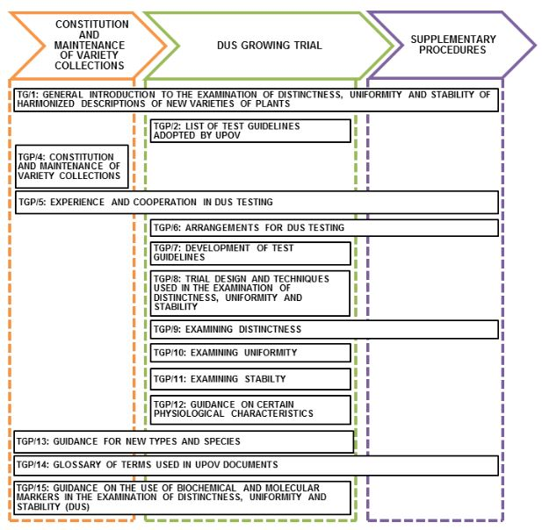

[Annex IV follows]

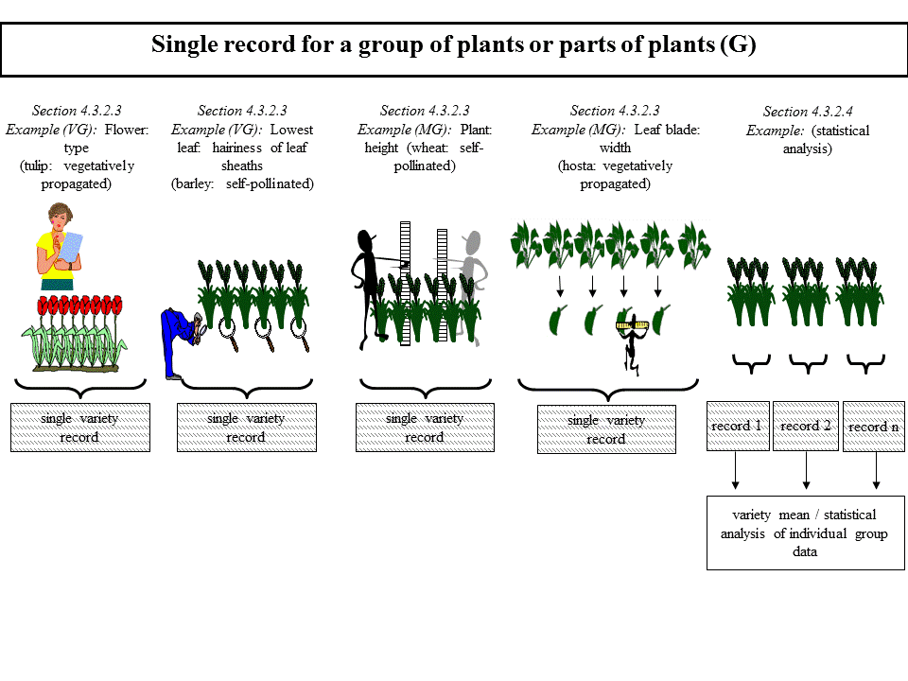

See Excel spreadsheet.

[Appendix follows]

See Excel spreadsheet.

[End of Annex V and of document]

1. As set out in the Annex to documents TC/50/5 and CAJ/69/3, respectively (see document TC/50/36 “Report on the Conclusions”, paragraph 75, and document CAJ/69/13 “Report”, paragraph 66, respectively).
2. Adopted by the Council at its forty-eighth session, held on October 16, 2014.