E
CAJ/69/10
ORIGINAL: English
DATE: February 27, 2014
INTERNATIONAL UNION FOR THE PROTECTION OF NEW VARIETIES OF PLANTS
Geneva
ADministrative and legal committee
Sixty-Ninth Session
Geneva, April 10, 2014
Matters raised by the International Seed Federation (ISF)
Document prepared by the Office of the Union
Disclaimer: this document does not represent UPOV policies or guidance
The purpose of this document is to:

(a) present matters identified by the Consultative Committee, at its eighty-sixth session, held in Geneva on October 23 and 24, 2013, in relation to the the letter of the International Seed Federation (ISF) on the subject “Application, examination and granting aspects of PBR applications” (see document C/47/15 Rev. “Report by the President on the work of the eighty-sixth session of the Consultative Committee; adoption of recommendations, if any, prepared by that Committee”, paragraphs 62 to 66) and invite the Administrative and Legal Committee (CAJ) to consider proposals on how they could be addressed through existing and possible future UPOV information materials; and

(b) invite the CAJ to consider the development of document UPOV/INF/15 “Guidance for Members of UPOV on Ongoing Obligations and Related Notifications and on the Provision of Information to Facilitate Cooperation” into an umbrella document that would identify key issues for the operation of a plant variety protection system and which would provide links to detailed information materials.

TABLE OF CONTENTS

BACKGROUND 2
I. Individual matters which the CAJ is invited to consider 2
Application slot 2
Pedigree information 3
Electronic application 3
Correspondence 4
Material 5
(a) Providing parental lines for applications concerning hybrids 5
(b) Availability and exchange of material 7
(c) Confidentiality of the applicant's material when the examination centers are breeding varieties of the same species 8
Frequency of data submission and completeness of databases 8
Denomination rules 9
II. UMBRELLA DOCUMENT UPOV/inf/15 “Guidance for Members of UPOV on Ongoing Obligations and Related Notifications and on the Provision of Information to Facilitate Cooperation” 10
ANNEX: UPOV Distance Learning Program “Examination of applications for plant breeders’ rights” (DL-305)

- Module 1 “The Plant Breeders’ Rights Office”
- Module 2 “Administration of applications”

BACKGROUND

The Council, at its forty-seventh ordinary session, held in Geneva on October 24, 2013, received a report from the Consultative Committee on its consideration of the letter of the International Seed Federation (ISF) on the subject “Application, examination and granting aspects of PBR applications” (see document C/47/15 Rev. “Report by the President on the work of the eighty-sixth session of the Consultative Committee; adoption of recommendations, if any, prepared by that Committee”, paragraphs 62 to 66).

The report noted that the Consultative Committee had concluded that many of the matters could be addressed through existing and possible future UPOV information materials. Such matters would be considered by the relevant bodies within UPOV, particularly the CAJ and Technical Committee (TC). With regard to the idea of an international filing system, a UPOV quality assurance program and a central examination system for variety denominations, it was reported that the Consultative Committee had requested the Office of the Union and ISF to elaborate the problems faced and possible solutions in relation to ISF’s ideas, for consideration at the subsequent session of the Consultative Committee (see document C/47/19 “Report on the Decisions”, Annex II).

I. Individual matters which the CAJ is invited to consider

The Consultative Committee, at its eighty-sixth session, considered the letter of ISF on the subject “Application, examination and granting aspects of PBR applications” (see document C/47/15 Rev. “Report by the President on the work of the eighty-sixth session of the Consultative Committee; adoption of recommendations, if any, prepared by that Committee”, paragraphs 62 to 66): the Consultative Committee agreed to invite the CAJ and TC to consider the ISF recommendations in relation to existing and possible future information materials, in parallel with the development of document UPOV/INF/15 into an umbrella document. The individual matters raised by ISF are considered in that context.

Application slot

[Extract from ISF letter – (English)]
Application slot: In certain countries the period during which an application can be filed is limited. E.g. an application for a certain crop can only be filed during a specific period of 1 or 2 months per year. ISF members feel that such specificity and limited duration of a time slot is problematic, especially when the time slot for variety registration differs from the time slot for PBR applications. When requesting priority for the application, a good timing is essential, and a time slot can hamper such possibilities. It should be possible to file applications all year round, however, in the case that a time slot is set; it should be sensible, and realistic.

The CAJ may wish to consider whether to develop guidance on the possibility of filing applications all year round and/or the use of restricted time periods for filing applications in document UPOV/INF/15.

The CAJ is invited to consider the development of guidance on the possibility of filing applications all year round and/or use of restricted time periods for filing applications in document UPOV/INF/15.

Pedigree information

[Extract from ISF letter – (English)]

Pedigree information: ISF members feel that pedigree information should not be requested, and if countries did decide to request such information then such pedigree information should not become public. In addition a breeder should be able to indicate whether certain information provided in the application should be considered confidential.

The CAJ may wish to consider whether the existing guidance in document TGP/7 “Development of Test Guidelines”, Annex 1: TG Template, Section 4 “Information on the breeding scheme and propagation of the variety” and its footnote (see http://www.upov.int/edocs/tgpdocs/en/tgp_7.pdf) provide a suitable approach to address the situation of requests of pedigree information (Section 4 is reproduced below), or whether further guidance would be appropriate.

#4. Information on the breeding scheme and propagation of the variety

4.1 Breeding scheme

{ ASW 15 (Chapter 10: TQ 4.1) – information on breeding scheme }

4.2 Method of propagating the variety

{ GN 31 (Chapter 10: TQ 4.2) – information on method of propagating the variety }
{ GN 32 (Chapter 10: TQ 4.2) – information on method of propagation of hybrid varieties }

# Authorities may allow certain of this information to be provided in a confidential section of the Technical Questionnaire.

The CAJ is invited to consider if the existing guidance in document TGP/7 “Development of Test Guidelines”, Annex 1: TG Template, Section 4 “Information on the breeding scheme and propagation of the variety” and its footnote provide a suitable approach to address the situation of requests of pedigree information, or whether further guidance would be appropriate.

Electronic application

[Extract from ISF letter – (English)]
Electronic application: In certain countries or regions the application can be sent electronically, e.g. by e-mail whereas in other countries an application can only be made as a paper hard copy. ISF members indicate their preference for the possibility of filing an application by email or otherwise electronically and that such a system should be enabled in all UPOV member countries.

The CAJ may wish to note the following initiatives in relation to electronic applications:

(a) the project for the development of a prototype electronic form (see document CAJ/69/8 “Electronic application systems”); and

(b) the survey of members of the Union on their use of databases for plant variety protection purposes and on their use of electronic application systems (see document CAJ/69/6 “UPOV information databases”).

The CAJ may wish to consider whether to develop guidance in document UPOV/INF/15 on the possibility to file applications electronically.

The CAJ is invited to:

(a) note the existing initiatives, as set out in paragraph 9 above, concerning electronic applications; and

(b) consider whether to develop guidance in document UPOV/INF/15 on the possibility to file applications electronically.

Correspondence

[Extract from ISF letter – (English)]
Correspondence: In certain countries the PBR office will only send correspondence to the local agent, and not to the applicant, who can be in another country. This can cause unwanted and risky delays when a response is needed by the applicant before a certain deadline. ISF members feel that such correspondence should be sent to the address as indicated by the applicant, and preferably by email. In addition, it is often difficult to find a local agent who is knowledgeable of local PBR laws. In any event, both the local agent as well as the applicant should be informed. In countries where English is not the national language, then the ability to correspond in English should be available.

Document TGP/5 Section 2 “UPOV Model Form for the Application for Plant Breeders' Rights” provides the following with regard to correspondence (see items 1 and 2 of TGP/5 Section 2 reproduced below).

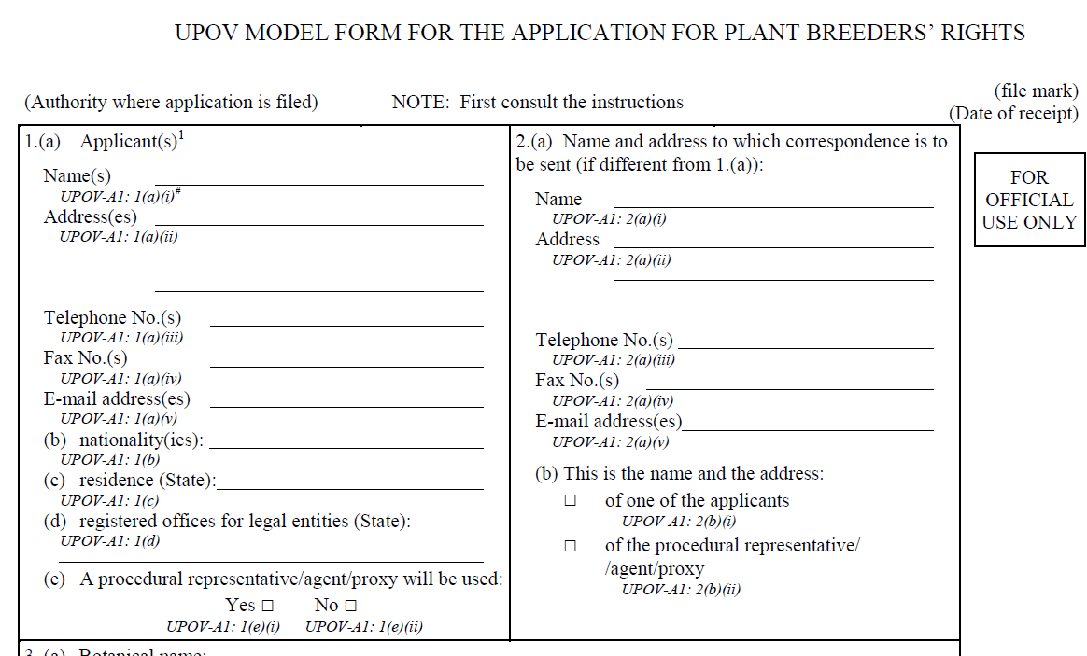

The CAJ may wish to consider whether it would be appropriate to develop additional guidance to consider matters raised by ISF with regard to correspondence in document TGP/5 Section 2 and/or in document UPOV/INF/15.

The CAJ is invited to:

(a) note the existing guidance in document TGP/5 Section 2 “UPOV Model Form for the Application for Plant Breeders' Rights”, with regard to correspondence; and

(b) consider whether it would be appropriate to develop additional guidance, with regard to correspondence, in document TGP/5 Section 2 and/or in document UPOV/INF/15.

Material

[Extract from ISF letter – (English)]
Confidentiality of the material: In certain countries when filing a PBR application for a hybrid, the authorities require the applicant to provide seeds (or where applicable vegetatively propagated material) of the parent lines as well, although often the material is not used for the examination of the variety. ISF members are emphatic that there should be no obligation whatsoever to provide parental lines for hybrid applications.

In certain countries confidentiality of the information or the seed that is provided is not guaranteed by PBR authorities. Under such circumstances there is a heightened risk that parent lines could become publicly available. A request to provide seeds of parent lines is a major reason why seed companies may chose not to file an application in those countries.

According to TGP/4/1, PBR authorities shall take all necessary steps to safeguard the rights of the applicant. According to ISF, this responsibility includes handling the material with utmost confidentiality and use of a material transfer agreement between the PBR office and the applicant which should then guarantee confidential treatment of such material. Once confidentiality is guaranteed, then the requested seed sample size should still be reasonable. In countries where the requested seed sample size is too high, then this again becomes a reason for seed companies to consider not filing an application.

In those cases where organizations which are in charge of the PBR examination process, are also themselves breeding varieties of the same species as those of other applicants, then clear and strict measures should be implemented to secure confidentiality of the applicant's material.

[Extract from ISF letter – (English)]
Rules for exchange of material: In many countries there are no formal rules or guidelines for the exchange of plant or seed material between examination offices. ISF members consider that good traceability is very important. Often breeders are not aware of what happens to their material after the application is complete. As a minimum the breeder should be notified and ideally required to grant authorization before material of his variety is sent to other authorities. These rules of exchange are especially crucial for parental lines. Clear and harmonized rules linked to a prior agreement would be helpful in maintaining integrity and security of plant or seed materials. Having no formal rules for the exchange of material undermines for some companies their desire to file for PBR in that country.

[Extract from ISF letter – (English)]
Availability of the material: Certain countries require the applicant to make material of the protected variety publicly available. This may pose a problem in the case of parent lines, where a competitor could request material from the protected parent line. According to the survey seed companies are very reluctant or would not honor a request to provide their parent line material to others. Material should not become publicly available without the breeders consent. Nowhere in the UPOV convention is it stated that protected material has to be made publicly available. For some companies this requirement is a reason not to file for PBR in that country.

The material which is publicly available has to be restricted to the material which is made commercially available.

Existing guidance and possible approaches concerning material requirements are presented in the following paragraphs.

(a) Providing parental lines for applications concerning hybrids

Guidance on parent lines in relation to applications concerning hybrids is provided in the “General Introduction to the Examination of Distinctness, Uniformity and Stability and the Development of Harmonized Descriptions of new Varieties of Plants” (see “General Introduction”, document TG/1/3) and in document TGP/7/3 “Development of Test Guidelines” (see at http://www.upov.int/resource/en/dus_guidance.html).

[Extract from the General Introduction]

“7.3.2 Hybrid Varieties

“The stability of a hybrid variety may, in addition to an examination of the hybrid variety itself, also be assessed by examination of the uniformity and stability of its parent lines.”

[Extracts from document TGP/7/3]

“ASW 7(a) (Chapter 4.1.1) – Distinctness: parent formula

“To assess distinctness of hybrids, the parent lines and the formula may be used according to the following recommendations:

- description of parent lines according to the Test Guidelines;

- check of the originality of the parent lines in comparison with the variety collection, based on the characteristics in Chapter 7, in order to identify similar parent lines;

- check of the originality of the hybrid formula in relation to the hybrids in the variety collection, taking into account the most similar lines; and

- assessment of the distinctness at the hybrid level for varieties with a similar formula.

“Further guidance is provided in documents TGP/9 “Examining Distinctness” and TGP/8 “Trial Design and Techniques Used in the Examination of Distinctness, Uniformity and Stability”.

[…]

“(e) Uniformity assessment where the parent formula is used

“Where the assessment of a hybrid variety involves the parent lines, the uniformity of the hybrid variety should, in addition to an examination of the hybrid variety itself, also be assessed by examination of the uniformity of its parent lines.”

[…]

“ASW 10 (TG Template: Chapter 4.3.3) – Stability assessment: hybrid varieties

“Where appropriate, or in cases of doubt, the stability of a hybrid variety may, in addition to an examination of the hybrid variety itself, also be assessed by examination of the uniformity and stability of its parent lines.”

[…]

“ASW 13 (TG Template: Chapter 10: TQ Title) – TQ for hybrid varieties

“In cases where the parent formula may be used for the assessment of distinctness (see ASW 7(a) (Chapter 4.1.1) – Distinctness: parent formula), the following wording may be added:

“In the case of hybrid varieties which are the subject of an application for plant breeders’ rights, and where the parent lines are to be submitted as a part of the examination of the hybrid variety, this Technical Questionnaire should be completed for each of the parent lines, in addition to being completed for the hybrid variety.”

The CAJ may wish to consider whether it would be appropriate to to develop additional guidance on parent lines in relation to applications concerning hybrids and/or to include a reference to the existing guidance on parent lines in document UPOV/INF/15.

The CAJ is invited to:

(a) note the existing guidance, with regard to parent lines in relation to applications concerning hybrids, as set out in paragraph 16 above; and

(b) consider whether it would be appropriate to develop additional guidance on parent lines in relation to applications concerning hybrids and/or to include a reference to the existing guidance on parent lines in document UPOV/INF/15.

(b) Availability and exchange of material

Guidance concerning material furnished by the breeder for examination purposes is provided in:

(i) TGP/5 “Experience and Cooperation in DUS Testing”, Section 11 “Examples of Policies and Contracts for Material Submitted by the Breeder” (see relevant extracts below also available at http://www.upov.int/tgp/en/).

“1.3 This document [document TGP/5, Section 11] provides some examples of the policies of authorities to ensure that the legitimate interests of the breeder are safeguarded.”
[…]

“Annex I to this document [document TGP/5, Section 11] presents an example of a contract between Seminis Vegetable Seeds, Inc. and IP Australia.”

“Annex II to this document presents the policy of the Community Plant Variety Office (CPVO) of the European Community with regard to the status of plant material submitted for DUS testing in the framework of applications for Community Plant Variety Rights.”

(ii) TGP/4 “Constitution and Maintenance of Variety Collections”, Section 3.1.2 “Living plant material”.

“3.1.2.2.2 For the purposes of the examination of DUS, UPOV encourages cooperation between variety collectors (see Section 3.2) including, in particular, the exchange of information and living plant material for the examination of distinctness. However, in the particular case of parent lines submitted as a part of the examination of a candidate hybrid variety, living plant material should only be made available to other variety collectors in such a way that the legitimate interests of the breeder would be safeguarded. Examples of policies and contracts for material submitted by the breeder are provided in document TGP/5 “Experience and Cooperation in DUS Testing” (document TGP/5).”

(iii) TGP/5 “Experience and Cooperation in DUS Testing”, Section 1 “Model Administrative Agreement for International Cooperation in the Testing of Varieties”, Article 4.

“Article 4

“(1) The Authorities shall take all necessary steps to safeguard the rights of the applicant.

“(2) Except with the specific authorization of the Receiving Authority and the applicant, the Executing Authority shall refrain from passing on to a third person any material of the varieties for which testing has been requested.

“(3) Access to the documents and the test plots shall be given only to:

“(i) the Receiving Authority, the applicant and any duly authorized person;

“(ii) the necessary staff of the institution that carries out the testing and special experts called in who are bound to secrecy in public service. Those special experts shall have access to the formulae of hybrid varieties only if it is strictly necessary and if the applicant does not object.

“This paragraph does not exclude general access to test plots by visitors, provided due regard is had to paragraph (1) above.

“(4) If another authority is a Receiving Authority under a similar agreement, access may be granted in accordance with the rules applicable under that agreement.”

The CAJ may wish to consider whether further guidance should be developed on material furnished by the breeder for examination purposes and/or to include a reference to the existing guidance on parent lines in document UPOV/INF/15.

The CAJ is invited to:

(a) note the existing guidance in relation to the availability and exchange of material, as set out in paragraph 19 above; and

(b) consider whether further guidance should be developed on material furnished by the breeder for examination purposes and/or to include a reference to the existing guidance in document UPOV/INF/15.

(c) Confidentiality of the applicant's material when the examination centers are breeding varieties of the same species

The CAJ may wish to note the discussions that took place in the CAJ, from 2002 to 2005, concerning the “Recommendations to Ensure the Independence of those DUS Examination Centers Which Have, or Have Links to, Breeding Activities” (see document CAJ/49/5 “Report”, paragraph 69, and document CAJ/49/3 “Recommendations to Ensure the Independence of those DUS Examination Centers Which Have, or Have Links to, Breeding Activities” available at http://www.upov.int/meetings/en/topic.jsp?group_id=252) and to consider whether it would be appropriate to develop guidance on this matter in document UPOV/INF/15.

The CAJ is invited to:

(a) note the discussions that took place in the CAJ concerning the “Recommendations to Ensure the Independence of those DUS Examination Centers Which Have, or Have Links to, Breeding Activities”, as set out in paragraph 22 above; and

(b) consider whether it would be appropriate to develop guidance, in document UPOV/INF/15, on confidentiality of applicants’ material when DUS examination centers have, or have links to, breeding activities.

Frequency of data submission and completeness of databases

Updating frequency

[Extract from ISF letter – (English)]
Updating frequency: In certain countries the national website with PBR related information is updated infrequently, sometimes only every 2 years or less. ISF members believe it should be mandatory that each PBR office maintain a continuously updated website. In a similar manner the UPOV office should receive updates on a regular basis and regularly revise their informational databases (at least every 2 months). It would be highly beneficial if PBR offices, in addition to their national language, also placed PBR related information in English on their websites

Document CAJ/69/6 “UPOV information databases” reports that the proposal to increase the frequency of updating of the PLUTO database was agreed by the CAJ at its sixty-eighth session, held in Geneva on October 21, 2013. Section 4 of the Program, as amended by the CAJ at its sixty-eighth session, provides as follows:

“4. Frequency of data submission

“Contributors will be encouraged to provide data as soon as practical after it is published by the authority(ies) concerned. The PLUTO database will be updated with new data as quickly as possible after receipt, in accordance with the uploading procedure. The PLUTO database can, as necessary, be updated with corrected data, in accordance with the uploading procedure.”

Scope of database

[Extract from ISF letter – (English)]
Scope of database: In certain countries the national websites only list the granted PBR's and ignore those that are pending. ISF members feel that it would be useful to also place information on pending applications on the official websites. Such notification would provide for a more complete and adequate level of information allowing companies to check their own and competitors pending PBR applications. Such information is helpful for follow-up in the application process and facilitates respecting IP rights.

Document CAJ/69/6 “UPOV information databases” contains the replies from a survey of members of the Union on their use of databases for plant variety protection purposes and on their use of electronic application systems.
The CAJ, at its sixty-eighth session, held in Geneva on October 21, 2013, agreed to include an item for the updating of document UPOV/INF/5 “UPOV Model Plant Breeders’ Rights Gazette” in the program for the seventieth session of the CAJ, to be held in October 2014 (see document CAJ/68/10 “Report on the Conclusions”, paragraph 17). The CAJ may wish to consider matters concerning the frequency and completeness of the data to be published in conjunction with the updating of document UPOV/INF/5 “UPOV Model Plant Breeders’ Rights Gazette”.

The CAJ is invited to:

(a) note that document CAJ/69/6 “UPOV information databases” contains relevant matters on the regular provision of information to the PLUTO Plant Variety Database;

(b) note that document CAJ/69/6 contains the replies from a survey of members of the Union on their use of databases for plant variety protection purposes and on their use of electronic application systems; and

(c) consider whether to develop guidance concerning frequency of data submission and completeness of databases in conjunction with the updating of document UPOV/INF/5 “UPOV Model Plant Breeders’ Rights Gazette”, as set out in paragraph 26, above.

Denomination rules

[Extract from ISF letter – (English)]
Differences in denomination rules: Name-giving rules differ within and between different countries. It is a known fact that name conflicts arise frequently due to the fact that several countries have inconsistent internal naming rules. For example a name which is accepted in a country or region XYZ for national listing, can at a later date be refused for national or region-wide PBR. At the minimum there should be consistency in the naming rules for national listing and for PBR in the same country.

In general it is felt that more harmonization is needed, in other words, naming rules should be standardized across the globe, and where possible there should be a central approval system.

Where global rules are not possible, e.g. because of different fonts, then regional regulations might be considered.

The CAJ is invited to note that developments on variety denominations that might be relevant in the context of a possible revision of the “Explanatory Notes on Variety Denominations under the UPOV Convention” (document UPOV/INF/12/4) are considered in documents CAJ/69/2 “Development of information materials concerning the UPOV Convention”, document CAJ/69/5 “Variety Denominations” and document CAJ/69/9 “Possible development of a UPOV similarity search tool for variety denomination purposes”.

The CAJ is invited to consider the matters raised by ISF concerning denomination rules in conjunction with the possible revision of the “Explanatory Notes on Variety Denominations under the UPOV Convention”, as set out in paragraph 28, above.

II. UMBRELLA DOCUMENT UPOV/inf/15 “Guidance for Members of UPOV on Ongoing Obligations and Related Notifications and on the Provision of Information to Facilitate Cooperation”

Document UPOV/INF/15 currently provides guidance for members of the Union on ongoing obligations and related notifications and on the provision of information to facilitate cooperation. Upon their appointment, representatives to the Council are provided with a copy of document UPOV/INF/15.

The invitation of the Consultative Committee, at its eighty-sixth session, was to develop document UPOV/INF/15 into an umbrella document that would provide:

(i) an overview of the operation of key issues for a plant variety protection system; and

(ii) a link to relevant detailed guidance.

In accordance with the invitation of the Consultative Committee, it is proposed to amend the title of document UPOV/INF/15 accordingly and to incorporate relevant elements from Modules 1 and 2 of UPOV Distance Learning Program “Examination of applications for plant breeders’ rights” (DL 305) (Modules 1 and 2 of DL-305 are reproduced in the Annex to this document) and the elements agreed in relation to the matters in this document.

The CAJ is invited to develop document UPOV/INF/15 “Guidance for Members of UPOV on Ongoing Obligations and Related Notifications and on the Provision of Information to Facilitate Cooperation” into an umbrella document that would identify key issues for the operation of a plant variety protection system and provide a link to relevant detailed guidance, as set out in paragraph 32.

[Annex follows]

CAJ/69/10

ANNEX

UPOV DISTANCE LEARNING PROGRAM “EXAMINATION OF APPLICATIONS FOR PLANT BREEDERS’ RIGHTS” (DL 305)

MODULE 1: THE PLANT BREEDERS’ RIGHTS OFFICE

Objective

The objective of this Module is to provide an overview of the structure and functions of a Plant Breeders’ Rights Office (PBR Office).

INTRODUCTION

Applications for plant breeders’ rights (PBR) are subject to examination by the authority in the territory of the UPOV member concerned. According to Article 30 of the 1991 Act and Article 7 of the 1978 Act of the UPOV Convention, UPOV members shall maintain an authority entrusted with the task of granting PBR, also referred to as the “PBR Office” in this course. UPOV members should also ensure that the public is informed about applications and grants of breeders' rights, as well as proposed and approved denominations.

“Article 30 Implementation of the Convention (1) Each Contracting Party shall adopt all measures necessary for the implementation of this Convention; in particular, it shall: […] (ii) maintain an authority entrusted with the task of granting breeders' rights or entrust the said task to an authority maintained by another Contracting Party; (iii) ensure that the public is informed through the regular publication of information concerning applications for and grants of breeders' rights, and proposed and approved denominations.”

The PBR Office will vary in size and structure according to how each UPOV member provides for the implementation of the UPOV Convention and the examination of applications for PBR, in particular.

The examination of applications for PBR is required in Article 12 of the 1991 Act and in Article 7 of the 1978 Act of the UPOV Convention. Any decision to grant a breeder's right shall require an examination for compliance with the conditions for protection, as set out in Articles 5 to 9 of the 1991 Act and Article 6 of the 1978 Act of the UPOV Convention, namely the requirements of Novelty, Distinctness, Uniformity and Stability (DUS), a suitable denomination and the applicable formalities.

“Article 12 Examination of the Application Any decision to grant a breeder's right shall require an examination for compliance with the conditions under Article 5 to Article 9. In the course of the examination, the authority may grow the variety or carry out other necessary tests, cause the growing of the variety or the carrying out of other necessary tests, or take into account the results of growing tests or other trials which have already been carried out. For the purposes of examination, the authority may require the breeder to furnish all the necessary information, documents or material.”

PBR Offices need to take appropriate steps to safeguard the legitimate interests of the breeder with regard to documents, information and material provided as part of the application.

UPOV has developed the “UPOV Collection” of guidance and information materials concerning plant variety protection under the UPOV Convention, on which this distance learning course is based. However, it should be recalled that the only binding obligations on members of the Union are those contained in the text of the UPOV Convention itself, and the materials must not be interpreted in a way that is inconsistent with the relevant Act for the member of the Union concerned.

A current list of the contents and status of materials in the UPOV Collection is provided in the Table of Contents published on the UPOV website and illustrated below. All designated persons in UPOV bodies receive an electronic notification each time the UPOV Collection is updated. Other users can register to receive an electronic notification each time the UPOV Collection is updated.

Table of Contents

(a) UPOV Convention
(b) UPOV/INF document series
(c) Explanatory notes on the UPOV Convention
(d) General Introduction to the Examination of Distinctness, Uniformity and Stability and the Development of Harmonized Descriptions of New Varieties of Plants
(e) TGP documents
(f) Test Guidelines
(g) UPOV Collection of Laws and Treaties (UPOV Lex)(h) List of UPOV members
(i) Directory of Plant Variety Protection Offices
(j) UPOV Organigram
(k) Databases and information
- List of the Taxa Protected by the Members of the Union
- Cooperation in Examination
- List of genera and species for which authorities have practical experience in the examination of distinctness, uniformity and stability
- Plant Variety Database
Genie Database
References to the materials in the UPOV Collection will be made throughout the DL-305 course for those students wishing to obtain further information on relevant topics.

ESTABLISHMENT OF A PBR OFFICE

The PBR Office is often established under the ministry responsible for agriculture or the ministry responsible for intellectual property. Ministries responsible for agriculture typically have experience in plant variety related schemes, such as seed certification and the national listing of varieties. However, the PBR Office can, for example, be established under a ministry that is responsible for intellectual property.

A UPOV member may also choose to entrust the task of granting breeders’ rights to a PBR Office maintained by another UPOV member, such as a regional or a supranational intergovernmental organization.

FUNCTIONS AND STRUCTURE OF A PBR OFFICE

The UPOV Convention establishes the activities to be undertaken by the PBR Office, but does not define a particular model. Therefore, UPOV members may organize the PBR Office according to their own situation.

The following flow diagram illustrates the basic flow of tasks within a typical PBR Office. Module 2: “Administration of Applications” provides further information on the tasks included in the flow diagram.

Flow diagram 1: Basic tasks within the PBR Office

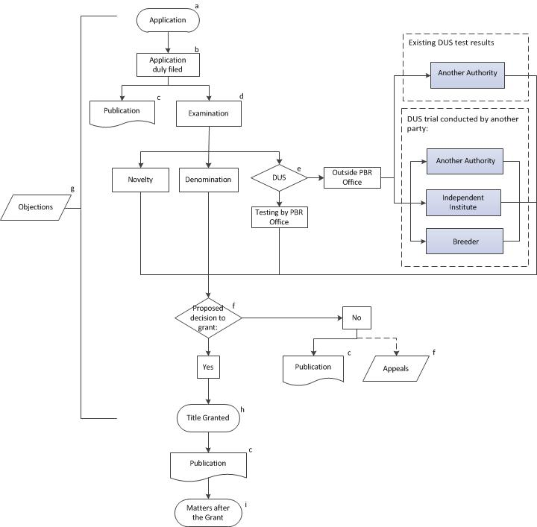

MODULE 2: ADMINISTRATION OF APPLICATIONS

Objective

The objective of this Module is to provide an explanation of the basic tasks of the PBR Office in the administration of applications for plant breeders’ rights. The module provides explanation on the basic tasks within the PBR Office, as presented in the flow diagram in Module I “The Plant Breeders’ Rights Office”.

APPLICATION FOR PLANT BREEDERS’ RIGHTS (SEE NOTE (A) IN THE FLOW DIAGRAM IN MODULE 1)

Introduction

Prior to receiving applications for plant breeders’ rights, the PBR Office needs to develop relevant forms and be ready to assign a filing date and time.

Legal provisions in some UPOV members allow for the filing of applications in paper copy only. Others allow the use of electronic application forms to substitute or to complement paper copy applications, thereby facilitating the use of databases and information management. In order to accept applications in electronic format, UPOV members may need to have auxiliary systems in place, such as for the recognition of digital signatures, electronic payment and security matters.

Applications for protection need to be managed by the PBR Office and their administration may involve the use of specific software applications. The sharing of software applications by UPOV members provides an important means of support for the administration of applications and examination of varieties. Information on the sharing of software by UPOV members is provided in document UPOV/INF/16 “Exchangeable Software” (available at http://www.upov.int/information_documents/en/)

Development of forms

In order to facilitate the implementation of procedures for filing applications for plant variety protection UPOV has developed model forms that can be used by individual PBR Offices within their national or regional contexts.

UPOV Model Application Form

Document TGP/5 “Experience and Cooperation in DUS Testing” contains the “UPOV Model Form for the Application for Plant Breeders’ Rights” (TGP/5, Section 2). The UPOV Model Form has the layout shown in the extract on the following page (available at: http://www.upov.int/tgp/en/).

When converting the UPOV Model Form into the form of a PBR Office and when drafting explanations for completing that form, the contents and the terminology of the applicable law of the UPOV member need to be taken into account. To ensure that the UPOV Model Form fulfills its function, it is important that the general structure, the contents and the numbering of the individual parts be maintained in the PBR Office’s own forms.

A standard UPOV reference has been provided for each field in the UPOV Model Form. For example, for item 1.(a) “Applicant(s) Name(s)”, the standard UPOV reference is “UPOV A1: 1(a)(i)”. To facilitate harmonization and to assist applicants, a PBR Office may include that standard UPOV reference in the corresponding field of the PBR Office’s own form. It is a matter for each PBR Office to decide if the field in the PBR Office’s own form corresponds sufficiently precisely to the field in the UPOV Model Application Form for the standard UPOV reference to be included.

Document TGP/5, Section 2 provides further information on the individual items of the UPOV Model Form.

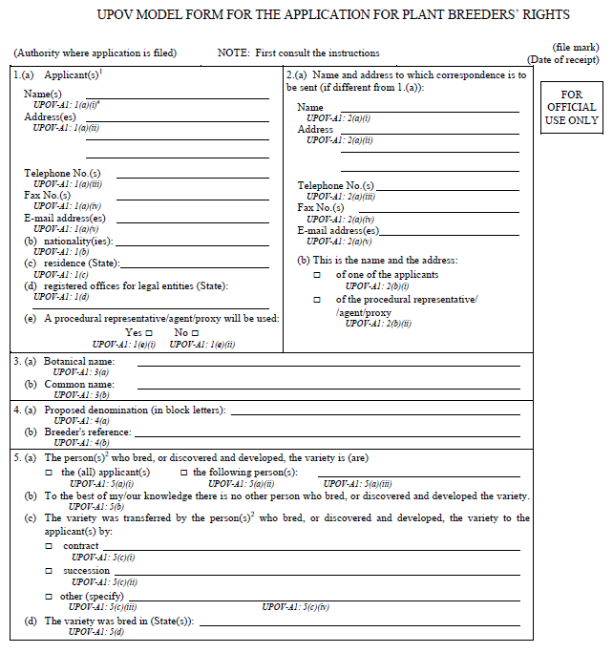

Technical Questionnaire

To help in the process of examining varieties, certain information is requested from the breeder, usually through a Technical Questionnaire to be submitted with the application. The Technical Questionnaire seeks information on specific characteristics of importance for distinguishing varieties, information on the breeding scheme of the variety and any other information which may help to distinguish the variety. It also requests the breeder to identify similar varieties and characteristics by which the candidate may be distinguished from these similar varieties. Where UPOV has developed “Guidelines for the Conduct of Tests for Distinctness, Uniformity and Stability,” or “Test Guidelines”, for individual species or other variety groupings (see http://www.upov.int/test_guidelines/en/), the Test Guidelines provide a model Technical Questionnaire in Chapter 10.

Sample of the Variety

Document TGP/5 “Experience and Cooperation in DUS Testing”, Section 4 “UPOV Model Form for the Designation of the Sample of the Variety” provides a model to be used in conjunction with the plant material submitted for the examination of candidate varieties.

Assigning filing date

Applications received by the PBR Office need to be assigned a date of filing. This step is relevant for the examination of novelty (see Module 4 “Examining Novelty”) and distinctness (see Module 9 “Examining Distinctness”).

The UPOV Convention provides for a right of priority of 12 months, based upon an earlier application for the protection of the same variety with another UPOV member, whereby a subsequent application is treated as if it were filed on the filing date of the first application. The right of priority has effects for the examination of the novelty and distinctness conditions and proposed denominations (see online distance learning course DL-205 “Plant Breeders’ Rights under the UPOV Convention”, Module 4: “Applying for a Plant Breeder’s Right”, and document UPOV/EXN/PRI “Explanatory notes on the right of priority under the UPOV Convention” available at: http://www.upov.int/explanatory_notes/en/).

APPLICATION DULY FILED (SEE NOTE (B) IN THE FLOW DIAGRAM IN MODULE 1)

Applications need to be checked for compliance with the applicable formalities and fee requirements in order to be considered as a duly filed application. In order for an application to be duly filed it must be submitted by a person that is entitled to a breeder’s right (see Module 3 “Entitlement to a breeder’s right”).

Duly filed applications need to be prepared for publication by the case officer or person in charge of the initial processing of the application forms. Information should also be provided for other concerned officers within the PBR Office to prepare for the subsequent steps of the examination.

PUBLICATION (SEE NOTE (C) IN THE FLOW DIAGRAM IN MODULE 1)

See Module 4 “Information to be published”.

EXAMINATION OF REQUIREMENTS (SEE NOTE (D) IN THE FLOW DIAGRAM IN MODULE 1)

The examination of novelty, proposed denomination and DUS should be conducted in parallel in order to avoid a delay in the grant of the breeders’ rights. In particular, the UPOV Convention requires that the denomination shall be registered by the PBR Office at the same time as the breeder's right is granted (Article 20(3) of the 1991 Act and Article 13(3) of the 1978 Act). There are different options for administration of the examination. For example, one person may be designated to act as a “case officer” responsible for the administration of all the aspects of the above mentioned examination, or there may be specialized professionals for individual parts of the work.

The examination of the denomination will be discussed in Module 6 “Examining the variety denomination”. The examination of novelty will be dealt with in Module 5 “Examining novelty”, while Modules 7 to 13 explain “DUS Examination”.

DUS EXAMINATION (SEE NOTE (E) IN THE FLOW DIAGRAM IN MODULE 1)

The size and structure of PBR Offices is influenced by the arrangements for DUS testing. A PBR Office may, for example, use one or more of the following arrangements:

- The PBR Office conducts growing trials, or other tests, itself (testing by PBR Office)
- The PBR Office arranges for another party / other parties to conduct the growing trials or other tests (outside PBR Office). In such an arrangement, another party could include, for example, another PBR Office, an independent institute or the breeder.
- The PBR Office takes into account the results of growing tests or other trials which have already been carried out (outside PBR Office).

The different options for cooperation between PBR Offices and cooperation with breeders in DUS examination will be further discussed in Module 13 “Cooperation in DUS examination”. Document TGP5 “Experience and Cooperation in DUS Testing”, Section 1 “Experience and Cooperation in DUS Testing” also provides useful information with a model administrative agreement for international cooperation in the testing of varieties. UPOV members may have informal arrangements for the purchasing of DUS test reports (for instance exchange of letters).

PROPOSED DECISION (SEE NOTE (F) IN THE FLOW DIAGRAM IN MODULE 1)

On the basis of the results of novelty, denomination and DUS examination a decision can be proposed with regard to the grant of protection. Such a decision may be proposed to the authority responsible for the grant of the breeders’ rights (PBR Office) by an official or by a group of professionals, such as a board or a panel of experts. If the decision is negative, the rejection of the application shall be published (see Module 4 “Information to be published”). The applicant may make an appeal against a proposed negative decision by the PBR Office.

OBJECTIONS (SEE NOTE (G) IN THE FLOW DIAGRAM IN MODULE 1)

The PBR Office needs to have procedures in place to handle objections received as a result of the publication of information. Objections received from the public may bring relevant data for the examination of applications and denominations. The applicant may also provide further relevant information when appealing against a decision of the PBR Office.

TITLE GRANT (SEE NOTE (H) IN THE FLOW DIAGRAM IN MODULE 1)

If the decision with regard to the grant of protection if positive, the title shall be granted. The title shall be transmitted to the holder of the breeder’s right. Grants of breeders’ rights and approved denominations shall be registered and published at the same time by the PBR Office (see Module 4 “Information to be published”).

MATTERS AFTER THE GRANT (SEE NOTE (I) IN THE FLOW DIAGRAM IN MODULE 1)

The tasks of the PBR Office after the grant of the PBR include the obligation to maintain up-to-date relevant information in the registry and databases, the management of the payment of fees (if applicable) by the breeder to keep the PBR in force, and the publication of relevant information after the grant, for example, the termination of the PBR and changes concerning the holder of the PBR and denominations (see Module 4 “Information to be published”). The PBR Office may also choose to take measures to verify the maintenance of the variety.

[End of Annex and of document]

Please note that this table is provided for illustrative purposes and may be out of date at the time of reading: the link to the current table of contents is provided in the text above.
The notes in the above diagram relate to the administration of examination and are explained in Module 2 “Administration of Applications”.

