E
CAJ/68/11
ORIGINAL: English
DATE: April 9, 2014
INTERNATIONAL UNION FOR THE PROTECTION OF NEW VARIETIES OF PLANTS
Geneva
ADministrative and legal committee
Sixty-Eighth Session
Geneva, October 21, 2013
REPORT
adopted by the Administrative and Legal Committee
Disclaimer: this document does not represent UPOV policies or guidance
Opening of the session

* The Administrative and Legal Committee (CAJ) held its sixty-eighth session in Geneva on October 21, 2013, under the chairmanship of Mr. Lü Bo (China).

* The session was opened by the Chair, who welcomed the participants. The list of participants is reproduced in the Annex to this report.

* The Secretary-General reported that, following a competition, Mrs. Alexandra Fava had been appointed to the post of Secretary I on October 1, 2013.

* The Chair confirmed that the report of the sixty-seventh session of the CAJ, held in Geneva on March 21, 2013 (document CAJ/67/15), had been adopted by correspondence and was available on the UPOV website.

Adoption of the agenda

* The CAJ adopted the draft agenda, as proposed in document CAJ/68/1.

Development of information materials concerning the UPOV Convention

* The CAJ considered documents CAJ/68/2 and UPOV/EXN/HRV Draft 10.

Explanatory Notes on Acts in Respect of Harvested Material under the 1991 Act of the UPOV Convention

* The CAJ approved document UPOV/EXN/HRV Draft 10 as the basis for the adoption of the “Explanatory Notes on Acts in Respect of Harvested Material under the 1991 Act of the UPOV Convention” by the Council at its forty-seventh ordinary session, to be held in Geneva on October 24, 2013.

Future work concerning the Explanatory Notes on Acts in Respect of Harvested Material

* The CAJ noted that the comments of the Russian Federation were circulated to participants and would be posted on the Administrative and Legal Committee Advisory Group (CAJ-AG) section of the UPOV website.

* The CAJ noted that the representatives of European Seed Association (ESA) and International Seed Federation (ISF) considered that paragraph 4 of document UPOV/EXN/HRV Draft 10 (reproduced below) should be reviewed in relation to future work by the CAJ-AG on illustrative examples.

“4. ‘Unauthorized use’ refers to the acts in respect of the propagating material that require the authorization of the holder of the breeder’s right in the territory concerned (Article 14(1) of the 1991 Act), but where such authorization was not obtained. Thus, unauthorized acts can only occur in the territory of the member of the Union where a breeder’s right has been granted and is in force.”

* The CAJ noted the comments made by the Delegation of the Russian Federation, the representatives of ESA and ISF, and agreed to consider those comments in relation to the future work on the Explanatory Notes on Acts in Respect of Harvested Material by the CAJ-AG, as set out in document CAJ/68/2, paragraphs 9 to 11.

Seminar on Essentially Derived Varieties and Explanatory Notes on Essentially Derived Varieties under the 1991 Act of the UPOV Convention (Revision)

* The CAJ requested the CAJ-AG to consider at its eighth session, to be held in Geneva on October 25, 2013, the discussions at the Seminar on Essentially Derived Varieties, to be held on October 22, 2013, in relation to the CAJ-AG work on future guidance concerning essentially derived varieties, as set out in document CAJ/68/2, paragraphs 13 to 16.

Participation of observers in the CAJ-AG

* The CAJ noted that the conclusions of the Consultative Committee, at its eighty-sixth session to be held in Geneva on October 23, 2013, concerning the participation of observers in the CAJ-AG would be reported to the CAJ.

* The CAJ noted that the Association for Plant Breeding for the Benefit of Society (APBREBES), the European Coordination Via Campesina (ECVC), the International Community of Breeders of Asexually Reproduced Ornamental and Fruit-Tree Varieties (CIOPORA) and ISF had been invited to participate in the relevant part of the eighth session of the CAJ-AG, as set out in document CAJ/68/2, paragraph 26.

Matters to be considered by the CAJ-AG at its eighth session

* The CAJ recalled that a report on the work of the CAJ-AG, at its eighth session, to be held in Geneva on October 25, 2013 (see document CAJ/68/2, paragraph 28), would be presented to the sixty-ninth session of the CAJ, to be held in April 2014. The draft agenda of the eighth session of the CAJ-AG is reproduced below:

1. Opening of the session
2. Adoption of the agenda
3. Explanatory Notes on Essentially Derived Varieties under the 1991 Act of the UPOV Convention (Revision) (document CAJ-AG/13/8/2)
4. Explanatory Notes on Propagation and Propagating Material (document UPOV/EXN/PPM Draft 1)
5. Explanatory Notes on Acts in Respect of Harvested Material (document CAJ-AG/13/8/3)
6. Matters concerning cancellation of the breeder's right (document CAJ-AG/13/8/4)
7. Matters concerning nullity of the breeder's right (document CAJ-AG/13/8/5)
8. Matters concerning variety denominations (document CAJ-AG/13/8/6)
9. Matters concerning variety descriptions (document CAJ-AG/13/8/7)
10. Matters arising after the grant of a breeder’s right on: provisional protection, filing of applications and enforcement of breeders’ rights (document CAJ-AG/13/8/8)
11. Matters concerning observers in the CAJ-AG (document CAJ-AG/13/8/9)
12. Matters referred by the CAJ to the CAJ-AG for consideration since the seventh session of the CAJ-AG
13. Date and program for the ninth session.

Program for the updating of document UPOV/INF/5 “UPOV Model Plant Breeders’ Rights Gazette”

* The CAJ considered document CAJ/68/3.

* The CAJ noted the developments relevant for the updating of document UPOV/INF/5 concerning the development a prototype electronic form, matters concerning essentially derived varieties, and the distance learning course “Examination of Applications for Plant Breeders’ Rights” (DL-305), reported in document CAJ/68/3.

* The CAJ agreed to include an item for the updating of document UPOV/INF/5 “UPOV Model Plant Breeders’ Rights Gazette” in the program for the seventieth session of the CAJ, to be held in October 2014.

Molecular techniques

* The CAJ considered document CAJ/68/4.

* The CAJ noted that the Technical Committee (TC), at its forty-ninth session, held in Geneva, from March 18 to 20, 2013, had received the following presentations on the application of models for the use of molecular techniques in the examination of DUS by members of the Union, copies of which were posted on the UPOV website at *http://upov.int/meetings/en/details.jsp?meeting_id=28343 (see paragraph 4 of document CAJ/68/4).

Use of characteristic specific molecular markers to assess seasonal type in Barley | Mr. Andrew Mitchell  (United Kingdom)
Applications of molecular data in DUS testing | Mr. Joel Guiard (France)
Use of molecular techniques in the renewal of reference material | Mr. Kees van Ettekoven (Netherlands)
Use of molecular techniques in Brazil | Mr. Fabricio Santana Santos (Brazil)

The Delegation of the European Union expressed its support for any initiative that increased exchange and cooperation with other international organizations.

* The CAJ noted that a date had been proposed for the fourteenth session of the Working Group on Biochemical and Molecular Techniques, and DNA-Profiling in Particular (BMT) (see document CAJ/68/4, paragraph 14), which had been coordinated with the International Seed Testing Association (ISTA) and the Organisation for Economic Co-operation and Development (OECD).

Variety denominations

* The CAJ considered document CAJ/68/5.

The Delegation of the European Union recalled the role of the Community Plant Variety Office of the European Union (CPVO) in the field of variety denominations. It explained that the CPVO would be willing to participate in discussions on variety denominations with other international organizations.

The Vice Secretary-General expressed his appreciation of the cooperation between UPOV and the CPVO, including CPVO’s participation at the meeting of the International Commission for the Nomenclature of Cultivated Plants of the International Union of Biological Sciences (IUBS Commission), which was held in Beijing, China, on July 20 and 21, 2013. He noted that the Office of the Union would be willing to coordinate with the IUBS Commission in order to explain the differences between recommendations on variety denominations at the UPOV level and individual denomination guidelines at the national or regional authorities’ level.

* The CAJ noted the developments concerning potential areas for cooperation between the International Commission for the Nomenclature of Cultivated Plants of the International Union for Biological Sciences (IUBS Commission) and the International Society for Horticultural Science Commission for Nomenclature and Cultivar Registration (ISHS Commission) and UPOV, as set out in document CAJ/68/5.

Information and databases

(a) UPOV information databases

* The CAJ considered document CAJ/68/6.

* The CAJ approved the amendments to the program for improvements to the PLUTO database, as set out in Annex II of document CAJ/68/6, on the basis of the explanations in document CAJ/68/6, paragraphs 4 to 18, subject to the following amendments (highlighted in grey):

Paragraph 2.4 | “2.4 With regard to the assistance to be provided to contributors, the UPOV-ROM “General Notice and Disclaimer” states that “[…] All contributors to the UPOV-ROM are responsible for the correctness and completeness of the data they supply. […]”. Thus, in cases where assistance is provided to contributors, the contributor will continue to be responsible for the correctness and completeness of the data. In cases where the PLUTO database administrator is requested by the contributor to allocate UPOV codes, or where it is considered to be appropriate to amend a UPOV code allocated by the contributor, the PLUTO database administrator will make proposals for approval by the contributor. In the absence of objections responses within the designated time, the proposed UPOV codes will be used in the PLUTO database. Where the contributor subsequently notifies the PLUTO database administrator of a need for correction, the correction will be made at the first opportunity, in accordance with Section 4 “Frequency of data updating”.”
Paragraph 4 | “4. Frequency of data submission  “The Plant Variety Database will be developed in such a way as to allow updating at any frequency determined by the members of the Union. Prior to completion and publication of the web-based version of the Plant Variety Database, no change is proposed to the frequency of updating, i.e. contributors will be requested to update their data on a bimonthly basis. Once that stage is complete, the TC and CAJ will be invited to consider whether to create possibilities for data to be updated on a more frequent basis. Contributors will be encouraged to provide data as soon as possible practical after it is published by the authority(ies) concerned. The PLUTO database will be updated with new data as quickly as possible after receipt, in accordance with the uploading procedure. The PLUTO database can, as necessary, be updated with corrected data, in accordance with the uploading procedure.”

* In relation to the amendments to the program for improvements to the PLUTO database, as set out in Annex II, the CAJ agreed to amend the disclaimer as follows:

“The data currently in the Plant Variety Database (PLUTO database) was last updated on [dd/mm/yyyy] is the data in version 201303 of the UPOV-ROM Plant Variety Database. A subscription service will also shortly be introduced for PLUTO, which will allow us to inform users of future updates of the data.

“To continue to the PLUTO page, you must first agree to acknowledge the following disclaimer.

“Please note that the information concerning plant breeders' rights provided in the PLUTO Plant Variety database (PLUTO) does not constitute the official publication of the authorities concerned. To consult the official publication, or to obtain details on the status and completeness of the information in the PLUTO database, please contact the relevant authority, contact details for which are provided at *http://www.upov.int/members/en/pvp_offices.html.

“All contributors to the PLUTO database are responsible for the correctness and completeness of the data they supply. Users are particularly requested to note that it is not obligatory for members of the Union to supply data the PLUTO database and, for those members of the Union who supply data, it is not obligatory to supply data for all items.”

* The CAJ approved the following disclaimer for reports generated by the PLUTO database, as set out in document CAJ/68/6, paragraph 24:

“The *data in this report was generated from the PLUTO database on [dd/mm/yyyy].

“Please note that the information concerning plant breeders' rights provided in the PLUTO database does not constitute the official publication of the authorities concerned. To consult the official publication, or to obtain details on the status and completeness of the information in the PLUTO database, please contact the relevant authority, contact details for which are provided at *http://www.upov.int/members/en/pvp_offices.html.

“All contributors to the PLUTO database are responsible for the correctness and completeness of the data they supply. Users are particularly requested to note that it is not obligatory for members of the Union to supply data the PLUTO database and, for those members of the Union who supply data, it is not obligatory to supply data for all items.”

The Delegation of the European Union welcomed the proposed amendments to the PLUTO database and recalled the role of the CPVO in collecting data from its contributors in accordance with the Memorandum of Understanding (MOU) between UPOV and the CPVO. The Delegation noted that although the content of both databases was similar, the objectives were to some extent different. It explained that the CPVO Variety Finder was used by breeders and by national authorities to evaluate the possibility of using a variety denomination. In that regard, there had been more than 60,000 denomination tests produced in 2012, which related to plant variety protection as well as to national and European catalogues for commercialization. The Delegation was in favor of a broad approach on variety denominations matters. It expressed its support to the proposed amendment regarding the frequency of data submission.

The Delegation of New Zealand requested that the date of submission of the data be clearly indicated in the PLUTO database, in order to facilitate the interpretation of the information.

* The CAJ recalled that any changes to the PLUTO database would be implemented in accordance with the Memorandum of Understanding between UPOV and the Community Plant Variety Office of the European Union (CPVO).

* The CAJ agreed on the draft questions for the survey of members of the Union on their use of databases for plant variety protection purposes and on their use of electronic application systems, as set out in document CAJ/68/6, Annex III, subject to the following amendments:

Question 2 | To clarify that the questionnaire concerns authorities’ databases, rather than the PLUTO database
Question 9 | To be modified to include other forms of authorization, in addition to an electronic signature
New question | To add a box to indicate other information/features that are included in the authority’s electronic application form
New question | To add a question after (o) concerning the end date of protection

(b) Exchangeable software

* The CAJ considered documents CAJ/68/7 and UPOV/INF/16/3 Draft 1.

* The CAJ agreed with the conclusions of the TC, at its forty-ninth session, that the title of document UPOV/INF/16 “Exchangeable Software” and the text of Section 1 “Requirements for exchangeable software” should remain unchanged on the basis that the document concerns software that has been developed or customized by a member of the Union for UPOV purposes; and that it would be useful for the TC to seek to develop a separate information document that would allow members of the Union to provide information on the use of non-customized software and equipment (e.g. data loggers) that was used by members of the Union.

* The CAJ approved the proposed revision of document UPOV/INF/16 for inclusion of new software, as set out in paragraphs 6 and 7 of document CAJ/68/7, on the basis of document UPOV/INF/16/3 Draft 1.

* With regard to the possible translation of the “Information System (IS) used for Test and Protection of Plant Varieties in the Russian Federation”, it was agreed that the Office of the Union would arrange a telephone meeting in Russian with the IT expert of the Russian Federation in order to clarify translation requirements.

* The CAJ approved the proposed revision of document UPOV/INF/16, concerning the inclusion of information on software used by members of the Union, as set out in document CAJ/68/7, paragraphs 13 and 14, on the basis of document UPOV/INF/16/3 Draft 1.

* The CAJ noted that the revision of document UPOV/INF/16 would be considered for adoption by the Council at its forty-seventh ordinary session, to be held on October 24, 2013.

(c) Electronic application systems

* The CAJ considered document CAJ/68/8.

* The CAJ noted that a report of the meeting on the development of a prototype electronic form to be held in Geneva on October 24, 2013, would be made to the CAJ at its sixty-ninth session, to be held in April 2014.

* The CAJ noted the request of the Delegation of Switzerland to participate in the meetings on the development of a prototype electronic form.

Possible development of a UPOV similarity search tool for variety denomination purposes

* The CAJ considered document CAJ/68/9.

* The CAJ noted the following correction in the Annex to document CAJ/68/9:

“5. Detailed description of the similarity test.

“The steps below are implemented for each couple (WT,WR).

“Preliminary filter: in the list of WR, all words with more than 3 characters as the WT, or less than 3 characters as the WR WT are not considered for the following calculations.

* The CAJ approved the establishment of a working group to develop proposals for a UPOV similarity search tool for variety denomination purposes, as proposed in document CAJ/68/9, paragraphs 4 to 7, as follows:

The composition of the group will be:

(a) Denomination examiners from members of the Union (3 to 6 experts);

(b) WIPO Global Databases Service (responsible for the PLUTO database);

(c) Community Plant Variety Office of the European Union (CPVO); and

(d) Office of the Union.

The work plan of the working group will be established by the working group itself; however, it is anticipated that the first step will be to review the search types currently available in the denomination search tab of the PLUTO database, particularly the Similarity factor (CPVO search tool), and to review search types in use in other situations (e.g. in relation to trademarks) that might provide an alternative basis for a UPOV similarity search tool.

The review of the suitability of search types will, in particular, take into account document UPOV/INF/12 “Explanatory notes on variety denominations under the UPOV Convention”. In that regard, the working group will need to refer to the CAJ for further guidance if its work indicates that a review of document UPOV/INF/12 would be necessary for the development of an effective UPOV similarity search tool.

The meetings of the working group will be hosted by the Office of the Union in Geneva and will be chaired by the Office of the Union. The meetings will not be arranged to coincide with UPOV sessions and electronic participation by denomination examiners and the CPVO will be anticipated. Proposals developed by the working group will be presented to the CAJ and to the Technical Committee (TC), and the CAJ and TC will receive a brief report of the meetings of the working group.

* The CAJ noted the suggestion by the Delegation of the European Union for the inclusion in the working group of denomination examiners from the Netherlands and Spain and the importance of ensuring that there was sufficient coverage by the experts of the linguistic aspects of variety denominations.

The representative of the European Seed Association (ESA) requested information on whether observers would be invited to the meetings of the working group to develop proposals for a UPOV similarity search tool for variety denomination purposes.

The Vice Secretary-General agreed that the question of languages was an important aspect for the working group. He noted that some of the issues that could arise would have implications for existing explanatory notes, which should be considered by the CAJ. With regard to the participation of observers, the Vice Secretary-General noted that the working group could decide when to invite observers to participate in its meetings or to provide comments. At the initial stage, the working group would need to make an initial assessment and then to formulate proposals to be considered by the CAJ. He encouraged the CAJ to provide suggestions on matters concerning the tasks of the working group.

The Delegation of Australia reported that it would be useful to invite the members of the Union to make suggestions with regard to the possible outcome for the search tool. For instance, it explained that a member of the Union might want a particular rank-index calculation below which specific comparisons were not required. It was of the view that it would be useful if members of the Union notified particular searches requirements to the working group.

* The CAJ agreed that members and observers should be encouraged to provide suggestions on matters concerning the tasks of the working group.

Program for the sixty-ninth session

* The following program was agreed for the sixty-ninth session of the CAJ, to be held in Geneva on April 10, 2014.

1. Opening of the session

2. Adoption of the agenda

3. Report on developments in the Technical Committee

4. Development of information materials concerning the UPOV Convention

5. TGP documents

6. Molecular techniques

7. Variety denominations

8. Information and databases

(a) UPOV information databases
(b) Exchangeable software
(c) Electronic application systems

9. Possible development of a UPOV similarity search tool for variety denomination purposes

10. Program for the seventieth session

11. Adoption of the report on the conclusions (if time permits)

12. Closing of the session

This report was adopted by correspondence.

[Annex follows]

CAJ/68/11

ANNEXE / ANNEX / ANLAGE / ANEXO

LISTE DES PARTICIPANTS / LIST OF PARTICIPANTS /
TEILNEHMERLISTE / LISTA DE PARTICIPANTES

(dans l’ordre alphabétique des noms français des membres/
in the alphabetical order of the names in French of the members/
in alphabetischer Reihenfolge der französischen Namen der Mitglieder/
por orden alfabético de los nombres en francés de los miembros)
i. MEMBRES / MEMBERS / VERBANDSMITGLIEDER / MIEMBROS
AFRIQUE DU SUD / SOUTH AFRICA / SÜDAFRIKA / SUDÁFRICA
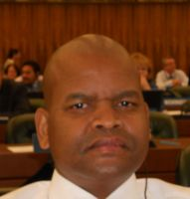 |  | Lentheng TSWAI, Minister, Permanent Mission, 65, rue du Rhone, 1204 Geneva, Switzerland  (tel.: + 41 22 5895407 e-mail: tsweni.agriculture@gmail.com)
ALLEMAGNE / GERMANY / DEUTSCHLAND / ALEMANIA
Barbara SOHNEMANN (Frau), Justiziarin, Leiterin, Rechtsangelegenheiten, Sortenverwaltung, Gebühren, Bundessortenamt, Postfach 610440, D-30604 Hannover (tel.: +49 511 95665624 fax: +49 511 95669600
e-mail: barbara.sohnemann@bundessortenamt.de)
AUSTRALIE / AUSTRALIA / AUSTRALIEN / AUSTRALIA
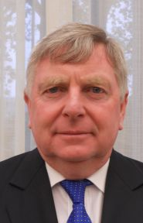 |  | Doug WATERHOUSE, Chief, Plant Breeder's Rights, IP Australia, P.O. Box 200, Woden ACT 2606  (tel.: +61 2 6283 7981 fax: +61 2 6283 7999  e-mail: doug.waterhouse@ipaustralia.gov.au)
BOLIVIE (ÉTAT PLURINATIONAL DE) / BOLIVIA (PLURINATIONAL STATE OF) /
BOLIVIEN (PLURINATIONALER STAAT) / BOLIVIA (ESTADO PLURINACIONAL DE)
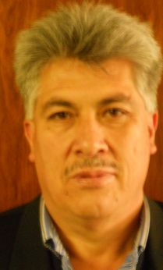 | Sergio Rider ANDRADE CÁCERES, Director Nacional de Semillas del INIAF, Instituto Nacional de Innovación Agropecuaria y Forestal (INIAF), Avenida 6 de agosto,  Nro. 2170, Edificio Hoy, Mezanine, 4793 La Paz  (tel.: +591 2 2441153 fax: +591 2 2441153 e-mail: rideran@yahoo.es)
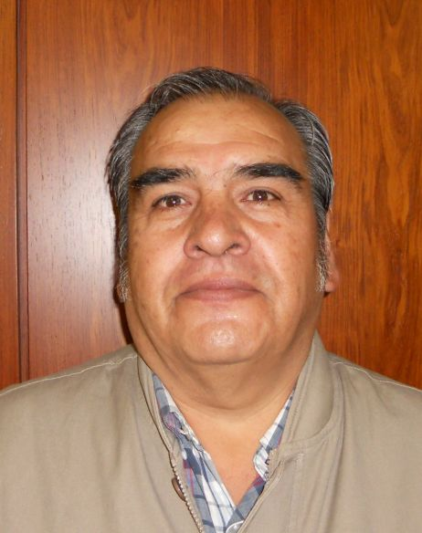 | Freddy CABALLERO LEDEZMA, Jefe de la Unidad de Fiscalización y Registros de Semillas, Instituto Nacional de Innovación Agropecuaria y Forestal (INIAF), Capitán Ravelo No. 2329, Belisario Salinas, No. 490, 4793 La Paz  (tel.: +591 2 2441153 fax: +591 2 2441153 e-mail: calefred@yahoo.es)
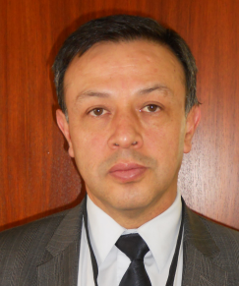 | Luis Fernando ROSALES LOZADA, Primer Secretario, Misión Permanente, 139, rue de Lausanne, 1202 Ginebra  (tel.: +41 22 908 0717 fax: +41 22 908 0722  e-mail: fernando.rosales@ mission-bolivia.ch)
Laurent GABERELL, Asistente Técnico Administrativo, Misión Permanente, 139, rue de Lausanne, 1202 Ginebra
(tel.: +41 22 908 0717 fax: +41 22 908 0722 e-mail: laurent.gaberell@mission-bolivia.ch)
BRÉSIL / BRAZIL / BRASILIEN / BRASIL
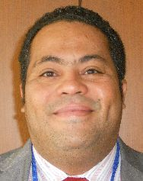 |  | Fabrício SANTANA SANTOS, Coordinator, National Plant Variety Protection Office (SNPC), Ministry of Agriculture, Livestock and Food Supply, Esplanada dos Ministerios, Bloco 'D', Anexo A, Sala 250, CEP 70043-900 Brasilia , D.F.  (tel.:+55 61 3218 2549 fax: +55 61 3224 2842  e-mail: fabricio.santos@agricultura.gov.br)
CANADA / CANADA / KANADA / CANADÁ
Anthony PARKER, Commissioner, Canadian Food Inspection Agency (CFIA), 59, Camelot Drive, Ottawa, Ontario K1A 0Y9
(tel.: +1 613 7737188 fax: +1 613 7737261 e-mail: anthony.parker@inspection.gc.ca)
CHILI / CHILE / CHILE / CHILE
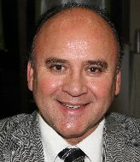 |  | Jaime IBIETA S., Director, División Semillas, Servicio Agrícola y Ganadero (SAG), Ministerio de Agricultura, Avda. Presidente Bulnes 140, piso 2, Santiago de Chile  (tel.: +56 2 345 1561 fax: +56 2 697 2179 e-mail: jaime.ibieta@sag.gob.cl)
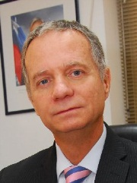 |  | Fernando Javier BAS MIR, Executive Director, Foundation for Agricultural Innovation, Ministry of Agriculture, Av. Loreley 1582, Santiago de Chile  (tel.: +56 2 2431 3064 fax.: +56 2 2431 3040 e-mail: fbas@fia.cl)
CHINE / CHINA / CHINA / CHINA
LV Bo, Director, Division of Variety Management, Bureau of Seed Management, Ministry of Agriculture, No. 11 Nongzhanguannanli, Beijing
(tel.: +86 10 59193150 fax: +86 10 59193142 e-mail: lvbo@agri.gov.cn)
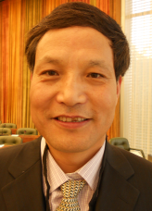 |  | QI Wang, Director, Division of Protection of New Varieties of Plants, State Forestry Administration, No. 18, Hepingli East Street, Beijing 100714  (tel.:+86 10 84239104 fax: +86 10 84238883 e-mail: wangqihq@sina.com)
Liying CHEN (Mrs.), Project Administrator, State Intellectual Property Office P.R. China, Division 2, International Cooperation Department, No. 6 Xitucheng Road, Beijing
(tel.: 0086 10 62083837 fax: 0086 10 62019615 e-mail: chenliying@sipo.gov.cn)
COLOMBIE / COLOMBIA / KOLUMBIEN / COLOMBIA
Ana Luisa DÍAZ JIMÉNEZ (Sra.), Directora Técnica de Semillas, Dirección Técnica de Semillas, Instituto Colombiano Agropecuario (ICA), Carrera 41 No. 17-81, Piso 4°, Zona Industrial de Puente Aranda, Bogotá D.C.
(tel.: +57 1 3323700 fax: +57 1 3323700 e-mail: ana.diaz@ica.gov.co)
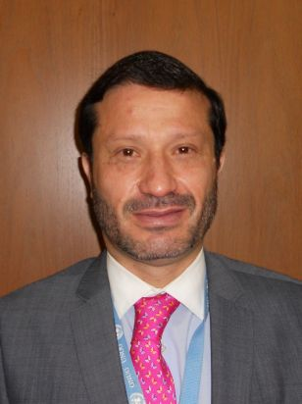 |  | Juan Camilo SARETZKI-FORERO, Consejero, Misión Permanente de Colombia, Chemin Champ dÁnier 17-19, 1209 Ginebra  (tel.: 41 22 798 4718 fax: 41 22 791 0787 e-mail: juan.saretzki@misioncolombia.ch)
CROATIE / CROATIA / KROATIEN / CROACIA
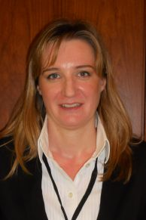 |  | Ivana BULAJIĆ (Ms.), Head, Plant Health Service, Vukovarska 78, HR-Zagreb  (tel.: +385 161 09390 e-mail: ivana.bulajic@mps.hr)
ESPAGNE / SPAIN / SPANIEN / ESPAÑA
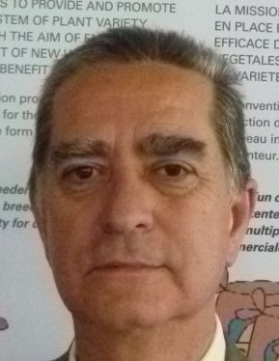 |  | Luis SALAICES, Jefe del Área del Registro de Variedades, Subdirección general de Medios de Producción Agrícolas y Oficina Española de Variedades Vegetales (MPA y OEVV), Ministerio de Agricultura, Alimentación y Medio Ambiente (MAGRAMA), C/ Almagro No. 33, planta 7a, E-28010 Madrid  (tel.: +34 91 347 6712 fax: +34 91 347 6703 e-mail: luis.salaices@magrama.es)
ESTONIE / ESTONIA / ESTLAND / ESTONIA
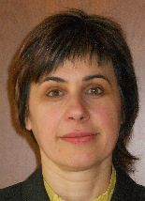 |  | Renata TSATURJAN (Ms.), Chief Specialist, Plant Production Bureau, Ministry of Agriculture, 39/41 Lai Street, EE-15056 Tallinn  (tel.: +372 625 6507 fax: +372 625 6200 e-mail: renata.tsaturjan@agri.ee)
ÉTATS-UNIS D'AMÉRIQUE / UNITED STATES OF AMERICA /
VEREINIGTE STAATEN VON AMERIKA / ESTADOS UNIDOS DE AMÉRICA
Kitisri SUKHAPINDA (Ms.), Patent Attorney, Office of Policy and External Affairs, United States Patent and Trademark Office (USPTO), Madison Building, West Wing, 600 Dulany Street, MDW 10A30, Alexandria VA 22313
(tel.: +1 571 272 9300 fax: + 1 571 273 0085 e-mail: kitisri.sukhapinda@uspto.gov)
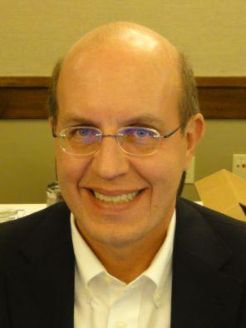 |  | Paul M. ZANKOWSKI, Commissioner, Plant Variety Protection Office, USDA, AMS, S&T, Plant Variety Protection Office, USDA, AMS, S&T, Plant Variety Protection Office, 1400 Independence Ave., S.W., Room 4512 - South Building, Mail Stop 0273, Washington D.C. 20250  (tel.: +1 202 720-1128 fax: +1 202 260-8976 e-mail: paul.zankowski@ams.usda.gov)
Ruihong GUO (Ms.), Deputy Administrator, AMS, Science & Technolgoy Program, United States Department of Agriculture (USDA), 1400 Independence Avenue, SW, Room 3543 - South Building, Washington D.C. D.C.
(tel.: +1 202 720 8556 fax: +1 202 720 8477 e-mail: ruihong.guo@ams.usda.gov)
Karin L. FERRITER (Ms.), Intellectual Property Attaché, United States Mission to the WTO, 11, route de Pregny, 1292 Chambesy, Switzerland
(tel.: +41 22 749 5281 e-mail: karin_ferriter@ustr.eop.gov)
FÉDÉRATION DE RUSSIE / RUSSIAN FEDERATION / RUSSISCHE FÖDERATION /
FEDERACIÓN DE RUSIA
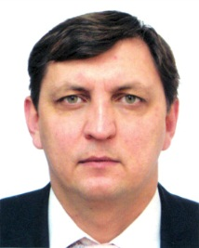 |  | Vitaly S. VOLOSCHCHENKO, Chairman, State Commission of the Russian Federation for Selection Achievements Test and Protection, Orlicov per. 1/11, 107139 Moscow  (tel.: +70 495 6076827 fax: +70 495 411 8366 e-mail: gossort@gossort.com)
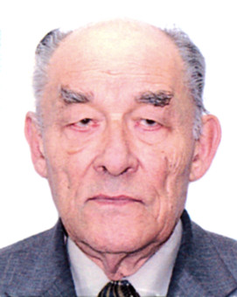 |  | Yuri A. ROGOVSKIY, Chief of Method Department, Deputy Chairman, State Commission of the Russian Federation for Selection Achievements Test and Protection, Orlikov per., 1/11, 107139 Moscow  (tel.: +7 499 9751082 fax: +7 495 411 83 66 e-mail: yrogovskij@yandex.ru)
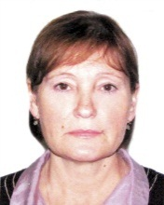 |  | Antonina TRETINIKOVA (Ms.), Leading Agronomist, Methodology Department, State Commission of the Russian Federation for Selection Achievements Test and Protection, Orlikov per., 1/11, 107139 Moscow  (tel.: +7 495 607 6827 fax: +7 495 411 8366 e-mail: tretinnikova@mail.ru)
FINLANDE / FINLAND / FINNLAND / FINLANDIA
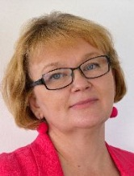 |  | Tarja Päivikki HIETARANTA (Ms.), Senior Officer, Finnish Food and Safety Authority (EVIRA), Seed Certification, Tampereentie 51, P.O. Box 111, FIN-32201 Loimaa  (tel.: +358 50 3443748 e-mail: tarja.hietaranta@evira.fi)
FRANCE / FRANCE / FRANKREICH / FRANCIA
Virginie BERTOUX (Mme), Chef, Instance nationale des obtentions végétales (INOV), INOV-GEVES, 25 Rue Georges Morel, CS 90024, F-49071 Beaucouzé
(tel.: +33 2 41 22 86 49 fax: +33 2 41 22 86 01 e-mail: Virginie.bertoux@geves.fr)
HONGRIE / HUNGARY / UNGARN / HUNGRÍA
Ágnes Gyözöné SZENCI (Mrs.), Senior Chief Advisor, Agricultural Department, Ministry of Agriculture and Rural Development, Kossuth Tér. 11, 1055 Budapest
(tel.: +36 1 7953826 fax: +36 1 7950498 e-mail: gyozone.szenci@vm.gov.hu)
Katalin MIKLÓ (Ms.), Head, Agriculture and Plant Variety Protection Section, Hungarian Intellectual Property Office, Budapest
(tel.: 36 1 474 5898 fax: 36 1 474 5850 e-mail: katalin.miklo@hipo.gov.hu)
IRLANDE / IRELAND / IRLAND / IRLANDA
Donal COLEMAN, Controller of Plant Breeders' Rights, National Crop Evaluation Centre, Department of Agriculture, National Crops Centre, Backweston Farm, Leixlip , Co. Kildare (tel.: +353 1 630 2902 fax: +353 1 628 0634
e-mail: donal.coleman@agriculture.gov.ie)
JAPON / JAPAN / JAPAN / JAPÓN
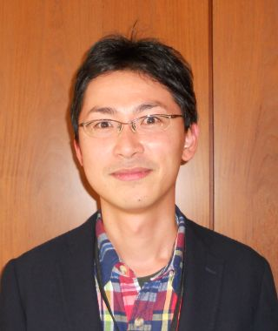 |  | Yoshihiko AGA, Associate Director for International Affairs, New Business and Intellectual Property Division, Food Industry Affairs Bureau, Ministry of Agriculture, Forestry and Fisheries (MAFF), 1-2-1 Kasumigaseki, Chiyoda-ku, 100-8950 Tokyo  (tel.: +81 3 6738 6444 fax: +81 3 3502 5301 e-mail: yoshihiko_aga@nm.maff.go.jp)
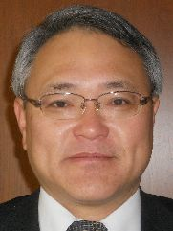 |  | Mitsutaro FUJISADA, Senior Policy Advisor: Intellectual Property, New Business and Intellectual Property Division, Food Industry Affairs Bureau, Ministry of Agriculture, Forestry and Fisheries (MAFF), 1-2-1, Kasumigaseki, Chiyoda-ku, 100-8950 Tokyo  (tel.:+81 3 6738 6445 fax: +81 3 3502 5301 e-mail: mitutarou_fujisada@nm.maff.go.jp)
LETTONIE / LATVIA / LETTLAND / LETONIA
Daiga BAJALE (Miss), Senior Officer, Seed Control Department, Division of Seed Certification and Plant Variety Protection, State Plant Protection Service, Lielvardes 36/38, LV-1006 Riga
(tel.: +371 67550938 fax: +371 67365571 e-mail: daiga.bajale@vaad.gov.lv)
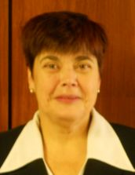 |  | Sofija KALININA (Mrs.), Senior Officer, Seed Control Department, Division of Seed Certification and Plant Variety Protection, State Plant Protection Service, Lielvardes iela 36/38, LV-1006 Riga  (tel.: +371 673 65568 fax: +371 673 65571 e-mail: sofija.kalinina@vaad.gov.lv)
LITUANIE / LITHUANIA / LITAUEN / LITUANIA
Arvydas BASIULIS, Deputy Director, State Plant Service under the Ministry of Agriculture of the Republic of Lithuania, Ozo 4A, LT-08200 Vilnius
(tel.: +370 5 237 5611 fax: +370 5 273 0233 e-mail: arvydas.basiulis@vatzum.lt)
Sigita JUCIUVIENE (Mrs.), Head, Division of Plant Variety, Registration and Legal Protection, State Plant Service under the Ministry of Agriculture of the Republic of Lithuania, Ozo St. 4a, LT-08200 Vilnius
(tel.: +370 5 234 3647 fax: +370 5 237 0233 e-mail: sigita.juciuviene@vatzum.lt)
Antonio ATAZ, Adviser to the Presidency of the European Union, Council of the European Union, Brussels
(tel.: +32 2 281 4964 fax: +32 2 281 6198 e-mail: antonio.ataz@consilium.europa.eu)
MAROC / MOROCCO / MAROKKO / MARRUECOS
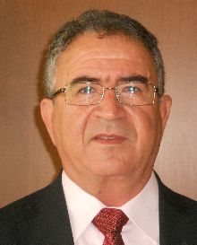 |  | Amar TAHIRI, Chef de la Division du contrôle des semences et plants, Office National de Sécurité sanitaire des Produits alimentaires (ONSSA), Ministère de l'Agriculture et de la Pêche Maritime, Rue Hafiane Cherkaoui, B.P. 1308, Rabat-Instituts  (fax: +212 537 779852 e-mail: amar.tahiri@gmail.com)
MEXIQUE / MEXICO / MEXIKO / MÉXICO
Enriqueta MOLINA MACÍAS (Srta.), Directora General, Servicio Nacional de Inspección y Certificación de Semillas (SNICS), Secretaría de Agricultura, Ganadería, Desarrollo Rural, Pesca y Alimentación (SAGARPA), Av. Presidente Juárez, 13, Col. El Cortijo, Tlalnepantla , Estado de México54000
(tel.: +52 (55) 3622-0667 al 70 fax: +52 55 3622 0670
e-mail: enriqueta.molina@snics.gob.mx)
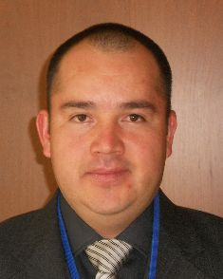 |  | Eduardo PADILLA VACA, Director de Variedades Vegetales, Registro y Control de Variedades Vegetales, Servicio Nacional de Inspección y Certificación de Semillas (SNICS), Av. Presidente Juárez 13, Col. El Cortijo, 54000 Tlalnepantla , Estado de México  (tel.: +52 55 3622 0667 fax: +52 55 3622 0670 e-mail: eduardo.padilla@snics.gob.mx)
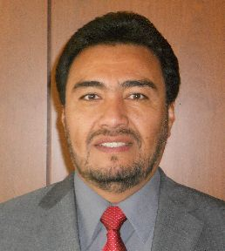 |  | Alejandro F. BARRIENTOS-PRIEGO, Subdirector General de Investigación, Universidad Autónoma Chapingo (UACh), Km. 38.5 Carretera México-Texcoco, CP 56230, Chapingo, Estadode México  (tel.: +52 59 59 52 1559 fax: +52 595 9521642 e-mail: abarrien@gmail.com)
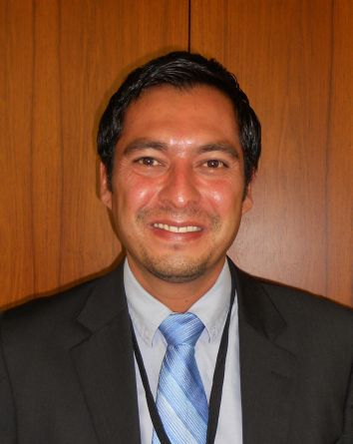 |  | Ivan POLANCO, Asistente del Ministro de Agricultura en Ginebra, Misión Permanente de México ante la Oficina de las Naciones Unidas en Ginebra, Case postale 433  CH-1211 Ginebra 19, Suiza
NORVÈGE / NORWAY / NORWEGEN / NORUEGA
Tor Erik JØRGENSEN, Head of Section, Norwegian Food Safety Authority, Felles postmottak, P.O. Box 383, N-2381 Brumunddal
(tel.: +47 6494 4393 fax: +47 6494 4411 e-mail: tor.erik.jorgensen@mattilsynet.no)
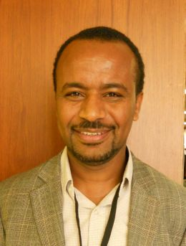 |  | Teshome HUNDUMA MULESA, The Development Fund, Mariboes gate 8, N-0183 Oslo  (tel.: +47 23 109600 fax: +47 23 109601 e-mail: teshome@utviklingsfondet.no)
NOUVELLE-ZÉLANDE / NEW ZEALAND / NEUSEELAND / NUEVA ZELANDIA
Christopher J. BARNABY, Assistant Commissioner / Principal Examiner, Plant Variety Rights Office, Intellectual Property Office of New Zealand, Private Bag 4714, Christchurch 8140
(tel.: +64 3 9626206 fax: +64 3 9626202 e-mail: Chris.Barnaby@pvr.govt.nz)
PARAGUAY / PARAGUAY / PARAGUAY
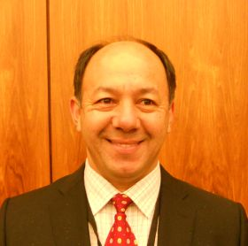 |  | Regis MERELES, Presidente, Servicio Nacional de Calidad y Sanidad Vegetal y de Semillas (SENAVE), Humaitá No. 145 entre Nuestra Señora de la, Asunción e Independencia Nacional, Asunción  (tel.: +595 21 490703 fax: +595 21 441491 e-mail: regis.mereles@senave.gov.py)
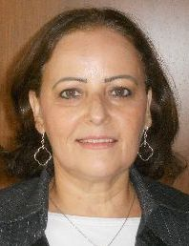 |  | Blanca Julia NUÑEZ TEIXIDO (Sra.), Tècnico de la Dirección de Semillas, Jefa del Departamento de Protección y Uso de Variedades, Dirección General de Semillas, Servicio Nacional de Calidad y Sanidad Vegetal y de Semillas (SENAVE), Gaspar Rodríguez de Francia, No. 685, Ruta Mariscal Estigarribia, San Lorenzo  (tel.: +595 21 584645 fax: +595 21 584645 email: blanca.nunez@senave.gov.py)
PAYS-BAS / NETHERLANDS / NIEDERLANDE / PAÍSES BAJOS
Kees Jan GROENEWOUD, Secretary to the Plant Variety Board (Raad voor Plantenrassen), Postbus 40, NL-2370 AA Roelofarendsveen
(tel.: +31713326310 fax: +31713326363)
POLOGNE / POLAND / POLEN / POLONIA
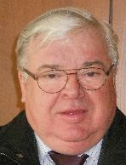 |  | Edward S. GACEK, Director, Research Centre for Cultivar Testing (COBORU), PL-63-022 Slupia Wielka  (tel.: +48 61 285 2341 fax: +48 61 285 3558 e-mail: e.gacek@coboru.pl)
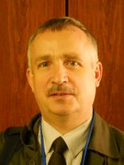 |  | Marcin BEHNKE, Deputy Director General for Experimental Affairs, Research Centre for Cultivar Testing (COBORU), PL-63-022 Slupia Wielka  (tel.: +48 61 285 2341 fax: +48 61 285 3558 e-mail: m.behnke@coboru.pl)
RÉPUBLIQUE DE CORÉE / REPUBLIC OF KOREA / REPUBLIK KOREA / REPÚBLICA DE COREA
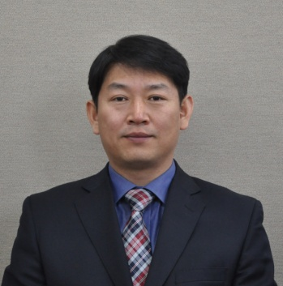 |  | Sanghyug LEE, Director, Plant Variety Protection Division, Korea Seed & Variety Service (KSVS), Korea Seed & Variety Service, Ministry of Agriculture, Food and rural Affairs (MAFRA), 184, Anyang-ro, Manan-Gu, Anyang City, Gyeonggi-do 430-016  (tel.: +82 31 467 0150 fax: +82 31 467 0160 e-mail: lsh68@korea.kr)
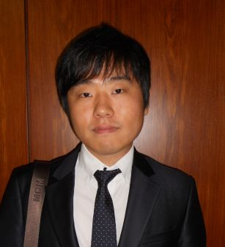 |  | Jino YOO, Deputy Director, Korean Intellectual Property Office (KIPO), 189, Cheongsa-Ro, Seo-Gu, Daejeon Metropolitan City 302-701  (tel.: +82 42 481 8387 fax: +82 42 472 3514 e-mail: jino0524@kipo.go.kr)
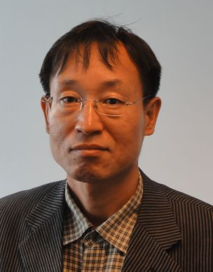 |  | Seung-In YI, Examiner, Plant Variety Division, Korea Seed and Variety Service (KSVS), Anyang-ro 184, Kyunggi-do, Anyang City , Kyunggi-do430-016  (tel.: +82 31 467 0112 fax: +82 31 467 0160 e-mail: seedin@korea.kr)
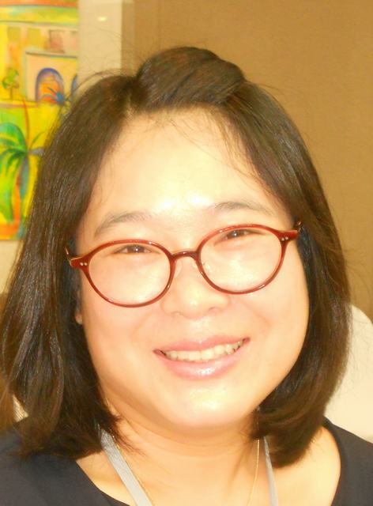 |  | Oksun KIM (Ms.), Plant Variety Protection Division, Korea Seed & Variety Service (KSVS) / MIFAFF, 328, Jungang-ro, Manan-gu, Anyang, 430-016 Gyeonggi-do  (tel.: +82 31 467 0191 fax: +82 31 467 0160 e-mail: oksunkim@korea.kr)
RÉPUBLIQUE DE MOLDOVA / REPUBLIC OF MOLDOVA / REPUBLIK MOLDAU /
REPÚBLICA DE MOLDOVA
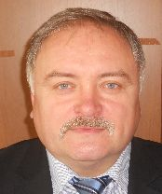 |  | Mihail MACHIDON, President, State Commission for Crops Variety Testing and Registration (SCCVTR), Bd. Stefan cel Mare, 162, C.P. 1873, MD-2004 Chisinau  (tel.: +373 22 220300 fax: +373 2 211537 e-mail: mihail.machidon@yahoo.com)
RÉPUBLIQUE TCHÈQUE / CZECH REPUBLIC / TSCHECHISCHE REPUBLIK /
REPÚBLICA CHECA
Daniel JUREÇKA, Director, Plant Production Section, Central Institute for Supervising and Testing in Agriculture (ÚKZÚZ), Hroznová 2, 656 06 Brno
(tel.: +420 543 548 210 fax: +420 543 217 649 e-mail: daniel.jurecka@ukzuz.cz)
ROUMANIE / ROMANIA / RUMÄNIEN / RUMANIA
Mihaela-Rodica CIORA (Mrs.), DUS Expert, State Institute for Variety Testing and Registration (ISTIS), 61, Marasti, Sector 1, P.O. Box 32-35, 011464 Bucarest
(tel.:+40 213 184380 fax: +40 213 184408 e-mail: mihaela_ciora@istis.ro)
ROYAUME-UNI / UNITED KINGDOM / VEREINIGTES KÖNIGREICH / REINO UNIDO
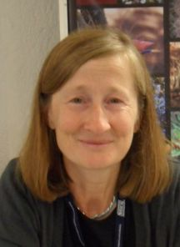 |  | Elizabeth M.R. SCOTT (Miss), Head of Crop Characterisation, National Institute of Agricultural Botany (NIAB), Huntingdon Road, Cambridge CB3 0LE  (tel.: +44 1223 342399 fax: +44 1223 277602 e-mail: elizabeth.scott@niab.com)
SLOVAQUIE / SLOVAKIA / SLOWAKEI / ESLOVAQUIA
Bronislava BÁTOROVÁ (Mrs.), National Coordinator, Senior Officer, Department of Variety Testing, Central Controlling and Testing Institute in Agriculture (ÚKSÚP), Akademická 4, SK-949 01 Nitra
(tel.: +421 37 655 1080 fax: +421 37 652 3086 e-mail: bronislava.batorova@uksup.sk)
SUISSE / SWITZERLAND / SCHWEIZ / SUIZA
Eva TSCHARLAND (Frau), Juristin, Direktionsbereich Landwirtschaftliche Produktionsmittel, Bundesamt für Landwirtschaft, Mattenhofstrasse 5, CH-3003 Bern
(tel.: +41 31 322 2594 fax: +41 31 323 2634 e-mail: eva.tscharland@blw.admin.ch)
Manuela BRAND (Frau), Leiterin, Büro für Sortenschutz, Fachbereich Zertifizierung, Pflanzen- und Sortenschutz, Bundesamt für Landwirtschaft, Mattenhofstrasse 5, CH-3003 Bern
(tel.: +41 31 322 2524 fax: +41 31 322 2634 e-mail: manuela.brand@blw.admin.ch)
UNION EUROPÉENNE / EUROPEAN UNION / EUROPÄISCHE UNION / UNIÓN EUROPEA
Päivi MANNERKORPI (Mrs.), Chef de section - Unité E2, Direction Générale Santé et Protection des Consommateurs, Commission européene (DG SANCO), rue Belliard 232, 04/075, 1040 Bruxelles
(tel.:+32 2 299 3724 fax: +32 2 296 0951 e-mail: paivi.mannerkorpi@ec.europa.eu)

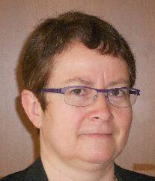 |  | Isabelle CLEMENT-NISSOU (Mrs.), Policy Officer – Unité E2, Direction Générale Santé et Protection des Consommateurs, Commission européene (DG SANCO), rue Belliard 232, 04/025, 1040 Bruxelles  (tel.:+32 229 87834 fax: +32 2 2960951 e-mail: isabelle.clement-nissou@ec.europa.eu)
Martin EKVAD, President, Community Plant Variety Office (CPVO), 3, boulevard Maréchal Foch, CS 10121, 49101 Angers Cedex 02, France
(tel.: +33 2 4125 6415 fax: +33 2 4125 6410 e-mail: ekvad@cpvo.europa.eu)
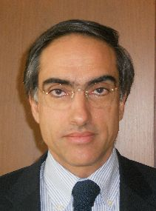 |  | Carlos GODINHO, Vice-President, Community Plant Variety Office (CPVO), 3, boulevard Maréchal Foch, CS 10121, 49101 Angers Cedex 02, France  (tel.: +33 2 4125 6413 fax: +33 2 4125 6410 e-mail: godinho@cpvo.europa.eu)
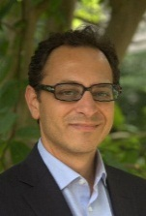 |  | Francesco MATTINA, Head of Legal Unit, Community Plant Variety Office (CPVO), 3 Boulevard Maréchal Foch, 49101 Angers  (tel.: +33 241256421 fax: +33241256410 e-mail: mattina@cpvo.europa.eu)
Muriel LIGHTBOURNE (Mme), Legal Affairs, Community Plant Variety Office (CPVO), 3, Bd. Maréchal Foch, Angers Cedex, France
(tel.: +33 2 41 256414 fax: +33 2 41 256410 e-mail: lightbourne@cpvo.europa.eu)
VIET NAM / VIET NAM / VIETNAM / VIET NAM
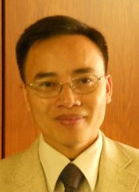 |  | Nguyen Quoc MANH, Deputy Chief of PVP Office, Plant Variety Protection Office of Viet Nam, No 2 Ngoc Ha Street, Ba Dinh Dist, (84) 48 Hanoi  (tel.: +84 4 38435182 fax: +84 4 37344967 e-mail: quocmanh.pvp.vn@gmail.com)
II. OBSERVATEURS / OBSERVERS / BEOBACHTER / OBSERVADORES
CAMBODGE / CAMBODIA / KAMBODSCHA / CAMBOYA
Chantravuth PHE, Deputy Director, Department Industrial Property, Ministry of Industry, Mines Energy, #45, Preah Norodom, Boulevard Hhan Doun Penh, Khan Daun Penh, Phnom Penh
(tel.: +855 23 211141 fax: 855 23 428 263 e-mail: phechantravuth@yahoo.com)
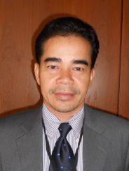 | Sao CHESDA, Deputy Director, Department of Horticulture and Subsidiary Crops, Ministry of Agriculture, Forestry and Fisheries (MAFF), #200 Sang Kat Tonle Basak, Khan Chamkarmorn, Preah Norodom Blvd, Phnom Penh  (tel.: +855 16 953194 fax: +855 23 212 266 e-mail: saochesda@yahoo.com)
IRAN (RÉPUBLIQUE ISLAMIQUE D') / IRAN (ISLAMIC REPUBLIC OF) / IRAN (ISLAMISCHE REPUBLIK) / IRÁN (REPÚBLICA ISLÁMICA DEL)
Nabiollah AZAMI SARDOUEI, First Secretary, Permanent Mission, 28, chemin du Petit-Saconnex, 1209 Geneva
(e-mail: mission.iran@ties.itu.int)
GHANA / GHANA / GHANA / GHANA
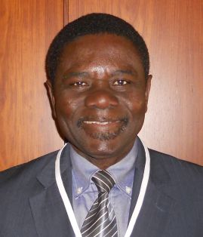 | Hans ADU DAPAAH, Director, CSIR-Crops Research Institute, P.O. Box 3785, Kumasi, Ghana  (tel.: +233 03220 60396 fax: +233 03220 60396 e-mail: hadapaah@cropsresearch.org)
Grace Ama ISSAHAQUE (Mrs.), Principal State Attorney, Registrar-General’s Department, Ministry of Justice, P.O. Box 118, Accra
(tel.: +233 21 666 469 fax: +233 21 666 081 e-mail: graceissahaque@hotmail.com)
RÉPUBLIQUE DÉMOCRATIQUE POPULAIRE LAO / LAO PEOPLE'S DEMOCRATIC REPUBLIC / DEMOKRATISCHE VOLKSREPUBLIK LAOS / REPÚBLICA DEMOCRÁTICA POPULAR LAO
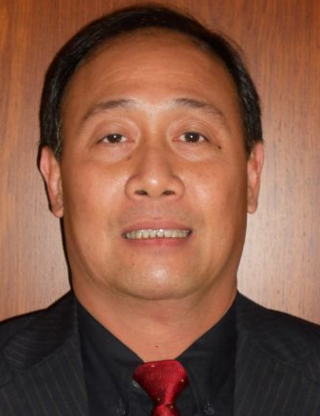 | Makha CHANTALA, Deputy Director General, Intellectual Property Division, National Authority for Science and Technology (NAST), Department of Intellectual Property, Standardization and Metrology (DISM), Makaidiao, P.O. Box 2279, Vientiane  (tel.: +856 21 248784 fax: +856 21 2134772 e-mail: c_makha@yahoo.com)
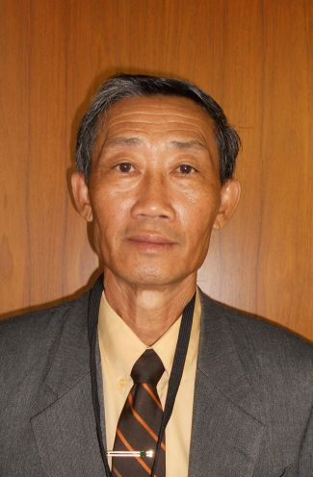 | Kham SANATEM, Deputy Director-General, Department of Agriculture, Ministry of Agriculture and Forestry, Lane Xang Avenue, Patuxay Square, P.O. Box 811  Vientiane  (tel.: + 856 21 412350 fax: + 856 20 5513011 e-mail: sanatemkham@yahoo.com)
THAÏLANDE / THAILAND / THAILAND / TAILANDIA
Chutima RATANASATIEN (Mrs.), Senior Specialist on Plant Variety Protection, Plant Variety Protection Office, Department of Agriculture, Ministry of Agriculture and Cooperatives, Ministry of Agriculture and Cooperatives, Phochakorn Building, 50 Phaholyothin Road, Ladyao, Chatuchak, 10900 Bangkok
(tel.: +66 2 940 7214 fax: +66 2 940 7214 e-mail: chutima_ratanasatien@yahoo.com)
III. ORGANISATIONS / ORGANIZATIONS / ORGANISATIONEN / ORGANIZACIONES
ORGANISATION MONDIALE DU COMMERCE (OMC) / WORLD TRADE ORGANIZATION (WTO) / WELTHANDELSORGANISATION (WTO) / ORGANIZACIÓN MUNDIAL DEL COMERCIO (OMC)
Sandeepan NEELAMBERA (Ms.), Research Associate, Intellectual Property Division, Centre William Rappard, 154, rue de Lausanne, 1211 Genève 21, Suisse
(tel.: +41 22 739 5114 fax: +41 22 739 5790 e-mail: sandeepan.neelambera@wto.org)
ASSOCIATION FOR PLANT BREEDING FOR THE BENEFIT OF SOCIETY (APBREBES)
Sangeeta SHASHIKANT (Ms.), Board Member, Association for Plant Breeding for the Benefit of Society (APBREBES), c/o Berne Declaration, 36 rue de Lausanne, 1201 Geneva , Switzerland
(tel.: +41 22 9083550 fax: +41 44 9083551 e-mail: ssangeeta@myjaring.net)
François MEIENBERG, Board Member, Berne Declaration, P.O. Box 8026, Zürich , Suisse
(tel.: +41 44 277 7004 fax: +41 44 277 7001 e-mail: food@evb.ch)
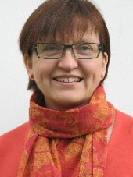 |  | Susanne GURA (Ms.), Coordinator, Association for Plant Breeding for the Benefit of Society (APBREBES), Burghofstr. 166, 53229 Bonn , Allemagne  (tel.: +49 228 9480670 e-mail: gura@dinse.net)
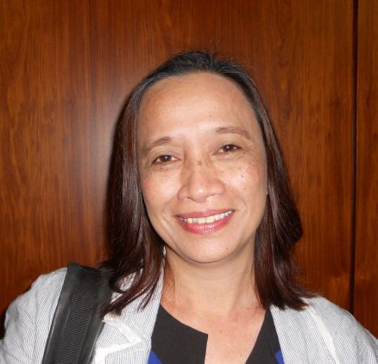 |  | Normita IGNACIO (Ms.), Executive Director, South East Asia Regional Initiatives of Community Empowerment (SEARICE), Gulod, Pulong Buhangin, Sta. Maria, 3019 Bulacan, Philippines  (tel.: +63 917 5124617 e-mail: nori_igancio@searice.org.ph)
 |  | Alexandra BHATTACHARYA (Ms.), Association for Plant Breeding for the Benefit of Society (APBREBES), 36, rue de Lausanne, 1201 Geneva, Switzerland
ORGANISATION RÉGIONALE AFRICAINE DE LA PROPRIÉTÉ INTELLECTUELLE (ARIPO) / AFRICAN REGIONAL INTELLECTUAL PROPERTY ORGANIZATION (ARIPO) / ORGANIZACIÓN REGIONAL AFRICANA DE LA PROPIEDAD INTELECTUAL (ARIPO)
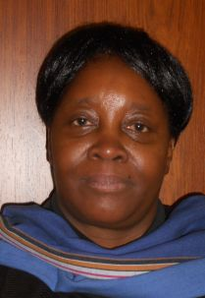 |  | Flora Kokwihyukya MPANJU (Mrs.), Senior Patent Examiner, Technical Department, P.O. Box 4228, Harare , Zimbabwe  (tel.: +263 4 794065/6 fax: +263 4 794072/3 e-mail: fmpanju@aripo.org)
COMMUNAUTÉ INTERNATIONALE DES OBTENTEURS DE PLANTES ORNEMENTALES ET
FRUITIÈRES À REPRODUCTION ASEXUÉE (CIOPORA) / INTERNATIONAL COMMUNITY
OF BREEDERS OF ASEXUALLY REPRODUCED ORNAMENTAL AND FRUIT PLANTS
(CIOPORA) / Internationale Gemeinschaft der Züchter vegetativ vermehrbarer Zier- und Obstpflanzen (CIOPORA) / Comunidad Internacional de Obtentores de Variedades Ornamentales y Frutales de Reproducción Asexuada (CIOPORA)
Edgar KRIEGER, Secretary General, CIOPORA - International Community of Breeders of Asexually Reproduced Ornamental and Fruit Plants (CIOPORA), Hamburg, Germany
(tel.: +49 40 555 63702 fax: +49 40 555 63703 e-mail: edgar.krieger@ciopora.org)
INTERNATIONAL SEED FEDERATION (ISF)
Marcel BRUINS, Secretary General, International Seed Federation (ISF), 7, chemin du Reposoir, 1260 Nyon, Switzerland
(tel.: +41 22 365 4420 fax: +41 22 365 4421 e-mail: isf@worldseed.org)
Bernard LE BUANEC, 24, Rue Treiz-an-Douric, 29100 Douarnenez, France
(e-mail: b.lebuanec@orange.fr)
Christoph HERRLINGER, Head Germplasm Legal and Intellectual Property, Syngenta International AG, Schwarzwaldallee 215, 4002 Basel , Suisse
(tel.: +41 61 3233216 e-mail: christoph.herrlinger@syngenta.com)
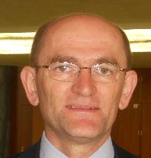 |  | Stevan MADJARAC, American Seed Trade Association (ASTA), 1701 Duke Street, Suite 275, Alexandria , VA22314, United States of America  (tel.: +1 636 7374395 e-mail: smadjarac@gmail.com)
ASIA AND PACIFIC SEED ASSOCIATION (APSA)
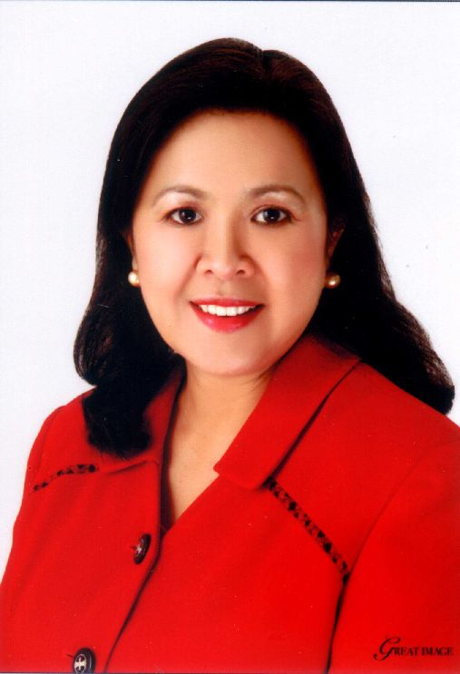 |  | Mary Ann SAYOC (Dr.), President, Asia and Pacific Seed Association, P.O. Box 33, Kasetsart Post Office, Bangkok 10903, Thaïlande  (tel.: +63 44 766 5192 fax: +63 44 766 1005 e-mail: maryann.sayoc@eastwestseed.com)
EUROPEAN SEED ASSOCIATION (ESA)
Szonja CSÖRGÖ (Mrs), Manager, Intellectual Property & Legal Affairs, European Seed Association (ESA), Bruxelles, Belgique
(tel.: +32 2 7432860 fax: +32 2 7432869 e-mail: szonjacsorgo@euroseeds.org)
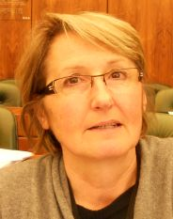 |  | Christiane DUCHENE (Mrs.), IP and Seed Regulation Manager, Limagrain, BP 1, 63720 Chappes, France  (tel.: +33 473 634083 e-mail: christiane.duchene@limagrain.com)
IV. BUREAU / OFFICER / VORSITZ / OFICINA
 |  | LV BO, Chair
 |  | Martin EKVAD, Vice-Chair
V. BUREAU DE L’OMPI / OFFICE OF WIPO / BÜRO DER WIPO / OFICINA DE LA OMPI
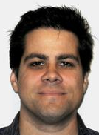 |  | Glenn MAC STRAVIC, Head, Brand Database Unit, Global Databases Service, Global Information Service
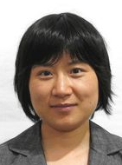 |  | Lili CHEN (Ms.), Software Developer, Brand Database Unit, Global Databases Service, Global Information Service
 |  | José APPAVE, Senior Service Data Administration Clerk, Brand Database Unit, Global Databases Service
VI. BUREAU DE L’UPOV / OFFICE OF UPOV / BÜRO DER UPOV / OFICINA DE LA UPOV
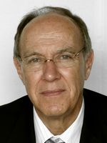 |  | Francis GURRY, Secretary-General
 |  | Peter BUTTON, Vice Secretary-General
 |  | Yolanda HUERTA (Mrs.), Legal Counsel
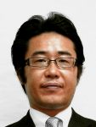 |  | Fuminori AIHARA, Counsellor
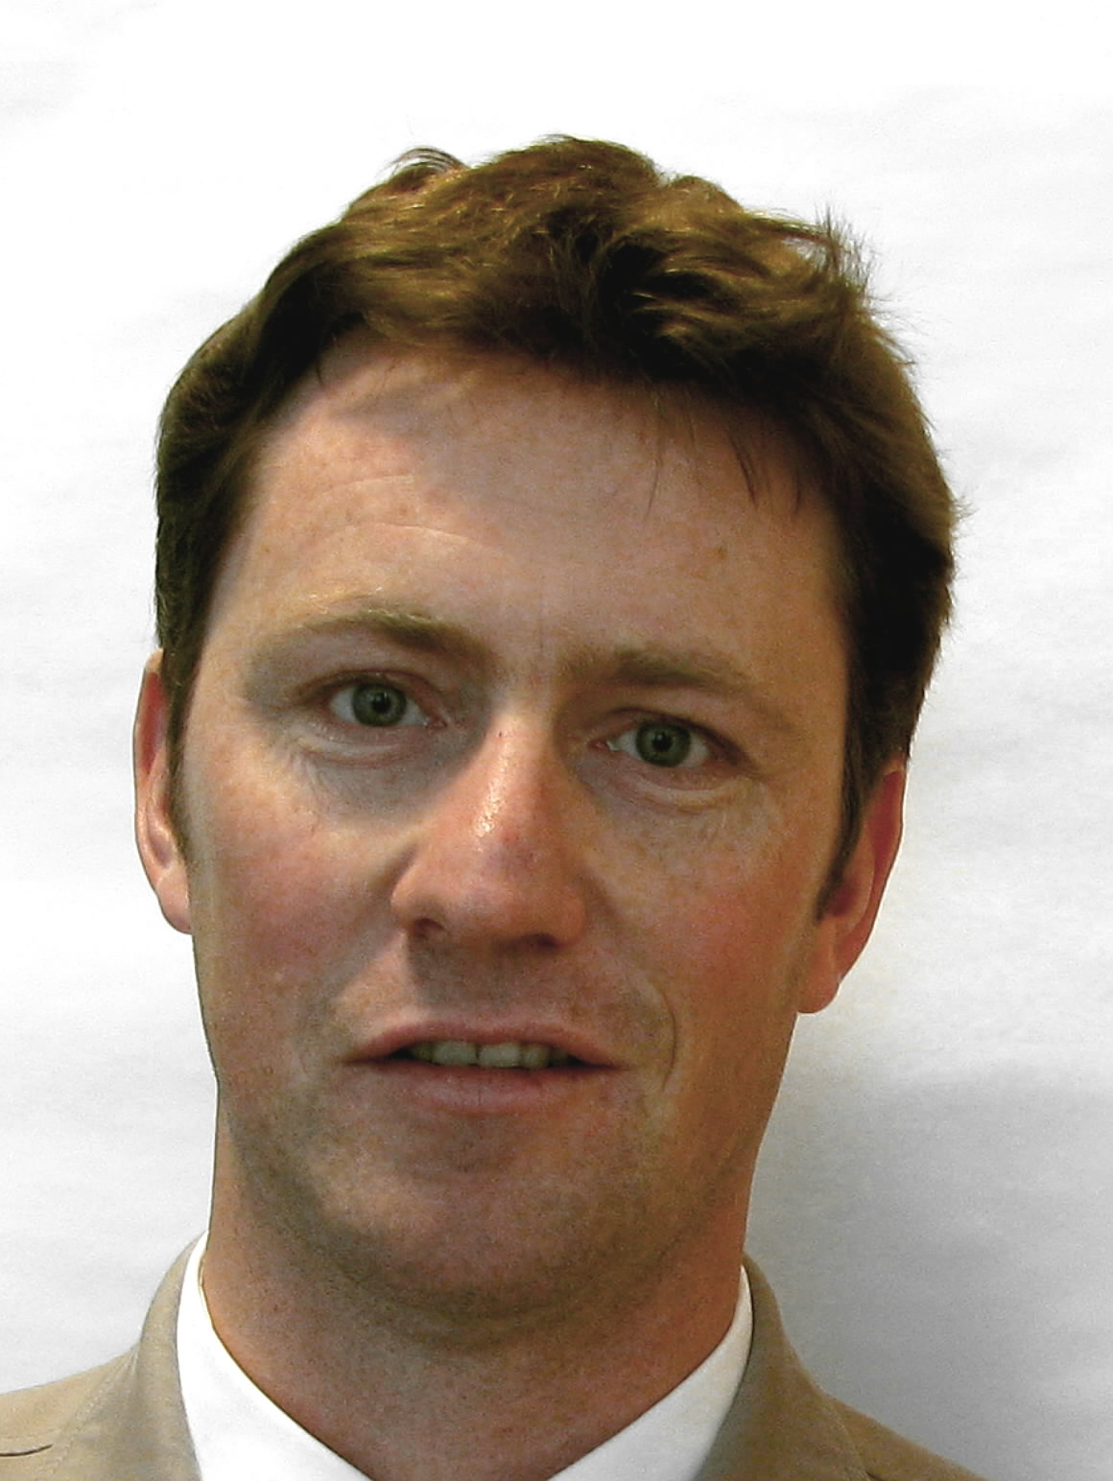 |  | Ben RIVOIRE, Technical/Regional Officer (Africa, Arab countries)
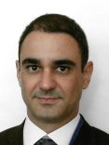 |  | Leontino TAVEIRA, Technical/Regional Officer (Latin America, Caribbean countries)

[Fin de l’annexe et du document /
End of Annex and of document /
Ende der Anlage und des Dokuments /
Fin del Anexo y del documento]

* An asterisk next to the paragraph number indicates that the text is reproduced from the Report on the Conclusions (document CAJ/68/10).

