 |  | E  C(Extr.)/30/7  ORIGINAL: English  DATE: March 22, 2013
INTERNATIONAL UNION FOR THE PROTECTION OF NEW VARIETIES OF PLANTS
Geneva
council
Thirtieth Extraordinary Session
Geneva, March 22, 2013
REPORT ON THE DECISIONS
adopted by the Council
Opening of the session

1 The Council of the International Union for the Protection of New Varieties of Plants (UPOV) held
its thirtieth extraordinary session in Geneva on March 22, 2013, chaired by Ms. Kitisri Sukhapinda (United States of America), President of the Council.

2 The list of participants is reproduced in Annex I to this report.

3 The session was opened by the President, who welcomed the participants.

4 The President informed the Council that Serbia had deposited its instrument of accession to the 1991 Act of the UPOV Convention on December 5, 2012, and had become the seventy-first member of UPOV on January 5, 2013.

5 The Council noted the intervention made by the Delegation of Serbia.

6 The Secretary-General reported that Mrs. Margaret Byskov and Mrs. Julia Borys would retire in 2013, after sixteen years and two years of service, respectively. He expressed his appreciation for their dedicated service and important contribution to the Office of the Union. The Secretary-General further reported that Mr. Benjamin Rivoire and Mr. Leontino Taveira had been appointed as Technical/Regional Officer (Africa, Arab countries) and Technical/Regional Officer (Latin America, Caribbean countries), respectively.

Adoption of the agenda

7 The Council adopted the revised draft agenda, as proposed in document C(Extr.)/30/1 Rev.

Examination of the conformity of the Plant Breeders’ Rights Bill for Zanzibar with the 1991 Act of the UPOV Convention

8 The Council considered documents C(Extr.)/30/4 Rev. and C(Extr.)/30/4 Add.

9 The Council noted the intervention made by the Association for Plant Breeding for the Benefit of Society (APBREBES).

10 The Council noted the intervention made by the Delegation of Kenya.

11 The Council decided to:

(a) note the analysis in documents C(Extr.)/30/4 Rev. and C(Extr.)/30/4 Add.;

(b) subject to the incorporation in the Plant Breeders’ Rights Bill for Zanzibar of the modifications recommended in paragraphs 26, 28, 30 and 35 of document C(Extr.)/30/4 Rev., and with no additional changes, take a positive decision on the conformity of the Plant Breeders’ Rights Bill for Zanzibar with the provisions of the 1991 Act of the International Convention for the Protection of New Varieties of Plants;

(c) note that the Draft Law of Plant Breeders’ Rights for Mainland Tanzania was adopted on November 5, 2012, and that the adoption of the Draft Law for Zanzibar is necessary for breeders’ rights to cover the whole territory of the United Republic of Tanzania;

(d) note that the Plant Breeders’ Rights Act for Mainland Tanzania, which was adopted on November 5, 2012, and published in the Gazette of the United Republic of Tanzania on March 1, 2013, had incorporated the changes presented in revision mode in the recommendations of the Council in its decision of November 1, 2012 (see document C/46/18 “Report on the decisions”, paragraph 15);

(e) agree that the additional changes in the Plant Breeders’ Rights Act for Mainland Tanzania, as presented in the Annex to document C(Extr.)/30/4 Add., did not affect the substantive provisions of the 1991 Act of the UPOV Convention, and confirm the decision on conformity of November 1, 2012;

(f) inform the Government of the United Republic of Tanzania that, subject to the modifications recommended by the Council, at its thirtieth extraordinary session, held in Geneva on March 22, 2013 (see paragraph (b) above), being incorporated in the Plant Breeders’ Rights Bill for Zanzibar and the adoption of the Bill with no additional changes,

the instrument of accession of the United Republic of Tanzania may be deposited; and

(g) authorize the Secretary-General to inform the Government of the United Republic of Tanzania of that decision.

12 The Delegation of the United Republic of Tanzania thanked the Council for the positive decision on the conformity of the Plant Breeders’ Rights Bill for Zanzibar with the provisions of the 1991 Act of the UPOV Convention. The Delegation looked forward to the United Republic of Tanzania becoming a member of the Union in the near future.

Report by the President on the work of the eighty-fifth session of the Consultative Committee; adoption of recommendations, if any, prepared by that Committee

13 The Council noted the work of the Consultative Committee, at its eighty-fifth session, as set out in document C(Extr.)/30/5.

Adoption of documents

14 The Council considered document C(Extr.)/30/2.

UPOV/INF/4/3: Financial Regulations and Rules of UPOV (Revision) (document C(Extr.)/30/2, Annex)

15 The Council adopted the revision of document UPOV/INF/4 “Financial Regulations and Rules of UPOV” (document UPOV/INF/4/3), on the basis of the amendments to document UPOV/INF/4/2, as presented in the Annex to document C(Extr.)/30/2.

UPOV/INF/15/2: Guidance for Members of UPOV on Ongoing Obligations and Related Notifications and on the Provision of Information to Facilitate Cooperation (Revision) (document UPOV/INF/15/2 Draft 2)

16 The Council adopted the revision of document UPOV/INF/15/2 “Guidance for Members of UPOV on Ongoing Obligations and Related Notifications and on the Provision of Information to Facilitate Cooperation”, on the basis of document UPOV/INF/15/2 Draft 2.

UPOV/INF-EXN/4: List of INF-EXN Documents and Latest Issue Dates (Revision) (document UPOV/INF-EXN/4 Draft 1)

17 The Council adopted the revision of document UPOV/INF-EXN “List of INF-EXN Documents and Latest Issue Dates” (document UPOV/INF-EXN/4) on the basis of document UPOV/INF-EXN/4 Draft 1.

Calendar of meetings

18 The Council considered document C(Extr.)/30/3.

19 The Council approved the organization of a seminar on essentially derived varieties (EDVs) on October 22, 2013. The seminar would consider the following:

(a) technical and legal views on “predominantly derived”, “essential characteristics” and “differences which result from the act of derivation” (see Article 14(5)(b) of the 1991 Act of the UPOV Convention), the relationship between Article 14(5)(b)(i) and (iii) of the 1991 Act of the UPOV Convention and the possible impact on breeding and agriculture;

(b) existing experience in relation to EDVs; and

(c) the possible role of future UPOV guidance on EDVs in cases before the courts.

20 With regard to the possible impact on breeding and agriculture, the Council agreed that the seminar should include the perspective of farmer-breeders. It further agreed that the program for the seminar and the speakers should be agreed between the Office of the Union and the Chair and Vice-Chair of the CAJ, and the President of the Council. The Council agreed that the seminar should be open to the public, subject to reservation of sufficient space for members and observers, with the presentations and discussions at the seminar being made available on the UPOV website after a suitable broadcast delay.

21 The Council approved the corresponding revision of document C/46/8 Rev. “Revised Calendar of Meetings in 2013”.

Press release

22 The Council considered document C(Extr.)/30/6.

23 The Council approved the draft press release contained in the Annex to document C(Extr.)/30/6. The press release approved by the Council is reproduced in Annex II to this report.

24 This report was adopted by the Council at the close of its extraordinary session on March 22, 2013.

[Annexes follow]

C(EXTR.)/30/7

ANNEXE I / ANNEX I / ANLAGE I / ANEXO I

LISTE DES PARTICIPANTS / LIST OF PARTICIPANTS /
TEILNEHMERLISTE / LISTA DE PARTICIPANTES

(dans l’ordre alphabétique des noms français des membres/
in the alphabetical order of the names in French of the members/
in alphabetischer Reihenfolge der französischen Namen der Mitglieder/
por orden alfabético de los nombres en francés de los miembros)
i. MEMBRES / MEMBERS / VERBANDSMITGLIEDER / MIEMBROS
AFRIQUE DU SUD / SOUTH AFRICA / SÜDAFRIKA / SUDÁFRICA
 |  |  | Noluthando NETNOU-NKOANA (Mrs.), Registrar: Plant Breeders' Rights Act, Directorate: Genetic Resources, Department of Agriculture, Forestry and Fisheries, 257 Harvest House, 30 Hamilton Street, Private Bag X973, 0001 Pretoria  (tel.: +27 12 319 6183 fax: +27 12 319 6385 e-mail: noluthandon@daff.gov.za)
ALLEMAGNE / GERMANY / DEUTSCHLAND / ALEMANIA
 |  |  | Udo VON KRÖCHER, Präsident, Bundessortenamt, Osterfelddamm 80, 30627 Hannover  (tel.: +49 511 9566 5603 fax: +49 511 9566 5904 e-mail: udo.vonkroecher@bundessortenamt.de)
 |  |  | Michael KÖLLER, Referent, Ministerium für Ernährung, Landwirtschaft und Verbraucherschutz, Wilhelmstrasse 54, 10117 Berlin  (tel.: +49 30 18529 4044 e-mail: Michael.Koeller@bmelv.bund.de)
ARGENTINE / ARGENTINA / ARGENTINIEN / ARGENTINA
 |  |  |  | Carmen Amelia M. GIANNI (Sra.), Coordinadora de Propiedad Intelectual / Recursos Fitogenéticos, Instituto Nacional de Semillas (INASE), Venezuela 162, 1063 Buenos Aires (tel.: +54 11 32205414 e-mail: cgianni@inase.gov.ar)
 |  |  |  | Raimundo LAVIGNOLLE, A/C Dirección de Registro de Variedades, Instituto Nacional de Semillas (INASE), Venezuela 162, Ciudad Autónoma de Buenos Aires C1095AAD  (tel.: + 54 11 3220 5424 e-mail: rlavignolle@inase.gov.ar)
AUSTRALIE / AUSTRALIA / AUSTRALIEN / AUSTRALIA
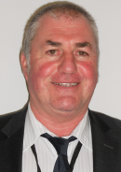 |  |  | Nik HULSE, Senior Examiner of PBR, Plant Breeder's Rights Office, IP Australia, 47 Bowes Street, Phillip ACT 2606  (tel.:+61 2 6283 7982 fax: +61 2 6283 7999 e-mail: nik.hulse@ipaustralia.gov.au)
BOLIVIE (ÉTAT PLURINATIONAL DE) / BOLIVIA (PLURINATIONAL STATE OF) /
BOLIVIEN (PLURINATIONALER STAAT) / BOLIVIA (ESTADO PLURINACIONAL DE)
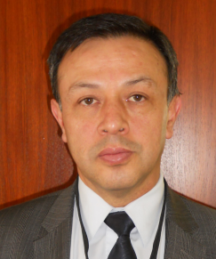 |  |  | Luis Fernando ROSALES LOZADA, Primer Secretario, Misión Permanente, 139, rue de Lausanne, 1202 Ginebra  (tel.: +41 22 908 0717 fax: +41 22 908 0722  e-mail: fernando.rosales@ mission-bolivia.ch)
 |  |  | Laurent GABERELL, Asistente Técnico Administrativo, Misión Permanente, 139, rue de Lausanne, 1202 Ginebra  (tel.: +41 22 908 0717 fax: +41 22 908 0722 e-mail: laurent.gaberell@mission-bolivia.ch)
BRÉSIL / BRAZIL / BRASILIEN / BRASIL
 |  |  | Fabrício SANTANA SANTOS, Coordinator, National Plant Variety Protection Office (SNPC), Ministry of Agriculture, Livestock and Food Supply, Esplanada dos Ministerios, Bloco 'D', Anexo A, Sala 250, CEP 70043-900 Brasilia , D.F.  (tel.:+55 61 3218 2549 fax: +55 61 3224 2842 e-mail: fabricio.santos@agricultura.gov.br)
 |  |  | Vera Lúcia DOS SANTOS MACHADO (Mrs.), Federal Agricultural Inspector, National Plant Variety Protection Office (SNPC), Ministry of Agriculture, Livestock and Food Supply, Esplanada dos Ministerios, Bloco D, Anexo A, sala 249, 70043-900 Brasilia, D.F.  (tel.: +55 61 3218 2549 fax: +55 61 3224 2842 e-mail: vera.machado@agricultura.gov.br)
CANADA / CANADA / KANADA / CANADÁ
 |  |  | Anthony PARKER, Commissioner, Canadian Food Inspection Agency (CFIA), 59, Camelot Drive, Ottawa, Ontario K1A 0Y9  (tel.: +1 613 7737188 fax: +1 613 7737261 e-mail: anthony.parker@inspection.gc.ca)
 |  |  | Sandy MARSHALL (Ms.), Senior Policy Specialist, Plant Breeders' Rights Office, Canadian Food Inspection Agency (CFIA), 59 Camelot Drive, Ottawa Ontario K1A 0Y9  (tel.: +1 613 773 7134 fax: +1 613 773 7261 e-mail: sandy.marshall@inspection.gc.ca)
CHILI / CHILE / CHILE / CHILE
 |  | Manuel TORO UGALDE, Jefe Subdepartamento, Registro de Variedades Protegidas, División Semillas, Servicio Agrícola y Ganadero (SAG), Avda Bulnes 140, piso 2, 1167-21 Santiago de Chile  (tel.: +56 2 23451833 ext 3063 fax: +56 2 6972179 e-mail: manuel.toro@sag.gob.cl)
Andres GUCCIANA, Consejero, Misión Permanente de Chile ante la Organización Mundial del Comercio, Case postale 332, CH-1211 Genève 19, Suisse
(e-mail: misionomc@minrel.gov.cl)
CHINE / CHINA / CHINA / CHINA
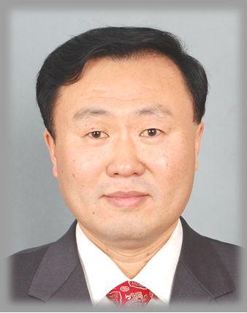 |  |  | LV Bo, Director, Division of Variety Management, Bureau of Seed Management, Ministry of Agriculture, No. 11 Nongzhanguannanli, Beijing  (tel.: +86 10 59193150 fax: +86 10 59193142 e-mail: lvbo@agri.gov.cn)
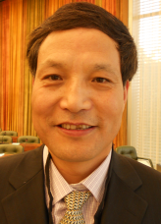 |  |  | QI Wang, Director, Division of Protection of New Varieties of Plants, State Forestry Administration, No. 18, Hepingli East Street, Beijing 100714  (tel.:+86 10 84239104 fax: +86 10 84238883 e-mail: wangqihq@sina.com)
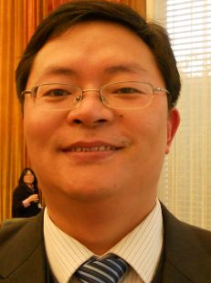 |  |  | Hong CHEN, Examiner, Development Center for Science and Technology, Ministry of Agriculture, Building 18, Maizidian Street, Chaoyang District, 100125 Beijing  (tel.: +86 10 59199397 fax: +86 10 59199396 e-mail: chenhong@agri.gov.cn)
 |  |  | SUN Jinsong, Project Administrator, International Cooperation Department, State Intellectual Property Office (SIPO), 6, Xitucheng Road, Haidian District, Beijing  (tel.: +86 10 62086504 fax: +86 10 62019615 e-mail: sunjinsong@sipo.gov.cn)
COLOMBIE / COLOMBIA / KOLUMBIEN / COLOMBIA
Juan Camilo SARETZKI-FORERO, Primer Secretario, Misión Permanente de Colombia, Chemin Champ d’Anier 17-19, 1209 Ginebra
(tel.: 41 22 789 4718 fax: 41 22 791 0787 e-mail: juan.saretzki@cancilleria.gov.co)
DANEMARK / DENMARK / DÄNEMARK / DINAMARCA
 |  |  | Gerhard DENEKEN, Head, Department of Variety Testing, The Danish AgriFish Agency (NaturErhvervestyrelsen), Ministry of Food, Agriculture and Fisheries, Teglvaerksvej 10, Tystofte, DK-4230 Skaelskoer  (tel.: +45 5816 0601 fax: +45 58 160606 e-mail: gde@naturerhverv.dk)
ESPAGNE / SPAIN / SPANIEN / ESPAÑA
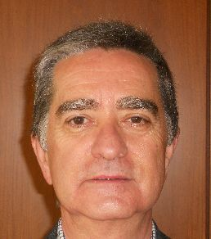 |  |  | Luis SALAICES, Jefe del Área del Registro de Variedades, Subdirección general de Medios de Producción Agrícolas y Oficina Española de Variedades Vegetales (MPA y OEVV), Ministerio de Agricultura, Alimentación y Medio Ambiente (MAGRAMA), C/ Almagro No. 33, planta 7a, E-28010 Madrid  (tel.: +34 91 347 6712 fax: +34 91 347 6703 e-mail: luis.salaices@magrama.es)
ESTONIE / ESTONIA / ESTLAND / ESTONIA
 |  |  | Laima PUUR (Ms.), Head, Variety Department, Estonian Agricultural Board, Vabaduse sq. 4, EE-71020 Viljandi  (tel.:+372 4351240 fax: +372 4351241 e-mail: laima.puur@pma.agri.ee)
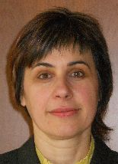 |  |  | Renata TSATURJAN (Ms.), Chief Specialist, Plant Production Bureau, Ministry of Agriculture, 39/41 Lai Street, EE-15056 Tallinn  (tel.: +372 625 6507 fax: +372 625 6200 e-mail: renata.tsaturjan@agri.ee)
ÉTATS-UNIS D'AMÉRIQUE / UNITED STATES OF AMERICA /
VEREINIGTE STAATEN VON AMERIKA / ESTADOS UNIDOS DE AMÉRICA
 |  |  | Kitisri SUKHAPINDA (Ms.), Patent Attorney, Office of Policy and External Affairs, United States Patent and Trademark Office (USPTO), Madison Building, West Wing, 600 Dulany Street, MDW 10A30, Alexandria VA 22313  (tel.: +1 571 272 9300 fax: + 1 571 273 0085 e-mail: kitisri.sukhapinda@uspto.gov)
 |  |  | Paul M. ZANKOWSKI, Commissioner, Plant Variety Protection Office, USDA, AMS, S&T, Plant Variety Protection Office, USDA, AMS, S&T, Plant Variety Protection Office, 1400 Independence Ave., S.W., Room 4512 - South Building, Mail Stop 0273, Washington D.C. 20250  (tel.: +1 202 720-1128 fax: +1 202 260-8976 e-mail: paul.zankowski@ams.usda.gov)
 |  |  | Karin L. FERRITER (Ms.), Intellectual Property Attaché, United States Mission to the WTO, 11, route de Pregny, 1292 Chambesy  (tel.: +41 22 749 5281 e-mail: karin_ferriter@ustr.eop.gov)
FINLANDE / FINLAND / FINNLAND / FINLANDIA
 |  |  | Sami MARKKANEN, Senior Officer, Control Department, Seed Certification Unit, Finnish Food Safety Authority Evira, P.O. Box 111, FIN-32201 Loimaa  (tel.:+358 7829 4543 fax: +358 77 25317 e-mail: sami.markkanen@evira.fi)
FRANCE / FRANCE / FRANKREICH / FRANCIA
 |  |  | Robert TESSIER, Sous-Directeur de la Qualité et de la protection des végétaux, Ministère de l’agriculture, de l’alimentation, de la pêche, de la ruralité et de l’aménagement du territoire, 251, rue de Vaugirard, F-75732 Paris Cédex 15  (tel.: +33 1 49555030 fax: +33 1 49554959 e-mail: robert.tessier@agriculture.gouv.fr)
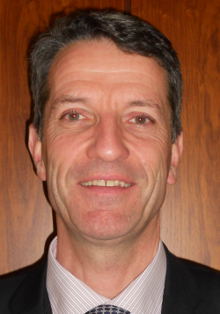 |  |  | Arnaud DELTOUR, CEO, Groupe d'étude et de contrôle des variétés et des semences (GEVES), 25 rue Georges Morel, CS 90024, F-49071 Beaucouze  (tel.: +33 241 22 86 40 e-mail: arnaud.deltour@geves.fr)
 |  |  | Joël GUIARD, Expert études des variétés, Relations internationales OCVV UPOV, Groupe d'étude et de contrôle des variétés et des semences (GEVES), Rue Georges Morel, BP 90024, F-49071 Beaucouzé Cedex  (tel.:+33 241 228637 fax: +33 241 228601 e-mail: joel.guiard@geves.fr)
FINLANDE / FINLAND / FINNLAND / FINLANDIA
Sami MARKKANEN, Senior Officer, Control Department, Seed Certification Unit, Finnish Food Safety Authority Evira, P.O. Box 111, FIN-32201 Loimaa
(tel.:+358 7829 4543 fax: +358 77 25317 e-mail: sami.markkanen@evira.fi)
HONGRIE / HUNGARY / UNGARN / HUNGRÍA
 |  | Ágnes Gyözöné SZENCI (Mrs.), Senior Chief Advisor, Agricultural Department, Ministry of Agriculture and Rural Development, Kossuth Tér. 11, H-1055 Budapest, Pf. 1  (tel.: +36 1 7953826 fax: +36 1 7950498 e-mail: gyozone.szenci@vm.gov.hu)
 |  | Katalin MIKLÓ(Ms.), Head, Agriculture and Plant Variety Protection Section, Hungarian Intellectual Property Office, Garibaldi U. 2., H-1054 Budapest  (tel.: 36 1 474 5898 fax: 36 1 474 5850 e-mail: katalin.miklo@hipo.gov.hu)
IRLANDE / IRELAND / IRLAND / IRLANDA
 |  |  | Donal COLEMAN, Controller of Plant Breeders' Rights, Department of Agriculture, National Crops Centre, Backweston Farm, Leixlip , Co. Kildare  (tel.: +353 1 630 2902 fax: +353 1 628 0634 e-mail: donal.coleman@agriculture.gov.ie)
 |  |  | Antonio ATAZ, Adviser to the Presidency of the European Union, Council of the European Union, Brussels  (tel.: +32 2 281 4964 fax: +32 2 281 6198 e-mail: antonio.ataz@consilium.europa.eu)
JAPON / JAPAN / JAPAN / JAPÓN
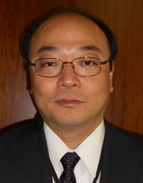 |  |  |  | Junya ENDO, Director, New Business and Intellectual Property Division, Food Industry Affairs Bureau, Ministry of Agriculture, Forestry and Fisheries of Japan (MAFF), 1-2-1 Kasumigaseki, Chiyoda-ku, 100-8950 Tokyo  (tel.: +81 3 6738 6444 fax: +81 3 3502 5301 e-mail: jyunya_endo@nm.maff.go.jp)
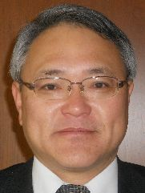 |  |  | Mitsutaro FUJISADA, Senior Policy Advisor: Intellectual Property, New Business and Intellectual Property Division, Food Industry Affairs Bureau, Ministry of Agriculture, Forestry and Fisheries (MAFF), 1-2-1, Kasumigaseki, Chiyoda-ku, 100-8950 Tokyo  (tel.:+81 3 6738 6445 fax: +81 3 3502 5301 e-mail: mitutarou_fujisada@nm.maff.go.jp)
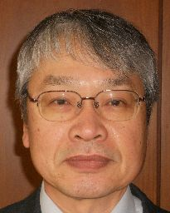 |  |  |  | Kenji NUMAGUCHI, Examiner, Plant Variety Protection Office, New Business and Intellectual Property Division, Seeds and Seedlings Division Agricultural Production Bureau, Ministry of Agriculture, Forestry and Fisheries, 1-2-1 Kasumigaseki, Chiyoda-ku, 100-8950 Tokyo  (tel.: +81 3 6738 6449 fax: +81 3 3502 6572 e-mail: kenji_numaguchi@nm.maff.go.jp)
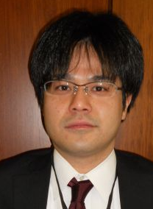 |  |  |  | Yoshinori YAMAUCHI, New Business and Intellectual Property Division, Ministry of Agriculture, Forestry and Fisheries (MAFF), 1-2-1 Kasumigaseki, Chiyoda-ku, 100-8950 Tokyo  (tel.: +81 3 6738 6444 fax: +81 3 3502 5301 e-mail: yoshinori_yamauchi@nm.maff.go.jp)
kenya / kenya / kenia / kenya
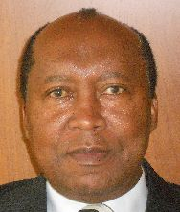 |  |  |  | James M. ONSANDO, Managing Director, Kenya Plant Health Inspectorate Service (KEPHIS), P.O. Box 49592, 00100 Nairobi  (tel.: +254 20 3536171/2 fax: +254 20 3536175 e-mail: director@kephis.org)
LITUANIE / LITHUANIA / LITAUEN / LITUANIA
 |  |  | Arvydas BASIULIS, Deputy Director, State Plant Service under the Ministry of Agriculture of the Republic of Lithuania, Ozo 4A, LT-08200 Vilnius  (tel.: +370 5 237 5611 fax: +370 5 273 0233 e-mail: arvydas.basiulis@vatzum.lt)
 |  |  | Sigita JUCIUVIENE (Mrs.), Head, Division of Plant Variety, Registration and Legal Protection, State Plant Service under the Ministry of Agriculture of the Republic of Lithuania, Ozo St. 4a, LT-08200 Vilnius  (tel.: +370 5 234 3647 fax: +370 5 237 0233 e-mail: sigita.juciuviene@vatzum.lt)
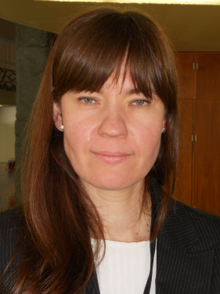 |  |  | Jovita KULIKAUSKAITÉ (Ms.), Attaché for Phytosanitary, Permanent Representation of Lithuania to the European Union, 41-43, rue Beilliard, LT-1040 Bruxelles  (tel.: +32 2 7759080 fax: +32 2 7714597 e-mail: jovita.kulikauskaite@eu.mfa.lt)
MEXIQUE / MEXICO / MEXIKO / MÉXICO
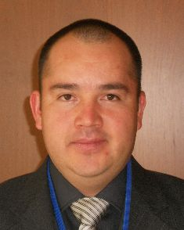 |  |  | Eduardo PADILLA VACA, Subdirector, Registro y Control de Variedades Vegetales, Servicio Nacional de Inspección y Certificación de Semillas (SNICS), Av. Presidente Juárez 13, Col. El Cortijo, 54000 Tlalnepantla , Estado de México  (tel.: +52 55 3622 0667 fax: +52 55 3622 0670 e-mail: eduardo.padilla@snics.gob.mx)
NORVÈGE / NORWAY / NORWEGEN / NORUEGA
 |  |  | Tor Erik JØRGENSEN, Head of Section, Norwegian Food Safety Authority, Felles postmottak, P.O. Box 383, N-2381 Brumunddal  (tel.: +47 6494 4393 fax: +47 6494 4411 e-mail: tor.erik.jorgensen@mattilsynet.no)
 |  |  | Bell Batta TORHEIM (Mrs.), Programme Coordinator, The Development Fund, Grensen 9b, Miljohuset, N-0159 Oslo  (tel.: +47 23 109600 fax: +47 23 109601 e-mail: bell@utviklingsfondet.no)
NOUVELLE-ZÉLANDE / NEW ZEALAND / NEUSEELAND / NUEVA ZELANDIA
 |  |  | Christopher J. BARNABY, Assistant Commissioner / Principal Examiner, Plant Variety Rights Office, Intellectual Property Office of New Zealand, Private Bag 4714, Christchurch 8140  (tel.: +64 3 9626206 fax: +64 3 9626202 e-mail: Chris.Barnaby@pvr.govt.nz)
PARAGUAY / PARAGUAY / PARAGUAY
 | Dólia Melania GARCETE GONZALEZ (Sra.), Directora, Dirección de Semillas (DISE), Servicio Nacional de Calidad y Sanidad Vegetal y de Semillas (SENAVE), Gaspar Rodriguez de Francia No. 685, e/ Julia Miranda Cueto y R. Mariscal Estigarribia, Asunción (tel.: +595 21 577243 / 584645 fax: +595 21 582201  e-mail: dolia.garcete@senave.gov.py)
PAYS-BAS / NETHERLANDS / NIEDERLANDE / PAÍSES BAJOS
 |  |  | Marien VALSTAR, Sector Manager Seeds and Plant Propagation Material, Ministerie van Economische Zaken, Landbouw en Innovatie, P.O. Box 20401, NL-2500 EK Den Haag  (tel.: +31 70 379 8911 fax: +31 70 378 6153 e-mail: m.valstar@minlnv.nl)
 |  |  | Groenewoud KEES JAN, Secretary to the Plant Variety Board (Raad voor Plantenrassen), Postbus 40, NL-2370 AA Roelofarendsveen  (tel.: +31713326310 fax: +31713326363)
POLOGNE / POLAND / POLEN / POLONIA
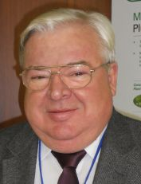 |  |  | Edward S. GACEK, Director, Research Centre for Cultivar Testing (COBORU), PL-63-022 Slupia Wielka  (tel.: +48 61 285 2341 fax: +48 61 285 3558 e-mail: e.gacek@coboru.pl)
 |  |  | Alicja RUTKOWSKA-ŁOŚ (Mrs.), Head, National Listing and Plant Breeders' Rights Protection Office, Research Centre for Cultivar Testing (COBORU), PL-63-022 Slupia Wielka  (tel.: +48 61 285 2341 fax: +48 61 285 3558 e-mail: a.rutkowska@coboru.pl)
 |  |  | Marcin KRÓL, Head, DUS Testing Department, Research Centre for Cultivar Testing (COBORU), PL-63022 Slupia Wielka  (tel.:+48 61 285 2341 fax: +48 61 285 3558 e-mail: m.krol@coboru.pl)
RÉPUBLIQUE DE CORÉE / REPUBLIC OF KOREA / REPUBLIK KOREA / REPÚBLICA DE COREA
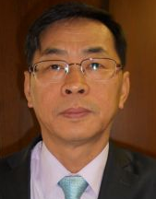 |  |  |  | SHIN Hyun-Kwan, Director General, Korea Seed & Variety Service (KSVS), Ministry for Food, Agriculture, Forestry and Fisheries (MIFAFF), 184, Anyang-ro, Manan-gu, Anyang, Gyeonggi-do 430-822  (tel.: +82 31 467 0100 fax: +82 31 467 0116 e-mail: boseyo58@korea.kr)
 |  |  |  | CHOI Keun-Jin, Director of Variety Testing Division, Korea Seed & Variety Service (KSVS), Ministry for Food, Agriculture, Forestry and Fisheries (MIFAFF), 39 Taejang-ro, Yeongtong-gu, Gyeonggi-do, Suwon-si 443-400  (tel.: +82 31 8008 0200 fax: +82 31 203 7431 e-mail: kjchoi1001@korea.kr)
 |  |  |  | Kyung-Jin CHO, Director, Plant Variety Protection Division, Korea Forest Seed & Variety Center, Korea Forest Service, 72 Suhoeri-ro, Suanbo-myeon, Chungju-si, Chuncheongbuk-do 380-941  (tel.: +82 43 850 3320 fax: +82 43 850 0451 e-mail: kyungcho@korea.kr)
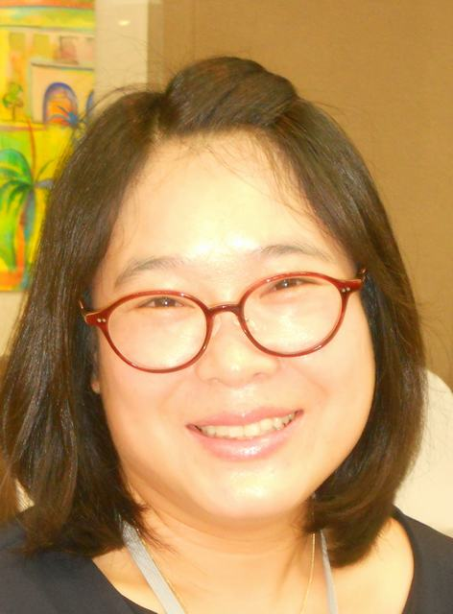 |  |  |  | Oksun KIM (Ms.), Plant Variety Protection Division, Korea Seed & Variety Service (KSVS) / MIFAFF, 184, Anyang-ro, Manan-gu, Anyang, 430-822 Gyeonggi-do  (tel.: +82 31 467 0191 fax: +82 31 467 0160 e-mail: oksunkim@korea.kr)
RÉPUBLIQUE DE MOLDOVA / REPUBLIC OF MOLDOVA / REPUBLIK MOLDAU /
REPÚBLICA DE MOLDOVA
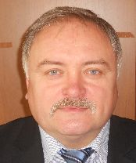 |  |  | Mihail MACHIDON, President, State Commission for Crops Variety Testing and Registration (SCCVTR), Bd. Stefan cel Mare, 162, C.P. 1873, MD-2004 Chisinau  (tel.: +373 22 220300 fax: +373 2 211537 e-mail: mihail.machidon@yahoo.com)
RÉPUBLIQUE DOMINICAINE / DOMINICAN REPUBLIC / DOMINIKANISCHE REPUBLIK /
REPÚBLICA DOMINICANA
 |  |  | Ysset ROMAN (Sra.), Ministro Consejero, Misión Permanente, 63 Rue de Lausanne, Ginebra, Suiza  (tel.: +41 22 715 3910 e-mail: yroman.omc@rep-dominicana.org)
RÉPUBLIQUE TCHÈQUE / CZECH REPUBLIC / TSCHECHISCHE REPUBLIK /
REPÚBLICA CHECA
 |  |  | Radmila SAFARIKOVA (Mrs.), Head of Division, National Plant Variety Office, Central Institute for Supervising and Testing in Agriculture (ÚKZÚZ), Hroznová 2, 656 06 Brno  (tel.: +420 543 548 221 fax: +420 543 212 440 e-mail: radmila.safarikova@ukzuz.cz)
ROUMANIE / ROMANIA / RUMÄNIEN / RUMANIA
 |  |  | Mirela Dana CINDEA (Mrs.), Director, State Institute for Variety Testing and Registration Romania (ISTIS), 61, Marasti, Sector 1, Bucarest  (tel.: +40 21 318 43 80 fax: +40 21 318 44 08 e-mail: istis@easynet.ro)
ROYAUME-UNI / UNITED KINGDOM / VEREINIGTES KÖNIGREICH / REINO UNIDO
 |  |  | Andrew MITCHELL, Head of Varieties and Seeds Policy, Department for Environment, Food and Rural Affairs (DEFRA), Eastbrook, Shaftesbury Road, CB2 8DR Cambridge  (tel.: +44 300 060 0762 e-mail: andrew.mitchell@defra.gsi.gov.uk)
SERBIE / SERBIA / SERBIEN / SERBIA
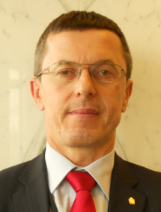 |  |  | Danilo GOLUBOVIĆ, State Secretary, Ministry of Agriculture, Forestry & Water Menagement, Nemanjina 22-26, 11 000 Beograd  (tel.: +381 11 3616 574 fax: +381 11 3620 893 e-mail: danilo.golubovic@minpolj.gov.rs)
 |  |  | Jovan VUJOVIC, Head, Plant Protection Directorate, Group for Plant Variety Protection and Biosafety, Ministry of Agriculture, Forestry and Water Management, Omladinskih brigada 1, 11124 Belgrade  (tel.: +381 11 311 70 94 fax: +381 11 311 70 94 e-mail: jovan.vujovic@minpolj.gov.rs)
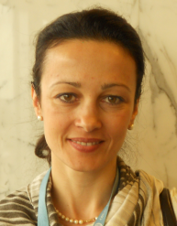 |  |  | Vesna FILIPOVIĆ-NIKOLIĆ (Mrs.), Counsellor, Permanent Mission, 5 chemin Thury, CH-1206 Geneva  (tel.: +41 22 839 3344 fax: +41 22 839 3359 e-mail: vesna.filipovic@bluewin.ch)
SLOVAQUIE / SLOVAKIA / SLOWAKEI / ESLOVAQUIA
 |  |  | Bronislava BÁTOROVÁ (Mrs.), National Coordinator, Senior Officer, Department of Variety Testing, Central Controlling and Testing Institute in Agriculture (ÚKSÚP), Akademická 4, SK-949 01 Nitra  (tel.: +421 37 655 1080 fax: +421 37 652 3086 e-mail: bronislava.batorova@uksup.sk)
SUÈDE / SWEDEN / SCHWEDEN / SUECIA
 |  |  | Olof JOHANSSON, Head, Plant and Environment Department, Swedish Board of Agriculture, S-551 82 Jönköping  (tel.: +46 36 155703 fax: +46 36 710517 e-mail: olof.johansson@jordbruksverket.se)
SUISSE / SWITZERLAND / SCHWEIZ / SUIZA
 |  |  | Manuela BRAND (Frau), Leiterin, Büro für Sortenschutz, Fachbereich Zertifizierung, Pflanzen- und Sortenschutz, Bundesamt für Landwirtschaft, Mattenhofstrasse 5,  CH-3003 Bern  (tel.: +41 31 322 2524 fax: +41 31 322 2634 e-mail: manuela.brand@blw.admin.ch)
 |  |  | Alexandra GRAZIOLI (Mme), Conseillere, Mission permanente de la Suisse auprès de l'UNOG, 9-11, rue de Varembé, Case postale 194, CH-1211 Genève 20
UNION EUROPÉENNE / EUROPEAN UNION / EUROPÄISCHE UNION / UNIÓN EUROPEA
 |  |  | Dana-Irina SIMION (Mme), Chef de l'Unité E7, Direction Générale Santé et Protection des Consommateurs, Commission européene, DG SANCO, B232 04/082, 1049 Bruxelles (tel.: +32 2 296 2345 e-mail: dana-irina.simion@ec.europa.eu)
 |  |  | Päivi MANNERKORPI (Mrs.), Chef de section - Unité E2, Direction Générale Santé et Protection des Consommateurs, Commission européene (DG SANCO), rue Belliard 232, 04/075, 1040 Bruxelles  (tel.:+32 2 299 3724 fax: +32 2 296 0951 e-mail: paivi.mannerkorpi@ec.europa.eu)
 |  |  | Isabelle CLEMENT-NISSOU (Mrs.), Policy Officer – Unité E2, Direction Générale Santé et Protection des Consommateurs, Commission européene (DG SANCO), rue Belliard 232, 04/025, 1040 Bruxelles  (tel.:+32 229 87834 fax: +32 2 2960951 e-mail: isabelle.clement-nissou@ec.europa.eu)
 |  |  | Martin EKVAD, President, Community Plant Variety Office (CPVO), 3, boulevard Maréchal Foch, CS 10121, 49101 Angers Cedex 02  (tel.: +33 2 4125 6415 fax: +33 2 4125 6410 e-mail: ekvad@cpvo.europa.eu)
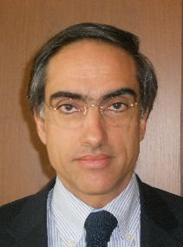 |  |  | Carlos GODINHO, Vice-President, Community Plant Variety Office (CPVO), 3, boulevard Maréchal Foch, CS 10121, 49101 Angers Cedex 02, France  (tel.: +33 2 4125 6413 fax: +33 2 4125 6410 e-mail: godinho@cpvo.europa.eu)
VIET NAM / VIET NAM / VIETNAM / VIET NAM
 |  |  | Nguyen Quoc MANH, Deputy Chief of PVP office, Plant Variety Protection Office of Viet Nam, No 2 Ngoc Ha Street, Ba Dinh Dist, (84) 48 Hanoi  (tel.: +84 4 38435182 fax: +84 4 37344967 e-mail: quocmanh.pvp.vn@gmail.com)
II. OBSERVATEURS / OBSERVERS / BEOBACHTER / OBSERVADORES
CAMBODGE / CAMBODIA / KAMBODSCHA / CAMBOYA
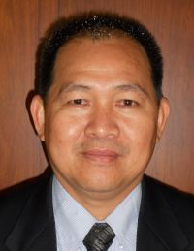 |  |  |  |  | Prak CHEATTHO, Deputy Director, General Directorate of Agriculture, Ministry of Agriculture, Forestry and Fisheries, #200, St. Preah Norodom BVD, Sangkat Tonlebasak, Khan Chamkamon, Phnom Penh  (tel.: +855 97 710 0721 +855 12 856 476 e-mail: cheattho@hotmail.com)
 |  |  |  |  | Chantravuth PHE, Deputy Director, Department Industrial Property, Ministry of Industry, Mines Energy, #45, Preah Norodom, Boulevard Hhan Doun Penh, Khan Daun Penh, Phnom Penh  (tel.: +855 23 211141 fax: 855 23 428 263 e-mail: phechantravuth@yahoo.com)
MALAISIE / MALAYSIA / MALAYSIA / MALASIA
 |  |  |  |  | Halimi MAHMUD, Director, Crop Quality Control Division, Ministry of Agriculture and Fisheries, Kuala Lumpur  (tel.: +603 8870 3447 fax: 603-8888 7639 e-mail: halimi@doa.gov.my)
RÉPUBLIQUE DÉMOCRATIQUE POPULAIRE LAO / LAO PEOPLE'S DEMOCRATIC REPUBLIC / DEMOKRATISCHE VOLKSREPUBLIK LAOS / REPÚBLICA DEMOCRÁTICA POPULAR LAO
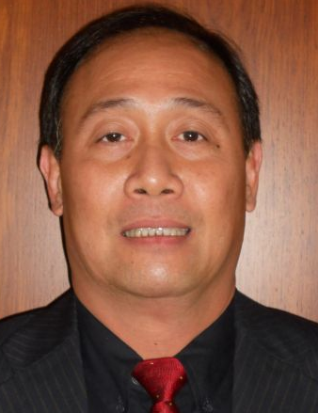 |  |  |  |  | Makha CHANTALA, Deputy Director General, Intellectual Property Division, National Authority for Science and Technology (NAST), Department of Intellectual Property, Standardization and Metrology (DISM), Makaidiao, P.O. Box 2279, Vientiane  (tel.: +856 21 248784 fax: +856 21 2134772 e-mail: c_makha@yahoo.com)
 |  |  |  |  | Bounchanh KHOMBOUNYASITH, Director, Agronomy Management Division, National Authority for Science and Technology (NAST), Department of Intellectual Property, Standardization and Metrology (DISM), Lane xang Avenue, Patuxay Square, P O Box 811, Vientiane  (tel.: +856 21 412350 fax: +856 21 412349 e-mail: bchanhb@yahoo.com)
THAÏLANDE / THAILAND / THAILAND / TAILANDIA
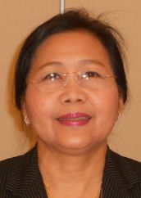 |  |  |  |  | Sopida HAEMAKOM (Ms.), Secretary of the Department of Agriculture and Chief of Legal Office, Ministry of Agriculture and Cooperatives, 50 Phaholyothin Road, Chatuchak, Bangkok 10900  (tel.: +66 2 5792445 fax: +66 2 9405527 e-mail: sopida_doa@yahoo.com)
RÉPUBLIQUE-UNIE DE TANZANIE / UNITED REPUBLIC OF TANZANIA /
VEREINIGTE REPUBLIK TANSANIA / REPÚBLICA UNIDA DE TANZANÍA
 |  |  | Juma Ali JUMA, Deputy Principal Secretary, Ministry of Agriculture and Natural Resources, P.O. Box 159, Zanzibar  (tel.: +255242230986 fax : +255242234650 e-mail: j_alsaady@yahoo.com)
 |  |  | Patrick NGWEDIAGI, Registrar, Plant Breeders' Rights Office, Ministry of Agriculture, Food Security and Cooperatives, P.O. Box 9192, Dar es Salaam  (tel.: +255 22 2861404 fax: +255 22 286 1403 e-mail: ngwedi@yahoo.com)
 |  |  | Audax Peter RUTABANZIBWA, Chairman, PBR Advisory Committee and Head of Legal Unit, Ministry of Agriculture, Food Security and Cooperatives (MAFC), P.O. Box 9192, Dar es Salaam  (tel.: +255 22 2865392 fax: +255 22 862077 e-mail: udax.rutabanzibwa@kilimo.go.tz)
 |  |  | Sidra Juma AMRAN (Ms.), Head of Legal Unit, Ministry of Agriculture and Natural Resources, P.O. Box 159, Zanzibar  (tel.: +255242230986 fax: +255242234650)
III. ORGANISATIONS / ORGANIZATIONS / ORGANISATIONEN / ORGANIZACIONES
ASSOCIATION FOR PLANT BREEDING FOR THE BENEFIT OF SOCIETY
 |  |  | François MEIENBERG, Board Member, Berne Declaration, P.O. Box 8026, Zürich , Suisse  (tel.: +41 44 277 7004 fax: +41 44 277 7001 e-mail: food@evb.ch)
Susanne GURA (Ms.), Coordinator, Association for Plant Breeding for the Benefit of Society (APBREBES), Burghofstr. 166, 53229 Bonn , Allemagne
(tel.: +49 228 9480670 e-mail: gura@dinse.net)
EUROPEAN COORDINATION VIA CAMPESINA (ECVC)
 |  |  |  |  |  | Guy KASTLER, Via Campesina, Le Sieure, 34 210 La Caunette  (tel.: +33 468 91 2895 e-mail: guy.kastler@wanadoo.fr)
INTERNATIONAL SEED FEDERATION (ISF)
 |  |  | Marcel BRUINS, Secretary General, International Seed Federation (ISF), 7, chemin du Reposoir, 1260 Nyon, Switzerland  (tel.: +41 22 365 4420 fax: +41 22 365 4421 e-mail: isf@worldseed.org)
 |  |  | Niels LOUWAARS, International Cooperation Manager, Centre for Plant Breeding and Reproduction Research - CPRO-DLO, Droevendaalsesteeg 1, Postbus 16, Wageningen, Netherlands  (tel.: +31 317 47 70 03 fax: +31 317 41 80 94 e-mail: n.louwaars@worldonline.nl)
iv. BUREAU DE L’OMPI / OFFICE OF WIPO / BÜRO DER WIPO / OFICINA DE LA OMPI
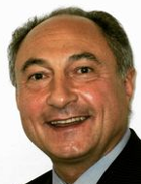 |  |  | Philippe FAVATIER, Chief Financial Officer (Controller), Department of Finance and Budget
V. BUREAU / OFFICER / VORSITZ / OFICINA
 |  |  | Kitisri SUKHAPINDA (Ms.), President
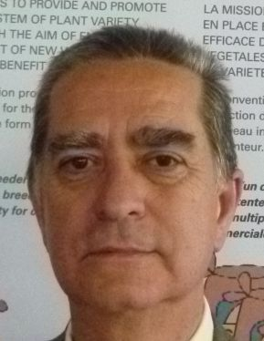 |  |  | Luis SALAICES, Vice-President
vi. BUREAU DE L’UPOV / OFFICE OF UPOV / BÜRO DER UPOV / OFICINA DE LA UPOV
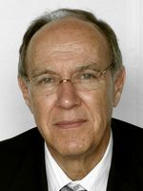 |  |  | Francis GURRY, Secretary-General
 |  |  | Peter BUTTON, Vice Secretary-General
 |  |  | Yolanda HUERTA (Mrs.), Legal Counsel
 |  |  | Julia BORYS (Mrs.), Senior Technical Counsellor
 |  |  | Fuminori AIHARA, Counsellor
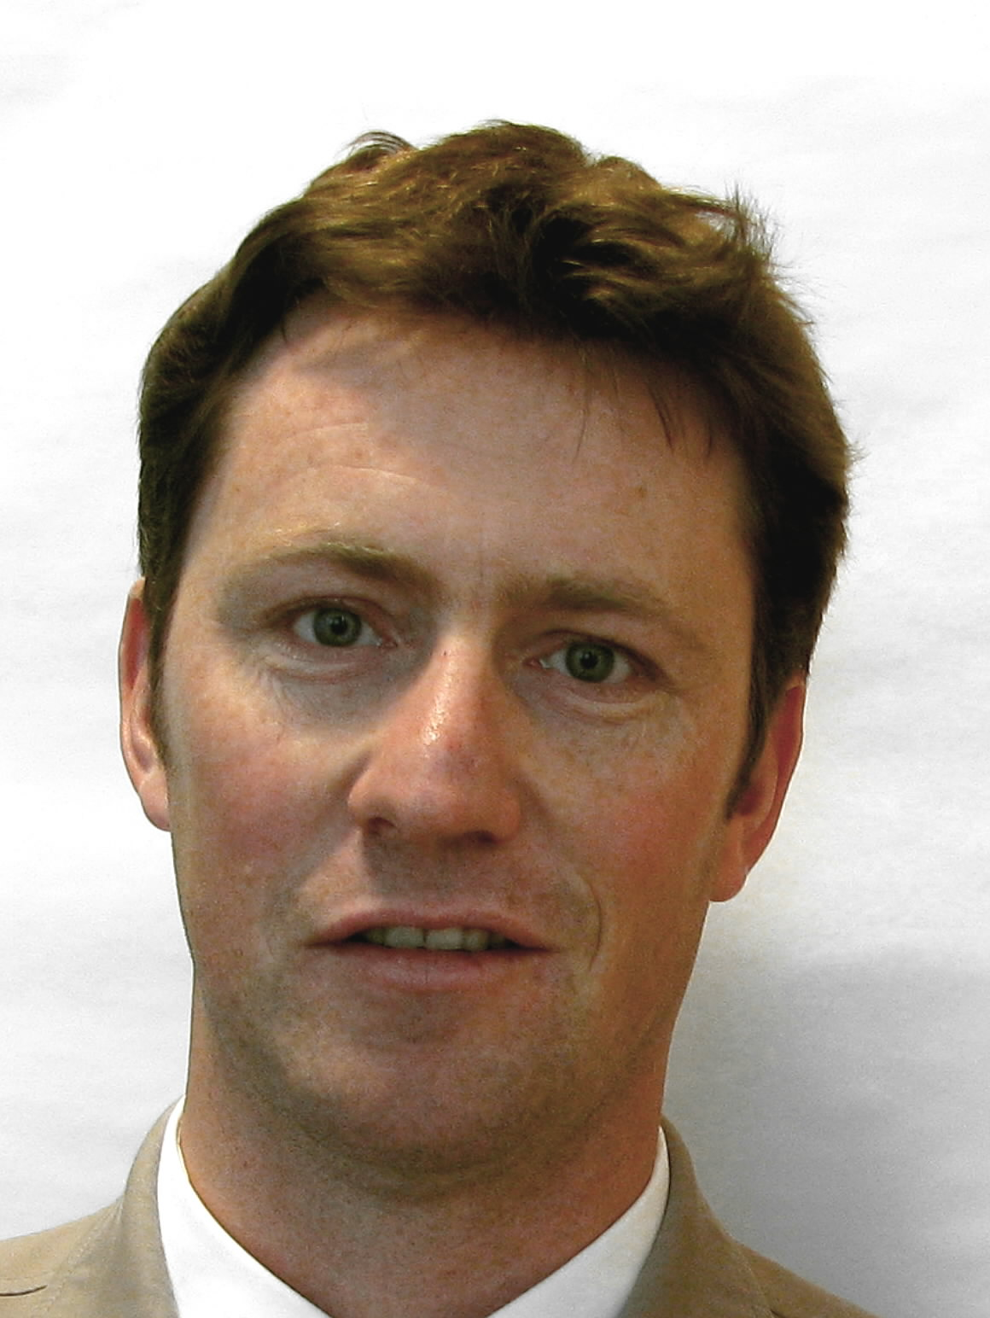 |  |  | Ben RIVOIRE, Technical/Regional Officer (Africa, Arab countries)
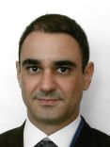 |  |  | Leontino TAVEIRA, Technical/Regional Officer (Latin America, Caribbean countries)

[L’annexe II suit /
Annex II follows /
Anlage II folgt /
Sigue el Anexo II]

INTERNATIONALER  VERBAND  ZUM SCHUTZ VON  PFLANZENZÜCHTUNGEN  GENF, SCHWEIZ |  |  | INTERNATIONAL UNION  FOR THE PROTECTION  OF NEW VARIETIES  OF PLANTS  GENEVA, SWITZERLAND
 | UNION INTERNATIONALE  POUR LA PROTECTION  DES OBTENTIONS  VÉGÉTALES  GENÈVE, SUISSE | UNIÓN INTERNACIONAL  PARA LA PROTECCIÓN  DE LAS OBTENCIONES  VEGETALES  GINEBRA, SUIZA

PRESS RELEASE

UPOV Press Release 94

Geneva, March 22, 2013

UPOV Council Holds its Thirtieth Extraordinary Session

The Council of the International Union for the Protection of New Varieties of Plants (UPOV) held its thirtieth extraordinary session on March 22, 2013.

Round-up of key developments:

New UPOV member: Serbia

Serbia deposited its instrument of accession to the 1991 Act of the UPOV Convention on December 5, 2012, and became the seventy-first member of the Union on January 5, 2013. A full list of the members of the Union can be consulted at http://www.upov.int/members/en/.

Positive decision on the Plant Breeders’ Bill for Zanzibar (United Republic of Tanzania)

The Council welcomed the adoption of the Plant Breeders’ Rights Act for Mainland Tanzania on November 5, 2012, for which there was a positive decision by the Council. The Council decided that the Plant Breeders’ Rights Bill for Zanzibar, subject to certain modifications, was in conformity with the provisions of the 1991 Act of the UPOV Convention. The Council noted that, once the Draft Law for Zanzibar was adopted, breeders’ rights would cover the whole territory and the United Republic of Tanzania could become a UPOV member.

Adoption of documents

The Council adopted the revision of documents UPOV/INF/4 “Financial Regulations and Rules of UPOV” and UPOV/INF/15 “Guidance for Members of UPOV on Ongoing Obligations and Related Notifications and on the Provision of Information to Facilitate Cooperation”.

Seminar on essentially derived varieties (EDVs) on October 22, 2013

The Council endorsed the organization of a Seminar on EDVs, to be held in Geneva on October 22, 2013, to consider technical and legal views on EDVs and the possible impact on breeding and agriculture, existing experience in relation to EDVs, and the possible role of future UPOV guidance on EDVs in cases before the courts. The Seminar will be open to the public, with the presentations and discussions at the seminar being made available on the UPOV website after a suitable broadcast delay.

Contribution to the work of multi-stakeholder team on enhancing public-private partnerships in pre-breeding

Following a request from the Plant Genetic Resources and Seeds Team of the Food and Agriculture Organization of the United Nations (FAO) and a number of other functional units, especially the International Treaty on Plant Genetic Resources for Food and Agriculture, UPOV members agreed to the UPOV Office working as part of a multi-stakeholder team on the “definition of mechanisms for enhancing public-private partnerships in pre-breeding”.

Gold Medal

Mr. Joël Guiard (France) was awarded a UPOV Gold Medal on completing his term as Chairman of the Technical Committee (TC) at its forty-ninth session, held in Geneva from March 18 to 20, 2013. Mr. Guiard, who will be retiring from his position in Group for Study and Control of Varieties and Seeds (GEVES) in 2013, was awarded a Gold Medal on the basis of his outstanding contribution to plant variety protection, which included the following notable contributions:

• Chairman of the Working Group on Article 1 “Definitions” at the Diplomatic Conference in March 1991
• Member of the UPOV Editorial Committee (31 years)
• Twice Chairman of the Technical Committee (1996-1998 & 2011-2013)
• Chairman of the Technical Working Party for Agricultural Crops (1985-1987)
• Twice Chairman of the Working Group on Biochemical and Molecular Techniques, and DNA-Profiling in Particular (1994-1998)
• Leading Expert for a number of important Test Guidelines

Mr. Guiard’s contribution has extended beyond his direct participation in UPOV bodies. In his role as Directeur adjoint, GEVES, Mr. Guiard has made a unique contribution to the advancement of UPOV’s technical work. The contributions from GEVES include:

• Software which is made freely available to all members of the Union:
o GAIA - for the management of reference collections
o SIRIUS - for hand-held data capture in DUS trials

• GEVES has provided the examples for the models approved by UPOV for the use of biochemical and molecular markers in the examination of DUS. Those models/examples are the basis for document TGP/15 “Guidance on the Use of Biochemical and Molecular Markers in the Examination of Distinctness, Uniformity and Stability”, which is planned for adoption in October 2013.

Mr. Guiard has also provided support, personally and through GEVES, for a multitude of UPOV activities during his time at GEVES. His knowledge, intelligence and personality have enabled him to become a focal point for new and old experts alike.

Test Guidelines

The Council welcomed the adoption by the Technical Committee of 14 new UPOV Test Guidelines for the Conduct of Tests for Distinctness, Uniformity and Stability (Test Guidelines) and 10 revised Test Guidelines. UPOV has now developed 295 Test Guidelines, all of which are freely available on the UPOV website (http://www.upov.int/test_guidelines/en/).

Distance Learning Course DL-205

On-line registration for the UPOV Distance Learning Program “Introduction to the UPOV System of Plant Variety Protection under the UPOV Convention” is now open.

The timetable for the session is as follows:

Study period: May 13 to June 16, 2013
Final exam: June 10 to 16, 2013

On-line registration is available until March 31, 2013. After that date, registration will not be possible. For Category 1 and 2 participants, all endorsements must be provided by May 1, 2013.

The categories of participants are as follows:

Category 1:
Government officials of members of the Union endorsed by the relevant representative to the UPOV Council
No fee

Category 2:
Officials of observer States / intergovernmental organizations endorsed by the relevant representative to the UPOV Council
(One non-fee paying student per State / intergovernmental organization;
Additional students: CHF1,000 per student)

Category 3:
Others

Fee: CHF1,000

Please note that registration of participants in categories 1 and 2 must be accompanied by an endorsement from the representative to the UPOV Council of the UPOV member or observer, as appropriate, formally nominating the participant.

More detailed information concerning the course content and on-line registration is available on the UPOV website: http://www.upov.int/resource/en/dl205_training.html.

For further information about UPOV, please contact the UPOV Secretariat:
Tel: (+41-22) 338 9111 E-mail: upov.mail@upov.int
Fax: (+41-22) 733 0336 Website: www.upov.int

[End of Annex II and of document]

