E
International Union for the Protection of New Varieties of Plants

Council  Fifty-Fourth Ordinary Session  Geneva, October 30, 2020 | C/54/9  Original: English  Date: August 18, 2020
Performance Report for the 2018-2019 Biennium
Document prepared by the Office of the Union
Disclaimer: this document does not represent UPOV policies or guidance
This document presents the Performance Report for the 2018-2019 Biennium on the basis of the Program and Budget for the 2018-2019 Biennium adopted by the Council (see document C/51/4 Rev. “Program and Budget for the 2018-2019 Biennium”).

The performance report for the 2018-2019 Biennium provides information on expenditure, total number of posts for the Office of the Union and results and performance indicators by subprogram on the basis of the program and budget adopted by the Council. This document also provides a view of trends over time.

EXECUTIVE SUMMARY

The following map provides a graphic overview of developments concerning the status in relation to UPOV during the 2018-2019 Biennium.

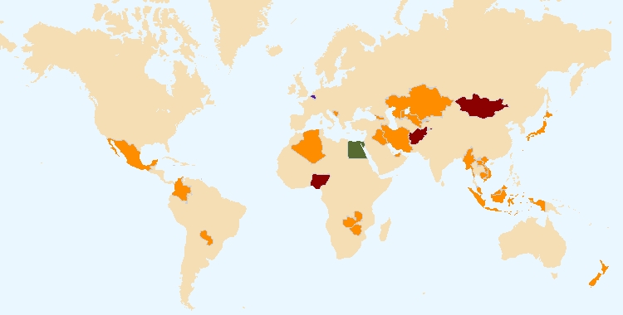
The boundaries shown on this map do not imply the expression of any opinion whatsoever on the part of UPOV concerning the legal status of any country or territory
States and organizations that became members of the Union during 2018-2019 (Egypt)
States and organizations that acceded or ratified the 1991 Act of the UPOV Convention during 2018-2019 (Belgium and Egypt)
States and organizations that initiated with the Council of UPOV the procedure for becoming members of the Union during 2018-2019 (Afghanistan, Mongolia, Nigeria and Saint Vincent and the Grenadines)
States and organizations that contacted the Office of the Union for assistance in the development of legislation on plant variety protection during 2018-2019 (Afghanistan, Algeria, Antigua and Barbuda, Bosnia and Herzegovina, Cambodia, Colombia, Egypt, Georgia, Indonesia, Iran (Islamic Republic of), Iraq, Jamaica, Japan, Kazakhstan, Lao People’s Democratic Republic, Liechtenstein, Malaysia, Mauritius, Mexico, Mongolia, Myanmar, New Zealand, Nigeria, Paraguay, Saint Vincent and the Grenadines, Trinidad and Tobago, United Arab Emirates, Uzbekistan, Viet Nam, Zambia, Zimbabwe)
Overall Policy on Plant Variety Protection (Sub-program UV.1)

This sub-program provides the framework for policy making, management and coordination of the activities within UPOV’s overall program, as established by the Council with the guidance of the Consultative Committee.

The Council approved the Draft Program and Budget for the 2020-2021 Biennium, including the amount of contributions from members of the Union, the maximum ceiling of expenditure in the regular budget and the total number of posts.

The Consultative Committee reviewed the implementation of the Strategic Business Plan to diversify UPOV’s revenue portfolio to maintain and enhance the sustainability of existing activities and services, as a part of which the Consultative Committee requested the development of options for the financing of the UPOV PRISMA PBR application tool and requested the development of proposals for database/IT services that UPOV might consider as potential revenue sources. On the basis of recommendations by the Consultative Committee, the Council decided to introduce a UPOV PRISMA fee per application at 90 Swiss Francs, starting in January 2020 and to introduce a “freemium” approach for the PLUTO Plant Variety Database. The freemium approach for PLUTO would provide two options: (i) free option: the PLUTO database with a search function would be free to all users. Search results would be limited to an on-screen display of a single page of results. There would be no facility to download search results or data from the PLUTO database; (ii) premium option: users paying a fee would have access to all PLUTO database features and would be able to download data without restrictions. The fee would be CHF 750 per annum.

With regard to interrelations with other organizations, the Council agreed to invite the World Farmers’ Organisation (WFO) to become a full partner in the World Seed Partnership (WSP) and approved the draft joint paper “Benefits of the WSP for farmers”. The Consultative Committee requested the Office of the Union to consult the Executive Secretary of the CBD and the Secretary of the ITPGRFA on how the objectives of the CBD and ITPGRFA might be reflected in the FAQ on the relationship between the UPOV Convention and other international treaties, and to explore means on how to facilitate the exchanges of experiences and information on the implementation of the UPOV Convention, the CBD and the ITPGRFA. The Council further requested the Office of the Union to cooperate with FAO in relation to the request of the Commission on Genetic Resources for Food and Agriculture (CGRFA) to carry out, in coordination with the International Treaty on Plant Genetic Resources for Food and Agriculture (ITPGRFA) and in consultation with UPOV, in-depth case studies to consider the effects of seed policies, laws and regulations.

The decision to approve the organization of a seminar on the concept of essentially derived varieties (EDV) was an important step to clarify the subject and to support discussions in the Administrative and Legal Committee (CAJ).

As a part of the Communication Strategy, the Consultative Committee approved the engagement of UPOV in Twitter and LinkedIn and the Council agreed a revised text of the FAQ “What are the benefits of new varieties of plants for society?”

As a part of the measures to enable the organization of a single set of sessions, the Council used, for the first time, a procedure by correspondence to take positive decisions on the conformity of the “Plant Variety Protection Bill of Nigeria” and the “Plant Breeders’ Protection Bill 2019 of Saint Vincent and the Grenadines” with the 1991 Act of UPOV Convention.

Services to the Union for enhancing the Effectiveness of the UPOV System (Sub-program UV.2)

This sub-program covers the provision of guidance, information and resources for the operation of the UPOV system of plant variety protection, support for cooperation between members of the Union, the work of the relevant UPOV bodies and measures to facilitate applications for plant breeders’ rights.

The introduction of UPOV PRISMA in 2017 was a major development in facilitating applications for plant breeders’ rights. By the end of 2019, 35 members of the Union, covering 74 States, were participating in UPOV PRISMA. Use of UPOV PRISMA continued to grow during the Biennium, with 214 applications made for PBR via UPOV PRISMA in 2019, compared to 77 in 2018 and 14 in 2017.

The effectiveness of the UPOV system is enhanced by the provision of guidance and information materials. In 2019, the “Seminar on the impact of policy on essentially derived varieties (EDVs) on breeding strategy”, led the CAJ to agree to open up the “Explanatory Notes on Essentially Derived Varieties under the 1991 Act of the UPOV Convention” (document UPOV/EXN/EDV/2). The CAJ is also working on the revision of the “Explanatory notes on variety denominations under the UPOV Convention”, with a view to increasing harmonization in the examination of variety denominations.

Cooperation between members of the Union is a key benefit of UPOV membership. In 2019, the TC discussed technical concerns that can prevent cooperation in DUS examination and agreed to invite the UPOV Office to develop a coherent plan, based on specified proposals, to address the concerns and to propose how to assess the impact of the plan. The TC also agreed to report to the CAJ the related policy or legal issues that can prevent cooperation in DUS examination. The work of the Technical Working Parties (TWPs) and the Technical Committee (TC) on the development and revision of Test Guidelines (TG) continues to be a cornerstone for cooperation between members of the Union in the examination of Distinctness, Uniformity and Stability (“DUS”). At the same time, the harmonization provided by TG and the availability of TG data in the web-based Test Guidelines Template (TG Template) enabled the rapid expansion of UPOV PRISMA to cover all crops and species for those members of the Union that use the UPOV Test Guidelines as the basis for the technical questionnaires in their application forms. In 2019, the adopted Test Guidelines covered 94% of all PBR-related entries in the Plant Variety Database. The UPOV Code System was developed to overcome the problem of synonyms for plant taxa and is essential for the functioning of UPOV PRISMA and the PLUTO and GENIE databases. However, the TC will now explore a new approach that would enable UPOV Codes to provide additional information on variety groups or types for DUS testing purposes, while continuing to enable the UPOV code system to be based on taxonomic criteria.

Assistance in the Introduction and Implementation of the UPOV System (Sub-Program UV.3)

This sub-program covers the assistance provided in response to requests by members of the Union and potential members of the Union. Satisfying the demand for assistance in the introduction and implementation of the UPOV system within available resources relies on the use of distance-learning courses, training of trainers, the prioritization of assistance by the Office of the Union and the use of external resources for administration, training and assistance according to available finances. This sub-program is supported by the regular budget, but extra-budgetary funds and support in kind provide a substantial proportion of the resources deployed for assistance. In order to utilize the available resources in the most effective way, the Office of the Union continued to prioritize its activities and to explore synergies in its activities with members of the Union and other partners.

The priority for providing assistance by the Office of the Union is as follows: (i) assistance to existing members of the Union; (ii) assistance to States and certain organizations that are not members of the Union, particularly governments of developing countries and countries in transition to a market economy, in the development of legislation in line with the 1991 Act of the UPOV Convention and their accession to the UPOV Convention; and (iii) assistance to States and certain organizations that are not members of the Union, in the implementation of legislation that has received a positive decision of the Council, according to their commitment to accede to the UPOV Convention.

The increasing interest in UPOV membership in recent years continued. The number of non-UPOV member States/organizations provided with comments on laws (17) was the highest for more than 20 years (see map below). The number of States/organizations which received positive advice from the Council was also the highest since 2000.

States/organizations provided with comments on laws

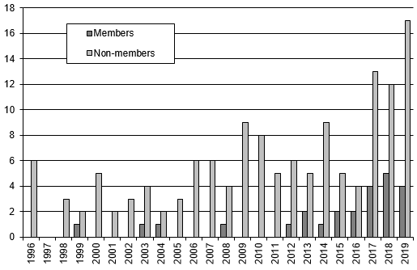

Thirty one States (10 members of the Union and 21 non-members of the Union) contacted the Office of the Union for assistance in the development of legislation on plant variety protection. A total of 22 States (5 members of the Union and 17 non-members of the Union) were provided with comments on their laws or draft laws. Four States initiated with the Council the procedure for becoming members of the Union. The Council provided a positive advice to 6 States on the conformity of their laws or draft laws with the 1991 Act of the UPOV Convention. One member of the Union (Belgium) ratified the 1991 Act of the UPOV Convention. One State (Egypt) became a member of the Union.

The Office of the Union organized or participated in 235 missions/events in the 2018 2019 Biennium, at which 141 States and 17 organizations were provided with information about the UPOV system. A total of 1,166 students from 102 States and 4 organizations participated in UPOV’s distance learning courses.

External Relations (Sub-Program UV.4)

UPOV’s mission is to provide and promote an effective system of plant variety protection, with the aim of encouraging the development of new varieties of plants, for the benefit of society. The aim of this Sub-program is to explain how the UPOV system encourages the development of new varieties of plants, how new varieties benefit society and the role of the UPOV system in relation to agriculture and economic policy.

A significant development in 2019 was the introduction of the @UPOVint and @vsgupov Twitter accounts, combined with the use of the UPOV LinkedIn account (including UPOV PRISMA Showcase page). From March 2019 to May 2020, UPOV posted more than 1,000 tweets and gained more than 1,000 followers on Twitter. During that same period, the combined UPOV Twitter accounts registered more than: 500,000 “impressions”; 10,000 “engagements”; 2,000 “likes” and 1,000 ”retweets”. The number of UPOV website visitors (“visits”) and sessions since the launch of UPOV’s social media accounts in March, provides some evidence of a positive impact on outreach of the UPOV website, in addition to the additional direct outreach from social media postings.

The publication of a series of videos produced in Canada, China, Colombia, Kenya, Japan and Peru, covering cherry, rose, rice and other crops, provided an important new source of information on the benefits of plant variety protection and UPOV membership. This material also provides important information for use in UPOV’s various outreach activities. As a part of the Communication Strategy, the Council agreed a revised text of the FAQ “What are the benefits of new varieties of plants for society?”

RESULTS TABLE FOR THE 2018-2019 BIENNIUM

Table of contents

1. INTRODUCTION 7
2. PROGRAM PERFORMANCE 10
2.1 Sub-program UV.1: Overall Policy on Plant Variety Protection 10
Objectives 10
Results Achieved: Selected Performance Indicators 11
1. ORGANIZATION OF COUNCIL AND CONSULTATIVE COMMITTEE SESSIONS 11
(a) Participation in the sessions of the Council and the Consultative Committee 11
2. Coordination, monitoring and performance assessment of Program and Budget for the 2018-2019 Biennium 12
(a) Delivery of program within budget for the 2018-2019 Biennium 12
3. Preparation and adoption of the Program and Budget for the 2020-2021 Biennium 12
(a) Preparation and adoption of the Program and Budget for the 2020-2021 Biennium in accordance with the “Financial Regulations and Rules of UPOV” 12
4. Review of developments concerning applications and grants of plant breeders’ rights 12
(a) Number of applications for plant breeders’ rights 12
(b) Number of titles granted 12
(c) Number of titles in force 12
(d) Number of genera/species protected by members of the Union 13
(e) Number of genera/species for which varieties have been protected 14
(f) Analysis by crop type 14
5. Facilitating applications through UPOV PRISMA (formerly known as the UPOV Electronic Application Form (EAF) tool) 14
(a) Number of UPOV members participating in UPOV PRISMA 14
(b) Number of crops/species covered by UPOV PRISMA 14
(c) Number of applications made via UPOV PRISMA (see UV. 2) 14
6. Council policy 14
(a) Recommendations by the Consultative Committee, and decisions by the Council 14
(b) Other decisions by the Council 15
(c) Other work of the Consultative Committee 15
(d) Adoption of information and position papers by the Council 16
2.2 Sub-program UV.2: Services to the Union for Enhancing the Effectiveness of the UPOV System 17
Objectives 17
Results Achieved: Selected Performance Indicators 18
1. Participation by members of the Union and observers in the work of the UPOV bodies 18
(a) Participation in the Administrative and Legal Committee 18
(b) Participation in the Technical Committee 18
(c) Participation in Technical Working Party Sessions 19
(d) Participation in Preparatory Workshops for the Technical Working Party Sessions 19
2. Guidance on the UPOV Convention and its implementation and information on its application 20
(a) Adoption of new or revised information materials concerning the UPOV Convention 20
(b) Publication of the UPOV Gazette and Newsletter 20
(c) Inclusion of laws of members of the Union in UPOV Lex database 21
(d) Availability of UPOV documents and materials in languages other than the UPOV languages (English, French, German and Spanish) 21
3. Guidance on the examination of varieties 21
(a) Adoption of new or revised TGP documents and information materials 21
(b) Adoption of new or revised Test Guidelines 22
(c) Number of PBR applications covered by adopted Test Guidelines 23
(d) Participation in the development of Test Guidelines 24
(e) Development of web-based Test Guidelines Template (TG Template) with facility for: 25
1. Translation in UPOV languages 25
2. Use by members of the Union in the preparation of individual authorities’ test guidelines 25
4. Cooperation IN DUS examination 25
(a) Plant genera and species for which members of the Union have practical experience 26
(b) Plant genera and species for which members of the Union cooperate in DUS examination, as indicated in GENIE database 26
5. Cooperation IN examination of variety denominations 26
(a) Quantity and quality of data in PLUTO database 27
1. Number of contributors 27
2. Number of new submissions 27
3. Number of records 27
6. dEVELOPMENT OF upov prisma (FORMERLY KNOWN AS THE UPOV electronic application form (EAF) tool) 27
2.3 Sub-Program UV.3: Assistance in the Introduction and Implementation of the UPOV System 28
Objectives 28
Results Achieved: Selected Performance Indicators 28
1. Raising awareness of the role of plant variety protection in accordance with the UPOV Convention 28
(a) States and organizations provided with information at UPOV activities 28
(b) States and organizations that contacted the Office of the Union for assistance in the development of legislation on plant variety protection 30
(c) States and organizations that initiated with the Council of UPOV the procedure for becoming members of the Union 30
(d) Participation in UPOV awareness-raising activities, or activities involving UPOV staff or UPOV trainers on behalf of UPOV staff 30
2. Assistance in drafting legislation on plant variety protection in accordance with the 1991 Act of the UPOV Convention 31
(a) Meetings with government officials to discuss legislative matters 31
(b) States and organizations provided with comments on laws 32
(c) States and organizations which received a positive advice from the Council of UPOV 32
3. Assistance to States and organizations in the accession to the 1991 Act of the UPOV Convention 32
(a) States and organizations that acceded to or ratified the 1991 Act of the UPOV Convention 32
(b) States and organizations that became members of the Union 32
4. Assistance in implementing an effective plant variety protection system in accordance with the UPOV Convention 34
(a) Participation in distance learning courses 34
(b) Training of trainers 36
(c) Training activities developed in conjunction with UPOV 36
(d) Participation by observer States and organizations in the CAJ, TC, TWPs and the associated preparatory workshops 36
(e) Participation in UPOV activities 36
(f) Participation in activities involving UPOV staff or UPOV trainers on behalf of UPOV staff 36
(g) Courses featuring the UPOV system of plant variety protection 36
(h) Implementation of projects with partner organizations and donors 36
2.4 Sub-Program UV.4: External Relations 37
Objectives 37
Results Achieved: Selected Performance Indicators 37
1. Broaden public understanding of UPOV’s role and activities 37
(a) Availability of suitable information and materials for the general public, on UPOV website and through other media 37
(b) Visits to UPOV website 37
2. Enhance understanding of UPOV’s role and activities for stakeholders 40
(a) Availability on UPOV website and through other media of suitable information and materials, particularly for breeders, farmers and policy-makers 40
(b) Stakeholder-focused features on the UPOV website 40
Visits to the UPOV Website in 2019 40
(c) Participation by stakeholders in seminars and symposia 40
(d) Participation at meetings of, and with, relevant stakeholders 40
(e) Articles in relevant publications to which UPOV has contributed 40
3. Enhance understanding of UPOV’s role and activities with other organizations 40
(a) Participation at meetings of, and with, relevant organizations 40
3. FINANCIAL PERFORMANCE 41
ANNEX List of missions and activities, and contribution to performance indicators in 2018-2019
Appendix Acronyms and abbreviations

1. INTRODUCTION

This document presents the Performance Report for the 2018-2019 Biennium on the basis of the Program and Budget for the 2018-2019 Biennium adopted by the Council at its fifty-first ordinary session, held in Geneva on October 26, 2017 (see document C/51/4 Rev. “Program and Budget for the 2018-2019 Biennium”).

The Performance Report for the 2018-2019 Biennium provides an overview of UPOV’s performance based on information from the following documents, which contain further detailed information:

(a) document C/51/4 Rev. “Program and Budget of the Union for the 2018-2019 Biennium;
(b) document C/53/2 “Annual Report of the Secretary-General for 2018”;
(c) document C/54/2 “Annual Report of the Secretary-General for 2019”; and
(d) document C/54/4 “Financial Management Report for the 2018-2019 Biennium”.

Section 2 “Program Performance”, provides a brief summary of the progress made towards the achievements of objectives at the level of sub-programs, followed by performance tables summarizing information on objectives, expected results and performance indicators. Section 3 “Financial Performance”, provides an overview of the financial performance, in relation to the Program and Budget for the 2018­2019 Biennium.

The following map provides a graphic overview of developments concerning the status in relation to UPOV during the 2018-2019 Biennium.

Figure 1 - Changes of status in relation to UPOV during the 2018-2019 Biennium

The boundaries shown on this map do not imply the expression of any opinion whatsoever on the part of UPOV concerning the legal status of any country or territory.
States and organizations that became members of the Union during 2018-2019 (Egypt)
States and organizations that acceded or ratified the 1991 Act of the UPOV Convention during 2018-2019 (Belgium and Egypt)
States and organizations that initiated with the Council of UPOV the procedure for becoming members of the Union during 2018-2019 (Afghanistan, Mongolia, Nigeria and Saint Vincent and the Grenadines)
States and organizations that contacted the Office of the Union for assistance in the development of legislation on plant variety protection during 2018-2019
(Members of the Union: Bosnia and Herzegovina, Colombia, Georgia, Japan, Mexico, New Zealand, Paraguay, Trinidad and Tobago, Uzbekistan and Viet Nam)
(Non-members of the Union: Afghanistan, Algeria, Antigua and Barbuda, Cambodia, Egypt, Indonesia, Iraq, Iran (Islamic Republic of), Jamaica, Kazakhstan, Lao People’s Democratic Republic, Liechtenstein, Malaysia, Mauritius, Mongolia, Myanmar, Nigeria, Saint Vincent and the Grenadines, United Arab Emirates, Zambia and Zimbabwe)

The following map provides a graphic overview of the status in relation to UPOV at the end of 2019.

Figure 2 - Status in relation to UPOV at the end of the 2019
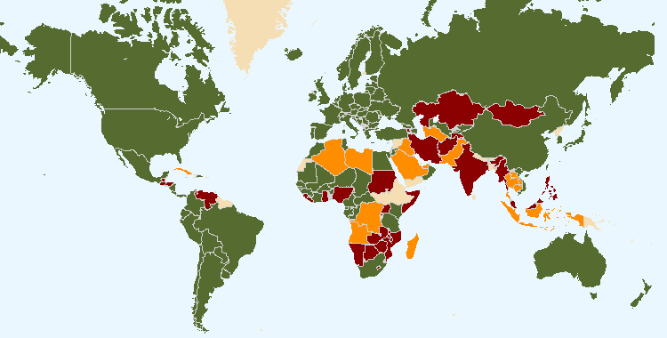
The boundaries shown on this map do not imply the expression of any opinion whatsoever on the part of UPOV concerning the legal status of any country or territory
76 members of UPOV covering 95 States at the end of 2019
19 States and 1 intergovernmental organization had initiated the procedure for acceding the UPOV Convention at the end of 2019
23 States and 1 intergovernmental organization which had been in contact with the Office of the Union for assistance in the development of laws based on the UPOV Convention at the end of 2019

The following table provides detailed information on the status in relation to UPOV.

UPOV members

African Intellectual Property Organization^{2, 4}
Albania²
Argentina1
Australia²
Austria2
Azerbaijan²
Belarus²
Belgium2
Bolivia (Plurinational State of)¹
Bosnia and Herzegovina²
Brazil¹
Bulgaria²
Canada2
Chile¹
China¹
Colombia¹
Costa Rica²
Croatia²
Czech Republic²
Denmark2
Dominican Republic²
Ecuador¹
Egypt²
Estonia²
European Union^{2, 3}
Finland2
France2
Georgia²
Germany2
Hungary2
Iceland2
Ireland2
Israel²
Italy1
Japan²
Jordan²
Kenya²
Kyrgyzstan²
Latvia²
Lithuania²
Mexico¹
Montenegro²
Morocco2
Netherlands²
New Zealand1
Nicaragua¹
North Macedonia²
Norway1
Oman²
Panama²
Paraguay¹
Peru²
Poland2
Portugal¹
Republic of Korea²
Republic of Moldova²
Romania²
Russian Federation²
Serbia²
Singapore²
Slovakia²
Slovenia²
South Africa1
Spain2
Sweden²
Switzerland²
Trinidad and Tobago¹
Tunisia²
Turkey²
Ukraine²
United Kingdom²
United Republic of Tanzania²
United States of America²
Uruguay¹
Uzbekistan²
Viet Nam²

(Total 76)

¹ 1978 Act is the latest Act by which 17 States are bound.
² 1991 Act is the latest Act by which 57 States and 2 organizations are bound.
³ Operates a plant breeders’ rights system which covers the territory of its 28 member States (Austria, Belgium, Bulgaria, Croatia, Cyprus, Czech Republic, Denmark, Estonia, Finland, France, Germany, Greece, Hungary, Ireland, Italy, Latvia, Lithuania, Luxembourg, Malta, Netherlands, Poland, Portugal, Romania, Slovakia, Slovenia, Spain, Sweden, United Kingdom).
⁴ Operates a plant breeders’ rights system which covers the territory of its 17 member States (Benin, Burkina Faso, Cameroon, Central African Republic, Chad, Comoros, Congo, Côte d’Ivoire, Equatorial Guinea, Gabon, Guinea, Guinea Bissau, Mali, Mauritania, Niger, Senegal, Togo).

States and intergovernmental organizations which had initiated the procedure
for acceding to the UPOV Convention

Afghanistan, Armenia, Brunei Darussalam, Ghana, Guatemala, Honduras, India, Iran (Islamic Republic of), Kazakhstan, Malaysia, Mauritius, Mongolia, Myanmar, Nigeria, Philippines, Saint Vincent and the Grenadines, Tajikistan, Venezuela (Bolivarian Republic of), Zimbabwe, as well as the African Regional Intellectual Property Organization (ARIPO).

States and intergovernmental organizations which had been in contact with the Office of the Union
for assistance in the development of laws based on the UPOV Convention

Algeria, Bahrain, Barbados, Cambodia, Cuba, Cyprus, El Salvador, Indonesia, Iraq, Jamaica, Lao People’s Democratic Republic, Libya, Liechtenstein, Mozambique, Namibia, Pakistan, Saudi Arabia, Sudan, Thailand, Tonga, Turkmenistan, United Arab Emirates, Zambia, as well as the Southern African Development Community (SADC).

2. PROGRAM PERFORMANCE

2.1 Sub-program UV.1: Overall Policy on Plant Variety Protection

This sub-program provides the framework for policy making, management and coordination of the activities within UPOV’s overall program, as established by the Council with the guidance of the Consultative Committee.

The Council approved the Draft Program and Budget for the 2020-2021 Biennium, including the amount of contributions from members of the Union, the maximum ceiling of expenditure in the regular budget and the total number of posts.

The Consultative Committee reviewed the implementation of the Strategic Business Plan to diversify UPOV’s revenue portfolio to maintain and enhance the sustainability of existing activities and services, as a part of which the Consultative Committee requested the development of options for the financing of the UPOV PRISMA PBR application tool and requested the development of proposals for database/IT services that UPOV might consider as potential revenue sources.
On the basis of recommendations by the Consultative Committee, the Council decided to introduce a UPOV PRISMA fee per application at 90 Swiss Francs, starting in January 2020 and to introduce a “freemium” approach for the PLUTO Plant Variety Database. The freemium approach for PLUTO would provide two options:

- free option: the PLUTO database with a search function would be free to all users. Search results would be limited to an on-screen display of a single page of results. There would be no facility to download search results or data from the PLUTO database;

- premium option: users paying a fee would have access to all PLUTO database features and would be able to download data without restrictions. The fee would be CHF 750 per annum;

With regard to interrelations with other organizations, the Council agreed to invite the World Farmers’ Organisation (WFO) to become a full partner in the World Seed Partnership (WSP) and approved the draft joint paper “Benefits of the WSP for farmers”. The Consultative Committee requested the Office of the Union to consult the Executive Secretary of the CBD and the Secretary of the ITPGRFA on how the objectives of the CBD and ITPGRFA might be reflected in the FAQ on the relationship between the UPOV Convention and other international treaties, and to explore means on how to facilitate the exchanges of experiences and information on the implementation of the UPOV Convention, the CBD and the ITPGRFA. The Council further requested the Office of the Union to cooperate with FAO in relation to the request of the Commission on Genetic Resources for Food and Agriculture (CGRFA) to carry out, in coordination with the International Treaty on Plant Genetic Resources for Food and Agriculture (ITPGRFA) and in consultation with UPOV, in-depth case studies to consider the effects of seed policies, laws and regulations.

The decision to approve the organization of a seminar on the concept of essentially derived varieties (EDV) was an important step to clarify the subject and to support discussions in the Administrative and Legal Committee (CAJ).

As a part of the Communication Strategy, the Consultative Committee approved the engagement of UPOV in Twitter and LinkedIn and the Council agreed a revised text of the FAQ “What are the benefits of new varieties of plants for society?”.

As a part of the measures to enable the organization of a single set of sessions, the Council used, for the first time, a procedure by correspondence to take positive decisions on the conformity of the “Plant Variety Protection Bill of Nigeria” and the “Plant Breeders’ Protection Bill 2019 of Saint Vincent and the Grenadines” with the 1991 Act of UPOV Convention.

Objectives | - Policy direction and executive management.  - Planning, implementation and evaluation of program and budget.

Results Achieved: Selected Performance Indicators

1. ORGANIZATION OF COUNCIL AND CONSULTATIVE COMMITTEE SESSIONS

(a) Participation in the sessions of the Council and the Consultative Committee
(see Figures 3 to 5)

Figure 3. Participation* in Ordinary Sessions of the Council (October sessions) | Figure 4. Participation* in Extraordinary Sessions of the Council (April sessions)

Figure 5. Participation* in Consultative Committee Sessions

Note: On April 6, 2017, the Council decided to organize a single set of sessions from 2018 to be held in October/November.

2. Coordination, monitoring and performance assessment of Program and Budget for the 2018-2019 Biennium

(a) Delivery of program within budget for the 2018-2019 Biennium
See Section 3 “Financial Performance”

3. Preparation and adoption of the Program and Budget for the 2020-2021 Biennium

(a) Preparation and adoption of the Program and Budget for the 2020-2021 Biennium in accordance with the “Financial Regulations and Rules of UPOV”
The Program and Budget for the 2020-2021 Biennium was adopted by the Council at its fifty-third ordinary session, on November 1, 2019 (see document C/53/4 Rev.).

4. Review of developments concerning applications and grants of plant breeders’ rights

(a) Number of applications for plant breeders’ rights
(see Figures 6 and 8)

(b) Number of titles granted
(see Figure 9)

(c) Number of titles in force
(see Figure 7)

Figure 6. Applications for Plant Breeders’ Rights  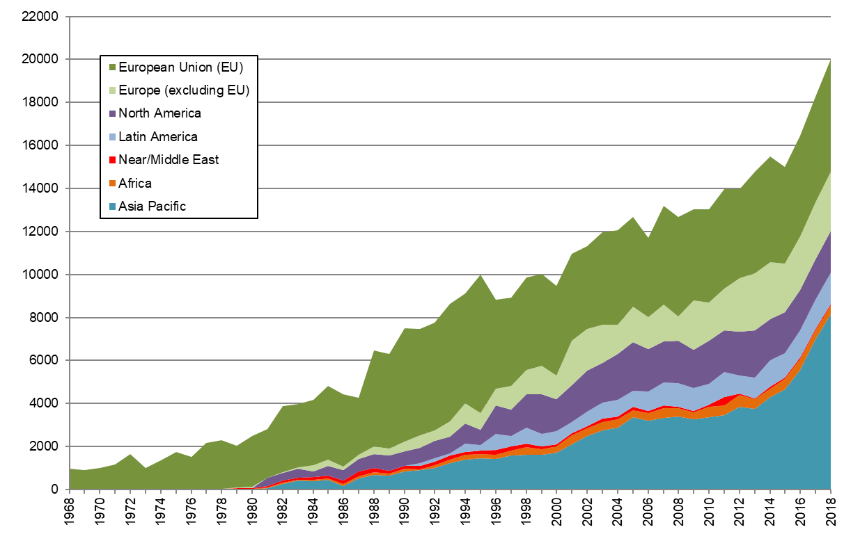 | Figure 7. Plant Breeders’ Rights Titles in Force  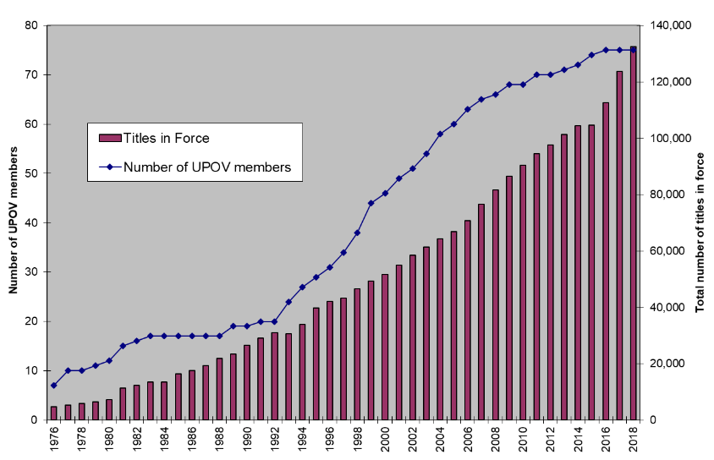
Figure 8. Applications for Plant Breeders’ Rights by Resident/Non-Resident  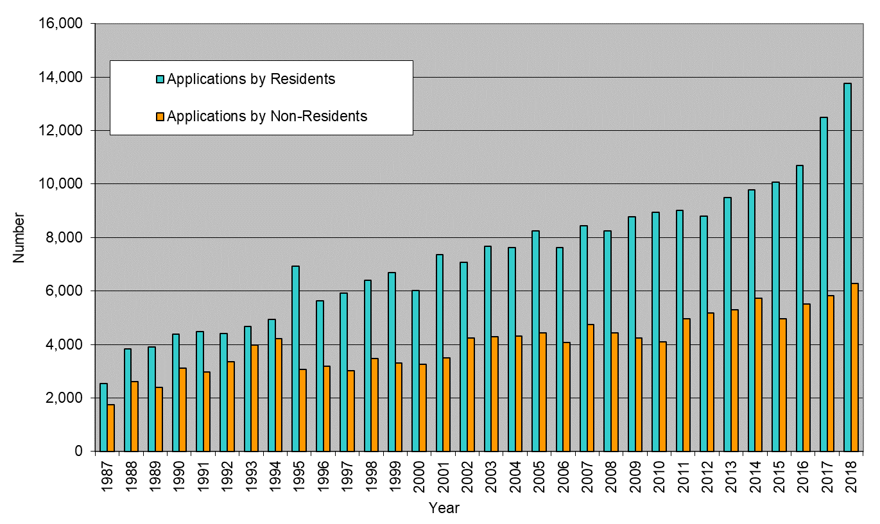 | Figure 9. Plant Breeders’ Rights Titles  Granted by Resident/Non-Resident  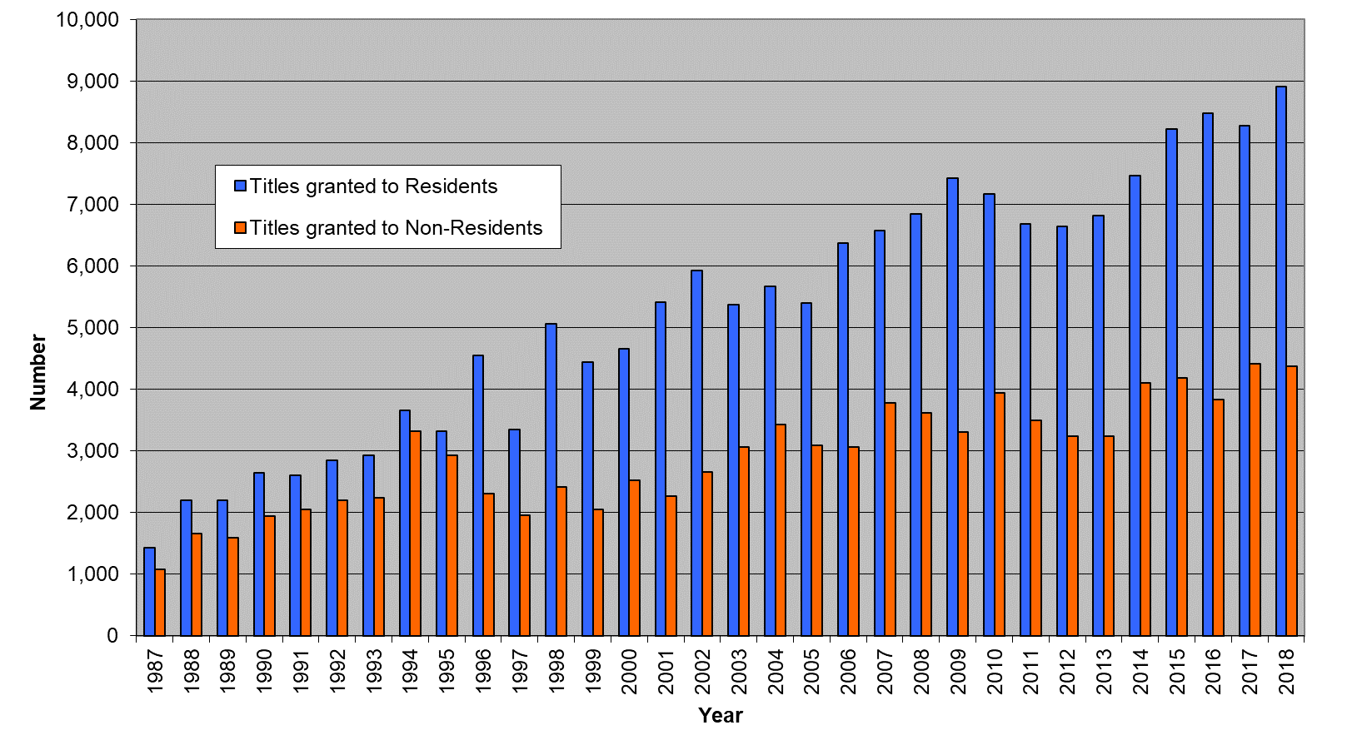

(d) Number of genera/species protected by members of the Union
(see Figures 10 and 11)

Figure 10. Protection to plant genera and species in 2019
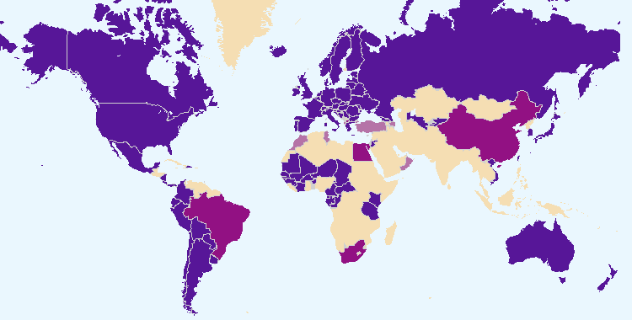
The boundaries shown on this map do not imply the expression of any opinion whatsoever on the part of UPOV concerning the legal status of any country or territory.
Members of the Union offering protection for all plant genera and species
Members of the Union offering protection for a limited number of plant genera and species
Members of the Union who had not notified the extension of protection to all genera and species

Figure 11. Evolution of protection to plant genera and species
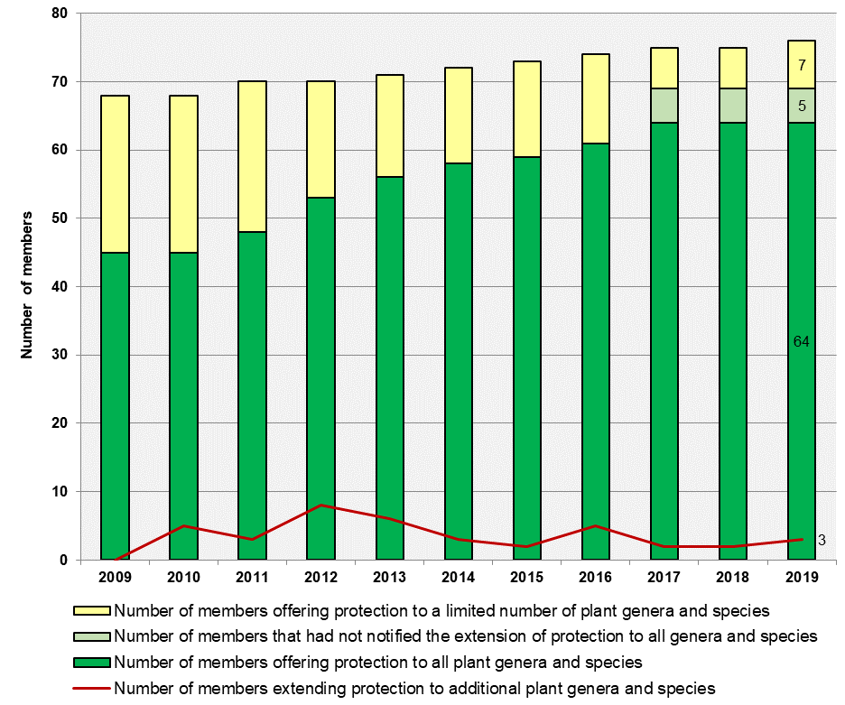

(e) Number of genera/species for which varieties have been protected
See Figure 18 “Plant Genera/Species with Cooperation Agreements, Practical Experience and Plant Breeders’ Rights Entries in Plant Variety Database”

(f) Analysis by crop type
Data from PLUTO database

Applications filed by crop type:  Crop type  Year Agri-culture Forest trees Fruit Orna-mental Vege-tables  2012 27% 0.9% 12% 48% 12%  2013 25% 1.0% 12% 49% 11%  2014 30% 0.8% 11% 47% 10%  2015 33% 0.5% 14% 36% 16%  2016 37% 0.6% 11% 34% 18%  2017 33% 0.5% 11% 38% 17%  2018 35% 0.5% 12% 33% 20%  2019 34.2% 0.6% 9.6% 36.8% 18.6% | Titles issued by crop type:  Crop type  Year Agri-culture Forest trees Fruit Orna-mental Vege-tables  2012 26% 0.7% 9% 48% 15%  2013 34% 0.7% 10% 42% 13%  2014 35% 0.6% 10% 43% 12%  2015 32% 0.9% 10% 44% 13%  2016 32% 1.1% 9% 40% 18%  2017 27% 0.4% 12% 45% 16%  2018 27% 0.5% 11% 43% 18%  2019 34.3% 0.4% 9.1% 37.6% 17.7%

5. Facilitating applications through UPOV PRISMA (formerly known as the UPOV Electronic Application Form (EAF) tool)

(a) Number of UPOV members participating in UPOV PRISMA
At the end of 2019, 35 members of the Union, covering 74 States, were participating in UPOV PRISMA.
At the end of 2018, 30 UPOV members were participating in UPOV PRISMA.

(b) Number of crops/species covered by UPOV PRISMA
At the end of 2019, UPOV PRISMA was available for all genera and species in 23 members of the Union, and for a limited list of genera & species (1-100 crops) in 12 UPOV members.
At the end of 2018, UPOV PRISMA was available for all genera a species in 20 UPOV members, and for a limited list of genera & species (1-100 crops) in 10 UPOV members.

(c) Number of applications made via UPOV PRISMA (see UV. 2)
In 2019, 214 applications were made for PBR via UPOV PRISMA (77 in 2018; 14 in 2017).
In 2019, 5 applications were made for National Listing via UPOV PRISMA (new functionality introduced in June 2019).

6. Council policy

(a) Recommendations by the Consultative Committee, and decisions by the Council
The Council took decisions, based on recommendations by the Consultative Committee or by correspondence (as indicated), concerning the following:
- to recommend that Afghanistan incorporate the amendments in the “Plant Variety Protection Act”, as provided in document C/52/19, and recommend that, once the amendments have been incorporated in the Act, the amended Act be submitted to the Council for examination in conformity with Article 34(3) of the 1991 Act;
- to take a positive decision on the conformity of:
- the “Plant Variety Protection Bill of Nigeria” (by correspondence);
- the “Plant Breeders’ Protection Bill 2019 of Saint Vincent and the Grenadines” (by correspondence);
- the relevant parts of the “Draft Law of Mongolia on Crop Seed and Variety”;
- the “Draft Plant Variety Protection Act of Afghanistan”;
- agreed that the changes introduced in Book Four “Plant Varieties” of Law Pertaining to the Protection of Intellectual Property Rights” of Egypt, as last amended in 2019, did not affect the substantive provisions of the 1991 Act of the UPOV Convention and reaffirmed its decision on conformity of March 27, 2015;
- agreed that the changes introduced in the New Plant Variety Protection Law of Myanmar, which had been adopted by the Parliament on September 17, 2019, and published in the Official Gazette on September 24, 2019, did not affect the substantive provisions of the 1991 Act of the UPOV Convention and reaffirmed its decision on conformity of October 26, 2017;
- to make the use of UPOV PRISMA free of charge in 2019, and to introduce a UPOV PRISMA fee per application at 90 Swiss Francs, starting in January 2020, subject to resolution of the technical issues and improvements being made to the user experience, before a fee was introduced. It further agreed that, where the same variety was submitted for both plant breeders’ rights and national listing in the same participating member of the Union, a single fee would be charged at the time of the first submission for the variety;
- to continue to make the GENIE database available without charge to users on the basis that a new feature in UPOV PRISMA based on cooperation in DUS examination information contained in the GENIE database, would be captured in the UPOV PRISMA fee, as appropriate;
- to approve the following approach for the PLUTO database from November 2020:
- free option: the PLUTO database with a search function would be free to all users. Search results would be limited to an on-screen display of a single page of results. There would be no facility to download search results or data from the PLUTO database,
- premium option: users paying a fee would have access to all PLUTO database features and would be able to download data without restrictions. The fee would be CHF 750 per annum,
- members of the Union and data contributors: access to all PLUTO database “premium” features would be free to all members of the Union and data contributors (i.e. OECD), and
- access to PLUTO data could also be granted in cases approved by the Consultative Committee, in a similar way to the assistance provided by the Office of the Union to the International Treaty on Plant Genetic Resources for Food and Agriculture (ITPGRFA);
- to discontinue the arrangement between UPOV and WIPO concerning the UPOV Plant Variety Database (UPOV-WIPO arrangement) as soon as the knowledge transfer and rationalization of the PLUTO database data management had been completed to the satisfaction of the Office of the Union;
- agreed a revised text of the FAQ “What are the benefits of new varieties of plants for society?”;
- to approve the proposed text for updating of FAQs and the proposed amendments to the UPOV Distance Learning materials, to reflect developments concerning UPOV PRISMA;
- to request the Office of the Union to cooperate with FAO in relation to the request of the Commission on Genetic Resources for Food and Agriculture (CGRFA) to carry out, in coordination with the International Treaty on Plant Genetic Resources for Food and Agriculture (ITPGRFA) and in consultation with UPOV, in-depth case studies to consider the effects of seed policies, laws and regulations;
- to invite the World Farmers’ Organisation (WFO) to become a full partner in the WSP, as reproduced in document C/53/15 “Report”, paragraph 23(i);
- to approve the draft joint paper “Benefits of the WSP for farmers”, to be posted on the WSP website and to be used for communication purposes;
- to place a restriction in a UPOV bank account for funds allocated for financing UPOV’s After Service Health Insurance (ASHI) liability, and that the amount represented by the provisions for ASHI obligations at the end of the 2016-2017 biennium, together with the balance from the 6 per cent charge after deduction of the respective biennium’s payments, if any, be transferred to that account with the restriction starting from the 2018-2019 biennium and to apply to that funds thus restricted in the UPOV bank account the investment policy that WIPO applied to the account for financing WIPO’s ASHI liability.

(b) Other decisions by the Council
The Council also took decisions concerning the following:
- work programs of the Administrative and Legal Committee (CAJ), the Technical Committee (TC), the Technical Working Parties (TWPs) and the Working Group on Biochemical and Molecular Techniques, and DNA-Profiling in Particular (BMT);
- election of the:
– President and Vice-President of the Council
– Chair and Vice-Chair of the CAJ
– Chair and Vice-Chair of the TC

(c) Other work of the Consultative Committee
The Consultative Committee:
- requested the Office of the Union to present options to the Consultative Committee, at its ninety-sixth session, for the financing of UPOV PRISMA, including: fee per submission; fee per variety; subscription model(s) for applicants; subscription model(s) for members of the Union and package(s) of UPOV services;
- noted the progress in the work of the Working Group on an International System of Cooperation (WG-ISC) at the fourth meeting of the WG-ISC, held in Geneva on October 31, 2018. The Consultative Committee noted that, subject to agreement by the WG-ISC, a document would be presented to the Consultative Committee at its ninety-sixth session, immediately after the fifth meeting of the WG-ISC, to be held on the evening of October 30, 2019. At its ninety-sixth session, the Consultative Committee noted the proposals, analysis and information agreed by the Working Group on a possible International System of Cooperation (WG-ISC), at its fifth meeting, held in Geneva on October 30, 2019, and invited the Office of the Union to present a summary of existing work/initiatives relevant for each proposal alongside the proposals of the WG-ISC, at the ninety-seventh session of the Consultative Committee to be held on October 29, 2020;
- agreed that the redrafting of the adopted FAQ on Sustainable Development Goals (SDGs) should not be pursued further. However, the Consultative Committee agreed that the Office of the Union should use relevant material to communicate to the general public the role of the UPOV system in supporting sustainable development and to seek to develop an FAQ for that purpose;
- requested the Office of the Union to invite comments on the FAQ on the benefits of new varieties of plants for society, by the end of November 2018. Based on the comments received, it requested the preparation of a new draft to be circulated to the Consultative Committee by correspondence. It requested a further draft to be presented for consideration at its ninety-sixth session;
- agreed that the Office of the Union should prepare proposals to update relevant FAQs to reflect developments concerning UPOV PRISMA and the UPOV Distance Learning Programs, for consideration at its ninety-sixth session;
- agreed that the draft text for an FAQ on “How the UPOV system supports sustainable development”, as reproduced in document C/53/9 Rev., be circulated for comments and, on the basis of the comments received, the Office of the Union to prepare an updated version of the draft FAQ for consideration by the Consultative Committee at its ninety seventh-session in 2020;
- approved the proposed redesign of the UPOV website and noted the plans for the implementation of the redesigned UPOV website and a new content management system (CMS);
- approved the introduction of a UPOV Twitter account and of a Twitter account for the Vice Secretary General to communicate matters concerning UPOV;
- approved the use of the UPOV LinkedIn entry to share the same type of information that would be disseminated via the UPOV Twitter account;
- approved the plans of the Office of the Union to create a separate LinkedIn entry for UPOV PRISMA in order to achieve better functionality for publicizing UPOV PRISMA in conjunction with its e-mail campaigns;
- approved the following performance indicators for the communication strategy, as follows: visits to UPOV website; number of followers, impressions and engagement rate in Twitter and number of followers and connections in LinkedIn; and participation in workshops;
- agreed that more materials from events from outside Geneva should be posted on the UPOV website, according to available resources;
- encouraged members of the Union which were also Contracting Parties to the International Treaty on Plant Genetic Resources for Food and Agriculture (ITPGRFA) to send submissions to the Ad Hoc Technical Expert Group on Farmers’ Rights (AHTEG) on measures implementing Article 9 of the ITPGRFA (to:
pgrfa-treaty@fao.org with copy to: upov.mail@upov.int);
- requested the Office of the Union to report to the Consultative Committee at its ninety-sixth session on the progress of the AHTEG;
- requested the Vice Secretary-General to consult the Executive Secretary of the Convention on Biological Diversity (CBD) and the Secretary of the ITPGRFA on how the objectives of the CBD and ITPGRFA might be reflected in the FAQ on the relationship between the UPOV Convention and other international treaties, and to explore means on how to facilitate the exchanges of experiences and information on the implementation of the UPOV Convention, the CBD and the ITPGRFA.
- approved the assistance of the Office of the Union to Mr. Jacob Moscona in relation to data in the PLUTO database for research on the factors that determine the types of innovations that different countries produce and export in the agricultural sector with the understanding that the results of the study would be made available to UPOV;
- agreed to invite Oxfam, Plantum and Euroseeds, authors of the “Report and Recommendations of the project ‘Options to interpret the notion of private and non-commercial use as included in Article 15. 1. I of the UPOV 1991 Convention’”, concerning small holder farmers, to make a presentation at the ninety-seventh session of the Consultative Committee in 2020;
- requested the Office of the Union to include an item and prepare a document, for its ninety-seventh session, in order to provide a summary of the work of the Consultative Group on Long-Term Financial Issues of UPOV and the consideration of those issues by the Consultative Committee;
- agreed to include an item to review Regulation 4.6 of UPOV Financial Regulations and Rules (document UPOV/INF/4/5) at its ninety-seventh session.

(d) Adoption of information and position papers by the Council
The adoption of information materials by the Council is reported under Sub-Program UV.2.

2.2 Sub-program UV.2: Services to the Union for Enhancing the Effectiveness of the UPOV System

This sub-program covers the provision of guidance, information and resources for the operation of the UPOV system of plant variety protection, support for cooperation between members of the Union, the work of the relevant UPOV bodies and measures to facilitate applications for plant breeders’ rights.

The introduction of UPOV PRISMA in 2017 was a major development in facilitating applications for plant breeders’ rights. By the end of 2019, 35 members of the Union, covering 74 States, were participating in UPOV PRISMA. Use of UPOV PRISMA continued to grow during the Biennium, with 214 applications made for PBR via UPOV PRISMA in 2019, compared to 77 in 2018 and 14 in 2017.

The effectiveness of the UPOV system is enhanced by the provision of guidance and information materials. In 2019, the “Seminar on the impact of policy on essentially derived varieties (EDVs) on breeding strategy”, led the CAJ to agree to open up the “Explanatory Notes on Essentially Derived Varieties under the 1991 Act of the UPOV Convention” (document UPOV/EXN/EDV/2). The CAJ is also working on the revision of the “Explanatory notes on variety denominations under the UPOV Convention”, with a view to increasing harmonization in the examination of variety denominations.

Cooperation between members of the Union is a key benefit of UPOV membership. In 2019, the TC discussed technical concerns that can prevent cooperation in DUS examination and agreed to invite the UPOV Office to develop a coherent plan, based on specified proposals, to address the concerns and to propose how to assess the impact of the plan. The TC also agreed to report to the CAJ the related policy or legal issues that can prevent cooperation in DUS examination.

The work of the Technical Working Parties (TWPs) and the Technical Committee (TC) on the development and revision of Test Guidelines (TG) continues to be a cornerstone for cooperation between members of the Union in the examination of Distinctness, Uniformity and Stability (“DUS”). At the same time, the harmonization provided by TG and the availability of TG data in the web-based Test Guidelines Template (TG Template) enabled the rapid expansion of UPOV PRISMA to cover all crops and species for those members of the Union that use the UPOV Test Guidelines as the basis for the technical questionnaires in their application forms. In 2019, the adopted Test Guidelines covered 94% of all PBR-related entries in the Plant Variety Database. .

The UPOV Code System was developed to overcome the problem of synonyms for plant taxa and is essential for the functioning of UPOV PRISMA and the PLUTO and GENIE databases. However, the TC will now explore a new approach that would enable UPOV Codes to provide additional information on variety groups or types for DUS testing purposes, while continuing to enable the UPOV code system to be based on taxonomic criteria.

Objectives | - To maintain and improve the effectiveness of the UPOV system.  - To provide and develop the legal, administrative and technical basis for international cooperation in plant variety protection according to the UPOV Convention.

Results Achieved: Selected Performance Indicators

1. Participation by members of the Union and observers in the work of the UPOV bodies

(a) Participation in the Administrative and Legal Committee
(see Figure 12)

Figure 12. Number of Participating Members and Observer States/Organizations in the CAJ

(b) Participation in the Technical Committee
(see Figure 13)

Figure 13. Number of Participating Members and Observer States/Organizations in the TC
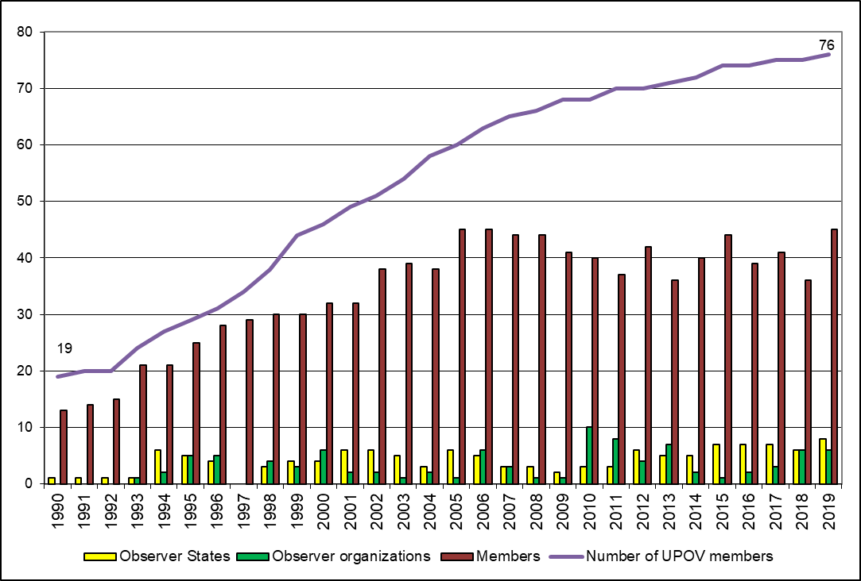

(c) Participation in Technical Working Party Sessions
(see Figure 14)

Figure 14. Number of Participating Members and Observer States/Organizations in the TWPs
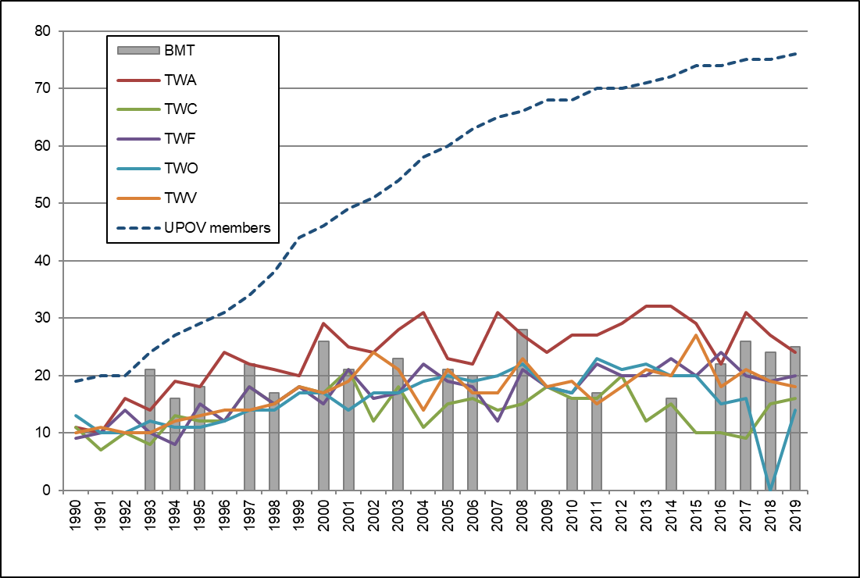

(d) Participation in Preparatory Workshops for the Technical Working Party Sessions
(see Figure 15)
Figure 15

(i) Number of individual participants in the Preparatory Workshops: members and observers

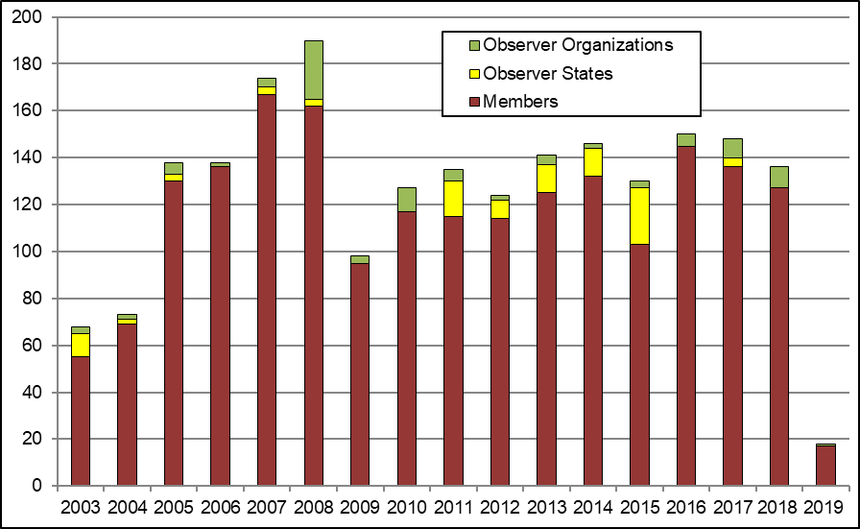

(ii) Number of individual participants in the Preparatory Workshops by Technical Working Party

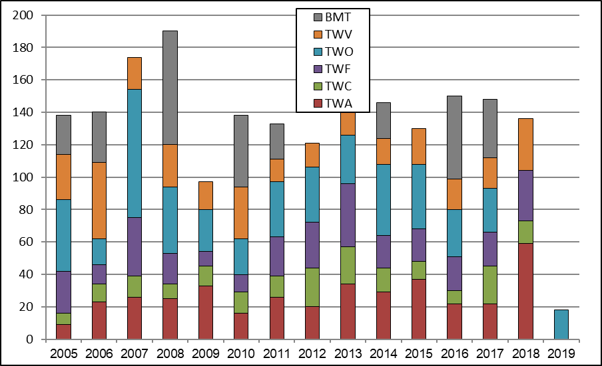

2. Guidance on the UPOV Convention and its implementation and information on its application

(a) Adoption of new or revised information materials concerning the UPOV Convention
The Council adopted:
- 8 revisions to previously adopted information documents
UPOV/INF/4/5 Financial Regulations and Rules of UPOV (Revision)
UPOV/INF/5/2 UPOV Model Plant Breeders’ Rights Publication (Revision)
UPOV/INF/16/8 Exchangeable Software (Revision)
UPOV/INF/22/5 Software and equipment used by members of the Union (Revision)
UPOV/INF/22/6 Software and equipment used by members of the Union (Revision)
UPOV/INF-EXN/12 List of INF-EXN Documents and Latest Issue Dates (Revision)
UPOV/INF-EXN/13 List of INF-EXN Documents and Latest Issue Dates (Revision)

The CAJ and TC, as appropriate, considered drafts of the following:
- 4 revisions to previously adopted information documents
UPOV/INF/5/2 UPOV Model Plant Breeders’ Rights Publication (Revision)
UPOV/INF/16/8 Exchangeable Software (Revision)
UPOV/INF/22/5 Software and equipment used by members of the Union (Revision)
UPOV/INF/22/6 Software and equipment used by members of the Union (Revision)
- 1 new explanatory note
UPOV/EXN/DEN/1 Explanatory Notes on Variety Denominations under the UPOV Convention
- for TGP documents, see Section 2.2 “Sub-Program UV.2”, expected result “2. Guidance on the examination of varieties” and “(a) Adoption of new or revised TGP documents and information materials”

(b) Publication of the UPOV Gazette and Newsletter
There was no issue of UPOV Publication No. 438 “Plant Variety Protection Gazette and Newsletter” in the 2018-2019 Biennium.

(c) Inclusion of laws of members of the Union in UPOV Lex database
- 7 laws concerning the following 7 members of the Union were included in the UPOV Lex database
Argentina, Australia, Belgium, Colombia, Dominican Republic, Egypt and Norway

UPOV Lex database: visits to the UPOV Website in 2019

Language | Pageviews | Unique pageviews
English | 60,499 | 41,770
Spanish | 22,667 | 15,703
French | 5,891 | 4,162
German | 1,700 | 1,240
Total: | 90,757 | 62,875

Evolution of visits

Year | Pageviews | Unique pageviews
2019 | 90,757 | 62,875
2018 | 92,199 | 64,413
2017 | 82,861 | 59,166
2016 | 85,374 | 60,294
2015 | 80,460 | 55,991
2014 | 88,305 | 60,439
2013 | 88,533 | 61,230
2012 | 91,245 | 62,411
2011 | 19,269 | 12,575

(d) Availability of UPOV documents and materials in languages other than the UPOV languages (English, French, German and Spanish)
- Translation into Chinese and Thai of the UPOV Video on “Tsuyahime rice, the secret of its success”.

(see http://www.upov.int/about/en/languages.html)

3. Guidance on the examination of varieties

(a) Adoption of new or revised TGP documents and information materials
TGP documents adopted and published on the UPOV website:
- - 9 revisions to previously adopted TGP documents
TGP/5: Section 1/3 Experience and Cooperation in DUS Testing: Model Administrative Agreement for International Cooperation in the Testing of Varieties (Revision)
TGP/7/6 Development of Test Guidelines (Revision)
TGP/7/7 Development of Test Guidelines (Revision)
TGP/8/4 Trial Design and Techniques Used in the Examination of Distinctness, Uniformity and Stability (Revision)
TGP/10/2 Examining Uniformity (Revision)
TGP/14/4 Glossary of Terms Used in UPOV Documents (Revision)
TGP/15/2 Guidance on the Use of Biochemical and Molecular Markers in the Examination of Distinctness, Uniformity and Stability (DUS) (Revision)
TGP/0/10 List of TGP Documents and Latest Issue Dates (Revision)
TGP/0/11 List of TGP Documents and Latest Issue Dates (Revision)

- Drafts of TGP documents advanced in the CAJ, TC and/or the TWPs
- 7 revisions to previously adopted TGP documents
TGP/5: Section 1 Experience and Cooperation in DUS Testing: Model Administrative Agreement for International Cooperation in the Testing of Varieties (Revision)
TGP/7 Development of Test Guidelines (Revision)
TGP/8 Trial Design and Techniques Used in the Examination of Distinctness, Uniformity and Stability (Revision)
TGP/10 Examining Uniformity (Revision)
TGP/14 Glossary of Terms Used in UPOV Documents (Revision)
TGP/15 Guidance on the Use of Biochemical and Molecular Markers in the Examination of Distinctness, Uniformity and Stability (DUS) (Revision)
TGP/0 List of TGP Documents and Latest Issue Dates (Revision)
- Drafts of information materials advanced in the CAJ, TC and/or the TWPs
- 3 revisions to previously adopted information materials
UPOV/INF/5 UPOV Model Plant Breeders’ Rights Publication (Revision)
UPOV/INF/16 Exchangeable Software (Revision)
UPOV/INF/22 Software and equipment used by members of the Union (Revision)
- Revision of the following document considered in the Working Variety Denominations (WG-DEN):
UPOV/INF/12 Explanatory Notes on Variety Denominations under the UPOV Convention (Revision)

(b) Adoption of new or revised Test Guidelines
Adopted Test Guidelines
- In 2019, 22 Test Guidelines were adopted by the TC, comprising:
– 3 new Test Guidelines
– 6 revised Test Guidelines
– 13 partially revised Test Guidelines
- In 2018, 23 Test Guidelines were adopted by the TC, comprising:
– 8 new Test Guidelines
– 7 revised Test Guidelines
– 8 partially revised Test Guidelines
(see Figure 16)

Test Guidelines advanced in the Technical Working Parties
- In 2019, 44 draft Test Guidelines were advanced by the TWPs, comprising:
– 9 new Test Guidelines
– 27 revisions
– 8 partial revisions
- In 2018, 27 draft Test Guidelines were advanced by the TWPs, comprising:
– 4 new Test Guidelines
– 16 revisions
– 7 partial revisions
(see Figure 17)
Test Guidelines: visits to the UPOV Website in 2019

Language | Pageviews | Unique pageviews
English | 53,063 | 31,497
Spanish | 9,109 | 5,301
French | 3,483 | 2,047
German | 1,357 | 908
Total: | 67,012 | 39,753

Evolution of visits

Year | Pageviews | Unique pageviews
2019 | 67,012 | 39,753
2018 | 63,172 | 37,630
2017 | 66,567 | 38,621
2016 | 61,966 | 38,054
2015 | 64,425 | 38,144
2014 | 67,900 | 40,102
2013 | 68,479 | 38,979
2012 | 65,471 | 37,227
2011 | not available | not available

Figure 16. Adoption of Test Guidelines  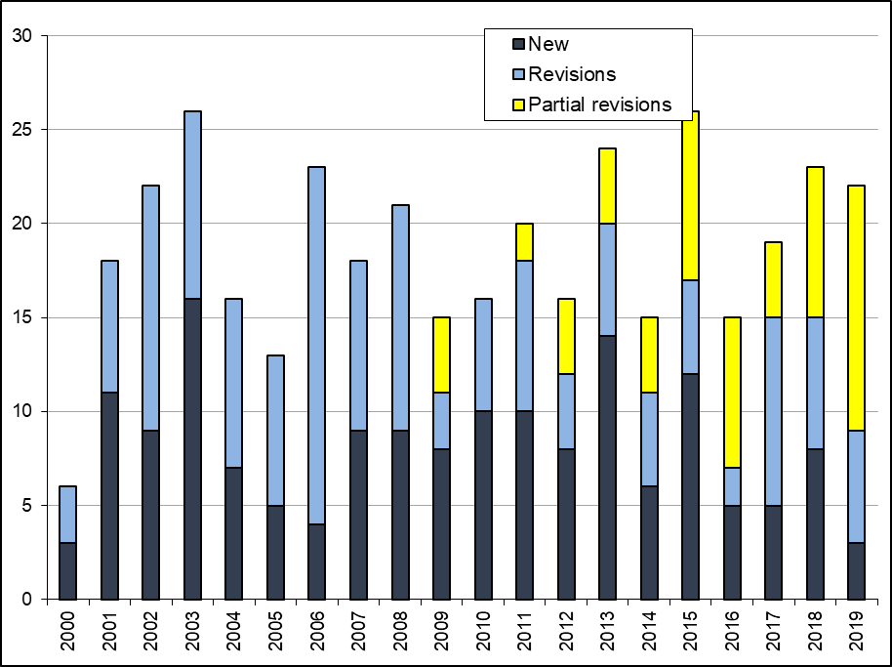 | Figure 17. Draft Test Guidelines discussed in TWPs  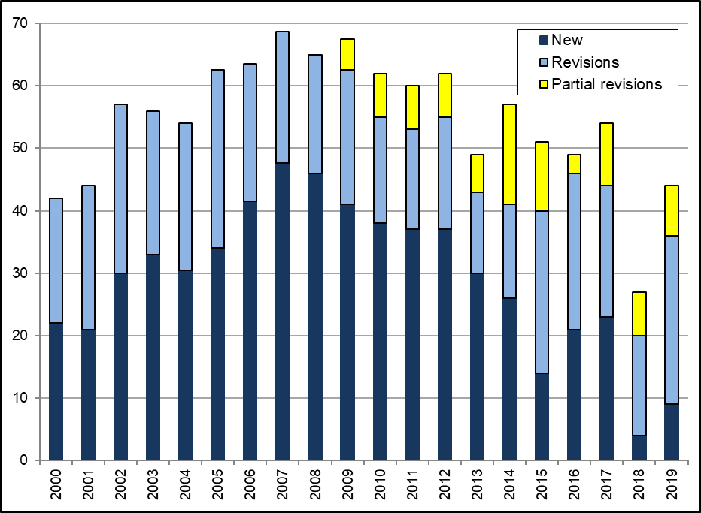

(c) Number of PBR applications covered by adopted Test Guidelines
At the end of 2019, the adopted Test Guidelines covered 94% of all PBR-related entries in the PLUTO Plant Variety Database (307,853 of 328,525) (94% at the end of 2017 (280,687 of 299,031))
(see Figure 18)

Figure 18. Plant Breeders’ Rights Entries in Plant Variety Database covered by Test Guidelines

(d) Participation in the development of Test Guidelines
An overview of participation in the development of Test Guidelines by TWPs and by region of the leading expert is provided in Figures 19 to 22.

Figure 19. Total number of Test Guidelines adopted (by Technical Working Party)  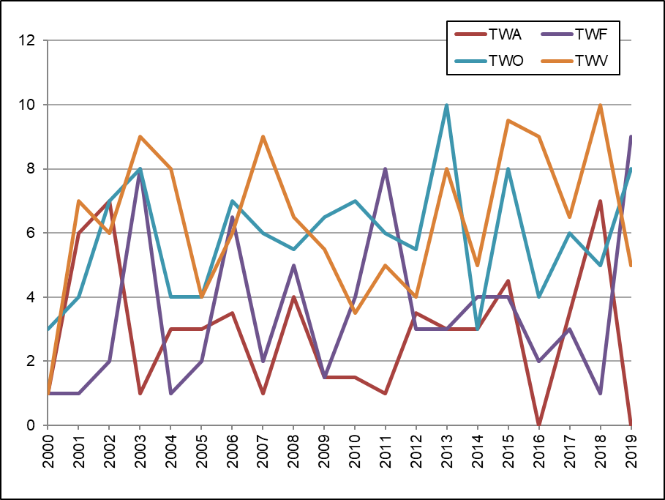 | Figure 20. Total number of Test Guidelines under development  (by Technical Working Party)  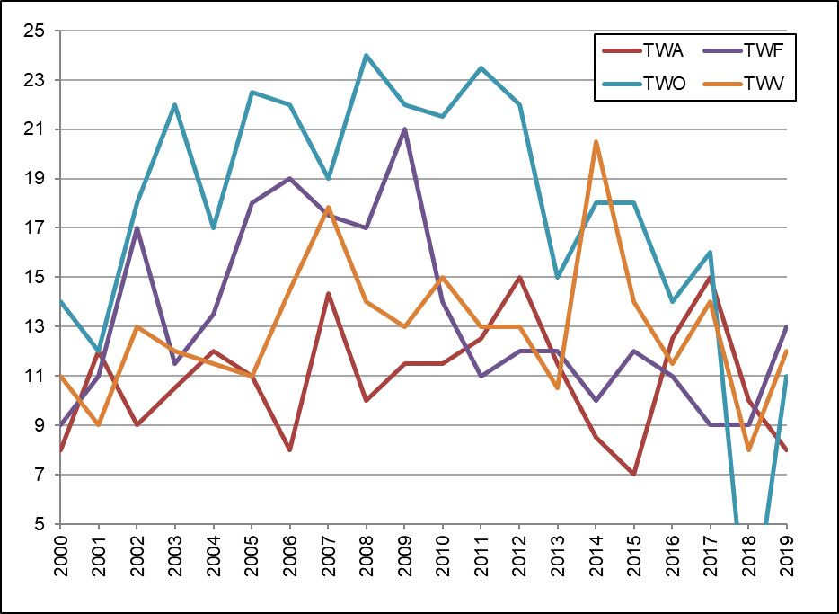
Figure 21. Total number of Test Guidelines adopted  (by region of the leading expert)  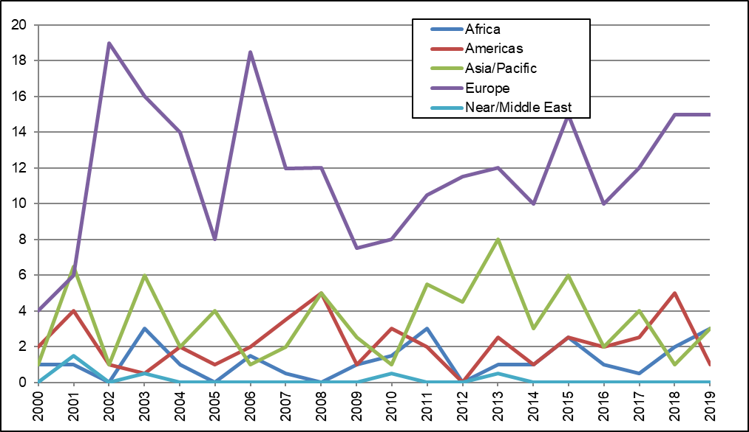 | Figure 22. Total number of Test Guidelines under development  (by region of the leading expert)  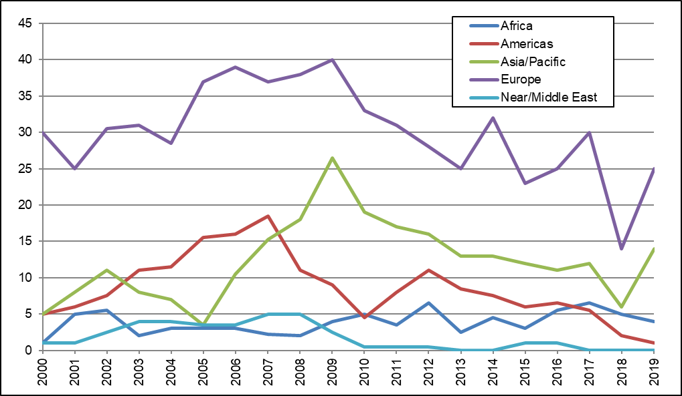
Total of 19 members of the Union involved in drafting Test Guidelines in the biennium (AR, AU, BR, DE, DK, ES, FR, GB, HU, IT, JP, KE, KR, MA, NL, NZ, QZ, SK, ZA)

(see Figure 23)

Figure 23. Number of members of the Union involved in drafting Test Guidelines
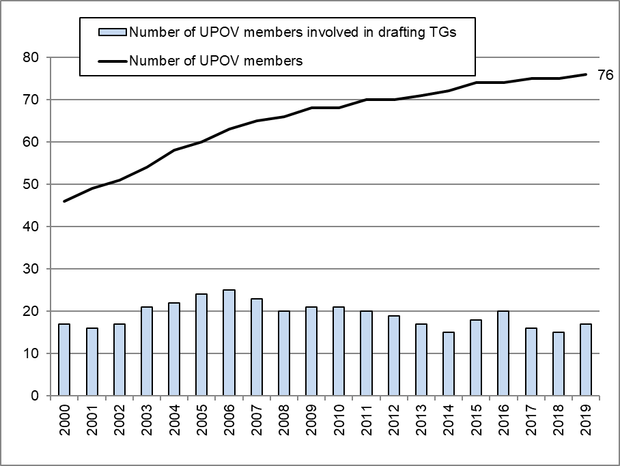

(e) Development of web-based Test Guidelines Template (TG Template) with facility for:
The web-based TG Template was used for the preparation of draft Test Guidelines for the TWPs at their sessions in 2018 and 2019.

1. Translation in UPOV languages
In 2018, Serbian, Swedish, Korean and Vietnamese were added to the translation interface to enable the insertion of adopted Test Guidelines characteristics and corresponding states of expression in those languages.

2. Use by members of the Union in the preparation of individual authorities’ test guidelines
No developments.

4. Cooperation IN DUS examination

GENIE Database: visits to the UPOV Website in 2019

2019 (July to Dec) 2017 (2018 not available)  Sessions 6,214 14,861  Users 4,058 9,991  Pageviews 30,251 72,756  New Visitors 64.6% 69.8%  Returning Visitors 35.4% 30.2% | Language* Pageviews  English 22,117  Spanish 5,021  French 1,719  German 1,394  Total: 30,251  * The analytics for language are based  on the language of the browser.
Top 10 countries from which visits were made to GENIE database in 2019

Country / Territory | Sessions | New Users
China | 340 | 203
United States of America | 287 | 199
Turkey | 283 | 179
France | 349 | 148
Mexico | 281 | 141
Spain | 291 | 146
Japan | 458 | 109
India | 174 | 112
Germany | 227 | 91
Netherlands | 169 | 61

Evolution of visits

Year | Pageviews | Unique pageviews
2019 (July to December) | 30,251 | (not available)
2018 | (not available) | (not available)
2017 | 72,756 | 40,830
2016 | 76,990 | 42,886
2015 | 67,175 | 39,165
2014 | 72,018 | 40,027
2013 | 84,306 | 49,280
2012 | 85,149 | 46,122
2011 | 59,735 | 32,839
2010 | 51,457 | 28,565
2009 | 11,474 | 5,337
2008 | 14,063 | 5,763
2007 | 5,357 | 2,530

(a) Plant genera and species for which members of the Union have practical experience
In 2019, there were 3,599 genera and species (3,752 taxa including subspecies) for which members of the Union had reported practical experience in DUS examination (see document TC/55/INF/4).
In 2018, there were 3,583 genera and species (3,732 taxa including subspecies) and 3,416 genera and species in 2017 (3,561 taxa including subspecies).
(see Figure 24)

Figure 24. Plant Genera/Species with Cooperation Agreements, Practical Experience and
Plant Breeders’ Rights Entries in Plant Variety Database
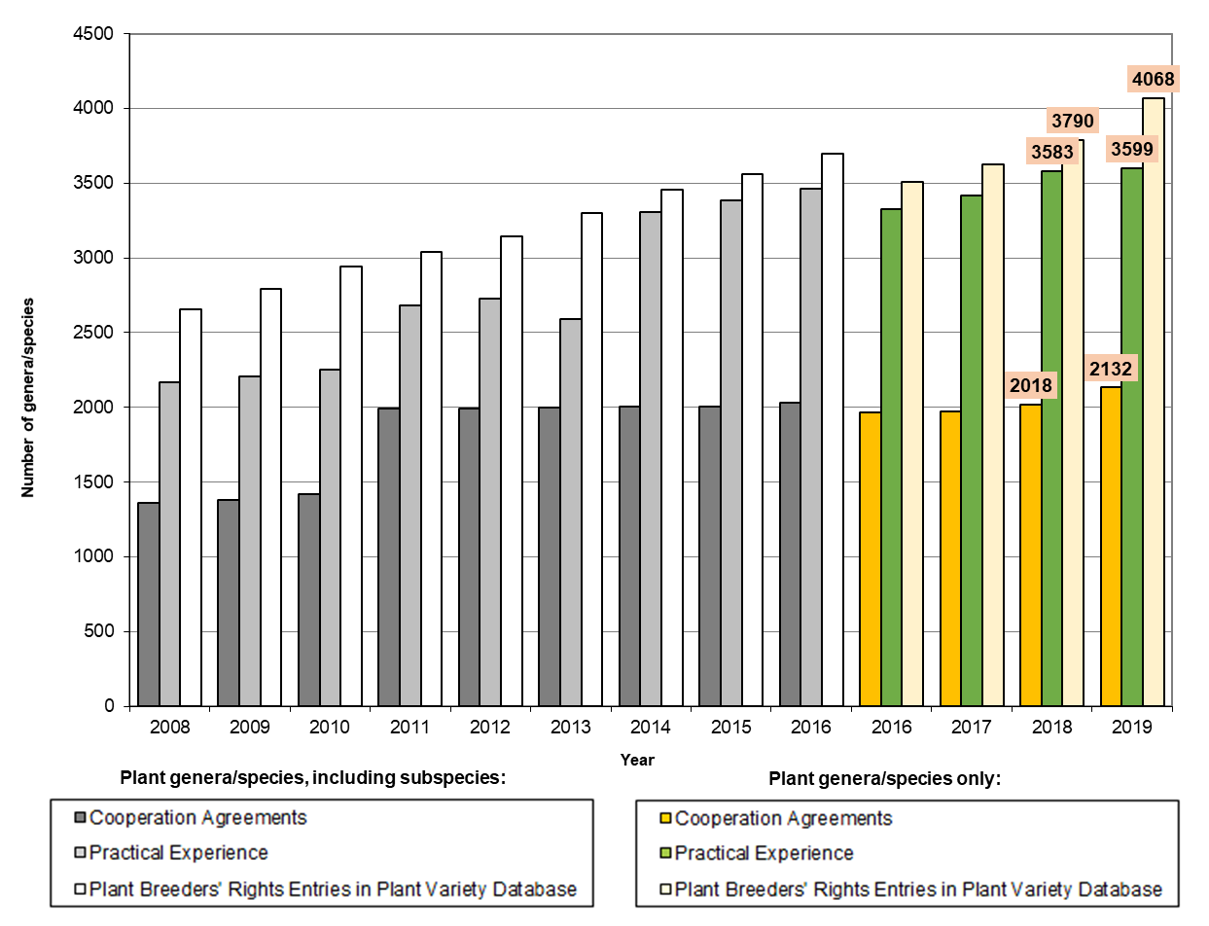

(b) Plant genera and species for which members of the Union cooperate in DUS examination, as indicated in GENIE database
In 2019, there were 2,063 genera and species (2,132 taxa including subspecies) for which there were agreements between members of the Union for cooperation in DUS examination (see document C/53/INF/5).
In 2018, there were 2,018 genera and species (2,089 taxa including subspecies) and 1,974 genera and species in 2017 (2,038 taxa including subspecies).

(see Figure 18 and document C/54/5)

5. Cooperation IN examination of variety denominations

PLUTO Database: visits to the UPOV Website in 2019

Sessions 35,673  Users 14,414  Pageviews 54,088  New Visitors 67.7%  Returning Visitors 32.3% | Language Pageviews Unique pageviews  English 45,486 32,091  Spanish 5,588 3,385  French 2,231 1,558  German 783 569  Total: 54,088 37,603

Top 10 countries visiting the PLUTO database in 2019

Country | Sessions | New Users
United States of America | 5,464 | 2,083
Netherlands | 2,375 | 431
France | 2,087 | 795
Australia | 1,629 | 428
Brazil | 1,553 | 471
Turkey | 1,305 | 446
Japan | 1,290 | 283
Mexico | 1,154 | 520
Spain | 1,021 | 519
China | 712 | 325

Evolution of visits

Year | Pageviews | Unique pageviews
2019 | 54,088 | 37,603
2018 | 53,154 | 42,768
2017 | 69,457 | 48,108
2016 | 90,630 | 63,359
2015 | 80,382 | 57,159
2014 | 74,226 | 50,203
2013 | 70,739 | 44,370
2012 | 255,108 | 51,111
2011 | 30,226 | 6,316

(a) Quantity and quality of data in PLUTO database

1. Number of contributors
- Number of contributors included in the PLUTO database:
50 in 2019 (63 in 2018; 62 in 2017; 60 in 2016)
- Number of members of the Union that contributed data:
49 in 2019 (48 in 2018; 48 in 2017; 48 in 2016)

2. Number of new submissions
- Number of submissions of new data:
327 in 2019 (248 in 2018; 222 in 2017; 255 in 2016)
- Number of members of the Union that contributed data for the first time:
1 in 2019 (1 in 2018; 2 in 2017; 2 in 2016)

3. Number of records
- Total number of records included in the PLUTO database at the end of 2019:
873,549 (828,808 at the end of 2018; 797,669 at the end of 2017; 765,070 at the end of 2016)

6. dEVELOPMENT OF upov prisma (FORMERLY KNOWN AS THE UPOV electronic application form (EAF) tool)

See Sub-Program UV.1, performance indicator 8 “Facilitating applications through UPOV PRISMA (formerly known as the UPOV Electronic Application Form (EAF) tool)”

2.3 Sub-Program UV.3: Assistance in the Introduction and Implementation of the UPOV System

This sub-program covers the assistance provided in response to requests by members of the Union and potential members of the Union. Satisfying the demand for assistance in the introduction and implementation of the UPOV system within available resources relies on the use of distance-learning courses, training of trainers, the prioritization of assistance by the Office of the Union and the use of external resources for administration, training and assistance according to available finances. This sub-program is supported by the regular budget, but extra-budgetary funds and support in kind provide a substantial proportion of the resources deployed for assistance. In order to utilize the available resources in the most effective way, the Office of the Union continued to prioritize its activities and to explore synergies in its activities with members of the Union and other partners.

The priority for providing assistance by the Office of the Union is as follows:

- assistance to existing members of the Union;
- assistance to States and certain organizations that are not members of the Union, particularly governments of developing countries and countries in transition to a market economy, in the development of legislation in line with the 1991 Act of the UPOV Convention and their accession to the UPOV Convention; and
- assistance to States and certain organizations that are not members of the Union, in the implementation of legislation that has received a positive decision of the Council, according to their commitment to accede to the UPOV Convention.

The increasing interest in UPOV membership in recent years continued. The number of non-UPOV member States/ Organizations provided with comments on laws (17) was the highest for more than 20 years. The number of States/organizations which received positive advice from the Council was also the highest since 2000.

Thirty-one States (10 members of the Union and 21 non-members of the Union) contacted the Office of the Union for assistance in the development of legislation on plant variety protection. A total of 22 States (5 members of the Union and 17 non-members of the Union) were provided with comments on their laws or draft laws. Four States initiated with the Council the procedure for becoming members of the Union. The Council provided a positive advice to 6 States on the conformity of their laws or draft laws with the 1991 Act of the UPOV Convention. One member of the Union (Belgium) ratified the 1991 Act of the UPOV Convention. One State (Egypt) became a member of the Union.

The Office of the Union organized or participated in 235 missions/events in the 2018-2019 Biennium, at which 141 States and 17 organizations were provided with information about the UPOV system. A total of 1,166 students from 102 States and 4 organizations participated in UPOV’s distance learning courses.

Objectives

- To raise awareness of the role of plant variety protection according to the UPOV Convention.
- To assist States and organizations, particularly governments of developing countries and countries in transition to a market economy, in the development of legislation in accordance with the 1991 Act of the UPOV Convention.
- To assist States and organizations in their accession to the 1991 Act of the UPOV Convention.
- To assist States and organizations in implementing an effective plant variety protection system in accordance with the UPOV Convention.

Results Achieved: Selected Performance Indicators

1. Raising awareness of the role of plant variety protection in accordance with the UPOV Convention

(a) States and organizations provided with information at UPOV activities
States provided with information at UPOV activities:

Afghanistan, Algeria, Argentina, Australia, Azerbaijan, Bangladesh, Barbados, Belarus, Belgium, Benin, Bhutan, Bolivia (Plurinational State of), Bosnia and Herzegovina, Botswana, Brazil, Brunei Darussalam, Bulgaria, Burkina Faso, Burundi, Cambodia, Cameroon, Canada, Chad, Chile, China, Colombia, Comoros, Congo, Costa Rica, Côte d’Ivoire, Cuba, Cyprus, Czech Republic, Denmark, Dominican Republic, Ecuador, Egypt, Eritrea, Eswatini, Ethiopia, Fiji, Finland, France, Gabon, Gambia, Georgia, Germany, Ghana, Greece, Guatemala, Guinea, Guinea-Bissau, Guyana, Haiti, Iceland, India, Indonesia, Iran (Islamic Republic of), Iraq, Ireland, Israel, Italy, Jamaica, Japan, Jordan, Kazakhstan, Kenya, Kuwait, Kyrgyzstan, Lao People’s Democratic Republic, Latvia, Lebanon, Lesotho, Liberia, Liechtenstein, Lithuania, Luxembourg, Madagascar, Malawi, Malaysia, Mali, Mauritius, Mexico, Mongolia, Mozambique, Myanmar, Namibia, Nepal, Netherlands, New Zealand, Niger, Nigeria, Norway, Oman, Pakistan, Panama, Paraguay, Peru, Philippines, Poland, Republic of Korea, Republic of Moldova, Romania, Russian Federation, Rwanda, Saint Kitts and Nevis, Saint Vincent and the Grenadines, Saint Lucia, Sao Tome and Principe, Saudi Arabia, Senegal, Serbia, Seychelles, Sierra Leone, Singapore, Slovakia, Slovenia, Solomon Islands, South Africa, Spain, Sri Lanka, Sudan, Sweden, Switzerland, Syrian Arab Republic, Thailand, Togo, Tunisia, Turkey, Uganda, Ukraine, United Arab Emirates, United Kingdom, United Republic of Tanzania, United States of America, Uruguay, Uzbekistan, Venezuela, Viet Nam, Zambia, Zimbabwe (141 States)
(see Figure 25)

Figure 25. States provided with information at UPOV activities
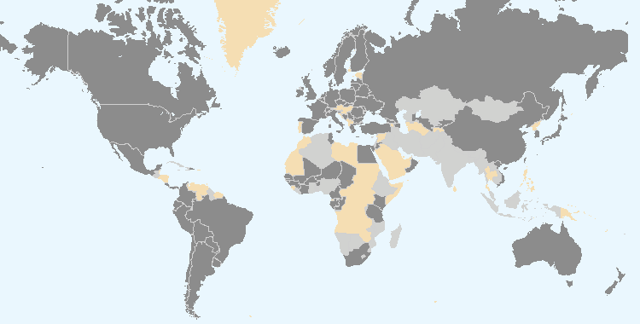
The boundaries shown on this map do not imply the expression of any opinion whatsoever on the part of UPOV concerning the legal status of any country or territory.
Members of the Union Non-members of the Union

Intergovernmental organizations provided with information at UPOV activities (10):

ARIPO, CBD, COMESA, CPVO (European Union), EPO, EUIPO, ITPGRFA, OAPI, South Centre, WIPO

Non-governmental organizations provided with information at UPOV activities (7):

AATF, AFSTA, CIOPORA, CropLife International, ESA, ISF, SAA

Location of UPOV activities:

Australia, Bosnia and Herzegovina, Bulgaria, Cameroon, Canada, China, Côte d'Ivoire, Ecuador, Egypt, India, Indonesia, Japan, Jordan, Kazakhstan, Kenya, Lao People’s Democratic Republic, Malaysia, Mexico, Mongolia, Myanmar, Namibia, Netherlands, New Zealand, Oman, Peru, Philippines, Republic of Korea, Russian Federation, Singapore, South Africa, Sweden, Switzerland, United States of America, Uzbekistan, Viet Nam
(see Figure 26)

Figure 26. Location of UPOV activities
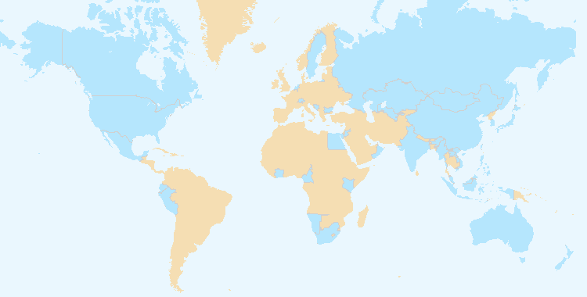
The boundaries shown on this map do not imply the expression of any opinion whatsoever on the part of UPOV concerning the legal status of any country or territory.

(b) States and organizations that contacted the Office of the Union for assistance in the development of legislation on plant variety protection
Members of the Union (10): Bosnia and Herzegovina, Colombia, Georgia, Japan, Mexico, New Zealand, Paraguay, Trinidad and Tobago, Uzbekistan and Viet Nam

Non-members of the Union (21): Afghanistan, Algeria, Antigua and Barbuda, Cambodia, Egypt (2018), Indonesia, Iraq, Iran (Islamic Republic of), Jamaica, Kazakhstan, Lao People’s Democratic Republic, Liechtenstein, Malaysia, Mauritius, Mongolia, Myanmar, Nigeria, Saint Vincent and the Grenadines, United Arab Emirates, Zambia and Zimbabwe

(see Figure 27)

(c) States and organizations that initiated with the Council of UPOV the procedure for becoming members of the Union
Afghanistan, Mongolia, Nigeria and Saint Vincent and the Grenadines (4)

(see Figure 27)

Figure 27. States and organizations that contacted the Office of the Union for assistance in the development of legislation on plant variety protection and States and organizations that initiated
with the Council of UPOV the procedure for becoming members of the Union
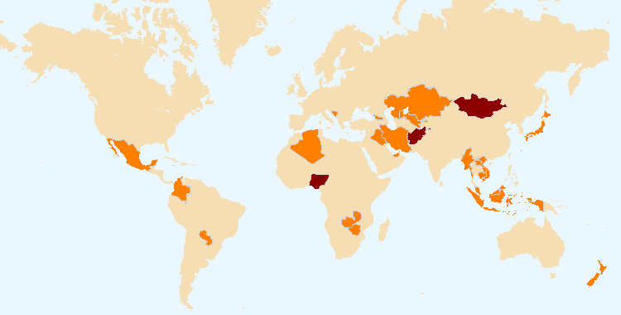
The boundaries shown on this map do not imply the expression of any opinion whatsoever on the part of UPOV concerning the legal status of any country or territory.
States and organizations that initiated with the Council of UPOV the procedure for becoming members of the Union

States and organizations that contacted the Office of the Union for assistance in the development of legislation on plant variety protection

(d) Participation in UPOV awareness-raising activities, or activities involving UPOV staff or UPOV trainers on behalf of UPOV staff
- Activities organized by, or with, UPOV: see (b) above

- Activities/meetings in which UPOV participated: see Figure 28

Location of activities/meetings where UPOV made presentations:

Argentina, Australia, Belgium, Brazil, Burkina Faso, Cameroon, China, Costa Rica, Côte d'Ivoire, Finland, France, Germany, India, Japan, Kenya, Liberia, Luxembourg, Malaysia, Mali, Netherlands, New Zealand, Nigeria, Peru, Philippines, Russian Federation, South Africa, Spain, Sweden, Switzerland, Togo, Turkey, United Kingdom, United States of America, Viet Nam, Zimbabwe

Figure 28. Location of activities/meetings where UPOV made presentations
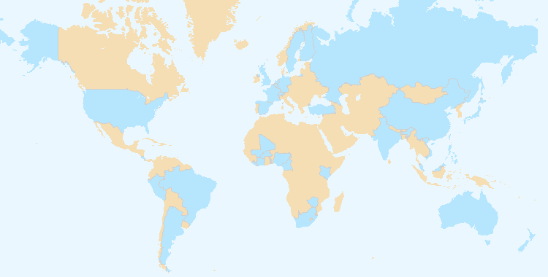
The boundaries shown on this map do not imply the expression of any opinion whatsoever on the part of UPOV concerning the legal status of any country or territory.

2. Assistance in drafting legislation on plant variety protection in accordance with the 1991 Act of the UPOV Convention

(a) Meetings with government officials to discuss legislative matters
Members of the Union (9): Colombia, Ecuador, Georgia, Mexico, New Zealand, Paraguay, Trinidad and Tobago, Uzbekistan and Viet Nam

Non-members of the Union (22): ARIPO, Afghanistan, Antigua and Barbuda, Brunei Darussalam, Cambodia, Egypt (2018), Ghana, Guatemala, Iran (Islamic Republic of), Iraq, Jamaica, Kazakhstan, Lao People’s Democratic Republic, Liechtenstein, Malaysia, Mongolia, Myanmar, Nigeria, Saint Vincent and the Grenadines, United Arab Emirates, Zambia and Zimbabwe

(see Figure 29)

Figure 29. Assistance provided in drafting legislation on plant variety protection
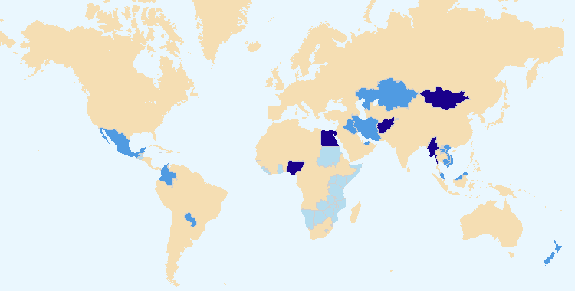

The boundaries shown on this map do not imply the expression of any opinion whatsoever on the part of UPOV concerning the legal status of any country or territory.
States and organizations which received a positive advice from the Council of UPOV
States and organizations provided with comments on laws
Meetings with government officials

(b) States and organizations provided with comments on laws
Members of the Union (5): Colombia, Mexico, New Zealand, Paraguay and Viet Nam

Non-members of the Union (17): Afghanistan, Cambodia, Egypt (2018), Jamaica, Iran (Islamic Republic of), Iraq, Kazakhstan, Lao People’s Democratic Republic, Liechtenstein, Malaysia, Mongolia, Myanmar, Nigeria, Saint Vincent and the Grenadines, United Arab Emirates, Zambia and Zimbabwe

(see Figure 30)

(c) States and organizations which received a positive advice from the Council of UPOV
Afghanistan, Egypt, Mongolia, Myanmar, Nigeria and Saint Vincent and the Grenadines (6)

(see Figure 31)

3. Assistance to States and organizations in the accession to the 1991 Act of the UPOV Convention

(a) States and organizations that acceded to or ratified the 1991 Act of the UPOV Convention
Belgium and Egypt (2)

(see Figure 33)

(b) States and organizations that became members of the Union
Egypt (1)

(see Figure 32)

Figure 30. States/Organizations provided with  comments on laws | Figure 31. States/Organizations which received  positive advice from the Council  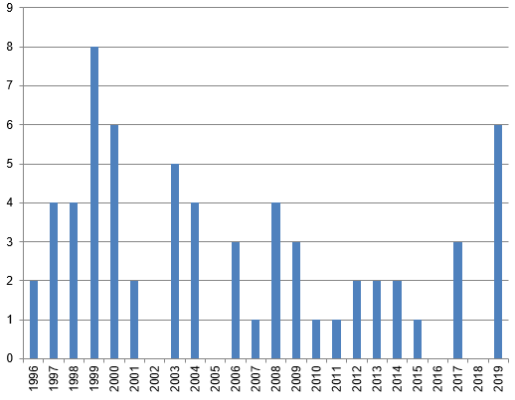

Figure 32. New members of the Union
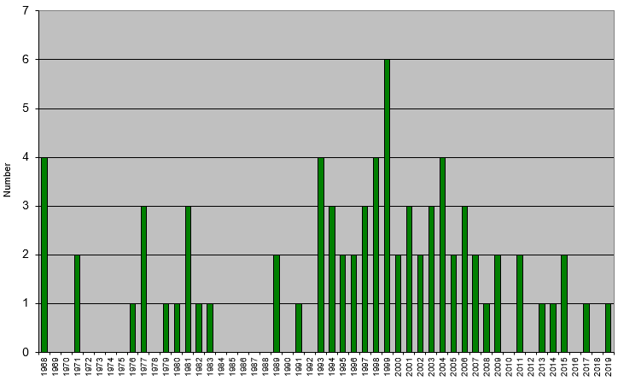

Figure 33. Accession to/ratification of the 1991 Act
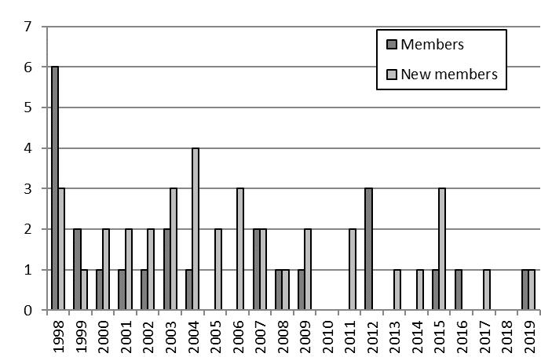

4. Assistance in implementing an effective plant variety protection system in accordance with the UPOV Convention

(a) Participation in distance learning courses
Number of participants in main sessions of UPOV distance learning courses in 2018 and 2019
by category

Category | Number of participants
 | DL-205 | DL-305 | DL-305A | DL-305B | Total
Category 1: Government officials of members of the Union | 587 | 174 | 116 | 96 | 973
Category 2: Officials of observer States / intergovernmental organizations | 95 | 10 | 6 | 7 | 118
Category 3: Others (Fee: CHF1,000) | 32 | 4 | 2 | 1 | 39
Category 4: Discretionary waiving of fee for selected students | 28 | 3 | 3 | 2 | 36
Total: | 742 | 191 | 127 | 106 | 1,166

List of countries and organizations from which there were participants
in all distance learning sessions in 2018 and 2019

Afghanistan, Argentina, Australia, Austria, Azerbaijan, Barbados, Belgium, Benin, Bolivia (Plurinational State of), Bosnia and Herzegovina, Brazil, Bulgaria, Burkina Faso, Burundi, Cameroon, Canada, Chad, Chile, China, Colombia, Costa Rica, Côte d’Ivoire, Croatia, Cuba, Cyprus, Czech Republic, Denmark, Dominican Republic, Ecuador, Egypt, Ethiopia, France, Gabon, Georgia, Germany, Ghana, Greece, Guatemala, Guinea, Haiti, Hungary, India, Indonesia, Iran (Islamic Republic of), Iraq, Ireland, Israel, Italy, Jamaica, Japan, Jordan, Kazakhstan, Kenya, Lao People’s Democratic Republic, Latvia, Lithuania, Madagascar, Malaysia, Mali, Mexico, Mongolia, Myanmar, Nepal, Netherlands, New Zealand, Niger, Nigeria, Norway, Pakistan, Panama, Paraguay, Peru, Philippines, Poland, Portugal, Republic of Korea, Republic of Moldova, Russian Federation, Rwanda, Saint Vincent and the Grenadines, Saudi Arabia, Senegal, Singapore, Slovakia, South Africa, Spain, Sudan, Suriname, Sweden, Switzerland, Thailand, Togo, Trinidad and Tobago, Turkey, Uganda, Ukraine, United Kingdom, United Republic of Tanzania, United States of America, Uruguay, Viet Nam, Zambia, ARIPO, European Union, FAO, OAPI

(total: 102 countries and 4 organizations)

Figure 34. UPOV DL-205, DL-305, DL-305A and DL-305B Courses:
2018 and 2019 participation
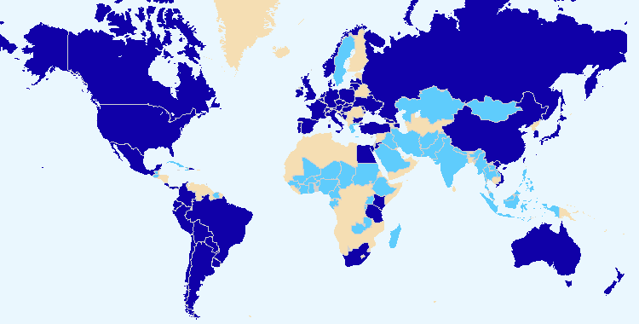
The boundaries shown on this map do not imply the expression of any opinion whatsoever on the part of UPOV concerning the legal status of any country or territory.
Members of the Union Non-members of the Union

Total number of participants by category in regular DL-205 sessions since 2006

Category | Number of students
Category 1: Government officials of members of the Union nominated by the relevant representative to the UPOV Council | 4,388
Category 2: Officials of observer States / intergovernmental organizations nominated by the relevant representative to the UPOV Council | 385
Category 3: Others | 268
Category 4: Discretionary waiving of fee for selected students | 123
Total: | 5,164

Figure 35. Participants in the main sessions of the  DL-205 Course by registration category  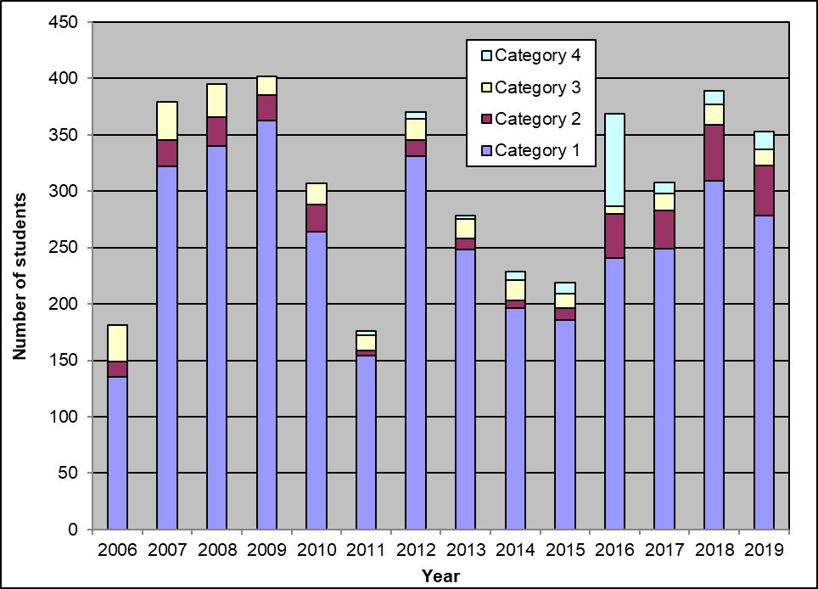 | Figure 36. Participants in the main sessions of the DL-205 Course by language  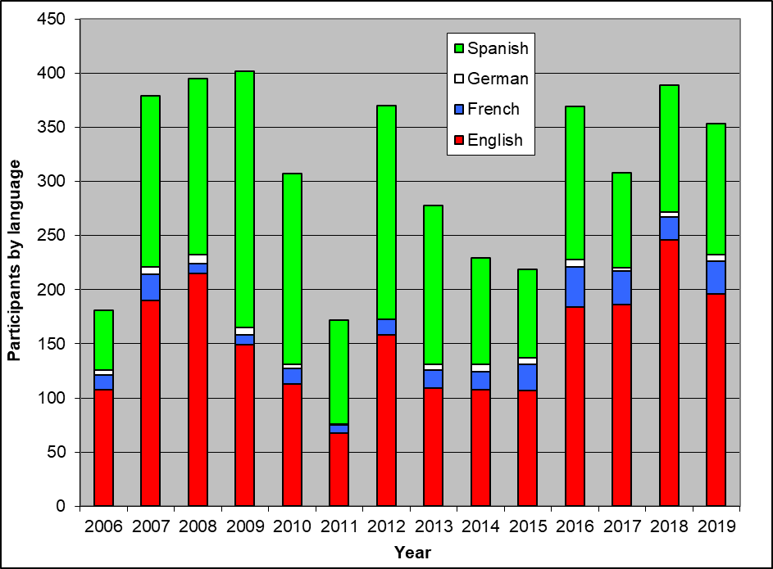

Figure 37. Participants in the main sessions of the  DL-305, 305A, 305B Courses by registration category  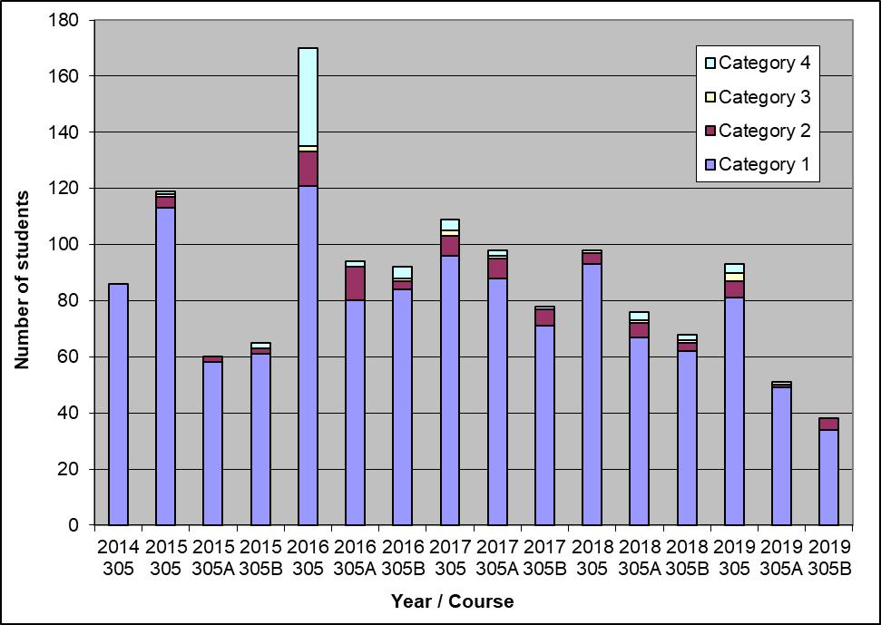 | Figure 38. Participants in the main sessions of the  DL-305, 305A, 305B Courses by language  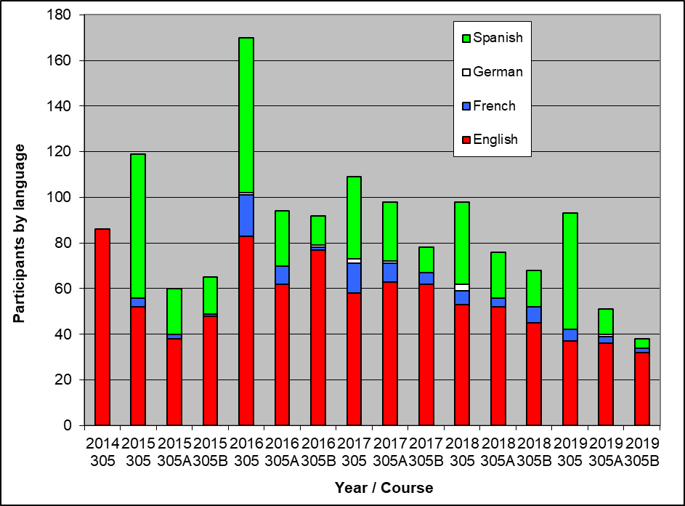

Special sessions of DL-205 in 2018 and 2019

Year | Name of Course | Number of participants
2018 | La Salle Beauvais University - IP Plant Breeding Master Programme | 7
2018 | OAPI Masters IP Training Course | 24
2018 | Maastricht University Advanced Master Intellectual Property Law and Knowledge Management | 16
2018 | KOICA Training Course on Plant Variety Protection | 9
2018 | Forum on the role of UPOV in the development of agriculture | 2
2018 | Máster Lvcentinvs in Plant Variety Protection, Alicante University, Spain | 32
2019 | La Salle Beauvais University - IP Plant Breeding Master Programme | 21
2019 | OAPI Masters IP Training Course | 27
2019 | Naktuinbouw International Course on Plant Variety Protection Course (Netherlands) | 23
2019 | Maastricht University Advanced Master Intellectual Property Law and Knowledge Management | 19
2019 | JICA Training Course on “Internationally Harmonized Plant Variety Protection System” | 6
2019 | Workshop on drafting legislation in accordance with the UPOV Convention | 3
 | Total: | 189

 | English | French | German | Spanish
DL-205 special sessions, 2018-2019:  Total number of participants, by language | 122 | 51 | 0 | 24

(b) Training of trainers
See Annex to this document.

(c) Training activities developed in conjunction with UPOV
See Annex to this document.

(d) Participation by observer States and organizations in the CAJ, TC, TWPs and the associated preparatory workshops
See Sub-Program UV.2, Section 1 “Participation by members of the Union and observers in the work of the UPOV bodies”, sub-sections (a) to (d)

(e) Participation in UPOV activities
See Annex to this document.

(f) Participation in activities involving UPOV staff or UPOV trainers on behalf of UPOV staff
See Annex to this document.

(g) Courses featuring the UPOV system of plant variety protection
See Annex to this document.

(h) Implementation of projects with partner organizations and donors
World Seed Partnership:
- In 2018: 5 electronic meetings, 4 face-to-face meetings of the Steering Committee
- In 2019: 9 electronic meetings of the Steering Committee (no face-to-face meeting was held)

2.4 Sub-Program UV.4: External Relations

UPOV’s mission is to provide and promote an effective system of plant variety protection, with the aim of encouraging the development of new varieties of plants, for the benefit of society. The aim of this Sub-program is to explain how the UPOV system encourages the development of new varieties of plants, how new varieties benefit society and the role of the UPOV system in relation to agriculture and economic policy.

A significant development in 2019 was the introduction of the @UPOVint and @vsgupov Twitter accounts, combined with the use of the UPOV LinkedIn account (including UPOV PRISMA Showcase page). From March 2019 to May 2020, UPOV posted more than 1,000 tweets and gained more than 1,000 followers on Twitter. During that same period, the combined UPOV Twitter accounts registered more than: 500,000 “impressions”; 10,000 “engagements”; 2,000 “likes” and 1,000 ”retweets”. The number of UPOV website visitors (“visits”) and sessions since the launch of UPOV’s social media accounts in March, provides some evidence of a positive impact on outreach of the UPOV website, in addition to the additional direct outreach from social media postings

The publication of a series of videos produced in Canada, China, Colombia Kenya, Japan and Peru, covering cherry, rose, rice and other crops, provided an important new source of information on the benefits of plant variety protection and UPOV membership. This material also provides important information for use in UPOV’s various outreach activities.

As a part of the Communication Strategy, the Council agreed a revised text of the FAQ “What are the benefits of new varieties of plants for society?”

Objectives | - To broaden and enhance the understanding of the UPOV system of plant variety protection.  - To provide information on the UPOV Convention to other intergovernmental organizations, with the aim of achieving mutual supportiveness with other international treaties.

Results Achieved: Selected Performance Indicators

1. Broaden public understanding of UPOV’s role and activities

(a) Availability of suitable information and materials for the general public, on UPOV website and through other media

- Launch of @UPOVint and @vsgupov Twitter accounts
- Launch of a UPOV LinkedIn account (including UPOV PRISMA Showcase page)
- UPOV Video: “Canadian cherry growers benefit from government policy”
- UPOV Video: “Rose industry blooming in Kenya”
- UPOV Video: “Tsuyahime rice, the secret of its success” Tsuyahime Rice”
- Colombia: “UPOV system bringing benefits for agriculture in Colombia”
- China: “Celebration of the twentieth anniversary of the accession of China to UPOV Convention”
- Peru “The plant variety protection system: the benefits for the development of the rice sector in Peru”
- FAQ on the benefits of new varieties of plants for society
- Updated editions of the information leaflet “What it is, What it does” on UPOV and plant variety protection in English, French, German and Spanish (Publication No. 437)
- 11 press releases

(b) Visits to UPOV website
 | 2019 | 2018 | 2017 | 2016 | 2015 | 2014
Number of sessions: | 186,155 | 173,882 | 177,469 | 200,539 | 191,534 | 187,125
Unique users: | 92,966 | 85,002 | 84,393 | 88,906 | 86,366 | 86,291
Number of pageviews: | 683,097 | 672,169 | 857,442 | 1,153,307 | 1,087,382 | 1,127,786
Number of pages/visit: | 3.67 | 3.87 | 4.83 | 5.75 | 5.68 | 6.03
Average visit duration: | 00:03:53 | 00:03:48 | 00:04:30 | 00:05:13 | 00:05:15 | 00:06:00
Percentage of new visits: | 80% | 79.8% | 79.4% | 42.70% | 43.21% | 44.19%

Website Overview: Global Coverage in 2019  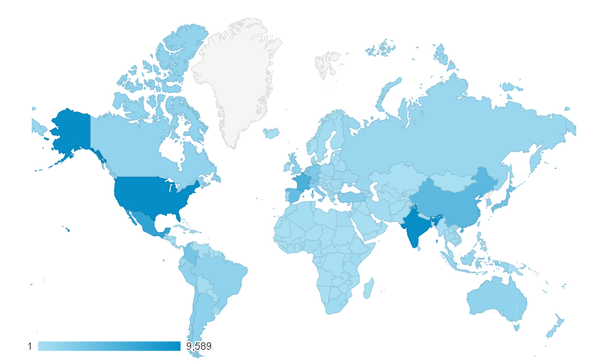 | Sessions by country:  1. United States of America (8.22%)  2. India (6.69%)  3. Mexico (6.49%)  4. France (5.94%)  5. Japan (4.64%)  6. China (4.18%)  7. Spain (4.06%)  8. Netherlands (3.58%)  9. Germany (3.10%)  10. Colombia (2.40%)

Language of  visitor’s browser | 2019 |  | 2018 |  | 2017 |  | 2016 |  | 2015
 |  |  | Sessions | % | Sessions | % | Sessions | % | Sessions | %
- en-us | 52,371 | 28.13% | 47,702 | 27.43% | 48,128 | 30.39 | 60,689 | 42.11 | 66,347 | 39.58
- es-es | 21,555 | 11.58% | 17,042 | 10.78% | 6,091 | (3.45)3.43 | 7,273 | 49.06 | 7,972 | 4.16
- en-gb | 11,992 | 6.44% | 10,494 | 6.08% | 10,062 | 5.78 | 8,639 | 45.87 | 6,743 | 3.52
- fr-fr | 10,242 | 5.50% | 8,600 | 4.49% | 5,185 | (2.52)2.92 | 5,502 | 42.31
- zh-cn | 8,318 | 4.47% | 6,564 | 3.73% | 5,349 | (3.13)3.01
- es-419 | 6,937 | 3.73% | 6,442 |  | 6,542 | (4.76)3.69 | 5,605 | 57.38
- fr | 3,902 | 2.10% | 5,674 | 3.54% | 9,471 | 5.71
- tr-tr | 3.669 | 1.97%
- it-it | 3,278 | 1.76%
- es-us | 2,714 | 1.46%
Total: | 121,313 |  | 173,882 |  | 177,469 |  | 200,539 |  | 191,534

1. en-us: American English; 2. es-es: Castilian Spanish; 3. en-gb: British English; 4. fr-fr (France); 5. zh-cn: Chinese;.
6. es-419: Spanish (Latin America and the Caribbean); 7. fr: French; 8. tr-tr: Turkish (Turkey); 9. it-it: Italian (Italy);
10. es-us: Spanish (United States of America)

Website Overview for 2019: Where are the users going?

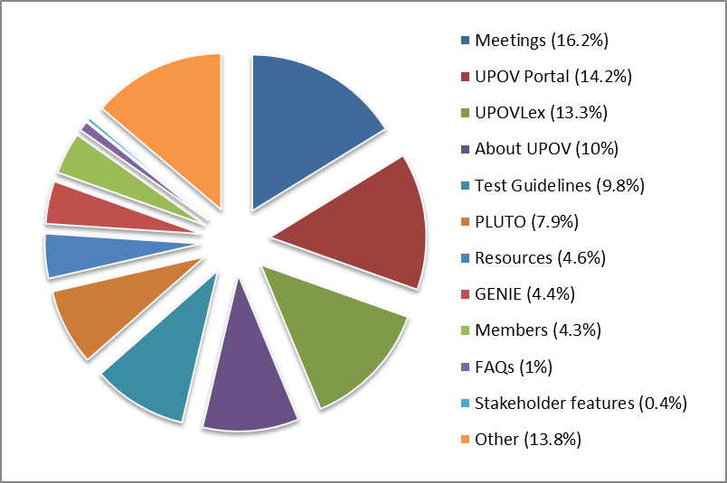
Note: Statistics concerning GENIE are not available for 2018 due to configuration changes.
Statistics concerning GENIE are available for the period July to December only in 2019.

Number of sessions and users of the UPOV site since 2007

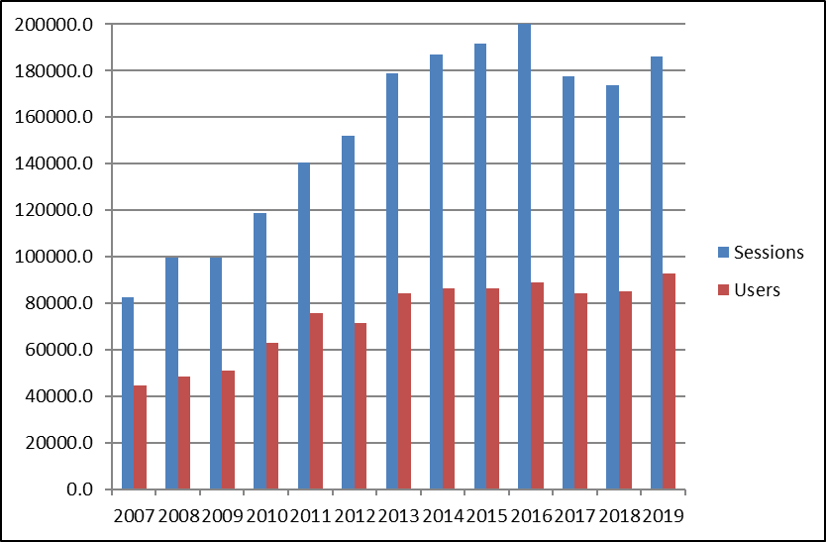

One of the impacts that was anticipated from the use of social media was to increase the awareness and visits to the UPOV website. The number of UPOV website visitors (“visits”) and sessions, presented below, provides some evidence of a positive impact since the launch of UPOV’s social media accounts.

Number of visitsa to the website | Number of sessionsa on the website
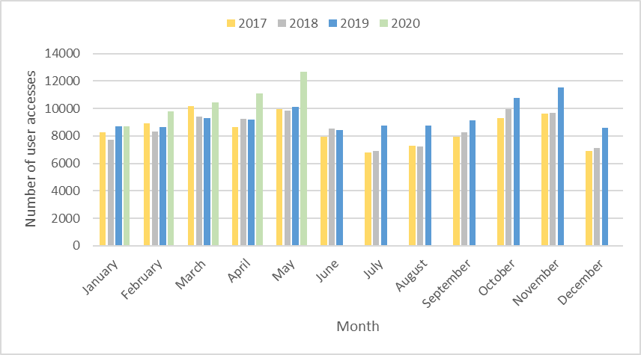 | 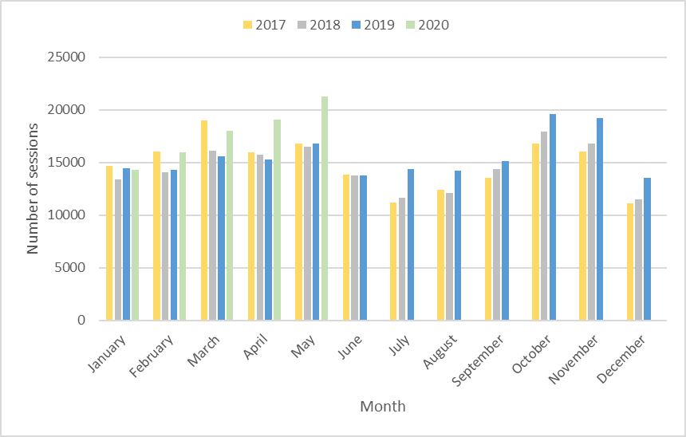

Summary of most popular website features for the past five years (Pageviews)

 | 2019 | 2018 | 2017 | 2016 | 2015
UPOV LEX | 90,757 | 92,199 | 82,861 | 85,374 | 80,382
GENIE | *30,251 | * | 72,756 | 76,990 | 67,175
PLUTO | 54,088 | 53,154 | 69,457 | 90,630 | 80,283
Test Guidelines | 67,012 | 63,172 | 66,567 | 61,966 | 64,425
Note: Statistics concerning GENIE are not available for 2018 due to configuration changes. Statistics concerning GENIE are available for the period July to December only in 2019.

Devices used to consult the UPOV Website between 2015 and 2019 (sessions)

 | 2019 | 2018 | 2017 | 2016 | 2015
Desktop | 151,180 (81%) | 148,607 (85%) | 155,520 (88%) | 178,284 (89%) | 175,755 (92%)
Mobile | 30,424 (16%) | 20,944 (12%) | 18,499 (10%) | 17,971 (9%) | 11,645 (6%)
Tablet | 4,551 (2%) | 4,331 (2%) | 3,450 (2%) | 3,848 (2%) | 4,134 (2%)

2. Enhance understanding of UPOV’s role and activities for stakeholders

(a) Availability on UPOV website and through other media of suitable information and materials, particularly for breeders, farmers and policy-makers
See Sub-Program UV.4, performance indicator “1. Broaden public understanding of UPOV’s role and activities”, section (a)

(b) Stakeholder-focused features on the UPOV website

Visits to the UPOV Website in 2019
2,514 pageviews (0. 37% of total pageviews on UPOV website (683,097 pageviews))

Language | Pageviews | Unique pageviews
English | 1,624 | 1,264
Spanish | 670 | 504
French | 160 | 126
German | 60 | 55

(c) Participation by stakeholders in seminars and symposia
See Annex to this document.

(d) Participation at meetings of, and with, relevant stakeholders
See Annex to this document.

(e) Articles in relevant publications to which UPOV has contributed
- Contribution to Seed Info No 55
- Contribution to Cultivar Magazine France with article on “Development of the Plant Breeders’ Right Application tool (UPOV PRISMA)”
- Contribution to European Seed with article on “Helping breeders making their varieties more widely available UPOV PRISMA - the new on-line PBR Application Tool”
- Video interview for IssuesInk / European Seed on the impact of the UPOV system and latest developments with UPOV PRISMA. The video is available from the UPOV website at https://youtu.be/1yS7qbqu1oc
- Contribution to WIPO Magazine with article on “UPOV: supporting food security with plant variety protection”

3. Enhance understanding of UPOV’s role and activities with other organizations

(a) Participation at meetings of, and with, relevant organizations
See Annex to this document.

3. FINANCIAL PERFORMANCE

This section provides an overview of financial performance of the Office of the Union on a budgetary basis, using the “actual” figures as stated in the Program and Budget documents for relevant biennia. Further detailed information and the number of posts are provided in documents C/54/4 “Financial Management Report for the 2018-2019 Biennium””.

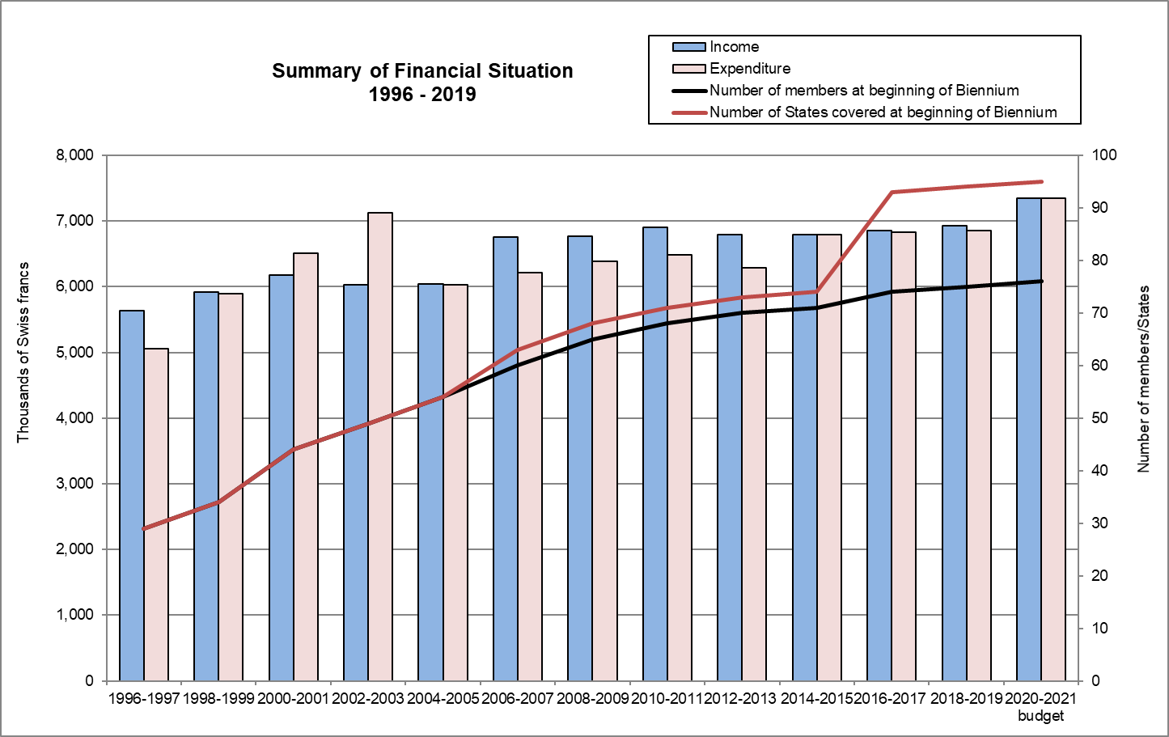

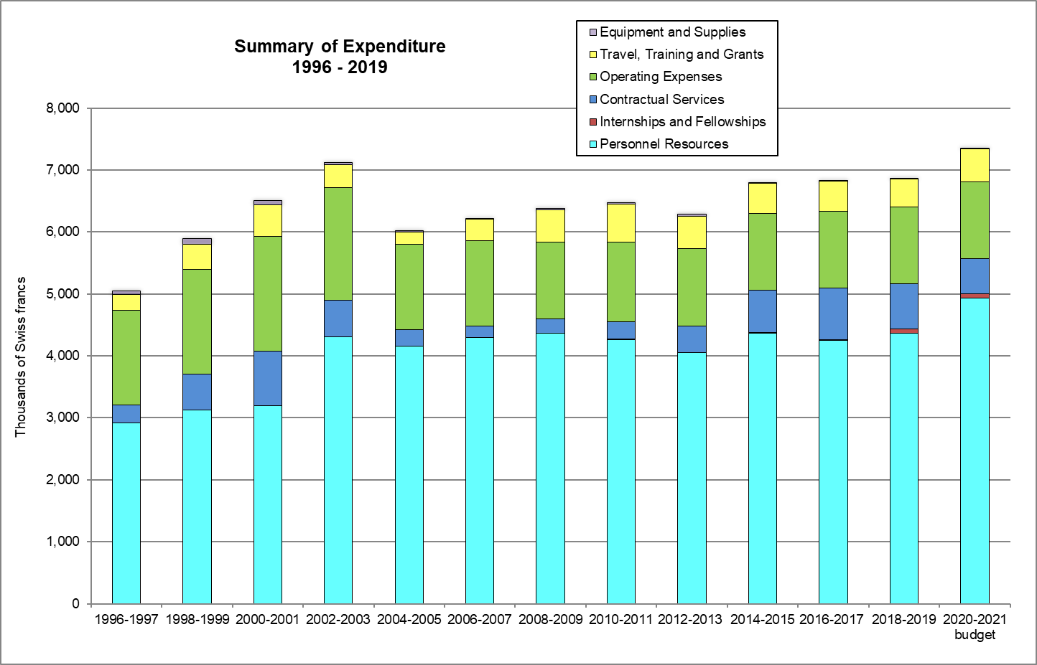

The following table and graph summarizes, at the end of each biennium, the evolution of posts of the Office of the Union.

Post Category | 2000-2001 | 2002-2003 | 2004-2005 | 2006-2007 | 2008-2009 | 2010-2011 | 2012-2013 | 2014-2015 | 2018-  2019 | 2020-  2021
Directors* | 4 | 3 | 3 | 3 | 3 | 3 | 2 | 2 | 3 | 3
Professionals | 4 | 6 | 4 | 4 | 3 | 3 | 4 | 4 | 3 | 5
General Service | 6 | 5 | 4 | 4 | 5 | 5 | 5 | 5 | 5 | 4
Total | 14 | 14 | 11 | 11 | 11 | 11 | 11 | 11 | 11 | 12

* The posts of the Secretary-General and Vice Secretary-General are included in this count.

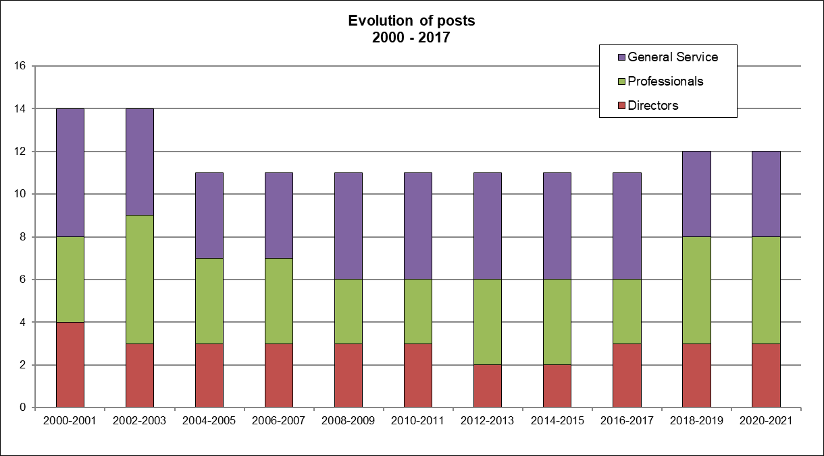

[Annex follows]
LIST OF MISSIONS* AND ACTIVITIES, AND CONTRIBUTION TO PERFORMANCE INDICATORS IN 2018-2019

Description of the Performance Indicators presented in the table below (see Annex III of documents C/53/2 and C/54/2):
UV.3 – 1(a) States and organizations provided with information at UPOV activities  UV.3 – 1(d) Participation in UPOV awareness-raising activities, or activities involving UPOV staff or UPOV trainers on behalf of UPOV staff  UV.3 – 2(a) Meetings with government officials to discuss legislative matters  UV.3 – 4(b) Training of trainers  UV.3 – 4(c) Training activities developed in conjunction with UPOV  UV.3 – 4(d) Participation by observer States and organizations in the CAJ, TC, TWPs and the associated preparatory workshops | UV.3 – 4(e) Participation in UPOV activities  UV.3 – 4(f) Participation in activities involving UPOV staff or UPOV trainers on behalf of UPOV staff  UV.3 – 4(g) Courses featuring the UPOV system of plant variety protection  UV.3 – 4(h) Implementation of projects with partner organizations and donors  UV.4 – 2(c) Participation by stakeholders in seminars and symposia  UV.4 – 2(d) Participation at meetings of, and with, relevant stakeholders  UV.4 – 3(a) Participation at meetings of, and with, relevant organizations

 | From | To | Activity/mission | City | Country | UPOV staff/ representative | organized  by or with UPOV |  | Organizers | UV.3  1(a) | UV.3  1(d) | UV.3  2(a) | UV.3  4(b) | UV.3  4(c) | UV.3  4(d) | UV.3  4(e),(f) | UV.3  4(g) | UV.3  4(h) |  | UV.4  2(c) | UV.4  2(d) | UV.4  3(a)
1 | 08-01-18 | 10-01-18 | Seminar on the Protection of New Plant Varieties | Hangzhou | China | Motomura |  | X | SFA of China | 1 | 1 |  |  | 1 |  |  |  |  |  | 1
2 | 12-01-18 | 12-01-18 | AOHE General Assembly | Paris | France | Rivoire, Madhour |  |  | AOHE |  |  |  |  |  |  |  |  |  |  |  | 1
3 | 23-01-18 | 23-01-18 | Meeting with Syngenta Foundation for Sustainable Agriculture | Basel | Switzerland | Rivoire, Madhour |  | X | SFSA |  |  |  |  |  |  |  |  |  |  |  | 1
4 | 27-01-18 | 29-01-18 | ASTA Vegetable and Flower Seed Conference. | San Diego | United States of America | Rivoire |  |  | ASTA |  |  |  |  |  |  |  |  |  |  |  | 1
5 | 29-01-18 | 30-01-18 | Legal Consultation with the responsible authorities to explain proposed amendments of Book Four of the IP Law | Cairo | Egypt | Huerta |  | X | Egypt |  |  | 1
6 | 30-01-18 | 02-02-18 | Ad-Hoc Working Group Meetings and Technical Working Group Meeting of the OECD Seed Schemes | Paris | France | Taveira |  |  | OECD |  |  |  |  |  |  |  |  |  |  |  |  | 1
7 | 21-02-18 | 24-02-18 | Workshop on "India-EU collaboration in seed sector development and plant variety protection" | New Delhi | India | Button, Huerta |  |  | India, Germany, Netherlands, CPVO | 1 | 1 |  |  |  |  |  |  |  |  | 1
8 | 26-02-18 | 01-03-18 | Eighteenth AFSTA Annual Congress | Cairo | Egypt | Button, Rivoire |  |  | AFSTA |  |  |  |  |  |  |  |  |  |  |  | 1
9 | 27-02-18 | 27-02-18 | WSP Steering Committee meeting with Bill & Melinda Gates Foundation and Syngenta Foundation | Cairo | Egypt | Button, Rivoire |  | X | WSP (ISF, ISTA, OECD, UPOV) |  |  |  |  |  |  |  |  |  | 1 | 1
10 | 27-02-18 | 27-02-18 | Courtesy visit to the Minister for Agriculture and Land Reclamation of Egypt | Cairo | Egypt | Button, Rivoire |  |  | Egypt | 1 |  | 1
11 | 05-03-18 | 05-03-18 | ISF Intellectual Property Committee meeting | Zurich | Switzerland | Button, Huerta |  |  | ISF |  |  |  |  |  |  |  |  |  |  |  | 1
12 | 05-03-18 | 07-03-18 | Meeting with the CPVO on future developments for UPOV PRISMA | Angers | France | Madhour |  | X | CPVO, UPOV |  |  |  |  |  |  |  |  |  |  |  |  | 1
13 | 12-03-18 | 12-03-18 | Meeting with a Delegation from Myanmar on the legislative process of the PVP Law of Myanmar | Roelofarendsveen | Netherlands | Huerta, Motomura |  | X | Naktuinbouw | 1 |  | 1
14 | 14-03-18 | 15-03-18 | 15th edition of the International Career Day | Basel | Switzerland | Huerta |  |  | Switzerland |  |  |  |  |  |  |  |  |  |  |  | 1
15 | 15-03-18 | 15-03-18 | WIPO-WTO Advanced Course on Intellectual Property for Government Officials | Geneva | Switzerland | Taveira |  |  | WIPO, WTO |  |  |  |  | 1 |  |  | 1
16 | 19-03-18 | 23-03-18 | Thirty-fifth session of the WIPO IGC | Geneva | Switzerland | Motomura |  |  | WIPO |  |  |  |  |  |  |  |  |  |  |  |  | 1
17 | 21-03-18 | 22-03-18 | CPVO Administrative Council meeting | Angers | France | Button |  |  | CPVO |  |  |  |  |  |  |  |  |  |  |  |  | 1
18 | 22-03-18 | 22-03-18 | Meeting with CPVO and ISF | Angers | France | Button |  | X | CPVO, ISF, UPOV |  |  |  |  |  |  |  |  |  |  |  | 1 | 1
19 | 22-03-18 | 22-03-18 | Meeting on the implementation of the Nagoya Protocol and Access and Benefit Sharing | Angers | France | Rivoire |  |  | Vegepolys |  |  |  |  |  |  |  |  |  |  |  | 1
20 | 26-03-18 | 28-03-18 | Meeting of the Enlarged Editorial Committee (TC-EDC/MAR18) | Geneva  (UPOV HQ)  (UPOV body) | Switzerland |  |  | X | UPOV |  |  |  |  |  | 1
21 | 28-03-18 | 28-03-18 | Meeting on the Development of an Electronic Application Form (UPOV/EAF/11) | Geneva  (UPOV HQ)  (UPOV body) | Switzerland |  |  | X | UPOV |  |  |  |  |  | 1
22 | 11-04-18 | 11-04-18 | Study visit to WIPO of officials from the Department of Industrial Property of Cambodia | Geneva | Switzerland | Huerta, Motomura |  |  | WIPO | 1 | 1
23 | 16-04-18 | 16-04-18 | Lecture at the Institut Polytechnique LaSalle | Beauvais | France | Rivoire |  |  | Institut Polytechnique LaSalle Beauvais |  |  |  |  |  |  |  | 1
24 | 16-04-18 | 20-04-18 | Training provided to one UPOV staff by CPVO on other organizations' administration and procedures | Angers | France | Sanchez-Vizcaino |  | X | UPOV  CPVO |  |  |  |  | 1
25 | 23-04-18 | 23-04-18 | Meeting on the preparatory work for the 2018 Edition of the International Course on Plant Variety Protection | Amsterdam | Netherlands | Huerta |  | X | Naktuinbouw, Wageningen University, UPOV |  |  |  |  |  |  |  |  |  |  | 1
26 | 25-04-18 | 26-04-18 | CIOPORA Academy and 57th Annual General Meeting of CIOPORA | Ghent | Belgium | Button, Rivoire, Madhour |  |  | CIOPORA |  |  |  |  |  |  |  |  |  |  |  | 1
27 | 30-04-18 | 30-04-18 | WIPO/UKIPO Roving Seminar: WIPO Services and Initiatives | London | United Kingdom | Button |  |  | WIPO, UKIPO |  | 1 |  |  |  |  |  |  |  |  | 1
28 | 02-05-18 | 03-05-18 | Programme Master II en propriété intellectuelle | Yaoundé | Cameroon | Rivoire |  |  | OAPI, WIPO Academy, University of Yaoundé | 1 | 1 |  |  |  |  |  | 1
29 | 03-05-18 | 03-05-18 | Advanced Training Programme on Intellectual Property and Genetic Resources in Support of Innovation | Stockholm | Sweden | Motomura |  |  | WIPO, PRV, Sida | 1 | 1 |  |  | 1 |  |  | 1
30 | 03-05-18 | 03-05-18 | Meeting of the WSP Steering Committee with WFO | Rome | Italy | Button |  | X | WSP (ISF, ISTA, OECD, UPOV), WFO |  |  |  |  |  |  |  |  |  | 1
31 | 14-05-18 | 16-05-18 | XML4IP Task Force of the Committee on WIPO Standards | Moscow | Russian Federation | Madhour |  |  | WIPO |  |  |  |  |  |  |  |  |  |  |  |  | 1
32 | 15-05-18 | 17-05-18 | KOICA/KSVS Training Course on Plant Variety Protection and DUS Testing | Gimcheon | Republic of Korea | Huerta |  | X | KOICA, KSVS, UPOV | 1 | 1 |  |  | 1
33 | 16-05-18 | 16-05-18 | Coordination meeting of TWC work | Paris | France | Button, Taveira |  | X | UPOV |  |  |  |  |  | 1
34 | 19-05-18 | 19-05-18 | Seminar on the implementation of the UPOV 1991 Act | Nairobi | Kenya | Taveira |  | X | KEPHIS | 1 | 1 |  |  | 1 |  | 1 |  |  |  | 1
35 | 21-05-18 | 21-05-18 | TWA/47 Preparatory Workshop | Naivasha | Kenya | Taveira, Oertel, May |  | X | UPOV |  |  |  |  | 1
36 | 21-05-18 | 25-05-18 | Technical Working Party for Agricultural Crops (TWA/47) | Naivasha | Kenya | Taveira, Oertel, May |  | X |  |  |  |  |  |  | 1
37 | 23-05-18 | 23-05-18 | Study visit to Geneva of students of the Advanced Training Programme on Intellectual Property and Genetic Resources in Support of Innovation | Geneva | Switzerland | Huerta, Motomura, Taveira |  |  | WIPO, PRV, Sida | 1 | 1 |  |  | 1 |  |  | 1
38 | 28-05-18 | 28-05-18 | WFO 2018 General Assembly | Moscow | Russian Federation | Button |  |  | WFO |  |  |  |  |  |  |  |  |  |  |  | 1
39 | 28-05-18 | 28-05-18 | Visit to the State Commission of the Russian Federation for Selection Achievements Test and Protection | Moscow | Russian Federation | Button |  |  | Russian Federation | 1
40 | 03-06-18 | 06-06-18 | ISF World Seed Congress 2018 | Brisbane | Australia | Button, Rovere |  |  | ISF |  |  |  |  |  |  |  |  |  |  |  | 1
41 | 05-06-18 | 05-06-18 | WIPO QUT Master of Laws (LL.M) in Intellectual Property | Brisbane | Australia | Button |  |  | WIPO, QUT of Australia | 1 | 1 |  |  |  |  |  | 1
42 | 05-06-18 | 05-06-18 | Meeting of the Council for TRIPS | Geneva | Switzerland | Taveira |  |  | WTO |  |  |  |  |  |  |  |  |  |  |  |  | 1
43 | 05-06-18 | 06-06-18 | Seminar on legal protection of new plant varieties | Tashkent | Uzbekistan | Huerta, Motomura |  | X | IPA of Uzbekistan | 1 | 1 | 1 |  |  |  |  |  |  |  | 1
44 | 05-06-18 | 06-06-18 | SeedConnect Conference | Abuja | Nigeria | Rivoire |  |  | NASC of Nigeria |  |  |  |  |  |  |  |  |  |  |  | 1
45 | 07-06-18 | 08-06-18 | Visit to IP Office, Canberra, Australia | Canberra | Australia | Button |  | X | IP Australia, UPOV | 1
46 | 11-06-18 | 12-06-18 | Visit to IP Office, Wellington, New Zealand | Wellington | New Zealand | Button |  | X | IPONZ, UPOV | 1 |  |  |  |  |  |  |  |  |  | 1
47 | 14-06-18 | 14-06-18 | Plant Variety Protection Debates: Connecting Law, Science and Social Science | Warwick | United Kingdom | Huerta |  |  | University of Warwick |  |  |  |  |  |  |  |  |  |  | 1
48 | 15-06-18 | 15-06-18 | Eighth edition of the Annual Agri-Food Law Seminar | Brussels | Belgium | Huerta |  |  | ALTIUS |  |  |  |  |  |  |  |  |  |  | 1
49 | 18-06-18 | 22-06-18 | Forum on the role of UPOV in the development of agriculture | Geneva  (UPOV HQ) | Switzerland |  |  | X | UPOV, WIPO, MAFF of Japan | 1 | 1 | 1 |  | 1 |  | 1 |  |  |  | 1
50 | 19/06/18  25/06/18 | 19/06/18  25/06/18 | 21st International Course on Plant Variety Protection (training session on UPOV) | Wageningen | Netherlands | Huerta |  | X | Naktuinbouw | 1 | 1 | 1 |  | 1 |  |  |  |  |  | 1
51 | 25-06-18 | 25-06-18 | WIPO-WTO Colloquium for Teachers of Intellectual Property | Geneva | Switzerland | Rivoire |  |  | WIPO, WTO | 1 | 1 |  |  | 1 |  |  | 1
52 | 25-06-18 | 28-06-18 | High-Level Study Tour on Plant Variety Protection for promoting investments in Plant Breeding | Des Moines  Saskatoon | United States of America  Canada | Button, Taveira |  | X | CFIA, Ministry of Agriculture, Nature and Food Quality of the Netherlands, UPOV, USPTO, WIPO | 1 | 1 |  |  |  |  |  |  |  |  | 1
53 | 25-06-18 | 29-06-18 | Thirty-sixth session of the WIPO IGC | Geneva | Switzerland | Huerta |  |  | WIPO |  |  |  |  |  |  |  |  |  |  |  |  | 1
54 | 26-06-18 | 26-06-18 | Awareness-raising workshop on industrial property | Dijon | France | Rivoire |  |  | Agence Economique Régionale de Bourgogne-Franche-Comté (France) |  |  |  |  |  |  |  |  |  |  |  | 1
55 | 26-06-18 | 29-06-18 | Ad-Hoc Working Group Meetings, Technical Working Group Meeting and Annual Meeting of the OECD Seed Schemes | Paris | France | Motomura |  |  | OECD |  |  |  |  |  |  |  |  |  |  |  |  | 1
56 | 02-07-18 | 02-07-18 | TWC/36 Preparatoy Workshop | Hanover | Germany | Taveira, Motomura |  | X | UPOV |  |  |  |  | 1
57 | 02-07-18 | 06-07-18 | Technical Working Party on Automation and Computer Programs (TWC/36) | Hanover | Germany | Taveira, Motomura |  | X | UPOV |  |  |  |  |  | 1
58 | 04-07-18 | 04-07-18 | Study Visit to WIPO of the Attorney General and Minister for Justice and Senior Government Officials of Ghana | Geneva | Switzerland | Button, Huerta, Rivoire |  |  | WIPO | 1
59 | 05-07-18 | 05-07-18 | WTO National Seminar on Certain Aspects of the TRIPS Agreement | Amman | Jordan | Rivoire |  |  | WTO | 1 | 1
60 | 12-07-18 | 12-07-18 | Training provided to one UPOV staff by CPVO: observation of formal assessment by the CPVO Quality Audit Service (QAS) of the Finnish Food Safety Authority (Evira) as an examination office | Turku | Finland | Motomura |  | X | CPVO, UPOV |  |  |  |  | 1 |  |  |  |  |  |  |  | 1
61 | 18-07-18 | 18-07-18 | First Edition of the WIPO Summer Course on Intellectual Property [participation via video conference] | Rio de Janeiro | Brazil | Taveira |  |  | WIPO |  |  |  |  |  |  |  | 1
62 | 25-07-18 | 27-07-18 | JICA Training Course “Plant Variety Protection and Quality Control System of Seeds to Facilitate Distribution of High Quality Seeds” | Tsukuba | Japan | Motomura |  | X | JICA | 1 | 1 | 1 |  | 1
63 | 25-07-18 | 27-07-18 | Ninth Session of the Intergovernmental Technical Working Group on Plant Genetic Resources for Food and Agriculture | Rome | Italy | Taveira |  |  | CGRFA |  |  |  |  |  |  |  |  |  |  |  |  | 1
64 | 30-07-18 | 30-07-18 | Meeting with officials of MAFF of Japan | Tokyo | Japan | Button, Motomura |  | X | MAFF of Japan | 1
65 | 01-08-18 | 01-08-18 | 11th Annual Meeting of the East Asia Plant Variety Protection Forum | Muntinlupa | Philippines | Button, Motomura |  | X | EAPVP Forum, JATAFF | 1 | 1
66 | 02-08-18 | 02-08-18 | International Seminar on the Benefits of Plant Variety Protection under the UPOV System | Muntinlupa | Philippines | Button, Motomura |  | X | PVP Office of the Philippines, MAFF of Japan, EAPVP Forum, UPOV | 1 | 1 |  |  |  |  | 1 |  |  |  | 1
67 | 15-08-18 | 17-08-18 | Legal consultations with responsible authorities to provide assistance with the process of amending the Protection of New Plant Varieties Act 2004 of Malaysia | Putrajaya | Malaysia | Button, Huerta |  | X | Department of Agriculture of Malaysia | 1 | 1 | 1
68 | 23-08-18 | 24-08-18 | Regional Workshop on examination of PVP applications | Lima | Peru | Taveira |  | X | IPKey Latin America, UPOV, INDECOPI, CPVO, EUIPO | 1 | 1 |  |  |  |  | 1
69 | 27-08-18 | 29-08-18 | Regional Seminar on Plant Variety Protection under the 1991 Act of the UPOV Convention: benefits of public-private partnerships for transfer of technology | Lima | Peru | Taveira |  | X | IPKey Latin America, UPOV, INDECOPI, CPVO, Comunidad Andina, EUIPO | 1 | 1 |  |  |  |  |  |  |  |  | 1
70 | 27-08-18 | 31-08-18 | Thirty-seventh session of the WIPO IGC | Geneva | Switzerland | Motomura |  |  | WIPO |  |  |  |  |  |  |  |  |  |  |  |  | 1
71 | 30-08-18 | 30-08-18 | Conference on “Encouraging Plant Breeding, Challenges and Perspectives”, at the official launch of the Erasmus Mundus Master Program in Plant Breeding – emPLANT | Beauvais | France | Rivoire |  |  | Institut Polytechnique LaSalle Beauvais |  |  |  |  |  |  |  | 1
72 | 30-08-18 | 31-08-18 | Seminar on Breeders’ Rights under the UPOV Convention and benefits for the promotion of public-private partnerships and transfer of technology | Quito | Ecuador | Taveira |  | X | IPKey Latin America, UPOV, SENADI, CPVO, Comunidad Andina, EUIPO | 1 | 1 |  |  |  |  |  |  |  |  | 1
73 | 06-09-18 | 06-09-18 | CIOPORA Academy Workshop | Washington D. C. | United States of America | Rivoire |  |  | CIOPORA |  |  |  |  |  |  |  |  |  |  |  | 1
74 | 07-09-18 | 07-09-18 | Visit to PVP Office, USDA | Washington D. C. | United States of America | Rivoire |  |  | USDA | 1
75 | 10-09-18 | 13-09-18 | Working Group on Biochemical and Molecular Techniques and DNA-Profiling in Particular (BMT/17) | Montevideo | Uruguay | Button, Motomura, Taveira, Han |  | X | UPOV |  |  |  |  |  | 1
76 | 11-09-18 | 14-09-18 | First meeting of the Ad Hoc Technical Expert Group (AHTEG) on Farmers’ Rights of the ITPGRFA | Rome | Italy | Huerta |  |  | ITPGRFA |  |  |  |  |  |  |  |  |  |  |  |  | 1
77 | 14-09-18 | 14-09-18 | Visit to FAO Legal Office | Rome | Italy | Huerta |  |  | FAO |  |  |  |  |  |  |  |  |  | 1 |  |  | 1
78 | 17-09-18 | 17-09-18 | TWV/52 Preparatory Workshop | Beijing | China | Rivoire, Oertel, Han |  | X | UPOV |  |  |  |  | 1
79 | 17-09-18 | 21-09-18 | Technical Working Party for Vegetable Crops (TWV/52) | Beijing | China | Rivoire, Oertel, Han |  | X | UPOV |  |  |  |  |  | 1
80 | 19-09-18 | 19-09-18 | CPVO Administrative Committee meeting | Sofia | Bulgaria | Button |  |  | CPVO |  |  |  |  |  |  |  |  |  |  |  |  | 1
81 | 20-09-18 | 20-09-18 | Seminar on the Benefits of Plant Variety Protection | Sofia | Bulgaria | Button |  |  | CPVO | 1 | 1 |  |  |  |  |  |  |  |  | 1 |  | 1
82 | 21-09-18 | 21-09-18 | Advanced Training Programme on Intellectual Property and Genetic Resources in Support of Innovation | Geneva | Switzerland | Huerta, Motomura |  |  | WIPO, PVR, Sida | 1 |  |  |  | 1 |  |  | 1
83 | 24-09-18 | 02-10-18 | Fifty-Eighth Series of Meetings of the WIPO Assemblies | Geneva | Switzerland | Huerta |  |  | WIPO |  |  |  |  |  |  |  |  |  |  |  |  | 1
84 | 25-09-18 | 26-09-18 | International Seminar on New Plant Variety Protection, as part of the Celebration of the 60th Anniversary of the Establishment of the Agriculture Research Institute of Beijing | Beijing | China | Button, Han |  |  | MARA of China | 1 |  |  |  |  |  |  |  |  |  | 1
85 | 25-09-18 | 25-09-18 | World Seed Partnership (WSP) meeting | Nay Pyi Taw | Myanmar | Huerta, Rivoire |  | X | WSP (ISF, ISTA, OECD, UPOV), WFO,  MOALI, Netherlands |  |  |  |  |  |  |  |  |  | 1
86 | 26-09-18 | 26-09-18 | Fourth National Seed Committee meeting | Nay Pyi Taw | Myanmar | Huerta, Rivoire |  |  | MOALI, ISSD, Wageningen University | 1 | 1
87 | 27-09-18 | 27-09-18 | Legal Consultation with relevant authorities of Myanmar | Nay Pyi Taw | Myanmar | Huerta, Rivoire |  | X | MOALI | 1 | 1 | 1
88 | 08-10-18 | 10-10-18 | European Seed Association Annual Meeting | Madrid | Spain | Button, Rovere |  |  | ESA |  |  |  |  |  |  |  |  |  |  |  | 1
89 | 08-10-18 | 08-10-18 | Meeting of the WSP Steering Committee and WFO | Madrid | Spain | Button |  | X | WSP (ISF, ISTA, OECD, UPOV), WFO |  |  |  |  |  |  |  |  |  | 1
90 | 09-10-18 | 11-10-18 | Workshop on "Strengthening the knowledge of effective implementation of the Plant Breeders' Rights system in the Sultanate of Oman" | Muscat | Oman | Rivoire |  |  | DGALR of Oman, WIPO | 1 | 1 | 1 |  | 1
91 | 10-10-18 | 10-10-18 | Master of Laws (LL.M.) in Intellectual Property (WIPO/University of Turin/ITC-ILO) | Geneva | Switzerland | Huerta |  |  | WIPO, University of Turin, ITC-ILO |  |  |  |  | 1 |  |  | 1
92 | 11-10-18 | 11-10-18 | First Pilot Project Meeting for Regional Cooperation | Hanoi | Viet Nam | Button, Motomura |  | X | EAPVP Forum |  |  |  |  |  |  | 1
93 | 11-10-18 | 11-10-18 | Contribution with ARIPO via videoconferencing to presentations on plant variety protection at the Masters Degree in Intellectual Property Program at Africa University | Mutare | Zimbabwe | Huerta, Rivoire |  |  | WIPO, ARIPO,  Africa University |  |  |  |  | 1 |  |  | 1
94 | 11-10-18 | 12-10-18 | Conference “Genome Editing/CRISPR als Herausforderung für das Life Sciences-Recht” | Basel | Switzerland | Huerta |  |  | University of Basel |  |  |  |  |  |  |  |  |  |  | 1 | 1
95 | 17-10-18 | 17-10-18 | Annual General Meeting of the British Society of Plant Breeders | London | United Kingdom | Button |  |  | BSPB |  |  |  |  |  |  |  |  |  |  |  | 1
96 | 18-10-18 | 18-10-18 | AFSTA Plant Variety Protection Workshop | Nairobi | Kenya | Rivoire |  |  | AFSTA |  |  |  |  | 1 |  |  |  |  |  |  | 1
97 | 19-10-18 | 23-10-18 | WIPO Forum on Strengthening IP Management in African Universities | Nairobi | Kenya | Rivoire |  |  | WIPO | 1 | 1 |  |  |  |  |  |  |  |  |  |  | 1
98 | 22-10-18 | 22-10-18 | Workshop on UPOV PRISMA | Nairobi | Kenya | Rivoire |  | X | KEPHIS |  |  |  |  |  |  | 1
99 | 24-10-18 | 24-10-18 | National Stakeholder Consultation on South Africa’s approval of the 1991 Act of the UPOV Convention | Pretoria | South Africa | Rivoire |  |  | DAFF of South Africa | 1 |  | 1 |  |  |  |  |  |  |  | 1
100 | 25-10-18 | 25-10-18 | Workshop on UPOV PRISMA | Pretoria | South Africa | Rivoire |  | X | DAFF of South Africa |  |  |  |  |  |  | 1
101 | 26-10-18 | 26-10-18 | GRUR Annual Committee Meeting | Munich | Germany | Button |  |  | GRUR |  |  |  |  |  |  |  |  |  |  |  | 1
102 | 29-10-18 | 30-10-18 | Technical Committee (TC/54) | Geneva  (UPOV HQ)  (UPOV body) | Switzerland |  |  | X | UPOV |  |  |  |  |  | 1
103 | 31-10-18 | 31-10-18 | Administrative and Legal Committee (CAJ/75) | Geneva  (UPOV HQ)  (UPOV body) | Switzerland |  |  | X | UPOV |  |  |  |  |  | 1
104 | 01-11-18 | 01-11-18 | Consultative Committee (CC/95) | Geneva  (UPOV HQ)  (UPOV body) | Switzerland |  |  | X | UPOV |  |  |  |  |  | 1
105 | 01-11-18 | 01-11-18 | Meeting to discuss cooperation in Asia | Geneva  (UPOV HQ) | Switzerland |  |  | X | UPOV | 1 | 1
106 | 02-11-18 | 02-11-18 | Council (C/52) | Geneva  (UPOV HQ)  (UPOV body) | Switzerland |  |  | X | UPOV |  |  |  |  |  | 1
107 | 05-11-18 | 06-11-18 | IPKey SEA Study Visit on Plant Variety Protection | Hanoi | Viet Nam | Button, Motomura |  |  | IPKey SEA | 1 | 1 | 1 |  |  |  |  |  |  |  | 1
108 | 05-11-18 | 06-11-18 | Meetings with Working Group responsible for drafting the Plant Variety and Seed Act | Ulaanbaatar | Mongolia | Huerta |  |  | MOFALI of Mongolia, DMKNL | 1 | 1 | 1
109 | 08-11-18 | 09-11-18 | IPKey SEA Conference on the benefits of membership in the International Union for the Protection of New Varieties of Plants | Yogyakarta | Indonesia | Button, Motomura |  |  | IPKey SEA | 1 | 1 |  |  |  |  |  |  |  |  | 1
110 | 08-11-18 | 09-11-18 | Colombian Seed Congress (Acosemillas 2018) | Bogota | Colombia | Taveira |  |  | Acosemillas, ICA |  |  |  |  |  |  |  |  |  |  |  | 1
111 | 09-11-18 | 09-11-18 | WIPO/Tongji University Master’s Degree in Intellectual Property with specialization in Design (MIP in Design), Shanghai, China | Shanghai | China | Huerta, Han  (by video-conference from Geneva) |  |  | WIPO,  Tongji University |  |  |  |  |  |  |  | 1
112 | 11-11-18 | 14-11-18 | APSA Asian Seed Congress 2018 | Manila | Philippines | Motomura |  |  | APSA |  |  |  |  |  |  |  |  |  |  |  | 1
113 | 13-11-18 | 13-11-18 | Master in Intellectual Property of the University of Alicante (Magister Lvcentinvs) | Alicante | Spain | Button |  |  | University of Alicante |  |  |  |  |  |  |  | 1
114 | 19-11-18 | 19-11-18 | Open session of the ARIPO Administrative Council | Windhoek | Namibia | Huerta, Han |  |  | ARIPO |  |  |  |  |  |  |  |  |  |  |  |  | 1
115 | 20-11-18 | 20-11-18 | Seminar on Plant Variety Protection for ARIPO Member States | Windhoek | Namibia | Huerta, Han |  | X | ARIPO, UPOV, USPTO | 1 | 1 | 1 |  | 1
116 | 19-11-18 | 23-11-18 | Technical Working Party for Fruit Crops (TWF/49) | Santiago | Chile | Rivoire, Oertel |  | X | UPOV, Chile |  |  |  |  |  | 1
117 | 05-12-18 | 06-12-18 | Annual Meeting between the CPVO and its Examination Offices | Angers | France | Taveira |  |  | CPVO |  |  |  |  |  |  |  |  |  |  |  |  | 1
118 | 05-12-18 | 07-12-18 | Meeting on UPOV PRISMA PBR Application Tool with the Development Center of Science and Technology (DCST), Ministry of Agriculture and Rural Affairs of China | Beijing | China | Madhour |  |  | MARA of China | 1
119 | 06-12-18 | 06-12-18 | Award ceremony of “Les insignes de Chevalier de l’Ordre National du Mérite” | Paris | France | Button |  |  | Limagrain (France) |  |  |  |  |  |  |  |  |  |  |  | 1
120 | 19-12-18 | 20-12-18 | Workshop on Awareness of Protection of Plant Variety under the UPOV Convention | Vientiane | Lao People’s Democratic Republic | Motomura |  |  | EAPVP Forum | 1 | 1 | 1 |  | 1
121 | 14/01/19 | 14/01/19 | Advanced Masters on Intellectual Property Law and Knowledge Management | Maastricht | Netherlands | Huerta |  |  | University of Maastricht |  | 1 |  |  |  |  |  | 1
122 | 16/01/19 | 17/01/19 | Meeting with OAPI and IP Master’s Program Ceremony | Yaoundé | Cameroon | Button, Rivoire |  |  | OAPI |  |  |  |  |  |  | 1 | 1 |  |  |  |  | 1
123 | 22/01/19 | 22/01/19 | Meeting with EUIPO and CPVO to discuss areas of cooperation | Alicante | Spain | Button |  | X | EUIPO, CPVO, UPOV |  |  |  |  |  |  | 1
124 | 23/01/19 | 23/01/19 | Twentieth EIPIN Congress on Intellectual Property and Innovation | Alicante | Spain | Button |  |  | EIPIN |  | 1 |  |  |  |  |  | 1
125 | 23/01/19 | 23/01/19 | Study visit to WIPO by a Switzerland, Belgium and Netherlands (SBN) research delegation from the Tsinghua University of China | Geneva | Switzerland | Huerta, Han |  |  | WIPO, Tsinghua University of China |  | 1
126 | 28/01/19 | 30/01/19 | Workshop on drafting legislation in accordance with the UPOV Convention | Geneva  (UPOV HQ) | Switzerland | Button, Huerta, Rivoire, Taveira, Motomura, Han |  | X | UPOV | 1 | 1 | 1
127 | 17/02/19 | 17/02/19 | TWO/51 Preparatory Workshop | Christchurch | New Zealand | Taveira, Oertel |  | X | UPOV |  |  |  |  | 1
128 | 18/02/19 | 22/02/19 | Technical Working Party for Ornamental Plants and Forest Trees (TWO/51) | Christchurch | New Zealand | Taveira, Oertel |  | X | UPOV |  |  |  |  |  | 1
129 | 13/02/19 | 13/02/19 | Meeting of the Council for TRIPS | Geneva | Switzerland | Huerta |  |  | WTO |  |  |  |  |  |  |  |  |  |  |  |  | 1
130 | 18/02/19 | 22/02/19 | 17th Regular Session of the Commission on Genetic Resources for Food and Agriculture | Rome | Italy | Motomura |  |  | CGRFA |  |  |  |  |  |  |  |  |  |  |  |  | 1
131 | 26/02/19 | 27/02/19 | Second EAPVP Pilot Project Meeting | Vung Tau | Viet Nam | Button, Motomura |  | X | EAPVP Forum |  |  |  |  |  |  | 1 |  |  | 1
132 | 01/03/19 | 01/03/19 | Meeting with the Intellectual Property Office of Singapore | Singapore | Singapore | Button |  | X | IPOS, UPOV | 1
133 | 01/03/19 | 01/03/19 | Seminar on Plant Variety Protection | Can Tho | Viet Nam | Motomura |  | X | PVP Office of Viet Nam | 1 | 1 |  |  | 1 |  |  |  |  |  | 1
134 | 03/03/19 | 07/03/19 | Nineteenth AFSTA Annual Congress | Mombasa | Kenya | Rivoire |  |  | AFSTA |  |  |  |  |  |  |  |  |  |  |  | 1
135 | 11/03/19 | 13/03/19 | XML4IP Task Force Meeting | Seoul | Republic of Korea | Madhour |  |  | WIPO, KIPO |  |  |  |  |  |  |  |  |  | 1 |  |  | 1
136 | 13/03/19 | 14/03/19 | Workshops on Plant Variety Protection | Sarajevo and  Banja Luka | Bosnia and Herzegovina | Button |  |  | Administration of Bosnia and Herzegovina for Plant Health Protection | 1 | 1 |  |  | 1 |  |  |  |  |  | 1
137 | 14/03/19 | 14/03/19 | WIPO-WTO Advanced Course on Intellectual Property for Government Officials | Geneva | Switzerland | Huerta, Taveira |  |  | WIPO, WTO |  | 1 |  |  |  |  |  | 1
138 | 14/03/19 | 14/03/19 | Meeting with KSVS and other IT experts on UPOV PRISMA and EAPVP Pilot Project | Gimcheon | Republic of Korea | Madhour |  |  | KSVS, UPOV | 1 |  |  |  |  |  | 1
139 | 14/03/19 | 14/03/19 | Workshop on the benefits of UPOV membership and the procedure to become a UPOV member | Astana | Kazakhstan | Huerta |  | X | Kazakhstan, UPOV | 1 | 1 |  |  | 1 |  |  |  |  |  | 1
140 | 14/03/19 | 15/03/19 | Legal Consultation with officials from the Government of Kazakhstan | Astana | Kazakhstan | Huerta |  | X | Kazakhstan, UPOV |  |  | 1
141 | 18/03/19 | 22/03/19 | Thirty-ninth session of the WIPO IGC | Geneva | Switzerland | Huerta |  |  | WIPO |  |  |  |  |  |  |  |  |  |  |  |  | 1
142 | 19/03/19 | 19/03/19 | CPVO Administrative Council meeting | Angers | France | Button |  |  | CPVO |  |  |  |  |  |  |  |  |  |  |  |  | 1
143 | 20/03/19 | 20/03/19 | CPVO internal event on the benefits of UPOV membership | Angers | France | Button |  |  | CPVO |  | 1 |  |  | 1 |  |  |  |  |  |  |  | 1
144 | 26/03/19 | 27/03/19 | Meeting of the Enlarged Editorial Committee (TC-EDC/MAR19) | Geneva  (UPOV HQ)  (UPOV body) | Switzerland |  |  | X | UPOV
145 | 28/03/19 | 28/03/19 | Meeting on the Development of an Electronic Application Form (UPOV/EAF/13) | Geneva  (UPOV HQ)  (UPOV body) | Switzerland |  |  | X | UPOV |  |  |  |  |  | 1 | 1
146 | 27/03/19 | 27/03/19 | Advanced International Training Programme on “Intellectual Property and Genetic Resources - in Support of Innovation” | Stockholm | Sweden | Huerta |  | X | PVR, WIPO, Sida |  | 1 |  |  |  |  |  | 1
147 | 02/04/19 | 05/04/19 | 58th Annual General Meeting of CIOPORA | near Stellenbosch | South Africa | Button |  |  | CIOPORA |  |  |  |  |  |  |  |  |  |  |  | 1
148 | 10/04/19 | 10/04/19 | Lecture at Institut Polytechnique LaSalle as part of the MSc in Plant Breeding Course | Beauvais | France | Rivoire |  | X | Institut Polytechnique LaSalle |  | 1 |  |  |  |  |  | 1
149 | 12/04/19 | 12/04/19 | Advanced International Training Programme on “Intellectual Property and Genetic Resources - in Support of Innovation” | Geneva | Switzerland | Huerta, Motomura |  | X | PVR, WIPO, Sida |  | 1 |  |  |  |  |  | 1
150 | 15/04/19 | 15/04/19 | Seedconnect Conference and Expo 2019 | Abuja | Nigeria | Huerta |  |  | NASC of the MARD of Nigeria |  |  | 1 |  |  |  |  |  |  |  |  | 1
151 | 22/04/19 | 22/04/19 | IPKey Seminar on EDV and FSS: China-EU Seminar on PVP | Beijing | China | Button, Motomura, Han |  |  | IP Key SEA |  | 1 |  |  |  |  |  |  |  |  | 1
152 | 23/04/19 | 23/04/19 | Celebration Conference of China’s 20th Anniversary of Accession to the International Convention on the Protection of New Plant Varieties | Beijing | China | Button, Motomura, Han |  |  | MARA of China |  | 1
153 | 23/04/19 | 23/04/19 | International Seminar on PVP | Beijing | China | Button, Motomura, Han |  | X | MARA of China, MAFF of Japan, UPOV, EAPVP Forum |  | 1 |  |  |  |  |  |  |  |  | 1
154 | 24/04/19 | 24/04/19 | 12th Annual Meeting of the EAPVP Forum | Beijing | China | Button, Motomura, Han |  | X | EAPVP Forum, JATAFF |  | 1
155 | 24/04/19 | 24/04/19 | Meeting on PVP cooperation in the Asian region | Beijing | China | Button, Motomura, Han |  | X | UPOV | 1 | 1 |  |  |  |  | 1
156 | 24/04/19 | 24/04/19 | Meeting on the EAPVP Pilot Project | Beijing | China | Button, Motomura, Han |  | X | EAPVP Forum |  |  |  |  |  |  | 1 |  |  | 1
157 | 25/04/19 | 25/04/19 | Meeting with DCST to discuss areas of cooperation | Beijing | China | Button, Motomura, Han |  |  | DCST, UPOV |  |  |  |  |  |  | 1
158 | 25/04/19 | 25/04/19 | Meeting on communications with ESA | Brussels | Belgium | Rovere, Falquet |  | X | ESA, UPOV |  |  |  |  |  |  |  |  |  |  |  | 1
159 | 29/04/19 | 30/04/19 | Programme Master II en propriété intellectuelle | Yaoundé | Cameroon | Rivoire |  |  | OAPI, WIPO Academy, University of Yaoundé |  | 1 |  |  |  |  |  | 1
160 | 13/05/19 | 15/05/19 | Meeting of Experts on Formulation and Implementation of National Intellectual Property Strategies: Updating and Improving the Methodology and Tools of the World Intellectual Property Organization | Geneva | Switzerland | Huerta |  |  | WIPO |  |  |  |  |  |  |  |  |  |  |  |  | 1
161 | 13/05/19 | 17/05/19 | Training program to one CPVO staff to exchange experience and knowledge of UPOV and CPVO activities | Geneva | Switzerland | all staff |  | X | UPOV, CPVO |  |  |  |  | 1
162 | 16/05/19 | 16/05/19 | Visit for the staff of ISF at UPOV Office | Geneva | Switzerland | all staff |  | X | UPOV, ISF |  |  |  |  |  |  |  |  |  |  |  | 1
163 | 20/05/19 | 22/05/19 | WFO General Assembly meeting | Luxembourg | Luxembourg | Button |  |  | WFO |  |  |  |  |  |  |  |  |  |  |  | 1
164 | 20/05/19 | 22/05/19 | Food Systems Dialogues (FSDs) event | Luxembourg | Luxembourg | Button |  |  | WFO |  |  |  |  |  |  |  |  |  |  |  | 1
165 | 20/05/19 | 23/05/19 | Second meeting of the Ad Hoc Technical Expert Group (AHTEG) on Farmers’ Rights of the ITPGRFA | Rome | Italy | Huerta |  |  | ITPGRFA |  |  |  |  |  |  |  |  |  |  |  |  | 1
166 | 20/05/19 | 24/05/19 | Technical Working Party for Vegetables (TWV/53) | Seoul | Republic of Korea | Rivoire, Oertel |  | X | UPOV |  |  |  |  |  | 1
167 | 03/06/19 | 06/06/19 | ISF World Seed Congress 2019 | Nice | France | Button, Rivoire |  |  | ISF |  |  |  |  |  |  |  |  |  |  |  | 1
168 | 06/06/19 | 06/06/19 | Meeting of the Council for TRIPS | Geneva | Switzerland | Huerta |  |  | WTO |  |  |  |  |  |  |  |  |  |  |  |  | 1
169 | 10/06/19 | 14/06/19 | Ad-Hoc Working Group Meetings, Technical Working Group Meeting and Annual Meeting of the OECD Seed Schemes | Vienna | Austria | Taveira |  |  | OECD |  |  |  |  |  |  |  |  |  |  |  |  | 1
170 | 14/06/19 | 14/06/19 | Ninth edition of the Annual Agri-Food Law Seminar | Brussels | Belgium | Huerta |  |  | ALTIUS |  |  |  |  |  |  |  |  |  |  |  | 1
171 | 14/06/19 | 14/06/19 | Study visit for a Chinese delegation to CPVO and UPOV | Geneva | Switzerland | Button, Rivoire, Madhour, Motomura |  | X | IP Kea SEA, CPVO, UPOV | 1 | 1
172 | 17/06/19 | 21/06/19 | Fortieth session of the WIPO IGC | Geneva | Switzerland | Huerta, Motomura |  |  | WIPO |  |  |  |  |  |  |  |  |  |  |  |  | 1
173 | 17/06/19 | 21/06/19 | International Course on Plant Variety Protection | Wageningen | Netherlands | Huerta, Santos |  | X | Naktuinbouw |  | 1 | 1 |  | 1 |  |  | 1
174 | 19/06/19 | 21/06/19 | JICA Training Course “Plant Variety Protection and Quality Control System of Seeds to Facilitate Distribution of High Quality Seeds” | Tsukuba | Japan | Motomura |  | X | JICA |  | 1 | 1 |  | 1 |  |  | 1
175 | 20/06/19 | 20/06/19 | Meeting on the use of DUS characteristics for enforcement purposes | Roelofarendsveen | Netherlands | Button, Taveira |  | X | UPOV |  |  |  |  |  |  | 1
176 | 24/06/19 | 28/06/19 | Technical Working Party for Fruit Crops (TWF/50) | Budapest | Hungary | Rivoire, Oertel, May |  | X | UPOV |  |  |  |  |  | 1
177 | 26/06/19 | 26/06/19 | WIPO-WTO Colloquium for Teachers of Intellectual Property | Geneva | Switzerland | Huerta, Taveira |  |  | WIPO, WTO |  | 1 |  |  | 1 |  |  | 1
178 | 29/06/19 | 29/06/19 | Joint ISTA/OECD/UPOV Workshop on Molecular Techniques | Hyderabad | India | Taveira |  | X | ISTA, OECD, UPOV |  |  |  |  | 1 |  |  |  |  |  | 1
179 | 29/06/19 | 01/07/19 | 32nd ISTA Congress | Hyderabad | India | Taveira |  |  | ISTA |  |  |  |  |  |  |  |  |  |  |  | 1
180 | 08/07/19 | 10/07/19 | Kick-off meeting on “Innovation in Plant Variety Testing in Europe” (INVITE project) | Angers | France | Taveira |  |  | INRA |  |  |  |  |  |  |  |  |  |  |  | 1
181 | 09/07/19 | 09/07/19 | OAPI kick-off meeting on the reinforcement and promotion of the PVP system in OAPI and its member States | Brussels | Belgium | Rivoire |  |  | OAPI |  | 1 |  |  |  |  |  |  |  |  |  |  | 1
182 | 12/07/19 | 12/07/19 | IP Delegation Network meeting at the Directorate-General for Trade of the European Commission | Brussels | Belgium | Huerta |  |  | European Commission |  |  |  |  |  |  |  |  |  |  |  |  | 1
183 | 16/07/19 | 16/07/19 | Study Visit for Senior Lebanese Officials at WIPO headquarters | Geneva | Switzerland | Rivoire |  |  | WIPO |  | 1
184 | 16/07/19 | 16/07/19 | Meeting with MAFF of Japan | Tokyo | Japan | Button |  | X | MAFF of Japan, UPOV |  |  |  |  | 1
185 | 18/07/19 | 19/07/19 | Meeting with the Plant Variety Rights Office, Intellectual Property Office of New Zealand | Wellington | New Zealand | Button |  | X | IPONZ, UPOV | 1
186 | 22/07/19 | 23/07/19 | WIPO-QUT Master of Laws (LL.M) in Intellectual Property | Brisbane | Australia | Button |  |  | WIPO, QUT of Australia |  | 1 |  |  |  |  |  | 1
187 | 29/08/19 | 30/08/19 | Meeting on “Building capacity and raising awareness of the OAPI PVP System” | Yaoundé | Cameroon | Madhour |  |  | OAPI | 1 | 1 |  |  |  |  |  |  |  |  |  |  | 1
188 | 30/08/19 | 30/08/19 | JICA Training - Q&A session | Tsukuba | Japan | Motomura |  |  | JICA |  | 1 |  |  | 1 |  |  | 1
189 | 03/09/19 | 04/09/19 | Third EAPVP Pilot Project Meeting | Hanoi | Viet Nam | Button, Motomura, Tran |  | X | EAPVP Forum |  |  |  |  |  |  | 1 |  |  | 1
190 | 04/09/19 | 04/09/19 | UPOV PRISMA Workshop | Eindhoven | Netherlands | Rivoire, Madhour |  | X | VanBerlo, UPOV |  |  |  |  | 1 |  |  |  |  |  | 1
191 | 06/09/19 | 06/09/19 | Seminar on Plant Variety Protection | Da Nang | Viet Nam | Motomura, Tran |  |  | MARD of Viet Nam | 1 | 1 |  |  | 1 |  |  |  |  |  | 1
192 | 09/09/19 | 11/09/19 | Seventh Seeds Congress of the Americas | Buenos Aires | Argentina | Button, Taveira |  |  | SAA |  |  |  |  |  |  |  |  |  |  |  | 1
193 | 09/09/19 | 11/09/19 | CORAF training course on plant variety protection | Abidjan | Côte d'Ivoire | Rivoire |  |  | CORAF/WECARD |  | 1 |  |  | 1 |  |  |  |  |  |  | 1
194 | 12/09/19 | 12/09/19 | Meeting with the Ministry of Agriculture and Rural Development of Côte d'Ivoire | Abidjan | Côte d'Ivoire | Rivoire |  | X | MARD of Côte d'Ivoire, UPOV | 1 |  | 1
195 | 16/09/19 | 20/09/19 | Technical Working Party for Agricultural Crops (TWA/48) | Montevideo | Uruguay | Taveira, Oertel |  | X | UPOV |  |  |  |  |  | 1
196 | 17/09/19 | 17/09/19 | CIOPORA Board Meeting | Frankfurt | Germany | Button |  |  | CIOPORA |  |  |  |  |  |  |  |  |  |  |  | 1
197 | 18/09/19 | 18/09/19 | Legal consultation in the SNICS | Mexico city | Mexico | Huerta |  | X | SNICS of Mexico |  |  | 1
198 | 19/09/19 | 19/09/19 | Seminar on breeders' rights | Mexico city | Mexico | Huerta |  | X | SNICS of Mexico | 1 | 1 |  |  | 1 |  |  |  |  |  |  | 1
199 | 19/09/19 | 19/09/19 | CPVO Administrative Council meeting | Brussels | Belgium | Button |  |  | CPVO |  |  |  |  |  |  |  |  |  |  |  |  | 1
200 | 23/09/19 | 27/09/19 | OAPI training course on plant variety protection | Lomé | Togo | Rivoire |  | X | OAPI |  | 1 |  |  | 1 |  |  |  |  |  | 1
201 | 23/09/19 | 27/09/19 | IP Kea SEA “Study Visit on Plant Variety Protection and UPOV 1991” | Angers, The Hague, Bleiswijk, De Lier, Brussels | France, Netherlands, Belgium | Button, Motomura |  |  | IP Key SEA |  | 1 |  |  |  |  |  |  |  |  | 1
202 | 13/10/19 | 15/10/19 | Euroseeds Congress 2019 | Stockholm | Sweden | Button |  |  | Euroseeds |  |  |  |  |  |  |  |  |  |  |  | 1
203 | 14/10/19 | 16/10/19 | Technical Working Party on Automation and Computer Programs (TWC/37) | Hangzhou | China | Taveira, Motomura, Wen, Tran |  | X | UPOV |  |  |  |  |  | 1
204 | 16/10/19 | 18/10/19 | Working Group on Biochemical and Molecular Techniques and DNA-Profiling in Particular (BMT/18) | Hangzhou | China | Taveira, Motomura, Wen, Tran |  | X | UPOV |  |  |  |  |  | 1
205 | 16/10/19 | 18/10/19 | OAPI Training course on plant variety protection | Ouagadougou | Burkina Faso | Rivoire |  |  | OAPI, MCIH of Burkina Faso |  | 1 |  |  | 1 |  |  |  |  |  | 1
206 | 19/10/19 | 19/10/19 | International Training Course on Plant Variety Protection | Beijing | China | Motomura |  |  | DCST, MARA of China |  | 1 |  |  | 1 |  |  |  |  |  | 1
207 | 21/10/19 | 23/10/19 | OAPI Training course on plant variety protection | Bamako | Mali | Rivoire |  |  | OAPI, MIC of Mali |  | 1 |  |  | 1 |  |  |  |  |  | 1
208 | 25/10/19 | 25/10/19 | WIPO/Tongji University Master's Degree in Intellectual Property with specialization in Design (MIP in Design) | Shanghai | China | Huerta, Motomura, Wen  (via videoconference from Geneva) |  |  | WIPO, Tongji University |  | 1 |  |  |  |  |  | 1
209 | 27/10/19 | 28/10/19 | Meeting of the Enlarged Editorial Committee (TC-EDC/OCT19) | Geneva  (UPOV HQ)  (UPOV body) | Switzerland |  |  | X | UPOV
210 | 28/10/19 | 29/10/19 | Technical Committee (TC/55) | Geneva  (UPOV HQ)  (UPOV body) | Switzerland |  |  | X | UPOV |  |  |  |  |  | 1
211 | 28/10/19 | 28/10/19 | Meeting on the Development of an Electronic Application Form (UPOV/EAF/14) | Geneva  (UPOV HQ)  (UPOV body) | Switzerland |  |  | X | UPOV |  |  |  |  |  | 1
212 | 29/10/19 | 29/10/19 | Working Group on Variety Denominations (UPOV/WG-DEN/5) | Geneva  (UPOV HQ)  (UPOV body) | Switzerland |  |  | X | UPOV |  |  |  |  |  | 1
213 | 30/10/19 | 30/10/19 | Seminar on the impact of policy on essentially derived varieties (EDVs) on breeding strategy” (EDV Seminar) | Geneva  (UPOV HQ) | Switzerland |  |  | X | UPOV | 1 | 1 |  |  |  |  | 1 |  |  |  | 1
214 | 30/10/19 | 30/10/19 | Administrative and Legal Committee (CAJ/76) | Geneva  (UPOV HQ)  (UPOV body) | Switzerland |  |  | X | UPOV |  |  |  |  |  | 1
215 | 30/10/19 | 30/10/19 | Working Group on a Possible International System of Cooperation (UPOV/WG-ISC/5) | Geneva  (UPOV HQ)  (UPOV body) | Switzerland |  |  | X | UPOV
216 | 31/10/19 | 31/10/19 | Consultative Committee (CC/96) | Geneva  (UPOV HQ)  (UPOV body) | Switzerland |  |  | X | UPOV
217 | 01/11/19 | 01/11/19 | Council (C/53) | Geneva  (UPOV HQ)  (UPOV body) | Switzerland |  |  | X | UPOV |  |  |  |  |  | 1
218 | 10/11/19 | 16/11/19 | Eighth Session of the Governing Body of the ITPGRFA | Rome | Italy | Button, Huerta, Motomura |  |  | ITPGRFA |  |  |  |  |  |  |  |  |  |  |  |  | 1
219 | 13/11/19 | 15/11/19 | IP Key LA Regional Workshop on Cooperation in Examination of Plant Variety Protection Applications | Lima | Peru | Taveira |  | X | IP Key LA, INDECOPI of Peru, CPVO and UPOV |  | 1 |  |  | 1 |  |  |  |  |  | 1
220 | 20/11/19 | 22/11/19 | 43rd session of ARIPO's Administrative Council and 17th session of ARIPO's Council of Ministers | Monrovia | Liberia | Huerta |  |  | ARIPO |  |  |  |  |  |  |  |  |  |  |  |  | 1
221 | 20/11/19 | 22/11/19 | Workshop on the Design and Implementation of Intellectual Property Policies and Strategies as a Tool for National Development | Monrovia | Liberia | Huerta |  |  | ARIPO |  | 1 |  |  | 1 |  |  |  |  |  | 1
222 | 21/11/19 | 21/11/19 | Seminar on Plant Variety Protection | Da Lat | Viet Nam | Motomura, Tran |  |  | MARD of Viet Nam |  | 1 |  |  | 1 |  |  |  |  |  |  | 1
223 | 22/11/19 | 22/11/19 | Meeting with the Secretariat of CBD and the Secretary of the ITPGRFA | Montreal | Canada | Button |  | X | UPOV, CBD, ITPGRFA |  |  |  |  |  |  |  |  |  |  |  |  | 1
224 | 25/11/19 | 27/11/19 | APSA Asian Seed Congress 2019 | Kuala Lumpur | Malaysia | Button, Motomura |  |  | APSA |  |  |  |  |  |  |  |  |  |  |  | 1
225 | 26/11/19 | 26/11/19 | Study visit to WIPO by members of the Governing Council of the African Academy of Sciences (AAS) | Geneva | Switzerland | Huerta |  |  | WIPO, AAS |  | 1
226 | 26/11/19 | 28/11/19 | Visit to the CPVO for Communications Training | Angers | France | Rovere |  | X | UPOV, CPVO
227 | 28/11/19 | 28/11/19 | INIA Seminar on the use of molecular markers in DUS examination | Madrid | Spain | Taveira |  |  | INIA of Spain |  | 1 |  |  |  |  | 1 |  |  |  |  | 1
228 | 29/11/19 | 29/11/19 | Ninth International Conference on Intellectual Property Protection for Plant Innovation | Amsterdam | Netherlands | Button |  |  | FORUM lnstitut für Management GmbH |  |  |  |  |  |  |  |  |  |  | 1 | 1
229 | 29/11/19 | 29/11/19 | Train the trainer’s course of the Costa Rican Academy of Intellectual Property (ACOPI) | (via videoconference from Geneva) | Costa Rica | Taveira |  |  | ACOPI |  | 1 |  |  | 1 |  |  |  |  |  |  | 1
230 | 30/11/19 | 30/11/19 | 7th ECOSA Seed Trade Congress | Ankara | Turkey | Rivoire |  |  | ECOSA |  |  |  |  |  |  |  |  |  |  |  | 1
231 | 03/12/19 | 04/12/19 | Annual Meeting between the CPVO and its Examination Offices | Angers | France | Taveira |  |  | CPVO |  |  |  |  |  |  |  |  |  |  |  |  | 1
232 | 04/12/19 | 04/12/19 | Meeting with a high level delegation from Nigeria, visiting the Netherlands | Amsterdam | Netherlands | Button |  | X | Netherlands, CPVO, UPOV |  | 1 |  |  |  |  |  |  |  |  |  | 1
233 | 12/12/19 | 12/12/19 | 59th session of OAPI Administrative Council | N'Djamena | Chad | Rivoire |  |  | OAPI |  |  |  |  |  |  |  |  |  |  |  |  | 1
234 | 12/12/19 | 12/12/19 | Meeting with ISF | Nyon | Switzerland | Button |  | X | UPOV, ISF |  |  |  |  |  |  |  |  |  |  |  | 1
235 | 18/12/19 | 18/12/19 | Meeting with CPVO | Angers | France | Madhour |  | X | UPOV, CPVO |  |  |  |  |  |  |  |  |  |  |  |  | 1
 |  |  |  |  |  |  |  |  | Total: | 59 | 78 | 22 | 0 | 46 | 24 | 19 | 28 |  | 8 | 36 | 48 | 42

[Appendix follows]

C/54/9

APPENDIX

ACRONYMS AND ABBREVIATIONS

UPOV terms

BMT | Working Group on Biochemical and Molecular Techniques, and DNA-Profiling in Particular
CAJ | Administrative and Legal Committee
DL-205 | UPOV distance learning course “Introduction to the UPOV System of Plant Variety Protection under the UPOV Convention”
DL-305 | UPOV distance learning course “Examination of Applications for Plant Breeders’ Rights”
DL-305A | UPOV distance learning course “Administration of Plant Breeders’ Rights” (part A of DL-305)
DL-305B | UPOV distance learning course “DUS Examination”  (part B of DL-305)
DUS | Distinctness, Uniformity and Stability
EAF (see also UPOV PRISMA) | UPOV Electronic Application Form
EDV | essentially derived variety
Office | Office of the Union
PBR | Plant Breeder’s Right
TC | Technical Committee
TC-EDC | Enlarged Editorial Committee
TWA | Technical Working Party for Agricultural Crops
TWC | Technical Working Party on Automation and Computer Programs
TWF | Technical Working Party for Fruit Crops
TWO | Technical Working Party for Ornamental Plants and Forest Trees
TWP(s) | Technical Working Party(ies)
TWV | Technical Working Party for Vegetables
UPOV PRISMA | UPOV PRISMA PBR Application Tool
WG-DEN | Working Group on Variety Denominations
WG-ISC | Working Group on a Possible International System of Cooperation
WSP | World Seed Partnership

Acronyms

AAS | African Academy of Sciences
ACOPI | Costa Rican Academy of Intellectual Property
Acosemillas | Asociación colombiana de semillas y biotecnología (Colombian Seed and Biotechnology Association)
AFSTA | African Seed Trade Association
ALTIUS | Belgian law firm
AOHE | Association of European Horticultural Breeders
APSA | Asia and Pacific Seed Association
ARIPO | African Regional Intellectual Property Organization
ASTA | American Seed Trade Association
BSPB | British Society of Plant Breeders Ltd.
CFIA | Canadian Food Inspection Agency
CGIAR | Consultative Group on International Agricultural Research
CGRFA | Commission on Genetic Resources for Food and Agriculture
CIOPORA | International Community of Breeders of Asexually Reproduced Ornamental and Fruit Varieties
CIPO of Saint Vincent and the Grenadines | Commerce and Intellectual Property Office of Saint Vincent and the Grenadines
CLI | CropLife International
COMESA | Common Market for Eastern and Southern Africa
CORAF (see also WECARD) | Conseil Ouest et Centre Africain pour la Recherche et le Développement Agricoles
CPVO | Community Plant Variety Office of the European Union
DAFF of South Africa | Department of Agriculture, Forestry and Fisheries of South Africa
DCST of China | Development Center of Science and Technology of China
DGALR of Oman | Directorate General of Agriculture and Livestock Research (DGALR), Ministry of Agriculture and Fisheries of the Sultanate of Oman
DMKNL | Deutsch – Mongolisches Kooperationsprojekt Nachhaltige Landwirtschaft  (German-Mongolian cooperation project for sustainable agriculture)
EAPVP Forum | East Asia Plant Variety Protection Forum
ECOSA | Economic Cooperation Organization Seed Association
EIPIN | European Intellectual Property Institutes Network
EPO | European Patent Office
ESA | European Seed Association
ESA | European Seed Association (now Euroseeds)
EUIPO | European Intellectual Property Office
FAO | Food and Agriculture Organization of the United Nations
GRUR | Deutsche Vereinigung für gewerblichen Rechtsschutz und Urheberrecht  (German Association for the Protection of Intellectual Property)
ICA | Instituto Colombiano Agropecuario (Colombian Agriculture and Livestock Institute)
INDECOPI of Peru | National Institute for the Defense of Free Competition and the Protection of Intellectual Property
INIA of Spain | National Institute for Agricultural and Food Research and Technology of Spain
INRA | Institut national de la recherche agronomique
IP Key | IP Key is co-financed by the European Union and the European Intellectual Property Office (EUIPO). It is implemented by EUIPO in cooperation with EPO.
IP Key LA | IP Key Latin America
IP Key SEA | IP Key South-East Asia
IPA of Uzbekistan | Agency on Intellectual Property of Uzbekistan
IPO | Intellectual Property Office
IPONZ | Intellectual Property Office of New Zealand
IPOS | Intellectual Property Office of Singapore
ISF | International Seed Federation
ISSD | Integrated Seed Sector Development
ISTA | International Seed Testing Association
ITC-ILO | International Training Centre of the International Labour Organization
ITPGRFA | International Treaty on Plant Genetic Resources for Food and Agriculture
JATAFF | Japan Association for Techno-innovation in Agriculture, Forestry and Fisheries
JICA | Japan International Cooperation Agency
KEPHIS | Kenya Plant Health Inspectorate Service
KIPO | Korean Intellectual Property Office
KOICA | Korea International Cooperation Agency
KSVS | Korea Seed and Variety Service
MAFF of Japan | Ministry of Agriculture, Forestry and Fisheries of Japan
MAFRA of the  Republic of Korea | Ministry of Agriculture, Food and Rural affairs of the Republic of Korea
MARA of China | Ministry of Agriculture and Rural Affairs of China
MARD of Côte d’Ivoire | Ministry of Agriculture and Rural Development of Côte d’Ivoire
MARD of Viet Nam | Ministry of Agriculture and Rural Development of Viet Nam
MCIH of Burkina Faso | Ministry of Commerce, Industry and Handicrafts of Burkina Faso
MIC of Mali | Ministry of Industry and Commerce of Mali
MINMIDT of Cameroon | Ministry of Mines, Industry and Technological Development
MINRESI of Cameroon | Ministry of Scientific Research and Innovation
MOALI of Myanmar | Ministry of Agriculture, Livestock and Irrigation of Myanmar
MOFALI of Mongolia | Ministry of Food, Agriculture and Light Industry of Mongolia
Naktuinbouw | The Netherlands Inspection Service for Horticulture
NASC of Nigeria | National Agricultural Seeds Council of Nigeria
OAPI | African Intellectual Property Organization
OECD | Organisation for Economic Co-Operation and Development
PRV of Sweden | Swedish Patent and Registration Office
QUT of Australia | Queensland University of Technology of Australia
SAA | Seed Association of the Americas
SENADI of Ecuador | Servicio Nacional de Derechos Intelectuales (National Service of Intellectual Rights of Ecuador)
SFA of China | State Forestry Administration of China
SFSA | Syngenta Foundation for Sustainable Agriculture
Sida | Swedish International Development Cooperation Agency
SNICS of Mexico | Servicio Nacional de Inspección y Certificación de Semillas (National Service for Seed Inspection and Certification of Mexico)
TRIPS | Trade Related Aspects of Intellectual Property Rights
UKIPO | Intellectual Property Office of the United Kingdom
UNCTAD | United Nations Conference on Trade and Development
USDA | United States Department of Agriculture
USPTO | United States Patent and Trademark Office
WECARD (see also CORAF) | West and Central African Council for Agricultural Research and Development
WFO | World Farmers’ Organization
WIPO | World Intellectual Property Organization
WIPO IGC | WIPO Intergovernmental Committee on Intellectual Property and Genetic Resources, Traditional Knowledge and Folklore
WTO | World Trade Organization

* Participation is assessed on the basis of the number of participating members and observer States/organization, rather than the number of individual participants.
Provision of detailed comments on laws and/or assistance in the development of laws.
Statistics concerning GENIE are only available from July to December 2019 (due to configuration changes).
The methodology in google analytics for calculating the exclusion of internal traffic & ‘bots’ changed in January 2017. The new methodology was used to produce the website statistics for 2017.
* Missions relate to events held outside UPOV headquarters.
A list of acronyms and abbreviations is provided in the Appendix.
Definitions used in Website statistics in this report: - “Users” are individuals who have had at least one session within the selected date range. - A “session” is a group of user interactions with your website that take place within a given time frame. For example a single session can contain multiple page views, events, social interactions, and ecommerce transactions. A single user can open multiple sessions. Those sessions can occur on the same day, or over several days, weeks, or months. As soon as one session ends, there is then an opportunity to start a new session. There are two methods by which a session ends: • Time-based expiration: - After 30 minutes of inactivity - At midnight • Campaign change: - If a user arrives via one campaign, leaves, and then comes back via a different campaign. - “Unique Pageviews” are the number of visits during which the specified page was viewed at least once. - “Pageviews” are the total number of times that a page was viewed. Repeated views of a single page by the same user during the same session are counted. - “Number of visits” is the number of devices used to visit the website in a month (a person may use more than one device). [End of appendix and of document]

