E
International Union for the Protection of New Varieties of Plants

Council  Fifty-Fourth Ordinary Session  Geneva, October 30, 2020 | C/54/6  Original: English  Date: August 14, 2020
Report of the External Auditor
Document prepared by the Office of the Union
Disclaimer: this document does not represent UPOV policies or guidance
The Financial Statements of the International Union for the Protection of New Varieties of Plants (UPOV) for the year ended December 31, 2019, together with the audit report of the External Auditor, are transmitted to the Council in accordance with Regulation 6.5 of the Financial Regulations and Rules of UPOV (document UPOV/INF/4/5), which requires that the Council examine and approve the financial statements. The Financial Statements for 2019 are presented in document C/54/5. The Annex to this document contains the audit report of the External Auditor.

The Council is invited to take note of the present document.

[Annex follows]

C/54/6

ANNEX

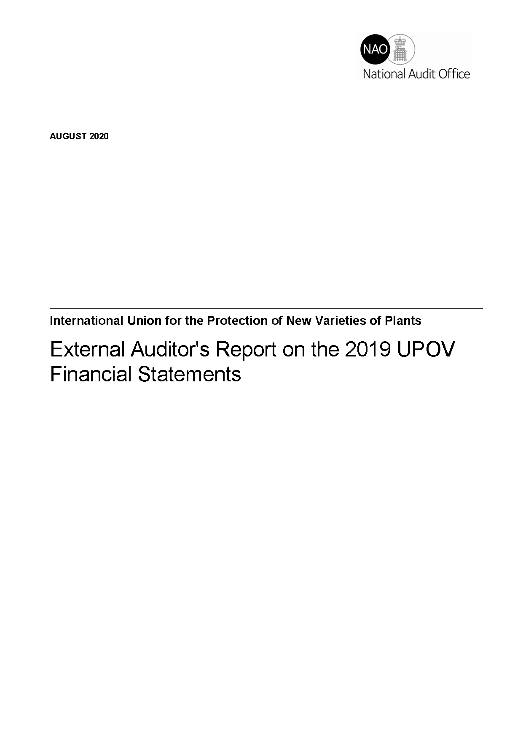
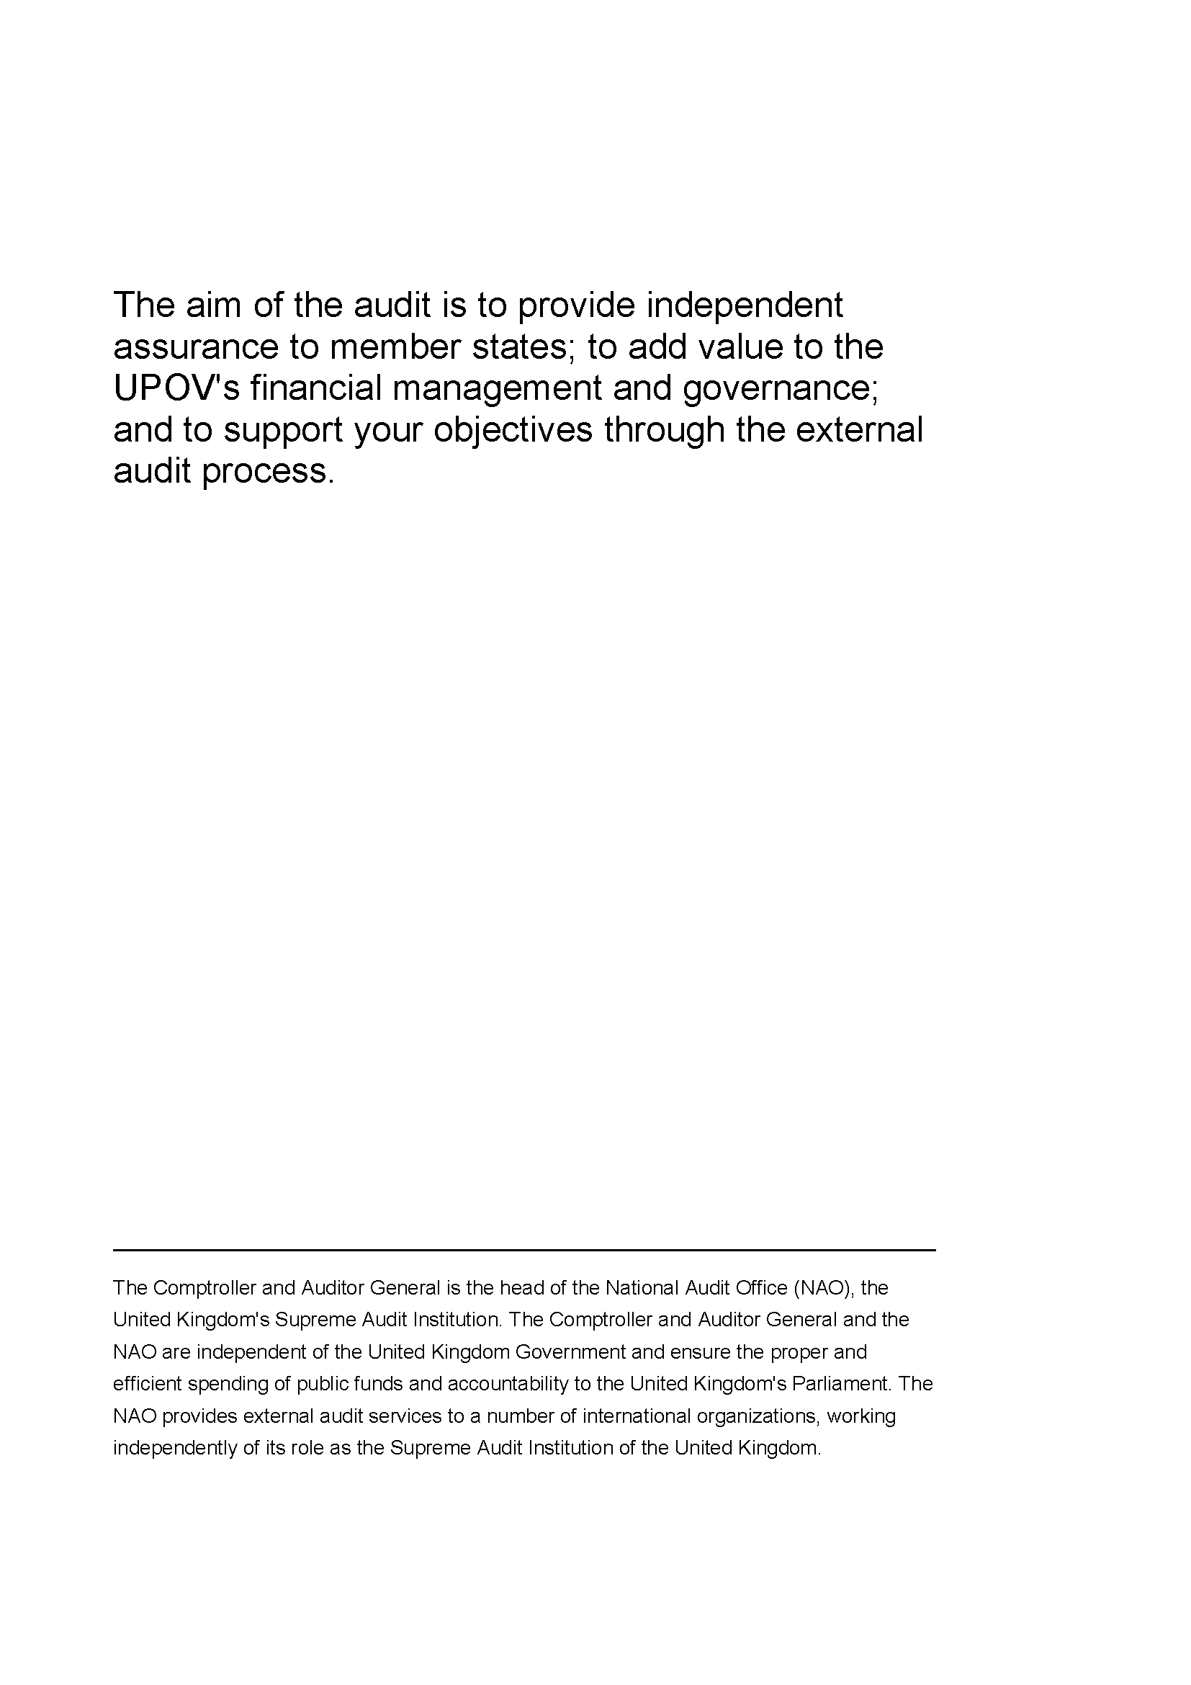
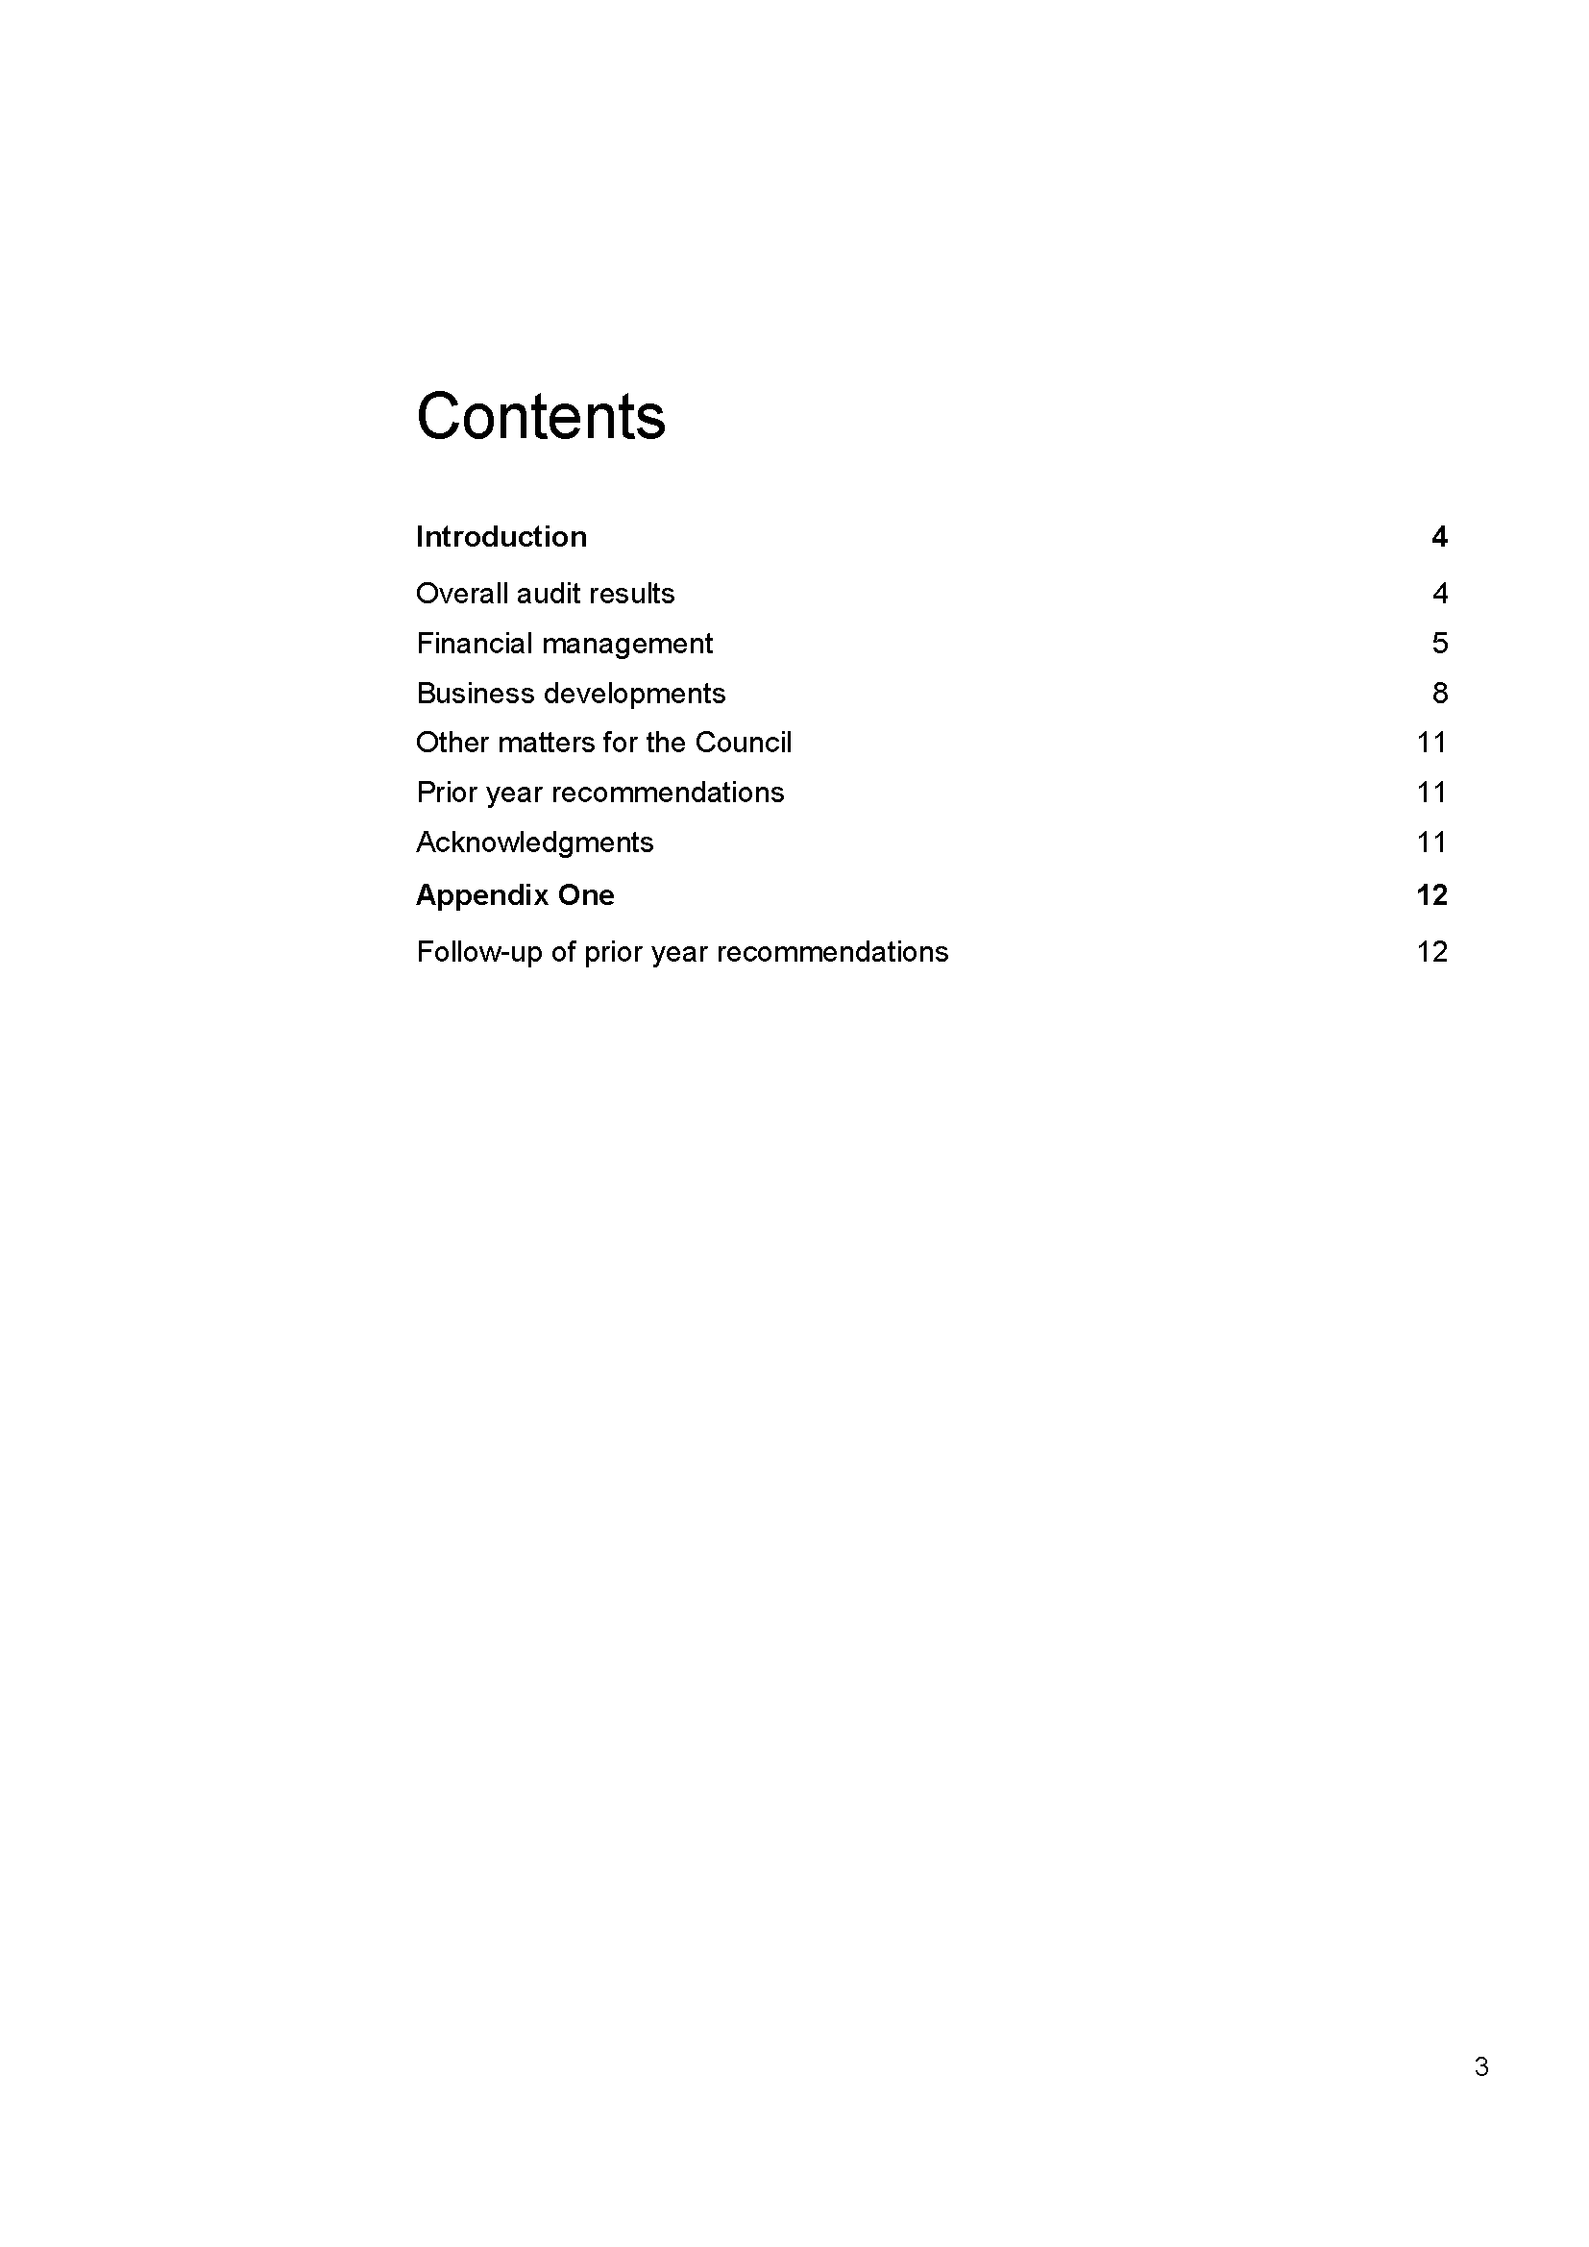
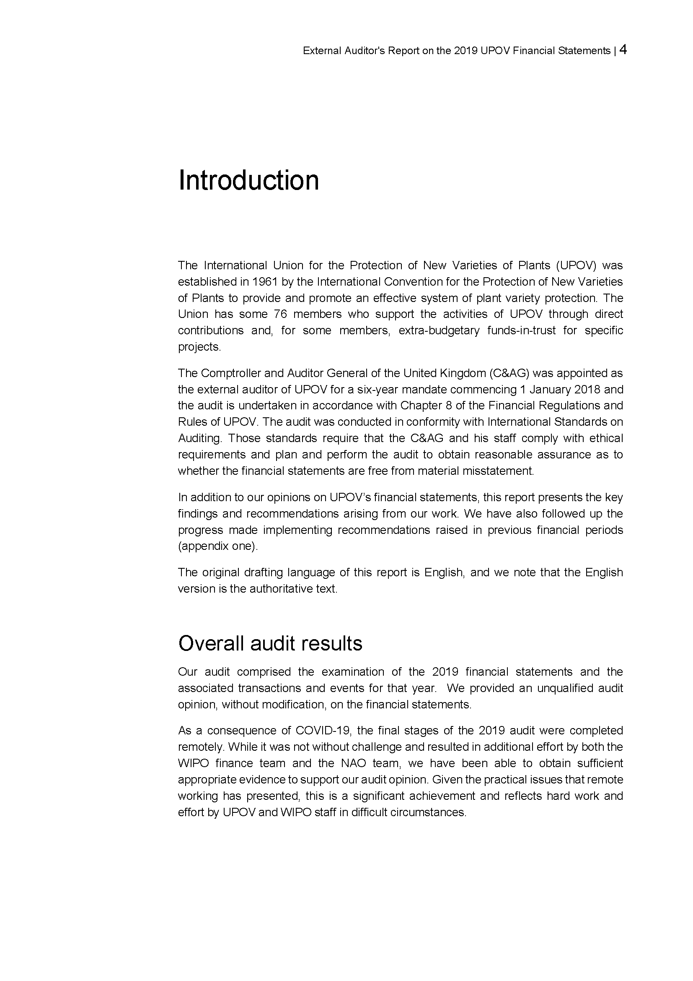
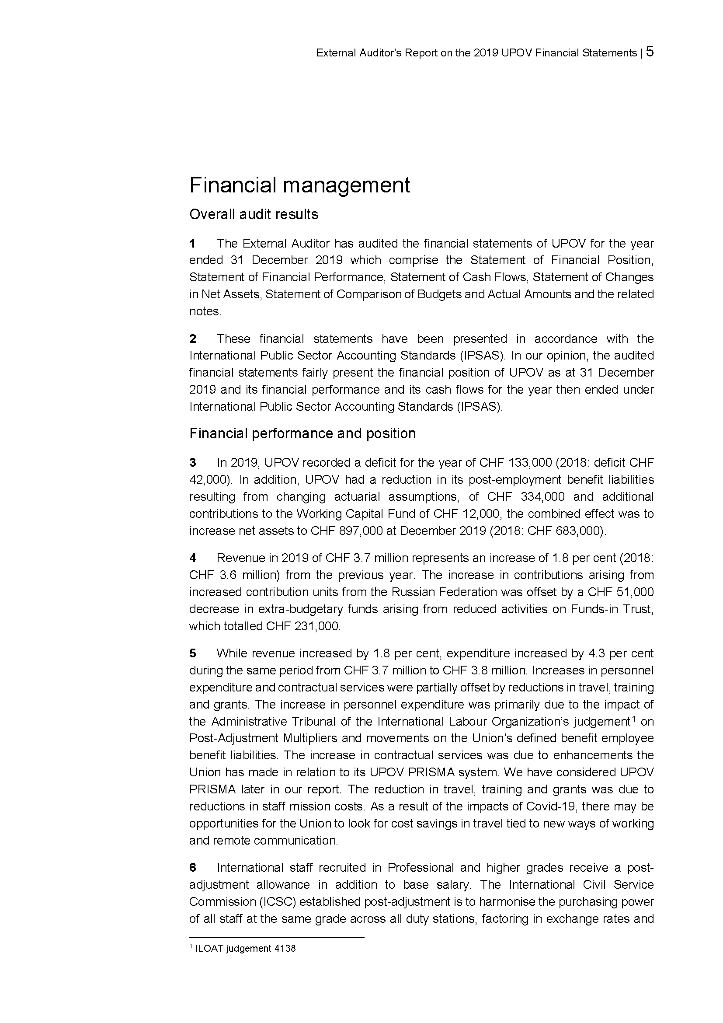
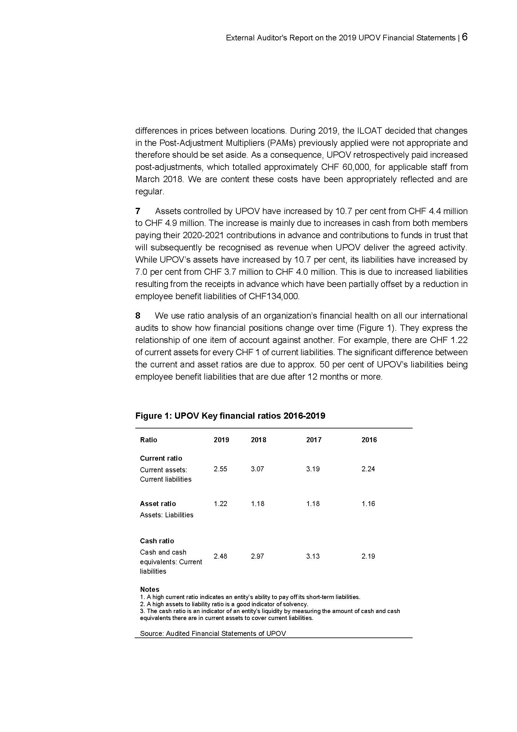
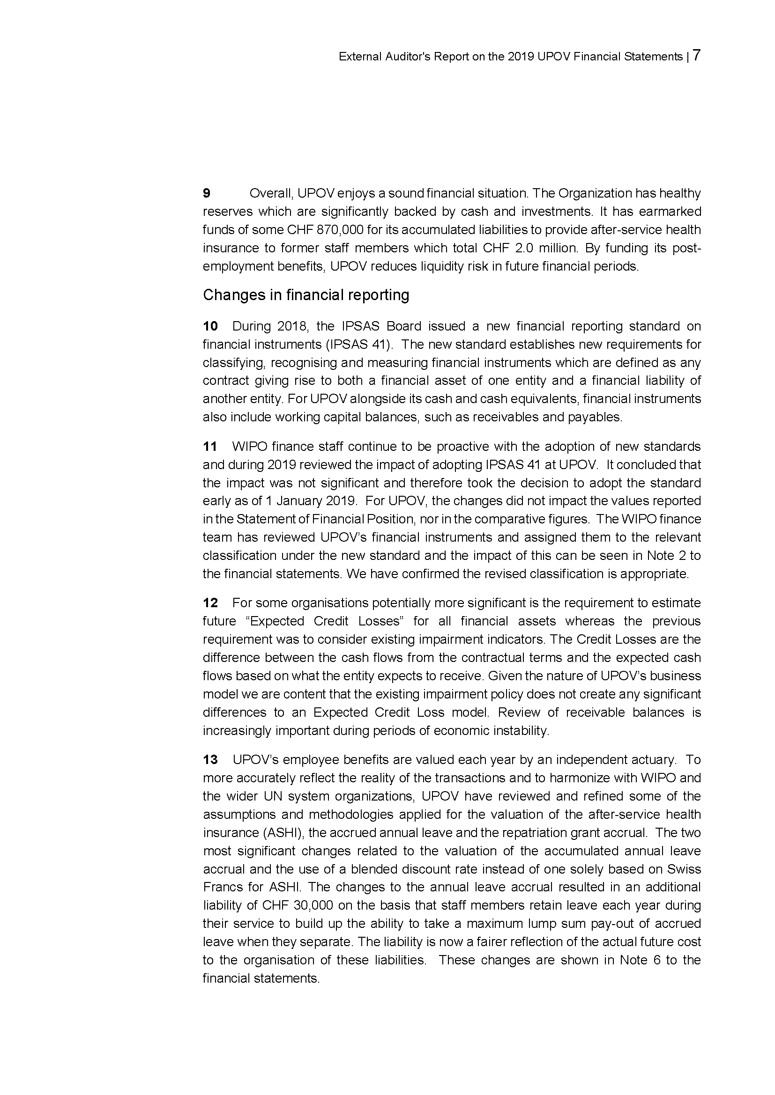
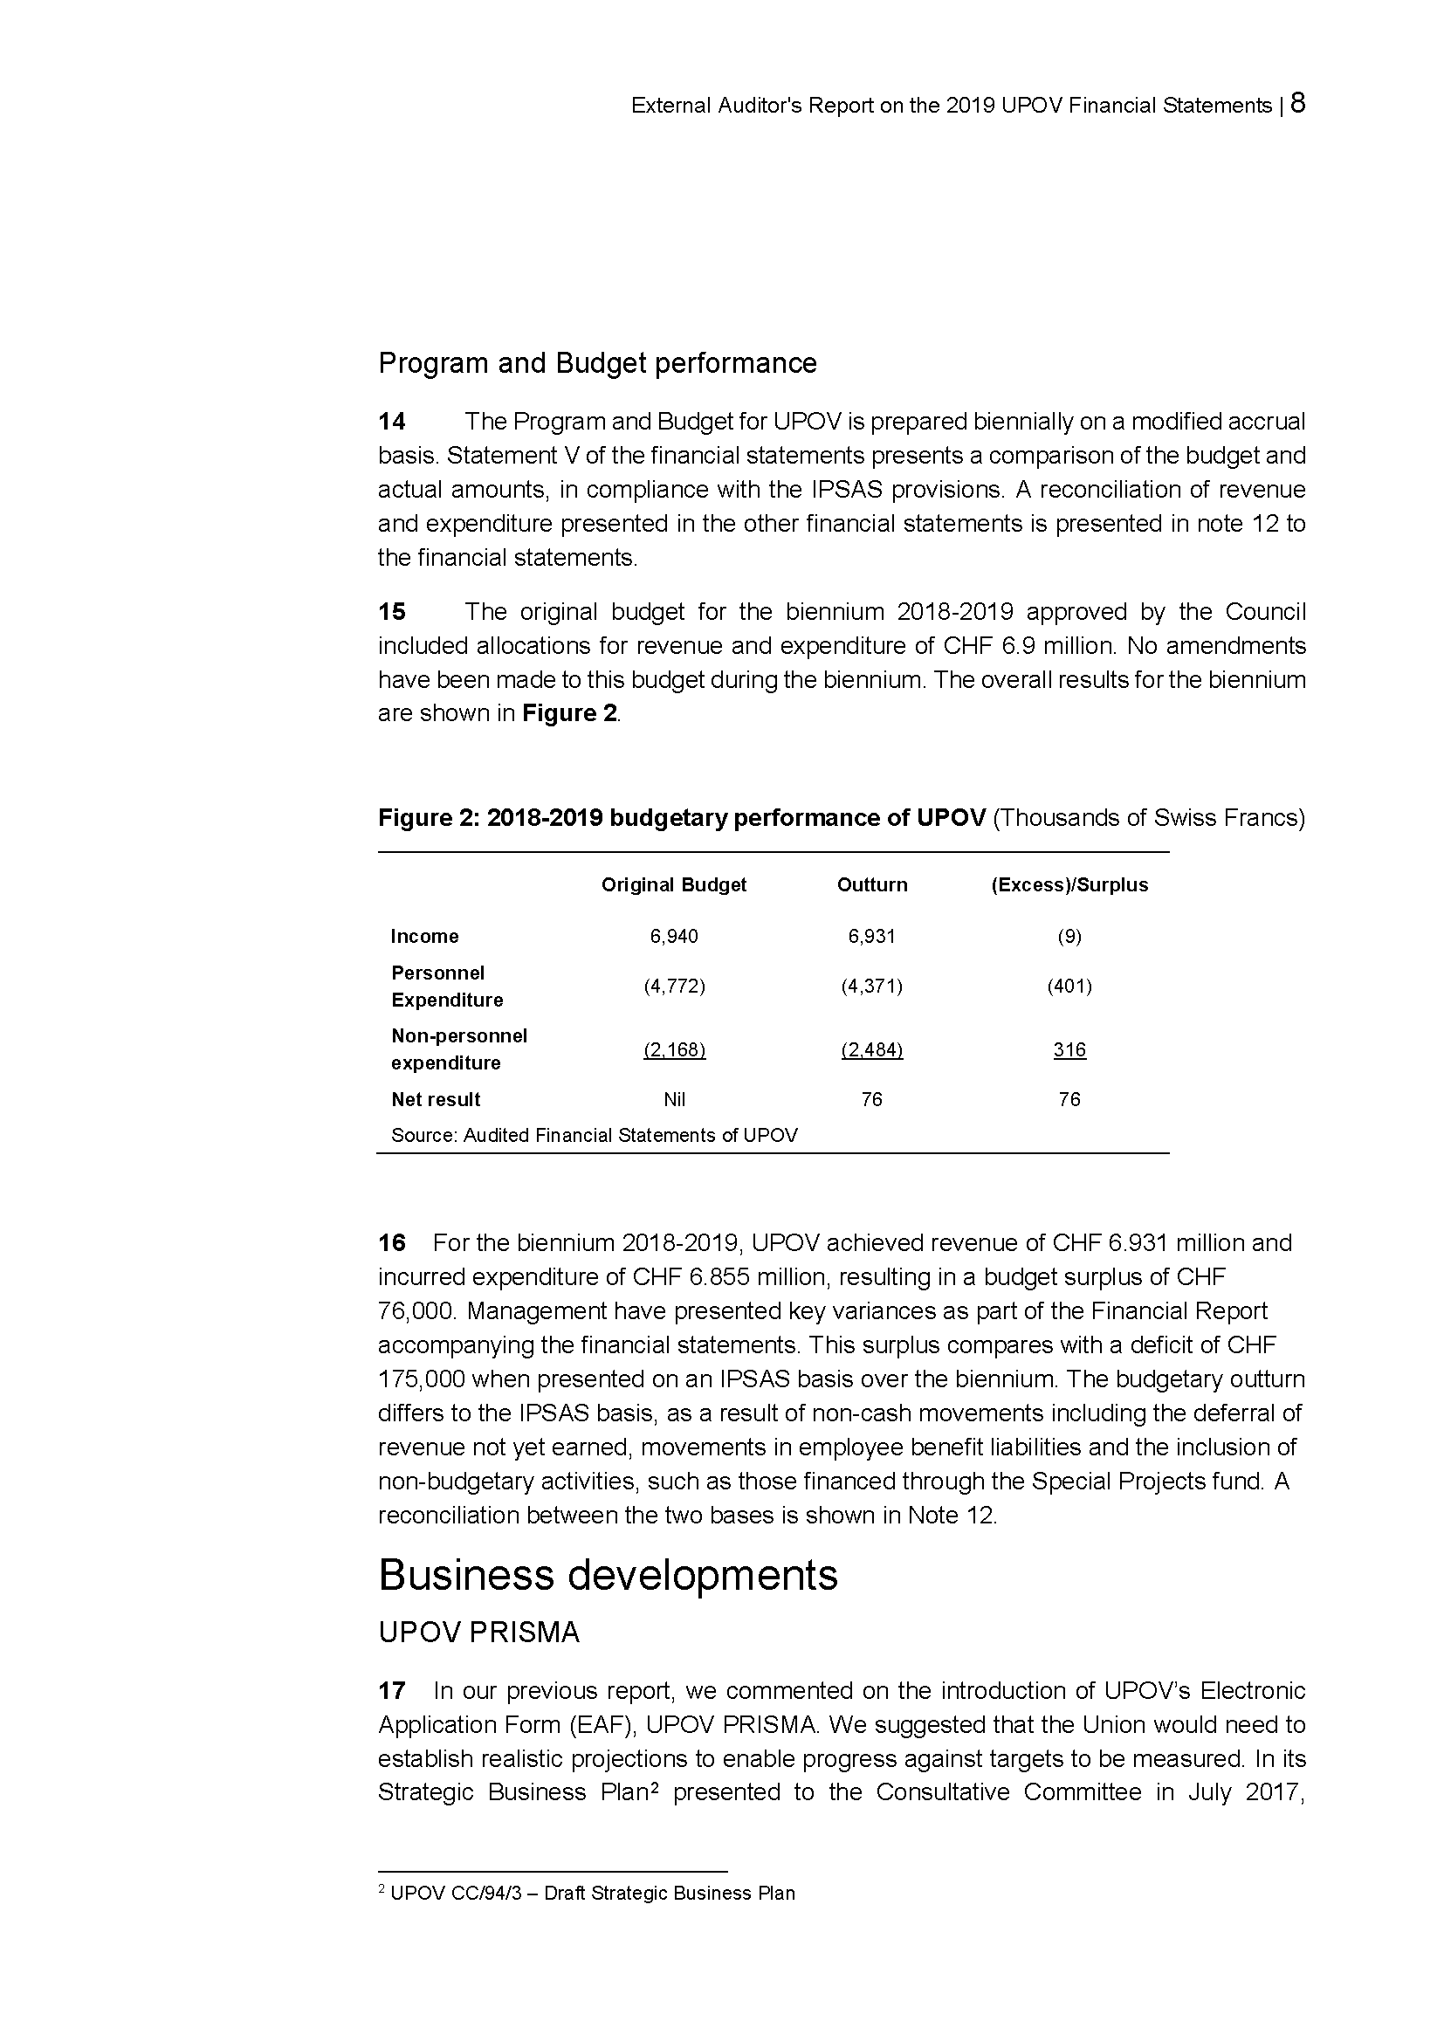
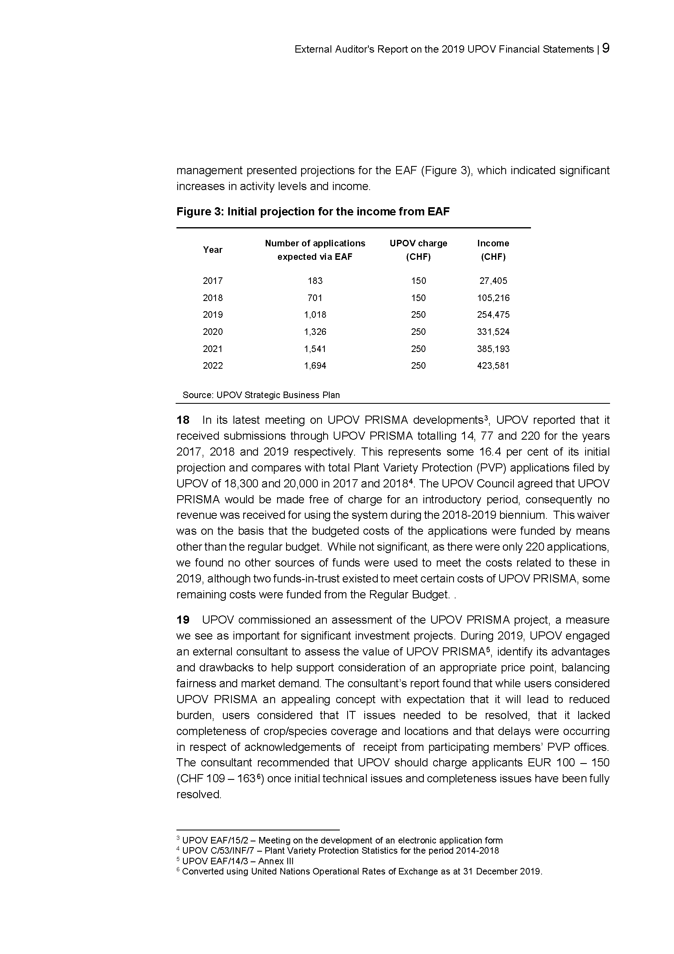
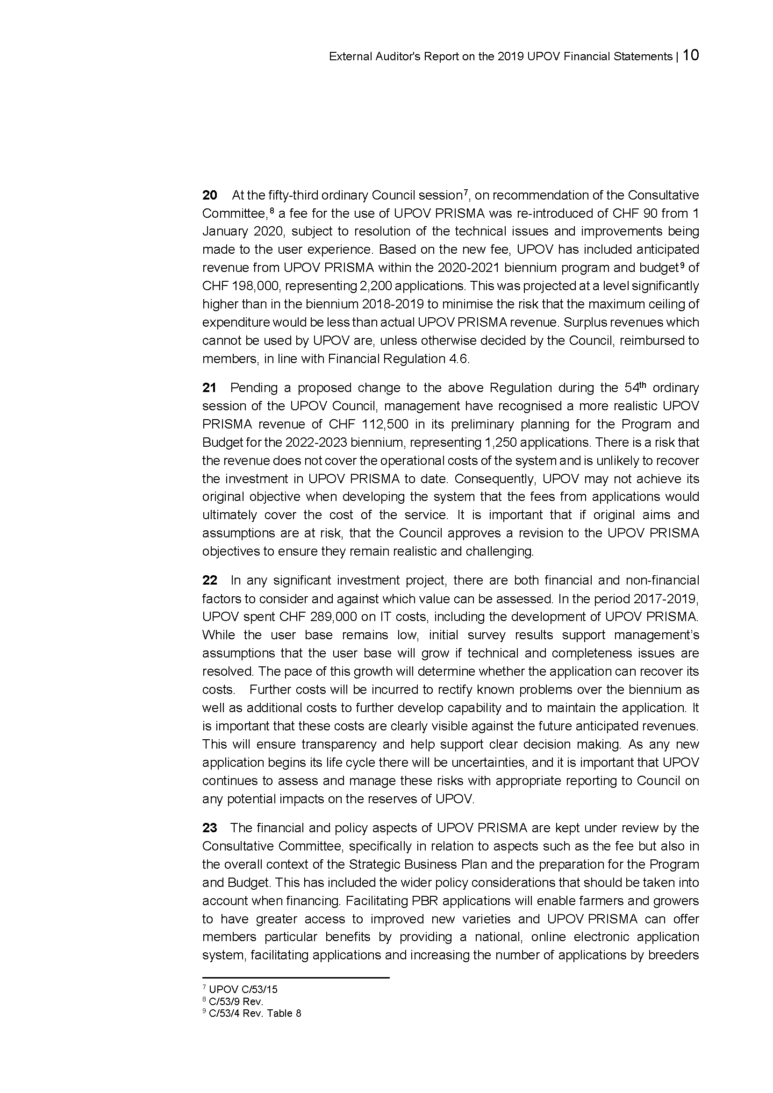
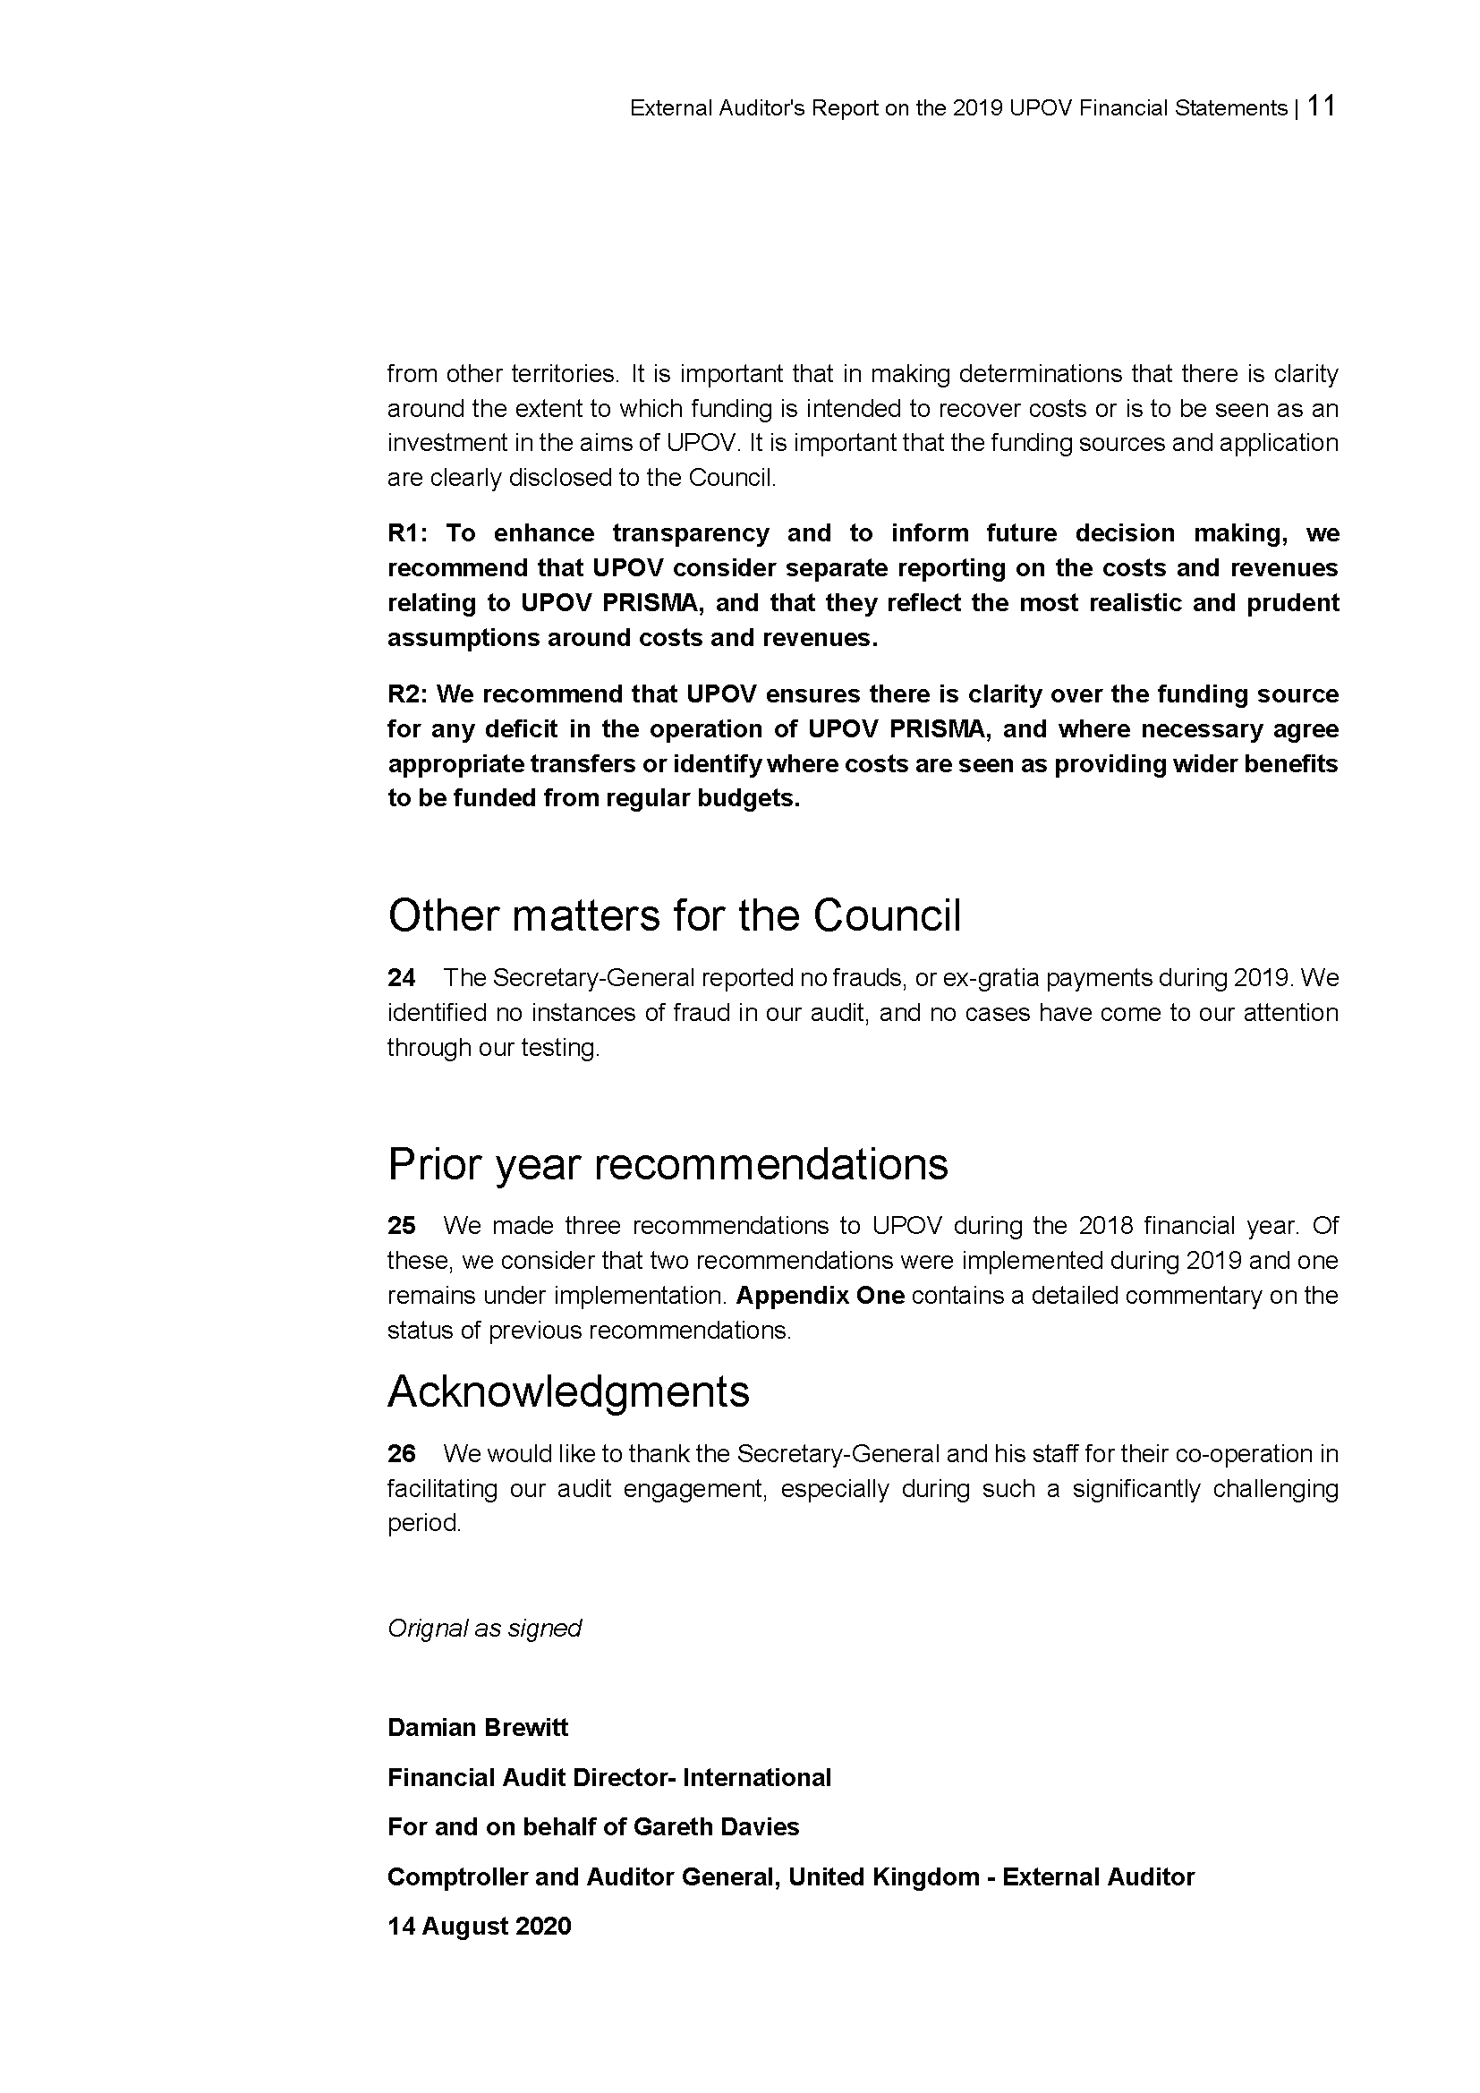

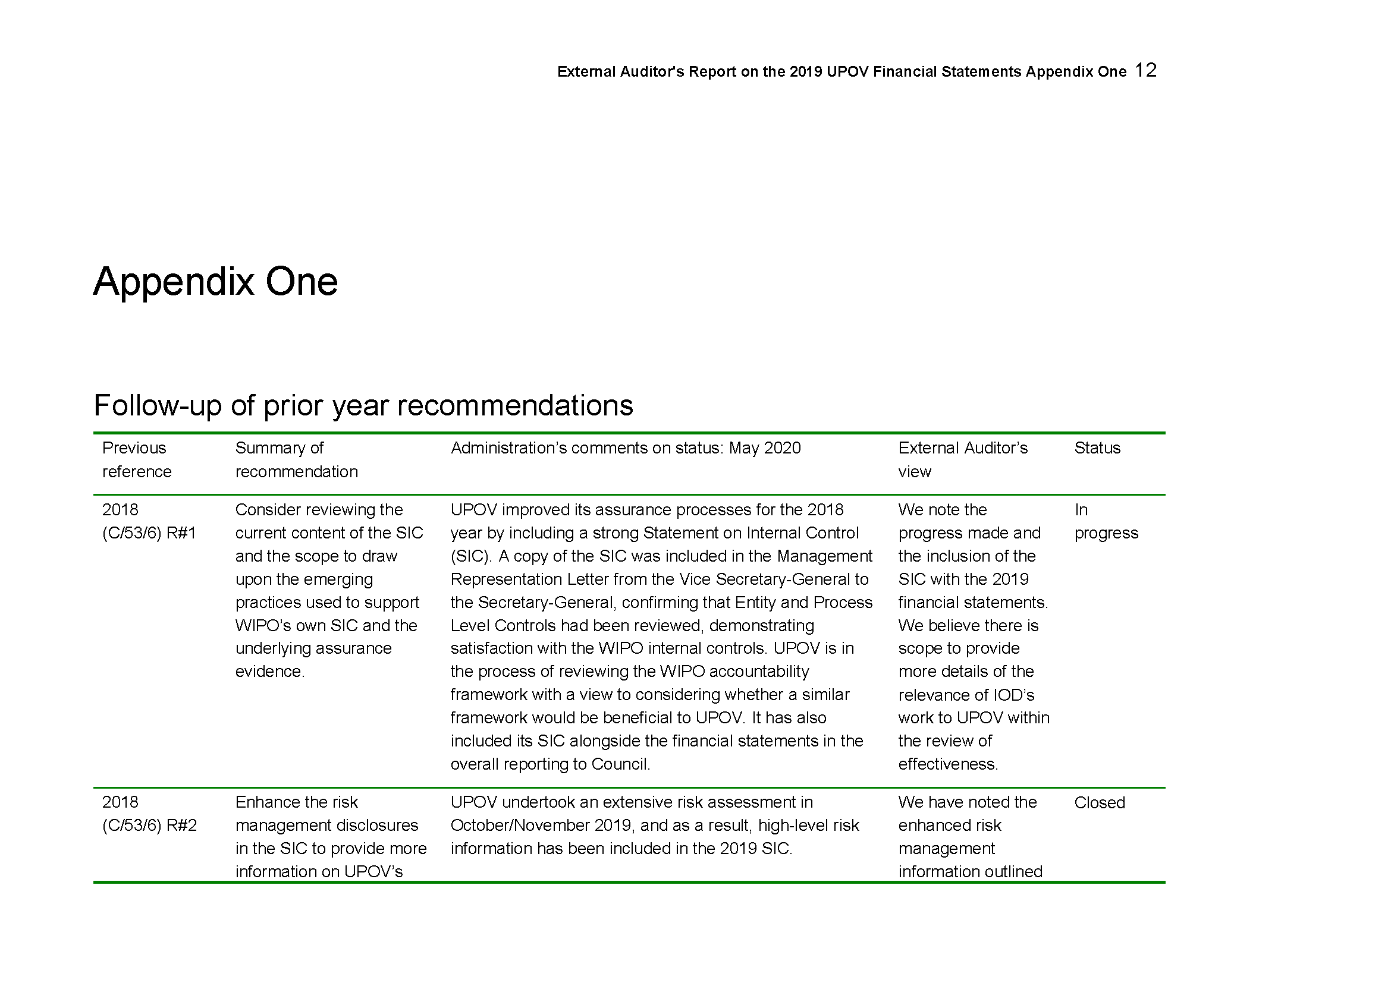
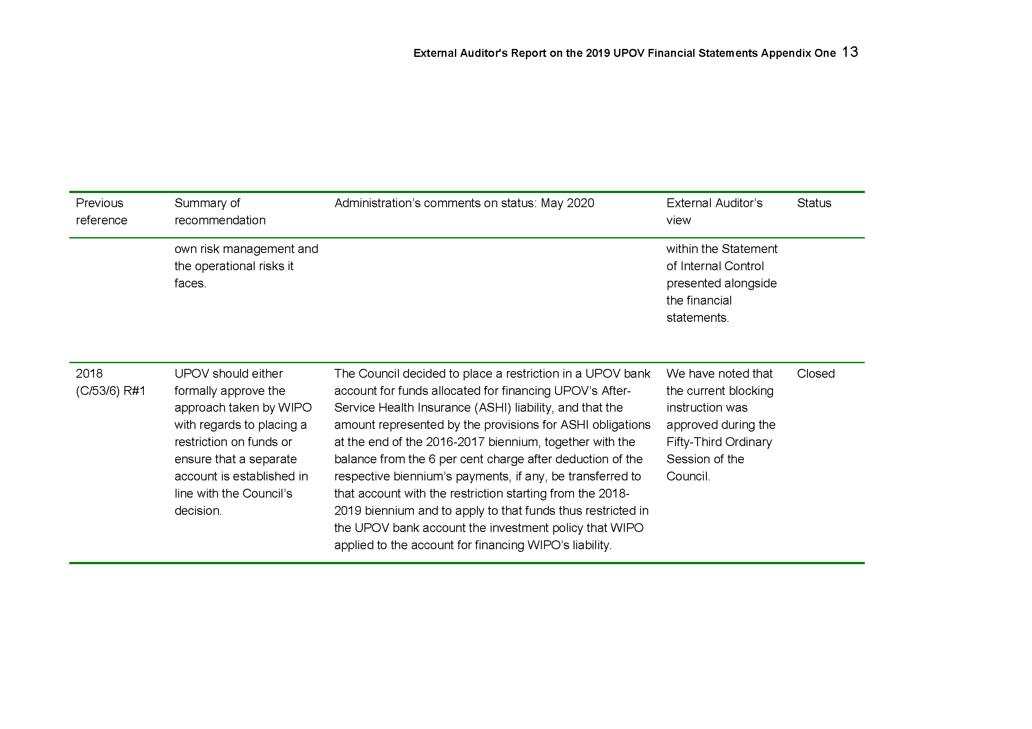
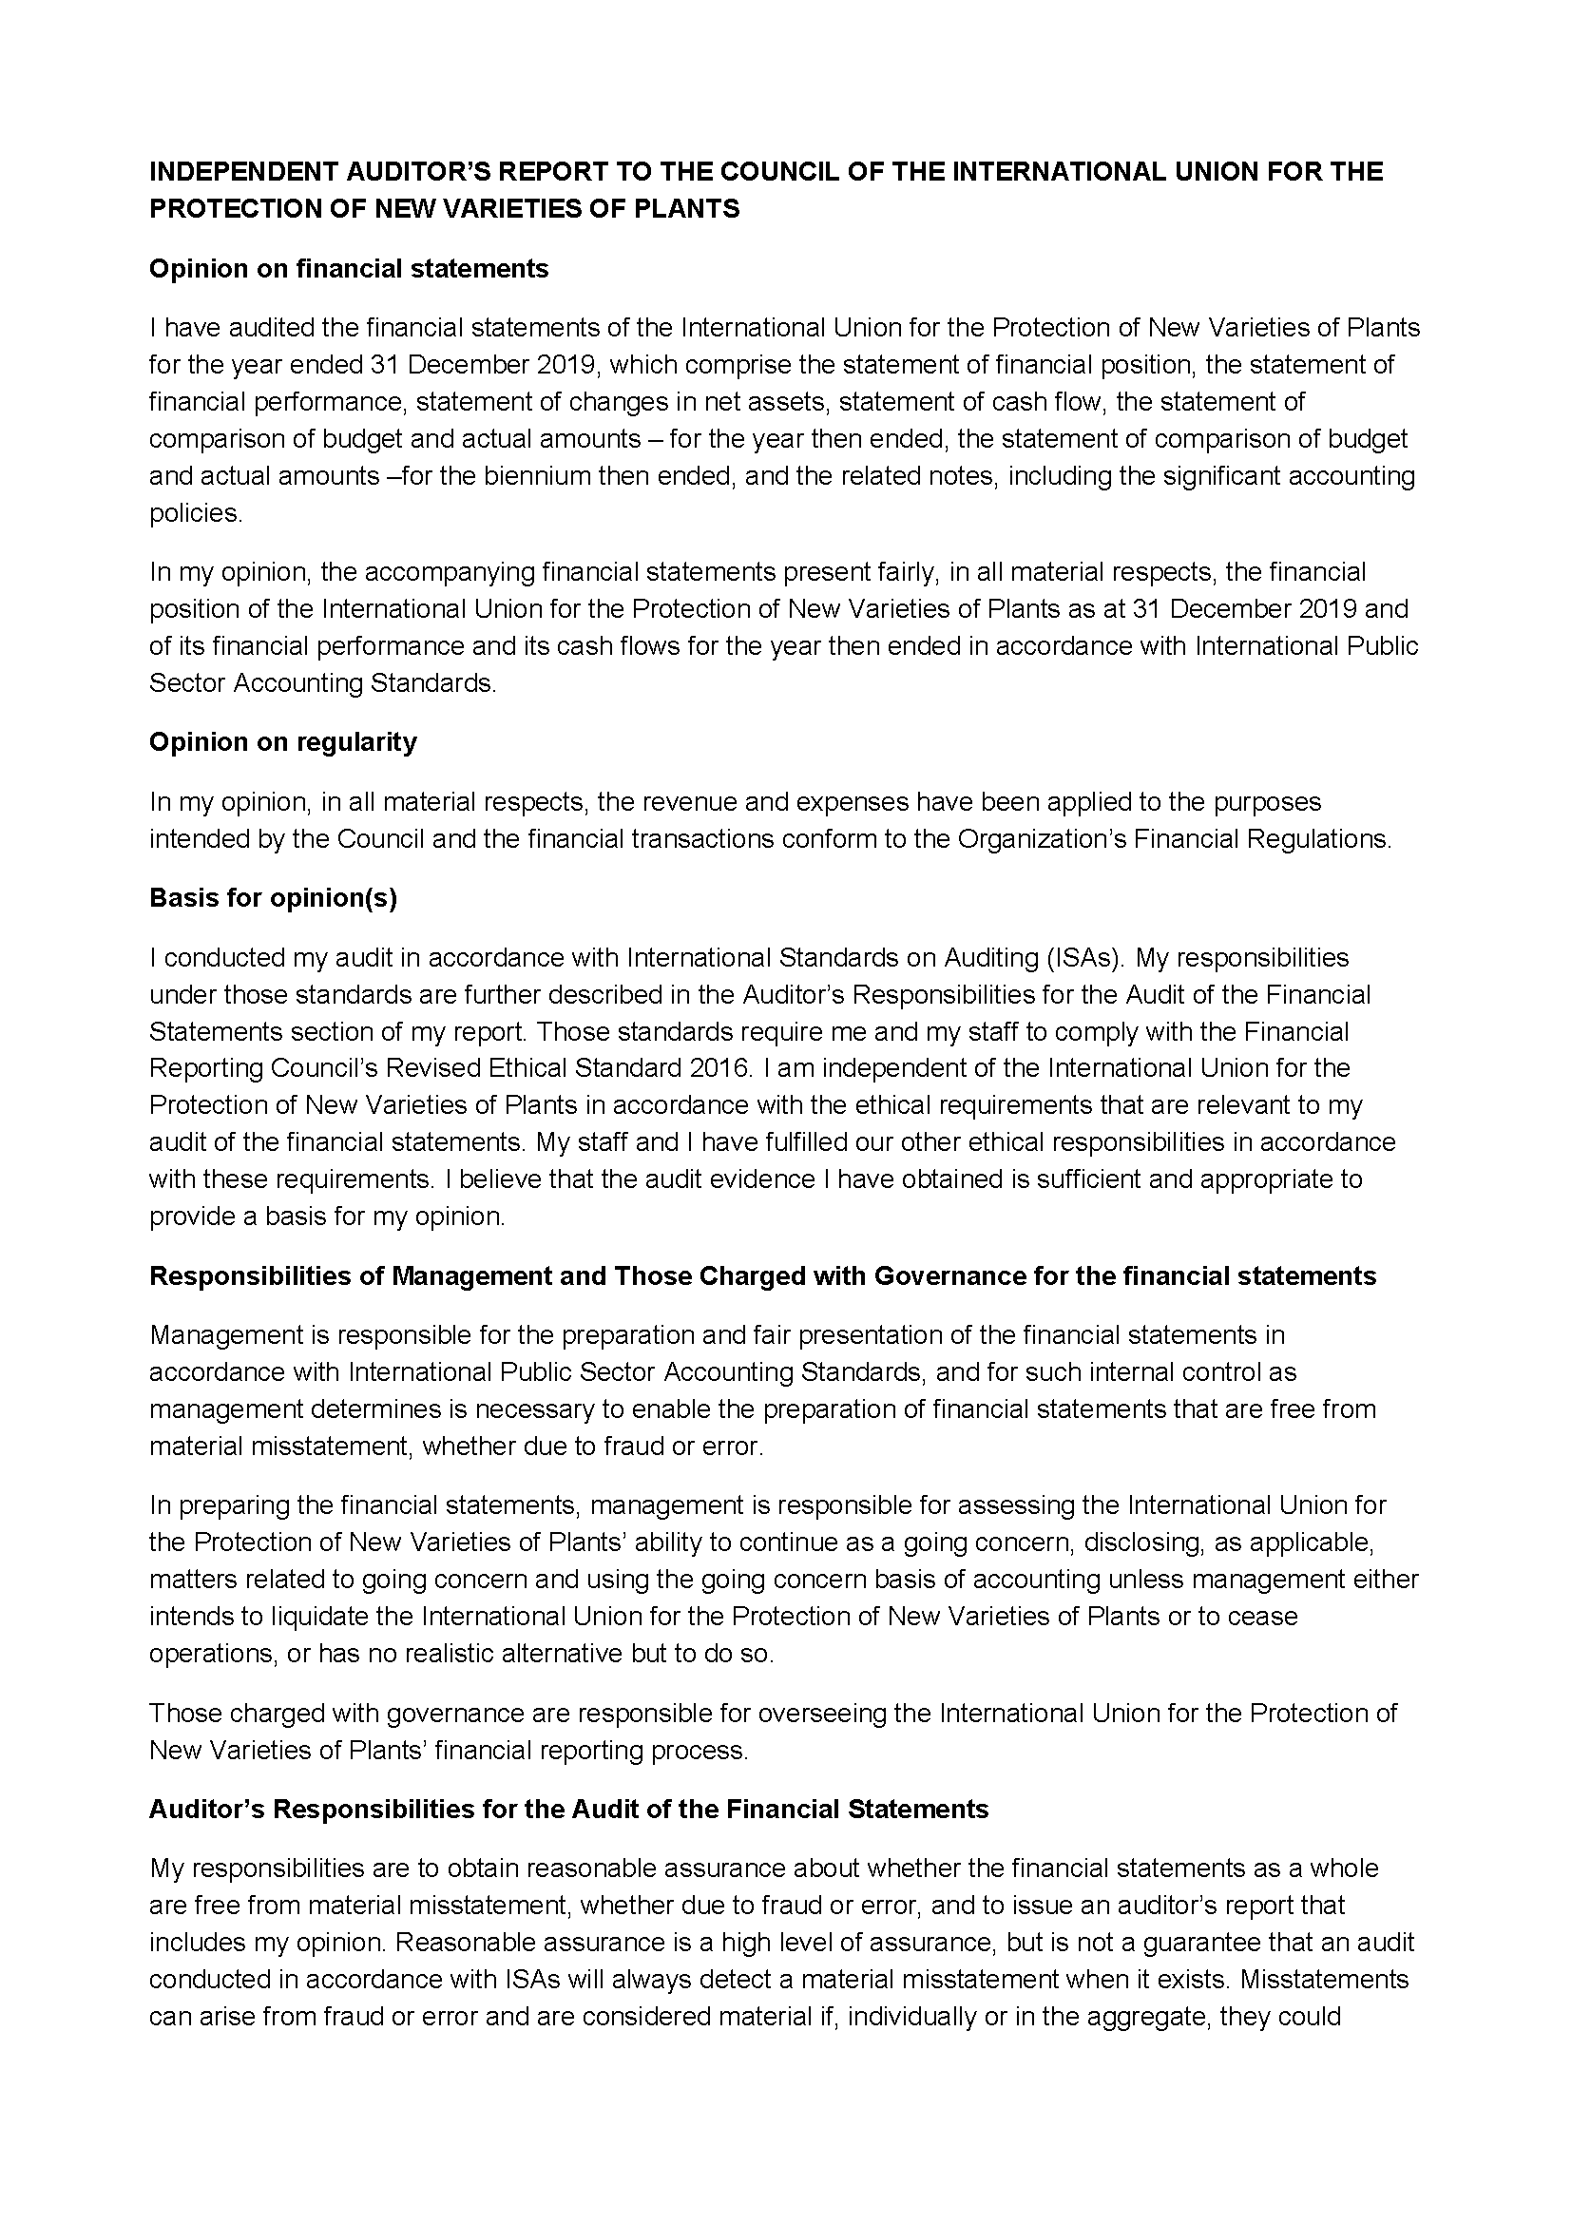

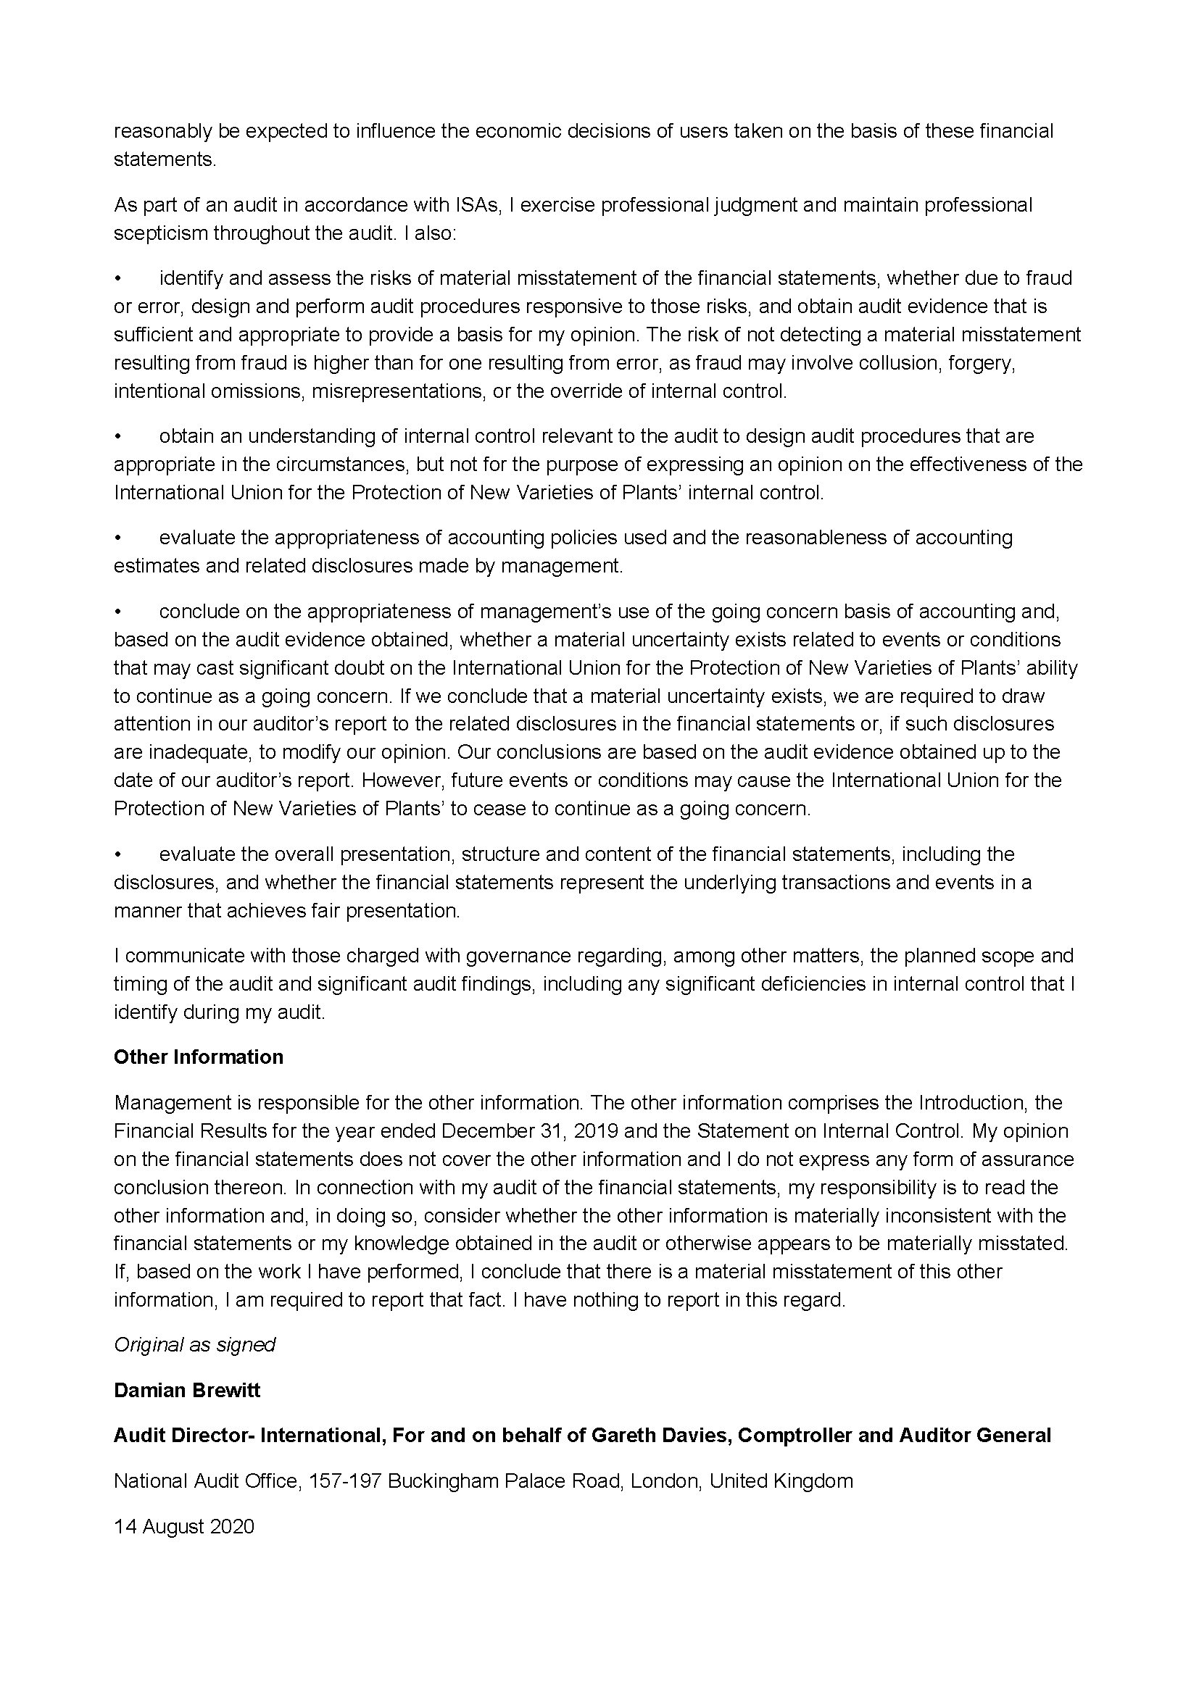
[End of Annex and of document]
[End of Annex and of document]

