|  |  |
| --- | --- |
|  | E |
| International Union for the Protection of New Varieties of Plants |  |

|  |  |
| --- | --- |
| Council  Fifty-Fourth Ordinary Session Geneva, October 30, 2020 | C/54/4  Original: English  Date: August 7, 2020 |
| *to be considered by correspondence* |  |

Financial Management Report for the 2018-2019 Biennium

Document prepared by the Office of the Union

Disclaimer: this document does not represent UPOV policies or guidance

The Annex to this document contains the Financial Management Report (FMR) of the International Union for the Protection of New Varieties of Plants (UPOV) for the 2018-2019 Biennium, in accordance with Regulations 2.14 and 2.14*bis* of the Financial Regulations and Rules of UPOV (FRR) (see document UPOV/INF/4/5 “Financial Regulations and Rules of UPOV”), for approval by the Council.

The FMR is not subject to an external audit.

Regulation 2.14*bis* of the FRR states as follows:

Regulation 2.14*bis*

[…]

Rule 102.7

(a) The Controller of WIPO shall prepare the program and financial management report […]

(b) Within eight months after the end of each financial period, the Secretary-General shall submit to the Council the program and financial management report prepared in accordance with Regulations 2.14 and 2.14*bis*.

*The Council is invited to approve the Financial Management Report for the 2018-2019 Biennium.*

[Annex follows]

**INTERNATIONAL UNION FOR THE PROTECTION OF NEW VARIETIES OF PLANTS**

Financial Management Report for the 2018-2019 Biennium

**TABLE OF CONTENTS page**

SUMMARY AND ANALYSIS OF BUDGET RESULT 2

Table 1. 2018-2019 Income, Expenditure and Reserve and Working Capital Funds (RWCF) 2

Table 2. 2018-2019 Budgeted and Actual Income by Source 3

Table 3. 2018-2019 Approved Budget and Expenditure by Object of Expenditure 4

Table 4. 2018-2019 Approved Budget and Expenditure by Sub-Programs 4

Table 5. 2018-2019 Expenditure Details by Sub-Programs 6

Table 6. 2018-2019 Budgeted and Actual Posts 7

Table 7. Evolution of Actual Income and Expenditure during 2008-2019 7

FINANCIAL STATEMENTS 8

Statement I Statement of Financial Position 9

Statement II Statement of Financial Performance 10

Statement III Statement of Changes in Net Assets 11

Statement IV Statement of Cash Flow 12

Statement V Statement of Comparison of Budget and Actual Amounts 13

Analysis of the Statement of Financial Position 14

Analysis of Statement of Financial Performance 17

WORKING CAPITAL FUND AND CONTRIBUTIONS 18

Working Capital Fund as at December 31, 2019 18

Contributions of Members of the Union 19

Contribution Payments Received in Advance 21

Amounts of the Contributions Due and Unpaid Working Capital as at December 31, 2019 22

EXTRABUDGETARY FUNDS (FUNDS IN TRUST) 24

# SUMMARY AND ANALYSIS OF BUDGET RESULT

Table 1 below presents the overall budgetary result for UPOV in the 2018-2019 Biennium as well as the Reserve and Working Capital Funds (RWCF) as at the end of 2019. The total income (before IPSAS adjustments) amounted to 6,930,932 Swiss francs, and the total budgetary expenditure amounted to 6,854,494 Swiss francs, resulting in a budgetary surplus of 76,438 Swiss francs for the 2018-2019 Biennium.

At the end of 2019, the total RWCF amounted to 896,605 Swiss francs, comprising 809,578 Swiss francs in the Reserve Fund, 560,845 Swiss francs in the Working Capital Fund and Actuarial losses through Net Assets of 473,818 Swiss francs.

## Table 1. 2018-2019 Income, Expenditure and Reserve and Working Capital Funds (RWCF)

*(in thousands of Swiss francs)*



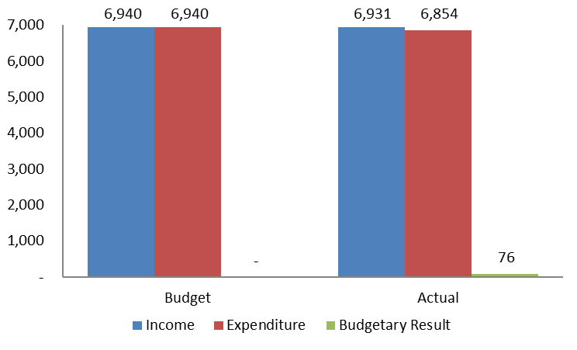

The actual budgetary income amounted to 6.9 million Swiss francs in the 2018-2019 Biennium, i.e. 8,894 Swiss francs lower than the budget (Table 2 below).

Income from contributions continued to be the single largest source of income representing 98.6 per cent of total income, in line with the approved 2018-2019 Program and Budget. In the 2018-2019 Biennium, actual contributions received were higher than budgeted, driven by an increase in the number of contribution units from the Russian Federation. The number of units increased from one-half (0.5) to two (2.0) units as of 2019.

No income was generated from publications in the 2018-2019 Biennium because all publications are available free of charge.

Other income amounted to 97,090 Swiss francs, i.e. 78,627 Swiss francs lower than the budget. Other income included: (i) revenue generated from program support costs related to Funds-in-Trusts (FITs) which, at 58,223 Swiss francs, was slightly lower than the budget of 69,717 Swiss francs; and (ii) fee income from participants in the UPOV distance learning program which, at 40,000 Swiss francs, was significantly higher than the budget of 16,000 Swiss francs.

Also within other income, 90,000 Swiss francs was budgeted for UPOV PRISMA fees in the 2018-2019 Biennium but no income was received as a result of a decision to make the use of UPOV PRISMA free of charge until the end of 2019.

## Table 2. 2018-2019 Budgeted and Actual Income by Source

*(in thousands of Swiss francs)*



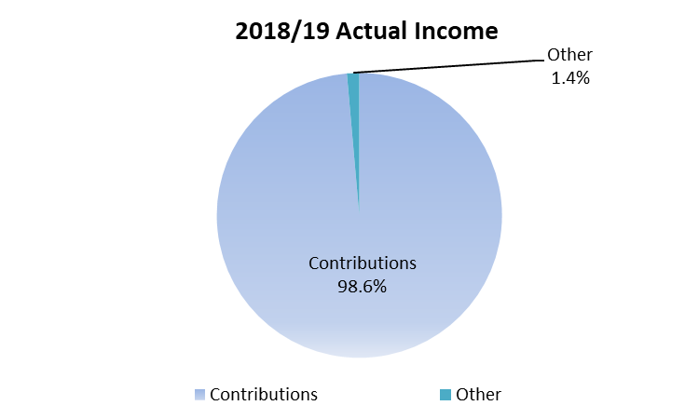

Actual expenditure in 2018-2019 compared to the approved 2018-2019 Program and Budget is presented below by cost categories in Table 3 and by sub-programs in Table 4.

## Table 3. 2018-2019 Approved Budget and Expenditure by Object of Expenditure

*(in thousands of Swiss francs)*



* Any differences in numbers between this table and subsequent tables from the Financial Statements are due to rounding.

## Table 4. 2018-2019 Approved Budget and Expenditure by Sub-Programs

*(in thousands of Swiss francs)*



Personnel Resources

Personnel expenditure (before IPSAS adjustments) amounted to 4.4 million Swiss francs in 2018-2019, i.e. 401,577 Swiss francs (8.4 per cent) lower than the approved 2018-2019 Program and Budget.

Expenditure on posts was in line with the budget as a result of the following: expenditure on two posts in the professional staff category was higher than projected because the posts were occupied several months earlier than planned. This was offset by two posts in the general service staff category being occupied at 80 per cent.

Expenditure on temporary staff reached 16.3 per cent of the budgeted costs for 2018-2019 due to the fact that two posts in the professional staff category, which were initially covered by temporary staff, were occupied earlier than planned (see (i) above) and no temporary administrative staff was recruited because work was instead performed by agency workers.

Non-Personnel Resources

Non-personnel expenditure (before IPSAS adjustments) amounted to 2.5 million Swiss francs in 2018-2019, 316,171 Swiss francs, or 14.6 per cent higher than budgeted. Explanations by cost categories are provided below.

*Interns*

For the Biennium 2018-2019, expenditure on Internships and Fellowships, of 70,321 Swiss francs, was significantly higher than the budget (40,000 Swiss francs), resulting from the recruitment of an IT intern for UPOV PRISMA and higher than budgeted expenditure on travel for fellows.

*Travel*

Total expenditure on Travel amounted to 445,548 Swiss francs, i.e. 25,548 Swiss francs (or 6.1 per cent) higher than the budget. However, this represented a reduction of 9.3 per cent on travel expenditure as compared to the 2016/17 Biennium (491,226 Swiss francs). The higher than budgeted costs in 2018-2019 reflect a higher number of staff missions, which were made possible following the decision to change to a single set of UPOV sessions in Geneva.

*Contractual Services*

Total Contractual Services amounted to 726,475 Swiss francs, i.e. 291,475 Swiss francs higher than the budget, due to higher than budgeted expenditure for Other Contractual Services.

Expenditure on Conferences of 139,090 Swiss francs was in line with the budget (140,000 Swiss francs). As a result of moving to a single set of UPOV sessions in Geneva, the cost for Conferences decreased by 24.4 per cent (44,821 Swiss francs) as compared to the 2016/17 Biennium.

Expenditure on Publishing and Individual Contractual Services was minimal and broadly in line with the budget.

Higher expenditure on Other Contractual Services (580,314 Swiss francs as compared to the budget of 265,000 Swiss francs) was due to:

* Additional expenditure on agency workers (324,014 Swiss francs as compared to the budget of 110,000 Swiss francs) to provide coverage for: (i) the two general service staff members working part-time (80%); and (ii) the vacant temporary position in the administrative staff category (see “Personnel Resources”).
* Higher than budgeted IT development costs (232,001 Swiss francs as compared to the budget of 135,000 Swiss francs), which were required for the development of machine to machine interfaces with PVP offices for UPOV PRISMA and for the implementation of improvements to the user interface.
* Expenditure on social media tools and external staff training.

*Operating Expenses*

Operating Expenses of 1.2 million Swiss francs were slightly lower than the budget due to the containment of the costs of services provided by the World Intellectual Property Organization (WIPO) to UPOV.

*Equipment and Supplies*

Equipment and Supplies amounted to 2,984 Swiss francs, i.e. 17,016 Swiss francs lower than the budget.

The breakdown of 2018-2019 expenditure by sub-programs and cost categories is shown below in Table 5.

## Table 5. 2018-2019 Expenditure Details by Sub-Programs

*(in thousands of Swiss francs)*



* Any differences in numbers between this table and subsequent tables from the financial statements are due to rounding.

Table 6 below provides a summary of the number of posts by category.

## Table 6. 2018-2019 Budgeted and Actual Posts



As indicated in Table 6, there was no change in the biennium in the total number of posts. The higher number of posts in the General Service category was due to a delay in the reclassification of a post from General Service to Professional not being completed during the biennium. The post of the Secretary-General is included within the post count, but at no cost, because the current Director General of WIPO has declined any salary or allowance from his functions as Secretary-General of UPOV.

The overall evolution of actual income and expenditure (before IPSAS adjustments) for the period from 2008 to 2019 is shown below in Table 7.

## Table 7. Evolution of Actual Income and Expenditure during 2008-2019

*(in thousands of Swiss francs)*



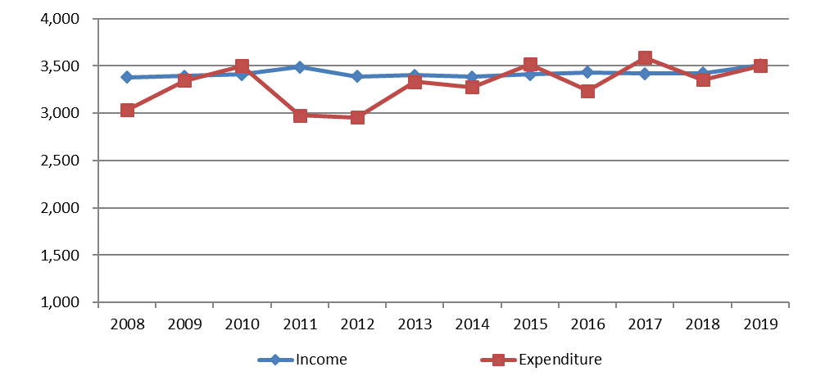

# FINANCIAL STATEMENTS

For each of the two years of the 2018-2019 Biennium, the annual financial statements of UPOV have been prepared in accordance with the International Public Sector Accounting Standards (IPSAS).

**Accrual Accounting under IPSAS**

Under IPSAS the financial statements are prepared applying the full accrual basis of accounting. Accrual basis accounting means the recognition of transactions and events when they occur. As such they are recorded in the accounting records and reported in the financial statements of the financial periods to which they relate, and not only when cash or its equivalent is received or paid.

IPSAS requires that revenue for both contributions and extrabudgetary funds (funds in trust) is recognized when UPOV has a right to receive the contribution. Where contributions are due to UPOV, a receivable balance is recognized. Extrabudgetary fund arrangements are analyzed to see if UPOV needs to meet performance conditions, and if these are present, revenue is only recognized when the conditions are fulfilled.

The value of future employee benefits (including accumulated annual leave, repatriation grants and After-Service Health Insurance (ASHI)) that UPOV staff have earned but not yet received is recorded to capture the full cost of employing staff.

The UPOV Program and Budget is established on a modified accrual basis, which differs from the full accrual basis applied to the financial statements. Other differences between the budgetary result and the result per the financial statements are due to the inclusion in the financial statements of funds in trust and the Special Project Fund, which are not included in UPOV’s Program and Budget. A reconciliation between the budgetary result and the principal financial statements is provided in UPOV’s financial statements in accordance with the requirements of IPSAS.

**Presentation of Financial Information under IPSAS**

As IPSAS requires the preparation of annual financial statements, UPOV financial statements are prepared individually for each calendar year of the biennium. These annual financial statements are presented separately from the Financial Management Report, and for complete financial information of UPOV prepared in accordance with IPSAS requirements, reference should be made to the UPOV annual financial statements.

Under IPSAS, the financial statements include the following elements:

* + Statement I - Statement of Financial Position
  + Statement II - Statement of Financial Performance
  + Statement III - Statement of Changes in Net Assets
  + Statement IV - Statement of Cash Flow
  + Statement V - Statement of Comparison of Budget and Actual Amounts
  + Notes to the Financial Statements

In the Financial Management Report, Statements I-V are presented for the 2018-2019 Biennium. Financial information is provided to give an understanding of the differences between the result of UPOV on a budgetary basis and the result according to the IPSAS financial statements. Other extracts from the annual financial statements provide further details of UPOV’s assets and liabilities.

## Statement I Statement of Financial Position

**as at December 31, 2019**

*(in Swiss francs)*



## Statement II Statement of Financial Performance

**for the Biennium ended December 31, 2019**

*(in Swiss francs)*



## Statement III Statement of Changes in Net Assets

**for the Biennium ended December 31, 2019**

*(in Swiss francs)*



## Statement IV Statement of Cash Flow

**for the Biennium ended December 31, 2019**

*(in Swiss francs)*



## Statement V Statement of Comparison of Budget and Actual Amounts

**for the Biennium ended December 31, 2019**

*(in thousands of Swiss francs)*



1. represents the approved 2018-2019 Program and Budget;
2. represents the difference between the final (revised) budget and actual expense on a comparable basis (before IPSAS adjustments).

## Analysis of the Statement of Financial Position

**Movement in Net Assets**

As at December 31, 2019, UPOV has net assets on an IPSAS basis of 896,830 Swiss francs. Between 2017 and 2019, net assets increased by 266,775 Swiss francs. This was mainly attributable to the impact of actuarial gains from the ASHI valuation, which were partly offset by deficits in both 2018 and 2019. In addition, contributions were made to the Working Capital Fund in both years. The table below summarizes the increase in net assets during the 2018-2019 Biennium:

Movement in Net Assets 2017-2019



**Summary of Assets and Liabilities**

The chart below provides a summary of the Statement of Financial Position of UPOV as at December 31, 2019:

Summary of Assets and Liabilities December 31, 2019



As at December 31, 2019, UPOV had cash balances of 4,763,272 Swiss francs, representing 97.5 per cent of total assets. This balance includes amounts classified as restricted under IPSAS, and also strategic cash representing funds allocated for the future financing of UPOV’s ASHI liability. The remaining assets are accounts receivable totaling 121,052 Swiss francs.

The most significant liability of UPOV is employee benefits of 2,356,399 Swiss francs, including primarily the ASHI liability of 2,026,390 Swiss francs. Advance receipts of 768,104 Swiss francs include contributions paid in advance (423,763 Swiss francs) and deferred revenue from extrabudgetary funds (344,341 Swiss francs). Payables and other liabilities (863,216 Swiss francs) are almost entirely comprised of the amount payable to WIPO.

**Cash and Cash Equivalents**



Total cash and cash equivalent balances have increased over the biennium by 15.7 per cent between December 31, 2017 and December 31, 2019. Cash deposits are generally held in instant access bank accounts. For the purposes of IPSAS presentation, cash balances are split between unrestricted, restricted and strategic. Working Capital Fund balances are considered as restricted, although interest received on Working Capital Fund balances is credited to the general fund of UPOV. Funds in trust held on behalf of donors of extrabudgetary funds are deposited in the currency in which expenditures will be reported, based upon agreements with donors.

At its thirty-third extraordinary session on March 17, 2016, the Council of UPOV decided to hold in a separate account the funds allocated for the future financing of UPOV’s ASHI liability. As at December 31, 2019, the total balance of these funds is 870,169 Swiss francs (783,128 Swiss francs as at December 31, 2018). In accordance with the Council decision at the fifty-third ordinary session on November 1, 2019, the funds are held in one of UPOV’s principal bank accounts, but are managed separately from operating funds through a blocking instruction currently in place with the bank. UPOV manages the ASHI funds in accordance with WIPO’s Policy on Investments, under which they are classified as strategic cash.

**Accounts Receivable**



Total accounts receivable at December 31, 2019 are 121,052 Swiss francs, compared to 86,196 Swiss francs as at December 31, 2017. The balance of receivables from extrabudgetary funds (funds in trust) at the end of 2019 totaled 43,876 Swiss francs, whereas at the end of 2017 there were no receivables from these funds.

**Employee Benefits**



As can be seen from the table above, by far the most significant employee benefit liability for UPOV is ASHI, which represents 86.0 per cent of the total employee benefit liability as at December 31, 2019. Over the period of the 2018-2019 Biennium the ASHI liability decreased by 183,071 Swiss francs, and this movement is detailed in the table below:



The liability is calculated by an independent actuary, and reflects the total future cost of UPOV’s share of collective medical insurance premiums for both existing UPOV retirees and the projected number of active UPOV staff who will retire in the future. The current service cost in the table above is the net impact of employee service performed for the 2018-2019 Biennium. The interest cost is the result of each member of the active staff moving closer to the age of eligibility for ASHI participation. The benefits paid out by UPOV during the biennium are the monthly contributions (currently 65.0 per cent of premiums) that UPOV makes for retirees participating in ASHI. Actuarial gains and losses result from changes to actuarial assumptions, including the discount rate, medical cost trend rates, staff turnover rates and mortality rates. For the 2019 actuarial calculations, UPOV modified certain actuarial assumptions and methodologies to align more closely to the relevant provisions of the employee benefit. The 2019 discount rates were established with reference to the underlying currency of medical claims. In addition, the attribution of costs was modified to reflect the qualifying period of service and accrued benefit at the valuation date, as opposed to a linear attribution over the period of employment. These changes, combined with other movements in actuarial assumptions, largely explain the overall actuarial gain over the 2018-2019 Biennium.

**Advance Receipts**



Contributions received in advance are recorded as advance receipt liabilities and are recognized as revenue in the year to which they relate. Extrabudgetary funds from donors to funds in trust containing conditions related to performance are treated as deferred revenue until the conditions are fulfilled, whereupon revenue is recognized.

**Payables and Other Liabilities**



Payables and other liabilities totaled 863,216 Swiss francs as at December 31, 2019. These are almost entirely comprised of amounts payable to WIPO.

## Analysis of Statement of Financial Performance

**Revenue**



Contributions under the Program and Budget represent amounts payable at the start of each year of the biennium. Extrabudgetary funds under funds in trust represent revenue received in connection with contributions made by donors to individual projects not included in the Program and Budget. Revenue from extrabudgetary funds (funds in trust) is deferred until earned through the fulfillment of the performance conditions included in the donor agreement.

**Expenses**



Personnel expenditure includes employee benefits such as base salary, post adjustment, dependents’ allowance, pension contributions, health and other insurance contributions, home leave and other entitlements. Under IPSAS, personnel expenditure also includes certain amounts for the movements in after-service employee benefit liabilities. Travel, training and grants includes the costs of airfare, daily subsistence allowances, terminal allowances and other travel costs for staff on official business and travel for participants and lecturers in connection with training activities. Contractual services include translators, interpreters and other non-staff service agreements. Operating expenses include items such as premises rent, maintenance and bank charges.

# WORKING CAPITAL FUND AND CONTRIBUTIONS

## Working Capital Fund as at December 31, 2019

Under Regulation 4.2 of the Financial Regulations and Rules of UPOV (see document UPOV/INF/4/5), UPOV has a Working Capital Fund. According to the Statement of Financial Position as at December 31, 2019, the Working Capital Fund stands at 560,845 Swiss francs.  The share of each member of the Union, calculated in accordance with the decision taken by the Council at its twenty-third extraordinary session, held in Geneva on April 7, 2006 (see document C(Extr.)/23/5 “Report”, paragraph 12, Annex II and document UPOV/INF/13/2, Annex), is as follows:



## Contributions of Members of the Union

*(Swiss francs)*





## Contribution Payments Received in Advance



## Amounts of the Contributions Due and Unpaid Working Capital as at December 31, 2019





# EXTRABUDGETARY FUNDS (FUNDS IN TRUST)

The extrabudgetary funds (including funds in trust) allocated by donor are presented below as independent accounts.



**Income and expenditure for the 2018-2019 Biennium**



*Note*: Funds in trust in the form of an extrabudgetary fund from the Government of Japan intended for regional seminars and workshops on the protection of new plant varieties in the Asian region.



*Note*: Extrabudgetary fund from the Government of the United States of America, intended for education in intellectual property protection in the area of plant variety protection. The accounts and financial reports for this trust fund are kept in US dollars.



*Note*: Extrabudgetary fund from the Netherlands intended to provide and promote the UPOV system of plant variety protection.



*Note*: Extrabudgetary fund from various organizations, communities and federations to promote the UPOV PRISMA PBR application tool. UPOV PRISMA is an on-line tool to assist in making plant variety protection (PVP) applications to PVP Offices of participating members of the Union.



*Note:* UPOV PRISMA is an on-line tool to assist in making plant variety protection (PVP) applications to PVP Offices of participating members of the Union.  The UPOV PRISMA Fund is a contribution made by Naktuinbouw (Netherlands) to support the development of UPOV PRISMA.

[End of Annex and of document]