E
International Union for the Protection of New Varieties of Plants

Council  Fifty-Fourth Ordinary Session  Geneva, October 30, 2020 | C/54/11  Original: English  Date: July 6, 2020
to be considered by correspondence
Appointment of the Secretary-General
Document prepared by the Office of the Union
Disclaimer: this document does not represent UPOV policies or guidance
Introduction

The UPOV Convention (Article 26(5)(iii) of the 1991 Act and Article 21(b) of the 1978 Act) states that the Council of UPOV shall appoint the Secretary-General of UPOV and determine the terms of appointment.

The Agreement between the World Intellectual Property Organization and the International Union for the Protection of New Varieties of Plants (WIPO/UPOV Agreement, document UPOV/INF/8), signed on November 26, 1982, Article 4 provides as follows:

“(1) The Council of UPOV shall appoint as Secretary-General of UPOV the Director General of WIPO.
“(2) When the post of Director General of WIPO is vacant, and as long as it is vacant, the person acting as Director General of WIPO shall be Acting Secretary-General of UPOV.
“(3) During the period between the effective date of appointment of the
Director General of WIPO and his appointment as Secretary-General of UPOV, he shall be Acting Secretary-General of UPOV.
“(4) The appointment of the Secretary-General of UPOV shall last as long as he is Director General of WIPO and shall cease on the day his appointment as Director General of WIPO ceases.
“(5) The indemnity of the Secretary-General of UPOV, payable by UPOV, shall be determined by the Council of UPOV.”

The Council, at its forty-eighth ordinary session, held in Geneva on October 16, 2014, decided to re-appoint Mr. Francis Gurry as the Secretary-General of UPOV for the period from October 16, 2014, to September 30, 2020.

Appointment of the Director General of WIPO

The General Assembly of WIPO, at its fifty-second (28th extraordinary) session, conducted on May 7 and 8, 2020, in the form of a written procedure, appointed Mr. Daren Tang as the Director General of WIPO for the period from October 1, 2020, to September 30, 2026.

In accordance with Article 4(3) of the WIPO/UPOV Agreement, Mr. Tang is Acting Secretary-General of UPOV as from October 1, 2020.

Appointment of the Secretary-General of UPOV

In accordance with the relevant provisions of the UPOV Convention (Article 26(5)(iii) of the 1991 Act and Article 21(b) of the 1978 Act) and of the WIPO/UPOV Agreement (see paragraphs 1 and 2, above), the Council is invited to appoint Mr. Tang as the Secretary-General of UPOV for the period from October 30, 2020 to September 30, 2026. The Annex to this document contains the curriculum vitae of Mr. Tang.

Furthermore, Article 4(5) of the WIPO/UPOV Agreement provides that “[t]he indemnity of the Secretary-General of UPOV, payable by UPOV, shall be determined by the Council of UPOV.”

In accordance with decisions of the Council, the indemnity of the Secretary-General of UPOV corresponds to twenty percent of the salary, including post adjustment, which he receives in his capacity as Director General of WIPO.

Mr. Tang has expressed his wish not to receive an indemnity as Secretary-General of UPOV and to use this indemnity in the UPOV program and budget for financing activities of particular interest to developing countries.

The Council is invited to appoint Mr. Daren Tang as the Secretary-General of UPOV for the period from October 30, 2020, to September 30, 2026.

[Annex follows]

Curriculum Vitae of Mr. Daren Tang
(Chief Executive, Intellectual Property Office of Singapore)
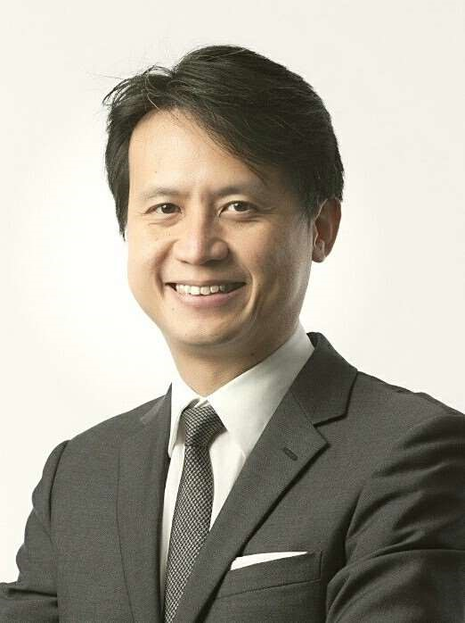
Year of Birth: 1972
Nationality: Singaporean
ACADEMIC QUALIFICATIONS
2013 Advanced Management Program
Harvard Business School, USA
2006 Master of Laws (LL.M) with Distinction
Georgetown University Law Centre, USA
Fellow, Institute of International Economic Law
1997 Bachelor of Laws (LL.B) with Honours
National University of Singapore
PROFESSIONAL EXPERIENCE
2015 – Chief Executive
present Intellectual Property Office of Singapore (IPOS)
Ministry of Law, Singapore
Drove the strategic transformation of IPOS from an intellectual property (IP) registry and regulator into an innovation agency that helps to build Singapore’s future economy:
- Launched a series of world’s first IP products including a mobile app for trademark application, and a national-level IP skills and jobs framework. Initiated and oversaw a collaboration with a local university to provide one of the few post-graduate programmes in IP and Innovation Management in the world.
- Put in place legislative reforms to the IP civil litigation system to make it more accessible for SMEs and strengthen IP mediation.
- Developed new capabilities at IPOS covering IP strategy and patent analytics, as well as the release of the world’s first mobile app for trademark applications.
- Supported the use of IP by enterprises for business growth by providing training to 5000 persons in 2018, engaging 800 enterprises from 2017 to 2018, and collaborating with private sector to provide IP insurance to enterprises.
For these efforts, IPOS was recognised as Asia’s most innovative IP office and ranked 2nd in the world by World Trademark Review in 2019. Singapore has also been ranked 2nd in the world for IP protection by the World Economic Forum (2018/2019) and one of the top 10 countries in the World Intellectual Property Organization (WIPO) Global Innovation Index (2015 to 2019).
Member of the Committee for the Future Economy tasked with reviewing Singapore’s economic strategies. Updated the IP Hub Masterplan in 2017 to broaden the mandate of IPOS to include IP commercialisation. Forged agreements with regional and international partners covering over 70 markets.

2012 – 2015 Deputy Chief Executive and Chief Legal Counsel
Intellectual Property Office of Singapore
Ministry of Law, Singapore
Oversaw key projects as IPOS broadened its mission and developed its regional and international networks:
- Singapore’s appointment as the 19th International Searching and Preliminary Examining Authority and the 1st in ASEAN under the WIPO-Patent Cooperation Treaty.
- Singapore’s accession and ratification of the Marrakesh Treaty.
- Establishment of the 2013 national IP Hub Master Plan, a 10-year blueprint to guide Singapore’s development as a Global IP Hub in Asia.
- Redevelopment of the IPOS registry filing system and implemented IP²SG, a one-stop integrated online platform for IP registration in Singapore.
- Major IP legislative and policy reforms to Singapore’s patent, trademark, registered design and copyright regimes.
Helped to steer ASEAN’s IP agenda during Singapore’s term as Chair of the ASEAN Working Group on IP Cooperation (AWGIPC) and strengthened the patent eco-system for ASEAN. The AWGIPC covered 28 initiatives and 108 deliverables across the ASEAN IP Review Action Plan, including Singapore’s hosting of the ASEAN IP Portal – an integrated IP centre linking all ASEAN IP Offices on matters related to IP.
Chaired IP negotiations in Free Trade Agreements, including the TransPacific Partnership Agreement and the Regional Comprehensive Economic Partnership Agreement. Led and concluded negotiations for the IP chapter of the EU-Singapore FTA.
2003 – 2012 Senior State Counsel
International Affairs Division
Attorney-General’s Chambers, Singapore
Senior legal counsel and negotiator for various international law matters of critical importance to Singapore, including Free Trade Agreements, Double Taxation Agreements, International Investment Agreements, Law of the Sea matters, ASEAN regional agreements and UN-related issues. Part of the Singapore legal team that argued a territorial dispute before the International Court of Justice.
2001 – 2003 Legal Consultant
Ministry of Trade and Industry, Singapore
Lead negotiator and legal counsel for Singapore in the US-Singapore Free Trade Agreement, the US’ first FTA with an Asian nation.
1997 – 2001 State Counsel/Deputy Public Prosecutor
Held various appointments at both the Attorney-General’s Chambers, Singapore, and at the Ministry of Home Affairs, Singapore.

CURRENT APPOINTMENTS
Chairperson, Standing Committee on Copyright and Related Rights (SCCR), WIPO
Appointed as Chairperson in May 2017. Advanced discussions amongst the Member States on the agenda of the SCCR, including the Treaty to Protect Broadcasting Organisations (Broadcast Treaty), and Limitations and Exceptions. Brokered a consensus for SCCR members to put a recommendation relating to the Broadcast Treaty in 2018 and 2019 before the WIPO General Assembly.
Member, Singapore-Guangdong Collaboration Council (SGCC)
Established an intergovernmental IP collaboration in the Sino-Singapore Guangzhou Knowledge City.
Member, Manufacturing Sub-Committee of the Future Economy Council, Singapore
Member, Modern Services Sub-Committee of the Future Economy Council,
Singapore
Member, Research, Innovation and Enterprise Strategy Committee (RIE SC), Prime Minister’s Office, Singapore
Member, Research, Innovation and Enterprise Executive Committee (RIE Exco), Prime Minister’s Office, Singapore
Co-Chair, National IP Working Group, Prime Minister’s Office, Singapore
Advisory Board Member, Saudi Authority for Intellectual Property (SAIP)
Member, Group of Experts on IP Office of the Future Project, International Trademark Association (INTA)
Board Chairman, IPOS International
Board Member, EW Barker Centre for Law & Business, National University of Singapore
Board Director, Fraunhofer Singapore
Coordinator and Principal Examiner, Intellectual Property Law Course for the Singapore Bar Exam run by the Singapore Institute of Legal Education

HONOURS
2016 Public Administration Medal (Silver)
Prime Minister’s Office, Singapore
2006 Fellow
Institute of International Economic Law, Georgetown University, USA
LANGUAGES
English, Chinese
[End of Annex and of document]

