E
International Union for the Protection of New Varieties of Plants

Council  Fifty-Third Ordinary Session  Geneva, November 1, 2019 | C/53/15  Original: English  Date: November 1, 2019
Report
adopted by the Council
Opening of the session

xThe Council of the International Union for the Protection of New Varieties of Plants (UPOV) held its fifty-third ordinary session in Geneva on November 1, 2019, chaired by Mr. Raimundo Lavignolle (Argentina), President of the Council.

The session was opened by the President who welcomed the participants.

The President reported the granting of observer status to Lao People’s Democratic Republic and Liechtenstein in the Council.

The list of participants is reproduced in Annex I to this report.

Adoption of the agenda

The Council adopted the revised draft agenda, as presented in document C/53/1 Rev. 3, and agreed to move item 15(a) after item 10 “Financial statements for 2018” (document C/53/5).

Report by the Vice Secretary-General on developments in UPOV

The Council noted the presentation made by the Vice Secretary-General of UPOV, a copy of which will be published as document C/53/INF/8.

Examination of the conformity of the Draft Law of Mongolia on Crop Seed and Variety with the 1991 Act of the UPOV Convention

The Council considered document C/53/11.

The Council decided to:

(a) take note of the analysis in document C/53/11;

(b) take a positive decision on the conformity of the relevant parts of the Draft Law of Mongolia on Crop Seed and Variety (“Draft Law”) with the provisions of the 1991 Act of the International Convention for the Protection of New Varieties of Plants, which would allow Mongolia once the relevant parts of the Draft Law were adopted with no changes and the Law in force, to deposit its instrument of accession to the 1991 Act; and

(c) authorize the Secretary-General to inform the Government of Mongolia of the above decision.

The Delegation of Mongolia expressed its appreciation for the positive decision of the Council in respect of the examination of the relevant parts of the Draft Law of Mongolia on Crop Seed and Variety for conformity with the 1991 Act of the UPOV Convention. It looked forward to working closely with UPOV for accession to the UPOV Convention and to cooperating with members of the Union.
Examination of the conformity of the Draft Plant Variety Protection Act of Afghanistan with the 1991 Act of the UPOV Convention

The Council considered document C/53/12.

The Council decided to:

(a) note the analysis in document C/53/12;

(b) take a positive decision on the conformity of the “Draft Plant Variety Protection Act of Afghanistan” (“Draft Law”) with the provisions of the 1991 Act of the International Convention for the Protection of New Varieties of Plants, which would allow Afghanistan once the Draft Law was adopted with no changes and the Law in force, to deposit its instrument of accession to the 1991 Act; and

(c) authorize the Secretary-General to inform the Government of Afghanistan of the above decision.

The Delegation of Afghanistan expressed its appreciation for the positive decision of the Council in respect of the examination of the Draft Plant Variety Protection Act of Afghanistan with the 1991 Act of the UPOV Convention. It emphasized the importance of UPOV membership for the development of agriculture in Afghanistan and looked forward to the adoption of the Draft Law and to completing the membership procedure soon.

Developments on Book Four “Plant Varieties” of Law Pertaining to the Protection of Intellectual Property Rights of Egypt

The Council considered document C/53/13.

The Council decided to:

(a) note that certain provisions of Book Four "Plant Varieties” of Law Pertaining to the Protection of Intellectual Property Rights, as last amended in 2019, contained changes in relation to the text of the corresponding provisions of the Draft Law submitted to the Council in 2015 (see document C(Extr.)/32/10 “Report”, paragraph 11, and paragraph 2 of document C/53/13);

(b) agree that the changes introduced in Book Four “Plant Varieties” of Law Pertaining to the Protection of Intellectual Property Rights”, as last amended in 2019, presented in document C/53/13 and its Annex II and III, did not affect the substantive provisions of the 1991 Act of the UPOV Convention and, subject to that agreement,

(c) reaffirm the decision on conformity of March 27, 2015, and inform the Government of Egypt that the instrument of accession of Egypt could be deposited.

The Delegation of Egypt thanked the Council for its reaffirmation of the decision on conformity of the Law of Egypt. It expressed its appreciation for the assistance provided by the Office of the Union during the membership procedure. The Delegation informed the Council that, after the closing of the Council, Egypt would deposit with the Secretary-General of UPOV the instrument of accession of Egypt to the 1991 Act of the UPOV Convention. It emphasized the importance of UPOV membership for all types of farmers in Egypt and looked forward to cooperation with members of the Union.

Developments on the New Plant Variety Protection Law of Myanmar

The Council considered document C/53/14.

The Council noted the intervention by the Delegation of Myanmar, at the ninety-sixth session of the Consultative Committee, concerning the provisions of the Law on Article 15(2) of the 1991 Act of the UPOV Convention. It noted that Article 27(b) of the Law would apply only to agriculture crops and that Article 27(c) of the Law excluded fruit, ornamental, vegetable and forest crops from the exception under Article 27(b). It noted the explanation provided by the Delegation that farmers that were not small farmers would pay remuneration to the breeders on farm saved-seed. It further noted that that the provisions of Article 27(b) would be implemented in the regulations.

The Council decided to:

(a) note that the New Plant Variety Protection Law of Myanmar, which had been adopted by the Parliament on September 17, 2019 and published in the Official Gazette on September 24, 2019, contained changes in relation to the text of the Draft Law presented to the Council in 2017 (see document C/51/22 “Report”, paragraph 17, and paragraph 2 of document C/53/14);

(b) agree that the changes, as presented in document C/53/14 and its Annex II, did not affect the substantive provisions of the 1991 Act of the UPOV Convention and, subject to that agreement;

(c) reaffirm the decision on conformity of October 26, 2017, and inform the Government of Myanmar that the instrument of accession of Myanmar could be deposited.

The Delegation of Myanmar thanked the Council for its reaffirmation of the decision on conformity of the Law of Myanmar. It explained that Myanmar was taking the necessary steps towards becoming a UPOV member.

Report by the President on the work of the ninety-sixth session of the Consultative Committee; adoption of recommendations, if any, prepared by that Committee

The Council considered document C/53/9.

The Consultative Committee noted the intervention by the Association for Plant Breeding for the Benefit of Society (APBREBES) that it wished a revision of the Explanatory Notes on the Exceptions to the Breeders’ Rights under the 1991 Act of the UPOV Convention.

The Consultative Committee noted that APBREBES questioned certain parts of the draft FAQ “How does the UPOV system support sustainable development?”.

Based on the recommendations of the Consultative Committee reported in document C/53/9, the Council decided:

(a) to place a restriction in a UPOV bank account for funds allocated for financing UPOV’s After-Service Health Insurance (ASHI) liability, and that the amount represented by the provisions for ASHI obligations at the end of 2016-2017 biennium, together with the balance from the 6 per cent charge after deduction of the respective biennium’s payments, if any, be transferred to that account with the restriction starting from the 2018-2019 biennium and to apply to that funds thus restricted in the UPOV bank account the investment policy that WIPO applied to the account for financing WIPO’s ASHI liability;

(b) to approve the following approach for the PLUTO database from November 2020:

(i) free option: the PLUTO database with a search function would be free to all users. Search results would be limited to an on-screen display of a single page of results. There would be no facility to download search results or data from the PLUTO database;

(ii) premium option: users paying a fee would have access to all PLUTO database features and would be able to download data without restrictions. The fee would be CHF 750 per annum;

(iii) members of the Union and data contributors: access to all PLUTO database “premium” features would be free to all members of the Union and data contributors (i.e. OECD); and

(iv) access to PLUTO data could also be granted in cases approved by the Consultative Committee, in a similar way to the assistance provided by the Office of the Union to the International Treaty on Plant Genetic Resources for Food and Agriculture (ITPGRFA);

(c) to continue to make the GENIE database available without charge to users on the basis that
a new feature in UPOV PRISMA based on cooperation in DUS examination information contained in the GENIE database, would be captured in the UPOV PRISMA fee, as appropriate;

(d) to discontinue the arrangement between UPOV and WIPO concerning the UPOV Plant Variety Database (UPOV-WIPO arrangement) as soon as the knowledge transfer and rationalization of the PLUTO database data management had been completed to the satisfaction of the Office of the Union;

(e) to introduce a UPOV PRISMA fee per application at 90 Swiss Francs, starting in January 2020, subject to resolution of the technical issues and improvements being made to the user experience, before a fee was introduced, as presented in document C/53/9. It further agreed that, where the same variety was submitted for both plant breeders’ rights and national listing in the same participating member of the Union, a single fee would be charged at the time of the first submission for the variety;

(f) to revise the text of the FAQ “What are the benefits of new varieties of plants for society?”, on the basis of the text reproduced in Annex II to this report;

(g) to approve the proposed text for updating of FAQs and the proposed amendments to the UPOV Distance Learning materials, as reproduced below, to reflect developments concerning UPOV PRISMA:

How does plant variety protection work?

The UPOV Convention provides the basis for members (see https://www.upov.int/members/en/) to encourage plant breeding by granting breeders of new plant varieties an intellectual property right: the breeder’s right.

The breeder’s right means that the authorization of the breeder is required to propagate the variety for commercial purposes. The UPOV Convention specifies the acts that require the breeder’s authorization in respect of the propagating material of a protected variety and, under certain conditions, in respect of the harvested material. UPOV members may also decide to extend protection to products made directly from harvested material, under certain conditions.

In order to obtain protection, the breeder needs to file individual applications with the authorities of UPOV members entrusted with the task of granting breeders’ rights (see https://www.upov.int/members/en/pvp_offices.html). However, UPOV has developed UPOV PRISMA, an online tool which helps applicants to apply for breeders’ rights with all participating PVP Offices, via the UPOV website (see https://www.upov.int/upovprisma/en/index.html).

Where do I apply for protection of a variety?

In order to obtain protection, the breeder needs to file individual applications with the authorities of
UPOV members entrusted with the task of granting breeders’ rights (see https://www.upov.int/members/en/pvp_offices.html).

UPOV has developed UPOV PRISMA, an online tool which helps applicants to apply for breeders’ rights with all participating PVP Offices, via the UPOV website (see https://www.upov.int/upovprisma/en/index.html).

(h) to request the Office of the Union to cooperate with FAO in relation to the in-depth case studies on status and trends of seed policies and laws, as reproduced below:

“The CGRFA, at its Seventeenth Regular Session, held in Rome, Italy, from February 18 to 22, 2019, considered document CGRFA-17/19/9.3 ‘Status and trends of seed policies and laws’ and took note of the review undertaken (see document CGRFA-17/19/9.3/Inf.1), as follows:

‘The [CGRFA] considered the document Status and trends of seed policies and laws and took note of the review undertaken. It requested FAO to carry out, in coordination with the Treaty [ITPGRFA] and in consultation with the International Union for the Protection of New Varieties of Plants (UPOV), in-depth case studies for consideration by the Working Group, at its next session. These case studies should consider the effects of seed policies, laws and regulations on: (i) on-farm diversity of plant genetic resources for food and agriculture (PGRFA); (ii) smallholders’ access to sufficient, affordable, diversified and locally adapted PGRFA, including farmers’ varieties/landraces; and (iii) food security and nutrition under the different seed systems. The Commission requested FAO to clarify the terms ‘farmers’ seed systems’, ‘informal seed systems’, ‘formal seed systems’ and ‘integrated seed systems’, taking into account submissions by Members and observers.’”

(see document CGRFA-17/19/Report, available at http://www.fao.org/3/mz618en/mz618en.pdf, paragraph 67);

(i) to invite the World Farmers’ Organisation (WFO) to become a full partner in the World Seed Partnership (WSP);

(j) to approve the draft joint paper “Benefits of the WSP for farmers”, as reproduced in Annex III to this document, to be posted on the WSP website and to be used for communication purposes.

The Council noted the work of the Consultative Committee at its ninety-sixth session, as reported in document C/53/9.

Adoption of documents

The Council considered documents C/53/3, TGP/7/7 Draft 1 Rev., TGP/8/4 Draft 1, TGP/10/2 Draft 1, TGP/14/4 Draft 1, TGP/15/2 Draft 2, TGP/0/11 Draft 1, UPOV/INF/5/2 Draft 2, UPOV/INF/22/6 Draft 1 and UPOV/INF-EXN/13 Draft 1.

The Council considered the conclusions of the Technical Committee (TC) at its fifty-fifth session, held in Geneva on October 28 and 29, 2019 (see document TC/55/25 “Report”) and the conclusions of the Administrative and Legal Committee (CAJ) at its seventy-sixth session, held in Geneva on October 30, 2019 (see document CAJ/76/9 “Report”), and the recommendations of the Consultative Committee at its ninety-sixth session, held in Geneva on October 31 and November 1, 2019 (see document C/53/9).

TGP documents

TGP/7: Development of Test Guidelines (Revision) (document TGP/7/7 Draft 1 Rev.)

The Council adopted a revision of document TGP/7 “Development of Test Guidelines” (document TGP/7/7), on the basis of document TGP/7/7 Draft 1 Rev.

TGP/8: Trial Design and Techniques Used in the Examination of Distinctness, Uniformity and Stability (Revision) (document TGP/8/4 Draft 1)

The Council adopted a revision of document TGP/8 “Trial Design and Techniques Used in the Examination of Distinctness, Uniformity and Stability” (document TGP/8/4), on the basis of document TGP/8/4 Draft 1.

TGP/10: Examining Uniformity (Revision) (document TGP/10/2 Draft 1)

The Council adopted a revision of document TGP/10 “Examining Uniformity” (document TGP/10/2), on the basis of document TGP/10/2 Draft 1.

TGP/14: Glossary of Terms Used in UPOV Documents (Revision) (document TGP/14/4 Draft 1)

The Council adopted a revision of document TGP/14 “Glossary of terms used in UPOV documents” (document TGP/14/4), on the basis of document TGP/14/4 Draft 1.

TGP/15: Guidance on the Use of Biochemical and Molecular Markers in the Examination of Distinctness, Uniformity and Stability (DUS) (Revision) (document TGP/15/2 Draft 2)

The Council adopted a revision of TGP/15 “Guidance on the use of Biochemical and Molecular Markers in the examination of Distinctness, Uniformity and Stability (DUS)” (document TGP/15/2), on the basis of document TGP/15/2 Draft 2.

TGP/0: List of TGP documents and latest issue dates (Revision) (document TGP/0/11 Draft 1)

The Council adopted a revision of document TGP/0 “List of TGP documents and latest issue dates” (document TGP/0/11) on the basis of document TGP/0/11 Draft 1.

Information documents

UPOV/INF/5: UPOV Model Plant Breeders’ Rights Publication (Revision) (document UPOV/INF/5/2 Draft 2)

The Council adopted a revision of document UPOV/INF/5 “UPOV Model Plant Breeders’ Rights Gazette” (document UPOV/INF/5/2), as presented in document UPOV/INF/5/2 Draft 2 “UPOV Model Plant Breeders’ Rights Publication”.

UPOV/INF/22: Software and Equipment Used by Members of the Union (Revision)

(document UPOV/INF/22/6 Draft 1)

The Council adopted a revision of document UPOV/INF/22 “Software and equipment used by members of the Union” (document UPOV/INF/22/6), on the basis of document UPOV/INF/22/6 Draft 1.

UPOV/INF-EXN: List of UPOV/INF-EXN Documents and Latest Issue Dates (Revision)

(document UPOV/INF EXN/13 Draft 1)

The Council adopted a revision of document UPOV/INF-EXN “List of INF-EXN Documents and Latest Issue Dates” (document UPOV/INF-EXN/13) on the basis of document UPOV/INF-EXN/13 Draft 1.

Financial statements for 2018

The Council approved the Financial Statements for 2018, as presented in document C/53/5.

Report of the External Auditor

The Council noted the information contained in the Report of the External Auditor, as presented in document C/53/6, in conjunction with an oral report made by Mr. Damian Brewitt and Mr. Richard Tebbs, External Auditor.

The Council expressed its gratitude to the National Audit Office of the United Kingdom for acting as External Auditor of the UPOV accounts.

Examination and approval of the Draft Program and Budget for the 2020-2021 Biennium

The Council approved the proposals contained in this Draft Program and Budget for the 2020-2021 Biennium, as presented in the Annex to document C/53/4 and, in particular,

(a) the amount of contributions from members of the Union;

(b) the proposed maximum ceiling of expenditure in the regular budget being 7,347,285 Swiss francs or the income received in the Biennium, whichever is the lower; and

(c) the total number of posts.

Annual report of the Secretary-General for 2018

The Council noted the report of the Secretary-General on the activities of the Union in 2018, as provided in document C/53/2 and in the oral report by the Secretary-General.

Program of meetings

Approval of work programs for the Administrative and Legal Committee, the Technical Committee and the Technical Working Parties

The Council considered document C/53/7 and received an oral presentation by the Chair of the CAJ on the work of the seventy-sixth session of the CAJ, based on document CAJ/76/9 “Report”.

The Council approved the work program for the seventy-seventh session of the CAJ, as presented in the report of the seventy-sixth session of the CAJ (see document CAJ/76/9 “Report”, paragraphs 55 to 57).

The Council noted the work of the Technical Committee (TC) and of the Technical Working Parties (TWPs) and the Working Group on Biochemical and Molecular Techniques, and DNA-Profiling in Particular (BMT), as provided in document C/52/10, and in the oral presentation made by the Office of the Union on the work of the fifty-fifth session of the TC, based on document TC/55/25 “Report”.
The Council approved the work of the TC and the work programs of the TWPs and BMT reported to the Council, as provided in document TC/55/25.

Calendar of meetings in 2019

The Council considered document C/53/8 and the recommendation by the Consultative Committee at its ninety-sixth session, as reported in document C/53/9.

The Council approved the calendar of meetings in 2020, and the tentative dates for meetings in 2021 and 2022, as set out in document C/53/8, with the following changes:

Consultative Committee

[WG-ISC/5 October 28 (evening)
Working Group on a Possible International System of Cooperation (WG-ISC)]

Administrative and Legal Committee

EAF/15 March 26 (morning afternoon)
[WG-DEN/6 October 27 (evening)
Working Group on Variety Denominations (WG-DEN)]

Arrears in contributions as of September 30, 2019

The Council considered document C/53/INF/2.

The Council noted the status of payment of contributions as of September 30, 2019. The Council noted that due to recent payments, Belgium, Canada and Mexico had no arrears.

Matters for information:

The Council noted that the following documents under item 15 “Matters for information” had been posted as documents for information on the C/53 webpage:

(b) Report on activities during the first nine months of 2019 (document C/53/INF/3)

(c) Situation in the legislative, administrative and technical fields:

(i) Reports by representatives of members and observers (document C/53/INF/4)

(ii) Cooperation in examination (document C/53/INF/5); List of the taxa protected by the members of the Union (document C/53/INF/6); Plant variety protection statistics for the period 2014-2018 (document C/53/INF/7)

Situation in the legislative, administrative and technical fields

Cooperation in examination

The Council noted the information provided in document C/53/INF/5. The Council requested the Office of the Union to collect information on the duration of protection in members of the Union for presentation at the next session.

List of the taxa protected by the members of the Union

The Council noted the information provided in document C/53/INF/6.

Plant variety protection statistics for the period 2013-2017

The Council noted the information provided in document C/53/INF/7.

Election of new Chairpersons

The Council elected, in each case for a term of three years ending with the fifty-sixth ordinary session of the Council, in 2022:

(a) Mr. Marien Valstar (Netherlands), President of the Council;

(b) Mr. Yehan Cui (China), Vice-President of the Council;

(c) Mr. Patrick Ngwediagi (United Republic of Tanzania), Chair of the Administrative and Legal Committee;
(d) Mr. Manuel Antonio Toro Ugalde (Chile), Vice-Chair of the Administrative and Legal Committee;

(e) Mr. Nik Hulse (Australia), Chair of the Technical Committee; and

(f) Ms. Beate Rücker (Germany), Vice-Chair of the Technical Committee.

The Council expressed its appreciation to the outgoing President of the Council, Mr. Raimundo Lavignolle (Argentina), to Mr. Anthony Parker (Canada), outgoing Chair of the Administrative and Legal Committee, and to Mr. Kees van Ettekoven (Netherlands), outgoing Chair of the Technical Committee, for the work carried out during their terms.

Press release

The Council approved the press release, as contained in document C/53/10, and reproduced in Annex IV to this report.

Retirement

The President noted that Mr. Udo von Kröcher, Präsident, Bundessortenamt (Germany) would retire before the next session of the Council. On behalf of the Council, the President expressed his thanks to Mr. Udo von Kröcher for his contribution to the work of the Union and wished him a long and happy retirement.

The President noted that Mr. Keun-Jin Choi, Director, Korea Seed & Variety Service (KSVS), Ministry of Agriculture, Food and Rural Affairs (MAF) (Republic of Korea) would retire before the next session of the Council. On behalf of the Council, the President expressed his thanks to Mr. Keun-Jin Choi for his contribution to the work of the Union and wished him a long and happy retirement.

UPOV Medal

In recognition of his contribution as Chair of the Consultative Committee and President of the Council of UPOV, the Secretary-General awarded a UPOV Gold Medal to Mr. Lavignolle (Argentina).

This report was adopted by the Council at the close of its session, on November 1, 2019.

[Annexes follow]

C/53/15

ANNEX I

LISTE DES PARTICIPANTS / LIST OF PARTICIPANTS /
TEILNEHMERLISTE / LISTA DE PARTICIPANTES

(dans l’ordre alphabétique des noms français des membres /
in the alphabetical order of the French names of the Members /
in alphabetischer Reihenfolge der französischen Namen der Mitglieder /
por orden alfabético de los nombres en francés de los miembros)
I. MEMBRES / MEMBERS / VERBANDSMITGLIEDER / MIEMBROS
AFRIQUE DU SUD / SOUTH AFRICA / SÜDAFRIKA / SUDÁFRICA
Noluthando NETNOU-NKOANA (Ms.), Director, Genetic Resources, Department of Agriculture, Forestry and Fisheries, Pretoria
(e-mail: noluthandon@daff.gov.za)
ALLEMAGNE / GERMANY / DEUTSCHLAND / ALEMANIA
Udo VON KRÖCHER (Herr), Präsident, Bundessortenamt, Hanover
(e-mail: Postfach.Praesident@bundessortenamt.de)
ARGENTINE / ARGENTINA / ARGENTINIEN / ARGENTINA
Raimundo LAVIGNOLLE (Sr.), Presidente del Directorio, Instituto Nacional de Semillas (INASE), Secretaría de Agricultura, Ganadería, Pesca y Alimentación, Buenos Aires
(e-mail: rlavignolle@inase.gov.ar)
María Laura VILLAMAYOR (Sra.), Coordinadora de Propiedad Intelectual y Recursos Fitogenéticos, Secretaría de Agricultura, Ganadería, Pesca y Alimentación, Buenos Aires
(e-mail: mlvillamayor@inase.gov.ar)
Betina FABBIETTI (Ms.), Second Secretary, Misión Permanente de la República Argentina ante la Oficina de las Naciones Unidas en Ginebra, Geneva
(e-mail: batina.fabbietti@missionarg.ch)
AUSTRALIE / AUSTRALIA / AUSTRALIEN / AUSTRALIA
Nik HULSE (Mr.), Chief of Plant Breeders' Rights, Plant Breeder's Rights Office, IP Australia, Woden
(e-mail: nik.hulse@ipaustralia.gov.au)
AUTRICHE / AUSTRIA / ÖSTERREICH / AUSTRIA
Maximilian POCK (Mr.), Policy Officer - Seed and Varieties, Bundesministerium für Nachhaltigkeit und Tourismus, Vienna
(e-mail: maximilian.pock@bmmt.gv.at)
BÉLARUS / BELARUS / BELARUS / BELARÚS
Vladzimir HRAKUN (Mr.), Deputy Minister, Ministry of Agriculture and Food Production, Minsk
(e-mail: belsort@sorttest.by)
Uladzimir BEINIA (Mr.), Director, State Inspection for Testing and Protection of Plant Varieties, Minsk
(e-mail: belsort@sorttest.by)
Tatsiana SIAMASHKA (Ms.), Deputy Director of DUS Testing, State Inspection for Testing and Protection of Plant Varieties, Minsk
(e-mail: tatianasortr@mail.ru)
Maryna SALADUKHA (Ms.), Deputy Head, International Cooperation Department, State Inspection for Testing and Protection of Plant Varieties, Minsk
(e-mail: belsort@mail.ru)
BELGIQUE / BELGIUM / BELGIEN / BÉLGICA
Björn COENE (M.), Attaché, Office de la Propriété Intellectuelle, Direction générale de la Réglementation économique, Bruxelles
(e-mail: bjorn.coene@economie.fgov.be)
BOLIVIE (ÉTAT PLURINATIONAL DE) / BOLIVIA (PLURINATIONAL STATE OF) /
BOLIVIEN (PLURINATIONALER STAAT) / BOLIVIA (ESTADO PLURINACIONAL DE)
Mariana NARVAEZ VARGAS (Sra.), Segundo Secretario, Misión Permanente de Bolivia ante la Oficina de las Naciones Unidas en Ginebra, Ginebra
(e-mail: fernando.escobar@mission-bolivia.ch)
Sergio Rider ANDRADE CÁCERES (Sr.), Director Nacional de Semillas, Instituto Nacional de Innovación Agropecuaria y Forestal (INIAF), La Paz
(e-mail: rideran@yahoo.es)
Freddy CABALLERO LEDEZMA (Sr.), Responsable de la Unidad de Fiscalización y Registro de Semillas, Registros y protección de Variedades Vegetales, Instituto Nacional de Innovación Agropecuaria y Forestal (INIAF), La Paz
(e-mail: calefred@yahoo.es)
BRÉSIL / BRAZIL / BRASILIEN / BRASIL
Carolina PARANHOS COELHO (Ms.), Second Secretary, Permanent Mission of Brazil to the World Trade Organization and Other Economic Organizations in Geneva, Geneva
(e-mail: carolina.paranhos@itamaraty.gov.br)
Luis Henrique BARBOSA DA SILVA, Agricultural Attaché, Permanent Mission of Brazil to the World Trade Organization and Other Economic Organizations in Geneva, Geneva
(e-mail: luis.henrique@agricultura.gov.br)
Aline SCHRAIER DE QUADROS (Ms.), Intern, Permanent Mission of Brazil to the World Trade Organization and Other Economic Organizations in Geneva, Geneva
(e-mail: alinesdequadros@gmail.com)
CANADA / CANADA / KANADA / CANADÁ
Anthony PARKER (Mr.), Commissioner, Plant Breeders' Rights Office, Canadian Food Inspection Agency (CFIA), Ottawa
(e-mail: anthony.parker@canada.ca)
Ashley BALCHIN (Ms.), Examiner, Plant Breeders' Rights Office, Canadian Food Inspection Agency (CFIA), Ottawa
(e-mail: ashley.balchin@canada.ca)
CHILI / CHILE / CHILE / CHILE
Manuel Antonio TORO UGALDE (Sr.), Jefe Departamento, Registro de Variedades Protegidas,
División Semillas, Servicio Agrícola y Ganadero (SAG), Santiago de Chile
(e-mail: manuel.toro@sag.gob.cl)
CHINE / CHINA / CHINA / CHINA
Yehan CUI (Mr.), Division Director, Division of Plant Variety Protection, Development Center of Science & Technology (DCST), MARA, Beijing
(e-mail: cuiyehan@agri.gov.cn)
Zhiqiang MA (Mr.), Director, Division of Variety Management, Department of Seed Industry Management, Beijing
(e-mail: zyspzc@agri.gov.cn)
Sanqun LONG (Mr.), Deputy Director General, PVP Office, National Forestry and Grassland Administration, Beijing
(e-mail: LSQ9106@126.com)
Yongqi ZHENG (Mr.), Director, Laboratory for Molecular Testing of New Plant Varieties, Office of Protection of New Varieties of Plants, National Forestry and Grassland Administration, Beijing
(e-mail: zhengyq@caf.ac.cn)
Wu BOXUAN (Mr.), Principal Staff, China National Intellectual Property Administration, Beijing
(e-mail: wuboxuan@cnipa.gov.cn)
COLOMBIE / COLOMBIA / KOLUMBIEN / COLOMBIA
Yesid Andrés SERRANO (Sr.), Tercero Secretario, Misión Permanente de Colombia ante la Oficina de las Naciones Unidas en Ginebra, Ginebra
(e-mail: yesid.serrano@cancilleria.gov.co)
DANEMARK / DENMARK / DÄNEMARK / DINAMARCA
Kristine Bech KLINDT (Ms.), Special Consultant, Ministry of Environment and Food of Denmark, The Danish AgriFish Agency, Copenhagen
(e-mail: krba@naturerhverv.dk)
ÉQUATEUR / ECUADOR / ECUADOR / ECUADOR
Heidi VÁSCONES (Sra.), Tercer Secretario, Misión Permanente de la República del Ecuador ante la OMC, Ginebra
(e-mail: t.hvascones@cancilleria.gob.ec)
ESPAGNE / SPAIN / SPANIEN / ESPAÑA
José Antonio SOBRINO MATÉ (Sr.), Subdirector de Medios de Producción Agrícolas y Oficina Española de Variedades Vegetales (MPA y OEVV), Ministerio de Agricultura y Pesca, Alimentación y Medio Ambiente (MAPAMA), Madrid
(e-mail: jasobrino@mapa.es)
Nuria URQUÍA FERNÁNDEZ (Sra.), Jefe de Área de registro de variedades, Oficina Española de Variedades Vegetales (OEVV), Ministerio de Agricultura, Pesca y Alimentación (MAPA), Madrid
(e-mail: nurquia@mapa.es)
ESTONIE / ESTONIA / ESTLAND / ESTONIA
Kristiina DIGRYTE (Ms.), Adviser, Plant Health Department, Tallinn
(e-mail: kristiina.digryte@agri.ee)
ÉTATS-UNIS D'AMÉRIQUE / UNITED STATES OF AMERICA / VEREINIGTE STAATEN VON AMERIKA /
ESTADOS UNIDOS DE AMÉRICA
Elaine WU (Ms.), Senior Counsel, Office of Policy and International Affairs, United States Patent and Trademark Office, United States Department of Commerce, Alexandria
(e-mail: elaine.wu@uspto.gov)
Ruihong GUO (Ms.), Deputy Administrator, AMS, Science & Technology Program, United States Department of Agriculture (USDA), Washington D.C.
(e-mail: ruihong.guo@ams.usda.gov)
Brian IKENBERRY (Mr.), Plant Variety Protection Examiner, Plant Variety Protection Office, United States Department of Agriculture (USDA), Washington D.C.
(e-mail: brian.ikenberry@usda.gov)
Yasmine Nicole FULENA (Ms.), Intellectual Property Adviser, Permanent Mission, Chambésy
(e-mail: fulenayn@state.gov)
FÉDÉRATION DE RUSSIE / RUSSIAN FEDERATION / RUSSISCHE FÖDERATION /
FEDERACIÓN DE RUSIA
Aleksey VAGIN (Mr.), Head, Department of Methodology and International Cooperation, State Commission of the Russian Federation for Selection Achievements Test and Protection, Moscow
(e-mail: alexsky@yandex.ru)
Antonina TRETINNIKOVA (Ms.), Deputy Head, Methodology and International Cooperation Department, State Commission of the Russian Federation for Selection Achievements Test and Protection, Moscow
(e-mail: tretinnikova@mail.ru)
FINLANDE / FINLAND / FINNLAND / FINLANDIA
Tarja Päivikki HIETARANTA (Ms.), Senior Officer, Seed Certification, Finnish Food Authority, Loimaa
(e-mail: tarja.hietaranta@evira.fi)
Kati LASSI (Ms.), Senior Specialist, Helsinki
(e-mail: kati.lassi@mmm.fi)
FRANCE / France / FRANKREICH / FRANCIA
Yvane MERESSE (Mme), Responsable INOV, Groupe d'Étude et de Contrôle des Variétés et des Semences (GEVES), Beaucouzé
(e-mail: yvane.meresse@geves.fr)
Mariem OMRANI (Mme), Chargée d'études, Bureau des semences et de la protection intégrée des cultures, Sous-direction de la qualité, de la santé et de la protection des végétaux, Ministère de l’Agriculture et de l'Alimentation, Paris
(e-mail: mariem.omrani@agriculture.gouv.fr)
HONGRIE / HUNGARY / UNGARN / HUNGRÍA
Dóra GYETVAINÉ VIRÁG (Ms.), Vice President for Legal Affairs, Hungarian Intellectual Property Office, Budapest
(e-mail: dora.virag@hipo.gov.hu)
Katalin MIKLÓ (Ms.), Head, Patent Department, Hungarian Intellectual Property Office, Budapest
(e-mail: katalin.miklo@hipo.gov.hu)
ISRAEL/ ISRAEL / ISRAEL / ISRAEL
Moran HACOHEN-YAVIN (Ms.), PBR Registar, Ministry of Agriculture and Rural Development, Beit-Dagan
(e-mail: morany@moag.gov.il)
JAPON / JAPAN / JAPAN / JAPÓN
Atsuhiro MENO (Mr.), Senior Policy Advisor, Intellectual Property Division, Food Industry Affairs Bureau, Ministry of Agriculture, Forestry and Fisheries (MAFF), Tokyo
(e-mail: atsuhiro_meno150@maff.go.jp)
Manabu SUZUKI (Mr.), Deputy Director for International Affairs, Intellectual Property Division, Food Industry Affairs Bureau, Ministry of Agriculture, Forestry and Fisheries (MAFF), Tokyo
(e-mail: manabu_suzuki410@maff.go.jp)
Manabu OSAKI (Mr.), Senior Examiner, Plant Variety Protection Office, Intellectual Property Division, Food Industry Affairs Bureau, Ministry of Agriculture, Forestry and Fisheries (MAFF), Tokyo
(e-mail: manabu_osaki190@maff.go.jp)
KENYA / Kenya / KENIA / KENYA
George Ombaso MOGAKA (Mr.), Corporation Secretary and Head of Legal Affairs, Kenya Plant Health Inspectorate Service (KEPHIS), Nairobi
(e-mail: gmogaka@kephis.org)
Gentrix Nasimiyu JUMA (Ms.), Chief Plant Examiner, Kenya Plant Health Inspectorate Service (KEPHIS), Nairobi
(e-mail: gjuma@kephis.org)
MAROC / MOROCCO / MAROKKO / MARRUECOS
Zoubida TAOUSSI (Mme), Chargée de la protection des obtentions végétales, Office National de Sécurité de Produits Alimentaires, Rabat
(e-mail: ztaoussi67@gmail.com)
MEXIQUE / MEXICO / MEXIKO / MÉXICO
Maria del Pilar ESCOBAR BAUTISTA (Sra.), Consejera, Misión Permanente, Ginebra
(e-mail: pescobar@sre.gob.mx)
NORVÈGE / NORWAY / NORWEGEN / NORUEGA
Terje ROYNEBERG (Mr.), Senior Officer, Ministry of Agriculture and Food, Oslo
(e-mail: Terje.Royneberg@lmd.dep.no)
Elin Cecilie RANUM (Ms.), Advisor, Oslo
(e-mail: elin@utviklingsfondet.no)
NOUVELLE-ZÉLANDE / NEW ZEALAND / NEUSEELAND / NUEVA ZELANDIA
Christopher J. BARNABY (Mr.), PVP Manager / Assistant Commissioner, Plant Variety Rights Office, Intellectual Property Office of New Zealand, Ministry of Business, Innovation and Employment, Christchurch
(e-mail: Chris.Barnaby@pvr.govt.nz)
ORGANISATION AFRICAINE DE LA PROPRIÉTÉ INTELLECTUELLE /
AFRICAN INTELLECTUAL PROPERTY ORGANIZATION /
AFRIKANISCHE ORGANISATION FÜR GEISTIGES EIGENTUM /
ORGANIZACIÓN AFRICANA DE LA PROPIEDAD INTELECTUAL
Jean-Baptiste Noël WAGO (M.), Directeur Général Adjoint, Organisation africaine de la propriété intellectuelle (OAPI), Yaoundé
(e-mail: jean-baptiste.Wago@oapi.int)
Vladimir MEZUI (M.), Examinateur des Brevets, chargé des obtentions végétales, Organisation africaine de la propriété intellectuelle (OAPI), Yaoundé
(e-mail: vladimir.mezui@oapi.int)
Paraguay / Paraguay / Paraguay / Paraguay
Jadiyi Concepcion TORALES SALINAS (Sra.), Directora, Dirección de Semillas (DISE), Servicio Nacional de Calidad y Sanidad Vegetal y de Semillas (SENAVE), San Lorenzo
(e-mail: jadiyi.torales@senave.gov.py)
Dahiana María OVEJERO MALDONADO (Sra.), Jefe, Departamento de Protección y Uso de variedades, Direccion de Semillas, Servicio Nacional de Calidad y Sanidad Vegetal y de Semillas (SENAVE), San Lorenzo
(e-mail: dahiana.ovejero@senave.gov.py)
Walter CHAMORRO MILTOS (Mr.), Segundo Secretario, Misión Permanente de Paraguay ante la Oficina de las Naciones Unidas en Ginebra, Ginebra
(e-mail: wchamorro@misionparaguay.ch)
PAYS-BAS / NETHERLANDS / NIEDERLANDE / PAÍSES BAJOS
Marien VALSTAR (Mr.), Senior Policy Officer, Seeds and Plant Propagation Material, Ministry of Economic Affairs, DG AGRO & NATURE, The Hague
(e-mail: m.valstar@minlnv.nl)
Kees Jan GROENEWOUD (Mr.), Secretary, Dutch Board for Plant Variety (Raad voor Plantenrassen), Naktuinbouw, Roelofarendsveen
(e-mail: c.j.a.groenewoud@naktuinbouw.nl)
Kees VAN ETTEKOVEN (Mr.), Senior PVP Policy Advisor, Naktuinbouw NL, Roelofarendsveen
(e-mail: c.v.ettekoven@naktuinbouw.nl)
POLOGNE / POLAND / POLEN / POLONIA
Edward S. GACEK (Mr.), Director General, Research Centre for Cultivar Testing (COBORU), Slupia Wielka
(e-mail: e.gacek@coboru.pl)
Marcin BEHNKE (Mr.), Deputy Director General for Experimental Affairs, Research Centre for Cultivar Testing (COBORU), Slupia Wielka
(e-mail: m.behnke@coboru.pl)
Małgorzata JANISZEWSKA-MICHALSKA (Ms.), Head, Legal and Human Resources Office, Research Centre for Cultivar Testing (COBORU), Slupia Wielka
(e-mail: m.janiszewska@coboru.pl)
RÉPUBLIQUE DE CORÉE / REPUBLIC OF KOREA / REPUBLIK KOREA / REPÚBLICA DE COREA
Keun-Jin CHOI (Mr.), Director, Korea Seed & Variety Service (KSVS), Ministry of Agriculture, Food and Rural Affairs (MAF), Kangwon-do
(e-mail: kjchoi1001@korea.kr)
Eunhee SOH (Ms.), Senior Examiner, Korea Seed and Variety Service (KSVS), Gyeonsangbok-do
(e-mail: eunhee.soh@korea.kr)
Eun-Jung HEO (Ms.), Agricultural Researcher, Seobu Branch, Korea Seed and Variety Service (KSVS), Ministry of Agriculture, Food and Rural Affairs (MAFRA)
(e-mail: heoej@korea.kr)
RÉPUBLIQUE DE MOLDOVA / REPUBLIC OF MOLDOVA / REPUBLIK MOLDAU /
REPÚBLICA DE MOLDOVA
Mihail MACHIDON (Mr.), Chairman, State Commission for Crops Variety Testing (SCCVT), Chisinau
(e-mail: info@cstsp.md)
Ala GUSAN (Ms.), Deputy Head, Patents Division, Inventions and Plant Varieties Department, State Agency on Intellectual Property of the Republic of Moldova (AGEPI), Chisinau
(e-mail: ala.gusan@agepi.gov.md)
RÉPUBLIQUE Dominicaine / dominican REPUBLIC / dominikanische REPUBLIK /
REPÚBLICA Dominicana
Maria Ayalivis GARCIA MEDRANO (Sra.), Directora, Oficina de Registros de Variedades y Proteccion de los Derechos de Obtentor (Orevado), Santo Domingo
(e-mail: mgarcia@orevado.gob.do)
RÉPUBLIQUE TCHÈQUE / CZECH REPUBLIC / TSCHECHISCHE REPUBLIK / REPÚBLICA CHECA
Daniel JUREČKA (Mr.), Director General, Central Institute for Supervising and Testing in Agriculture (ÚKZÚZ), Brno
(e-mail: daniel.jurecka@ukzuz.cz)
RÉPUBLIQUE-UNIE DE TANZANIE / UNITED REPUBLIC OF TANZANIA /
VEREINIGTE REPUBLIK TANSANIA / REPÚBLICA UNIDA DE TANZANÍA
Patrick NGWEDIAGI (Mr.), Director General, Tanzania Official Seed Certification Institute (TOSCI), Morogoro
(e-mail: ngwedi@yahoo.com)
Twalib Mustafa NJOHOLE (Mr.), Registrar of Plant Breeders' Rights, Plant Breeders Rights' Office, Ministry of Agriculture (MoA), Dodoma
(e-mail: twalib.njohole@kilimo.go.tz)
Asia Filfil THANI (Ms.), Registrar of Plant Breeders' Rights Zanzibar, Ministry of Agriculture and Natural Resources, Zanzibar
(e-mail: asiathani@yahoo.com)
ROUMANIE / ROMANIA / RUMÄNIEN / RUMANIA
Mihaela-Rodica CIORA (Ms.), Counsellor, State Institute for Variety Testing and Registration (ISTIS), Bucarest
(e-mail: mihaela_ciora@istis.ro)
Teodor Dan ENESCU (Mr.), Counsellor, State Institute for Variety Testing and Registration (ISTIS), Bucarest
(e-mail: teonscu@yahoo.com)
ROYAUME-UNI / UNITED KINGDOM / VEREINIGTES KÖNIGREICH / REINO UNIDO
Andrew MITCHELL (Mr.), Policy Team Leader, Department for Environment, Food and Rural Affairs (DEFRA), Cambridge
(e-mail: andy.mitchell@defra.gov.uk)
SERBIE / SERBIA / SERBIEN / SERBIA
Gordana LONCAR (Ms.), Senior Adviser for Plant Variety protection, Plant Protection Directorate, Group for Plant Variety Protection and Biosafety, Ministry of Agriculture and Environmental protection, Belgrade
(e-mail: gordana.loncar@minpolj.gov.rs)
SLOVAQUIE / SLOVAKIA / SLOWAKEI / ESLOVAQUIA
Bronislava BÁTOROVÁ (Ms.), National Coordinator for the Cooperation of the Slovak Republic with UPOV/ Senior Officer, Department of Variety Testing, Central Controlling and Testing Institute in Agriculture (ÚKSÚP), Nitra
(e-mail: bronislava.batorova@uksup.sk)
SUÈDE / SWEDEN / SCHWEDEN / SUECIA
Magnus FRANZÉN (Mr.), Deputy Head, Plant and Control Department, Swedish Board of Agriculture, Jönköping
(e-mail: magnus.franzen@jordbruksverket.se)
SUISSE / SWITZERLAND / SCHWEIZ / SUIZA
Manuela BRAND (Ms.), Plant Variety Rights Office, Plant Health and Varieties, Office fédéral de l'agriculture (OFAG), Bern
(e-mail: manuela.brand@blw.admin.ch)
Eva TSCHARLAND (Frau), Juristin, Fachbereich Recht und Verfahren, Office fédéral de l'agriculture (OFAG), Bern
(e-mail: eva.tscharland@blw.admin.ch)
Alfred KLÄY (M.), Suppléant Responsable de secteur, Office fédéral de l'agriculture (OFAG), Bern
(e-mail: alfred.klay@blw.admin.ch)
TUNISIE / TUNISIA / TUNESIEN / TÚNEZ
Omar BRAHMI (Mr.), Chef, Service d'évaluation, d'homologation et de protection des obtentions végétales et des relations extérieures, Direction générale de la protection et du contrôle de la qualité des produits agricoles, Ministère de l'Agriculture, des Ressources Hydrauliques et de la Pêche, Tunis
(e-mail: bo.dgpcqpa@iresa.agrinet.tn)
TURQUIE / TURKEY / TÜRKEI / TURQUÍA
Suat YILMAZ (Mr.), Deputy General Director, General Directorate of Plant Production, Ministry of Agriculture and Forestry, Ankara
Mehmet CAKMAK (Mr.), PBR Expert, Seed Department, General Directorate of Plant Production, Ministry of Agriculture and Forestry, Ankara
(e-mail: mehmet.cakmak@tarim.gov.tr)
Sezgin KARADENIZ (Mr.), Head of Seed Depatment, General Directorate of Plant Production, Ministry of Agriculture and Forestry, Ankara
(e-mail: sezgin.karadeniz@tarim.gov.tr)
UNION EUROPÉENNE / EUROPEAN UNION / EUROPÄISCHE UNION / UNIÓN EUROPEA
Kati LASSI (Ms.), Senior Specialist, Helsinki
(e-mail: kati.lassi@mmm.fi)
Tarja Päivikki HIETARANTA (Ms.), Senior Officer, Seed Certification, Finnish Food Authority, Loimaa
(e-mail: tarja.hietaranta@evira.fi)
Dirk THEOBALD (Mr.), Senior Advisor, Community Plant Variety Office (CPVO), Angers
(e-mail: theobald@cpvo.europa.eu)
II. OBSERVATEURS / OBSERVERS / BEOBACHTER / OBSERVADORES
Afghanistan / Afghanistan / Afghanistan / Afganistán
Shoaib TIMORY (Mr.), Deputy Permanent Representative, Permanent Mission to the United Nations Office and other international organizations in Geneva, Geneva
(e-mail: s.timory@mfa.af)
ÉGYPTE / EGYPT / ÄGYPTEN / EGIPTO
Saad NASSAR (Mr.), Advisor to the Minister for Agriculture and Land Reclamation, Giza
(e-mail: saad.nassar@yahoo.com)
Hassan EL BADRAWY (Mr.), Vice President, Court Cassation, Ministry of Justice, Cairo
(e-mail: h_b49@hotmail.com)
Mahasen Fawaz Mohamed GAD (Ms.), General Manager, Plant Variety Protection Office, Central Administration for Seed Certification (CASC), Giza
(e-mail: mahansen.f.gad@gmail.com)
KAZAKHSTAN / KAZAKHSTAN / KASACHSTAN / KAZAJSTÁN
Talgat AZHGALIYEV (Mr.), Chairman, State Commission for Variety Testing of Crops, Astana
(e-mail: goskomKZ@mail.ru)
Zulfira BASHIROVA (Ms.), Deputy Director, Ministry of Agriculture of the Republic of Kazakhstan, Nur-Sultan
(e-mail: bashirova.z@minagri.gov.kz)
Gulferuz Mairambekovna SEITPENBETOVA (Ms.), Specialist, State Commission for Variety Testing for Crops, Nur-Sultan
(e-mail: goskomkz@mail.ru)
MADAGASCAR / MADAGASCAR / MADAGASKAR / MADAGASCAR
Claudia RAKOTONDRAHANTA N. (Mme), Secrétaire d'Ambassade, Mission permanente, Genève
(e-mail: rakotondrahanta_nambininaclaudia@yahoo.fr)
MONGOLIE / MONGOLIA / MONGOLEI / MONGOLIA
Uranchimeg BAZARRAGCHAA (Ms.), Officer, Department of Policy and Planning, Ministry of Food, Agriculture and Light Industry, Ulaanbaatar
(e-mail: bazarragchaau@yahoo.com)
Altantsetseg BALGAN (Ms.), National Project Manager / Legal Expert, Food and Agriculture Organization of the United Nations (FAO), Ulaanbaatar, Mongolie
(e-mail: altantsetseg.balcan@fao.org)
MYANMAR / MYANMAR / MYANMAR / MYANMAR
Naing Kyi WIN (Mr.), Director General, Department of Agricultural Research (DAR), Ministry of Agriculture, Livestock and Irrigation (MOALI), Nay Pyi Taw
(e-mail: dgdar.moai@gmail.com)
Pa Pa WIN (Ms.), Research Officer, Head of PVP Section, Department of Agricultural Research (DAR), Ministry of Agriculture, Livestock and Irrigation (MOALI), Nay Pyi Taw
(e-mail: papawin08@gmail.com)
Minn San THEIN (Mr.), Assistant Research Officer, Seed Bank, Department of Agricultural Research (DAR), Ministry of Agriculture, Livestock and Irrigation (MOALI), Nay Pyi Taw
(e-mail: minsanthein@gmail.com)
THAÏLANDE / THAILAND / THAILAND / TAILANDIA
Thidakoon SAENUDOM (Ms.), Director of the Plant Variety Protection Research Group, Plant Variety Protection Office, Ministry of Agriculture and Cooperatives, Bangkok
(e-mail: thidakuns@hotmail.com)
III. ORGANISATIONS / ORGANIZATIONS / ORGANISATIONEN / ORGANIZACIONES
ORGANISATION RÉGIONALE AFRICAINE DE LA PROPRIÉTÉ INTELLECTUELLE (ARIPO) /
AFRICAN REGIONAL INTELLECTUAL PROPERTY ORGANIZATION (ARIPO) /
AFRIKANISCHE REGIONALORGANISATION ZUM SCHUTZ GEISTIGEN EIGENTUMS (ARIPO) /
ORGANIZACIÓN REGIONAL AFRICANA DE LA PROPIEDAD INTELECTUAL (ARIPO)
Flora Kokwihyukya MPANJU (Ms.), Head, Search and Substantive Examination, African Regional Intellectual Property Organization (ARIPO), Harare
(e-mail: fmpanju@aripo.org)
CROPLIFE INTERNATIONAL
Marcel BRUINS, Consultant, CropLife International, Bruxelles
(e-mail: mbruins1964@gmail.com)
INTERNATIONAL SEED FEDERATION (ISF)
Hélène GUILLOT (Ms.), International Agricultural Manager, International Seed Federation (ISF), Nyon
(e-mail: h.guillot@worldseed.org)
ASSOCIATION FOR PLANT BREEDING FOR THE BENEFIT OF SOCIETY (APBREBES)
François MEIENBERG (Mr.), Coordinator, Association for Plant Breeding for the Benefit of Society (APBREBES), Zürich
(e-mail: meienberg@bluewin.ch)
Claire GALLONI DISTRIA (Ms.), Director, Fondation Salvia, Genève
(e-mail: claire.gallonidistria@graduateinstitute.ch)
Association africaine du commerce des semences (AFSTA) /
AFRICAN SEED TRADE ASSOCIATION (AFSTA) /
Afrikanisches Saatguthandelsverband (AFSTA) /
Asociación Africana de Comercio de Semillas (AFSTA)
Grace GITU (Ms), Technical Officer, Africa Seed Trade Association (AFSTA), Nairobi
(e-mail: gitu@afsta.org)
Iv. BUREAU DE L’OMPI / OFFICE OF WIPO / BÜRO DER WIPO / OFICINA DE LA OMPI
Chitra NARAYANASWANY (Ms.), Director, Program Planning and Finance (Controller), Department of Program Planning and Finance
Dorian CHAMBONNET (Mr.), Associate Finance Officer, Finance Division, Department of Program Planning and Finance
V. VÉRIFICATEUR EXTERNE DE L’UPOV / EXTERNAL AUDITOR OF UPOV /
EXTERNER REVISOR DER UPOV / AUDITOR EXTERNO DE LA UPOV
Damian BREWITT (Mr.), Director, National Audit Office, United Kingdom
Richard TEBBS (Mr.), Engagement Manager, National Audit Office, United Kingdom
VI. BUREAU / OFFICER / VORSITZ / OFICINA
Raimundo LAVIGNOLLE (Mr.), President
Marien VALSTAR (Mr.), Vice-President
VII. BUREAU DE L’UPOV / OFFICE OF UPOV / BÜRO DER UPOV / OFICINA DE LA UPOV
Francis GURRY (Mr.), Secretary-General
Peter BUTTON (Mr.), Vice Secretary-General
Yolanda HUERTA (Ms.), Legal Counsel and Director of Training and Assistance
Ben RIVOIRE (Mr.), Head of Seed Sector Cooperation and Regional Development (Africa, Arab Countries)
Leontino TAVEIRA (Mr.), Head of Technical Affairs and Regional Development (Latin America, Caribbean)
Hend MADHOUR (Ms.), IT Officer
Tomochika MOTOMURA (Mr.), Technical/Regional Officer (Asia)
Ariane BESSE (Ms.), Administrative Assistant
Caroline ROVERE (Ms.), Administrative Assistant
Wen WEN (Ms.), Fellow

[L’annexe II suit /
Annex II follows /
Anlage II folgt /
Sigue el Anexo II]

C/53/15

ANNEX II

DRAFT REVISED
FAQ “WHAT ARE THE BENEFITS OF NEW VARIETIES OF PLANTS FOR SOCIETY?”

Feeding the World

New, improved varieties of plants are an important and sustainable means of achieving food security in the context of population growth and climate change. New varieties that are adapted to the environment in which they are grown increase the choice of healthy, tasty and nutritious food while generating a viable income for farmers.

Improving lives in rural and urban areas and providing economic development

Innovation in agriculture and horticulture is important for economic development. Production of diverse, high quality varieties of fruit, vegetables, ornamentals and agricultural crops provides increased income for farmers and employment for millions of people around the world. New varieties can be the key to accessing global markets and improving international trade for developing countries. At the same time, new varieties can support the development of urban agriculture and the growing of ornamental plants, shrubs and trees that contribute to improving the lives of people in the expanding urban environment.

Respecting the natural environment

Increasing productivity whilst respecting the natural environment is a key challenge in the context of population growth and climate change. Breeding plant varieties with improved yield, more efficient use of nutrients, resistance to plant pests and diseases, salt and drought tolerance and better adaptation to climatic stress can sustainably increase productivity and product quality in agriculture, horticulture and forestry, whilst minimizing the pressure on the natural environment.

[Annex III follows]

C/53/15

ANNEX III

The World Seed Partnership

Global agriculture is expected to deliver on a formidable triple challenge:

- First, it must provide food security, by ensuring that healthy and nutritious food is available and affordable for the world population

- This needs to be done sustainably, by protecting and conserving the planet’s resources: producing more food on the same amount of land while using less water and other resources.

- It must also generate incomes and provide livelihoods to farmers worldwide, as well as others in the food chain.

Agriculture must respond to these challenges while adapting to climate change and supporting mitigation efforts such as reduced emissions from farming practices and land-use-change. The development of new plant varieties that respond to the effects of climate change, with features such as disease resistance, drought, salt & flood tolerance combined with high yields and good eating quality, need to be combined with farmer access to good quality seed.

High quality seed of new varieties has the potential to improve the sustainability and resilience of farming while raising income for farmers. These benefits will be passed on to consumers in the form of improved food security, greater choice and affordability.

For many countries, agricultural development continues to be central to their wider development prospects. The agricultural sector’s potential to drive economic growth, reduce poverty, provide food security and deliver environmental services is also dependent on government policies and regulations that create and shape an enabling business environment.

THE WORLD SEED PARTNERSHIP

The World Seed Partnership (WSP) aims to promote the development of a seed sector that addresses the challenges of food security, sustainability and creating livelihoods at national and global levels.

The WSP is built on the principle that countries need innovation to ensure that all farmers have access to good quality seed of high performing varieties. The WSP works to ensure that farmers have the seed and knowledge they need, that the needs of plant breeders and seed producers are understood and reflected in policies, and that governments have the information and tools they need to develop a regulatory framework that delivers a well-functioning and vibrant seed sector.

Each member of the WSP brings a specific set of skills to the broader challenge:

- Organisation for Economic Cooperation and Development (OECD) provides an international framework for agricultural seed trade by varietal certification, thereby increasing the availability of high performing varieties.

- International Union for the Protection of New Varieties of Plants (UPOV) provides and promotes an effective system of plant variety protection, with the aim of encouraging the development of new varieties of plants, for the benefit of society.

- International Seed Testing Association (ISTA) is an international association that represents the seed quality sampling and testing organisations and laboratories at the world level, helping to ensure that the seeds sewn by farmers are of the highest quality.

- International Seed Federation (ISF) represents the interests of national seed associations and seed companies at a global level. ISF works in partnership with the individuals and organizations shaping the policies, treaties conventions and agreements that affect the seed industry, to ensure that the seed industry speaks with one voice.

- World Farmers Organization (WFO) provides access to the voice of food producers on the global scene, enhancing their relevance as economic, social and environmental actors.

The WSP offers an entry point for countries, by providing them with guidance and expertise to develop a well-functioning seed sector, thereby enabling farmers to have access to high quality seed of new plant varieties.

Signatories:

OECD UPOV ISTA ISF WFO

[Annex IV follows]
C/53/15

ANNEX IV

UPOV Press Release 122

Geneva, November 1, 2019

UPOV Council Holds its Annual Session

The Council of the International Union for the Protection of New Varieties of Plants (UPOV) held
its fifty-third ordinary session on November 1, 2019.

Round-up of key developments:

Examination of Laws

Positive decision on the Draft Law of Mongolia

The Council took a positive decision on the conformity of the “Draft Law of Mongolia on Crop Seed and Variety” (“Draft Law”) with the provisions of the 1991 Act of the UPOV Convention, which allows Mongolia, once the Draft Law is adopted, with no changes and the Law is in force, to deposit its instrument of accession to the 1991 Act.

Positive decision on the Draft Law of Afghanistan

The Council took a positive decision on the conformity of the “Draft Plant Variety Protection Act of Afghanistan” (“Draft Law”) with the provisions of the 1991 Act of the UPOV Convention, which allows Afghanistan, once the Draft Law is adopted, with no changes and the Law is in force, to deposit its instrument of accession to the 1991 Act.

Reaffirmed decision on the Law of Egypt

The Council noted the developments on the Law on Plant Variety Protection of Egypt and reaffirmed its 2015 decision on conformity with the 1991 Act of the UPOV Convention, allowing Egypt to become a UPOV member.

Reaffirmed decision on the Law of Myanmar

The Council noted the developments on the Law on Plant Variety Protection of Myanmar and reaffirmed its 2017 decision on conformity with the 1991 Act of the UPOV Convention, allowing Myanmar to become a UPOV member.

Events

On October 30, 2019, UPOV organized a “Seminar on the Impact of Policy on Essentially Derived Varieties (EDVs) on Breeding Strategy”. The Seminar was attended by 180 participants.
(see https://www.upov.int/meetings/en/details.jsp?meeting_id=50787)

Abstract

The concept of Essentially Derived Varieties (EDVs) was introduced in the 1991 Act of the UPOV Convention with the aim of providing an effective incentive for plant breeding that would maximize progress in the development of new, improved varieties for the benefit of society.

The purpose of the Seminar is to consider the impact of EDV policy on breeding strategies and the consequences for the development of new, improved varieties of plants. The Seminar will provide perspectives covering various breeding methods and different types of plants. The Seminar is expected to assist the Administrative and Legal Committee (CAJ) in its review of the guidance on EDV provided in document UPOV/EXN/EDV/2.

In his closing remarks, the Moderator, Mr. Anthony Parker, Chair of the Administrative and Legal Committee of UPOV, concluded that:

- Evidence that the current UPOV guidance does not reflect the practice amongst breeders in the understanding of essentially derived varieties;
- Evolution of breeding technologies has created new opportunities/incentives for predominantly deriving varieties from initial varieties, more rapidly and at a lower cost;
- Clear indication from presentations and discussions that the understanding and implementation of the EDV concept influences breeding strategy – therefore, it is important that UPOV guidance is tuned to maximize benefits to society in terms of maximizing progress in breeding.

Program and Budget

The Council approved the Program and Budget for the 2020-2021 Biennium, including the maximum ceiling of expenditure in the regular budget of 7,347,285 Swiss francs compared to the 2018­2019 budget of 6,940,000 Swiss francs (5.9% increase).

UPOV PRISMA

The UPOV Council agreed to introduce a fee of 90 Swiss francs for UPOV PRISMA starting from January 2020.

UPOV PRISMA is an on-line, multi-lingual tool for making plant breeders’ rights’ applications in participating UPOV members. UPOV PRISMA currently has 35 participating UPOV members, covering 74 countries (see http://www.upov.int/upovprisma/en/index.html).

PLUTO database

The Council agreed the following approach for the PLUTO database from November 2020:

(i) free option: the PLUTO database with a search function will be free to all users. Search results will be limited to an on-screen display of a single page of results. There will be no facility to download search results or data from the PLUTO database;

(ii) premium option: users paying a fee will have access to all PLUTO database features and will be able to download data without restrictions. The fee will be CHF 750 per annum;

(iii) members of the Union and data contributors: access to all PLUTO database “premium” features will be free to all members of the Union and data contributors (i.e. OECD); and

(iv) access to PLUTO data may also be granted in cases approved by the Consultative Committee.

Revised FAQ on the benefits of new varieties of plants for society

The Council adopted the following revised FAQ:

WHAT ARE THE BENEFITS OF NEW VARIETIES OF PLANTS FOR SOCIETY?

Feeding the World

New, improved varieties of plants are an important and sustainable means of achieving food security in the context of population growth and climate change. New varieties that are adapted to the environment in which they are grown increase the choice of healthy, tasty and nutritious food while generating a viable income for farmers.

Improving lives in rural and urban areas and providing economic development

Innovation in agriculture and horticulture is important for economic development. Production of diverse, high quality varieties of fruit, vegetables, ornamentals and agricultural crops provides increased income for farmers and employment for millions of people around the world. New varieties can be the key to accessing global markets and improving international trade for developing countries. At the same time, new varieties can support the development of urban agriculture and the growing of ornamental plants, shrubs and trees that contribute to improving the lives of people in the expanding urban environment.

Respecting the natural environment

Increasing productivity whilst respecting the natural environment is a key challenge in the context of population growth and climate change. Breeding plant varieties with improved yield, more efficient use of nutrients, resistance to plant pests and diseases, salt and drought tolerance and better adaptation to climatic stress can sustainably increase productivity and product quality in agriculture, horticulture and forestry, whilst minimizing the pressure on the natural environment.

Observers in UPOV bodies

Observer status was granted to:

- Lao People’s Democratic Republic in the Council, the Administrative and Legal Committee, the Technical Committee and the Technical Working Parties;

- Liechtenstein in the Council.

Adoption of documents

The Council adopted revised versions of the following documents:

UPOV/INF/5 UPOV Model Plant Breeders’ Rights Publication
UPOV/INF/22 Software and Equipment Used by Members of the Union
TGP/7 Development of Test Guidelines
TGP/8 Trial Design and Techniques Used in the Examination of Distinctness, Uniformity and Stability (Revision)
TGP/10 Examining Uniformity
TGP/14 Glossary of Terms Used in UPOV Documents
TGP/15 Guidance on the Use of Biochemical and Molecular Markers in the Examination of Distinctness, Uniformity and Stability (DUS)
All adopted documents will be published in the UPOV Collection (see http://www.upov.int/upov_collection/en/).

Award of medals

Mr. Raimundo Lavignolle (Argentina) was awarded a UPOV Gold Medal on completing his term as President of the Council, from October 29, 2016 to November 1, 2019.

Mr. Anthony Parker (Canada) was awarded a UPOV Silver Medal on completing his term as Chairman of the Administrative and Legal Committee, from 2017 to 2019.

Mr. Kees van Ettekoven (Netherlands) was awarded a UPOV Silver Medal on completing his term as Chairman of the Technical Committee, from 2017 to 2019.

Election of the new Chairpersons

The Council elected, in each case for a term of three years ending with the fifty-sixth ordinary session of the Council, in 2022:

(a) Mr. Marien Valstar (Netherlands)
President of the Council

(b) Mr. Yehan Cui (China)
Vice-President of the Council

(c) Mr. Patrick Ngwediagi (United Republic of Tanzania)
Chair of the Administrative and Legal Committee

(d) Mr. Manuel Antonio Toro Ugalde (Chile)
Vice-Chair of the Administrative and Legal Committee

(e) Mr. Nik Hulse (Australia)
Chair of the Technical Committee

(f) Ms. Beate Rücker (Germany)
Vice-Chair of the Technical Committee

Cooperation in the Examination of New Plant Varieties

In 2018, the number of plant genera and species for which there were agreements between members of the Union for cooperation in the examination of distinctness, uniformity and stability totaled 2,132 (5.7 percent increase).

Plant Variety Protection Statistics

The number of applications for plant variety protection increased from 18,306 in 2017 to 20,031 in 2018 (8.6% percent increase).

The number of titles granted increased from 12,685 in 2017 to 13,288 in 2018 (4.5 percent increase).

The total of 132,403 titles in force in 2018 represented a 4.6 percent increase on figures for 2017 (126,322).

The following graphs indicate trends in applications filed and titles granted since 1986. Information is also provided on the 10 members of the Union receiving the largest number of applications in 2008, 2017 and 2018 and an analysis of applications by residence of breeders for the same years:

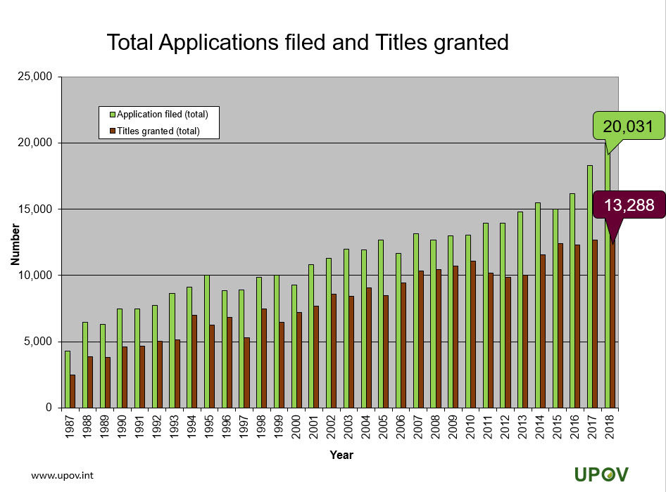

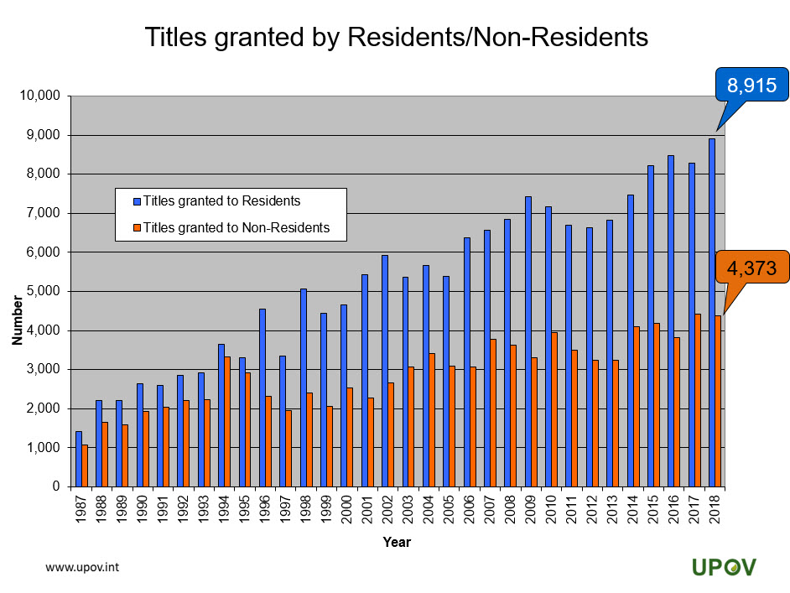

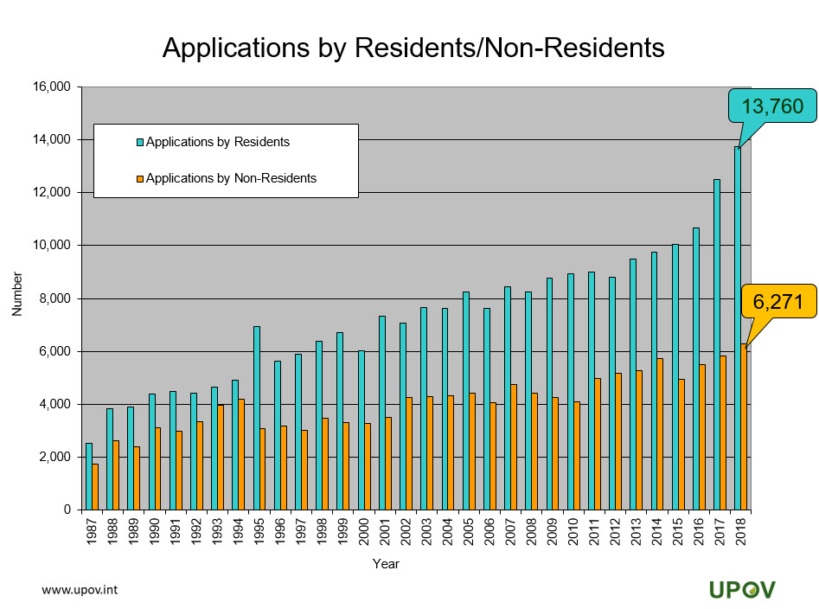

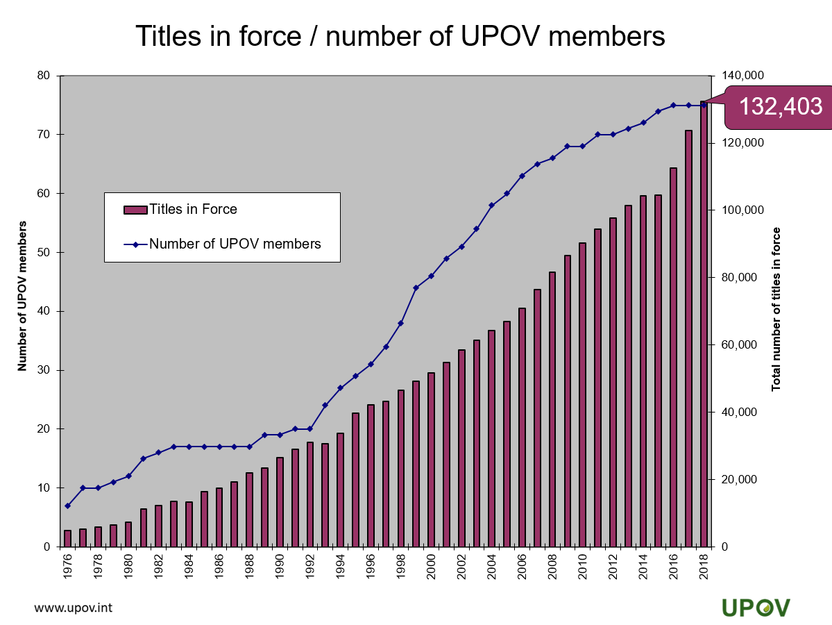

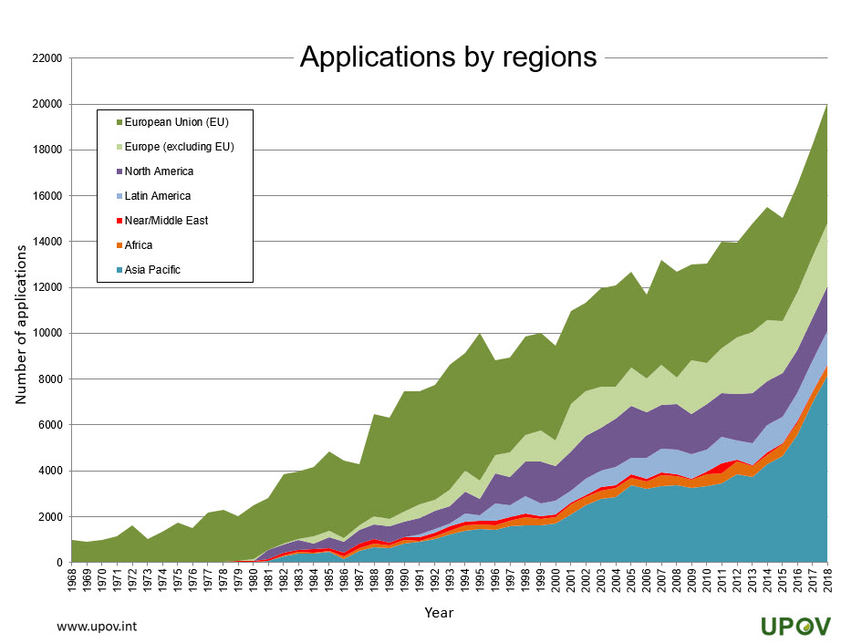

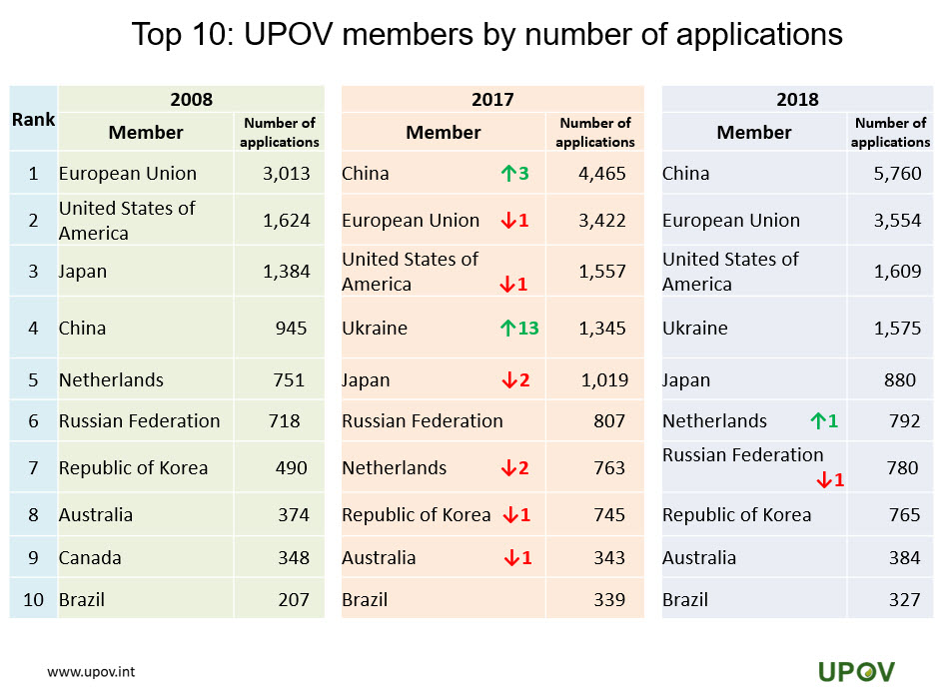

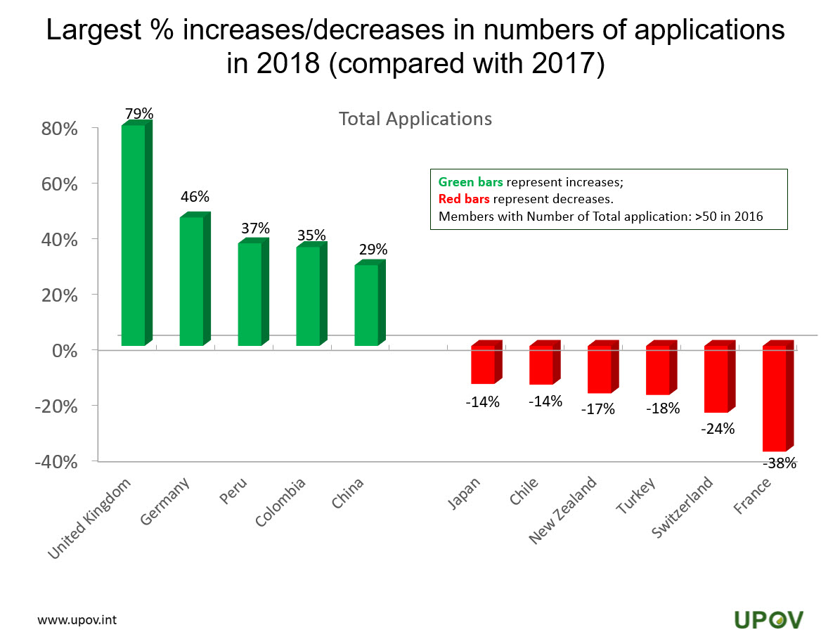

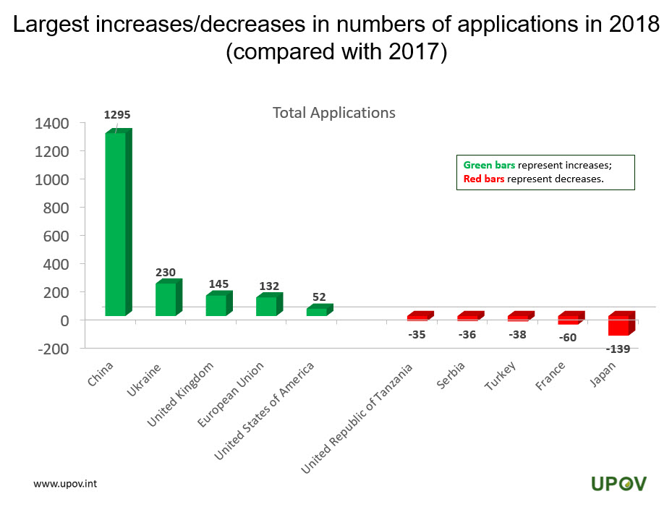

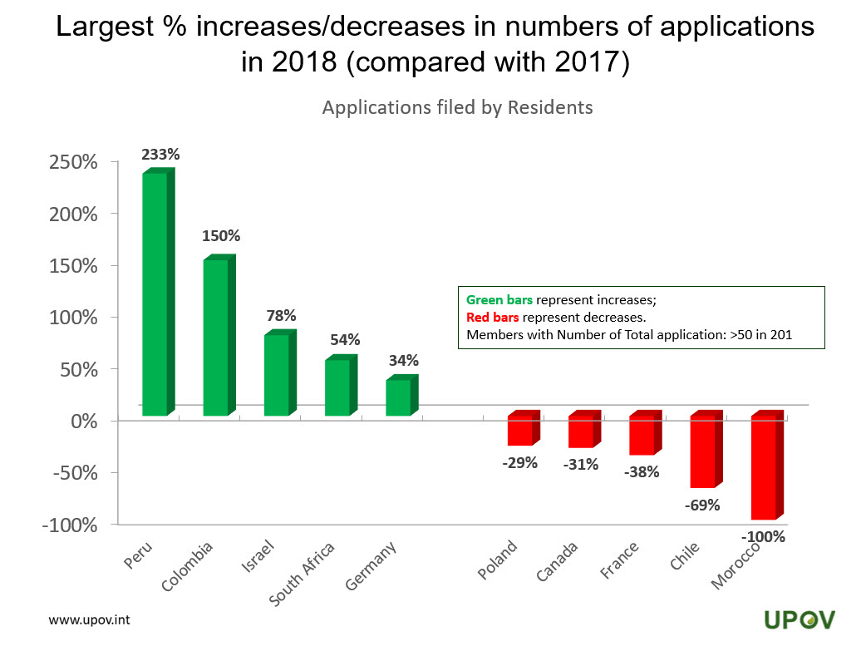

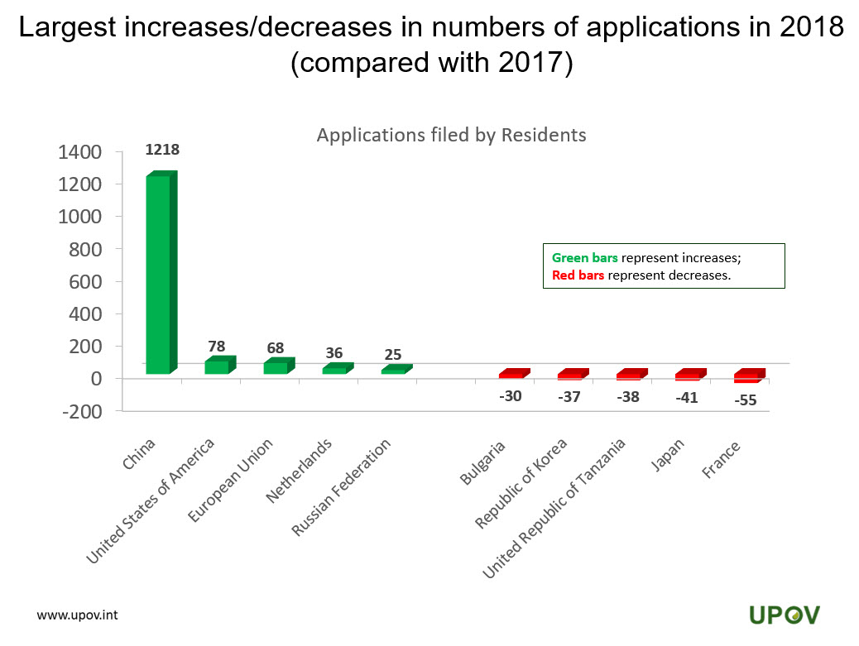

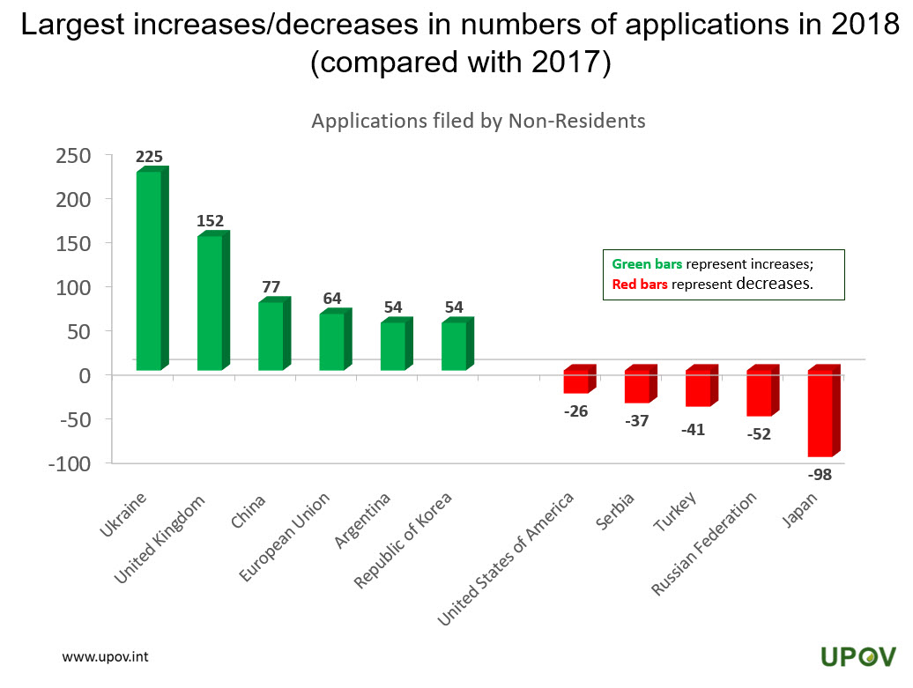

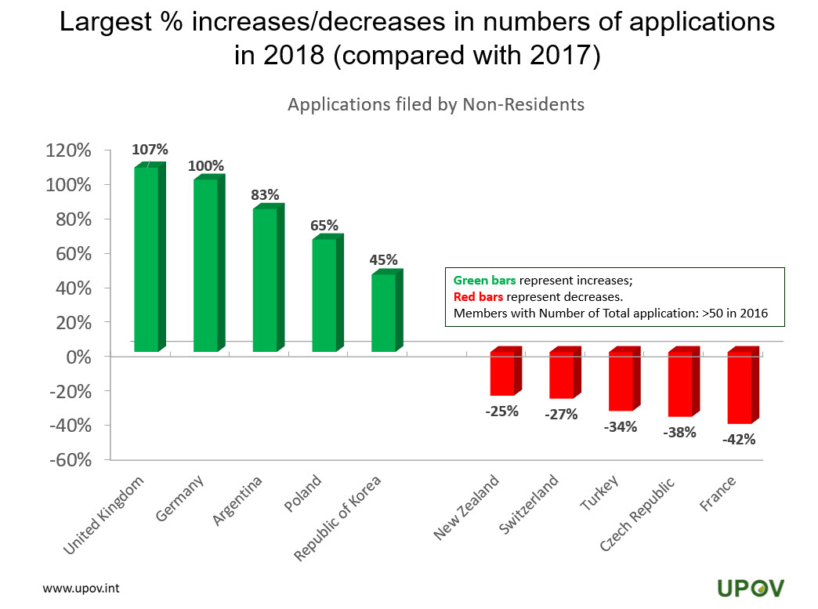

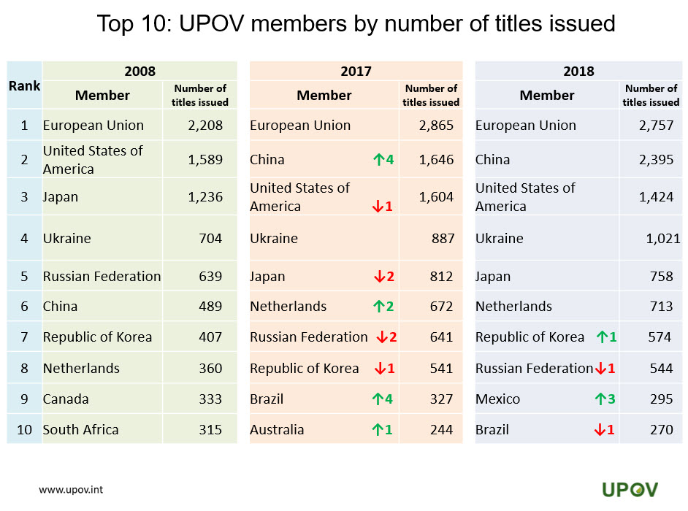

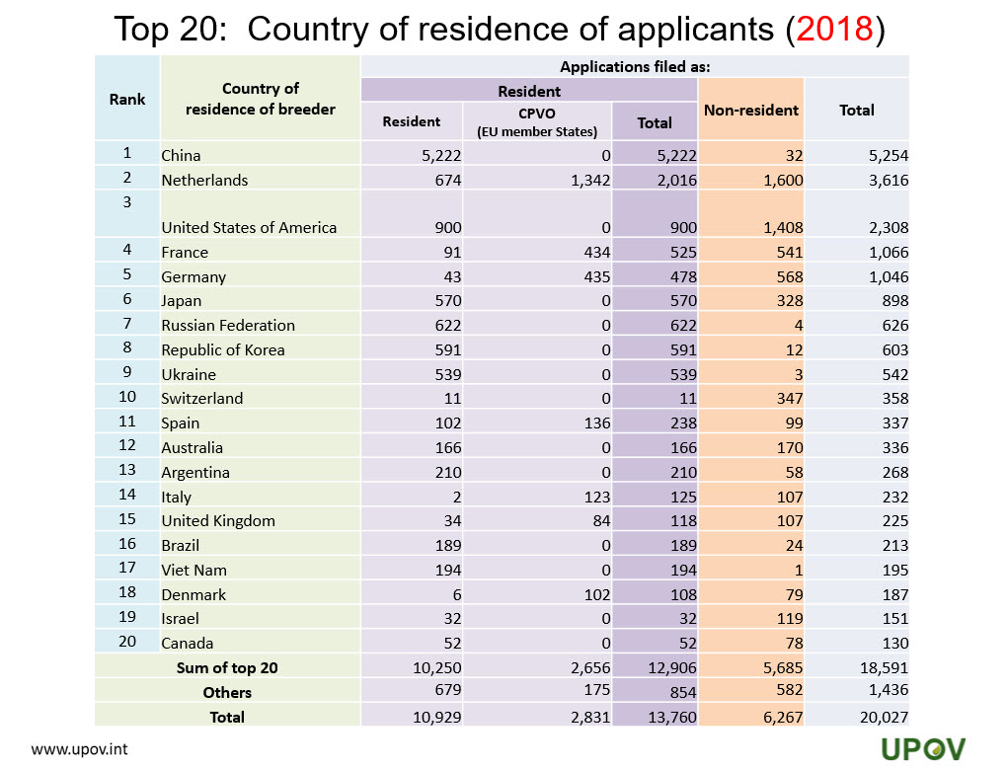

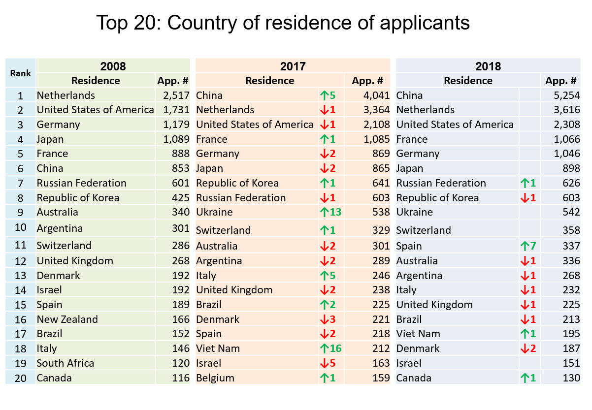

[End of Annex IV and of document]

