E
C/50/12
ORIGINAL: English
DATE: October 17, 2016
INTERNATIONAL UNION FOR THE PROTECTION OF NEW VARIETIES OF PLANTS
Geneva
COUNCIL
Fiftieth Ordinary Session
Geneva, October 28, 2016
Performance report for the 2014-2015 Biennium
Document prepared by the Office of the Union
Disclaimer: this document does not represent UPOV policies or guidance
This document presents the Performance Report for the 2014-2015 Biennium on the basis of the Program and Budget for the 2014-2015 Biennium adopted by the Council (see document C/47/4 Rev. “Program and Budget for the 2014-2015 Biennium”).

The performance report for the 2014-2015 Biennium provides information on expenditure, total number of posts for the Office of the Union and results and performance indicators by subprogram on the basis of the program and budget adopted by the Council. This document also provides a view of trends over time.

RESULTS TABLE FOR THE 2014-2015 BIENNIUM

Table of contents

1. INTRODUCTION 5
2. PROGRAM PERFORMANCE 7
2.1 Sub-program UV.1: Overall Policy on Plant Variety Protection 7
Objectives 7
Results Achieved: Selected Performance Indicators 7
1. ORGANIZATION OF COUNCIL AND CONSULTATIVE COMMITTEE SESSIONS 7
(a) Participation in the sessions of the Council and the Consultative Committee 7
Figure 1. Participation in Ordinary Sessions of the Council (October sessions) 7
Figure 2. Participation* in Extraordinary Sessions of the Council (April sessions) 7
Figure 3. Participation* in Consultative Committee Sessions 7
2. Coordination, monitoring and performance assessment of Program and Budget for the 2014-2015 Biennium 8
(a) Delivery of program within budget for the 2014-2015 Biennium 8
3. Preparation and adoption of the Program and Budget for the 2016-2017 Biennium 8
(a) Preparation and adoption of the Program and Budget for the 2016-2017 Biennium in accordance with the “Financial Regulations and Rules of UPOV” 8
4. Council policy 8
(a) Recommendations by the Consultative Committee, and decisions by the Council 8
(b) Other decisions by the Council 9
(c) Other work of the Consultative Committee 9
(d) Adoption of information and position papers by the Council 10
2.2 Sub-program UV.2: Services to the Union for Enhancing the Effectiveness of the UPOV System 11
Objectives 11
Results Achieved: Selected Performance Indicators 11
1. Guidance on the UPOV Convention and its implementation and information on its application 11
(a) Adoption of new or revised information materials concerning the UPOV Convention 11
(b) Publication of the UPOV Gazette and Newsletter 12
(c) Inclusion of laws of members of the Union in UPOV Lex database 12
UPOV Lex database: visits to the UPOV Website in 2015 12
(d) Participation in seminars and symposia held in Geneva in conjunction with UPOV sessions 12
2. Guidance on the examination of varieties 13
(a) Adoption of new or revised TGP documents and information materials 13
(b) Adoption of new or revised Test Guidelines 14
Test Guidelines: visits to the UPOV Website in 2015 14
Figure 4. Adoption of Test Guidelines 15
Figure 5. Draft Test Guidelines discussed in TWPs 15
Figure 6. Plant Breeders’ Rights Entries in Plant Variety Database covered by Test Guidelines 15
3. Cooperation for the examination of plant breeders’ rights 16
GENIE Database: visits to the UPOV Website in 2015 16
(a) Plant genera and species for which members of the Union have practical experience 17
Figure 7. Plant Genera/Species with Cooperation Agreements, Practical Experience and Plant Breeders’ Rights Entries in Plant Variety Database 17
(b) Plant genera and species for which members of the Union cooperate in DUS examination, as indicated in GENIE database 17
- General cooperation 17
- Number of specific bilateral and regional arrangements on plant variety protection 17
(c) Participation in the development of Test Guidelines 18
Figure 8. Total number of Test Guidelines adopted (by Technical Working Party) 18
Figure 9. Total number of Test Guidelines under development 18
Figure 10. Total number of Test Guidelines adopted (by region of the leading expert) 18
Figure 11. Total number of Test Guidelines under development 18
Figure 12. Number of members of the Union involved in drafting Test Guidelines 19
(d) Quality and completeness of data in the Plant Variety Database and quality of search facility; and facilities for access to other relevant data 19
PLUTO Database: visits to the UPOV Website in 2015 20
(e) Exchangeable software included in document UPOV/INF/16 “Exchangeable Software” 20
4. Participation by members of the Union and stakeholders in the work of the UPOV bodies 21
(a) Participation in the Administrative and Legal Committee 21
Figure 13. Number of Participating Members and Observer States/Organizations in the CAJ 21
(b) Participation in the Technical Committee 21
Figure 14. Number of Participating Members and Observer States/Organizations in the TC 21
(c) Participation in Technical Working Party Sessions 22
Figure 15. Number of Participating Members and Observer States/Organizations in the TWPs 22
(d) Participation in Preparatory Workshops for the Technical Working Party Sessions 22
Figure 16. 22
(i) Number of individual participants in the Preparatory Workshops: members and observers 22
(ii) Number of individual participants in the Preparatory Workshops by Technical Working Party 23
(e) Measures to improve the effectiveness of the TC, TWPs and Preparatory Workshops 23
5. UPOV documents and materials in additional languages 23
(a) Availability of UPOV documents and materials in languages other than the UPOV languages (English, French, German and Spanish) 23
6. Facilitating applications for plant breeders’ rights 23
(a) Number of applications for plant breeders’ rights 23
(b) Number of titles granted 23
(c) Number of titles in force 23
Figure 17. Applications for Plant Breeders’ Rights 24
Figure 18. Plant Breeders’ Rights Titles in Force 24
Figure 19. Applications for Plant Breeders’ Rights by Resident/Non-Resident 24
Figure 20. Plant Breeders’ Rights Titles Granted by Resident/Non-Resident 24
(d) Number of genera/species protected by members of the Union 24
Figure 21. Protection to plant genera and species in 2015 24
Figure 22. Evolution of offering protection to plant genera and species 25
(e) Number of genera/species for which varieties have been protected 25
(f) Use by members of the Union of standard UPOV references in application forms 25
(g) Use of linear blank forms corresponding to the “UPOV Model Form for the Application for Plant Breeders’ Rights” 25
7. Provision of information on the UPOV Convention for stakeholders (breeders, farmers, growers, seed-merchants, etc.) 26
(a) Stakeholder-orientated information on the UPOV website 26
2.3 Sub-Program UV.3: Assistance in the Introduction and Implementation of the UPOV System 27
Objectives 27
Results Achieved: Selected Performance Indicators 27
1. Raising awareness of the role of plant variety protection in accordance with the UPOV Convention 27
(a) Publications on the role of plant variety protection, including material on UPOV website 27
(b) States and organizations provided with information at UPOV activities 27
Figure 23. States provided with information at UPOV activities 27
Figure 24. Location of UPOV activities 28
(c) States and organizations that contacted the Office of the Union for assistance in the development of legislation on plant variety protection 28
(d) States and organizations that initiated with the Council of UPOV the procedure for becoming members of the Union 28
Figure 25. States and organizations that contacted the Office of the Union for assistance in the development of legislation on plant variety protection and States and organizations that initiated with the Council of UPOV the procedure for becoming members of the Union 29
(e) Participation in UPOV awareness-raising activities, or activities involving UPOV staff or UPOV trainers on behalf of UPOV staff 29
Figure 26. Location of activities/meetings where UPOV made presentations 29
2. Assistance in drafting legislation on plant variety protection in accordance with the 1991 Act of the UPOV Convention 30
(a) States and organizations provided with comments on laws 30
(b) States and organizations which received a positive advice from the Council of UPOV 30
(c) Meetings with government officials 30
Figure 27. Assistance provided in drafting legislation on plant variety protection 30
3. Assistance to States and organizations in the accession to the 1991 Act of the UPOV Convention 31
(a) States that acceded to or ratified the 1991 Act of the UPOV Convention 31
(b) States and organizations that became members of the Union 31
Figure 28. States/Organizations provided with comments on laws 31
Figure 29. States/Organizations which received positive advice from the Council 31
Figure 30. New members of the Union 31
Figure 31. Accession to/ratification of the 1991 Act 31
4. Assistance in implementing an effective plant variety rights system in accordance with the 1991 Act of the UPOV Convention 32
(a) Participation in distance learning courses 32
Figure 32. UPOV DL-205, DL-305, DL-305A and DL-305B Courses: 2014 and 2015 participation 33
Figure 33a. Participants in the main sessions of the DL-205 Course by registration category 34
Figure 34a. Participants in the main sessions of the DL-205 Course by language 34
Figure 33b. Participants in the main sessions of the DL-305, 305A, 305B Courses by registration category 34
Figure 34b. Participants in the main sessions of the DL-305, 305A, 305B Courses by language 34
(b) Participation by observer States and organizations in the CAJ, TC, TWPs and the associated preparatory workshops 36
(c) Participation in UPOV activities 36
(d) Participation in activities involving UPOV staff or UPOV trainers on behalf of UPOV staff 36
(e) Training provided by UPOV trainers in non-UPOV activities 36
(f) Implementation of projects with partner organizations and donors 36
(g) Use of training and assistance web-page 36
2.4 Sub-Program UV.4: External Relations 37
Objectives 37
Results Achieved: Selected Performance Indicators 37
1. Increased public understanding of UPOV’s role and activities 37
(a) Availability of public-orientated information and materials on UPOV Website 37
(b) Visits to website 37
2. Provision of information to other organizations 39
Participation at meetings and/or activities with relevant organizations 39
3. FINANCIAL PERFORMANCE 40

Appendix Acronyms and abbreviations

1. INTRODUCTION

1. This document presents the Performance Report for the 2014-2015 Biennium on the basis of the Program and Budget for the 2014-2015 Biennium adopted by the Council at its forty-seventh ordinary session, held in Geneva on October 24, 2013 (see document C/47/4 Rev. “Program and Budget for the 2014-2015 Biennium”).

2. The Performance Report for the 2014-2015 Biennium provides an overview of UPOV’s performance based on information from the following documents, which contain further detailed information:

(a) document C/47/4 Rev. “Program and Budget of the Union for the 2014-2015 Biennium;
(b) document C/49/2 “Annual Report of the Secretary-General for 2014”;
(c) document C/50/2 “Annual Report of the Secretary-General for 2015”; and
(d) document C/50/4 “Financial Management Report for the 2014-2015 Biennium”.

3. Section 2 “Program Performance”, provides a brief summary of the progress made towards the achievements of objectives at the level of sub-programs, followed by performance tables summarizing information on objectives, expected results and performance indicators. Section 3 “Financial Performance”, provides an overview of the financial performance, in relation to the Program and Budget for the 2014­2015 Biennium.

4. The following map provides a graphic overview of the status in relation to UPOV at the end of the 2014-2015 Biennium.

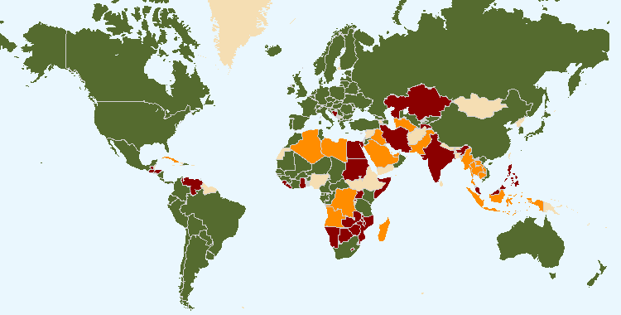
The boundaries shown on this map do not imply the expression of any opinion whatsoever on the part of UPOV concerning the legal status of any country or territory
- 74 members of UPOV

- 15 States and 1 intergovernmental organization which had initiated the procedure for acceding the UPOV Convention

- 23 States and 1 intergovernmental organization which had been in contact with the Office of the Union for assistance in the development of laws based on the UPOV Convention

5. The following table provides detailed information on the status in relation to UPOV.

UPOV members

African Intellectual Property Organization^{3, 5}
Albania³
Argentina2
Australia³
Austria3
Azerbaijan³
Belarus³
Belgium1
Bolivia (Plurinational State of)²
Brazil²
Bulgaria³
Canada3
Chile²
China²
Colombia²
Costa Rica³
Croatia³
Czech Republic³
Denmark3
Dominican Republic³
Ecuador²
Estonia³
European Union^{3, 4}
Finland3
France3
Georgia³
Germany3
Hungary3
Iceland3
Ireland3
Israel³
Italy2
Japan³
Jordan³
Kenya²
Kyrgyzstan³
Latvia³
Lithuania³
Mexico²
Montenegro³
Morocco3
Netherlands³
New Zealand2
Nicaragua²
Norway2
Oman³
Panama³
Paraguay²
Peru³
Poland3
Portugal²
Republic of Korea³
Republic of Moldova³
Romania³
Russian Federation³
Serbia³
Singapore³
Slovakia³
Slovenia³
South Africa2
Spain3
Sweden³
Switzerland³
The former Yugoslav Republic of Macedonia³
Trinidad and Tobago²
Tunisia³
Turkey³
Ukraine³
United Kingdom³
United Republic of Tanzania³
United States of America³
Uruguay²
Uzbekistan³
Viet Nam³

(Total 74)

¹ 1961 Convention as amended by the Additional Act of 1972 is the latest Act by which 1 State is bound.
² 1978 Act is the latest Act by which 18 States are bound.
³ 1991 Act is the latest Act by which 53 States and 2 organizations are bound.
⁴ Operates a plant breeders’ rights system which covers the territory of its 28 member States.
⁵ Operates a plant breeders’ rights system which covers the territory of its 17 member States.

States and intergovernmental organizations which had initiated the procedure
for acceding to the UPOV Convention

Armenia, Bosnia and Herzegovina, Egypt, Ghana, Guatemala, Honduras, India, Iran (Islamic Republic of), Kazakhstan, Malaysia, Mauritius, Philippines, Tajikistan, Venezuela (Bolivarian Republic of), Zimbabwe, as well as the African Regional Intellectual Property Organization (ARIPO).

States and intergovernmental organizations which had been in contact with the Office of the Union
for assistance in the development of laws based on the UPOV Convention

Algeria, Bahrain, Barbados, Brunei Darussalam, Cambodia, Cuba, Cyprus, El Salvador, Indonesia, Iraq, Lao People’s Democratic Republic, Libya, Mozambique, Myanmar, Namibia, Pakistan, Saudi Arabia, Sudan, Thailand, Tonga, Turkmenistan, United Arab Emirates, Zambia, as well as the Southern African Development Community (SADC).

2. PROGRAM PERFORMANCE

2.1 Sub-program UV.1: Overall Policy on Plant Variety Protection

The sessions of the Council and the Consultative Committee provided the basis for policy making, management and coordination of the activities within UPOV’s overall program.

Objectives | - Policy direction and executive management.  - Planning, implementation and evaluation of program and budget.

Results Achieved: Selected Performance Indicators

1. ORGANIZATION OF COUNCIL AND CONSULTATIVE COMMITTEE SESSIONS

(a) Participation in the sessions of the Council and the Consultative Committee
(see Figures 1 to 3)

Figure 1. Participation* in Ordinary Sessions of the Council (October sessions) | Figure 2. Participation* in Extraordinary Sessions of the Council (April sessions)

Figure 3. Participation* in Consultative Committee Sessions

2. Coordination, monitoring and performance assessment of Program and Budget for the 2014-2015 Biennium

(a) Delivery of program within budget for the 2014-2015 Biennium
See Section 3 “Financial Performance”

3. Preparation and adoption of the Program and Budget for the 2016-2017 Biennium

(a) Preparation and adoption of the Program and Budget for the 2016-2017 Biennium in accordance with the “Financial Regulations and Rules of UPOV”
The Program and Budget for the 2016-2017 Biennium was adopted by the Council at its forty-ninth ordinary session, on October 29, 2015 (see document C/49/4 Rev.).

4. Council policy

(a) Recommendations by the Consultative Committee, and decisions by the Council
The Council took decisions, based on recommendations by the Consultative Committee, concerning the following:
- examination of the conformity of the Draft ARIPO Protocol for the Protection of New Varieties of Plants with the provisions of the 1991 Act of the International Convention for the Protection of New Varieties of Plants;
- confirmation of the decision of March 22, 2013 on conformity of the Plant Breeders’ Rights Act for Zanzibar with the 1991 Act of the UPOV Convention;
- examination of the conformity of the “Draft provisions of Book Four ‘Plant Variety Protection’ of Law No. 82 of 2002 Pertaining to the Protection of Intellectual Property Rights” (“Draft Law”) of Egypt with the provisions of the 1991 Act of the International Convention for the Protection of New Varieties of Plants;
- recommendation that the Islamic Republic of Iran incorporate the additional provisions and amendments in the “Act of Plant Varieties Registration, Control And Certification of Seeds And Plant Materials of 2003”, and that once the additional provisions and amendments have been incorporated in the Law, the amended Law should be submitted to the Council for examination in conformity with Article 34(3) of the 1991 Act;
- adoption of information materials (the adoption of information materials by the Council is reported under Sub-Program UV.2);
- calendar of meetings
- press releases
- adoption of answers to frequently asked questions (FAQs) and revision of the answer to the FAQ “Can I obtain protection for more than one country from a single application?”;
- creation of a special UPOV account to finance extra-budgetary projects agreed by the Council (Project Account) and the transfer of the amount of the reserve fund exceeding 15 percent of the total income for the 2012­2013 Biennium to that account.
- appointment of Mr. Francis Gurry as the Secretary-General of UPOV for the period from October 16, 2014, to September 30, 2020;
- use of the special project fund for training purposes;
- financial statements for 2013;
- arrears in contributions as of September 30, 2014;
- financial management report for the 2012-2013 financial period;
- extension of the appointment of the Vice Secretary-General from December 1, 2015, until November 30, 2018;
- Draft Program and Budget of the Union for the 2016-2017 Biennium;
- financial statements for 2014;
- arrears in contributions as of September 30, 2015.

(b) Other decisions by the Council
The Council also took decisions concerning the following:
- work programs of the Administrative and Legal Committee (CAJ), the Technical Committee (TC), the Technical Working Parties (TWPs) and the Working Group on Biochemical and Molecular Techniques, and DNA-Profiling in Particular (BMT);
- election of the:
– President and Vice-President of the Council
– Chair and Vice-Chair of the TWA
– Chair and Vice-Chair of the TWC
– Chair and Vice-Chair of the TWF
– Chair and Vice-Chair of the TWO
– Chair and Vice-Chair of the TWV
– Chair and Vice-Chair of the BMT

(c) Other work of the Consultative Committee
The Consultative Committee:
- agreed to change the title of the standard item to “Internal Audit and Reports of the WIPO Independent Advisory Oversight Committee”;
- agreed to the procedure for the checking of translations before posting on the UPOV website;
- agreed to invite ISF, CIOPORA and CropLife International to elaborate the problems faced with the current situation and possible solutions offered by an international filing system, a UPOV quality assurance program and a central examination system for variety denominations, and requested the Office of the Union to provide relevant information on the international filing systems of WIPO;
- agreed to the separation of the DL-305 course into two separate courses, DL-305-1 “Administration of Plant Breeders’ Rights” and DL-305-2 “DUS Examination”, and approved the program for distance learning courses in 2014 to 2015;
- requested the Office of the Union to identify with the Secretary of the ITPGRFA and the Secretariat of WIPO possible areas of interrelations among the international instruments of the ITPGRFA, WIPO and UPOV with a view to a possible joint publication on interrelated issues regarding innovation and plant genetic resources, and other possible initiatives;
- requested the Office of the Union to prepare a document to clarify the issues raised and possible ways forward with regard to an international system of cooperation;
- decided to grant observer status to the South Centre in the Council and the CAJ, and to grant observer status to the World Farmers’ Organisation (WFO) in the Council, the CAJ and the TC;
- agreed that information concerning consultants that were used by UPOV in 2014 be presented to the Consultative Committee at its ninetieth session, in October 2015;
- endorsed the plans for the launch of the DL-305 course “Examination of Applications for Plant Breeders’ Rights”, both as a single course, and also as two component courses: DL 305A “Administration of Plant Breeders’ Rights”; and DL-305B “DUS Examination”;
- approved the development of a proposal for a new logo for consideration by the Consultative Committee at its eighty-ninth session and approval by the Council at its thirty-second extraordinary session in March 2015;
- deferred plans for the updating of the Impact Study pending work to identify with the Secretary of the ITPGRFA and the Secretariat of WIPO possible areas of interrelations among the international instruments of the ITPGRFA, WIPO and UPOV with a view to a possible joint publication on interrelated issues regarding innovation and plant genetic resources;
- approved the issue of invitations to the former Yugoslav Republic of Macedonia and Peru to make presentations at the ninetieth session of the Consultative Committee, to be held in October 2015;
- agreed to invite the WIPO Internal Oversight Division (IOD) to give a presentation on its work at the ninetieth session and to consider plans for an internal audit of UPOV in 2016-2017;
- expressed its approval of the review of the UPOV training and assistance strategy and approved the planned use of the Special Project Fund for training purposes in the context of the UPOV training and assistance strategy;
- agreed that the Office of the Union should produce a document with more information about the need for an international system of cooperation, providing a business analysis and cost estimate;
- agreed to consider proposals in relation to a policy on documents, including communications provided by observers, at its ninetieth session;
- agreed to consider matters on the schedule of the UPOV sessions under the item “Preparation of the calendar of meetings” at its ninetieth session
- agreed the approach concerning the procedure to appoint the External Auditor of UPOV for the financial periods between 2018 and 2023;
- agreed to invite the Office of the Union to present proposals for the financing and containment of ASHI liabilities at its ninety-first session, to be held in Geneva in March 2016;
- agreed that any new developments with regard to the Working Group of the United Nations CEB Finance and Budget Network and any measures considered by WIPO in relation to the financing of long-term employee benefits be presented for consideration by the Consultative Committee at its ninety-first session;
- agreed that the balance of the Special Project Fund (SPF) at the end of 2015 be used in 2016 for activities in the context of the UPOV training and assistance strategy;
- agreed to request WIPO Internal Oversight Division (IOD) to conduct an evaluation in 2016-2017 of the program of activities of UPOV;
- agreed to invite I3PM to be present, at the relevant part of the item on observers in the program for its ninety-second session in October 2016, in order to explain how its statues provided the basis to determine “competence in areas of direct relevance in respect of matters governed by the UPOV Convention”;
- agreed on proposals concerning the translation of UPOV session documents, reports of sessions of UPOV bodies and written comments;
- requested the Office of the Union to present a proposal for developing an updated version of the Impact Study for consideration at its ninety-second session;
- agreed that the new UPOV logo should be presented to the UPOV Council at its fiftieth ordinary session, and that the new UPOV logo should be introduced on the UPOV website in conjunction with the fiftieth ordinary session of the Council, with the introduction of the stakeholder-focused features on the UPOV website;
- agreed that all members of the Union should have the opportunity to participate in the development of the prototype electronic application form (EAF) Version 2 (PV2), that certain items would need to be addressed prior to the launch of the EAF, and agreed to consider the possible implementation of an operational system;
- agreed that more information, including statistical information, and a legal analysis was needed with regard to a possible international system of cooperation (ISC) and agreed to request the Office of the Union to prepare a document containing a draft mandate and terms of reference for a possible working group (ISC-WG) to explore the issues concerning a possible ISC, to be considered by the Consultative Committee at its ninety-first session; that document would also present the additional issues provided in writing by members of the Union;
- agreed to invite the Secretary of the ITPGRFA to make a presentation at its ninety-first session on possible areas of interrelations between the ITPGRFA and the UPOV Convention. The Consultative Committee also agreed that members of the Union should be invited to comment on the areas of interrelations identified by ITPGRFA and suggest any other areas of interrelations. The Consultative Committee agreed that the information should be compiled by the Office of the Union for discussion at the ninety-first session in conjunction with the presentation by the Secretary of the ITPGRFA;
- requested the Office of the Union to prepare a document with options and possible impacts of holding the sessions of the bodies that meet in Geneva consecutively, only once a year.

(d) Adoption of information and position papers by the Council
The adoption of information materials by the Council is reported under Sub-Program UV.2.

2.2 Sub-program UV.2: Services to the Union for Enhancing the Effectiveness of the UPOV System

The main focus and priority for the 2014-2015 Biennium continued to be support for members of the Union in the operation of their plant variety protection systems. The UPOV system continued to expand in terms of the number of members of the Union, applications, titles granted and titles in force. Within the members of the Union, the estimated number of genera or species for which protection was sought for varieties rose to more than 3,500. These developments demonstrate why cooperation between members of the Union is a key benefit of UPOV membership. The guidance developed by UPOV for variety examination promotes harmonization between members of the Union, thereby facilitating the exchange of information and reports on the examination of Distinctness, Uniformity and Stability (“DUS”). By the end of the Biennium, members of the Union had developed more than 300 Test Guidelines, which were estimated to cover approximately 92% of applications for plant breeders’ rights within the Union. In the Biennium, Version 1 of the web-based TG Template was introduced as a tool to assist in the development of Test Guidelines. In relation to cooperation between members of the Union, the information provided in the GENIE database, PLUTO database and database of laws of members of the Union (UPOV Lex) was enhanced. Members of the Union offered practical experience in the examination of DUS for more than 3,300 genera or species, although there was no significant increase in the number of agreements for cooperation between members of the Union during the Biennium, which remained at around 2,000. There was significant progress in the development of a UPOV electronic application form project, with the Prototype Version 1 (PV1) demonstrating the feasibility of the project. UPOV has developed an extensive set of guidance and information materials documents that enhance the understanding and the implementation of the provisions of the Convention in an internationally harmonized and effective way, thereby reinforcing the quality of protection and helping to reduce the cost of obtaining protection. In the Biennium, revisions to a number of information and guidance documents were adopted.

Objectives | - To maintain and improve the effectiveness of the UPOV system.  - To provide and develop the legal, administrative and technical basis for international cooperation in plant variety protection according to the UPOV Convention.

Results Achieved: Selected Performance Indicators

1. Guidance on the UPOV Convention and its implementation and information on its application

(a) Adoption of new or revised information materials concerning the UPOV Convention
The Council adopted:
- 1 new information document
UPOV/INF/22/1 Software and equipment used by members of the Union
- 9 revisions to previously adopted information documents
UPOV/INF/4/4 Financial Regulations and Rules of UPOV (Revision)
UPOV/INF/6/4 Guidance for the preparation of laws based on the 1991 Act of the UPOV Convention (Revision)
UPOV/INF/15/3 Guidance for members of UPOV on ongoing obligations and related notifications and on the provision of information to facilitate cooperation (Revision)
UPOV/INF/16/4 Exchangeable Software (Revision)
UPOV/INF/16/5 Exchangeable Software (Revision)
UPOV/INF/22/2 Software and equipment used by members of the Union (Revision)
UPOV/INF-EXN/6 List of INF-EXN Documents and Latest Issue Dates (Revision)
UPOV/INF-EXN/7 List of INF-EXN Documents and Latest Issue Dates (Revision)
UPOV/INF-EXN/8 List of INF-EXN Documents and Latest Issue Dates (Revision)
- 0 new explanatory notes
- 4 revisions to previously adopted explanatory notes
UPOV/EXN/CAN/2 Explanatory Notes on Cancellation of the Breeder's Right under the UPOV Convention (Revision)
UPOV/EXN/NUL/2 Explanatory Notes on the Nullity of the Breeder's Right under the UPOV Convention (Revision)
UPOV/EXN/PRP/2 Explanatory Notes on Provisional Protection under the UPOV Convention (Revision)
UPOV/INF/12/5 Explanatory Notes on Variety Denominations under the UPOV Convention (Revision)

The CAJ, in conjunction with the Administrative and Legal Committee Advisory Group (CAJ-AG) and TC, as appropriate, considered drafts of the following:
- 1 new information document
UPOV/INF/22 Software and equipment used by members of the Union
- 4 revisions to previously adopted information documents
UPOV/INF/5 UPOV model plant breeders' rights Gazette (Revision)
UPOV/INF/12 Explanatory Notes on Variety Denominations under the UPOV Convention (Revision)
UPOV/INF/15 Guidance for Members of the Union on Ongoing Obligations and Related Notifications and on the Provision of Information to Facilitate Cooperation (Revision)
UPOV/INF/16 Exchangeable Software (Revision)
UPOV/INF/22 Software and equipment used by members of the Union (Revision)
- 1 new explanatory notes
UPOV/EXN/PPM Explanatory Notes on Propagation and Propagating Material under the UPOV Convention
- 5 revisions to previously adopted explanatory notes
UPOV/EXNCAN Explanatory Notes on Cancellation of the Breeder's Right under the UPOV Convention (Revision)
UPOV/EXN/EDV Explanatory Notes on Essentially Derived Varieties under the 1991 Act of the UPOV Convention (Revision)
UPOV/EXN/HRV Explanatory Notes on Acts in Respect of Harvested Material under the 1991 Act of the UPOV Convention (Revision)
UPOV/EXN/NUL Explanatory Notes on Nullity of the Breeder's Right under the UPOV Convention (Revision)
UPOV/EXN/PRP Explanatory Notes on Provisional Protection under the UPOV Convention (Revision)
- for TGP documents, see Section 2.2 “Sub-Program UV.2”, expected result “2. Guidance on the examination of varieties” and “(a) Adoption of new or revised TGP documents and information materials”

(b) Publication of the UPOV Gazette and Newsletter
Two issues of UPOV Publication No. 438 “Plant Variety Protection Gazette and Newsletter” (English only) were published in the 2014-2015 Biennium.

(c) Inclusion of laws of members of the Union in UPOV Lex database
- 27 laws concerning the following 27 members of the Union were included in the UPOV Lex database
(African Intellectual Property Organization (OAPI), Australia, Belarus, Belgium, Bolivia (Plurinational State of), Canada, China, Colombia, Ecuador , Estonia, France, Georgia, Germany, Latvia, Lithuania, Montenegro, New Zealand, Panama, Peru, Poland, Republic of Moldova, Romania, Serbia, Singapore, Trinidad and Tobago, Russian Federation, United Republic of Tanzania)

UPOV Lex database: visits to the UPOV Website in 2015
Language | Pageviews | Unique pageviews
English | 53,580 | 37,259
Spanish | 18,379 | 12,543
French | 5,601 | 3,989
German | 2,875 | 2,185

Evolution of visits

Year | Pageviews | Unique pageviews
2015 | 80,460 | 55,991
2014 | 88,305 | 60,439
2013 | 88,533 | 61,230
2012 | 91,245 | 62,411
2011 | 19,269 | 12,575

(d) Participation in seminars and symposia held in Geneva in conjunction with UPOV sessions
No seminars/symposia were held in 2014-2015.

2. Guidance on the examination of varieties

(a) Adoption of new or revised TGP documents and information materials
TGP documents adopted and published on the UPOV website:
- 0 new TGP document
- 12 revisions to previously adopted TGP documents
TGP/2/2 List of Test Guidelines Adopted by UPOV (Revision)
TGP/5 Experience and Cooperation in DUS Testing
Section 3/2 Technical Questionnaire to be Completed in Connection with an Application for Plant Breeders’ Rights (Revision)
Section 8/2 Cooperation in Examination (Revision)
Section 9/2 List of Species in Which Practical Knowledge has Been Acquired or for Which National Test Guidelines Have Been Established (Revision)
Section 10/3 Notification of Additional Characteristics and States of Expression (Revision)
TGP/7/4 Development of Test Guidelines (Revision)
TGP/8/2 Trial Design and Techniques Used in the Examination of Distinctness, Uniformity and Stability (Revision)
TGP/9/2 Examining Distinctness (Revision)
TGP/14/2 Corr. (S) Correction of the Spanish version of document TGP/14: Section 2: Subsection 3: Color, paragraph 2.2.2
TGP/14/3 Glossary of Terms Used in UPOV Documents
TGP/0/7 List of TGP Documents and Latest Issue Dates (Revision)
TGP/0/8 List of TGP Documents and Latest Issue Dates (Revision)
- Drafts of TGP documents advanced in the CAJ, TC and/or the TWPs
- 7 revisions to previously adopted TGP documents
TGP/2 List of Test Guidelines Adopted by UPOV (Revision)
TGP/5 Experience and Cooperation in DUS Testing
Section 3/2 Technical Questionnaire to be Completed in Connection with an Application for Plant Breeders’ Rights (Revision)
Section 8/2 Cooperation in Examination (Revision)
Section 9/2 List of Species in Which Practical Knowledge has Been Acquired or for Which National Test Guidelines Have Been Established (Revision)
Section 10/3 Notification of Additional Characteristics and States of Expression (Revision)
TGP/7 Development of Test Guidelines (Revision)
TGP/8 Trial Design and Techniques Used in the Examination of Distinctness, Uniformity and Stability (Revision)
TGP/9 Examining Distinctness
TGP/10 Examining Uniformity
TGP/14 Glossary of Terms Used in UPOV Documents - Correction (Spanish)
- Drafts of information materials advanced in the CAJ, TC and/or the TWPs
- 5 revisions to previously adopted information materials
UPOV/INF/5 UPOV model plant breeders' rights Gazette (Revision)
UPOV/INF/12 Explanatory Notes on Variety Denominations under the UPOV Convention (Revision)
UPOV/INF/15 Guidance for Members of UPOV on Ongoing Obligations and Related Notifications (Revision)
UPOV/INF/16 Exchangeable Software (Revision)
UPOV/INF/22 Software and equipment used by members of the Union
- Revision of the following document considered in the Working Group for the Development of a UPOV Denomination Similarity Search Tool (WG-DST):
UPOV/INF/12 Explanatory Notes on Variety Denominations under the UPOV Convention (Revision)

(b) Adoption of new or revised Test Guidelines
Adopted Test Guidelines
- 41 Test Guidelines were adopted by the TC, comprising:
– 18 new Test Guidelines
– 10 revised Test Guidelines
– 13 partially revised Test Guidelines
(see Figure 4)
At the end of 2015, the adopted Test Guidelines covered 92% of all PBR-related entries in the Plant Variety Database (246,890 of 267,550) (91% at the end of 2013 (217,298 of 247,818))
(see Figure 6)
Test Guidelines advanced in the Technical Working Parties
- In 2014, 57 draft Test Guidelines were advanced by the TWPs, comprising:
– 26 new Test Guidelines
– 15 revisions
– 16 partial revisions
- In 2015, 46 draft Test Guidelines were advanced by the TWPs, comprising:
– 16 new Test Guidelines
– 21 revisions
– 9 partial revisions
(see Figure 5)

Test Guidelines: visits to the UPOV Website in 2015
Language | Pageviews | Unique pageviews
English | 52,103 | 30,391
Spanish | 8,157 | 5,138
French | 2,585 | 1,657
German | 1,561 | 942

Evolution of visits

Year | Pageviews | Unique pageviews
2015 | 64,425 | 38,144
2014 | 67,900 | 40,102
2013 | 68,479 | 38,979
2012 | 65,471 | 37,227
2011 | not available | not available

Figure 4. Adoption of Test Guidelines | Figure 5. Draft Test Guidelines  discussed in TWPs

Figure 6. Plant Breeders’ Rights Entries in Plant Variety Database covered by Test Guidelines

3. Cooperation for the examination of plant breeders’ rights

GENIE Database: visits to the UPOV Website in 2015

Sessions 15,727  Users 8,744  Pageviews 67,175  New Visitors 46.7%  Returning Visitors 53.3% | Language Pageviews Unique pageviews  English 47,367 26,989  Spanish 9,530 5,832  French 5,451 3,527  German 2,706 1,833

Top 10 countries visiting the GENIE database in 2015

Country / Territory | Sessions | % New Sessions | New Users
France | 1,355 | 52,18% | 707
Switzerland | 1,188 | 37,04% | 440
Germany | 909 | 67,99% | 618
United States of America | 861 | 70,27% | 605
Japan | 835 | 21,56% | 180
Spain | 798 | 63,16% | 504
India | 691 | 77,71% | 537
Mexico | 670 | 57,16% | 383
Netherlands | 471 | 42,04% | 198
Australia | 412 | 30,10% | 124

Evolution of visits

Year | Pageviews | Unique pageviews
2015 | 67,175 | 39,165
2014 | 72,018 | 40,027
2013 | 84,306 | 49,280
2012 | 85,149 | 46,122
2011 | 59,735 | 32,839
2010 | 51,457 | 28,565
2009 | 11,474 | 5,337
2008 | 14,063 | 5,763
2007 | 5,357 | 2,530

(a) Plant genera and species for which members of the Union have practical experience
Practical experience in examination of DUS reported for approximately 3,382 genera or species in 2015 (3,305 in 2014; 2,589 in 2013; 2,726 in 2012; 2,679 in 2011; 2,254 in 2010) (see Figure 7)

Figure 7. Plant Genera/Species with Cooperation Agreements, Practical Experience and Plant Breeders’ Rights Entries in Plant Variety Database

(b) Plant genera and species for which members of the Union cooperate in DUS examination, as indicated in GENIE database

- General cooperation
Number of authorities which would provide existing DUS reports to any member of the Union:
3 in 2015 (2 in 2013)

Number of authorities which would, for any species for which they have experience in DUS examination, provide existing DUS reports to any member of the Union:
7 in 2015 (6 in 2013)

Number of authorities which would accept DUS reports from any other member of the Union:
1 in 2015 (1 in 2013)

Number of authorities which would accept DUS reports from any other member of the Union under certain circumstances:
2 in 2015 (2 in 2013)

- Number of specific bilateral and regional arrangements on plant variety protection
Agreement for cooperation in variety testing extended to approximately 2,002 genera or species in 2015
(2,005 in 2014; 1,997 in 2013; 1,991 in 2012; 1,990 in 2011; 1,417 in 2010) – excluding general cooperation
(see Figure 7 and document C/49/5)

(c) Participation in the development of Test Guidelines
An overview of participation in the development of Test Guidelines by TWPs and by region of the leading expert is provided in Figures 8 to 11.

Figure 8. Total number of Test Guidelines adopted (by Technical Working Party)  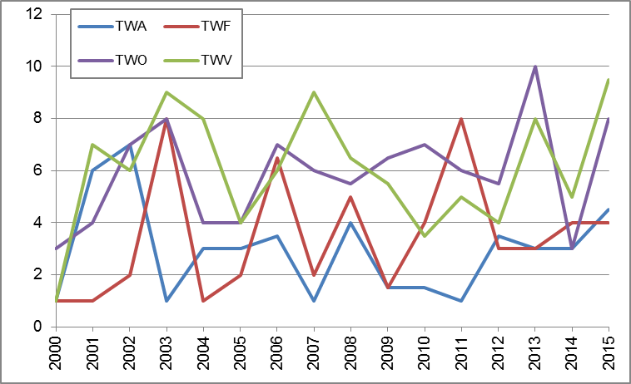 | Figure 9. Total number of Test Guidelines  under development  (by Technical Working Party)  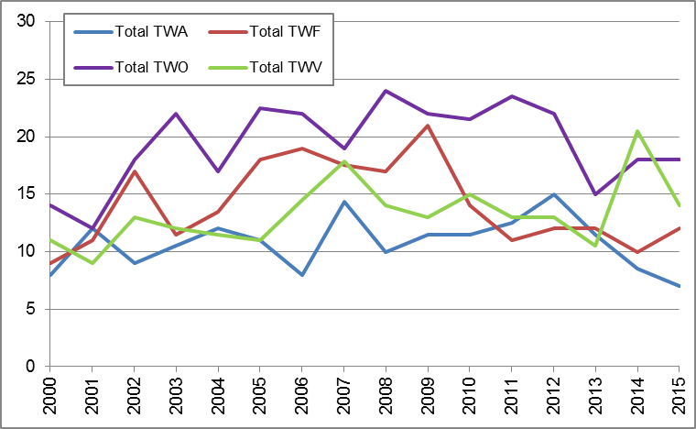
Figure 10. Total number of Test Guidelines adopted  (by region of the leading expert)  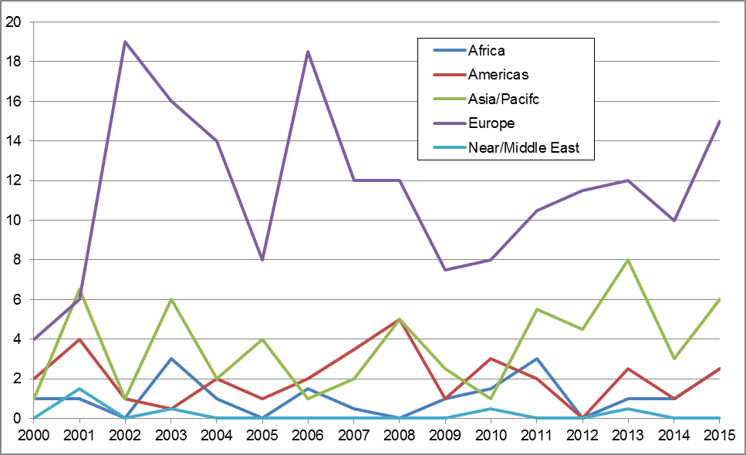 | Figure 11. Total number of Test Guidelines  under development  (by region of the leading expert)  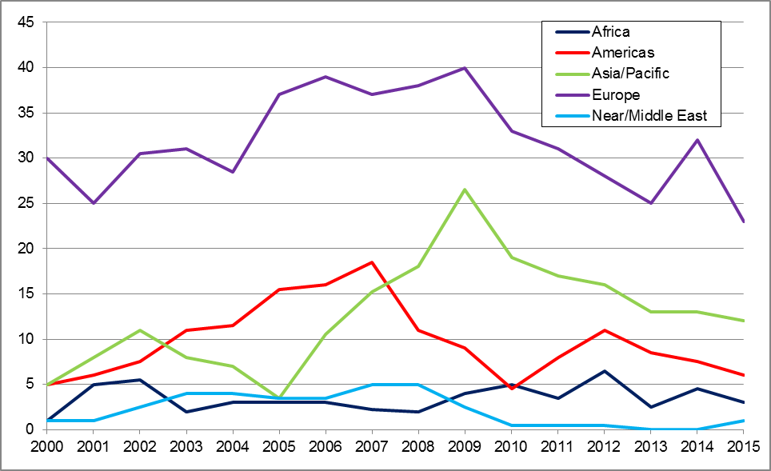

Total of 19 members of the Union involved in drafting Test Guidelines in the biennium (AR, AU, BR, CN, DE, DK, ES, FR, GB, IT, JP, KE, MA, MX, NL, NZ, OM, QZ, ZA).
(see Figure 12)

Figure 12. Number of members of the Union involved in drafting Test Guidelines

(d) Quality and completeness of data in the Plant Variety Database and quality of search facility; and facilities for access to other relevant data
- Total number of records included in the PLUTO database at the end of 2015:
723,783 (688,541 at the end of 2014; 645,068 at the end of 2013)
- Number of submissions of new data in 2014 and 2015 (each contributor was invited to make six submissions in 2015):
211 in 2015; 175 in 2014 (163 in 2013; 167 in 2012)
- Number of contributors included in the PLUTO database at the end of 2014 and 2015:
58 in 2015; 58 in 2014 (56 in 2013; 52 in 2012)
- Number of members of the Union that contributed data in 2014 and 2015:
44 in 2015; 48 in 2014 (45 in 2013; 45 in 2012)
- Number of members of the Union that contributed data for the first time in 2014 and 2015:
0 in 2015 (2 in 2014; 4 in 2013; 4 in 2012)
- Number of other contributors of data in 2014 and 2015:
0 in 2015; 1 in 2014, 2013 and 2012 (OECD)

PLUTO Database: visits to the UPOV Website in 2015

Sessions 53,270  Users 14,007  Pageviews 80,382  New Visitors 24.3%  Returning Visitors 75.7% | Language Pageviews Unique pageviews  English 69,520 49,679  Spanish 5,003 3,266  French 4,517 3,314  German 1,341 899

Top 10 countries visiting the PLUTO database in 2015

Country / Territory | Sessions | % New Sessions | New Users
United States of America | 6,735 | 19.60% | 1,320
Netherlands | 5,118 | 18.87% | 966
France | 4,311 | 26.47% | 1,141
Brazil | 3,991 | 18.92% | 755
Australia | 2,893 | 12.03% | 348
Ukraine | 2,753 | 13.04% | 359
Japan | 2,215 | 27.86% | 617
Switzerland | 2,143 | 24.31% | 521
New Zealand | 1,940 | 10.67% | 207
Russia | 1,803 | 12.26% | 221

Evolution of visits

Year | Pageviews | Unique pageviews
2015 | 80,382 | 57,159
2014 | 74,226 | 50,203
2013 | 70,739 | 44,370
2012 | 255,108 | 51,111
2011 | 30,226 | 6,316

Improvements in relation to the Plant Variety Database (PLUTO database) included:

In 2014:
- The fixed timetable for data submission was removed: new data can be sent to the database any time.
- The procedure for the allocation and correction of UPOV codes has been amended. On receipt of data, the PLUTO database administrator will allocate UPOV codes where they have not been provided and will amend UPOV codes where those do not correspond to the allocation in the GENIE database. Contributors will be notified of the proposed allocation and, in the absence of advice to the contrary, the UPOV codes proposed by the PLUTO database administrator will be used. In cases where the contributor notifies the PLUTO database administrator of a misallocation, the data will be amended at the subsequent uploading of data.

In 2015:
- The additional column showing the latest date on which the information was provided in the PLUTO database was introduced on May 4, 2015.
- The function to search both the data field “Denomination” and “Breeder’s Ref” using the denomination search tools on the Denomination Search page, either individually or in combination, was introduced in the PLUTO database on May 4, 2015.

(e) Exchangeable software included in document UPOV/INF/16 “Exchangeable Software”
The following software was included in document UPOV/INF/16:

Program name | Category | Proposing country
SIVAVE | Administration of applications | MX

4. Participation by members of the Union and stakeholders in the work of the UPOV bodies

(a) Participation in the Administrative and Legal Committee
(see Figure 13)

Figure 13. Number of Participating Members and Observer States/Organizations in the CAJ

(b) Participation in the Technical Committee
(see Figure 14)

Figure 14. Number of Participating Members and Observer States/Organizations in the TC

(c) Participation in Technical Working Party Sessions
(see Figure 15)

Figure 15. Number of Participating Members and Observer States/Organizations in the TWPs

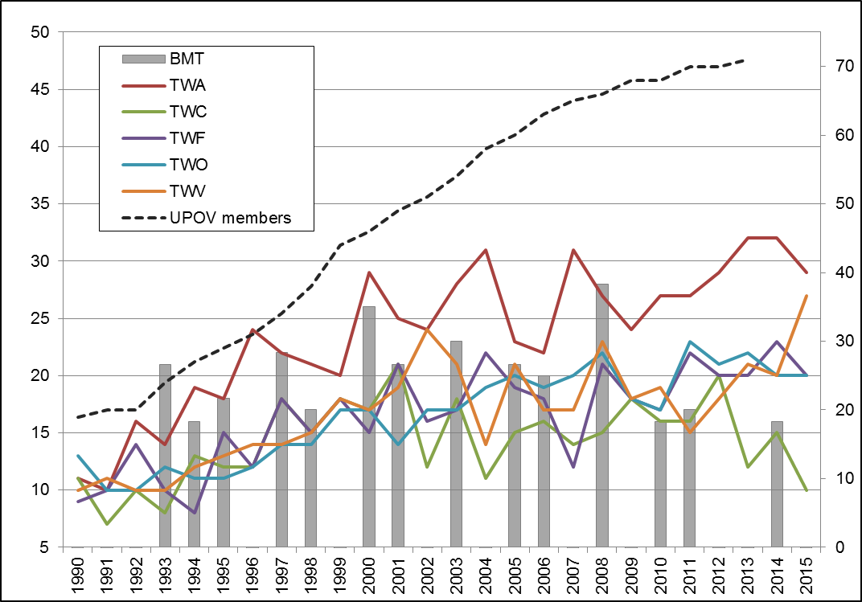

(d) Participation in Preparatory Workshops for the Technical Working Party Sessions
(see Figure 16)

Figure 16.

(i) Number of individual participants in the Preparatory Workshops: members and observers
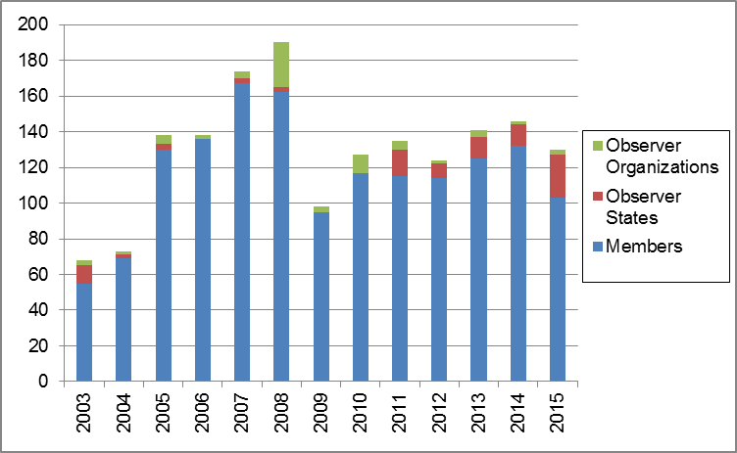

(ii) Number of individual participants in the Preparatory Workshops by Technical Working Party
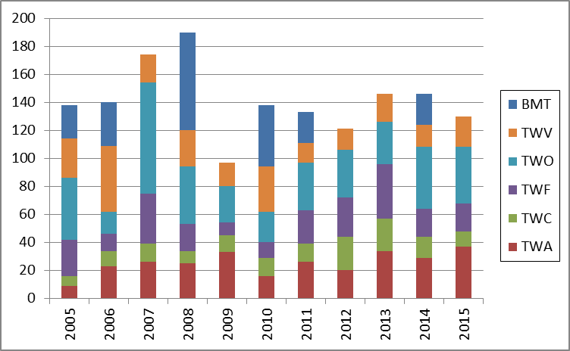

(e) Measures to improve the effectiveness of the TC, TWPs and Preparatory Workshops
The TC, at its fifty-first session, considered document TC/51/37 “Possible ways of improving the effectiveness of the Technical Committee, Technical Working Parties and Preparatory Workshops” and received a presentation by the UPOV Office. The TC noted the results of the surveys in 2014, presented in document TC/51/37, Annex I. The TC agreed with the proposals concerning possible means of improving the effectiveness of the TWPs, as set out in document TC/51/37, paragraph 24.

5. UPOV documents and materials in additional languages

(a) Availability of UPOV documents and materials in languages other than the UPOV languages (English, French, German and Spanish)
- The 1991 Act of the UPOV Convention was translated into Khmer and published on the UPOV website. The translations in Bahasa Indonesia, Malay, Serbian, Vietnamese languages of the 1991 Act will be verified before publication on the UPOV website.

Web pageviews for languages other than English, French, German and Spanish of the UPOV site in 2015
Language | Pageviews
Russian | 772
Chinese | 298
Arabic | 198
Khmer | 31

6. Facilitating applications for plant breeders’ rights

(a) Number of applications for plant breeders’ rights
(see Figures 17 and 19)

(b) Number of titles granted
(see Figure 20)

(c) Number of titles in force
(see Figure 18)

Figure 17. Applications for Plant Breeders’ Rights  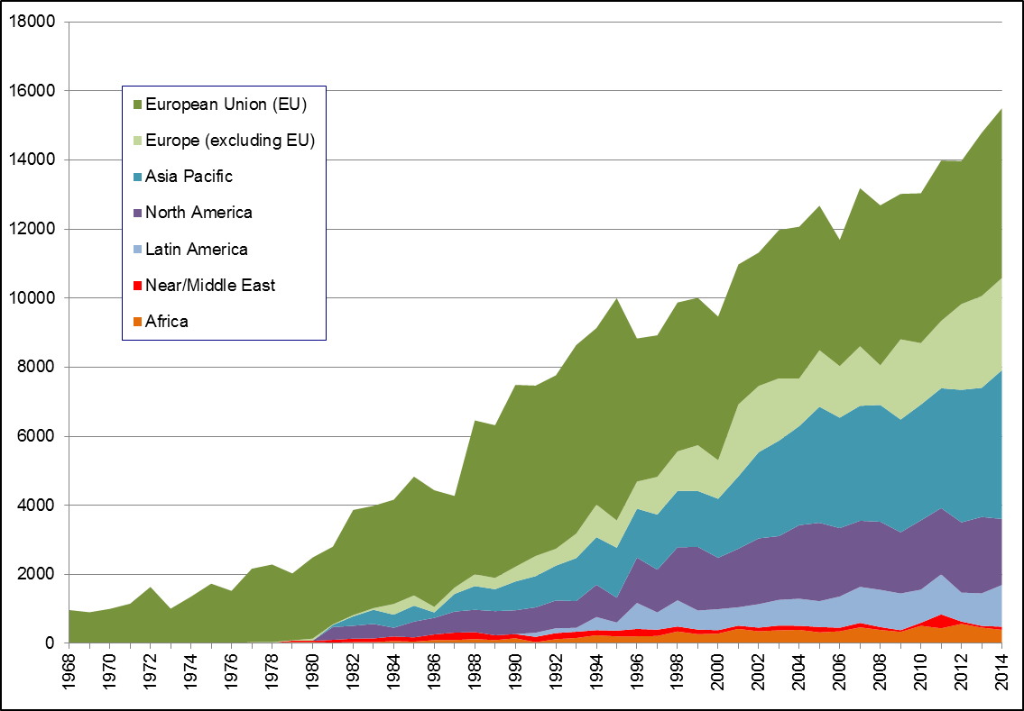 | Figure 18. Plant Breeders’ Rights Titles in Force  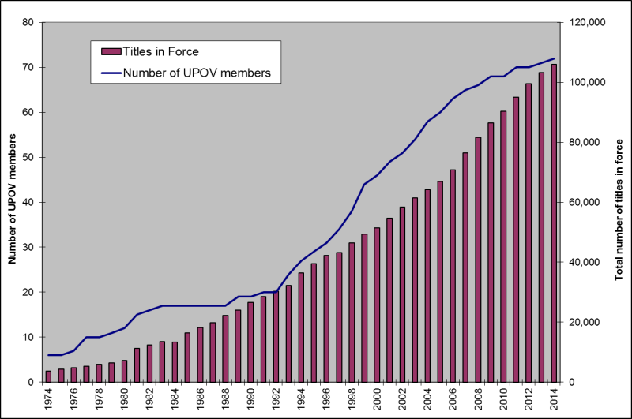
Figure 19. Applications for Plant Breeders’ Rights by Resident/Non-Resident  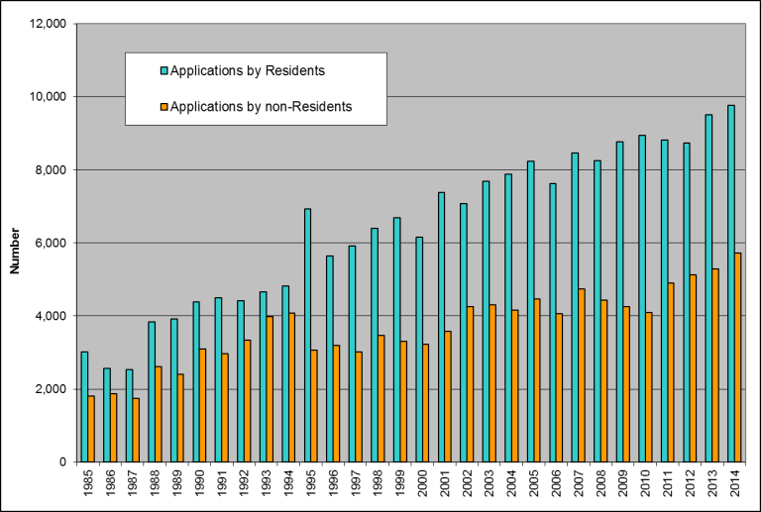 | Figure 20. Plant Breeders’ Rights Titles Granted by Resident/Non-Resident  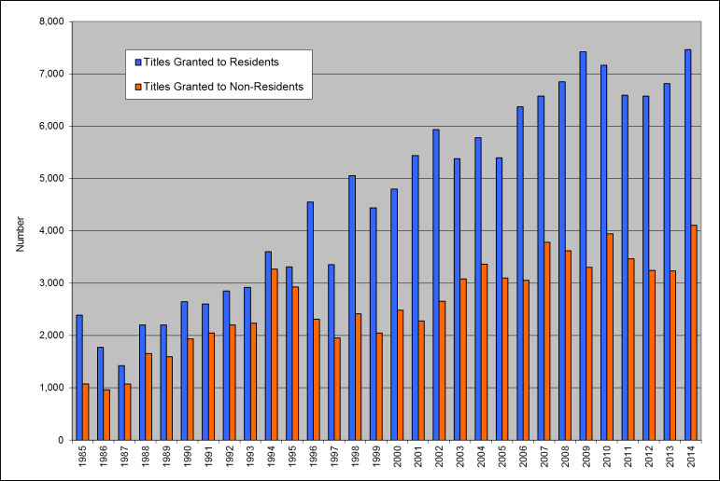

(d) Number of genera/species protected by members of the Union
(see Figures 21 and 22)

Figure 21. Protection to plant genera and species in 2015
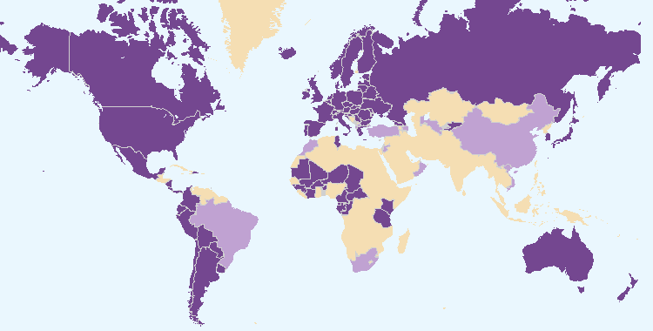

Members of the Union offering protection for all plant genera and species
Members of the Union offering protection for a limited number of plant genera and species

Figure 22. Evolution of offering protection to plant genera and species

(e) Number of genera/species for which varieties have been protected
See Figure 7 “Plant Genera/Species with Cooperation Agreements, Practical Experience and Plant Breeders’ Rights Entries in Plant Variety Database”

(f) Use by members of the Union of standard UPOV references in application forms
No new developments.

(g) Use of linear blank forms corresponding to the “UPOV Model Form for the Application for Plant Breeders’ Rights”
No new developments.

7. Provision of information on the UPOV Convention for stakeholders (breeders, farmers, growers, seed-merchants, etc.)

(a) Stakeholder-orientated information on the UPOV website
– The following material was published on the UPOV website in 2014:

- the UPOV Trilogy (in French, German and Spain), containing the following publications:
- Executive Summary (UPOV Publication 357.1)
- Symposium on Plant Breeding for the Future (UPOV Publication 357.2)
- Seminar on Plant Variety Protection and Technology Transfer: the Benefits of Public-Private Partnership (UPOV Publication 357.3)
- Symposium on the Benefits of Plant Variety Protection for Farmers and Growers (UPOV Publication 357.4)
- the Proceedings of the Seminar on Essentially Derived Varieties, held in Geneva, on October 22, 2013 (Publication 358) in English, French , German and Spanish
- updated editions of the information leaflet “What it is, What it does” on UPOV and plant variety protection in English, French, German and Spanish (Publication No. 437)
- answers to the following frequently asked questions (FAQs):
- What is UPOV?
- What does UPOV do?
- Who can attend UPOV meetings?
- What is a plant variety?
- Why do farmers and growers need new plant varieties?
- Why is plant variety protection necessary?
- How does plant variety protection work?
- What are the requirements for protecting a new plant variety?
- Why does UPOV require varieties to be uniform and stable; doesn’t that lead to a loss of diversity?
- Can breeders use a protected variety in their breeding programs
- Who can protect a plant variety?
- Where do I apply for protection of a variety?
- Can I obtain protection for more than one country from a single application?
- What are the benefits of plant variety protection and UPOV membership?
- What is the effect of plant variety protection on varieties that are not protected (e.g. traditional varieties, landraces etc.)?
- What is the relationship between the UPOV Convention and international treaties concerning genetic resources, e.g. the Convention on Biological Diversity (CBD) and the International Treaty on Plant Genetic Resources for Food and Agriculture (ITPGRFA)?
- What is the relationship between patents and plant breeders’ rights?
- What is the relationship between plant breeders’ rights and measures regulating commerce, e.g. seed certification, official registers of varieties admitted to trade (e.g. National List, Official Catalogue) etc.?
- Can I protect an existing plant or variety that I discover?
- Does the UPOV Convention allow a variety to be refused protection because it is genetically modified?
- Can I use plant variety protection to protect the following:
- a trait (e.g. disease resistance, flower color)
- a chemical or other substance (e.g. oil, DNA)
- a plant breeding technology (e.g. tissue culture)?
- Can I protect a hybrid variety under the UPOV system?
- Can a farmer replant seed of a protected variety without the authorization of the breeder?
- Can a farmer sell seed of a protected variety without the authorization of the breeder?
- How do I know if a variety is protected?
- Who is responsible for enforcing plant breeders’ rights?
- Does UPOV allow molecular techniques (DNA profiles) in the examination of Distinctness, Uniformity and Stability (“DUS”)?
- Is it true that UPOV only promotes commercially bred plant varieties geared to industrialized farmers?
- Does the UPOV Convention regulate varieties that are not protected by plant breeders’ rights?
- Is it possible for subsistence farmers to exchange propagating material of protected varieties against other vital goods within the local community?
- Under the UPOV system, breeders decide the conditions and limitations under which they authorize the exploitation of their protected varieties. Can farmers, for instance, be allowed to exchange seeds of protected varieties freely within the local community?
– No new material was published on the UPOV website in 2015.

2.3 Sub-Program UV.3: Assistance in the Introduction and Implementation of the UPOV System

UPOV assisted a number of States in the implementation of plant variety protection based on the UPOV Convention and provided advice to governments in the preparation of legislation. Cooperation with members of the Union, particularly with regard to training courses, provided substantial benefits for outreach. The use of the distance learning courses “Introduction to the UPOV System of Plant Variety Protection under the UPOV Convention” (DL-205) and “Examination of Applications for Plant Breeders’ Rights” (DL-305), and training of trainers have been of particular importance in providing assistance to a wide range of experts.

Objectives

- To raise awareness of the role of plant variety protection according to the UPOV Convention.
- To assist States and organizations, particularly governments of developing countries and countries in transition to a market economy, in the development of legislation in accordance with the 1991 Act of the UPOV Convention.
- To assist States and organizations in their accession to the 1991 Act of the UPOV Convention.
- To assist States and organizations in implementing an effective plant variety protection system in accordance with the UPOV Convention.

Results Achieved: Selected Performance Indicators

1. Raising awareness of the role of plant variety protection in accordance with the UPOV Convention

(a) Publications on the role of plant variety protection, including material on UPOV website
See section 2.2 “Sub-Program UV.2”, expected result “7. Provision of information on the UPOV Convention for stakeholders”, “(a) Stakeholder-orientated information on the UPOV website”

(b) States and organizations provided with information at UPOV activities
States provided with information at UPOV activities:

Albania, Argentina, Australia, Belarus, Benin, Bolivia (Plurinational State of), Botswana, Brazil, Brunei Darussalam, Burkina Faso, Cambodia, Cameroon, Central African Republic, Chile, China, Colombia, Costa Rica, Côte d’Ivoire, Cuba, Dominican Republic, Ecuador, El Salvador, France, Gambia, Georgia, Germany, Ghana, Guatemala, Guinea, Guinea-Bissau, Honduras, Indonesia, Iran (Islamic Republic of), Jamaica, Japan, Jordan, Kenya, Lao People’s Democratic Republic, Malawi, Malaysia, Mali, Mauritania, Mexico, Mozambique, Myanmar, Namibia, Netherlands, Nicaragua, Niger, Oman, Panama, Paraguay, Peru, Philippines, Republic of Korea, Republic of Moldova, Russian Federation, Rwanda, Senegal, Serbia, Sierra Leone, Singapore, South Africa, Spain, Sudan, Swaziland, Thailand, the former Yugoslav Republic of Macedonia, Togo, Trinidad and Tobago, Uganda, United Kingdom, United Republic of Tanzania, United States of America, Uruguay, Uzbekistan, Viet Nam, Zambia, Zimbabwe (see Figure 23)

Figure 23. States provided with information at UPOV activities
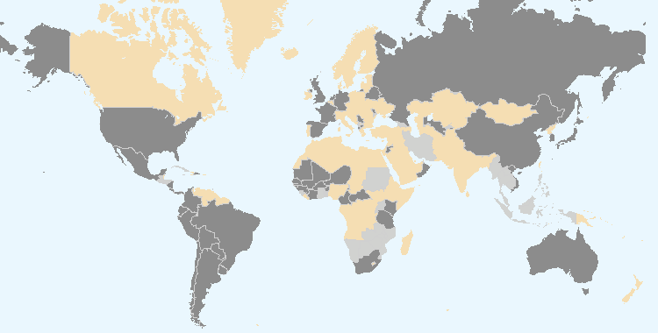

Members of the Union Non-members of the Union

Intergovernmental organizations provided with information at UPOV activities:

ARIPO, CGIAR, European Union, ISTA, OAPI, OECD,

Non-governmental organizations provided with information at UPOV activities:

AFSTA, ASTA, Croplife International, Groupement technique horticole de Genève, ISF

Location of UPOV activities:

Bolivia, Brunei Darussalam, Cambodia, Ecuador, Lao People’s Democratic Republic, Mexico, Peru, Republic of Korea, Spain, Switzerland, the former Yugoslav Republic of Macedonia, Tunisia, United Republic of Tanzania, Uruguay, Zimbabwe (see Figure 24)

Figure 24. Location of UPOV activities
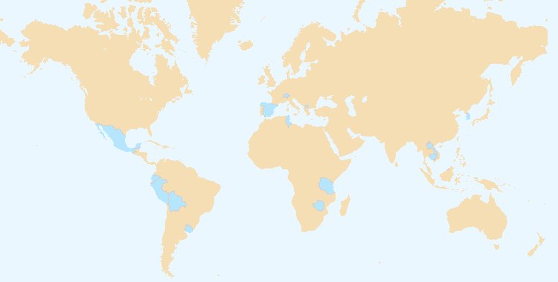

(c) States and organizations that contacted the Office of the Union for assistance in the development of legislation on plant variety protection
Members of the Union: Brazil, Canada, Chile, Colombia, Singapore

Non-members of the Union: ARIPO, Barbados, Bosnia and Herzegovina, Brunei Darussalam, Cambodia, Egypt, Guatemala, Iran (Islamic Republic of), Jamaica, Liberia, Malaysia, Mauritius, Myanmar, Pakistan, Tajikistan, United Arab Emirates, United Republic of Tanzania, Zimbabwe
(see Figure 25)

(d) States and organizations that initiated with the Council of UPOV the procedure for becoming members of the Union
ARIPO, Iran (Islamic Republic of), United Republic of Tanzania
(see Figure 25)

Figure 25. States and organizations that contacted the Office of the Union for assistance in the development of legislation on plant variety protection and States and organizations that initiated with the Council of UPOV the procedure for becoming members of the Union
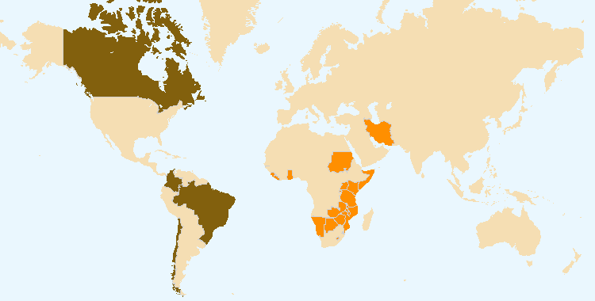

States and organizations that initiated with the Council of UPOV the procedure for becoming members of the Union
States and organizations that contacted the Office of the Union for assistance in the development of legislation on plant variety protection

(e) Participation in UPOV awareness-raising activities, or activities involving UPOV staff or UPOV trainers on behalf of UPOV staff
(i) Activities organized by, or with, UPOV: see (b) above

(ii) Activities/meetings in which UPOV participated: see Figure 26

Location of activities/meetings where UPOV made presentations:

Argentina, Australia, Austria, Barbados, Belgium, Bolivia (Plurinational State of), Brazil, Cameroon, Chile, China, Côte d’Ivoire, Croatia, France, Germany, India, Italy, Japan, Malaysia, Mauritius, Mexico, Netherlands, Paraguay, Poland, Republic of Korea, Republic of Moldova, Senegal, Slovakia, South Africa, Spain, Switzerland, Thailand, Tunisia, Turkey, Uganda, United Kingdom, United Arab Emirates, United Republic of Tanzania, Uzbekistan, Viet Nam, Zambia, Zimbabwe

Figure 26. Location of activities/meetings where UPOV made presentations
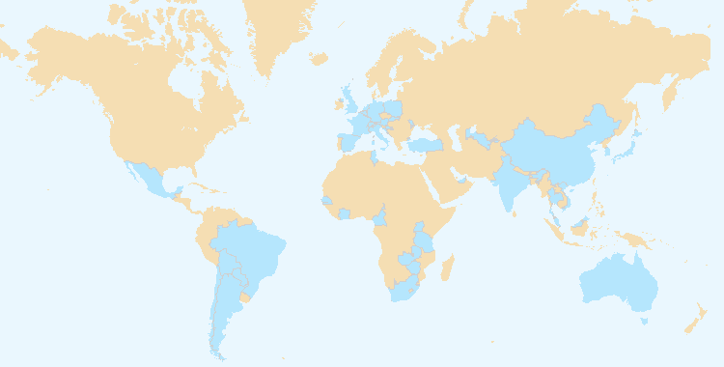

2. Assistance in drafting legislation on plant variety protection in accordance with the 1991 Act of the UPOV Convention

(a) States and organizations provided with comments on laws
Members of the Union: Brazil, Chile, Singapore

Non-members of the Union: ARIPO, Bosnia and Herzegovina, Brunei Darussalam, Egypt, Guatemala, Iran (Islamic Republic of), Malaysia, Mauritius, Myanmar, Tajikistan, United Arab Emirates, United Republic of Tanzania

(see Figure 28)

(b) States and organizations which received a positive advice from the Council of UPOV
ARIPO, Egypt, United Republic of Tanzania (whole territory)

(see Figure 29)

(c) Meetings with government officials
Members of the Union: Brazil, Canada, Chile, Colombia, Singapore, South Africa, Turkey

Non-members of the Union: ARIPO, Barbados, Bosnia and Herzegovina, Botswana, Brunei Darussalam, Egypt, Iran (Islamic Republic of), Jamaica, Kazakhstan, Liberia, Malaysia, Mauritius, Myanmar, Pakistan, Rwanda, United Arab Emirates, United Republic of Tanzania, Zimbabwe

(see Figure 27)

Figure 27. Assistance provided in drafting legislation on plant variety protection
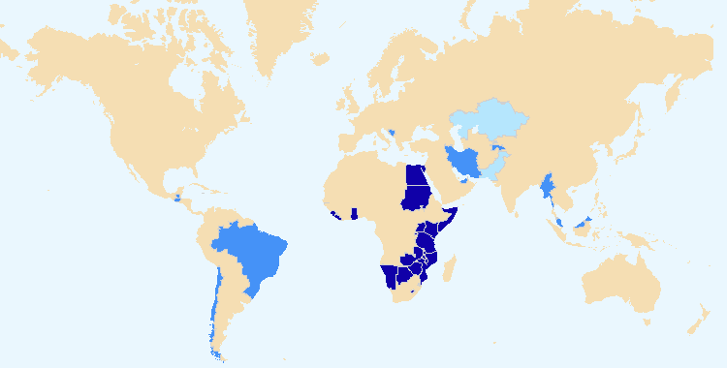

States and organizations which received a positive advice from the Council of UPOV
States and organizations provided with comments on laws
Meetings with government officials

3. Assistance to States and organizations in the accession to the 1991 Act of the UPOV Convention

(a) States that acceded to or ratified the 1991 Act of the UPOV Convention
Canada, Montenegro, OAPI, United Republic of Tanzania
(see Figure 31)

(b) States and organizations that became members of the Union
Montenegro, OAPI, United Republic of Tanzania
(see Figure 30)

Figure 28. States/Organizations provided with comments on laws  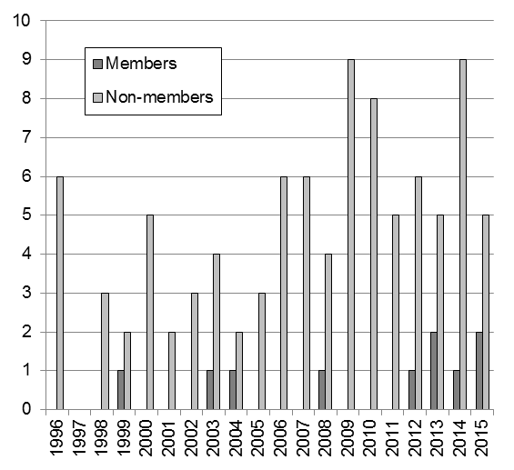 | Figure 29. States/Organizations which received positive advice from the Council  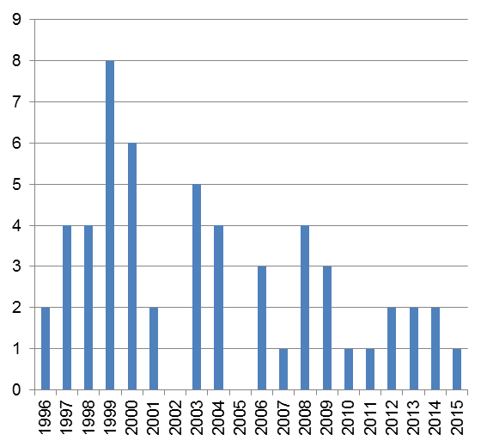
Figure 30. New members of the Union  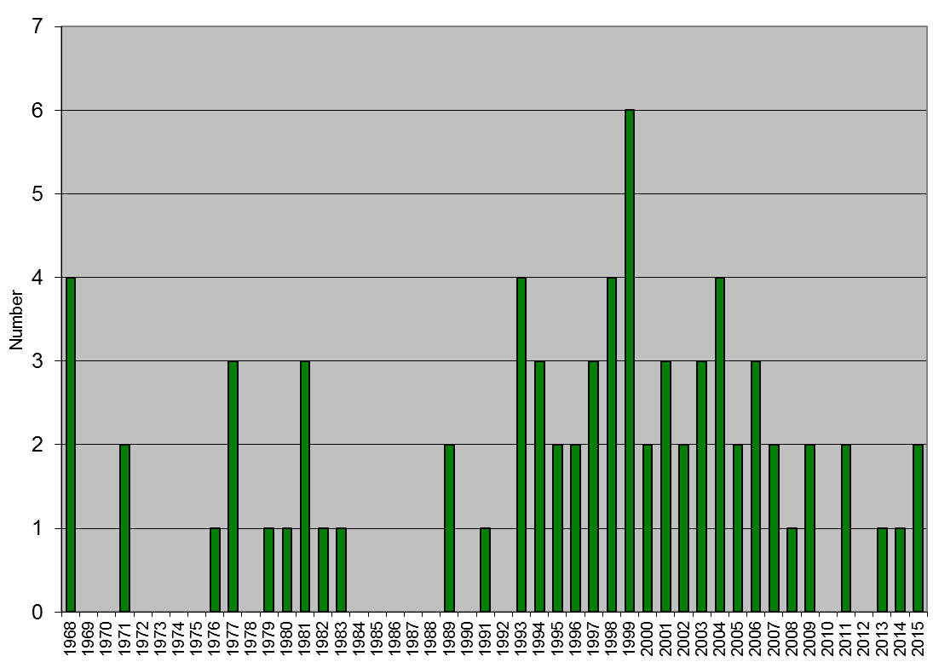 | Figure 31. Accession to/ratification of the 1991 Act  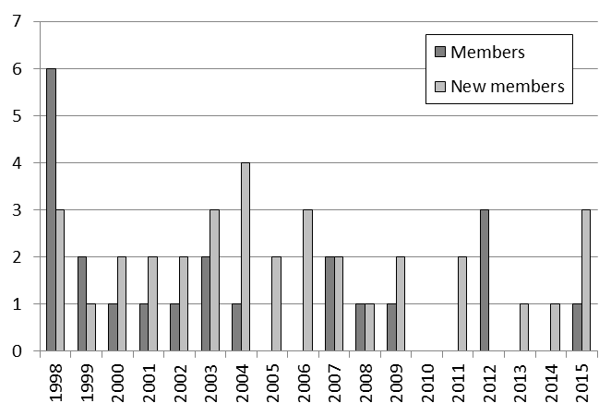

4. Assistance in implementing an effective plant variety rights system in accordance with the 1991 Act of the UPOV Convention

(a) Participation in distance learning courses
- UPOV DL-205 “Introduction to the UPOV System of Plant Variety Protection under the UPOV Convention”

Number of participants in regular DL-205 sessions in 2014 and 2015

Category | Number of students
Category 1: Government officials of members of the Union nominated by the relevant representative to the UPOV Council | 382
Category 2: Officials of observer States / intergovernmental organizations nominated by the relevant representative to the UPOV Council | 17
Category 3: Others | 31
Category 4: Discretionary waiving of fee for selected students | 18
Total: | 448

- UPOV DL-305 “Examination of applications for plant breeders’ rights”

Number of participants in the DL-305 Course in 2014 and 2015

Category | Number of students
Category 1: Government officials of members of the Union nominated by the relevant representative to the UPOV Council | 199
Category 2: Officials of observer States / intergovernmental organizations nominated by the relevant representative to the UPOV Council | 4
Category 3: Others | 1
Category 4: Discretionary waiving of fee for selected students | 1
Total: | 205

- UPOV DL-305A “Administration of Plant Breeders’ Rights”

Number of participants in the DL-305A Course (1 session in 2015)

Category | Number of students
Category 1: Government officials of members of the Union nominated by the relevant representative to the UPOV Council | 58
Category 2: Officials of observer States / intergovernmental organizations nominated by the relevant representative to the UPOV Council | 2
Category 3: Others | 0
Category 4: Discretionary waiving of fee for selected students | 0
Total: | 60

- UPOV DL-305B “DUS Examination”

Number of participants in the DL-305B Course (1 session in 2015)

Category | Number of students
Category 1: Government officials of members of the Union nominated by the relevant representative to the UPOV Council | 61
Category 2: Officials of observer States / intergovernmental organizations nominated by the relevant representative to the UPOV Council | 2
Category 3: Others | 0
Category 4: Discretionary waiving of fee for selected students | 2
Total: | 65

List of States from which there were participants in all distance learning sessions
in 2014 and 2015

Albania, Argentina, Bangladesh, Belgium, Benin, Bolivia (Plurinational State of), Bosnia and Herzegovina, Brazil, Burkina Faso, Cambodia, Cameroon, Canada, Central African Republic, Chile, China, Colombia, Costa Rica, Côte d’Ivoire, Croatia, Cuba, Czech Republic, Denmark, Dominican Republic, Ecuador, Egypt, El Salvador, Estonia, Ethiopia, France, France, Gabon, Germany, Ghana, Greece, Guatemala, Honduras, Hungary, India, Indonesia, Iran (Islamic Republic of), Israel, Italy, Jamaica, Japan, Kenya, Lao People's Democratic Republic, Latvia, Malaysia, Mali, Mauritania, Mexico, Mexico, Morocco, Myanmar, Netherlands, New Zealand, Nigeria, Norway, Oman, Panama, Paraguay, Peru, Philippines, Poland, Portugal, Republic of Korea, Republic of Moldova, Russian Federation, Rwanda, Saudi Arabia, Senegal, Serbia, Singapore, Slovakia, South Africa, Spain, Sri Lanka, Switzerland, the former Yugoslav Republic of Macedonia, Togo, Trinidad and Tobago, Tunisia, Turkey, Uganda, United Kingdom, United Republic of Tanzania, United States of America, Uruguay, Viet Nam, Zimbabwe, OAPI (total: 90 countries and 1 organization).

Figure 32. UPOV DL-205, DL-305, DL-305A and DL-305B Courses:
2014 and 2015 participation
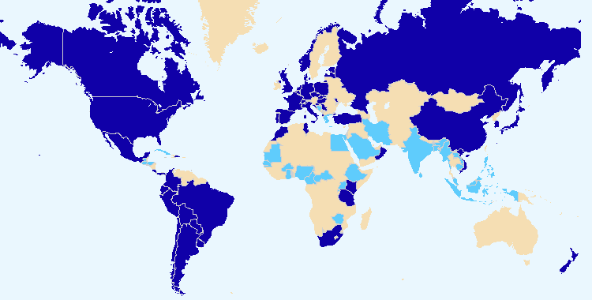

Members of the Union Non-members of the Union

Total number of participants by category in regular DL-205 sessions since 2006

Category | Number of students
Category 1: Government officials of members of the Union nominated by the relevant representative to the UPOV Council | 2385
Category 2: Officials of observer States / intergovernmental organizations nominated by the relevant representative to the UPOV Council | 147
Category 3: Others | 201
Category 4: Discretionary waiving of fee for selected students | 25
Total: | 2758

Figure 33a. Participants in the main sessions of the  DL-205 Course by registration category | Figure 34a. Participants in the main sessions of the DL-205 Course by language

Figure 33b. Participants in the main sessions of the  DL-305, 305A, 305B Courses by registration category | Figure 34b. Participants in the main sessions of the DL-305, 305A, 305B Courses by language

Special sessions of DL-205 in 2014 and 2015

Month/  Year | Name of Course | Language | Number. of participants
June 2014 | Naktuinbouw International Course on Plant Variety Protection Course (Netherlands) | EN | 11
July 2014 | KOICA Training Course on Plant Variety Protection (Republic of Korea) | EN | 13
July 2014 | JICA Training Course on “Internationally Harmonized Plant Variety Protection System” (Japan) | EN | 10
October 2014 | Arusha PVP Training Course (United Republic of Tanzania) | EN | 10
September 2014 | International Seminar on Plant Variety protection and International Workshop on Plant Variety Characteristics: fine cocoa aroma (Ecuador) | ES | 219
November 2014 | Training Course for Ibero-American Countries on the Protection of New Varieties of Plants (Uruguay) | ES | 2
May 2015 | Train the Trainer Course on Plant Variety Protection under the UPOV Convention (Geneva, Switzerland) | EN | 11
June 2015 | KOICA Training Course on Plant Variety Protection (Republic of Korea) | EN | 6
June 2015 | Naktuinbouw International Course on Plant Variety Protection Course (Netherlands) | EN | 10
June 2015 | JICA Training Course on “Internationally Harmonized Plant Variety Protection System” (Japan) | EN | 10
October 2015 | National Seminar on plant variety protection under the UPOV Convention (Chile) | ES | 39
November 2015 | Train the Trainer Course on Plant Variety Protection under the UPOV Convention (Geneva, Switzerland) | FR | 17
November 2015 | Train the Trainer Course for Ibero-American Countries on Plant Variety Protection Under the UPOV Convention and Complementary forms of Intellectual Property Protection (Santa Cruz, Bolivia) | ES | 5
November 2015 | Others (UPOV fee waiver) | EN, FR, ES | 10

(b) Participation by observer States and organizations in the CAJ, TC, TWPs and the associated preparatory workshops
See Sub-Program UV.2, Section 2.2, performance indicator 4 “Participation by members of the Union and stakeholders in the work of the UPOV bodies”, sections (a) to (d)

(c) Participation in UPOV activities
See Sub-Program UV.3, Section 2.3, performance indicator 1 “Raising awareness of the role of plant variety protection in accordance with the UPOV Convention”, section (b)

(d) Participation in activities involving UPOV staff or UPOV trainers on behalf of UPOV staff
See Sub-Program UV.3, Section 2.3, performance indicator 1 “Raising awareness of the role of plant variety protection in accordance with the UPOV Convention”, section (e)

(e) Training provided by UPOV trainers in non-UPOV activities
It was not possible to collect complete information on activities by UPOV trainers for the period 2014-2015.

(f) Implementation of projects with partner organizations and donors
World Seed Project:
- In 2014, 4 electronic meetings, 2 face-to-face meetings of the Steering Committee
- In 2015, 2 electronic meetings, 2 face-to-face meetings of the Steering Committee

(g) Use of training and assistance web-page
- The training and assistance web-page provides training materials from the Train the Trainer program.

2.4 Sub-Program UV.4: External Relations

UPOV maintained contacts with a number of intergovernmental organizations and non-governmental organizations representing stakeholders, including breeders, farmers and growers, in order to explain the UPOV system of plant variety protection and to exchange information. The UPOV website continues to be an important resource for dissemination of information. The regular publication of press releases, including those highlighting developments in the Council of UPOV, also continued to provide a valuable means of disseminating information to the general public.

A number of intergovernmental organizations have invited UPOV to contribute to their work. UPOV has participated in meetings with other relevant organizations.

Objectives | - To broaden and enhance the understanding of the UPOV system of plant variety protection.  - To provide information on the UPOV Convention to other intergovernmental organizations, with the aim of achieving mutual supportiveness with other international treaties.  - To inform members of the Union of developments of relevance to UPOV.

Results Achieved: Selected Performance Indicators

1. Increased public understanding of UPOV’s role and activities

(a) Availability of public-orientated information and materials on UPOV Website
- See Sub-Program UV.2, performance indicator “7. Provision of information on the UPOV Convention for stakeholders (breeders, farmers, growers, seed-merchants, etc.)”, section (a)
- 8 press releases (http://www.upov.int/news/en/pressroom/)

(b) Visits to website
 | 2015 | 2014 | 2013 | 2012 | 2011 | 2010
Number of sessions: | 191,534 | 187,125 | 178,732 | 151,914 | 140,371 | 118,895
Unique users: | 86,366 | 86,291 | 84,336 | 71,506 | 75,673 | 62,758
Number of pageviews: | 1,087,382 | 1,127,786 | 1,129,052 | 1,139,570 | 798,942 | 656,722
Number of pages/visit: | 5.68 | 6.03 | 6.32 | 7.50 | 5.69 | 5.52
Average visit duration: | 00:05:15 | 00:06:00 | 00:06:35 | 00:07:19 | 00:04:41 | 00:04:12
Percentage of new visits: | 43.21% | 44.19% | 54.6% | 45.05% | 51.91% | 50.57%

Website Overview: Global Coverage in 2015  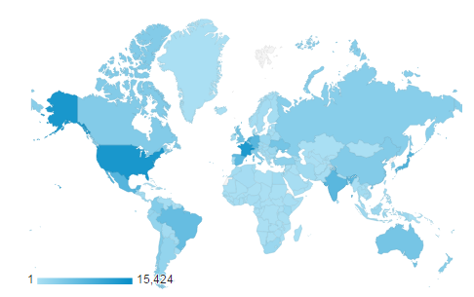 | Sessions by country:  1. Switzerland (8.05%)  2. United States of America (7.07%)  3. France (6.81%)  4. Netherlands (4.92%)  5. Japan (4.32%)  6. Mexico (4.08%)  7. Germany (4.00%)  8. India (3.91%)  9. Spain (3.70%)  10. Brazil (3.32%)

Language of  visitor’s browser | 2015 |  | 2014 |  | 2013 |  | 2012 |  | 2011
 | Visits | % | Visits | % | Visits | % | Visits | % | Visits | %
- en-us | 66,347 | 39.58 | 72,248 | 38.61 | 70,706 | 39.56 | 57,341 | 37.75 | 50,571 | 36.03
- es | 17,765 | 59.03 | 18,154 | 9.70 | 18,669 | 10.45 | 19,001 | 12.51 | 23,605 | 16.82
- fr | 11,413 | 52.99 | 11,862 | 6.34 | 13,876 | 7.76 | 14,212 | 9.36 | 10,670 | 7.60
- es-es | 7,972 | 4.16 | 9,180 | 4.91 | 9,234 | 5.17 | 5,698 | 3.75 | 9,124 | 6.50
- en-gb | 6,743 | 3.52 | 4,508 | 2.41 | 3,028 | 1.69 | 2,371 | 1.56 | 2,069 | 1.47
- ru | 6,608 | 3.45 | 6,824 | 3.65 | 6,596 | 3.69 | 3,630 | 2.39 | 3,168 | 2.26
- pt-br | 5,819 | 3.04 | 4,386 | 2.34 | 4,014 | 2.25 | 3,148 | 2.07 | 2,073 | 1.48
- ja | 5,277 | 2.76 | 5,729 | 3.06 | 6,444 | 3.61 | 7,562 | 4.98 | 6,387 | 4.55
- nl-nl | 4,981 | 2.60 | 2,837 | 1.52 | 4,347 | 2.43 | 4,152 | 2.73 | 2,742 | 1.95
- de | 4,925 | 2.57 | 3,619 | 1.93 | 4,065 | 2.27 | 4,562 | 3.00 | 5,577 | 3.97

1. en-us: American English; 2. es: Spanish; 3. fr: French; 4. es-es: Castilian Spanish; 5. en-gb: British English; 6. ru: Russian;
7. pt-br: Brazilian Portuguese; 8. ja: Japanese; 9. nl-nl: Dutch (Netherlands); 10. de: German

Website Overview: Where are the users going?

Number of sessions and users of the UPOV site since 2007

Summary of selected website features for the past five years (Pageviews)

 | 2015 | 2014 | 2013 | 2012 | 2011
GENIE | 67,175 | 72,018 | 84,306 | 85,149 | 59,735
PLUTO | 80,283 | 74,226 | 70,739 | 255,108 | 30,226
Test Guidelines | 64,425 | 67,900 | 68,479 | 65,471 | not available
UPOV LEX | 80,382 | 88,305 | 88,533 | 91,245 | 19,269

Devices used to consult the UPOV Website in 2015

Desktop | 175,755 (92%)
Mobile | 11,645 (6%)
Tablet | 4,134 (2%)

2. Provision of information to other organizations

Participation at meetings and/or activities with relevant organizations
Intergovernmental organizations:

- ARIPO, CGIAR, European Union (CPVO), FAO, ISTA, ITPGRFA, OIF, OAPI, OECD, United Nations, WIPO, World Bank and WTO.

Other organizations:

- AFSTA, APSA, ASIPI, CIOPORA, ESA, ISF, SAA, WECARD and WFO.

3. FINANCIAL PERFORMANCE

This section provides an overview of financial performance of the Office of the Union on a budgetary basis, using the “actual” figures as stated in the Program and Budget documents for relevant biennia (e.g. document C/49/4Rev. provides the actual figures on a budgetary basis for 2012-2013). Further detailed information and the number of posts are provided in documents C/50/4 “Financial Management Report for the 2014-2015 Biennium” and C/50/13 “Financial Statements for 2015”.

The following table and graph summarizes the evolution of posts of the Office of the Union.

Post Category | 2000-2001 | 2002-2003 | 2004-2005 | 2006-2007 | 2008-2009 | 2010-2011 | 2012-2013 | 2014-2015 | 2016-2017 Budget
Directors | 4 | 3 | 3 | 3 | 3 | 3 | 2 | 2 | 3
Professionals | 4 | 6 | 4 | 4 | 3 | 3 | 4 | 4 | 4
General Service | 6 | 5 | 4 | 4 | 5 | 5 | 5 | 5 | 4
Total | 14 | 14 | 11 | 11 | 11 | 11 | 11 | 11 | 11

[Appendix follows]

C/50/12

APPENDIX

ACRONYMS AND ABBREVIATIONS

UPOV terms

BMT | Working Group on Biochemical and Molecular Techniques, and DNA-Profiling in Particular
CAJ | Administrative and Legal Committee
DL-205 | UPOV distance learning course “Introduction to the UPOV System of Plant Variety Protection under the UPOV Convention”
DL-305 | UPOV distance learning course “Examination of Applications for Plant Breeders’ Rights”
DL-305A | UPOV distance learning course “Administration of Plant Breeders’ Rights”  (part A of DL-305)
DL-305B | UPOV distance learning course “DUS Examination” (part B of DL-305)
DUS | Distinctness, Uniformity and Stability
EDV | essentially derived variety
Office | Office of the Union
PBR | Plant Breeder’s Right
TC | Technical Committee
TC-EDC | Enlarged Editorial Committee
TWA | Technical Working Party for Agricultural Crops
TWC | Technical Working Party on Automation and Computer Programs
TWF | Technical Working Party for Fruit Crops
TWO | Technical Working Party for Ornamental Plants and Forest Trees
TWP(s) | Technical Working Party(ies)
TWV | Technical Working Party for Vegetables

Acronyms

AATF | African Agricultural Technology Foundation
AECID | Spanish Agency for Cooperation and Economic Development
AFSTA | African Seed Trade Association
AGEPI | State Agency on Intellectual Property of the Republic of Moldova
AGRA | Alliance for Green Revolution in Africa
APSA | Asia and Pacific Seed Association
ARIPO | African Regional Intellectual Property Organization
ASIPI | Inter-American Association of Intellectual Property
ASTA | American Seed Trade Association
CBD | Convention on Biological Diversity
CGIAR | Consultative Group on International Agricultural Research
CGRFA | Commission on Genetic Resources for Food and Agriculture
CIOPORA | International Community of Breeders of Asexually Reproduced Ornamental and Fruit Varieties
CPVO | Community Plant Variety Office of the European Union
EAPVP Forum | East Asia Plant Variety Protection Forum
ESA | European Seed Association
FAO | Food and Agriculture Organization of the United Nations
GIZ | Deutsche Gesellschaft für Internationale Zusammenarbeit GmbH  (German Agency for International Cooperation)
ICARDA | International Center for Agricultural Research in the Dry Areas
ICBA | International Center for Biosaline Agriculture
ICNP | Open-ended Ad Hoc Intergovernmental Committee for the Nagoya Protocol on Access and Benefit-sharing
IEPI | Instituto Ecuatoriano de la Propiedad Intelectual  (Ecuadorian Institute of Intellectual Property)
ILO | International Labour Organization
ISF | International Seed Federation
ISTA | International Seed Testing Association
ITPGRFA | International Treaty on Plant Genetic Resources for Food and Agriculture
JICA | Japan International Cooperation Agency
KOICA | Korea International Cooperation Agency
KSVS | Korea Seed and Variety Service
OAPI | African Intellectual Property Organization
OIF | Organisation internationale de la francophonie
OECD | Organisation for Economic Co-Operation and Development
OEVV | Spanish Plant Variety Office
QUT | Queensland University of Technology
SAA | Seed Association of the Americas
TAIEX | Technical Assistance and Information Exchange Instrument (TAIEX) of the European Union
TRIPS | Trade Related Aspects of Intellectual Property Rights
UBIS | University of Business and International Studies
UN | United Nations
UNIGE | University of Geneva
USPTO | United States Patent and Trademark Office
WECARD | West and Central African Council for Agricultural Research and Development
WFO | World Farmers’ Organization
WIPO | World Intellectual Property Organization
WIPO IGC | WIPO Intergovernmental Committee on Intellectual Property and Genetic Resources, Traditional Knowledge and Folklore
WTO | World Trade Organization

* Participation is assessed on the basis of the number of participating members and observer States/organization, rather than the number of individual participants.
Provision of detailed comments on laws and/or assistance in the development of laws.
Meetings and/or consultations for the provision of advice and information on legislative matters.
Definitions used in Website statistics in this report: - “Users” are individuals who have had at least one session within the selected date range. - A “session” is the period of time a user is actively engaged with your website. “Sessions” are the total number of sessions within the given date range. - “Unique Pageviews” are the number of visits during which the specified page was viewed at least once. - “Pageviews” are the total number of times that a page was viewed. Repeated views of a single page by the same user during the same session are counted. [End of appendix and of document]

