E
C/47/19
ORIGINAL: English
DATE: October 24, 2013
INTERNATIONAL UNION FOR THE PROTECTION OF NEW VARIETIES OF PLANTS
Geneva
COUNCIL
Forty-Seventh Ordinary Session
Geneva, October 24, 2013
REPORT ON THE DECISIONS
adopted by the Council
Opening of the session

The Council of the International Union for the Protection of New Varieties of Plants (UPOV) held its forty-seventh ordinary session in Geneva on October 24, 2013, chaired by Ms. Kitisri Sukhapinda (United States of America), President of the Council.

The list of participants is reproduced in Annex I to this report.

The session was opened by the President who welcomed the participants.

The Council took the decisions recorded below under each relevant agenda item.

The Secretary-General reported that, following a competition, Mrs. Alexandra Fava had been appointed to the post of Secretary I on October 1, 2013.

The draft detailed report on the session will be submitted to the Council for adoption by correspondence.

Adoption of the agenda

The Council adopted the revised draft agenda, as presented in document C/47/1 Rev.

Examination of the conformity of the law for the protection of new varieties of plants of Bosnia and Herzegovina with the 1991 Act of the UPOV Convention

The Council considered document C/47/17.

The Council noted the intervention made by the representative of International Community of Breeders of Asexually Reproduced Ornamental and Fruit-Tree Varieties (CIOPORA).

The Council decided to:

(a) note the analysis in this document;

(b) note the information provided by the Delegation of Bosnia and Herzegovina that the English translation of the Law required verification and that the following corrections would be made to the translation in accordance with the original text of the Law:
(i) to delete the text in Article 2(1)(f), which was already contained in Article 21(7);

(ii) to delete the words “a small” in Article 22(2);

(iii) to correct the translation in Article 11(6) to reflect that a procedure for granting a breeder's right can start also by filing an application outside of Bosnia and Herzegovina;

(iv) to correct the translation in Article 11(7) in accordance with the terms used for the national treatment provision in Article 5;

(c) take a positive decision on the conformity of the Law for the Protection of New Varieties of Plants of Bosnia and Herzegovina with the provisions of the 1991 Act of the International Convention for the Protection of New Varieties of Plants, which allows Bosnia and Herzegovina to deposit its instrument of accession to the 1991 Act; and

(d) authorize the Secretary-General to inform the Government of Bosnia and Herzegovina of the above decision.

The Council noted the intervention made by the Delegation of Bosnia and Herzegovina thanking the Council for its positive decision on the conformity of the Law for the Protection of New Varieties of Plants.

Developments concerning the Plant Breeders’ Bill of Ghana

The Council considered document C/47/18.

The Council decided to:

(a) note the information provided by the Delegation of Ghana that the text of Section 10 of the Bill provided in document C/47/18, Annex II, had been modified as follows: “Where the application is by an applicant who is a successor-in-title, the applicant shall support the applicant application with the proof of the successor’s title”;

(b) note that the Plant Breeders’ Bill of Ghana, which was presented to the Parliament incorporated the changes in the decision of the Council of November 1, 2012 (see document C/46/19 “Report”, paragraph 12, and paragraph 2 of document C/47/18);

(c) agree that the additional changes presented in the Annex II to document C/47/18, including the change in the above paragraph (a), do not affect the substantive provisions of the 1991 Act of the UPOV Convention, and

(d) confirm the decision on conformity of November 1, 2012.

The Council noted the intervention made by the Delegation of Ghana thanking the Council for confirming its positive decision of November 1, 2012, on the conformity of the Plant Breeders’ Bill.

Report by the President on the work of the eighty-sixth session of the Consultative Committee; adoption of recommendations, if any, prepared by that Committee

The Council considered document C/47/15 Rev.

The Council noted the intervention made by the representative of the Food and Agriculture Organization of the United Nations (FAO) concerning the developments in relation to the International Treaty on Plant Genetic Resources for Food and Agriculture (ITPGRFA) and in particular that the fifth session of the Governing Body of the ITPGRFA (GB), held in Muscat, Oman, from September 24 to 28, 2013, had adopted the following resolution under the item “Implementation of Article 9, Farmers’ Rights”:

“Resolution: Implementation of Article 9, Farmers’ Rights
“3. Requests the Secretary to invite UPOV and WIPO to jointly identify possible areas of interrelations among their respective international instruments;”
(see document C/47/15 Rev., paragraph 54).

The Council noted the interest expressed by the representative of CIOPORA to participate in the work reported in document C/47/15 Rev., paragraph 66.

The Council noted the information provided by the representative of the African Regional Intellectual Property Organization (ARIPO) concerning the development of the ARIPO Draft Legal Framework for the Protection of New Varieties of Plants.

The Council noted the work of the Consultative Committee at its eighty-sixth session, as reported in document C/47/15.

The Council agreed to copy the circular concerning cooperation in examination, e.g. see C/xx/5, to the Technical Committee (TC) designated persons in order to ensure that the maximum amount of information could be collected (see document C/47/15 Rev., paragraph 27).

Adoption of documents

The Council considered documents C/47/13, TGP/14/2 Draft 1, TGP/15/1 Draft 5, TGP/0/6 Draft 1, UPOV/EXN/BRD Draft 7, UPOV/EXN/HRV Draft 10, UPOV/INF/16/3 Draft 1 and UPOV/INF-EXN/5 Draft 1.

TGP/14/2: Glossary of Terms Used in UPOV Documents (Revision)

The Council adopted the revision of document TGP/14 “Glossary of Terms Used in UPOV Documents” (document TGP/14/2) and the supplementary document to TGP/14 “Glossary of terms used in UPOV documents” (TGP/14/2 Supplement), on the basis of documents TGP/14/2 Draft 1 and TGP/14/2 Supplement Draft 1.

TGP/15/1: [New Types of Characteristics] [Guidance on the Use of Biochemical and Molecular Markers in the Examination of Distinctness, Uniformity and Stability (DUS)]

The Council adopted document TGP/15/1 “Guidance on the Use of Biochemical and Molecular Markers in the Examination of Distinctness, Uniformity and Stability (DUS)” on the basis of document TGP/15/1 Draft 5.

TGP/0/6: List of TGP Documents and Latest Issue Dates (Revision)

The Council adopted document TGP/0/6 “List of TGP Documents and Latest Issue Dates”, on the basis of document TGP/0/6 Draft 1.

UPOV/EXN/BRD/1: Explanatory Notes on the Definition of Breeder under the 1991 Act of the UPOV Convention

The Council adopted document UPOV/EXN/BRD/1 “Explanatory Notes on the Definition of Breeder under the 1991 Act of the UPOV Convention”, on the basis of document UPOV/EXN/BRD Draft 7.

UPOV/EXN/HRV/1: Explanatory Notes on Acts in Respect of Harvested Material under the 1991 Act of the UPOV Convention

The Council noted that the Administrative and Legal Committee (CAJ), at its sixty-eighth session, held on October 21, 2013, had approved document UPOV/EXN/HRV Draft 10, as the basis for adoption of document UPOV/EXN/HRV/1 “Explanatory Notes on Acts in Respect of Harvested Material under the 1991 Act of the UPOV Convention” by the Council, at its forty-seventh ordinary session (see document CAJ/68/10 “Report on the Conclusions”, paragraph 7).

The Council noted that the CAJ, at its sixty-eighth session held in Geneva on October 21, 2013, had agreed that the comments of the Delegation of the Russian Federation on the Explanatory Notes on Acts in Respect of Harvested Material would be considered in the future work by the Advisory Group of the Administrative and Legal Committee (CAJ-AG).

The Council adopted document UPOV/EXN/HRV/1 “Explanatory Notes on Acts in Respect of Harvested Material under the 1991 Act of the UPOV Convention”, on the basis of document UPOV/EXN/HRV Draft 10.

UPOV/INF/6/3: Guidance for the preparation of laws based on the 1991 Act of the UPOV Convention (Revision)

The Council adopted the revision of document UPOV/INF/6 “Guidance for the preparation of laws based on the 1991 Act of the UPOV Convention” (document UPOV/INF/6/3), on the basis of the proposed amendments to document UPOV/INF/6/2, as presented in the Annex to document C/47/13.

UPOV/INF/16/3: Exchangeable Software (Revision)

The Council noted that the CAJ, at its sixty-eighth session, held on October 21, 2013, had approved document UPOV/INF/16/3 Draft 1, as the basis for adoption of document UPOV/INF/16/3 “Exchangeable Software” by the Council, at its forty-seventh ordinary session (see document CAJ/68/10 “Report on the Conclusions”, paragraphs 31 and 33).

The Council adopted the revision of document UPOV/INF/16 “Exchangeable Software”, on the basis of document UPOV/INF/16/3 Draft 1.

UPOV/INF-EXN/5: List of UPOV/INF-EXN Documents and Latest Issue Dates

The Council adopted the revision of document UPOV/INF-EXN “List of INF-EXN Documents and Latest Issue Dates” (document UPOV/INF-EXN/5) on the basis of document UPOV/INF EXN/5 Draft 1.

Examination and approval of the Draft Program and Budget of the Union for the 2014-2015 Biennium

The Council considered document C/47/4.

The Council approved:

(a) the proposals contained in the Draft Program and Budget for the 2014-2015 Biennium, as presented in the Annex to document C/47/4, including the amount of contributions from members of the Union;

(b) the proposed maximum ceiling of expenditure in the regular budget; and

(c) the total number of posts for the Office of the Union.

Financial statements for 2012

The Council considered document C/47/12, in conjunction with a presentation made by Mr. Didier Monnot, Responsable de mandats, Contrôle fédéral des finances (Switzerland), of Annex II of document C/47/12, containing the audit report of the External Auditor.

The Council approved the Financial Statements for 2012 and noted that the financial management report for the 2012-2013 financial period would be submitted to the Council by August 31, 2014, for approval by the Council at its forty-eighth ordinary session, in October 2014.

The Council expressed its gratitude to the Government of Switzerland for acting as External Auditor.

Arrears in contributions as of September 30, 2013

The Council considered document C/47/11.

The Council noted the status of payment of contributions as of September 30, 2013, and noted that due to recent payments, Nicaragua had no arrears and that the Plurinational State of Bolivia had a balance due of 10,728 Swiss francs.

The Council noted that Argentina, Brazil and Poland had reported that their payments would be made before the end of the year.

Annual report of the Secretary-General for 2012 (document C/47/2); Report on activities during the first nine months of 2013

The Council considered document C/47/2.

The Council noted the report of the Secretary-General on the activities of the Union in 2012 and the results and performance indicators for 2012, as provided in document C/47/2.

The Council noted the interventions made by the representatives of the Association for Plant Breeding for the Benefit of Society (APBREBES) and ARIPO, and the Delegation of Ghana.

The Council considered document C/47/3.

The Council noted the report on activities during the first nine months of 2013, as provided in document C/47/3.

Progress report of the work of the Administrative and Legal Committee

The Council considered document C/47/9.

The Council noted the work of the CAJ, as reported in document C/47/9 and in the oral report made by the Chair of the CAJ.

The Council approved the work program for the sixty-ninth session of the CAJ, as presented in the oral report of the Chair of the CAJ.

Progress report of the work of the Technical Committee, the Technical Working Parties and the Working Group on Biochemical and Molecular Techniques, and DNA-Profiling in Particular

The Council considered document C/47/10.

The Council noted the work of the TC and of the Technical Working Parties (TWPs) and the Working Group on Biochemical and Molecular Techniques, and DNA-Profiling in Particular (BMT), as reported to the TC in document C/47/10.

The Council approved the work of the TC and the work programs of the TWPs and BMT, as set out in document C/47/10.

Calendar of meetings in 2014

The Council approved the calendar of meetings in 2014, as set out in document C/47/8, with the following change:

“Working Group on Biochemical and Molecular Techniques, and DNA-Profiling in Particular (BMT)

BMT/14 November 11 to 14 10 to 13, Seoul, Republic of Korea
(Preparatory workshop on November 10 9)”

Election of the new Chair and the new Vice-Chair

The Council elected, in each case for a term of three years ending with the fiftieth ordinary session of the Council, in 2016:

(a) Mr. Martin Ekvad (European Union), Chair of the Administrative and Legal Committee;

(b) Mr. James M. Onsando (Kenya), Vice-Chair of the Administrative and Legal Committee;

(c) Mr. Alejandro Barrientos-Priego (Mexico), Chair of the Technical Committee; and

(d) Mr. Kees van Ettekoven (Netherlands), Vice-Chair of the Technical Committee.

The Council expressed its appreciation to the outgoing Chairs, Mr. Lv Bo (China), Chair of the Administrative and Legal Committee, and Mr. Joël Guiard (France), Chair of the Technical Committee, for the work carried out during their terms.

Situation in the legislative, administrative and technical fields:

The Council considered documents C/47/14, C/47/5, C/47/6 and C/47/7.

The Council noted the intervention made by the representative of CIOPORA.

List of the taxa protected by the members of the Union

The Council noted that a total of 56 members of the Union were offering protection to all plant genera and species (53 in 2012), with 15 members of the Union offering protection to a limited number of plant genera and species.

Plant variety protection statistics for the period 2008-2012

Following the suggestion made by the Delegation of Chile, the Council noted that the Office of the Union would explore the possibility of providing information on statistics by crop type (e.g. agriculture, fruit, ornamental, vegetable and forest trees) in future versions of document C/xx/7.

The Council noted that there had been a 1.1 percent increase in the number of applications for plant variety protection (13,867 in 2012; 13,714 in 2011), representing a 0.7 percent decrease in the number of applications by residents (8,751 in 2012; 8,813 in 2011) and a 4.4 percent increase in the number of applications by non-residents (5,116 in 2012; 4,901 in 2011).

The Council noted that the number of titles granted had decreased by 2.4 percent from 10,065 in 2011, to 9,822 in 2012.

The Council noted that a new record number of titles in force – 99,409 – was recorded in 2012, representing a 4.6 percent increase on figures for 2011 (95,041).

Cooperation in the examination of new plant varieties

In 2012, the number of plant genera and species for which there were agreements between members of the Union for cooperation in the examination of distinctness, uniformity and stability totaled 1,997, compared to 1,991 in 2011.

Press release

The Council considered document C/47/16.

The Council considered and approved the draft press release that was distributed at the end of its forty-seventh ordinary session (see document C/47/16). The press release approved by the Council is reproduced in Annex II to this report.

This report was adopted by the Council at the close of its session on October 24, 2013.

[Annexes follow]

C/47/19

ANNEXE I / ANNEX I / ANLAGE I / ANEXO I

LISTE DES PARTICIPANTS / LIST OF PARTICIPANTS /
TEILNEHMERLISTE / LISTA DE PARTICIPANTES

(dans l’ordre alphabétique des noms français des membres/
in the alphabetical order of the names in French of the members/
in alphabetischer Reihenfolge der französischen Namen der Mitglieder/
por orden alfabético de los nombres en francés de los miembros)
i. MEMBRES / MEMBERS / VERBANDSMITGLIEDER / MIEMBROS
AFRIQUE DU SUD / SOUTH AFRICA / SÜDAFRIKA / SUDÁFRICA
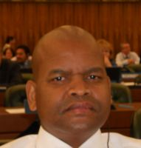 |  | Lentheng TSWAI, Minister, Permanent Mission, 65, rue du Rhone, 1204 Geneva, Switzerland  (tel.: + 41 22 5895407 e-mail: tsweni.agriculture@gmail.com)
ALLEMAGNE / GERMANY / DEUTSCHLAND / ALEMANIA
Pamela WILLE (Ms.), Counsellor, Permanent Mission, Case postale 171, D-1211 Geneva 19, Switzerland
(tel.: +4122 730 1260 fax: +41 22 730 12 95 e-mail: wi-2-io@genf.diplo.de)
ARGENTINE / ARGENTINA / ARGENTINIEN / ARGENTINA
Raimundo LAVIGNOLLE, Presidente, Instituto Nacional de Semillas (INASE), Venezuela 162, Ciudad Autónoma de Buenos Aires C1095AAD
(tel.: + 54 11 3220 5424 e-mail: rlavignolle@inase.gov.ar)
 |  | Carmen Amelia M. GIANNI (Sra.), Coordinadora de Propiedad Intelectual / Recursos Fitogenéticos, Instituto Nacional de Semillas (INASE), Venezuela 162, 1063 Buenos Aires (tel.: +54 11 32205414 e-mail: cgianni@inase.gov.ar)
AUSTRALIE / AUSTRALIA / AUSTRALIEN / AUSTRALIA
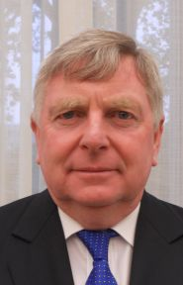 |  | Doug WATERHOUSE, Chief, Plant Breeder's Rights, IP Australia, P.O. Box 200, Woden ACT 2606  (tel.: +61 2 6283 7981 fax: +61 2 6283 7999 e-mail: doug.waterhouse@ipaustralia.gov.au)
BELGIQUE / BELGIUM / BELGIEN / BÉLGICA
Françoise DE SCHUTTER (Mme), Attachée, Office belge de la Propriété intellectuelle (OPRI), 16, bvd Roi Albert II, B-1000 Bruxelles
(tel.: 32 2 277 9555 e-mail:francoise.deschutter@economie.fgov.be)
BOLIVIE (ÉTAT PLURINATIONAL DE) / BOLIVIA (PLURINATIONAL STATE OF) /
BOLIVIEN (PLURINATIONALER STAAT) / BOLIVIA (ESTADO PLURINACIONAL DE)
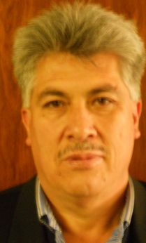 | Sergio Rider ANDRADE CÁCERES, Director Nacional de Semillas del INIAF, Instituto Nacional de Innovación Agropecuaria y Forestal (INIAF), Avenida 6 de agosto, Nro. 2170, Edificio Hoy, Mezanine, 4793 La Paz  (tel.: +591 2 2441153 fax: +591 2 2441153 e-mail: rideran@yahoo.es)
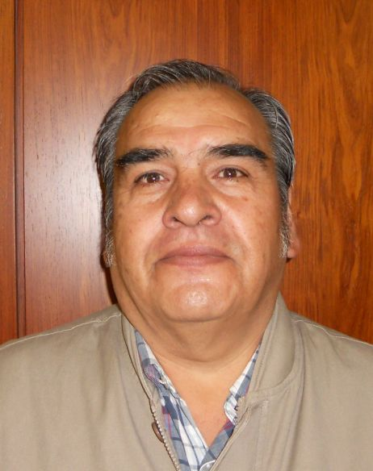 | Freddy CABALLERO LEDEZMA, Jefe de la Unidad de Fiscalización y Registros de Semillas, Instituto Nacional de Innovación Agropecuaria y Forestal (INIAF), Capitán Ravelo No. 2329, Belisario Salinas, No. 490, 4793 La Paz  (tel.: +591 2 2441153 fax: +591 2 2441153 e-mail: calefred@yahoo.es)
BRÉSIL / BRAZIL / BRASILIEN / BRASIL
Fabrício SANTANA SANTOS, Coordinator, National Plant Variety Protection Office (SNPC), Ministry of Agriculture, Livestock and Food Supply, Esplanada dos Ministerios, Bloco 'D', Anexo A, Sala 250, CEP 70043-900 Brasilia , D.F.
(tel.:+55 61 3218 2549 fax: +55 61 3224 2842 e-mail: fabricio.santos@agricultura.gov.br)
CANADA / CANADA / KANADA / CANADÁ
Anthony PARKER, Commissioner, Canadian Food Inspection Agency (CFIA), 59, Camelot Drive, Ottawa, Ontario K1A 0Y9
(tel.: +1 613 7737188 fax: +1 613 7737261 e-mail: anthony.parker@inspection.gc.ca)
CHILI / CHILE / CHILE / CHILE
Jaime IBIETA S., Director, División Semillas, Servicio Agrícola y Ganadero (SAG), Ministerio de Agricultura, Avda. Presidente Bulnes 140, piso 2, Santiago de Chile
(tel.: +56 2 345 1561 fax: +56 2 697 2179 e-mail: jaime.ibieta@sag.gob.cl)
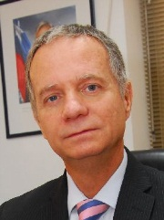 |  | Fernando Javier BAS MIR, Executive Director, Foundation for Agricultural Innovation, Ministry of Agriculture, Av. Loreley 1582, Santiago de Chile  (tel.: +56 2 2431 3064 fax.: +56 2 2431 3040 e-mail: fbas@fia.cl)
Andres GUGGIANA, Consejero, Misión Permanente ante la Organización Mundial del Comercio (OMC), Case postale 332, 1211 Ginebra 19
(tel.: +41 22 918 0080 e-mail: andres.guggiana@misionchileomc.ch)
CHINE / CHINA / CHINA / CHINA
LV Bo, Director, Division of Variety Management, Bureau of Seed Management, Ministry of Agriculture, No. 11 Nongzhanguannanli, Beijing
(tel.: +86 10 59193150 fax: +86 10 59193142 e-mail: lvbo@agri.gov.cn)
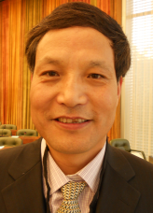 |  | QI Wang, Director, Division of Protection of New Varieties of Plants, State Forestry Administration, No. 18, Hepingli East Street, Beijing 100714  (tel.:+86 10 84239104 fax: +86 10 84238883 e-mail: wangqihq@sina.com)
Liying CHEN (Mrs.), Project Administrator, State Intellectual Property Office P.R. China, Division 2, International Cooperation Department, No. 6 Xitucheng Road, Beijing
(tel.: 0086 10 62083837 fax: 0086 10 62019615 e-mail: chenliying@sipo.gov.cn)
COLOMBIE / COLOMBIA / KOLUMBIEN / COLOMBIA
Ana Luisa DÍAZ JIMÉNEZ (Sra.), Directora Técnica de Semillas, Dirección Técnica de Semillas, Instituto Colombiano Agropecuario (ICA), Carrera 41 No. 17-81, Piso 4°, Zona Industrial de Puente Aranda, Bogotá D.C.
(tel.: +57 1 3323700 fax: +57 1 3323700 e-mail: ana.diaz@ica.gov.co)
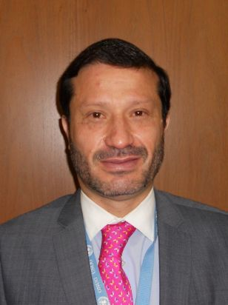 |  | Juan Camilo SARETZKI-FORERO, Consejo, Misión Permanente de Colombia, Chemin Champ dÁnier 17-19, 1209 Ginebra  (tel.: 41 22 798 4718 fax: 41 22 791 0787 e-mail: juan.saretzki@misioncolombia.ch)
CROATIE / CROATIA / KROATIEN / CROACIA
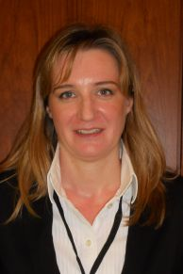 |  | Ivana BULAJIĆ (Ms.), Head, Plant Health Service, Vukovarska 78, HR-Zagreb  (tel.: +385 161 09390 e-mail: ivana.bulajic@mps.hr)
ESPAGNE / SPAIN / SPANIEN / ESPAÑA
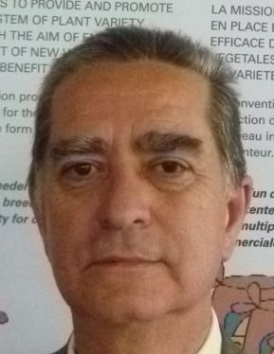 |  | Luis SALAICES, Jefe del Área del Registro de Variedades, Subdirección general de Medios de Producción Agrícolas y Oficina Española de Variedades Vegetales (MPA y OEVV), Ministerio de Agricultura, Alimentación y Medio Ambiente (MAGRAMA), C/ Almagro No. 33, planta 7a, E-28010 Madrid  (tel.: +34 91 347 6712 fax: +34 91 347 6703 e-mail: luis.salaices@magrama.es)
ESTONIE / ESTONIA / ESTLAND / ESTONIA
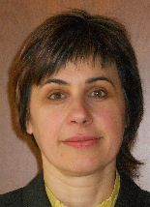 |  | Renata TSATURJAN (Ms.), Chief Specialist, Plant Production Bureau, Ministry of Agriculture, 39/41 Lai Street, EE-15056 Tallinn  (tel.: +372 625 6507 fax: +372 625 6200 e-mail: renata.tsaturjan@agri.ee)
Équateur / ECUADOR / ECUADOR / ECUADOR
Juan Carlos CASTRILLÓN J., Ministro, Misión Permanente, Rue de Lausanne 145 (7th floor), 1202 Ginebra
(tel.: +41 22 7315289 fax: +41 22 7318391 e-mail: jccastrillonj@gmail.com)
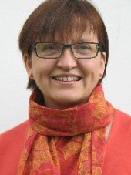 |  | Susanne GURA (Ms.), Coordinator, Association for Plant Breeding for the Benefit of Society (APBREBES), Burghofstr. 166, 53229 Bonn, Germany  (tel.: +49 228 9480670 e-mail: gura@dinse.net)
ÉTATS-UNIS D'AMÉRIQUE / UNITED STATES OF AMERICA /
VEREINIGTE STAATEN VON AMERIKA / ESTADOS UNIDOS DE AMÉRICA
Kitisri SUKHAPINDA (Ms.), Patent Attorney, Office of Policy and External Affairs, United States Patent and Trademark Office (USPTO), Madison Building, West Wing, 600 Dulany Street, MDW 10A30, Alexandria VA 22313
(tel.: +1 571 272 9300 fax: + 1 571 273 0085 e-mail: kitisri.sukhapinda@uspto.gov)
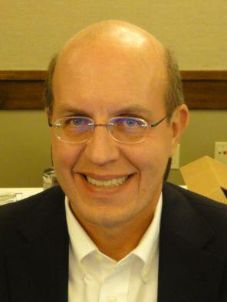 |  | Paul M. ZANKOWSKI, Commissioner, Plant Variety Protection Office, USDA, AMS, S&T, Plant Variety Protection Office, USDA, AMS, S&T, Plant Variety Protection Office, 1400 Independence Ave., S.W., Room 4512 - South Building, Mail Stop 0273, Washington D.C. 20250  (tel.: +1 202 720-1128 fax: +1 202 260-8976 e-mail: paul.zankowski@ams.usda.gov)
Karin L. FERRITER (Ms.), Intellectual Property Attaché, United States Mission to the WTO, 11, route de Pregny, 1292 Chambesy, Switzerland
(tel.: +41 22 749 5281 e-mail: karin_ferriter@ustr.eop.gov)
FÉDÉRATION DE RUSSIE / RUSSIAN FEDERATION / RUSSISCHE FÖDERATION /
FEDERACIÓN DE RUSIA
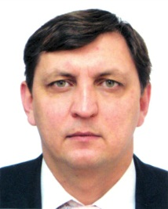 |  | Vitaly S. VOLOSCHCHENKO, Chairman, State Commission of the Russian Federation for Selection Achievements Test and Protection, Orlicov per. 1/11, 107139 Moscow  (tel.: +70 495 6076827 fax: +70 495 411 8366 e-mail: gossort@gossort.com)
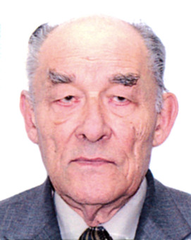 |  | Yuri A. ROGOVSKIY, Chief of Method Department, Deputy Chairman, State Commission of the Russian Federation for Selection Achievements Test and Protection, Orlikov per., 1/11, 107139 Moscow  (tel.: +7 499 9751082 fax: +7 495 411 83 66 e-mail: yrogovskij@yandex.ru)
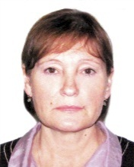 |  | Antonina TRETINIKOVA (Ms.), Leading Agronomist, Methodology Department, State Commission of the Russian Federation for Selection Achievements Test and Protection, Orlikov per., 1/11, 107139 Moscow  (tel.: +7 495 607 6827 fax: +7 495 411 8366 e-mail: tretinnikova@mail.ru)
FINLANDE / FINLAND / FINNLAND / FINLANDIA
Tarja Päivikki HIETARANTA (Ms.), Senior Officer, Finnish Food and Safety Authority (EVIRA), Seed Certification, Tampereentie 51, P.O. Box 111, FIN-32201 Loimaa
(tel.: +358 50 3443748 e-mail: tarja.hietaranta@evira.fi)
FRANCE / FRANCE / FRANKREICH / FRANCIA
Robert TESSIER, Sous-Directeur de la Qualité et de la protection des végétaux, DGAL, 251, rue de Vaugirard, F-75732 Paris 15 SP
(tel.: +33 1 49555030 fax: +33 1 49554959 e-mail: robert.tessier@agriculture.gouv.fr)
Virginie BERTOUX (Mme), Chef, Instance nationale des obtentions végétales (INOV), INOV-GEVES, 25 Rue Georges Morel, CS 90024, F-49071 Beaucouzé
(tel.: +33 2 41 22 86 49 fax: +33 2 41 22 86 01 e-mail: Virginie.bertoux@geves.fr)
HONGRIE / HUNGARY / UNGARN / HUNGRÍA
Ágnes Gyözöné SZENCI (Mrs.), Senior Chief Advisor, Agricultural Department, Ministry of Agriculture and Rural Development, Kossuth Tér. 11, 1055 Budapest
(tel.: +36 1 7953826 fax: +36 1 7950498 e-mail: gyozone.szenci@vm.gov.hu)
Katalin MIKLÓ (Ms.), Head, Agriculture and Plant Variety Protection Section, Hungarian Intellectual Property Office, Budapest
(tel.: 36 1 474 5898 fax: 36 1 474 5850 e-mail: katalin.miklo@hipo.gov.hu)
IRLANDE / IRELAND / IRLAND / IRLANDA
 |  | Donal COLEMAN, Controller of Plant Breeders' Rights, National Crop Evaluation Centre, Department of Agriculture, National Crops Centre, Backweston Farm, Leixlip , Co. Kildare (tel.: +353 1 630 2902 fax: +353 1 628 0634 e-mail: donal.coleman@agriculture.gov.ie)
JAPON / JAPAN / JAPAN / JAPÓN
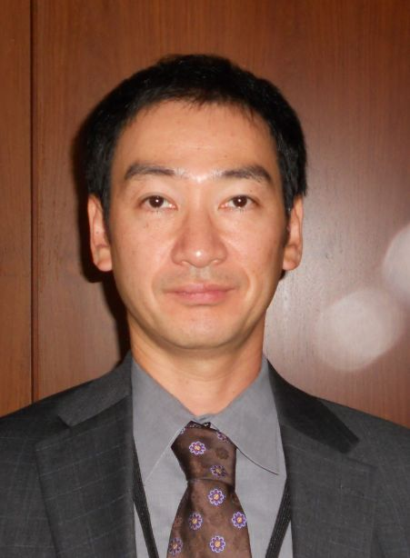 |  | Katsuhiro SAKA, Director, New Business and Intellectual Property Division, Food and Industry Affairs Bureau, Ministry of Agriculture, Forestry and Fisheries (MAFF),  1-2-1 Kasumigaseki, Chiyoda-ku, Tokyo 100-8950  (tel.: +81 3 6738 6168 fax: +81 3 3502 5301 e-mail: katsuhiro_saka@nm.maff.go.jp)
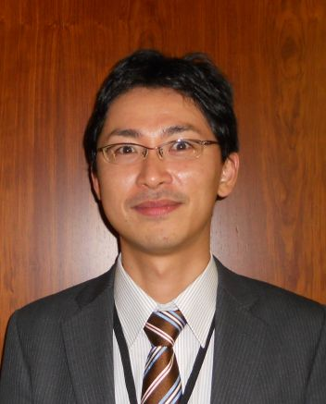 |  | Yoshihiko AGA, Associate Director for International Affairs, New Business and Intellectual Property Division, Food Industry Affairs Bureau, Ministry of Agriculture, Forestry and Fisheries (MAFF), 1-2-1 Kasumigaseki, Chiyoda-ku, 100-8950 Tokyo  (tel.: +81 3 6738 6444 fax: +81 3 3502 5301 e-mail: yoshihiko_aga@nm.maff.go.jp)
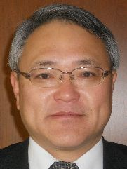 |  | Mitsutaro FUJISADA, Senior Policy Advisor: Intellectual Property, New Business and Intellectual Property Division, Food Industry Affairs Bureau, Ministry of Agriculture, Forestry and Fisheries (MAFF), 1-2-1, Kasumigaseki, Chiyoda-ku, 100-8950 Tokyo  (tel.:+81 3 6738 6445 fax: +81 3 3502 5301 e-mail: mitutarou_fujisada@nm.maff.go.jp)
kenya / kenya / kenia / kenya
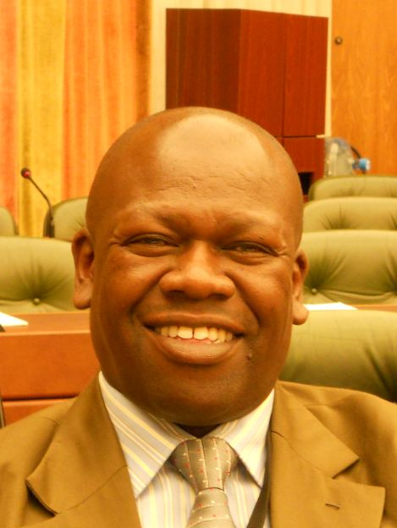 |  | Simon KIBET, General Manager – Quality Assurance, Kenya Plant Health Inspectorate Service (KEPHIS), P.O. Box 49592, 00100 Nairobi  (tel.: +254 20 3536171/2 fax: +254 20 3536175 e-mail: director@kephis.org)
LETTONIE / LATVIA / LETTLAND / LETONIA
Daiga BAJALE (Miss), Senior Officer, Seed Control Department, Division of Seed Certification and Plant Variety Protection, State Plant Protection Service, Lielvardes 36/38, LV-1006 Riga
(tel.: +371 67550938 fax: +371 67365571 e-mail: daiga.bajale@vaad.gov.lv)
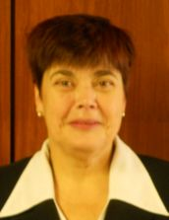 |  | Sofija KALININA (Mrs.), Senior Officer, Seed Control Department, Division of Seed Certification and Plant Variety Protection, State Plant Protection Service, Lielvardes iela 36/38, LV-1006 Riga  (tel.: +371 673 65568 fax: +371 673 65571 e-mail: sofija.kalinina@vaad.gov.lv)
LITUANIE / LITHUANIA / LITAUEN / LITUANIA
Arvydas BASIULIS, Deputy Director, State Plant Service under the Ministry of Agriculture of the Republic of Lithuania, Ozo 4A, LT-08200 Vilnius
(tel.: +370 5 237 5611 fax: +370 5 273 0233 e-mail: arvydas.basiulis@vatzum.lt)
Sigita JUCIUVIENE (Mrs.), Head, Division of Plant Variety, Registration and Legal Protection, State Plant Service under the Ministry of Agriculture of the Republic of Lithuania, Ozo St. 4a, LT-08200 Vilnius
(tel.: +370 5 234 3647 fax: +370 5 237 0233 e-mail: sigita.juciuviene@vatzum.lt)
Marija MARKOVA (Ms.), Attaché, Mission permanente de Lituanie auprès de l’Office des Nations Unies à Genève, 15, chemin Louis Dunand, CH-1202 Genève, Suisse
(e-mail: info@lithuania-mission.ch)
Antonio ATAZ, Adviser to the Presidency of the European Union, Council of the European Union, Brussels
(tel.: +32 2 281 4964 fax: +32 2 281 6198 e-mail: antonio.ataz@consilium.europa.eu)
MAROC / MOROCCO / MAROKKO / MARRUECOS
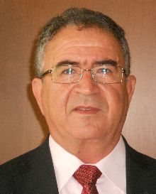 |  | Amar TAHIRI, Chef de la Division du contrôle des semences et plants, Office National de Sécurité sanitaire des Produits alimentaires (ONSSA), Ministère de l'Agriculture et de la Pêche Maritime, Rue Hafiane Cherkaoui, B.P. 1308, Rabat-Instituts  (fax: +212 537 779852 e-mail: amar.tahiri@gmail.com)
Salah Eddine TAOUIS, Counsellor, Mission permanente, Case postale 244,
1218 Grand-Saconnex, Genève, Suisse
(tel.: +41 22 791 8181 fax: +41 22 791 8180 e-mail: taouis@mission-maroc.ch)
MEXIQUE / MEXICO / MEXIKO / MÉXICO
Enriqueta MOLINA MACÍAS (Srta.), Directora General, Servicio Nacional de Inspección y Certificación de Semillas (SNICS), Secretaría de Agricultura, Ganadería, Desarrollo Rural, Pesca y Alimentación (SAGARPA), Av. Presidente Juárez, 13, Col. El Cortijo, Tlalnepantla , Estado de México54000
(tel.: +52 55 36220667 fax: +52 55 3622 0670
e-mail: enriqueta.molina@snics.gob.mx)
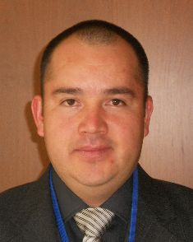 |  | Eduardo PADILLA VACA, Director de Variedades Vegetales, Registro y Control de Variedades Vegetales, Servicio Nacional de Inspección y Certificación de Semillas (SNICS), Av. Presidente Juárez 13, Col. El Cortijo, 54000 Tlalnepantla , Estado de México  (tel.: +52 55 36220667 fax: +52 55 3622 0670 e-mail: eduardo.padilla@snics.gob.mx)
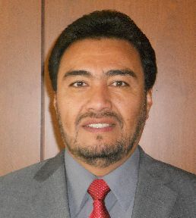 |  | Alejandro F. BARRIENTOS-PRIEGO, Subdirector General de Investigación, Universidad Autónoma Chapingo (UACh), Km. 38.5 Carretera México-Texcoco, CP 56230, Chapingo, Estadode México  (tel.: +52 59 59 52 1559 fax: +52 595 9521642 e-mail: abarrien@gmail.com)
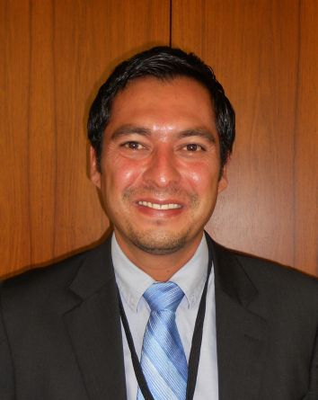 |  | Ivan POLANCO, Asistente del Ministro de Agricultura en Ginebra, Misión Permanente, Case postale 433, 1211 Ginebra 19, Suiza  (e-mail: mission.mexico@ties.itu.int)
NORVÈGE / NORWAY / NORWEGEN / NORUEGA
Marianne SMITH (Ms.), Senior Executive Officer, Royal Ministry of Agriculture,
P.O. Box 8007, Dep., N-0030 Oslo
(tel.: +47 22 24 9264 fax: +47 22 24 9559 e-mail: marianne.smith@lmd.dep.no)
Tor Erik JØRGENSEN, Head of Section, Norwegian Food Safety Authority, Felles postmottak, P.O. Box 383, N-2381 Brumunddal
(tel.: +47 6494 4393 fax: +47 6494 4411 e-mail: tor.erik.jorgensen@mattilsynet.no)
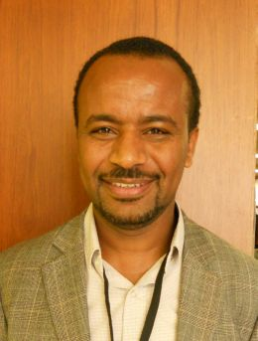 |  | Teshome Hunduma MULESA, The Development Fund, Mariboes gate 8, N-0183 Oslo  (tel.: +47 23 109600 fax: +47 23 109601 e-mail: teshome@utviklingsfondet.no)
NOUVELLE-ZÉLANDE / NEW ZEALAND / NEUSEELAND / NUEVA ZELANDIA
Christopher J. BARNABY, Assistant Commissioner / Principal Examiner, Plant Variety Rights Office, Intellectual Property Office of New Zealand, Private Bag 4714, Christchurch 8140
(tel.: +64 3 9626206 fax: +64 3 9626202 e-mail: Chris.Barnaby@pvr.govt.nz)
PARAGUAY / PARAGUAY / PARAGUAY
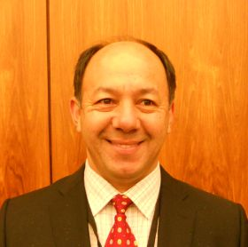 |  | Regis MERELES, Presidente, Servicio Nacional de Calidad y Sanidad Vegetal y de Semillas (SENAVE), Humaitá No. 145 entre Nuestra Señora de la, Asunción e Independencia Nacional, Asunción  (tel.: +595 21 490703 fax: +595 21 441491 e-mail: regis.mereles@senave.gov.py)
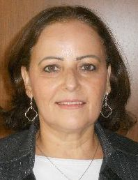 |  | Blanca Julia NUÑEZ TEIXIDO (Sra.), Tècnico de la Dirección de Semillas, Jefa del Departamento de Protección y Uso de Variedades, Dirección General de Semillas, Servicio Nacional de Calidad y Sanidad Vegetal y de Semillas (SENAVE), Gaspar Rodríguez de Francia, No. 685, Ruta Mariscal Estigarribia, San Lorenzo  (tel.: +595 21 584645 fax: +595 21 584645 email: blanca.nunez@senave.gov.py)
PAYS-BAS / NETHERLANDS / NIEDERLANDE / PAÍSES BAJOS
Kees Jan GROENEWOUD, Secretary to the Plant Variety Board (Raad voor Plantenrassen), Postbus 40, NL-2370 AA Roelofarendsveen
(tel.: +31713326310 fax: +31713326363)
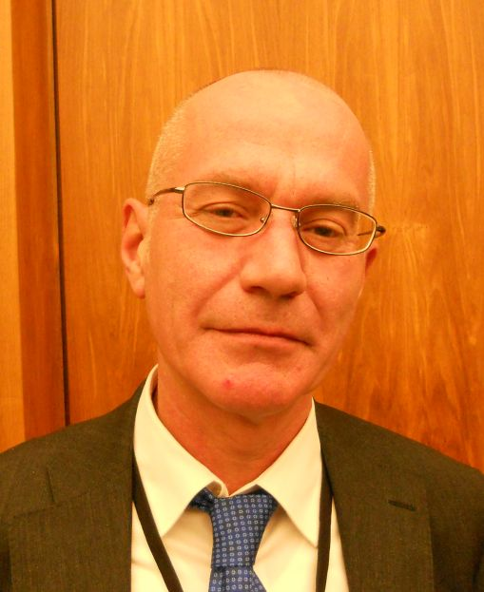 |  | Jaap SATTER, Policy Co-ordinator, Ministry of Economic Affairs, Directorate General for Agriculture, NL-The Hague  (tel.: +31 70 378 6519 e-mail: j.h.satter@minez.nl)
Kees VAN ETTEKOVEN, Head of Variety Testing Department, Naktuinbouw NL, Sotaweg 22, Postbus 40, NL-2370 AA Roelofarendsveen
(tel.: +31 71 332 6128 fax: +31 71 332 6565 e-mail: c.v.ettekoven@naktuinbouw.nl)
POLOGNE / POLAND / POLEN / POLONIA
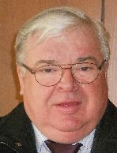 |  | Edward S. GACEK, Director, Research Centre for Cultivar Testing (COBORU),  PL-63-022 Slupia Wielka  (tel.: +48 61 285 2341 fax: +48 61 285 3558 e-mail: e.gacek@coboru.pl)
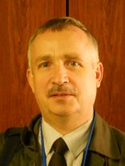 |  | Marcin BEHNKE, Deputy Director General for Experimental Affairs, Research Centre for Cultivar Testing (COBORU), PL-63-022 Slupia Wielka  (tel.: +48 61 285 2341 fax: +48 61 285 3558 e-mail: m.behnke@coboru.pl)
RÉPUBLIQUE DE CORÉE / REPUBLIC OF KOREA / REPUBLIK KOREA / REPÚBLICA DE COREA
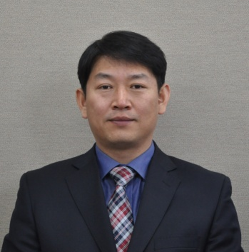 |  | Sanghyug LEE, Director, Plant Variety Protection Division, Korea Seed & Variety Service (KSVS), Ministry of Agriculture, Food and Rural Affairs (MAFRA), 184, Anyang-ro, Manan-Gu, Anyang City, Gyeonggi-do 430-016  (tel.: +82 31 467 0150 fax: +82 31 467 0160 e-mail: lsh68@korea.kr)
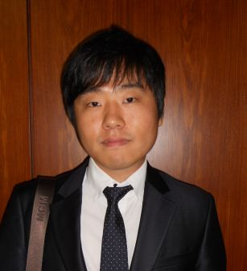 |  | Jino YOO, Deputy Director, Korean Intellectual Property Office (KIPO), 189, Cheongsa-Ro, Seo-Gu, Daejeon Metropolitan City 302-701  (tel.: +82 42 481 8387 fax: +82 42 472 3514 e-mail: jino0524@kipo.go.kr)
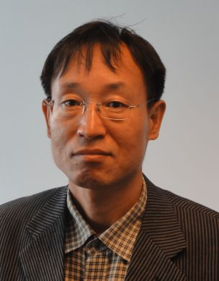 |  | Seung-In YI, Examiner, Plant Variety Protection Division, Korea Seed & Variety Service (KSVS), Anyang-ro 184, Anyang City , Kyunggi-do 430-016  (tel.: +82 31 467 0112 fax: +82 31 467 0160 e-mail: seedin@korea.kr)
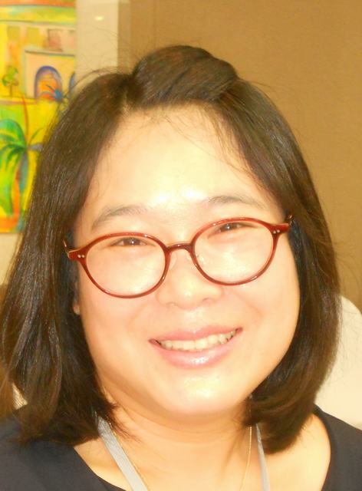 |  | Oksun KIM (Ms.), Plant Variety Protection Division, Korea Seed & Variety Service (KSVS) / MAFRA, Anyang-ro 184, Anyang City , Kyunggi-do 430-016  (tel.: +82 31 467 0191 fax: +82 31 467 0160 e-mail: oksunkim@korea.kr)
RÉPUBLIQUE DE MOLDOVA / REPUBLIC OF MOLDOVA / REPUBLIK MOLDAU /
REPÚBLICA DE MOLDOVA
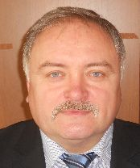 |  | Mihail MACHIDON, President, State Commission for Crops Variety Testing and Registration (SCCVTR), Bd. Stefan cel Mare, 162, C.P. 1873, MD-2004 Chisinau  (tel.: +373 22 220300 fax: +373 2 211537 e-mail: mihail.machidon@yahoo.com)
RÉPUBLIQUE TCHÈQUE / CZECH REPUBLIC / TSCHECHISCHE REPUBLIK /
REPÚBLICA CHECA
Daniel JUREÇKA, Director, Plant Production Section, Central Institute for Supervising and Testing in Agriculture (ÚKZÚZ), Hroznová 2, 656 06 Brno
(tel.: +420 543 548 210 fax: +420 543 217 649 e-mail: daniel.jurecka@ukzuz.cz)
ROUMANIE / ROMANIA / RUMÄNIEN / RUMANIA
Mihaela-Rodica CIORA (Mrs.), DUS Expert, State Institute for Variety Testing and Registration (ISTIS), 61, Marasti, Sector 1, P.O. Box 32-35, 011464 Bucarest
(tel.:+40 213 184380 fax: +40 213 184408 e-mail: mihaela_ciora@istis.ro)
ROYAUME-UNI / UNITED KINGDOM / VEREINIGTES KÖNIGREICH / REINO UNIDO
Elspeth NICOL (Mrs.), Policy Advisor, Varieties and Seeds Policy Team, Department for the Environment, Food and Rural Affairs (DEFRA), First Floor, Eastbrook, Shaftesbury Road, Cambridge CB2 8DR
(tel.: +44 300 060 0762 e-mail: elspeth.nicol@defra.gsi.gov.uk)
SLOVAQUIE / SLOVAKIA / SLOWAKEI / ESLOVAQUIA
Bronislava BÁTOROVÁ (Mrs.), National Coordinator, Senior Officer, Department of Variety Testing, Central Controlling and Testing Institute in Agriculture (ÚKSÚP), Akademická 4, SK-949 01 Nitra
(tel.: +421 37 655 1080 fax: +421 37 652 3086 e-mail: bronislava.batorova@uksup.sk)
SUÈDE / SWEDEN / SCHWEDEN / SUECIA
Jens WEIBULL, Senior Officer, Plant and Environment Department, Swedish Board of Agriculture, S-551 82 Jönköping
(tel.: +46 36 155703 fax: +46 36 710517 e-mail: olof.johansson@jordbruksverket.se)
SUISSE / SWITZERLAND / SCHWEIZ / SUIZA
Manuela BRAND (Frau), Leiterin, Büro für Sortenschutz, Fachbereich Zertifizierung, Pflanzen- und Sortenschutz, Bundesamt für Landwirtschaft, Mattenhofstrasse 5, CH-3003 Bern
(tel.: +41 31 322 2524 fax: +41 31 322 2634 e-mail: manuela.brand@blw.admin.ch)
UNION EUROPÉENNE / EUROPEAN UNION / EUROPÄISCHE UNION / UNIÓN EUROPEA
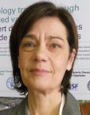 |  | Dana-Irina SIMION (Mme), Chef de l'Unité E7, Direction Générale Santé et Protection des Consommateurs, Commission européene, DG SANCO, B232 04/082, 1049 Bruxelles  (tel.: +32 2 296 2345 e-mail: dana-irina.simion@ec.europa.eu)
Päivi MANNERKORPI (Mrs.), Chef de section - Unité E2, Direction Générale Santé et Protection des Consommateurs, Commission européene (DG SANCO), rue Belliard 232, 04/075, 1040 Bruxelles
(tel.:+32 2 299 3724 fax: +32 2 296 0951 e-mail: paivi.mannerkorpi@ec.europa.eu)

Isabelle CLEMENT-NISSOU (Mrs.), Policy Officer – Unité E2, Direction Générale Santé et Protection des Consommateurs, Commission européene (DG SANCO), rue Belliard 232, 04/025, 1040 Bruxelles
(tel.:+32 229 87834 fax: +32 2 2960951 e-mail: isabelle.clement-nissou@ec.europa.eu)
Martin EKVAD, President, Community Plant Variety Office (CPVO), 3, boulevard Maréchal Foch, CS 10121, 49101 Angers Cedex 02, France
(tel.: +33 2 4125 6415 fax: +33 2 4125 6410 e-mail: ekvad@cpvo.europa.eu)
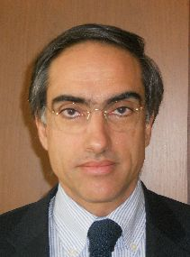 |  | Carlos GODINHO, Vice-President, Community Plant Variety Office (CPVO), 3, boulevard Maréchal Foch, CS 10121, 49101 Angers Cedex 02, France  (tel.: +33 2 4125 6413 fax: +33 2 4125 6410 e-mail: godinho@cpvo.europa.eu)
VIET NAM / VIET NAM / VIETNAM / VIET NAM
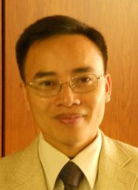 |  | Nguyen Quoc MANH, Deputy Chief of PVP Office, Plant Variety Protection Office of Viet Nam, No 2 Ngoc Ha Street, Ba Dinh Dist, (84) 48 Hanoi  (tel.: +84 4 38435182 fax: +84 4 37344967 e-mail: quocmanh.pvp.vn@gmail.com)
II. OBSERVATEURS / OBSERVERS / BEOBACHTER / OBSERVADORES
ALGÉRIE / ALGERIA / ALGERIEN / ARGELIA
Ahlem Sara CHARIKHI (Ms.), Attaché, Mission permanente, 308, route de Lausanne, 1293 Bellevue
(e-mail: mission.algeria@mission-algerie.ch)
Bosnie-Herzégovine / Bosnia and Herzegovina / Bosnien und Herzegowina / Bosnia y Herzegovina
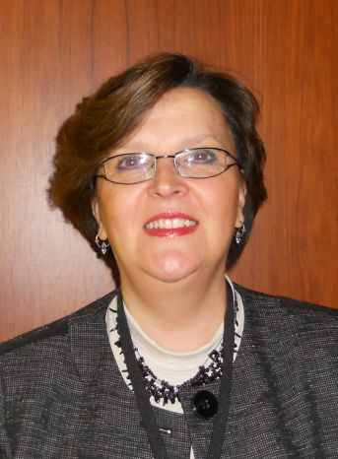 | Snežana AKULOVIĆ (Mrs), Director Advisor, Administration of Bosnia and Herzegovina for Plant Health Protection, Ministry of Foreign Trade and Economic Relations of Bosnia and Herzegovina, Radiceva 8, 71000 Sarajevo  (tel.: +387 33 290731 fax: +387 33 290711 e-mail: snezana.akulovic@uzzb.gov.ba)
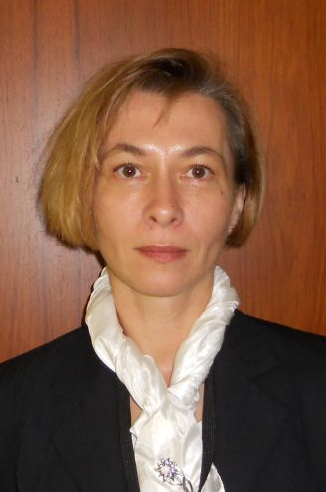 | Mirjana BRZICA (Mrs.), Head, Department of seeds, seedling and protection of new varieties of plants, Administration of Bosnia and Herzegovina for Plant Health Protection, Ministry of Foreign Trade and Economic Relations of Bosnia and Herzegovina, Radiceva, 8, 71000 Sarajevo  (tel.: +387 33 290 722 e-mail: mirjana.brzica@uzzb.gov.ba)
CAMBODGE / CAMBODIA / KAMBODSCHA / CAMBOYA
Chantravuth PHE, Deputy Director, Department Industrial Property, Ministry of Industry, Mines Energy, #45, Preah Norodom, Boulevard Hhan Doun Penh, Khan Daun Penh, Phnom Penh
(tel.: +855 23 211141 fax: 855 23 428 263 e-mail: phechantravuth@yahoo.com)
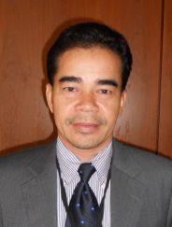 | Sao CHESDA, Deputy Director, Department of Horticulture and Subsidiary Crops, Ministry of Agriculture, Forestry and Fisheries (MAFF), #200 Sang Kat Tonle Basak, Khan Chamkarmorn, Preah Norodom Blvd, Phnom Penh  (tel.: +855 77989673 fax: +855 23 212 266 e-mail: saochesda@ymail.com)
GHANA / GHANA / GHANA / GHANA
 |  | Hon. Marrietta Brew APPIAH-OPONG, Attorney-General and Minister of Justice
 |  | Hon. Dr. Ahmed Yakubu ALHASSAN (MP), Deputy Minister of Agriculture
 |  | Hon. Alban BAGBIN (MP), Chairman, Select Committee for Legal and Constitutional Affairs, Parliament
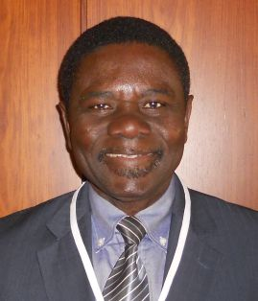 |  | Hans ADU DAPAAH, Director, CSIR-Crops Research Institute, P.O. Box 3785, Kumasi, Ghana  (tel.: +233 03220 60396 fax: +233 03220 60396 e-mail: hadapaah@cropsresearch.org)
 |  | Mavis AMOA (Mrs.), Chief State Attorney, Legislative Drafting Division, Attorney-General and Ministry of Justice
Grace Ama ISSAHAQUE (Mrs.), Chief State Attorney, Registrar-General’s Department, Ministry of Justice, P.O. Box 118, Accra
(tel.: +233 21 666 469 fax: +233 21 666 081 e-mail: graceissahaque@hotmail.com)
Angela Naa Dedei HEDO (Mrs.), Attorney, Attorney General's Department, Ministry of Justice, P.O. Box MB 60, Accra
(tel.: +233 302 665051 fax: +233 302 667 609 e-mail: angelahedos@gmail.com)
Jude L. OSEI, First Secretary, Permanent Mission of the Republic of Ghana to the United Nations Office at Geneva, 56, rue de Moillebeau, CH-1209 Geneva, Switzerland
(e-mail: oseij@ghanamission.ch)
RÉPUBLIQUE DÉMOCRATIQUE POPULAIRE LAO / LAO PEOPLE'S DEMOCRATIC REPUBLIC / DEMOKRATISCHE VOLKSREPUBLIK LAOS / REPÚBLICA DEMOCRÁTICA POPULAR LAO
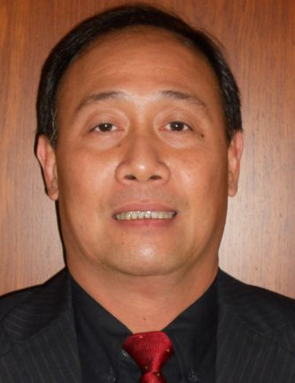 | Makha CHANTALA, Deputy Director General, Intellectual Property Division, National Authority for Science and Technology (NAST), Department of Intellectual Property, Standardization and Metrology (DISM), Makaidiao, P.O. Box 2279, Vientiane  (tel.: +856 21 248784 fax: +856 21 2134772 e-mail: c_makha@yahoo.com)
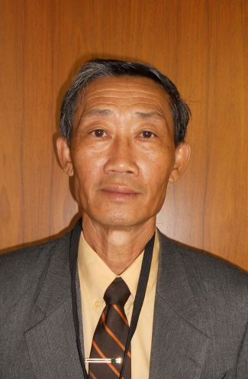 | Kham SANATEM, Deputy Director-General, Department of Agriculture, Ministry of Agriculture and Forestry, Lane Xang Avenue, Patuxay Square, P.O. Box 811  Vientiane  (tel.: + 856 21 412350 fax: + 856 20 5513011 e-mail: sanatemkham@yahoo.com)
THAÏLANDE / THAILAND / THAILAND / TAILANDIA
Chutima RATANASATIEN (Mrs.), Senior Specialist on Plant Variety Protection, Plant Variety Protection Office, Department of Agriculture, Ministry of Agriculture and Cooperatives, Ministry of Agriculture and Cooperatives, Phochakorn Building, 50 Phaholyothin Road, Ladyao, Chatuchak, 10900 Bangkok
(tel.: +66 2 940 7214 fax: +66 2 940 7214 e-mail: chutima_ratanasatien@yahoo.com)
III. ORGANISATIONS / ORGANIZATIONS / ORGANISATIONEN / ORGANIZACIONES
ORGANISATION MONDIALE DU COMMERCE (OMC) / WORLD TRADE ORGANIZATION (WTO) / WELTHANDELSORGANISATION (WTO) / ORGANIZACIÓN MUNDIAL DEL COMERCIO (OMC)
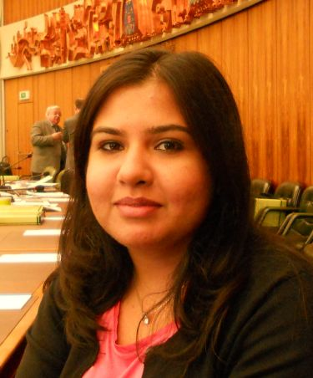 |  | Sandeepan NEELAMBERA (Ms.), Research Associate, Intellectual Property Division, Centre William Rappard, 154, rue de Lausanne, 1211 Genève 21, Suisse  (tel.: +41 22 739 5114 fax: +41 22 739 5790 e-mail: sandeepan.neelambera@wto.org)
ORGANISATION DES NATIONS UNIES POUR L'ALIMENTATION ET L'AGRICULTURE (FAO) / FOOD AND AGRICULTURE ORGANIZATION OF THE UNITED NATIONS (FAO) / ERNÄHRUNGS- UND LANDWIRTSCHAFTSORGANISATION DER VEREINTEN NATIONEN (FAO) / ORGANIZACIÓN DE LAS NACIONES UNIDAS PARA ORGANIZACIÓN DE LAS NACIONES UNIDAS PARA LA ALIMENTACIÓN Y LA AGRICULTURA
Silvano SOFIA, Public Information and External Relations, Food and Agriculture Organization of the United Nations (FAO), Room A-576, Palais des Nations, 1211 Geneva 10, Switzerland
(tel.: +41 22917 2770 fax: +41 22 917 0065 e-mail: ssofia@unog.ch)
ASSOCIATION FOR PLANT BREEDING FOR THE BENEFIT OF SOCIETY (APBREBES)
 |  | Alexandra BHATTACHARYA (Ms.), Association for Plant Breeding for the Benefit of Society (APBREBES), 36, rue de Lausanne, 1201 Geneva, Switzerland
ORGANISATION RÉGIONALE AFRICAINE DE LA PROPRIÉTÉ INTELLECTUELLE (ARIPO) / AFRICAN REGIONAL INTELLECTUAL PROPERTY ORGANIZATION (ARIPO) / ORGANIZACIÓN REGIONAL AFRICANA DE LA PROPIEDAD INTELECTUAL (ARIPO)
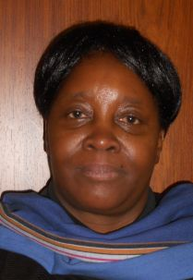 |  | Flora Kokwihyukya MPANJU (Mrs.), Senior Patent Examiner, Technical Department, P.O. Box 4228, Harare , Zimbabwe  (tel.: +263 4 794065/6 fax: +263 4 794072/3 e-mail: fmpanju@aripo.org)
ASSOCIATION INTERNATIONALE DES PRODUCTEURS HORTICOLES (AIPH) / INTERNATIONAL ASSOCIATION OF HORTICULTURAL PRODUCERS (AIPH) / INTERNATIONALER VERBAND DES ERWERBSGARTENBAUES (AIPH) / ASOCIACIÓN INTERNACIONAL DE PRODUCTORES HORTÍCOLAS (AIPH)
Mia BUMA (Mrs.), Secretary, Committee for Novelty Protection, International Association of Horticultural Producers (AIPH), Horticulture House, 19, High Street, Theale, RG7 5AH Reading, United Kingdom
(tel.: +44 118 9308956 e-mail: info@miabuma.nl)
ASSOCIATION INTERNATIONALE D'ESSAIS DE SEMENCES (ISTA) / INTERNATIONAL SEED TESTING ASSOCIATION (ISTA) / INTERNATIONALE VEREINIGUNG FÜR SAATGUTPRÜFUNG (ISTA) / ASOCIACIÓN INTERNACIONAL PARA EL ENSAYO DE SEMILLAS (ISTA)
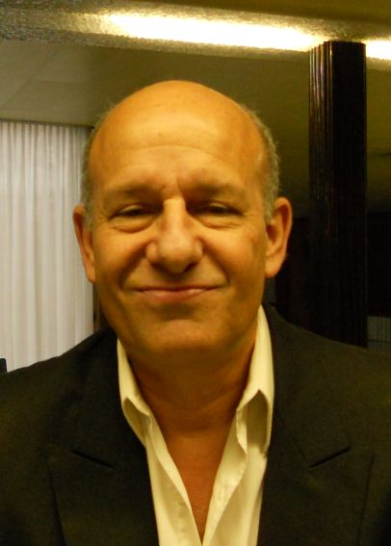 |  | Benjamin KAUFMAN, Secetary General, International Seed Testing Association (ISTA), Zürichstrasse 50, 8303 Bassersdorf , Suisse  (tel.: +41 44 838 6000 fax: +41 44 838 6001 e-mail: executive.office@ista.ch)
COMMUNAUTÉ INTERNATIONALE DES OBTENTEURS DE PLANTES ORNEMENTALES ET
FRUITIÈRES À REPRODUCTION ASEXUÉE (CIOPORA) / INTERNATIONAL COMMUNITY
OF BREEDERS OF ASEXUALLY REPRODUCED ORNAMENTAL AND FRUIT PLANTS
(CIOPORA) / Internationale Gemeinschaft der Züchter vegetativ vermehrbarer Zier- und Obstpflanzen (CIOPORA) / Comunidad Internacional de Obtentores de Variedades Ornamentales y Frutales de Reproducción Asexuada (CIOPORA)
Edgar KRIEGER, Secretary General, International Community of Breeders of Asexually Reproduced Ornamental and Fruit Plants (CIOPORA), Hamburg, Germany
(tel.: +49 40 555 63702 fax: +49 40 555 63703 e-mail: edgar.krieger@ciopora.org)
INTERNATIONAL SEED FEDERATION (ISF)
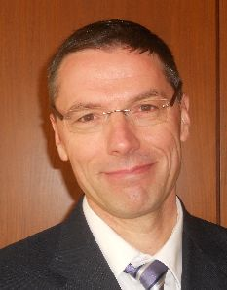 |  | Marcel BRUINS, Secretary General, International Seed Federation (ISF), 7, chemin du Reposoir, 1260 Nyon, Switzerland  (tel.: +41 22 365 4420 fax: +41 22 365 4421 e-mail: isf@worldseed.org)
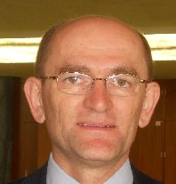 |  | Stevan MADJARAC, American Seed Trade Association (ASTA), 1701 Duke Street, Suite 275, Alexandria , VA22314, United States of America  (tel.: +1 636 7374395 e-mail: smadjarac@gmail.com)
ASIA AND PACIFIC SEED ASSOCIATION (APSA)
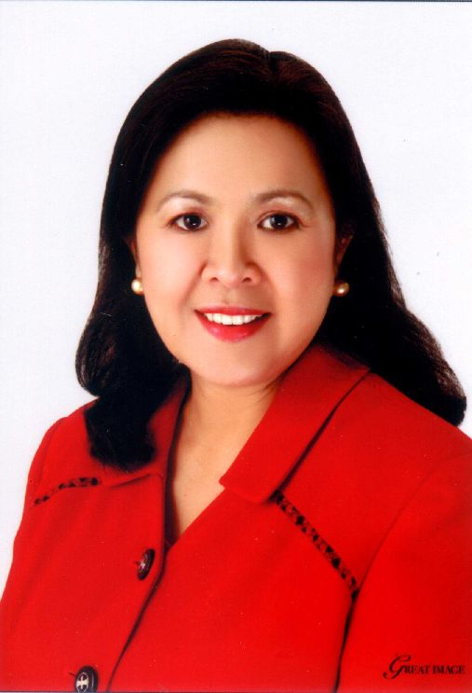 |  | Mary Ann SAYOC (Dr.), President, Asia and Pacific Seed Association, P.O. Box 33, Kasetsart Post Office, Bangkok 10903, Thaïlande  (tel.: +63 44 766 5192 fax: +63 44 766 1005 e-mail: maryann.sayoc@eastwestseed.com)
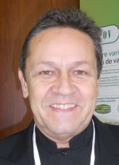 |  | François BURGAUD, APSA Standing Committee on Intellectual Property Rights, Asia and Pacific Seed Association (APSA), P.O. Box 1030, Kasetsart Post Office, Bangkok 10903, Thaïlande  (tel.: +66 2 9405464 fax: +66 2 9405467 e-mail: francois.burgaud@gnis.fr)
IV. BUREAU DE L’OMPI / OFFICE OF WIPO / BÜRO DER WIPO / OFICINA DE LA OMPI
 | Chitra NARAYANASWAMY (Mrs.), Director, Program Planning and Finance (Controller), Department of Finance and Budget
 | Janice COOK ROBBINS (Mrs.), Director, Finance Services, Department of Finance and Budget
V. VÉRIFICATEUR EXTERNE DE L’UPOV / EXTERNAL AUDITOR OF UPOV /
EXTERNER REVISOR DER UPOV / AUDITOR EXTERNO DE LA UPOV
 | Didier MONNOT, vérificateur externe, Contrôle fédéral des finances de la Confédération suisse, Berne
VI. BUREAU / OFFICER / VORSITZ / OFICINA
 |  | Kitisri SUKHAPINDA (Ms.), President
 |  | Luis SALAICES, Vice-President
VII. BUREAU DE L’UPOV / OFFICE OF UPOV / BÜRO DER UPOV / OFICINA DE LA UPOV
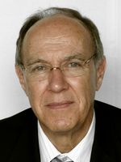 |  | Francis GURRY, Secretary-General
 |  | Peter BUTTON, Vice Secretary-General
 |  | Yolanda HUERTA (Mrs.), Legal Counsel
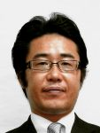 |  | Fuminori AIHARA, Counsellor
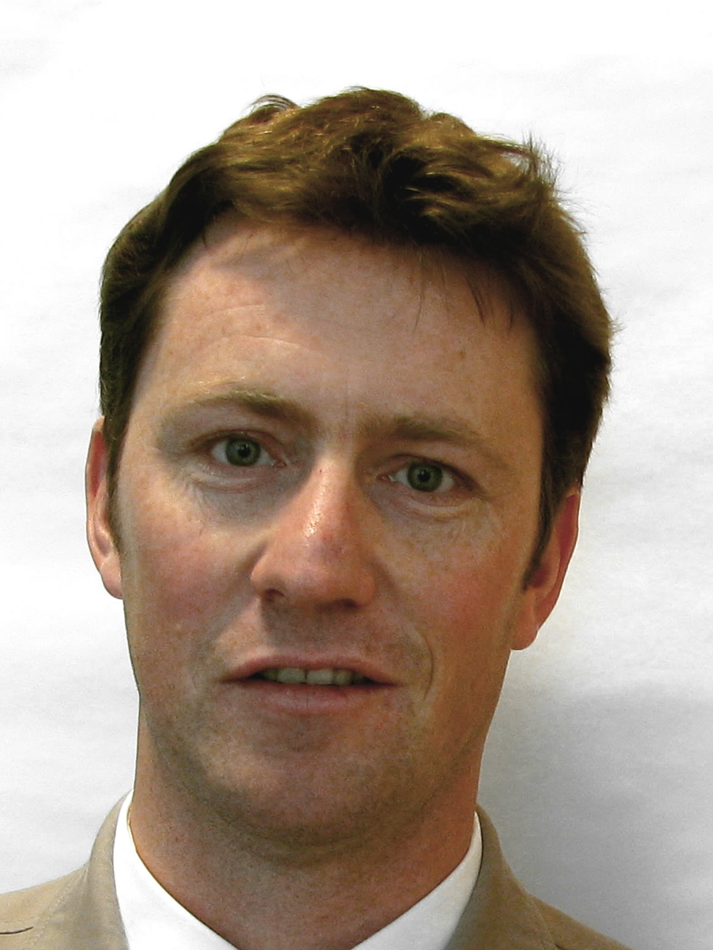 |  | Ben RIVOIRE, Technical/Regional Officer (Africa, Arab countries)
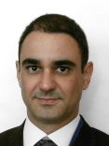 |  | Leontino TAVEIRA, Technical/Regional Officer (Latin America, Caribbean countries)

[L’annexe II suit /
Annex II follows /
Anlage II folgt /
Sigue el Anexo II]

INTERNATIONALER  VERBAND  ZUM SCHUTZ VON  PFLANZENZÜCHTUNGEN  GENF, SCHWEIZ |  |  | INTERNATIONAL UNION  FOR THE PROTECTION  OF NEW VARIETIES  OF PLANTS  GENEVA, SWITZERLAND
 | UNION INTERNATIONALE  POUR LA PROTECTION  DES OBTENTIONS  VÉGÉTALES  GENÈVE, SUISSE | UNIÓN INTERNACIONAL  PARA LA PROTECCIÓN  DE LAS OBTENCIONES  VEGETALES  GINEBRA, SUIZA

PRESS RELEASE

UPOV Press Release 95

Geneva, October 24, 2013

UPOV Council Holds its Forty-Seventh Ordinary Session

The Council of the International Union for the Protection of New Varieties of Plants (UPOV) held its forty-seventh ordinary session on October 24, 2013.

Round-up of key developments:

Positive decision on the Law for the Protection of New Varieties of Plants of Bosnia and Herzegovina

The Council decided that the Law for the Protection of New Varieties of Plants of Bosnia and Herzegovina was in conformity with the provisions of the 1991 Act of the UPOV Convention. Bosnia and Herzegovina is now in a position to deposit its instrument of accession to the 1991 Act of the UPOV Convention.

Plant Breeders’ Bill of Ghana

The Council noted that the Plant Breeders’ Bill of Ghana that had been presented to the Parliament incorporated the changes in the decision of the Council of November 1, 2012, and agreed that the additional changes, made during the first reading of the Bill by the Parliament of Ghana in June 2013, did not affect the substantive provisions of the 1991 Act of the UPOV Convention. Once the Bill is adopted and the Law is in force, Ghana will be in a position to deposit its instrument of accession to the 1991 Act of the UPOV Convention.

Communication strategy

The Council noted that the Consultative Committee had agreed a communication strategy with the aim of improving the level of understanding of the UPOV system. One of the priorities of the workplan would be the development of stakeholder-focused features on the UPOV website, with a focus on breeders, seed producers / plant propagators, farmers and policy-makers. As part of the strategy, a first set of answers to frequently asked questions was agreed and will be published on the UPOV website.

Matters raised by the International Seed Federation (ISF)

The Council received a report from the Consultative Committee on its consideration of the letter of the International Seed Federation (ISF) on the subject “Application, examination and granting aspects of PBR applications”. The Consultative Committee concluded that many of the matters could be addressed through existing and possible future UPOV information materials. Such matters would be considered by the relevant bodies within UPOV, particularly the CAJ and Technical Committee (TC). With regard to the idea of an international filing system, a UPOV quality assurance program and a central examination system for variety denominations, the Consultative Committee requested the Office of the Union and ISF to elaborate the problems faced and possible solutions in relation to ISF’s ideas, for consideration at the subsequent session of the Consultative Committee.

Program and Budget of the Union for the 2014-2015 Biennium

The Council approved the Program and Budget for the 2014-2015 biennium, amounting to Sfr6,794,000 (representing a 0.1% decrease from the 2012-2013 Biennium). This budget contains no change in the value of the contribution unit by members of the Union and no change in the total number of posts for the Office of the Union.

Election of the new Chair and the new Vice-Chair of the Administrative and Legal Committee and the Technical Committee

The Council elected, in each case for a term of three years ending with the fiftieth ordinary session of the Council, in 2016:

(a) Mr. Martin Ekvad (European Union), Chair of the Administrative and Legal Committee;
(b) Mr. James M. Onsando (Kenya), Vice-Chair of the Administrative and Legal Committee;
(c) Mr. Alejandro Barrientos-Priego (Mexico), Chair of the Technical Committee; and
(d) Mr. Kees van Ettekoven (Netherlands), Vice-Chair of the Technical Committee.

Plant Variety Protection Statistics

A total of 56 members of the Union now offer protection to all plant genera and species (53 in 2012), with 15 members of the Union offering protection to a limited number of plant genera and species.

A new record number of titles in force – 99,409 – was recorded in 2012, representing a 4.6 percent increase on figures for 2011 (95,041).

The Council noted that there had been a 1.1 percent increase in the number of applications for plant variety protection (13,867 in 2012; 13,714 in 2011), representing a 0.7 percent decrease in the number of applications by residents (8,751 in 2012; 8,813 in 2011) and a 4.4 percent increase in the number of applications by non-residents (5,116 in 2012; 4,901 in 2011). The number of titles granted decreased from 10,065 in 2011 to 9,822 in 2012 (2.4 percent decrease).

Cooperation in the Examination of New Plant Varieties

In 2012, the number of plant genera and species for which there were agreements between members of the Union for cooperation in the examination of distinctness, uniformity and stability totaled 1,997, compared to 1,991 in 2011.

Adoption of documents

The Council adopted the following documents:

- Guidance for the preparation of laws based on the 1991 Act of the UPOV Convention (Revision) (document UPOV/INF/6/3)
- Explanatory Notes on the Definition of Breeder under the 1991 Act of the UPOV Convention (document UPOV/EXN/BRD/1)
- Explanatory Notes on Acts in Respect of Harvested Material under the 1991 Act of the UPOV Convention (document UPOV/EXN/HRV/1)
- Glossary of Terms Used in UPOV Documents (Revision) (document TGP/14/2)
- Guidance on the Use of Biochemical and Molecular Markers in the Examination of Distinctness, Uniformity and Stability (DUS) (document TGP/15/1)
- Exchangeable Software (Revision) (document UPOV/INF/16/3)
- List of UPOV/INF-EXN Documents and Latest Issue Dates (Revision) (document UPOV/INF-EXN/5)
- List of TGP documents and latest issue dates (Revision) (document TGP/0/6)

All adopted documents will be included in the UPOV Collection (see http://www.upov.int/upov_collection/en/)

Seminar on Essentially Derived Varieties

SEMINAR on
ESSENTIALLY DERIVED VARIETIES
Geneva, October 22, 2013

The Seminar considered the following:

(a) technical and legal views on “predominantly derived”, “essential characteristics” and “differences
which result from the act of derivation”, the relationship between Article 14(5)(b)(i) and (iii) of the 1991 Act of the UPOV Convention and the possible impact on breeding and agriculture;
(b) existing experience in relation to EDVs; and
(c) the possible role of future UPOV guidance on EDVs in cases before the courts.

The Seminar was open to the public and was attended by 177 participants. Copies of the presentations and a video of the Seminar are available on the UPOV website at:

http://www.upov.int/meetings/en/details.jsp?meeting_id=29782

For further information about UPOV, please contact the UPOV Secretariat:
Tel: (+41-22) 338 9111 E-mail: upov.mail@upov.int
Fax: (+41-22) 733 0336 Website: www.upov.int

[End of Annex II and of document]

